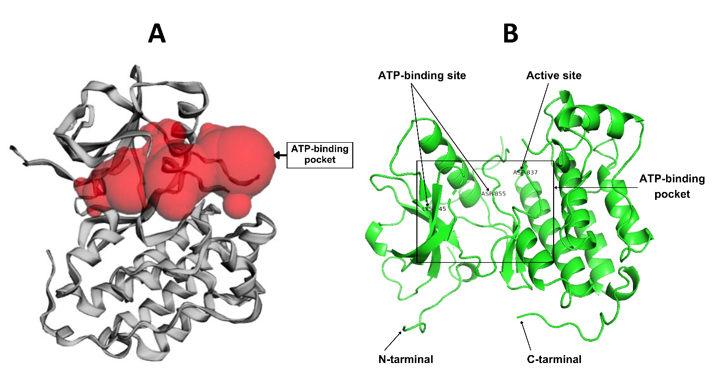
Figure S3: A) The surface representation of the ATP-binding pocket of the EGFR protein (B) The cartoon representation of the EGFR protein, highlighting the key structural features

