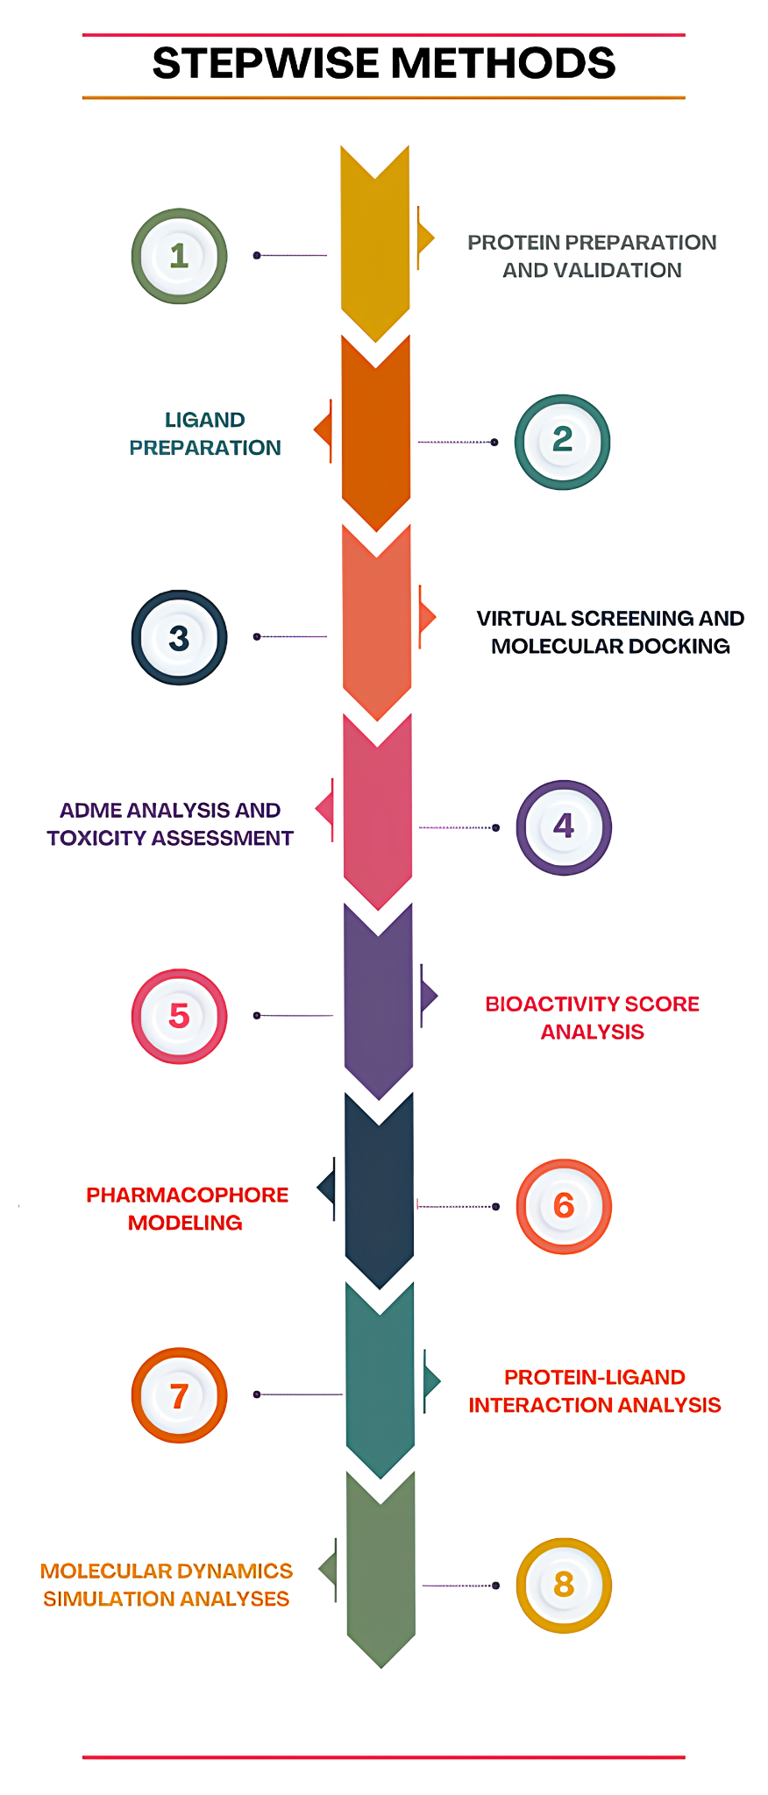
Figure S1: Stepwise flow diagram of the methods followed in the study

