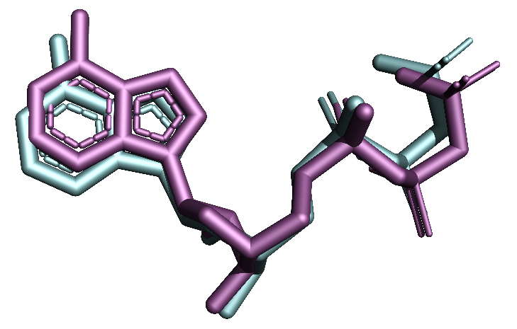
Figure S4: Superimposed structures of cocrystal ligand (Cyan), and its re-docked conformer (Magenta) with an RMSD of 0.00 Å.

