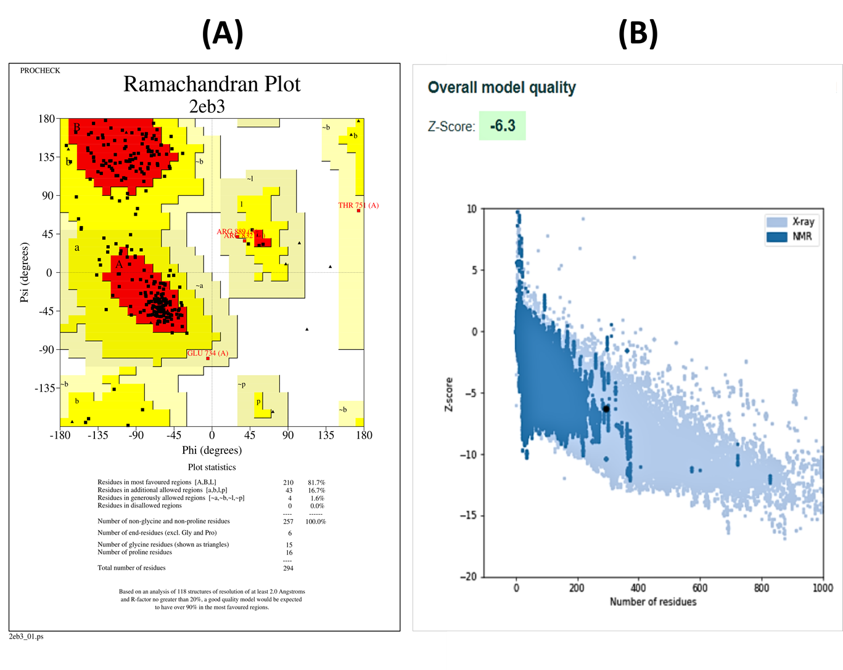
Figure S2: (A) Ramachandran plot EGFR protein (PDB: 2EB3) (B) Z-score EGFR protein (PDB: 2EB3)

