Supplementary Figures
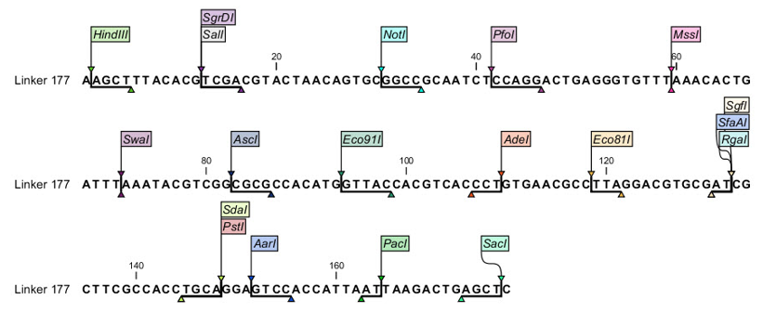
Fig. S1 Rare cutter 177 bp linker sequence added to develop MCS in pSB219 vector (CLC Bio Main Workbench, Qiagen). This sequence was added by replacing the GFP cassette originally present in pSB219 vector to develop the modified-pSB219 (pSB219M) having rare cutter sites that can be used for cloning
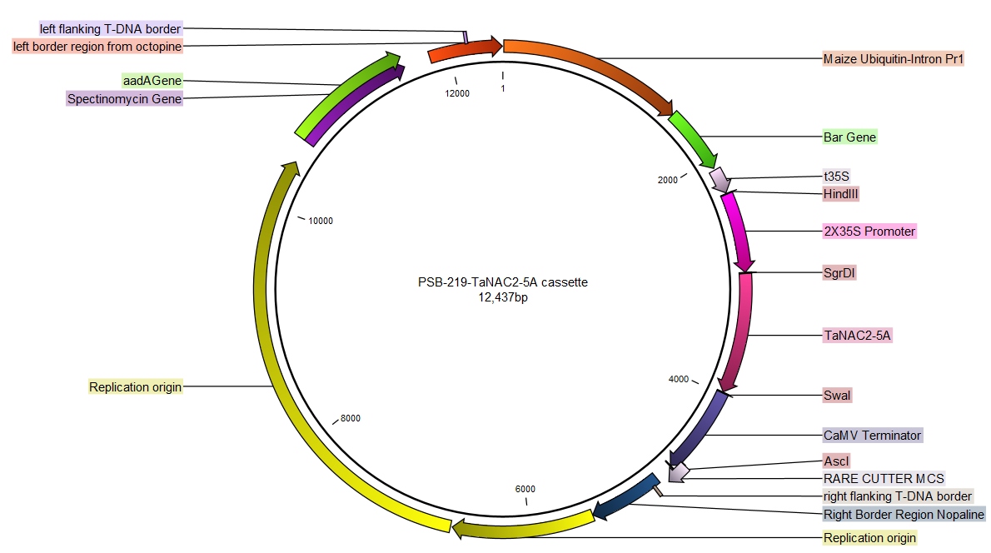
Fig. S2a Circular map of TaNAC2-5A harbouring construct named as pSB219-NAC2

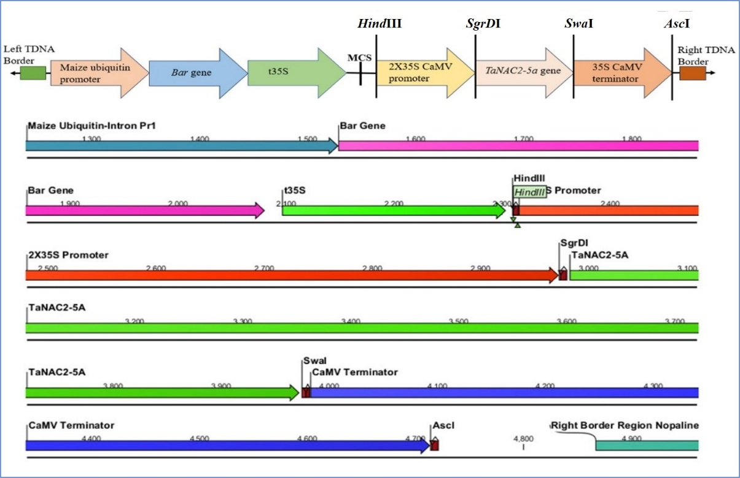
Fig. S2b Schematic representation of pSB219-NAC2 expression cassette. The TaNAC2-5A gene was cloned between SgrD1 and Swa1 sites in pSB219M-PT. Cassette designing in the transformation vector was done on CLC Main Workbench Ver. 6.7.1
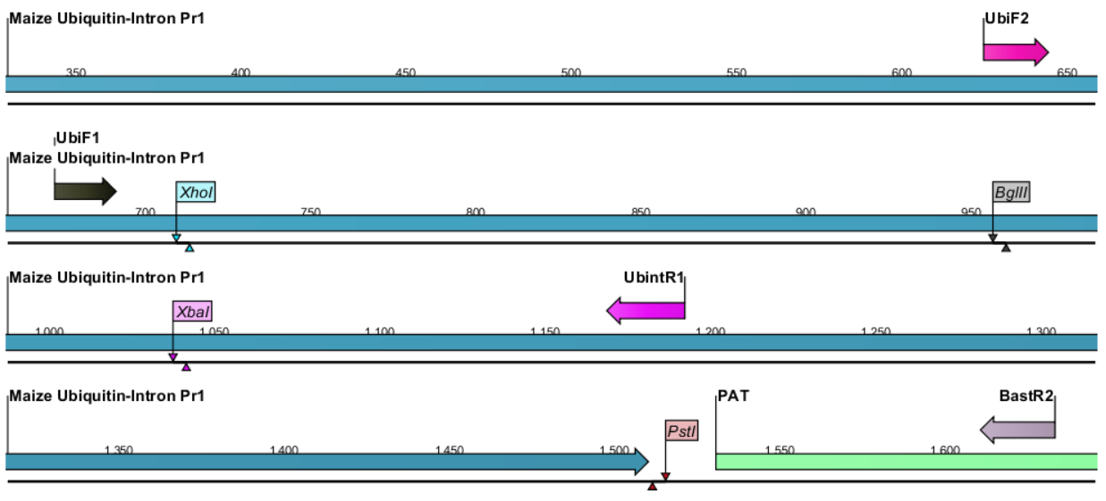
Fig. S3 Map showing the location of primers on the maize ubiquitin promoter and bar gene in vector pSB219M-PT for transgene detection
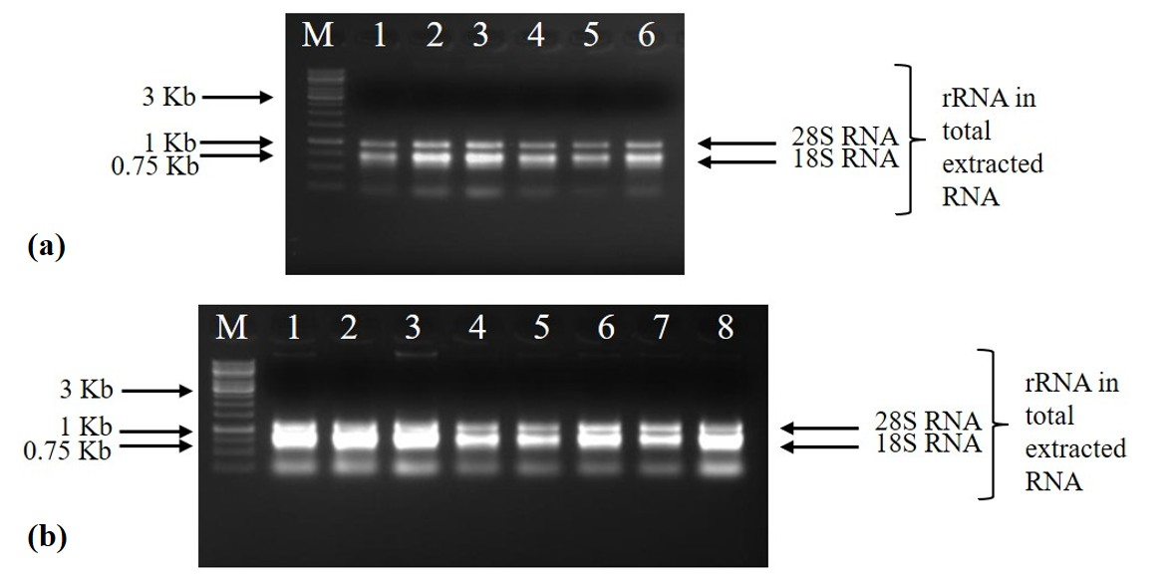
Fig. S4 Total RNA isolation of non- transgenic wheat controls and selected TaNAC2-5A T₂ wheat lines. (a) Lane M: 1 Kb DNA Ladder, Lane 1-6 specifies total RNA of FSD-2008 and Galaxy control plants. (b) Lane M: 1 Kb DNA Ladder, Lane 1-3 specifies total RNA of selected plants from NAC2-1, Lane 4-6 specifies the total RNA of selected plants from NAC2-2, Lane 7-8 indicates the total RNA of selected plants from NAC2-4. The upper band indicates 28SrRNA RNA and lower band indicates 18SrRNA
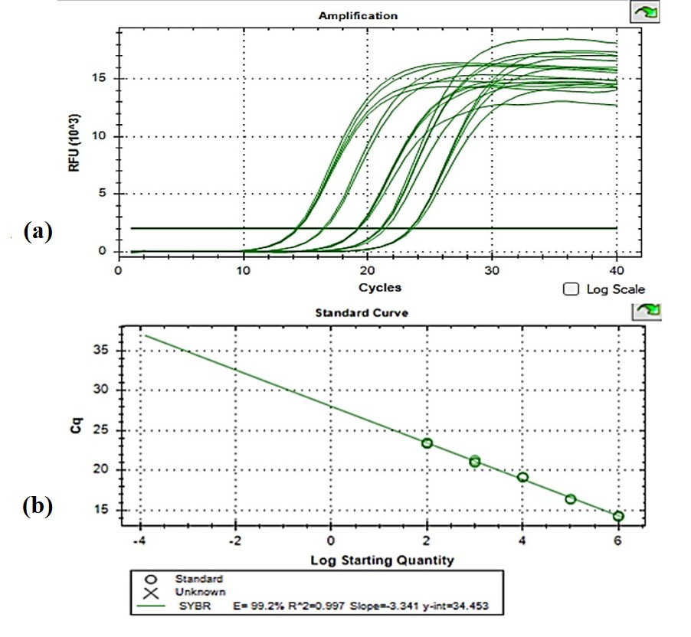
Fig. S5 Standard curve optimization using pre-amplified pooled cDNA for TaNAC2-5A gene. (a) Amplifications of different standards in 4 replicates at different Ct values are shown. (b) Standard curve showing 99.2 % efficiency of the PCR,0.997 R² value and -3.341 Slope value
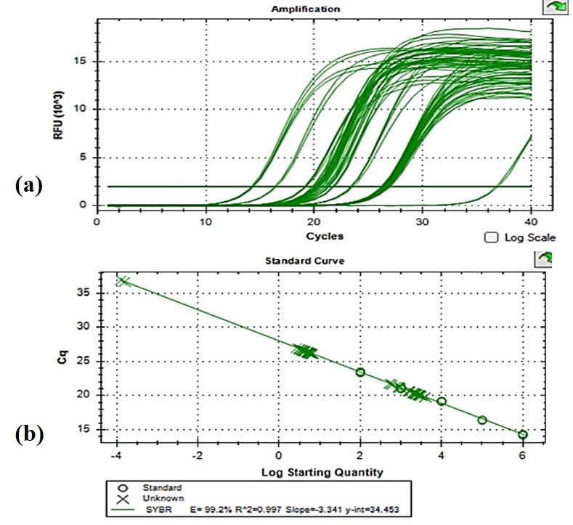
Fig. S6 Quantitative real time expression analysis of TaNAC2-5A gene in wheat parent line FSD-2008. (a) Amplification peaks showing cyclic thresholds (Ct) for different expression levels of TaNAC2-5A gene in each independent transgenic line. (b) Quantification cycles (Cq) of the unknown samples for TaNAC2-5A and internal control Alpha-Tubulin are shown on standard curve. PCR efficiency of 99.2 % and R² value of 0.997 is shown
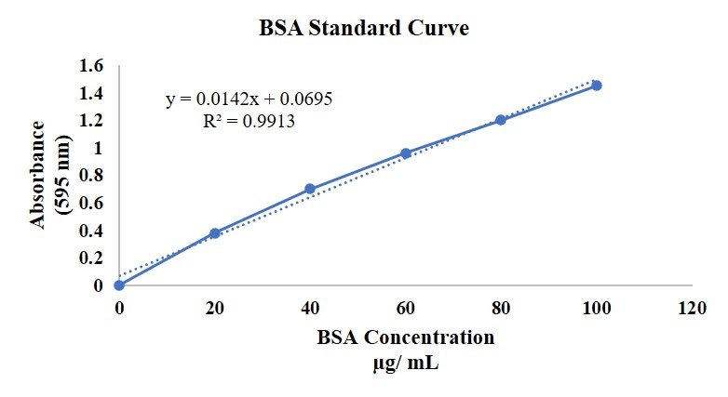
Fig. S7 BSA standard curve for the estimation of total protein content of the TaNAC2-5A transgenics and wild-type controls
Supplementary Tables

Table S1a Composition of digestion reaction for cloning TaNAC2-5A gene in pSB219M-PT
Components | Volume (µL)
Plasmid (pUC57-NAC2) | 3
Plasmid (pSB219M-PT) | 3
Tango Buffer (10X) | 4
SgrDI (10 Units/µL) | 0.5
SwaI (10 Units/µL) | 0.5
Nuclease free water | 9
Total volume | 20

Table S1b Composition of ligation reaction for ligating TaNAC2-5A gene in between SgrD1 and SwaI restriction sites in pSB219M-PT vector
Components | Ligation (µL)
TaNAC2-5A gene | 5
pSB219M-PT vector | 5
T4 DNA Ligase Buffer (10X) | 2
T4 DNA Ligase | 1
Nuclease free water | 7
Total | 20

Table S2a Composition of the PCR mix for the verification of pSB219-NAC2 cassette
Components of PCR Mix | Volume (μL)
Taq DNA Polymerase (5U/ μL) | 0.25
10X Taq Buffer | 2
MgCl₂ (25 mM) | 1.2
dNTPs (2.5 mM) | 1
Forward Primer (20 ng/ µL) | 1
Reverse Primer (20 ng/ µL) | 1
Template | 1
Nuclease free water | 12.55
Total Volume | 20

Table S2b. PCR profile for the verification of TaNAC2-5A gene in pSB219-NAC2 cassette
Steps | Temperature (ºC) | Time (min) | No. of Cycles
Initial Denaturation | 94.0 | 5 | 1
Denaturation | 94.0 | 1 | 40
Annealing | 58.0 | 1 | 40
Extension | 72.0 | 1 | 40
Final Extension | 72.0 | 10 | 1

Table S3. Different primer combinations for the expression studies in TaNAC2-5A wheat transgenic lines
Sr. No. | Primer Combination | Amplicon Size  (bp)
1 | NACqRTF1/ NACqRTR1 | 274
2 | NACqRTF1/ NACqRTR2 | 279
3 | NACqRTF1/ NACqRTR3 | 279
4 | NACqRTF2/ NACqRTR1 | 279
5 | NACqRTF2/ NACqRTR2 | 286
6 | NACqRTF2/ NACqRTR3 | 286
7 | NACqRTF3/ NACqRTR1 | 282
8 | NACqRTF3/ NACqRTR2 | 287
9 | NACqRTF3/ NACqRTR3 | 287
10 | AlphaTubF/AlphaTubR2 | 260

Table S4 Composition of the qRT-PCR master mix for the expression studies of TaNAC2-5A gene in wheat transgenics
Components of Master Mix | Volume (μL)
BlasTaq 2X qPCR Master Mix | 10
MgCl₂ (25 mM) | 1.2
Forward Primer (20 ng/ µL) | 1
Reverse Primer (20 ng/ µL) | 1
Template (cDNA) | 1
Nuclease free water | 5.8
Total Volume | 20

Table S5 PCR profile for expression analysis of TaNAC2-5A gene by qRT-PCR
Steps | Temperature ºC | Time | Number of Cycles
Initial Denaturation | 94.0 | 5 min | 1
Denaturation | 94.0 | 1 min | 40
Annealing | 62.0 | 30 sec | 40
Extension | 72.0 | 30 sec | 40
Final Extension | 72.0 | 10 | 1
Melt Curve | 72.0 ºC to 95.0 ºC, increment 0.5 ºC, for 0:05 + Plate Read

Table S6 Putative TaNAC2-5A transgenic lines and their T₁ seeds for collection of T₂ seeds and leaves for transgene analysis and expression studies
Sr. No. | Parent Wheat Line | T₀ Transgenic event | No. of T₁ seeds obtained from T₀ potted plants | No. of seeds sown | No. of T₁ seeds germinated | PCR positive T₁ plants
1 | Galaxy | NAC2-1 | 7 | 7 | 5 | L2, L3, L4
2 | Galaxy | NAC2-2 | 3 | 3 | 2 | L1, L2,
3 | Galaxy | NAC2-3 | 2 | 2 | - | -
4 | FSD-2008 | NAC2-4 | 15 | 10 | 8 | L1, L4-L8
5 | Galaxy | NAC2-5 | 4 | 4 | - | -
6 | FSD-2008 | NAC2-6 | 8 | 8 | 1 | -
7 | FSD-2008 | NAC2-7 | 1 | 1 | - | -

Table S7 Rhizo-scanning data of TaNAC2-5A T₂ transgenic lines grown in hydroponics
Transgenic Lines | Root Length (cm) | Surface Area (cm²) | Volume (cm³) | Average Diameter (mm) | Projected Area (cm²)
Control FSD-2008 | 42 | 1431.6 | 6716.482 | 187.664 | 455.692
NAC2-4(L6) | 44 | 1531.771 | 6199.411 | 189.383 | 465.747
NAC2-4(L7) | 46 | 1539.877 | 6776.648 | 198.256 | 468.327
NAC2-4(L5) | 43 | 1570.412 | 7720.079 | 196.638 | 499.878

