Supplementary Information

Electrically tunable ferroelectric NbOBr₂-integrated nonlinear photonics

Xiangxin Gong^{1,2}*, Ruihuan Duan³*, Yuhui Yang¹, Jinpeng Huo¹, Sung-Gyu Lee¹, Shi Guo¹, Xin Guo¹, Jeremy Leong^{1,4}, Lalit Singh¹, Wenduo Chen¹, Qi Jie Wang¹, Wonkeun Chang¹, Yue Gong^{1,4}, Beng Kang Tay^{1,4}, Huijun Liu⁵, Xiaoxu Zhao⁵, Qingyun Wu⁶, Lay Kee Ang⁶, Hong Wang¹, Jia Xu Brian Sia¹, Nanxi Li², Cheng-Wei Qiu⁷, Zheng Liu^{3,4✉}, Sang Hoon Chae^{1,3,4✉}

¹School of Electrical and Electronic Engineering, Nanyang Technological University, Singapore, 639798, Singapore.
²Institute of Microelectronics (IME), Agency for Science, Technology and Research (A*STAR), 2 Fusionopolis Way, Innovis #08-02, Singapore, 138634, Singapore.
³School of Materials Science and Engineering, Nanyang Technological University, Singapore, 639798, Singapore.
⁴CNRS-International-NTU-Thales Research Alliance (CINTRA), IRL 3288, 50 Nanyang Drive, Singapore, 637553, Singapore.
⁵School of Materials Science and Engineering, Peking University, Beijing 100871, China.
⁶Science, Mathematics and technology, Singapore University of technology and design, 8 Somapah Road, Singapore, 487372, Singapore.
⁷Department of Electrical and Computer Engineering, National University of Singapore, Singapore, Singapore.

* These authors contributed equally.
✉e-mail: z.liu@ntu.edu.sg, sanghoon.chae@ntu.edu.sg

List of Notes
Note S1. Device structure optimization.
Note S2. Extraction of NbOBr₂ index.
Note S3. Models used for coefficient extraction.
List of Figures
Figure S1. Scanning Transmission electron microscopy (STEM) analysis of NbOBr₂.
Figure S2. Energy dispersive spectroscopy (EDS) analysis of synthesized NbOBr₂ crystal.
Figure S3. Angle-dependence Raman measurement.
Figure S4. Raman peaks in terms of phonon vibration modes.
Figure S5. layer-dependent SHG data with AFM measurement.
Figure S6. Angle-dependence SHG intensity.
Figure S7. Angle-dependence I-V hysteresis caused by in-plane anisotropy.
Figure S8. PFM pattern for in-plane ferroelectric domain.
Figure S9. Optimization of microring radius for efficient NLO process.
Figure S10. Optimization of microring coupling gap for efficient NLO process.
Figure S11. Optimization of BUS_{SHG} width for efficient extraction of SHG signal.
Figure S12. OM-image and AFM measurement of fabricated SHG samples with various flake thickness.
Figure S13. Transmission spectrum of SHG devices with various flake thickness.
Figure S14. Index extraction of NbOBr₂.
Figure S15. Wavelength-dependence SHG measurement around resonance mode.
Figure S16. SFG measurement of sample 2.
Figure S17. SHG measurement of sample 1.
Figure S18. SHG measurement of sample 3.
Figure S19. Comparison of SHG response between NbOBr₂ and NbOCl₂
Figure S20. Resonance-wavelength modulation and Q-factor modulation as the function of applied voltage.
Figure S21. Schematic of a microring resonator.
Figure S22. Dependence of waveguide effective index on NbOBr₂ index.
Figure S23. Extraction: Resonance envelope.
Figure S24. SHG tunability from bare SiN waveguide integrated with NbOBr₂ without cavity.
Figure S25. Resonance envelope as a function of applied voltage loop.
Figure S26. OM-images and Modulated transmission Spectrums of fabricated tunable second harmonic generation (TSHG) samples with various flake thickness.
Figure S27. Comparison of modulation response between NbOBr₂ and NbOCl₂.
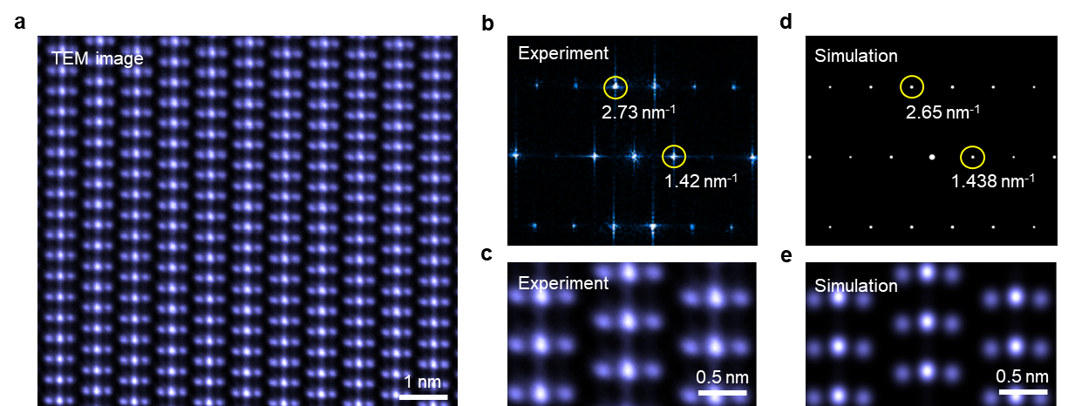
Figure S1. Scanning Transmission electron microscopy (STEM) analysis of NbOBr₂. a, High-resolution TEM image of NbOBr₂ along the c crystallographic axis, revealing the atomic structure with a layered nature and periodic AB-stacking configuration. The lattice image demonstrates clear periodicity with an interatomic distance of approximately 0.7 nm. b, Fast Fourier Transform (FFT) of the experimental TEM data showing diffraction spots at reciprocal lattice vectors of 2.73 nm⁻¹ and 1.42 nm⁻¹, confirming the crystallographic structure and periodicity. c, Zoomed-in view of the experimental atomic lattice structure, highlighting the precise arrangement of atoms. d, FFT simulation of the NbOBr₂ lattice, with corresponding reciprocal lattice points at 2.65 nm⁻¹ and 1.438 nm⁻¹. The simulated FFT pattern aligns closely with the experimental results in (b), validating the great quality of synthesized NbOBr₂ crystal. e, simulated atomic-scale image showing the AB-stacking arrangement, consistent with the experimental data (c), further corroborating the structural model. The comparison between experimental and simulated data illustrates excellent agreement, reinforcing the validity of the proposed structural model for NbOBr₂.

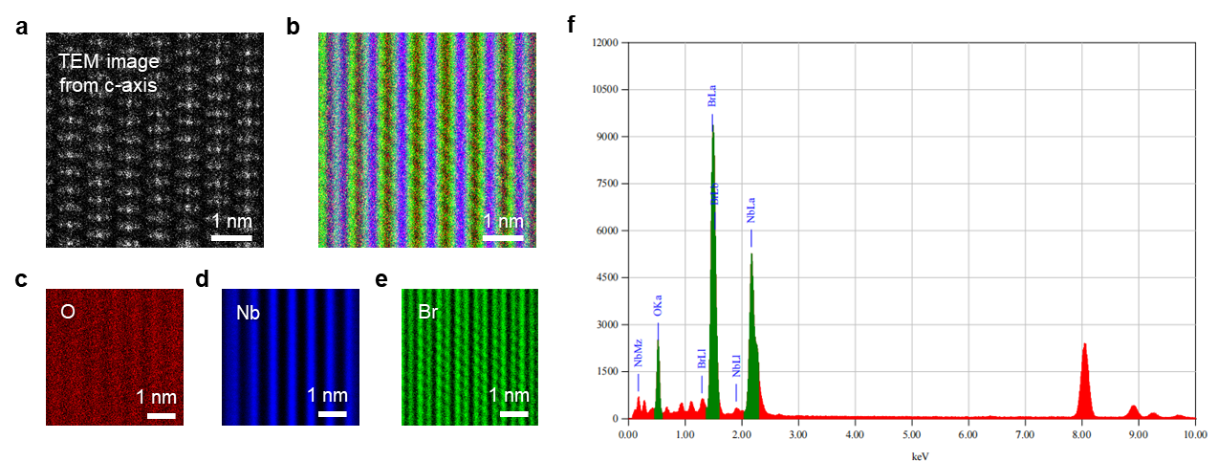
Figure S2. Energy Dispersive Spectroscopy (EDS) analysis of synthesized NbOBr₂ crystal. a, High-resolution TEM image of NbOBr₂ from c-axis showing a periodic lattice arrangement. The atomic structure exhibits a clear AB-stacking configuration with a scale bar of 1 nm, demonstrating layered nature and high structural uniformity. b, Elemental mapping overlay from EDS, combining the spatial distribution of oxygen (O) (red), niobium (Nb) (blue), bromine (Br) (green). The overlay confirms the homogeneous distribution of these elements throughout the sample, corresponding well to the atomic structure in TEM image in (a). c-e, EDS map of O (red) (c), Nb (blue) (d), Br (green) (e) highlights its consistent presence across the scanned area at atomic resolution, matched well with the atomic structure in TEM image in (a). f, EDS spectrum of the sample, displaying characteristic peaks for O, Nb, Br. The sharp and well-defined peaks confirm the NbOBr₂'s composition and stoichiometry.

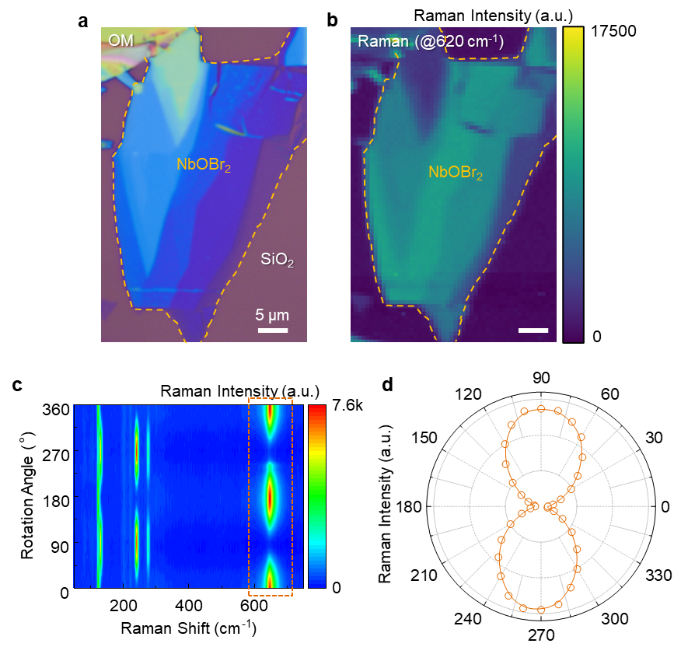
Figure S3. Angle-dependence Raman measurement. a, OM-image of sample on the SiO₂ substrate used for layer-dependent Raman spectrum measurement, with a clear color contrast indicating the thickness difference. b, Raman mapping of 4th peak (around 620 cm⁻¹), showing a clear intensity difference among various flake thickness, corresponding to (a). c, Angle-dependence Raman spectra of 4 peaks. All the Raman modes exhibit strong anisotropy. It is inferred that for A-symmetry modes, the polarization-dependent Raman intensity exhibits a π-periodicity in the parallel configuration and a π/2-periodicity in the perpendicular configuration. The result corresponds well to the characterization of A-symmetry modes ¹. d, The polarization-dependent Raman peak intensities of the 4th mode (around 620 cm⁻¹), with a periodicity of π.

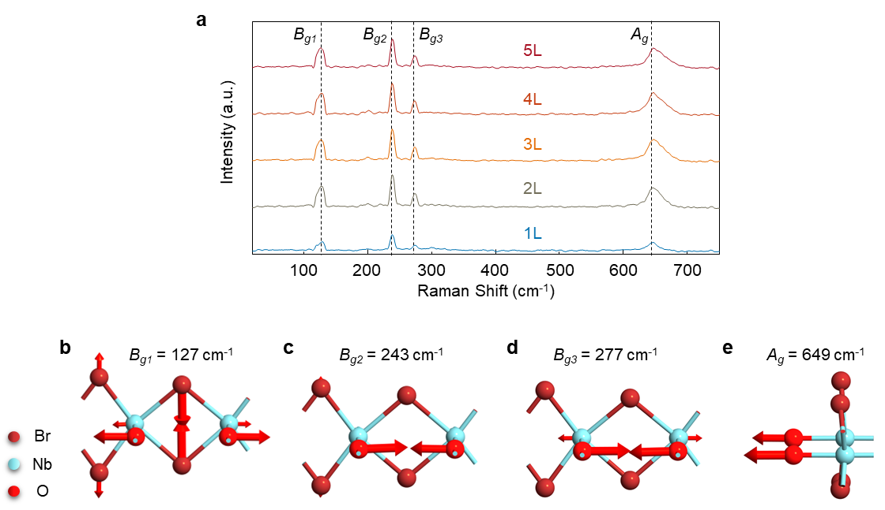
Figure S4. Raman peaks in terms of phonon vibration modes. a, Thickness-dependent Raman spectra of NbOBr₂ flakes. b-e, Schematic of phonon vibration modes for P1-P4, respectively.

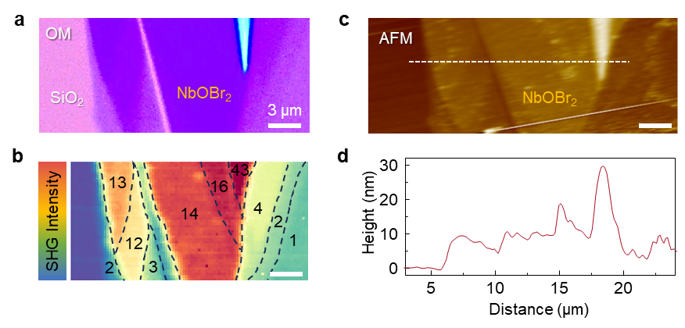
Figure S5. layer-dependent SHG data with AFM measurement. a, OM-image of sample on the SiO₂ substrate used for layer-dependent SHG measurement, with a clear color contrast indicating the thickness difference. b, SHG emission mapping with clear intensity difference among various layer numbers. c, AFM image of flakes, which is corresponding to the OM image in (a) and SHG mapping in (b). d, The position-dependent height, with clear steps between different layer numbers. The thickness of the flake is matched well with the SHG emission mapping in Fig. 1f, assuming the thickness of each layer is 7 Å.

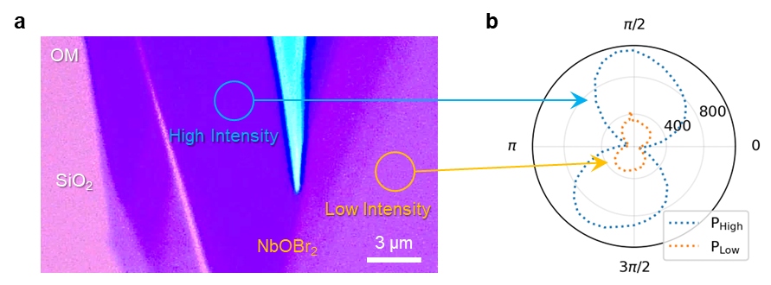
Figure S6. Angle-dependence SHG intensity. a, the OM image of NbOBr₂ flake on SiO₂ substrate. b, The SHG intensity is measured by rotating a polarizer with the pump from an 800 nm femto-second laser with both high intensity level and low intensity level excited at thicker layer (blue solid circle in (a)) and thinner layer region (orange solid circle in (a)), respectively. Different polarization of pump light results in various SHG intensity, indicating strong in-plane anisotropy.

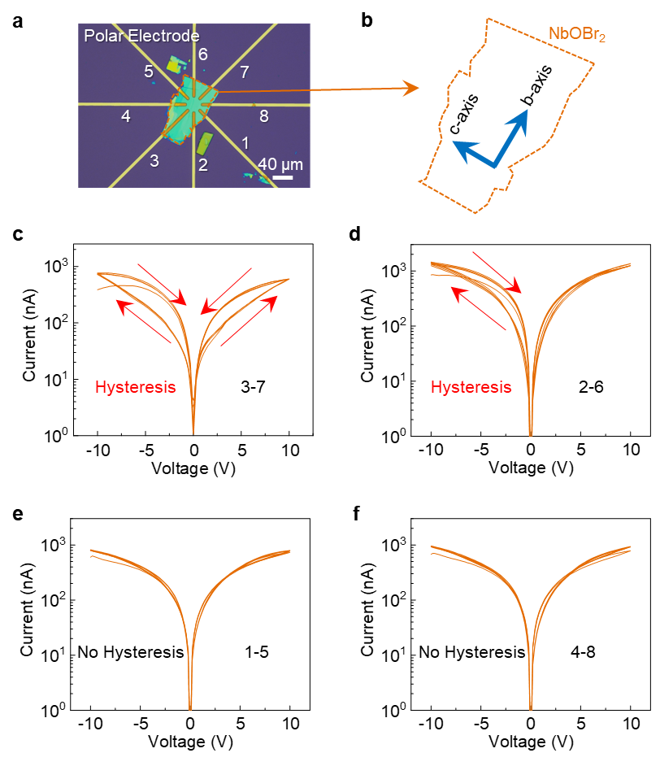
Figure S7. Angle-dependence I-V hysteresis caused by in-plane anisotropy. a, OM image of memristor composed of NbOBr₂ flake (25 nm) integrated on the polar electrode, with the number of various electrodes. b, schematic of boundary of integrated NbOBr₂ flake with the indication of b-axis and c-axis. c-f, the I-V curves measured by Keithley 2634B in room temperature along various crystal axis. As we can see, only through electrode 3-7 (b-axis of NbOBr₂), clear hysteresis occurs at both positive voltage and negative voltage. This is caused by the 2nd order peierls distortion only occurs along the b-axis of crystal¹⁻³.
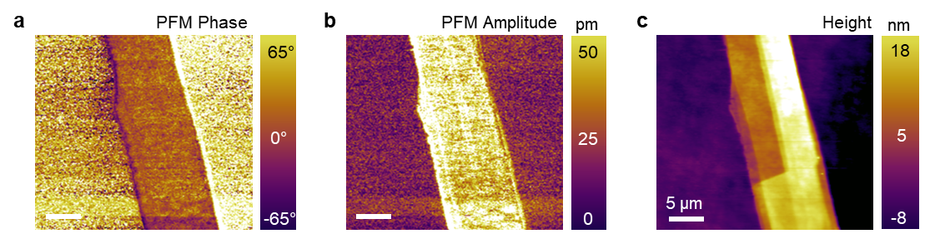
Figure S8. PFM pattern for in-plane ferroelectric domain. a-b, PFM phase (a) and amplitude patterns (b) for the NbOBr₂ flake. c, Height distribution of the NbOBr₂ flake. Sample was measured on the gold/high-doping Si substrate. The clear difference between NbOBr₂ flake and substrate in phase and amplitude pattern shows the tiny strain during the excitation of in-plane electric field, which is indicative of in-plane ferroelectricity.

Note S1. Device structure optimization
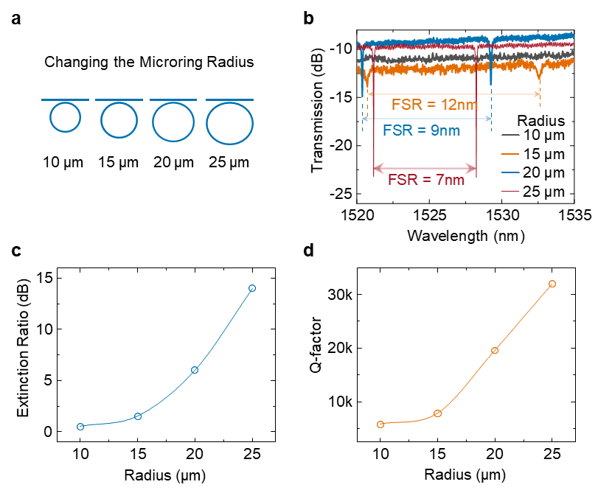
Figure S9. Optimization of microring radius for efficient NLO process. a, schematic of varying the ring radius from 10 µm to 25 µm in fabricated device arrays. b, measured transmission spectrum within the wavelength from 1520 nm to 1535 nm, which shows clear difference in terms of free-spectrum range (FSR), extinction ratio (ER), and quality factor (Q-factor). c-d, summarized ER (c) and Q-factor (d) as a function of microring radius. As expected, FSR presents a negative dependence with radius, while both ER and Q-factor exhibit a positive correlation with radius. This is because of the increased scattering loss introduced by waveguide of smaller radius.

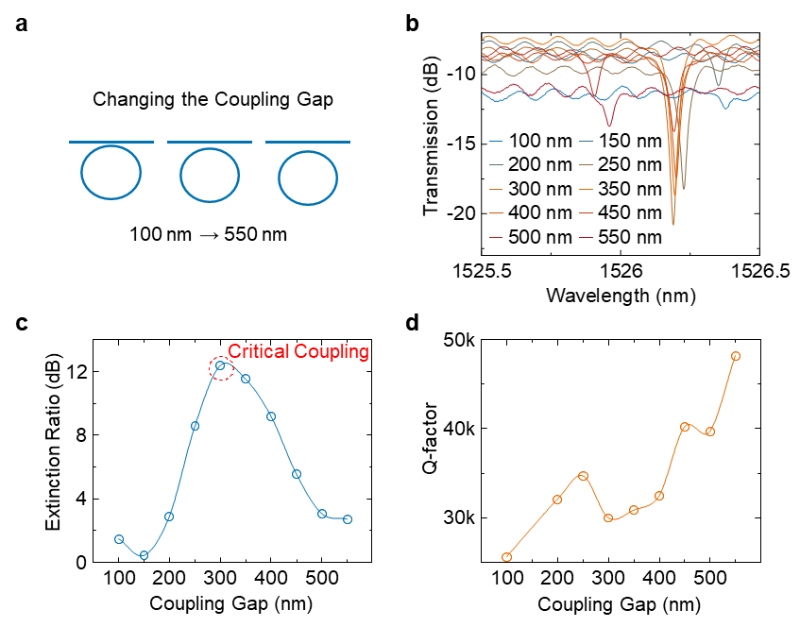
Figure S10. Optimization of microring coupling gap for efficient NLO process. a, Schematic of varying the ring coupling gap from 100 nm to 550 nm in fabricated device arrays. b, Measured transmission spectrum within the wavelength from 1520 nm to 1535 nm, which shows clear difference in terms of ER and Q-factor. c-d, Summarized ER (c) and Q-factor (d) as a function of microring coupling gap. As expected, ER shows a peaking trend until 300 nm coupling followed by the decreased trend. The critical coupling occurs at the maximum ER, which achieve the best enhancement for pump light enhancement in optical cavity. Q factor displays a roughly positive relationship with coupling gap.

The SHG process in a microring is related to two modes: the fundamental mode with frequency (ω_{a}) and the second-harmonic mode with frequency (ω_{b} ≈ 2ω_{a}). In the process, the following Hamiltonian can be used to describe the system⁴:
 | $H=ω_{a}a^{*}a+ω_{b}b^{*}b+g\left[{\left(a^{*}\right)}^{2}b+a^{2}b^{*}\right]+ϵ_{p}\left(ae^{iω_{p}t}+a^{*}e^{-iω_{p}t}\right.)$, | (1)
where a(b) represents the Bosonic operator for pump mode and SHG mode. The pump field strength is defined as $ϵ_{p}=\sqrt{\frac{2κ_{a,1}P_{p}}{ℏω_{p}}}$, where P_{p} and ω_{p} represent the pump power and pump frequency, respectively. The external coupling rate associated with mode a is represented by κ_{a,1}. The interaction strength governing the nonlinear coupling between the two modes is described as:
 | $ℏg=ϵ_{0}\iiint{dθ} dr dz \frac{3χ^{\left(2\right)}\left(r\right)}{4\sqrt{2}}{\left[u_{a,z}^{*}\left(r\right)\right]}^{2}u_{b,z}\left(r\right)$, | (2)
The electric field distribution of the optical modes in the microring is: $u_{a\left(b\right),z}\left(r\right)=u_{a\left(b\right),z}\left(r,z\right)e^{im_{a\left(b\right)}θ}$. This electric field distribution should meet the normalization as following: $\iiint{dθ}rdrdzϵ_{0}ϵ_{r}\left(ω_{a\left(b\right)},r\right){\left|u_{a\left(b\right),z}\left(r\right)\right|}^{2}=ℏω_{a\left(b\right)}$. In this context, m_{a}(m_{b}) represents the angular momentum of mode a(b). The relative permittivity of the dielectric, ϵ_{r}(ω_{a(b)},r), depends on both frequency and spatial position. Then the effective mode-overlap factor in the microring's cross-section is introduced here:
 | $ζ=\frac{\iint{dr} dz {\left[u_{a,z}^{*}\left(r,z\right)\right]}^{2}u_{b,z}\left(r,z\right)}{\iint{dr} dz {\left|u_{a,z}\left(r,z\right)\right|}^{2}\sqrt{\iint{dr} dz {\left|u_{b,z}\left(r,z\right)\right|}^{2}}}$. | (3)
The coupling strength can then be approximated as:
 | $g≈ζ\sqrt{\frac{ℏω_{a}^{2}ω_{b}}{ϵ_{0}2πR}⋅\frac{1}{ϵ_{a}\sqrt{ϵ_{b}}}⋅\frac{3χ^{\left(2\right)}}{4\sqrt{2}}}×δ\left(m_{b}-2m_{a}\right)$, | (4)
by assuming a much larger microring radius (R) than waveguide width.
The symmetry of the system imposes the momentum-conservation condition m_{b} - 2m_{a} = 0, reflected by the Kronecker delta function δ(m_{b} - 2m_{a}). Then the efficiency of SHG can be solved by non-depletion approximation:
 | $$η=\frac{P_{\text{SHG}}}{P_{p}^{2}}=g^{2}\frac{2κ_{b,1}}{δ_{b}^{2}+κ_{b}^{2}}{\left(\frac{2κ_{a,1}}{δ_{a}^{2}+κ_{a}^{2}}\right)}^{2}\frac{ℏω_{b}}{{\left(ℏω_{p}\right)}^{2}}.$$ | (5)

The angular frequency detuning is given by δ_{a} = ω_{a} - ω_{p} (δ_{b} = ω_{b} - 2ω_{p}) for mode a and δ_{b} = ω_{b} - 2ω_{p} for mode b. The total loss rate for cavity mode a(b) is represented as κ_{a} = κ_{a,1} + κ_{a,0} (κ_{b} = κ_{b,1} + κ_{b,0}), where κ_{a(b),1} accounts for external coupling and κ_{a(b),0} corresponds to intrinsic losses.
To get a large η, a higher-order mode for SHG wavelength with symmetric electric field (E-field) should be chosen according to the expression of effective mode-overlapping factor. Otherwise, an anti-symmetric E-field will lead to a $ζ$ of 0. Then the phase matching condition is required to be satisfied (Fig. 2e), which is expressed as δ_{a} = δ_{b} = 0. This corresponds to the energy conservation condition ω_{b} = 2ω_{a}. After that, the SHG efficiency reduces to:
 | $η=\frac{16g^{2}}{{\left(\frac{κ_{b,0}}{\sqrt{κ_{b,1}}}+\sqrt{κ_{b,1}}\right)}^{2}{\left(\frac{κ_{a,0}}{\sqrt{κ_{a,1}}}+\sqrt{κ_{a,1}}\right)}^{4}}⋅\frac{1}{ℏω_{f}}$. | (6)
Here, a higher g is required, with microring radius R serving as the denominator in the expression of g. Thus, a smaller R was required to maximize the SHG efficiency. Fig. S9 displayed the optimization process for microring radius. We fabricated series devices with a radius from 10 µm to 25 µm, as shown in Fig. S8. Extinction ratio (ER) and quality factor (Q-factor) were summarized in Fig. S8, and both exhibit positive dependence on radius. This occurs due to the intensified electric field on the etched surface of the SiN waveguide in cases with smaller radius, leading to increased radiation and scattering losses. For the cases with radius smaller than 25 µm, the low ER and Q-factor caused by introduced loss of small radius is not acceptable for pump light enhancement. Considering the trade-off between loss and g, the radius of microring cavity was chosen as 25 µm. To further optimize η, achieving critical coupling for both modes is essential, which requires κ_{a,1} = κ_{a,0} and κ_{b,1} = κ_{b,0}. The intrinsic loss rate, κ_{a,0}, is governed by material properties such as absorption and scattering, while the external coupling rate, κ_{b,0}​, can be adjusted by modifying the gap between the microring and the bus waveguide. As such, we fabricated microring array with various coupling gap, as displayed in Fig. S10. As the coupling gap increase from 100 nm to 550 nm, ER exhibit a peaking trend until 300 nm before declining, while Q-factor experience a positive correlation with gap (Fig. S10). In another word, the device transit from over-coupling to critical coupling and to under coupling. Thus, the coupling gap was chosen as 300 nm for critical coupling condition. When the critical coupling condition is satisfied for both modes, the conversion efficiency reaches its maximum value, expressed as:
 | $η=\frac{g^{2}}{4κ_{b,0}κ_{a,0}^{2}}⋅\frac{1}{ℏω_{f}}=\frac{g^{2}Q_{a,0}^{2}Q_{b,0}}{ℏω_{a}^{4}}$. | (7)
In this context, the intrinsic quality factor for mode a is defined as $Q_{a,0}=\frac{ω_{a}}{2κ_{a,0}}$. Thus, the final criterion for achieving high-efficiency second-harmonic generation (SHG) is a high intrinsic quality factor. According to our transmission spectrum measurement, the Q factor was extracted as 40k, which is relatively high among microring devices based on SiN.

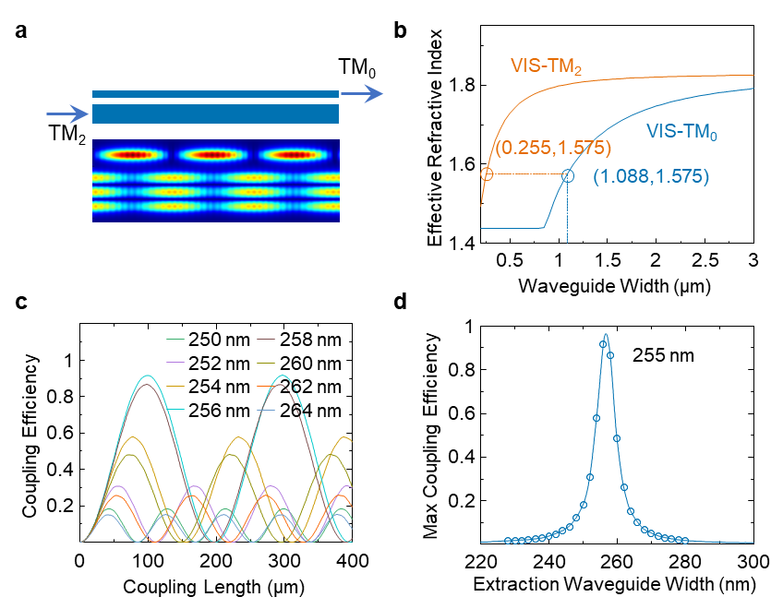
Figure S11. Optimization of BUS_{SHG} width for efficient extraction of SHG signal. a, upper panel: schematic of extraction of generated visible signal from cavity ring waveguide with a TM₂ mode distribution to the extraction bus waveguide with a TM₀ mode distribution. Lower panel: top view of E-field distribution in two nearby waveguides showing clear transition from TM₂ mode to TM₀ mode from ring cavity waveguide to extraction bus waveguide. b, effective index of TM₂ mode in ring cavity waveguide (blue) for visible light and TM₀ mode in extraction bus waveguide for visible light during transmission. There exists another phase matching condition: energy conservation and momentum conservation of visible light coupling from ring cavity waveguide to extraction bus waveguide. Because we choose 1.088 µm in microring cavity waveguide for the conversion from NIR to VIS with an effective index of 1.575, so the effective index of VIS light in extraction bus waveguide should be the same value to fulfill the phase matching condition. As such, the width of extraction bus waveguide was chosen as 255 nm. c, coupling efficiency from TM₂ to TM₀ versus the coupling length at different width of extraction bus waveguide thorough EME simulation. d, summarized maximum coupling efficiency as a dependence on extraction bus waveguide width extracted from (c), which also shows an optimized width of 255 nm.
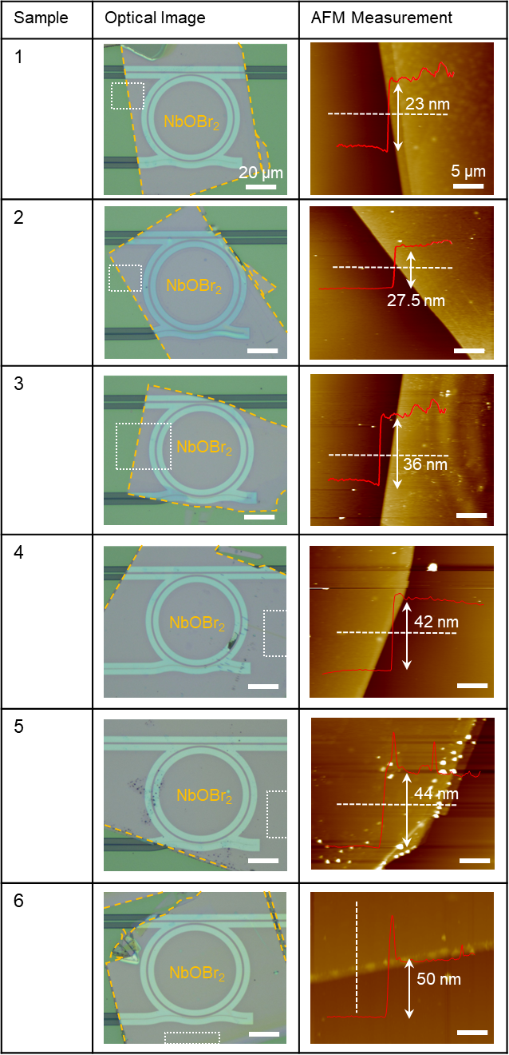
Figure S12. OM-image and AFM measurement of fabricated SHG samples with various flake thickness. The NbOBr₂ flake was highlighted by yellow dot square. The AFM measurements were conducted at the highlighted area by white dotted square, with the measured flake thickness indicated in respective figures. Six samples are named as Sample 1-6, respectively. Details and measurement of the second sample (Sample 2) is displayed in Fig. 2-3.
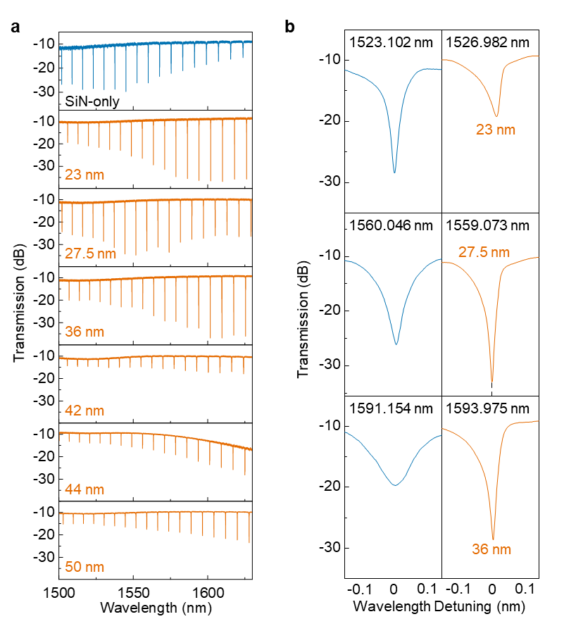
Figure S13. Transmission spectrum of SHG devices with various flake thickness. a, transmission spectrum measured from 1500 nm to 1630 nm. Different thickness of flake results in different ER. When flake is thicker than 40 nm, transmission spectrum shows small ER, which means the flake introduce too much loss to the cavity, not acceptable for pump enhancement. b, zoom-in transmission spectrum of Sample 1-3 (because only sample 1-3 shows SHG response), with resonance wavelength indicated inside the figures.

Note S2. Extraction of NbOBr₂ index
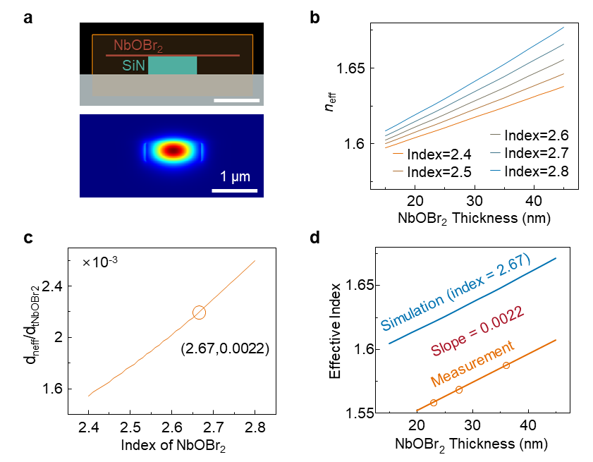
Figure S14. Index extraction of NbOBr₂. a, Schematic of FDE simulation considering NbOBr₂ as dielectric on the top of SiN waveguide. Lower panel displays the mode distribution at the cross-sectional view of NbOBr₂-covered waveguide part. b, Effective index of composite waveguide as a function of NbOBr₂ flake thickness at different NbOBr₂ index (simulation). c, $\frac{dn_{\text{eff}}}{dt_{NbOBr2}}$ as the dependence on NbOBr₂ index (simulation). d, the comparison between simulation data and measurement data. The slope of both simulation and measurement data are both 0.0022, when the index of flake was set as 2.67. Thus, the inferred NbOBr₂ index is 2.67.

The accurate refractive index of 2D materials is important for the integration on mutual photonic integrated circuit (PIC) devices for dimension engineering. However, it is challenging due to the small lateral flake dimension using conventional measurement tools, for example, ellipsometer⁵. Here we propose a semiempirical method to determine the refractive index of 2D material (n_{NbOBr2} = 2.67) near tele-communication relevant wavelength by integrating few-layers of NbOBr₂ onto the hole cavity region of micro-ring resonator.

We fabricated microring arrays with the same geometry to do NbOBr₂ integration with various thickness, not only for thickness-dependent SHG response, but also for extracting the index of NbOBr₂ flake. Firstly, we measured the transmission spectrums of devices with different NbOBr₂ thickness, as shown in Fig. S12. We choose the first three devices with acceptable ER which shows great resonance condition. That’s because relatively higher ER means the thin flakes below 40 nm introduce acceptable loss, which keep the microring in critical coupling region, while thicker samples shift the cavity to over coupling condition. The transmission spectrums of device array with series NbOBr₂ thickness were shown in Fig. S13a. Each spectrum displays 17 distinct resonance modes. We used the effective index of composite waveguide to obtain NbOBr₂ index.

According to the understanding on resonance condition of microring, we can get:
 | $mλ_{m}=n_{g}L$, | (8)
where $n_{g}$ represents the group index of composite waveguide, and $L$ means the diameter of microring cavity. $λ_{m}$ is the wavelength of every resonance mode. Extracting $n_{g}$ is the first step to get $n_{eff}$. By solving Eqs 1, we can get $n_{g}$ as following equation:
 | $n_{g}(λ_{m})=\frac{λ_{m}^{2}}{Δλ_{m}⋅L}$, | (9)
where $Δλ_{m}$ represent the FSR around resonance mode $m$, which can be extracted from the transmission spectrum of composite microring devices. As such, $n_{g}(λ_{m})$ can be extracted at the wavelength of all resonance modes. Then the effective index $n_{\text{eff}}(λ_{m})$ is related to the group index $n_{g}(λ_{m})$ by following equation:
 | $n_{\text{eff}}(λ_{m})=n_{g}(λ_{m})+λ_{m}\frac{dn_{\text{eff}}(λ_{m})}{dλ_{m}}$. | (10)
Since we still do not know the exact value of $\frac{dn_{\text{eff}}(λ_{m})}{dλ_{m}}$, FDE simulation was conducted to characterize the waveguide coefficients with the exact same parameter with optimized value, as shown in Figure S9a. Here, we assume the $\frac{dn_{\text{eff}}(λ_{m})}{dλ_{m}}$ is irrelevant to thickness of NbOBr₂ integrated on the top of waveguide, so the bare SiN waveguide without NbOBr₂ considered was used in simulation. By simulation, the value of $\frac{dn_{\text{eff}}(λ_{m})}{dλ_{m}}$ was decided at every $λ_{m}$. By substituting $\frac{dn_{\text{eff}}(λ_{m})}{dλ_{m}}$ to Eq S1, $n_{\text{eff}}(λ_{m})$ as a dependence of $λ_{m}$ was obtained for device 1-3, respectively, with various NbOBr₂ integrated, as displayed in Fig. 2j.
Here, we used FDE simulation again to evaluate the effect of NbOBr₂ index on the composite waveguide effective index. In simulation, NbOBr₂ was considered as dielectric, whose thickness $t_{NbOBr2}$ was swept from 15 nm to 45 nm while changing the index value of NbOBr₂ flake at 1550 nm, with result of $n_{\text{eff}}$ shown in Fig. S11a. $\frac{dn_{\text{eff}}}{dt_{NbOBr2}}$ was extracted at every index of NbOBr₂ (Figure S9c). We get the exact value of NbOBr2 index by comparing $\frac{dn_{\text{eff}}}{dt_{NbOBr2}}$ (understood as the effect of $t_{NbOBr2}$ on $n_{\text{eff}}$) obtained by simulation with exact slope fitted by measured data from sample 1-3. When NbOBr₂ index was considered as 2.67, simulation data can be aligned with measured data well as shown in Fig. S14d.
Note: this method only applies to the situation when flake fully covers the hole cavity region, which contributes an accurate value of waveguide effective index.

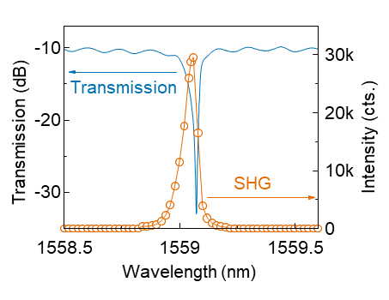
Figure S15. Wavelength-dependence SHG measurement around resonance mode. Due to destructive interference, only specific wavelength who satisfy $mλ=n_{eff}∙2πr (m=1,2,3,⋯)$ can be amplified in cavity. The wavelength was swept around the resonance mode by the step of 0.02nm, and SHG intensity was recorded at every wavelength point by spectrometer. As we predicted, the SHG signal only comes out when the wavelength of laser coincidence with resonance mode, which is 1559.073 nm compared with zero intensity at off-resonance wavelength.

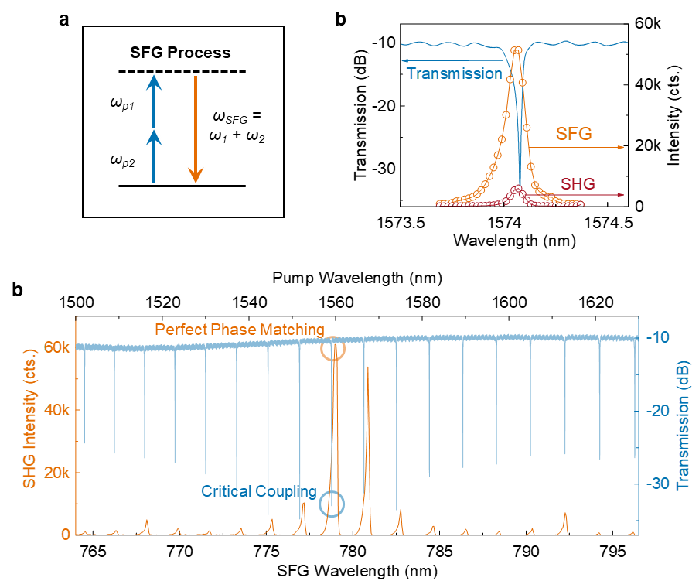
Figure S16. SFG measurement of sample 2. a, Due to destructive interference, only specific wavelengths which satisfy $mλ=n_{eff}∙2πr (m=1,2,3,⋯)$ can be amplified in cavity. The wavelength was swept around the resonance mode by the step of 0.02nm, and SHG intensity and SFG intensity were recorded at every wavelength point by spectrometer. As we predicted, both SHG signal and SFG signal only come out when the wavelength of laser coincidence with resonance mode compared with zero intensity at off-resonance wavelength. b, Transmission spectrum of pump light and the respective SFG spectrum of all resonance modes. The resonance mode at perfect matching condition shows the strongest SFG emission.

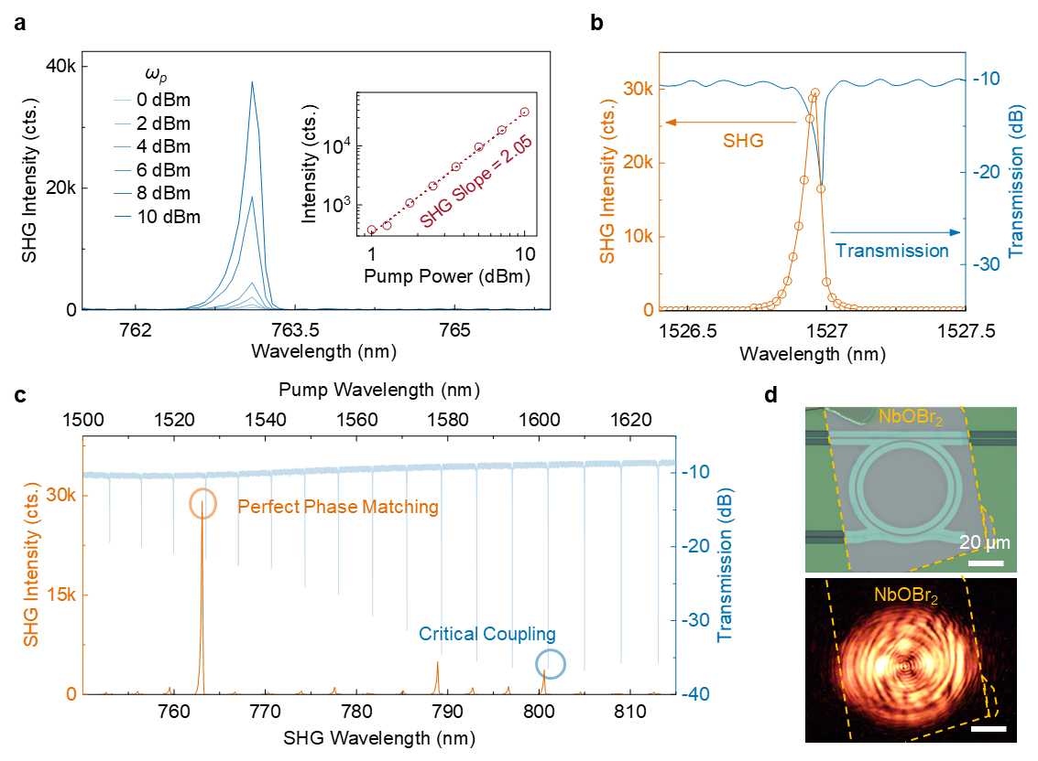
Figure S17. SHG measurement of sample 1. a, SHG spectrum pumped with low-power CW laser at wavelength of 1526.98 nm. Inset shows the dependence of SHG intensity on pump power at log-log scale. The linear fitted line shows a slope of 1.94, confirms the quadratic nature of the second-order nonlinear process. b, Due to destructive interference, only specific wavelengths which satisfy $mλ=n_{eff}∙2πr (m=1,2,3,⋯)$ can be amplified in cavity. The wavelength is swept around the resonance mode by the step of 0.02nm, and SHG intensity is recorded at every wavelength point by spectrometer. As we predicted, the SHG signal only comes out when the wavelength of laser coincidence with resonance mode, which is 1526.98 nm compared with zero intensity at off-resonance wavelength. This confirms the SHG response from optical cavity, instead from straight waveguide outside the cavity c, Transmission spectrum of pump light and the respective SHG spectrum of all resonance modes. And the resonance mode at perfect matching condition shows the strongest SHG emission. d, Optical microscope image of measured sample (upper panel) and corresponding giant SHG emission (lower panel) during measurement at dark environment with long exposure time, confirming the generation of visible light through microring.

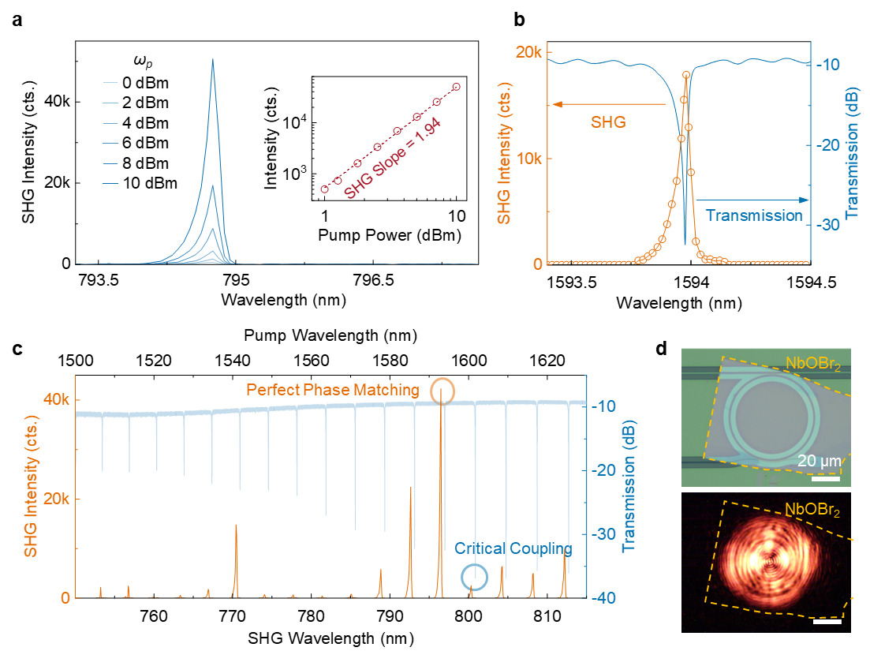
Figure S18. SHG measurement of sample 3. a, SHG spectrum pumped with low-power CW laser at wavelength of 1593.975 nm. Inset shows the dependence of SHG intensity on pump power at log-log scale. The linear fitted line shows a slope of 1.94, confirms the quadratic nature of the second-order nonlinear process. b, Due to destructive interference, only specific wavelengths which satisfy $mλ=n_{eff}∙2πr (m=1,2,3,⋯)$ can be amplified in cavity. The wavelength is swept around the resonance mode by the step of 0.02nm, and SHG intensity is recorded at every wavelength point by spectrometer. As we predicted, the SHG signal only comes out when the wavelength of laser coincidence with resonance mode, which is 1593.975 nm compared with zero intensity at off-resonance wavelength. This confirms the SHG response from optical cavity, instead from straight waveguide outside the cavity c, Transmission spectrum of pump light and the respective SHG spectrum of all resonance modes. And the resonance mode at perfect matching condition shows the strongest SHG emission. d, Optical microscope image of measured sample (upper panel) and corresponding giant SHG emission (lower panel) during measurement at dark environment with long exposure time, confirming the generation of visible light through microring.

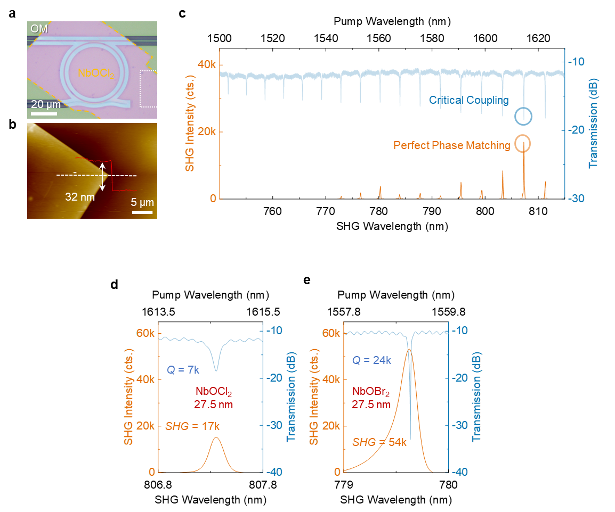
Figure S19. Comparison of SHG response between NbOBr₂ and NbOCl₂. a, OM image of the proposed device after integration of NbOCl₂ flake. b, AFM image of integrated few-layer NbOCl₂ at the region highlighted in dashed line in (a). The thickness of integrated NbOCl₂ is 32 nm. c, Transmission spectrum of pump light and the respective SHG spectrum of all resonance modes for NbOCl₂ sample. The resonance mode at perfect matching condition shows the strongest SHG emission. In this sample, phase matching wavelength (λ_{pm}) and critical coupling wavelength (λ_{cc}) occurs at the same point, which is the same case as NbOBr₂ sample 2 in Fig. 3d. d-e, Comparison of both transmission spectrum and SHG response between NbOBr₂ sample and NbOCl₂ sample when λ_{pm} and λ_{cc} aligned perfectly. NbOBr₂ exhibits superior Q factor and stronger SHG intensity. This improvement is attributed to the higher refractive index of NbOBr₂ compared to NbOCl₂¹. The larger index results in greater index contrast between the active nonlinear material and SiN, leading to stronger confinement of pump light within the NbOBr₂ layer, which enhances mode overlap with active nonlinear material and thereby improves SHG conversion efficiency. Additionally, the larger refractive index leads to tighter optical mode confinement, facilitating higher Q factors and more efficient SHG generation through enhanced cavity resonance⁶.
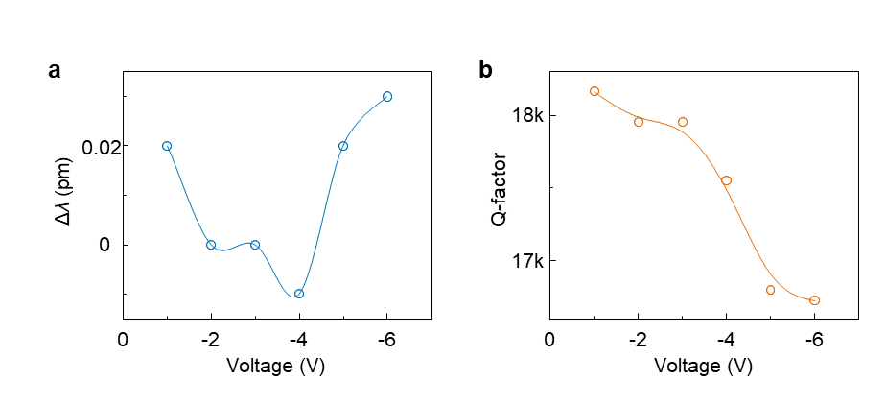
Figure S20. Resonance-wavelength modulation and Q-factor modulation as the function of applied voltage. a, Resonance-wavelength as the dependence on applied voltage. b, Q-factor of cavity at specific resonance mode as a function of applied voltage, which shows similar trend as ER change in Fig. 4d.

Note S3. Models used for coefficient extraction.
3.1. α and t
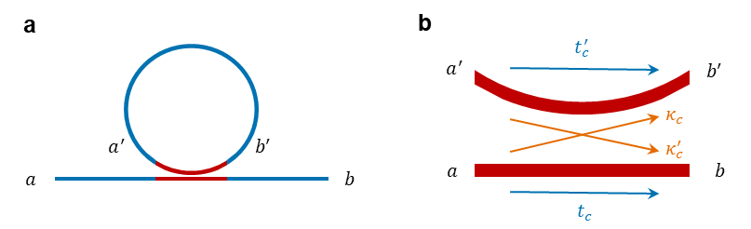
Figure S21. Schematic of a microring resonator. a, diagram of the microring resonator. b, zoomed-in schematic of the directional coupler (DC), showing the denotation for coefficient extraction.
In principle, a microring resonator is composed with a DC and ring waveguide which introduce the loss. Fig. S21 shows a microring resonator with DC and corresponding coefficients. Following model is used to analyze the condition of cavity resonance⁷. For the zoom-in DC in Fig. S21b, t_{c}/t'_{c} is self-coupling coefficients, while κ_{c}/κ'_{c} is cross-coupling coefficients. The relationship between the electric fields b/b' at the outputs and the electric fields a/a' at the inputs is expressed as following Eq. (S11) and (S12):
 | $b=t_{c}a+κ_{c}^{'}a^{'}$; | (11)
 | $b^{'}=t_{c}^{'}a^{'}+κ_{c}a$. | (12)
After the hole round trip, the field b is related with a by following formula:
 | $a^{'}=t_{r}^{'}b^{'}$. | (13)
According to Eq. (S11-13), b is solved as:
 | $b=a\left(\frac{t_{c}-(t_{c}t_{c}^{'}-{κ_{c}^{'}κ}_{c})t_{r}^{'}}{1-t_{c}^{'}t_{r}^{'}}\right)$. | (14)
Then the factor t_{c}t'_{c} - κ_{c}κ'_{c} in Eq. (S14) should be eliminated for the following derivation. Considering the loss introduced by coupler α_{c} and α'_{c}, energy conservation was expressed as followings^{8,9}:
 | ${\left|b\right|}^{2}+{\left|b^{'}\right|}^{2}=α_{c}^{2}{\left|a\right|}^{2}+α_{c}^{'2}{\left|a^{'}\right|}^{2}$. | (15)
Using b and b' from Eq. (S11-12) into Eq. (15) yield Eq. (S16-18):
 | ${\left|t_{c}\right|}^{2}+{\left|κ_{c}\right|}^{2}=α_{c}^{2}$; | (16)
 | ${\left|t_{c}^{'}\right|}^{2}+{\left|κ_{c}^{'}\right|}^{2}=α_{c}^{'2}$; | (17)
 | $t_{c}^{*}κ_{c}^{'}+κ_{c}^{*}t_{c}^{'}=0$. | (18)
Eq. (S17) and Eq. (S18) yield the relation in Eq. (S19). It can be further substituted in Eq. (S14):
 | $t_{c}t_{c}^{'}-κ_{c}κ_{c}^{'}=\left(t_{c}^{'}t_{c}^{'*}+κ_{c}^{'}κ_{c}^{'*}\right)\frac{t_{c}}{t_{c}^{'*}}=α_{c}^{'2}\frac{t_{c}}{t_{c}^{'*}}$. | (19)
the phases φ_{r} and φ_{c} are introduced for simplifying the result:
 | $t_{r}^{'}=\left|t_{r}^{'}\right|e^{iϕ_{r}^{'}}$; | (20)
 | $t_{c}^{'}=\left|t_{c}^{'}\right|e^{iϕ_{c}^{'}}$, | (21)
And the following coefficients are defined:
 | $t≡\frac{\left|t_{c}^{'}\right|}{α_{c}^{'}}$; | (22)
 | $κ≡\frac{\left|κ_{c}^{'}\right|}{α_{c}^{'}}$; | (23)
 | $α≡\left|t_{r}^{'}\right|α_{c}^{'}$; | (24)
 | $ϕ≡ϕ_{c}^{'}+ϕ_{r}^{'}$; | (25)
Then Eq. (S14) can be written as:
 | $\frac{b}{a}=\left(\frac{t-αe^{iϕ}}{1-αte^{iϕ}}\right)\frac{t_{c}}{t_{c}^{'*}}α_{c}^{'}e^{-iϕ_{c}^{'}}$. | (26)
Then we can get:
 | $T≡{\left|\frac{b}{a}\right|}^{2}={\left|\frac{t_{c}}{t_{c}^{'*}}\right|}^{2}α_{c}^{'2}\left(\frac{t^{2}+α^{2}-2αt\cos{ϕ}}{1+α^{2}t^{2}-2αt\cos{ϕ}}\right)={\left|\frac{t_{c}}{t_{c}^{'*}}\right|}^{2}α_{c}^{'2}T$. | (27)
Here, the factor $T$ is represented as Eq. (S28):
 | $T≡\frac{t^{2}+α^{2}-2αt\cos{ϕ}}{1+α^{2}t^{2}-2αt\cos{ϕ}}$. | (28)
The transmission $T$ exhibits resonances as a function of wavelength, marked by dips occurs at resonance wavelength. The light intensity is enhanced within the ring at resonance wavelengths. The coefficients α and t determine the resonance characteristics, including width and depth. The finesse $F$ is expressed in terms of $Δλ_{\text{FSR}}$ and $Δλ_{\text{FWHM}}$ as follows:
 | $F≡Δλ_{\text{FSR}}/Δλ_{\text{FWHM}}$, | (29)
And the extinction ratio is expressed by:
 | $E≡T_{\text{max}}/T_{\text{min}}$. | (30)
Then from Eq. (S28), we can get:
 | $E={\left[\frac{\left(α+t\right)\left(1-αt\right)}{\left(α-t\right)\left(1+αt\right)}\right]}^{2}$; | (31)
 | $\cos\left(\frac{π}{F}\right)=\frac{2αt}{1+α^{2}t^{2}}$. | (32)
By solving the equations, α and t can be extracted:
 | $\left(α,t\right)={\left(\frac{A}{B}\right)}^{1/2}±{\left(\frac{A}{B}-A\right)}^{1/2}$, | (33)
With A and B expressed as followings:
 | $A≡\frac{\cos\left(\frac{π}{F}\right)}{1+\sin\left(\frac{π}{F}\right)}$; | (34)
 | $B≡1-\left[\frac{1-\cos\left(\frac{π}{F}\right)}{1+\cos\left(\frac{π}{F}\right)}\right]\frac{1}{E}$. | (35)
As such, for 57 resonance mode in proposed tunable device, every resonance mode can result in an α and t. Owning to the DC nature of coupling region, t was fitted with sin function, while α was fitted with linear function¹⁰. The cross point of two curve indicates the critical coupling wavelength, as shown in the upper panel of Fig. 4e.

3.2. $Δk_{{eff}_{NbOBr2}}$ and $Δn_{{eff}_{NbOBr2}}$
According to the propagation of light along waveguide in our proposed device, α was defined as $α\left(V\right)=e^{-\frac{2π}{λ}k_{{eff}_{SiN}}\left(L-L_{NbOBr2}\right)-\frac{2π}{λ}k_{{eff}_{NbOBr2}}\left(V\right)L_{NbOBr2}}$. Compared with the state of -1 V where $α\left(-1\right)=e^{-\frac{2π}{λ}k_{{eff}_{SiN}}\left(L-L_{NbOBr2}\right)-\frac{2π}{λ}k_{{eff}_{NbOBr2}}\left(-1\right)L_{NbOBr2}}$, $Δk_{{eff}_{NbOBr2}}\left(V\right)$ can be obtained by dividing $α\left(V\right)$ by $α\left(-1\right)$ as following equation:
 | $Δk_{{eff}_{NbOBr2}}\left(V\right)=k_{{eff}_{NbOBr2}}\left(V\right)-k_{{eff}_{NbOBr2}}\left(V=-1\right)=-ln\frac{α\left(V\right)}{α\left(-1\right)}*\frac{λ}{2πL_{NbOBr2}}$. | (36)
To extract $Δn_{{eff}_{NbOBr2}}$, we have to understand the resonance condition of microring:
 | $2mπ=\frac{2π}{λ}n_{{eff}_{SiN}}\left(L-L_{\text{NbOBr2}}\right)+\frac{2π}{λ}n_{{eff}_{NbOBr2}}\left(V\right)L_{\text{NbOBr2}}$. | (37)
By monitoring how the resonance wavelength shifts in response to voltage changes, $Δn_{{eff}_{NbOBr2}}$ reads¹¹:
 | $Δn_{{eff}_{NbOBr2}}\left(V\right)=n_{{eff}_{NbOBr2}}\left(V\right)-n_{{eff}_{NbOBr2}}\left(-1\right)=\frac{m\left(λ_{\text{res}}\left(V\right)-λ_{\text{res}}\left(V=-1\right)\right)}{L_{\text{NbOBr2}}}$. | (38)

3.3. $Δk_{NbOBr2}$ and $Δn_{NbOBr2}$
To further characterize the evolution of $Δn_{NbOBr2}$ and $Δk_{NbOBr2}$, FDE simulation was conducted, with NbOBr₂ flake considered as the dielectric on the top of waveguide, as shown in Fig. S22. Both $Δn_{{eff}_{NbOBr2}}$ and $Δk_{{eff}_{NbOBr2}}$ exhibit the roughly linear relationship with $Δn_{NbOBr2}$ and $Δk_{NbOBr2}$, respectively. The slope is around 0.8724 and 0.87. We used this linear relationship to extract back the $Δn_{NbOBr2}$ and $Δk_{NbOBr2}$.

  - 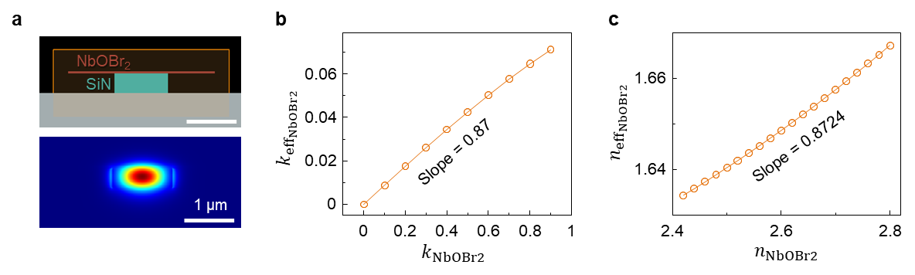
Figure S22. Dependence of waveguide effective index on NbOBr₂ index. a, Schematic of FDE simulation for the effect of flake index on effective index of composite waveguide. b, $k_{{eff}_{NbOBr2}}$as a dependence on $k_{NbOBr2}$. c, $n_{{eff}_{NbOBr2}}$as a dependence on $n_{NbOBr2}$.

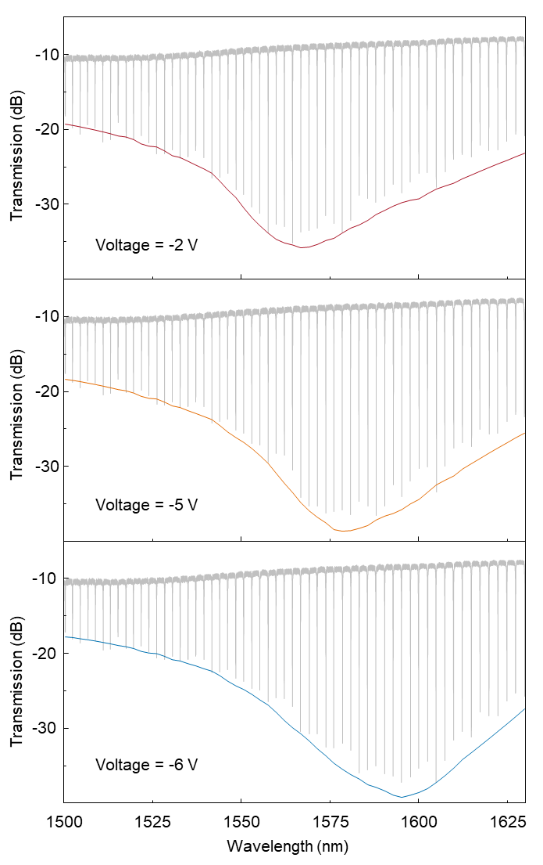
Figure S23. Extraction: resonance envelope. Transmission spectrum from 1500 nm to 1630 nm under the applied voltage as -2 V, -5 V, and -6 V. All the transmission spectrums show peaking trend, with a maximum value occurs at critical coupling wavelength. By smoothing the minimum points of all resonance modes, a curve with clear indication of coupling condition was obtained, which is defined as resonance envelope.

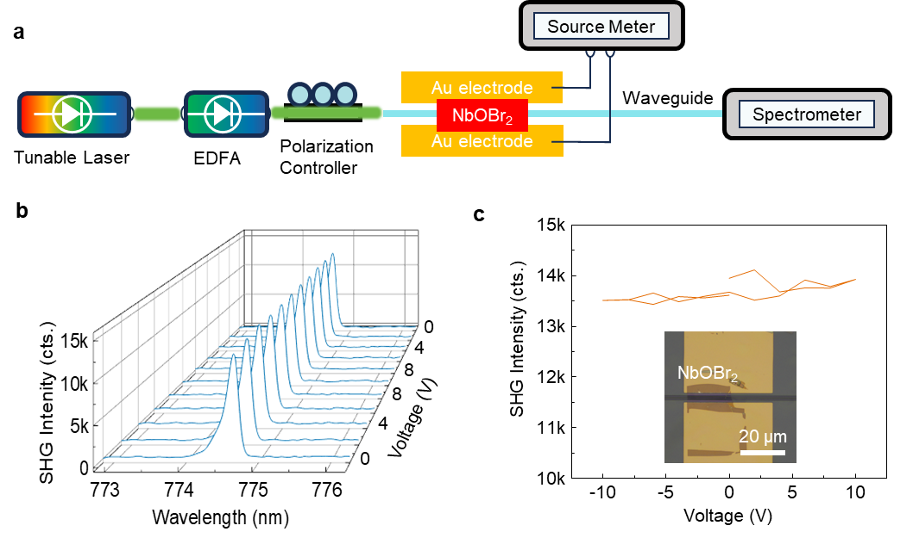Figure S24. SHG tunability from bare SiN waveguide integrated with NbOBr₂ without cavity. a, Measurement set up. b, SHG spectrum as a function of voltage loop. c, Summarized SHG intensity versus applied voltage, which shows a constant emission intensity even a voltage of 10 V was applied, with the OM image of sample shown in inset. This demonstrates that the polarization change of domain caused by in-plane ferroelectricity cannot affect the intrinsic second order susceptibility of NbOBr₂ crystal. The modulation effect was caused by the cavity resonance condition manipulation, which stem from loss change inside cavity. This comparison experiment clearly demonstrates the necessity of PIC cavity for the modulation of SHG response.

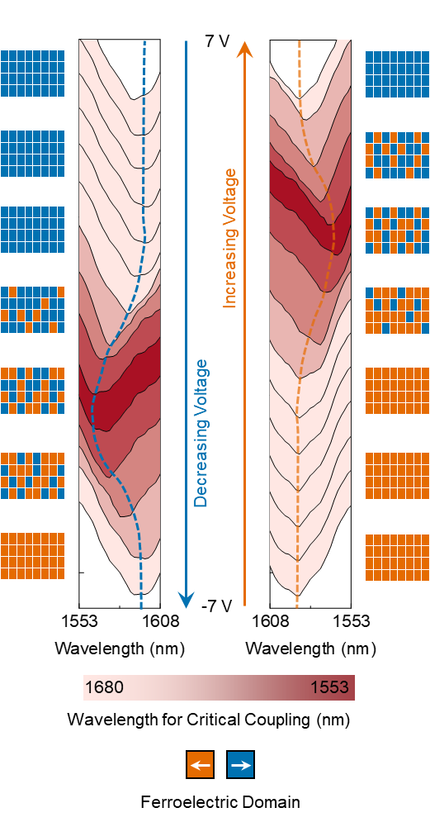
Figure S25. Resonance envelope as a function of applied voltage loop. By smoothing the minimum points of all resonance mode from transmission spectrum as the same method in Fig. S23, resonance envelope at all voltage were plotted. The gradient red color shows the gradual transition of critical coupling wavelength, with different trend during increasing voltage and decreasing voltage. The schematic indicates how domains are populated while increasing or decreasing the voltage. The applied voltage switches the critical coupling wavelength forward and backward by manipulating loss inside optical waveguide, with a nonvolatile trend which is shown by extra reverse voltage required to shift the critical coupling wavelength back to its initial value.
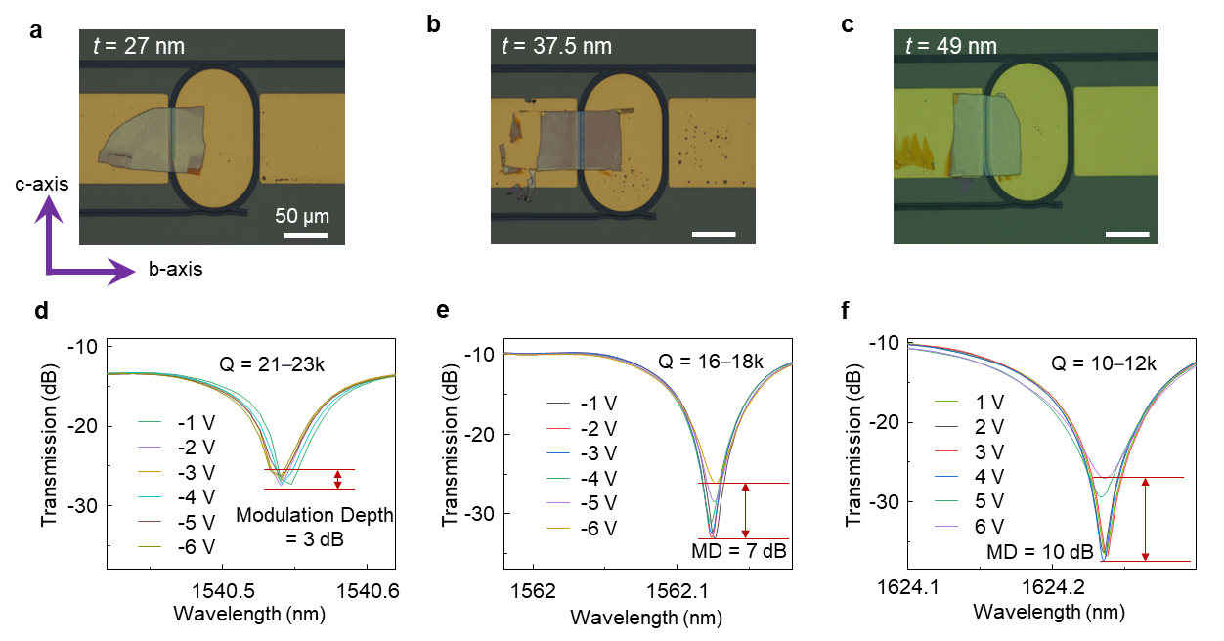
Figure S26. OM-image and Modulated transmission Spectrums of fabricated tunable second harmonic generation (TSHG) samples with various flake thickness. a-c, OM-images of fabricated TSHG devices, with different flake thickness indicated in figure and constant interaction length of 60 µm. The device in Fig. 4 is also shown here in (b). And the applied E-field are always along with b-axis, ensuring the effective polarization switching. d-e, modulated transmission spectrum as a function of applied voltage from -1 V to -6 V of sample in (a), (b), and (c). All devices show degraded ER for high applied E-field with the same trend as the device in Fig. 4. Sample in (c) (the thickest sample) shows the highest modulation depth (MD), and the lowest Q-factor. It can be inferred that the thicker NbOBr₂ flake integrated on PIC microring device presents a better modulation capability, while introduces a larger loss. Considering the trade-off between modulation capability and cavity loss, the sample in (b) (moderate thickness) is the best choice for SHG intensity modulation.

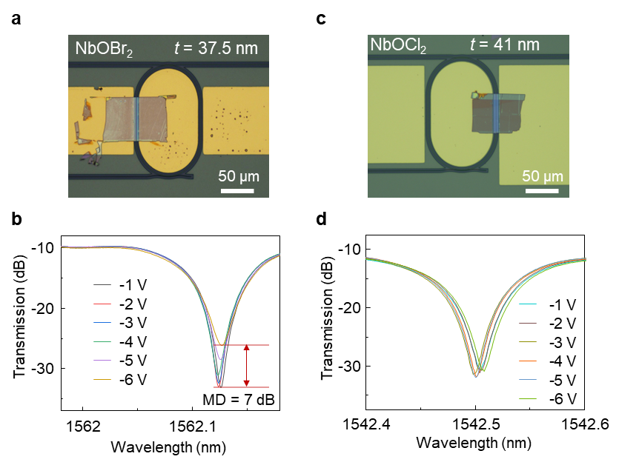
Figure S27. Comparison of modulation response between NbOBr₂ and NbOCl₂. a, OM-image of fabricated TSHG device using NbOBr₂ with a flake thickness of 37.5 nm. b, Measured modulation transmission spectrum of sample in (a) under various DC bias. c, OM-image of fabricated TSHG device using NbOCl₂ with a flake thickness of 41 nm. d, Measured modulation transmission spectrum of sample in (c) under various DC bias. The comparison shows NbOBr2 present better modulation efficiency. So we choose NbOBr₂ as active material for SHG emission and modulation.

References
1 Chen, W. et al. Extraordinary Enhancement of Nonlinear Optical Interaction in NbOBr2 Microcavities. Advanced Materials, 2400858 (2024).
2 Liu, C. et al. Ferroelectricity in niobium oxide dihalides NbOX2 (X= Cl, I): A macroscopic-to microscopic-scale study. ACS nano 17, 7170-7179 (2023).
3 Abdelwahab, I. et al. Giant second-harmonic generation in ferroelectric NbOI2. Nature Photonics 16, 644-650 (2022).
4 Guo, X., Zou, C.-L. & Tang, H. X. Second-harmonic generation in aluminum nitride microrings with 2500%/W conversion efficiency. Optica 3, 1126-1131 (2016).
5 Maiti, R. et al. A semi-empirical integrated microring cavity approach for 2D material optical index identification at 1.55 μm. Nanophotonics 8, 435-441 (2019).
6 Zograf, G. et al. Combining ultrahigh index with exceptional nonlinearity in resonant transition metal dichalcogenide nanodisks. Nature Photonics 18, 751-757 (2024).
7 McKinnon, W. et al. Extracting coupling and loss coefficients from a ring resonator. Optics express 17, 18971-18982 (2009).
8 Stokes, L. F., Chodorow, M. & Shaw, H. J. All-single-mode fiber resonator. Optics Letters 7, 288-290 (1982).
9 Loudon, R. The quantum theory of light. (OUP Oxford, 2000).
10 Delâge, A. et al. Wavelength-dependent model of a ring resonator sensor excited by a directional coupler. Journal of Lightwave Technology 27, 1172-1180 (2009).
11 Datta, I. et al. Low-loss composite photonic platform based on 2D semiconductor monolayers. Nature Photonics 14, 256-262 (2020).

