Comparative antimicrobial profiles of Histatin 5, Histatin 8, and their copper complexes.

Danuta Witkowska^{1*}, Justyna Sokołowska¹, Joanna Słowik¹, Katarzyna Zamłyńska², Jolanta Kutkowska², and Paweł Lenartowicz³

Table S1. Results of ITC-based interaction studies of the examined histatins with Ni(II) and Zn(II) ions, performed in MOPSO buffer at 25°C.
 | $$K_{DITC}[µM]$$ | ΔH [kcal/mol] | - TΔS [kcal/mol] | N [sites]
Ni(II)-Hst5 | 110.5 ± 5.85 | -10.65 ± 0.33 | 5.25 | 0.48 ± 0.06
Ni(II)-Hst8 | 203.0 ± 30.85 | -7.49 ± 0.95 | 2.46 | 0.45 ± 0.03
Zn(II)-Hst5 | 238.0 ± 28.20 | -6.80 ± 1.41 | 1.84 | 0.48 ± 0.07
Zn(II)-Hst8 | 195.0 ± 72.20 | -0.57 ± 0.14 | - 4.51 | 1.15 ± 0.11

A | B
C | D

Figure S1. ITC binding isotherms for the titration of Ni(II) into (A) Histatin 5 and (B) Histatin 8 and Zn (II) into (C) Histatin 5 and (D) Histatin 8, in 20 mM MOPS, pH 7.0, at 25 °C. The top panels show the differential power signals recorded for each injection, while the bottom panels present the integrated peak areas, representing the heat released during each injection.
A | B
C | D

Figure S2. Signature plots of the titration of Ni(II) into (A) Histatin 5 and (B) Histatin 8 and Zn (II) into (C) Histatin 5 and (D) Histatin 8, in 20 mM MOPS, pH 7.0, at 25 °C.

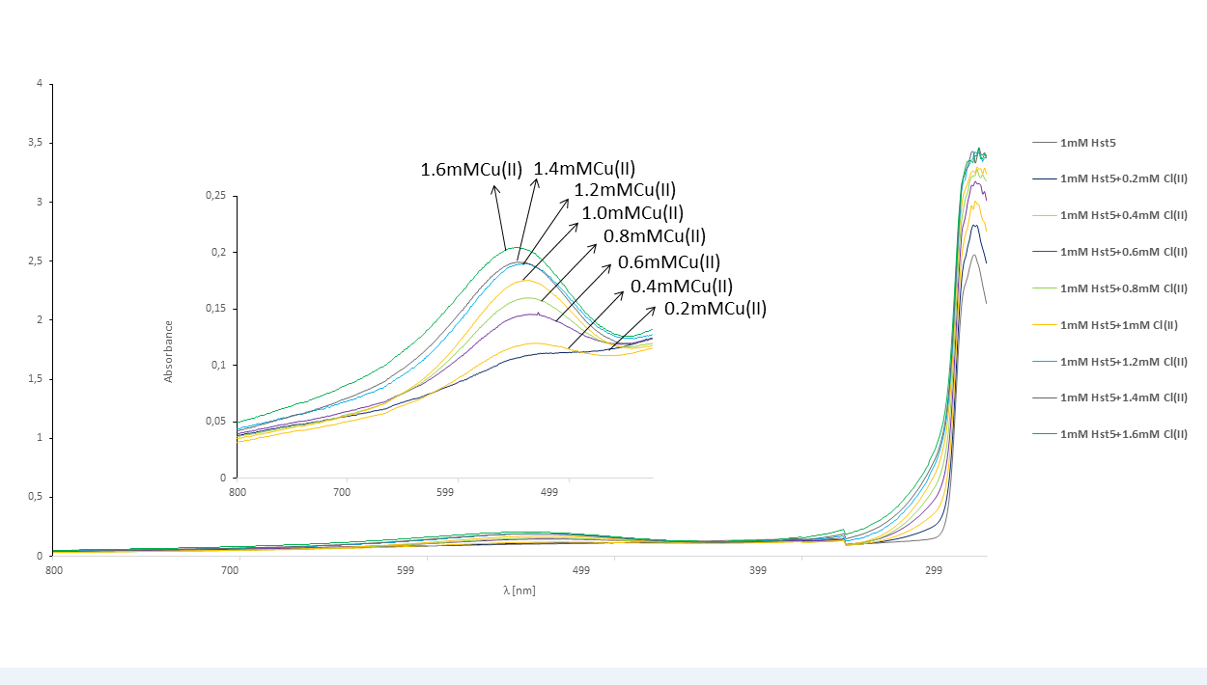
Figure S3. UV-ViS results of Cu(II)-Hst5 binding in 20 mM MOPS, pH 7.0, at 25 °C.

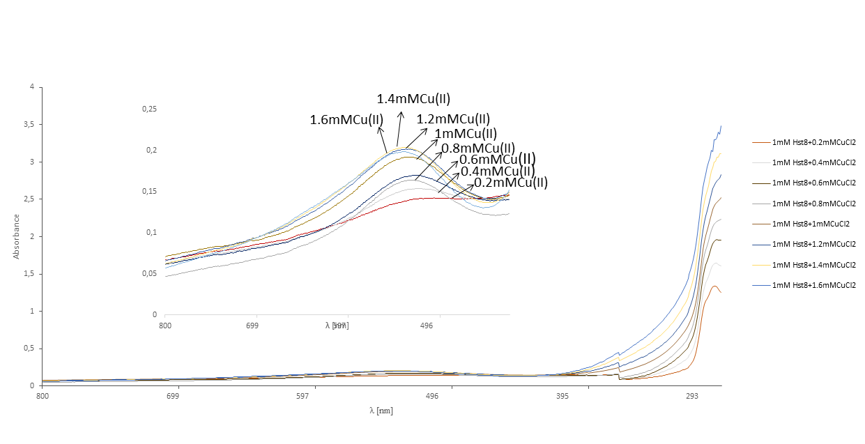

Figure S4. UV-ViS results of Cu(II)-Hst8 binding in 20 mM MOPS, pH 7.0, at 25 °C.

Table S2. Maximum absorbance in the d-d transition region for Cu(II) and Ni(II) complexes with Hst5 and Hst8 at a 1:1 ratio, measured in MOPSO buffer, at pH 7.0
 | Λ [nm]
Cu(II)-Hst5 | 520
Cu(II)-Hst8 | 515
Ni(II)-Hst5 | 420
Ni(II)-Hst8 | 420

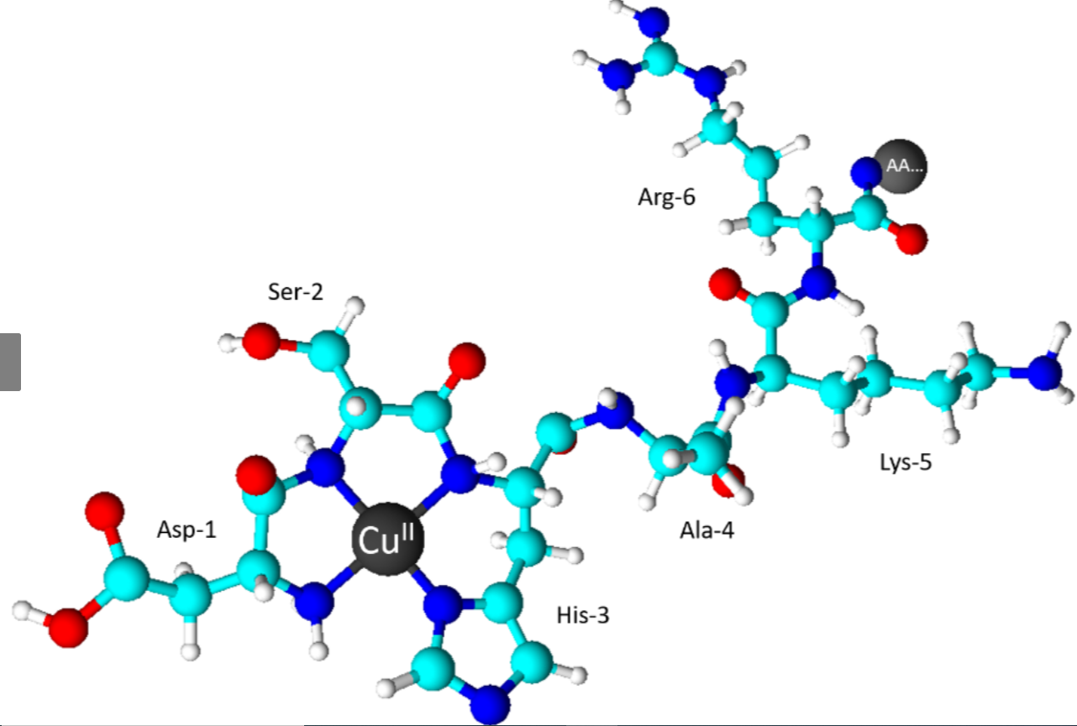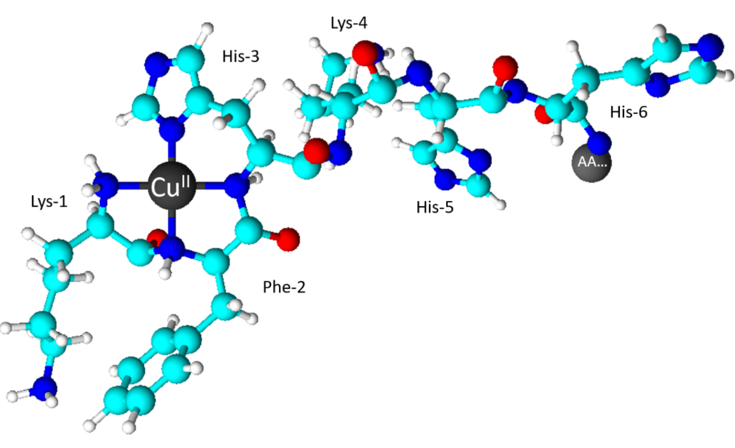
A B

Figure S5. Proposed coordination modes of Cu(II) complexes with the N-terminal regions of histatin 5 (A) and histatin 8 (B). The structures were drawn and optimized using ACD/ChemSketch software ver. 2021.2.1.

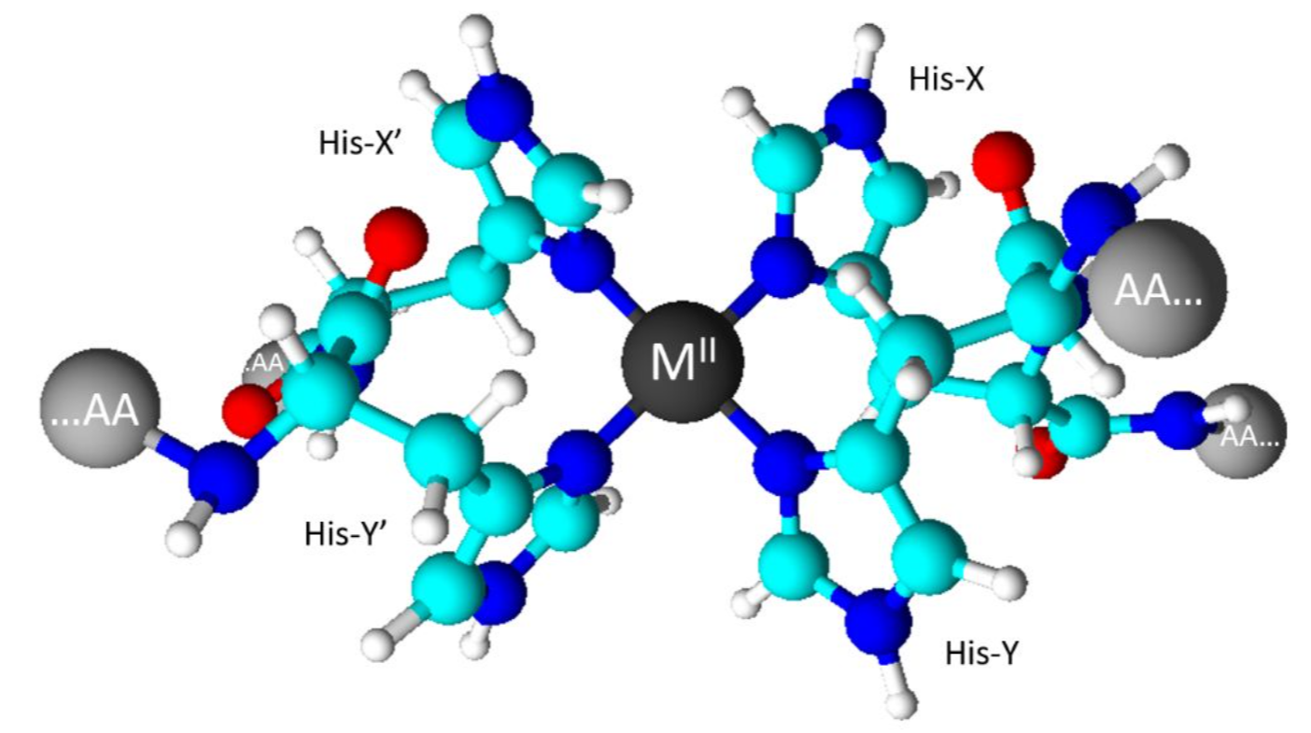

Figure S6. Proposed coordination modes of M(II) complexes with the interpeptide imidazoles, that can lead to oligomer formation.

