Supplementary materials
- Supplementary figures 1-10
- Supplementary tables 1-3

Supplementary figures
Figure S1. Overview of methylation sequencing data analysis workflow.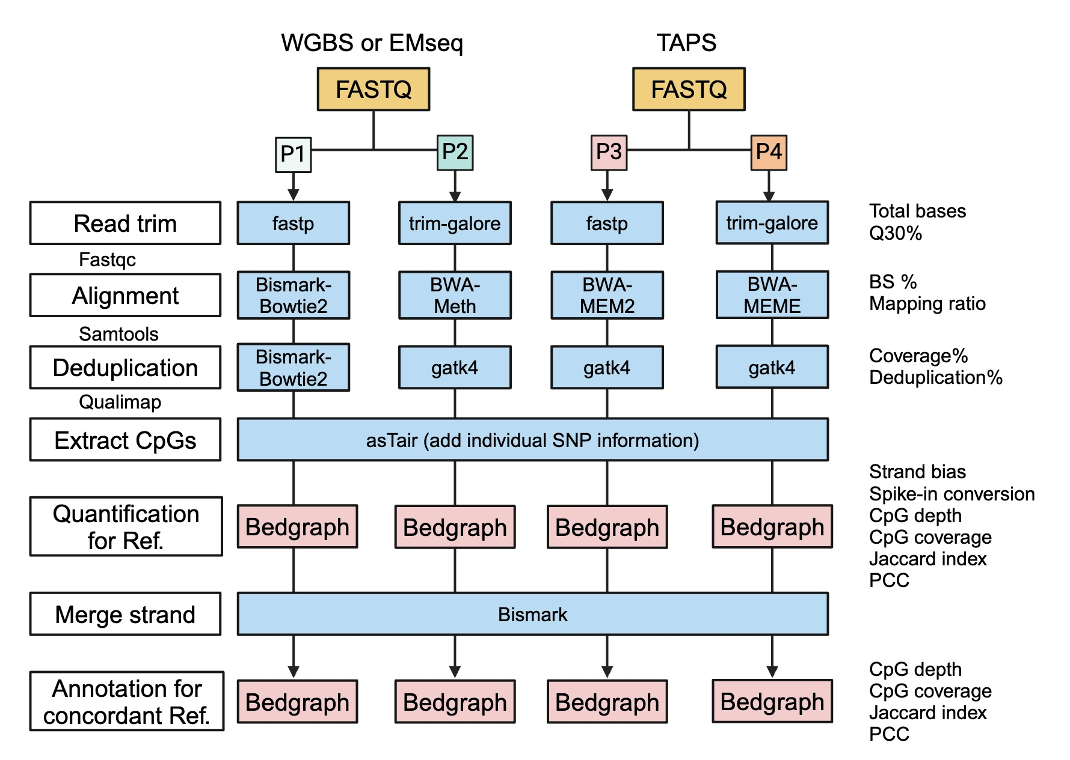
Figure S1. Overview of methylation sequencing data analysis workflow. This figure illustrates a detailed flowchart outlining the steps in processing FASTQ files for WGBS or EMseq (P1, P2) and TAPS (P3, P4) datasets. The flowchart highlights the key steps, including read trimming, alignment, deduplication, CpG extraction, quantification, strand merging, and annotation of reference datasets. The associated evaluation metrics for each step are also shown on the right side.

Figure S2. Cytosine detection counts across sequencing depth thresholds.
Figure S2. Cytosine detection counts across sequencing depth thresholds. This box plot illustrates the impact of cytosine sequencing depth on detection counts (millions) for positive and negative strands across nine batches (A1-A9), with box colors indicating the minimum cytosine sequencing depth threshold from 1× to 20×. Each row represents a strand-context combination: total cytosines (rows 1 and 4), CGA/CGT contexts (rows 2 and 5), and CGG/CGC contexts (rows 3 and 6).

Figure S3. Strand concordance across sequencing depth thresholds.
Figure S3. Strand concordance across sequencing depth thresholds. This box plot illustrates the impact of sequencing depth on cytosine concordance for positive and negative strands across nine batches (A1-A9), with box colors indicating the minimum sequencing depth threshold from 1× to 20×. The y-axis panels display (from top to bottom) the average cytosine sequencing depth on negative strands, average depth on positive strands, and RMSE of overlapping cytosines between strands.

Figure S4. Methylation frequency distribution across different batches.
Figure S4. Methylation frequency distribution across different batches. Bar plots represent the frequency of varying methylation levels, categorized into intervals ranging from 0% to 100%, with each interval spanning 5%. The y-axis shows the frequency of samples within each methylation interval, while the x-axis indicates the methylation level ranges. Each bar represents the mean frequency ± standard deviation (SD) for each interval, calculated from 12 measurements (3 replicates for each of the 4 sample types). The plot is presented in a 3x3 grid of panels, corresponding to one batch from A1 to A9, using WGBS, EMseq, or TAPS protocols, respectively.

Figure S5. PCA analysis of different protocols and pipelines.
Figure S5. PCA analysis of different protocols and pipelines. Principal component analysis (PCA) was performed on data from four different samples (D5, D6, F7, and M8) and two analysis pipelines (P1/P3 and P2/P4). SNR values and the number of sites used for plotting are indicated in the panel titles. Samples are represented by different colors: cyan for D5, green for D6, orange for F7, and red for M8. Different pipeline choices are denoted by shape: circles for P1/P3 and diamonds for P2/P4. The axes represent the first two principal components (PC1 and PC2), with the percentage of variance explained by each principal component noted on the axis labels. The plot is presented in a 3x3 grid of panels, corresponding to one batch from A1 to A9, using WGBS, EMseq, or TAPS protocols, respectively.

Figure S6. Intra-sample reproducibility assessment at concordant CpG sites.
Figure S6. Intra-sample reproducibility assessment at concordant CpG sites. Jaccard index of ≥ 20× concordant CpG sites for samples D5 (A), F7 (C), and M8 (E). Pearson coefficient correlation (PCC) of ≥ 20× concordant CpG sites for samples D5 (B), F7 (D), and M8 (F).

Figure S7. Inter-sample reproducibility assessment at concordant CpG sites.
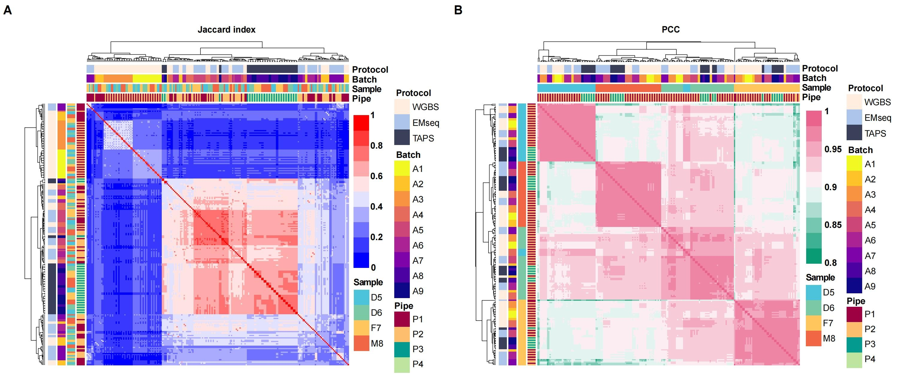
Figure S7. Inter-sample reproducibility assessment at concordant CpG sites. A Jaccard index of ≥ 20× concordant CpG sites for Quartet samples. B Pearson coefficient correlation (PCC) of ≥ 20× concordant CpG sites for Quartet samples.

Figure S8. Comparison of unique CpG sites covered and missed across different samples and batches.
Figure S8. Comparison of unique CpG sites covered and missed across different samples and batches. A The box plots display the number of unique CpG sites covered and missed in each of the nine batches (A1-A9) across four samples (D5, D6, F7, M8). The left three panels show unique CpG sites covered, while the right three panels show those missed. Plot are divided into three categories: (Top) sites detected in both strands, (Middle) sites detected in a single strand, and (Bottom) the combined detection across both and single strands. Points represent individual data points for each sample (D5 in cyan, D6 in green, F7 in yellow, M8 in red). The box color indicates the detection (covered) or missing status (missed) of the CpG sites, with the y-axis representing the number of sites (in thousands) or the Jaccard index. B The comparison of unique CpG sites covered and missed across four samples (D5, D6, F7, M8) for the 6 batches (A2, A5, A6, A7, A8, A9) used to construct the reference datasets. The plots are categorized in the same manner as in panel A.

Figure S9. Workflow for identifying annotation types of CpG sites in reference datasets.
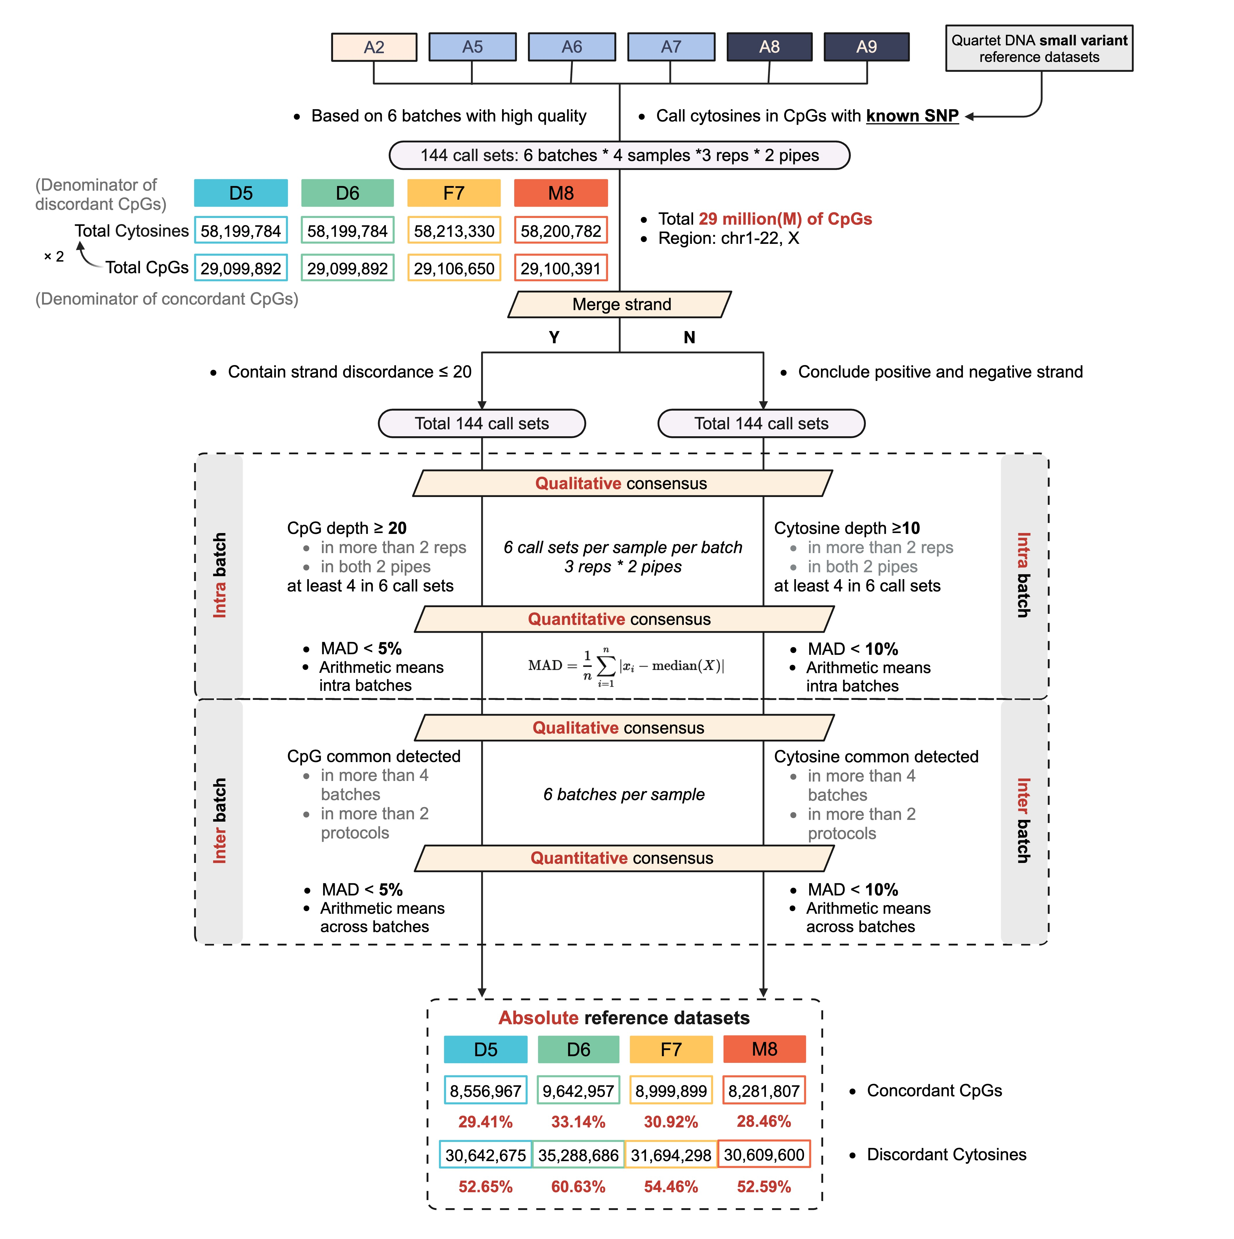
Figure S9. Workflow for identifying annotation types of CpG sites in reference datasets. Annotation for reference datasets was conducted according to the following steps: (1) merging CpG sites with a difference of less than 20% on the positive and negative strands; (2) identifying intra-batch qualification consistency CpGs; (3) identifying inter-batch quantification consistency CpGs; (4) calculating methylation levels based on reliable CpGs that were expressed consensus.

Figure S10. Schematic overview of 850K for validating reference datasets.
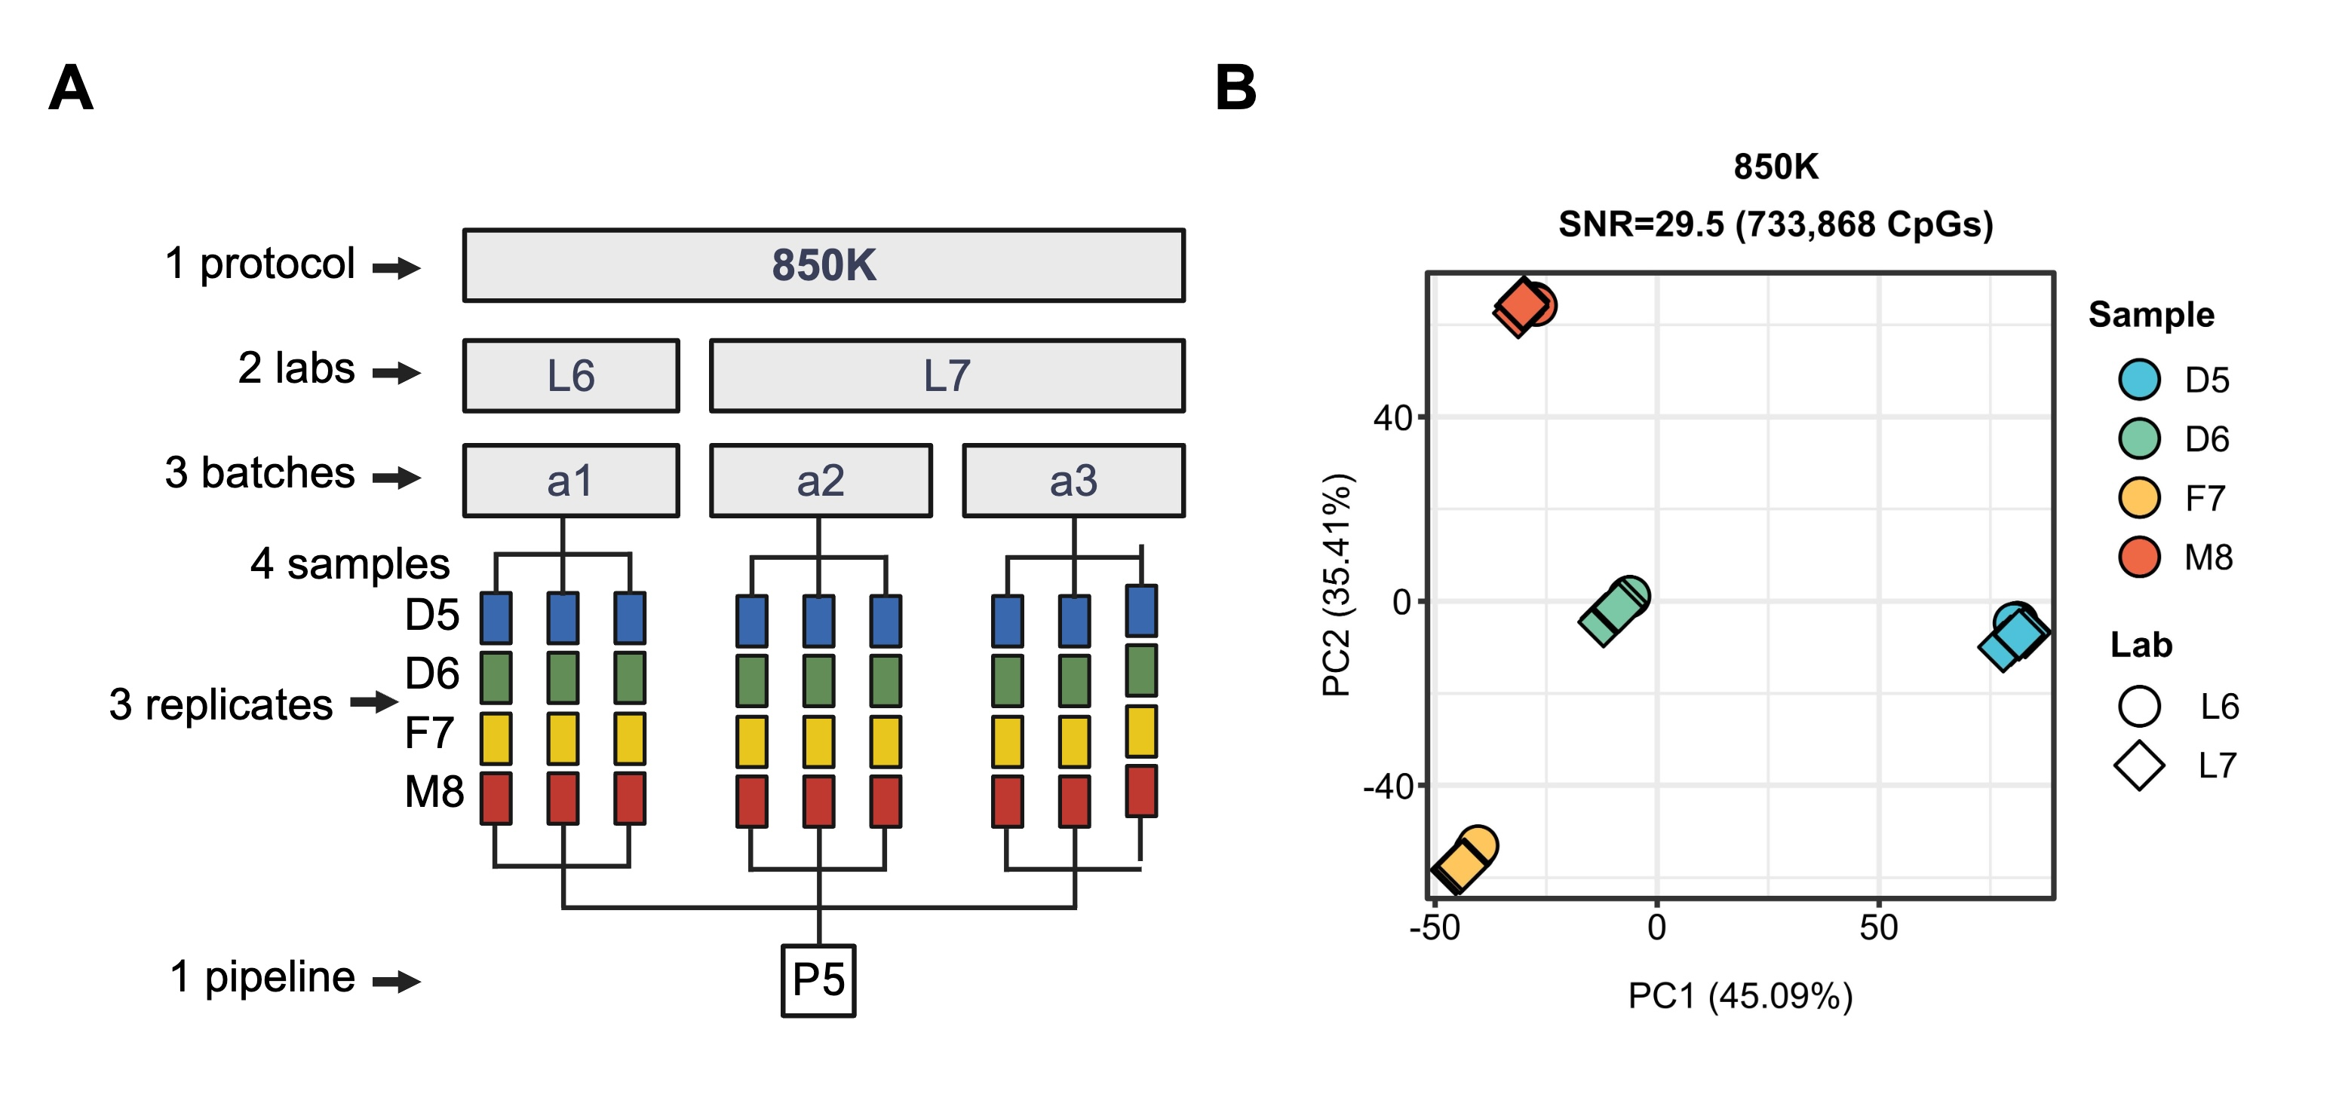
Figure S10. Schematic overview of 850K for validating reference datasets. A Scheme for generating the 850K dataset. Three technical replicates of each Quartet DNA reference material were processed in three batches using 850K arrays across two labs. A unified analytical pipeline identified 733,868 high-confidence CpG sites common to all batches. B PCA and SNR of 850K array data. 850K analyses incorporated 733,868 CpGs, inherently treated as concordant due to single-strand profiling.

Supplementary tables
Table S1. Performance metrics overview.
Metrics | WGBS A1 | WGBS A2 | WGBS A3 | WGBS A4 | EMseq A5 | EMseq A6 | EMseq A7 | TAPS A8 | TAPS A9
Total bases (G) | 96.75±6.96 | 103.68±6.36 | 107.31±9.58 | 117.54±33.84 | 155.87±50.44 | 110.64±7.6 | 111.08±10.75 | 108.47±9.82 | 127.65±16.15
Total reads (M) | 645.02±46.42 | 691.6±43.22 | 713.47±63.74 | 783.6±225.59 | 1037.75±336.26 | 735.58±50.51 | 740.54±71.68 | 753.24±68.18 | 886.47±112.17
Q30% | 88.77±0.81 | 89.88±1.13 | 91.77±0.2 | 88.98±0.73 | 90.05±0.57 | 91.84±0.34 | 94.09±0.57 | 94.27±0.54 | 94.38±0.42
Duplication% | 11.38±1.31 | 12.75±2.67 | 20.41±1.80 | 1.95±0.50 | 8.78±1.90 | 12.61±1.54 | 22.74±11.64 | 2.87±0.39 | 3.14±1.29
GC% | 20.26±0.07 | 23.78±0.72 | 20.72±0.12 | 22.19±0.26 | 21.75±0.17 | 21.36±0.15 | 23.82±1.58 | 41.06±0.92 | 40.67±0.42
Insert size (bp) | 238±8.28 | 247.58±14.17 | 268±0.00 | 263.92±0.29 | 268±0.00 | 268±0.00 | 233.75±12.53 | 161±0.00 | 168.92±27.42
Spike-in conversion% | 93.91±13.51 | 97.61±0.05 | 99.78±0.04 | 99.88±0.05 | NA | 99.97±0.06 | 97.11±0.28 | 91.2±0.63 | 96.49±1.05
CHH methylation% | 0.43±0.06 | 3.19±0.14 | 0.3±0.00 | 0.2±0.00 | 0.1±0.00 | 0.12±0.04 | 3.42±0.34 | 0.32±0.04 | 0.3±0.00
Coverage% 20× | 0.19±0.03 | 0.38±0.08 | 0.13±0.01 | 0.64±0.13 | 0.81±0.05 | 0.58±0.05 | 0.32±0.07 | 0.66±0.04 | 0.71±0.07
CpG depth | 15.54±1.03 | 20.6±2.45 | 13.03±0.79 | 31.55±8.87 | 37.63±9.61 | 24.3±1.39 | 21.57±3.33 | 32.24±3.29 | 35.95±5.64
Jaccard | 0.44±0.01 | 0.34±0.06 | 0.47±0.01 | 0.62±0.10 | 0.78±0.03 | 0.58±0.03 | 0.41±0.04 | 0.74±0.02 | 0.77±0.03
PCC | 0.97±0.00 | 0.97±0.00 | 0.98±0.00 | 0.98±0.00 | 0.98±0.00 | 0.97±0.00 | 0.97±0.00 | 0.98±0.00 | 0.98±0.00
SNR | 28.4 | 27.3 | 26.8 | 18.9 | 28.5 | 29.9 | 23.3 | 33.0 | 22.4
Table S1. Performance metrics overview. This table presents the performance metrics for each batch, with values reported as mean ± standard deviation (SD) for all indicators, except for the last row, which shows single values for each batch. Greener cells indicate better performance in the respective batch (for some metrics, higher values correspond to better performance, and for others, the reverse is true). Non-directional metrics (GC% and insert size) are filled with light grey, and the numerical value does not directly reflect the performance.

Table S2. Orthogonal validation of methylation reference datasets using 850K.
Metrics | D5 | D6 | F7 | M8
Total CpGs on 850K | 733,868 | 733,868 | 733,868 | 733,868
Overlapping CpGs with reference | 442,014 | 521,554 | 483,431 | 436,324
CpGs within reference ± 3SD | 362,887 | 435,276 | 396,165 | 357,759
Detection rate (%) | 60.23% | 71.07% | 65.87% | 59.46%
Validation rate (%) | 82.10% | 83.46% | 81.95% | 81.99%
Pearson correlation (PCC) | 0.99 | 0.99 | 0.99 | 0.99
Spearman correlation (SCC) | 0.95 | 0.96 | 0.95 | 0.96
Coefficient of determination (R²) | 0.98 | 0.97 | 0.98 | 0.98
Mean absolute error (MAE, %) | 5.14% | 5.49% | 5.01% | 5.20%
Root mean square error (RMSE, %) | 6.97% | 7.34% | 6.78% | 6.99%
Table S2. Orthogonal validation of methylation reference datasets using 850K. Total CpGs on 850K indicate the number of high-confidence probes retained after quality filtering (733,868 each sample). Overlapping CpGs with reference represent shared sites between array data and reference datasets, with the detection rate calculated as the percentage of array CpGs overlapping the reference. The validation rate reflects the proportion of overlapping CpGs where array methylation levels (0-100% scale) fell within ±3 standard deviations of reference values. PCC, SCC, R², MAE, and RSME metrics were calculated exclusively across all overlapping CpG sites shared between the reference datasets and 850K.

Table S3. Sensitivity analysis of the reference dataset robustness for sample D6 across 24 exclusion regimes.
Removed | Length | Intersection | Union | Jaccard | PCC | SCC | MAE | RMSE
A2_all_D6 | 19063274 | 13131539 | 19142125 | 0.6860 | 0.9997 | 0.9977 | 0.5367% | 0.8876%
A2_rep1_D6 | 15408679 | 12859403 | 15759666 | 0.8160 | 0.9997 | 0.9979 | 0.4662% | 0.8196%
A2_rep2_D6 | 15013488 | 12847470 | 15376408 | 0.8355 | 0.9997 | 0.9979 | 0.4667% | 0.8206%
A2_rep3_D6 | 14835646 | 12827386 | 15218650 | 0.8429 | 0.9997 | 0.9978 | 0.4786% | 0.8319%
A5_all_D6 | 13977313 | 13011871 | 14175832 | 0.9179 | 0.9997 | 0.9976 | 0.5923% | 0.9136%
A5_rep1_D6 | 13337929 | 12724818 | 13823501 | 0.9205 | 0.9999 | 0.9986 | 0.3240% | 0.6006%
A5_rep2_D6 | 12863252 | 12483532 | 13590110 | 0.9186 | 0.9998 | 0.9985 | 0.3325% | 0.6188%
A5_rep3_D6 | 13324267 | 12657475 | 13877182 | 0.9121 | 0.9998 | 0.9985 | 0.3494% | 0.6286%
A6_all_D6 | 19271863 | 13157888 | 19324365 | 0.6809 | 0.9998 | 0.9984 | 0.3813% | 0.7321%
A6_rep1_D6 | 14330913 | 13015602 | 14525701 | 0.8960 | 0.9998 | 0.9986 | 0.3625% | 0.7290%
A6_rep2_D6 | 14712621 | 13025700 | 14897311 | 0.8744 | 0.9998 | 0.9985 | 0.3975% | 0.7717%
A6_rep3_D6 | 14109027 | 13031575 | 14287842 | 0.9121 | 0.9998 | 0.9988 | 0.3255% | 0.6858%
A7_all_D6 | 17681395 | 13084437 | 17807348 | 0.7348 | 0.9996 | 0.9974 | 0.6064% | 0.9487%
A7_rep1_D6 | 15023962 | 12706856 | 15527496 | 0.8183 | 0.9998 | 0.9982 | 0.4018% | 0.7141%
A7_rep2_D6 | 14711383 | 12674967 | 15246806 | 0.8313 | 0.9998 | 0.9981 | 0.4232% | 0.7396%
A7_rep3_D6 | 14606029 | 12688993 | 15127426 | 0.8388 | 0.9998 | 0.9981 | 0.4239% | 0.7386%
A8_all_D6 | 15408896 | 13068940 | 15550346 | 0.8404 | 0.9996 | 0.9966 | 0.6768% | 1.0299%
A8_rep1_D6 | 13578673 | 12463116 | 14325947 | 0.8700 | 0.9998 | 0.9973 | 0.4108% | 0.7225%
A8_rep2_D6 | 13523144 | 12429181 | 14304353 | 0.8689 | 0.9998 | 0.9972 | 0.4252% | 0.7381%
A8_rep3_D6 | 13062915 | 12318863 | 13954442 | 0.8828 | 0.9998 | 0.9972 | 0.4270% | 0.7462%
A9_all_D6 | 14585856 | 13035534 | 14760712 | 0.8831 | 0.9996 | 0.9972 | 0.6184% | 0.9572%
A9_rep1_D6 | 13165823 | 12427265 | 13948948 | 0.8909 | 0.9998 | 0.9979 | 0.3708% | 0.6597%
A9_rep2_D6 | 12860093 | 12343394 | 13727089 | 0.8992 | 0.9998 | 0.9980 | 0.3631% | 0.6555%
A9_rep3_D6 | 13341186 | 12564669 | 13986907 | 0.8983 | 0.9998 | 0.9982 | 0.3558% | 0.6418%
Table S3. Sensitivity analysis of the reference dataset robustness for sample D6 across 24 exclusion regimes. The table shows the impact of excluding individual batches or technical replicates on reference dataset construction. Removed specifies excluded data subsets (e.g., rep1-3: removal of single libraries per batch; all: removal of entire batches). Length indicates retained CpG sites in perturbed references, Intersection and
Union quantifies overlaps with the original D6 reference dataset (22,078,295 CpG sites), and Jaccard measures their similarity. PCC and SCC assess methylation value correlations, while MAE and RMSE evaluate quantitative deviations.

