Appendix
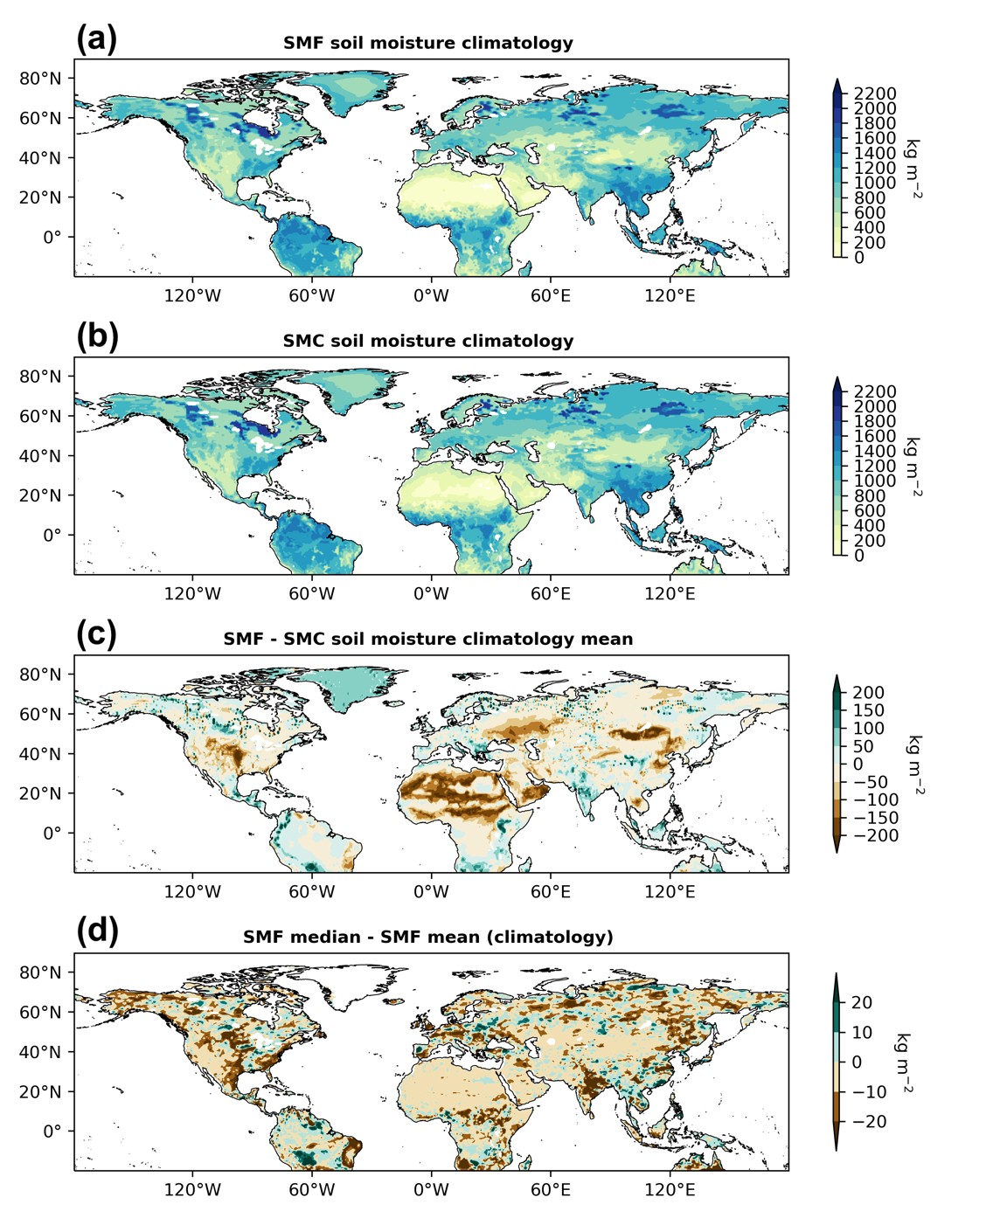

Figure A1. Soil moisture ensemble climatology means of both (a) SMF and (b) SMC experiments and differences between (c) SMF and SMC ensemble mean, (d) SMF median and SMF mean.
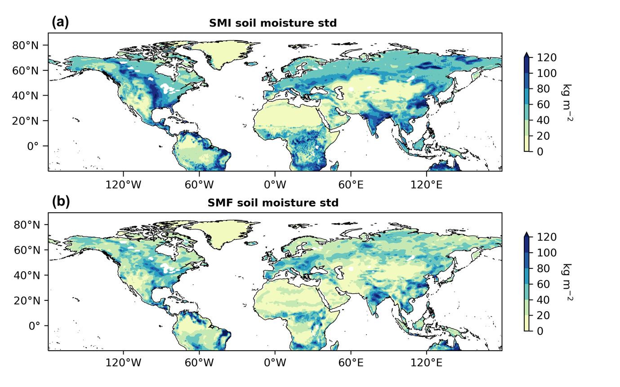
Figure A2. Soil moisture standard deviation plots between (a) SMI and (b) SMF.

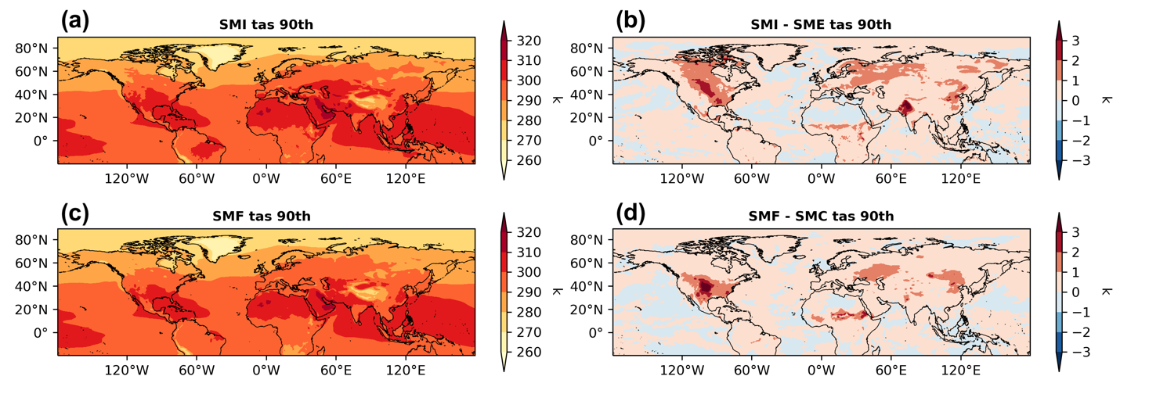
Figure A3. The 90th percentile of the daily near-surface temperature in July for simulated years 2009-2016 of (a) SMI and (c) SMF experiments, and differences between (b) SMI and SME, (d) SMF and SMC.

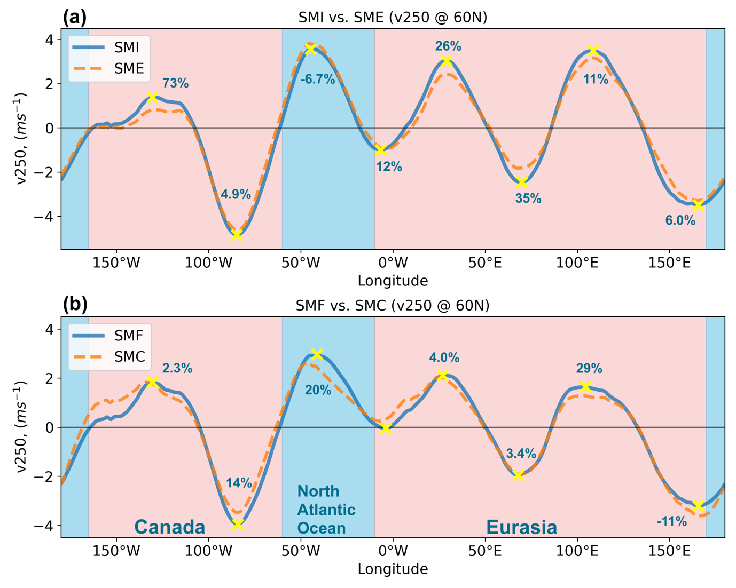
Figure A4. Meridional wind July ensemble means at 250hPa (v250) from all experiments at latitude 60N. (a) SMI vs. SME, (b) SMF vs. SMC. Yellow cross marks indicate the local maxima locations.

