Table 1 Studies included in analysis
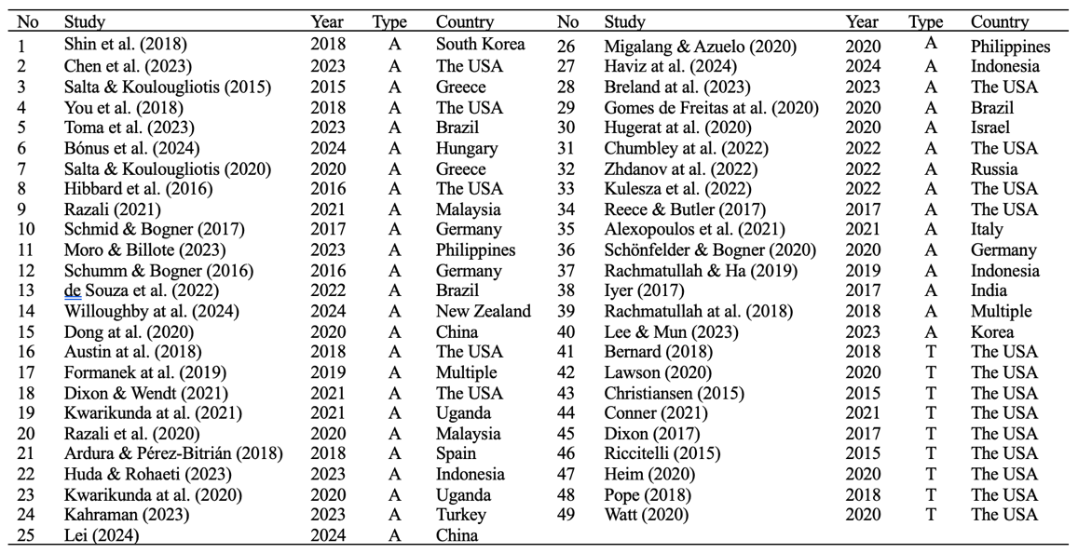
A: Article, T: Thesis

Table 2 Mean reliability coefficients, 95% confidence and credibility/prediction intervals, and heterogeneity statistics for each subscale
 |  |  | 95% CI |  | 95% PI
 | k | α₊ | LL | UL | LL | UL | Q | I²
CM | 45 | .88 | .86 | .90 | .72 | .95 | 1436.1580* | 96.96
GM | 41 | .83 | .80 | .85 | .60 | .93 | 1960.1004* | 96.98
IM | 41 | .85 | .82 | .87 | .62 | .94 | 1412.9436* | 97.40
SD | 42 | .84 | .82 | .86 | .67 | .92 | 1059.1763* | 95.88
SE | 46 | .85 | .84 | .87 | .70 | .93 | 1366.1194* | 95.95
Total | 26 | .94 | .93 | .95 | .85 | .98 | 664.0269* | 96.36
Abbreviations: k, number of studies; α_{+,} mean coefficients α; LL and UL, lower and upper limits of the 95% confidence and credibility/prediction intervals for α; Q, Cochran’s heterogeneity Q statistic; I², heterogeneity index; *p<.001

Table 3 Results of categorical moderator analyses for total scale and subscales
 |  |  |  | 95%
Moderator variable |  | k | α | LL | UL | Q_{M} | p
CM
Study Type | Article | 39 | .88 | .87 | .90 | .251 | .617
 | Thesis | 8 | .87 | .82 | .91
Language | English | 35 | .88 | .86 | .90 | .009 | .925
 | Other | 12 | .88 | .85 | .91
Sample Type | University students | 24 | .89 | .87 | .91 | 1.527 | .217
 | Other | 23 | .87 | .84 | .89
Test Version | Original | 26 | .88 | .86 | .90 | .018 | .892
 | Adapted | 21 | .88 | .86 | .90
GM
Study Type | Article | 36 | .83 | .80 | .86 | .384 | .535
 | Thesis | 9 | .81 | .74 | .86
Language | English | 32 | .82 | .79 | .85 | .182 | .670
 | Other | 13 | .84 | .79 | .87
Sample Type | University students | 27 | .83 | .79 | .85 | .090 | .765
 | Other | 18 | .83 | .79 | .87
Test Version | Original | 25 | .84 | .81 | .87 | 2.228 | .136
 | Adapted | 20 | .81 | .76 | .84
IM
Study Type | Article | 34 | .85 | .82 | .87 | .184 | .668
 | Thesis | 9 | .84 | .77 | .88
Language | English | 30 | .85 | .82 | .87 | .165 | .685
 | Other | 13 | .84 | .79 | .88
Sample Type | University students | 25 | .84 | .80 | .86 | 1.433 | .231
 | Other | 18 | .86 | .83 | .89
Test Version | Original | 25 | .86 | .83 | .88 | 2.873 | .090
 | Adapted | 18 | .82 | .78 | .86
SD
Study Type | Article | 38 | .84 | .82 | .86 | .029 | .865
 | Thesis | 8 | .84 | .78 | .88
Language | English | 35 | .84 | .81 | .86 | .348 | .555
 | Other | 11 | .85 | .81 | .88
Sample Type | University students | 26 | .84 | .81 | .86 | .187 | .666
 | Other | 20 | .84 | .81 | .87
Test Version | Original | 23 | .86 | .84 | .88 | 7.712 | .006***
 | Adapted | 23 | .81 | .78 | .84
SE
Study Type | Article | 42 | .86 | .84 | .87 | 1.275 | .259
 | Thesis | 8 | .83 | .77 | .87
Language | English | 38 | .85 | .83 | .87 | .388 | .533
 | Other | 12 | .86 | .83 | .89
Sample Type | University students | 26 | .85 | .82 | .87 | .897 | .344
 | Other | 24 | .86 | .84 | .88
Test Version | Original | 27 | .87 | .85 | .89 | 9.726 | .002***
 | Adapted | 23 | .82 | .79 | .85
Total scale
Study Type | Article | 24 | .94 | .93 | .95 | .382 | .536
 | Thesis | 3 | .93 | .88 | .96
Language | English | 17 | .94 | .92 | .95 | .005 | .945
 | Other | 10 | .94 | .92 | .95
Sample Type | University students | 10 | .92 | .89 | .93 | 10.540 | .001***
 | Other | 17 | .95 | .94 | .96
Test Version | Original | 14 | .95 | .93 | .96 | 1.864 | .172
 | Adapted | 13 | .93 | .91 | .95
Note: k=number of alpha coefficients; b_{j}=unstandardized regression coefficient; p=p value; Q_{E}=statistic to test for residual heterogeneity; SE=standard error; R²=proportion of variance accounted for by the predictor. ***p<.001

Table 4 Meta-regression results for continuous variables
Moderator variable |  | k | b_{j} | SE | p | R² | Q_{E}
CM | Sample Size | 45 | .000 | .000 | .157 | 2.37 | 1229.637***
CM | Female Percent | 40 | -.002 | .005 | .781 | .00 | 1164.501***
GM | Sample Size | 41 | .000 | .000 | .364 | .00 | 1959.794***
GM | Female Percent | 36 | -.011 | .005 | .028 | 12.08 | 1342.208***
IM | Sample Size | 41 | -.000 | .000 | .900 | .00 | 1236.701***
IM | Female Percent | 36 | -.005 | .004 | .249 | 1.87 | 945.370***
SD | Sample Size | 42 | .000 | .000 | .395 | .00 | 1058.111***
SD | Female Percent | 37 | -.005 | .004 | .209 | 2.17 | 715.175***
SE | Sample Size | 46 | .000 | .000 | .112 | 2.94 | 1363.766***
SE | Female Percent | 41 | -.005 | .004 | .248 | .99 | 1065.478***
Total scale | Sample Size | 26 | .001 | .000 | .028 | 13.87 | 486.755***
Total scale | Female Percent | 14 | -.016 | .009 | .088 | 14.43 | 281.182***
Note: k=number of alpha coefficients; b_{j}=unstandardized regression coefficients; SE=standard error; R²=explained variance; Q_{E}=test statistic of the test for residual heterogeneity; *p<.05; ***p<.001

