A novel coumarin-based fluorescent probe with aggregation induced emission for detecting CN⁻ and its applications in bioimaging
Sha Deng, Qiao Lei, Junzhe Cai, Yuliang Jiang*, Jian Shen*
Nanjing Normal Univ, Jiangsu Collaborat Innovat Ctr Biomed Funct Mat, Jiangsu Key Lab Biofunct Mat, Sch Chem & Mat Sci, Nanjing 210023, Jiangsu, Peoples R China
Corresponding Authors
Email: 07205@njnu.edu.cn (Y. L. Jiang)
jshen_njnu@163.com(J. Shen)

List of contents
1. ¹H NMR spectroscopy of C-BH
2. ¹³C NMR spectroscopy of C-BH
3. MS spectroscopy of C-BH
4. SEM of C-BH
5. UV-vis spectrum of C-BH and C-BH/CN⁻
6. Stokes shift of probe C-BH
7. MS spectroscopy of C-BH/CN⁻
8. Cytotoxicity of C-BH

- ¹H NMR spectrum
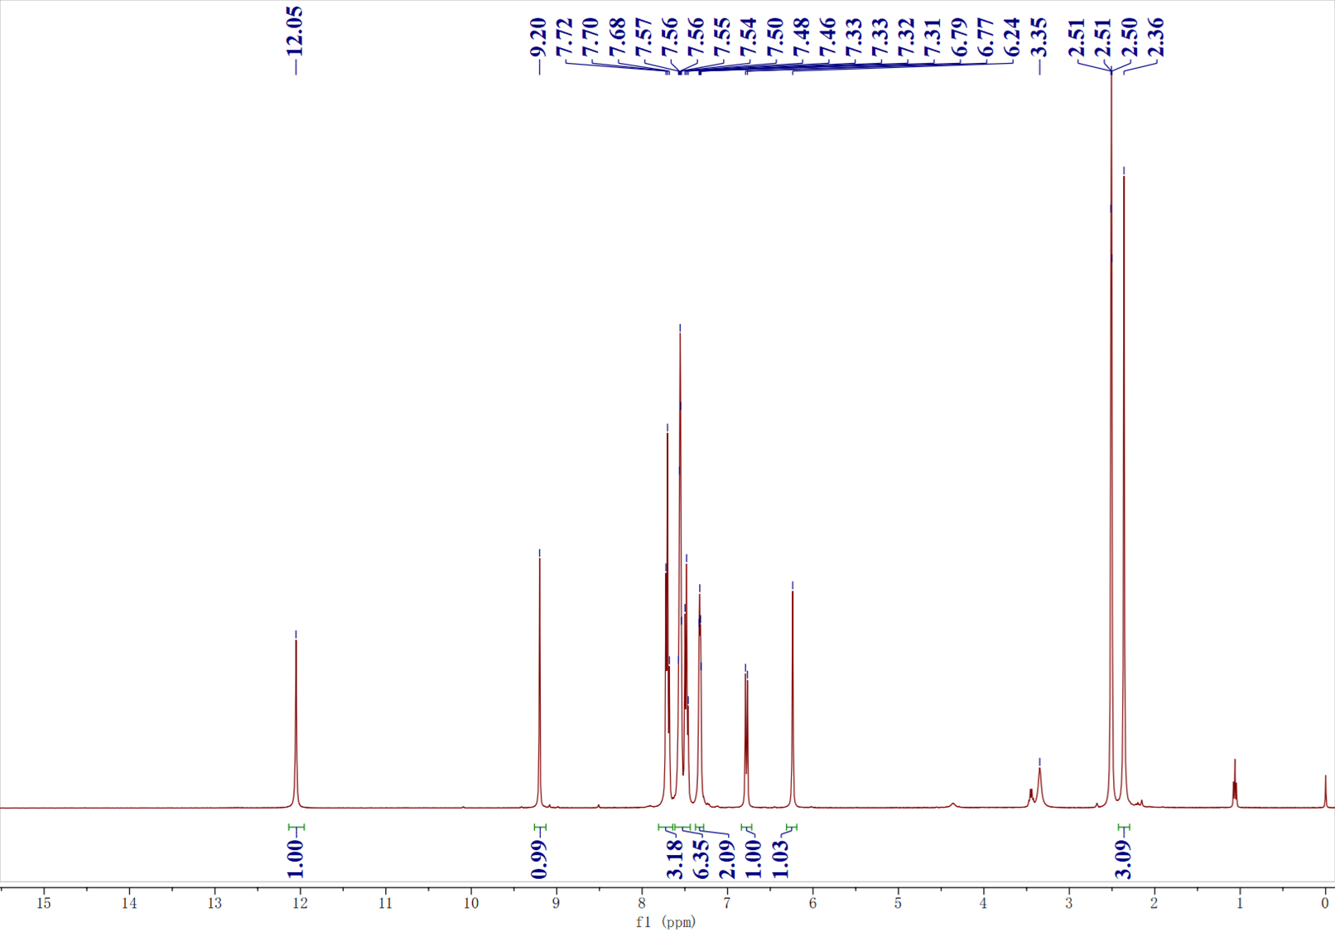
Fig. S1 ¹H NMR spectrum of C-BH
- ¹³C NMR spectrum

Fig. S2 ¹³C NMR spectrum of C-BH

- Mass spectrum
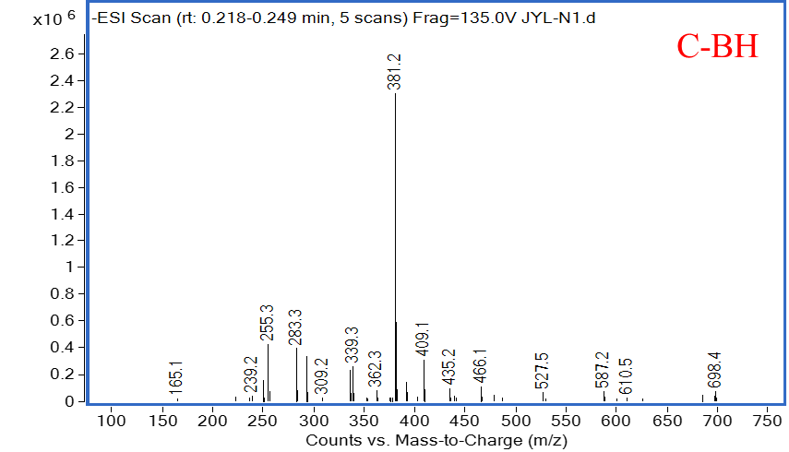
Fig. S3 MS spectrum of C-BH
4. SEM spectrum
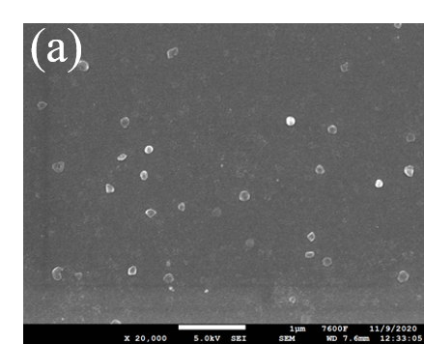
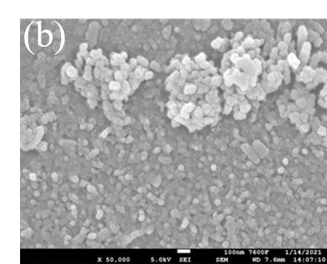
Fig. S4 SEM spectroscopy of C-BH

- UV-vis spectrum
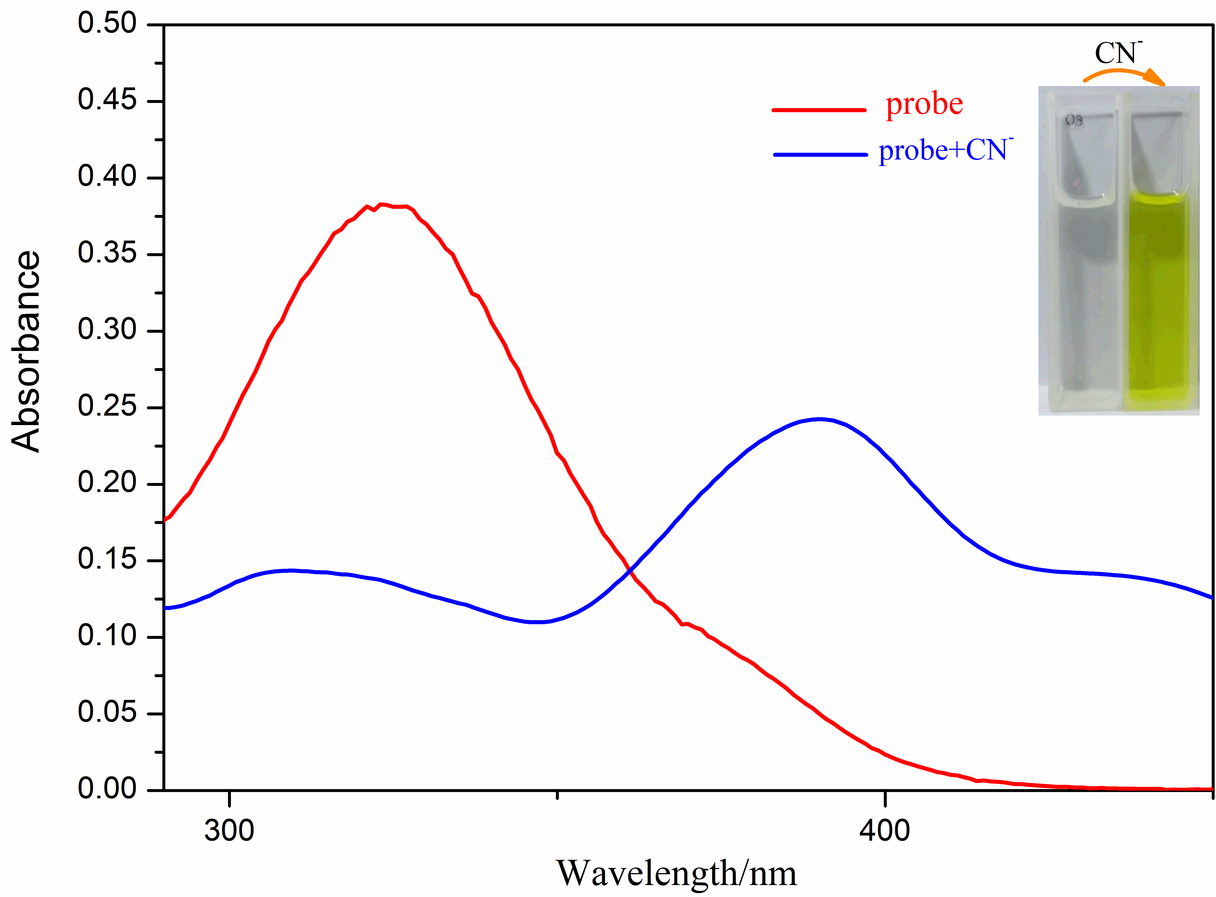
Fig. S5 UV-vis spectra of C-BH and C-BH/CN⁻
- Stokes shift
Fig. S6 Stokes shift of probe C-BH

7. MS spectrum of C-BH/CN⁻
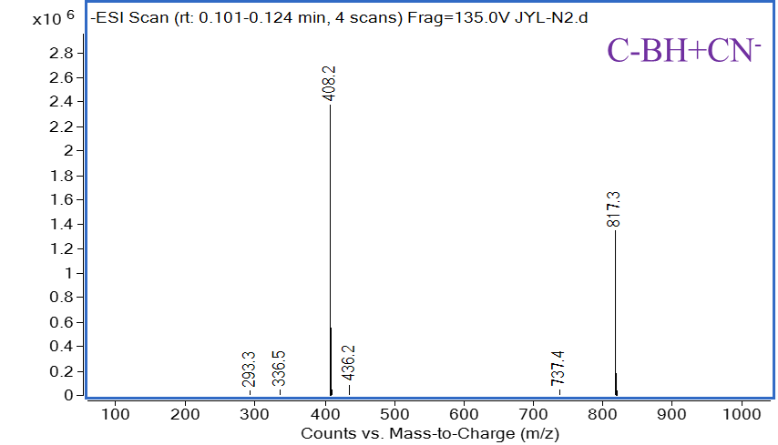
Fig. S7 The MS spectrum of C-BH/CN⁻

8. Cytotoxicity of C-BH
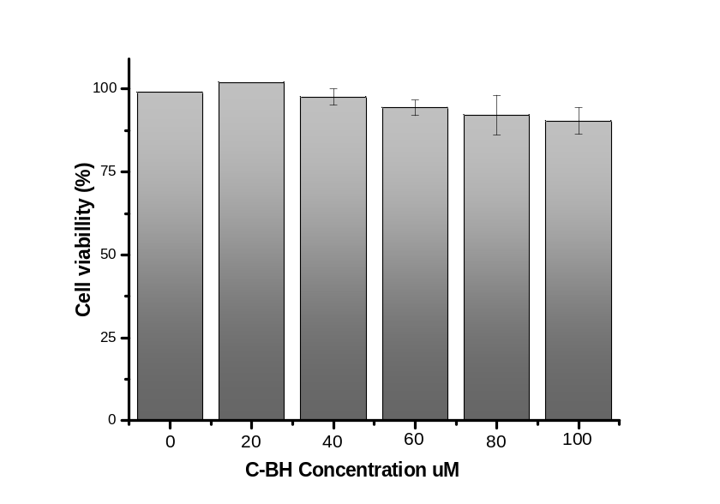
Fig. S8 Cytotoxicity of C-BH by a MTT assay (n = 3).

