Figure Captions: Supplementary
Figure S1. Distribution of unigenes in different orthologous classification according to COG, KOG and eggNOG databases. (A, D, G) represent COG classification for NoP_vs._Pi, NoP_vs._Po, and Pi_vs._Po, respectively. (B, E, H) represent eggNOG classification for NoP_vs._Pi, NoP_vs._Po, and Pi_vs._Po, respectively. (C, F, I) represent KOG classification for NoP_vs._Pi, NoP_vs._Po, and Pi_vs._Po, respectively.

Supplementary figure 1

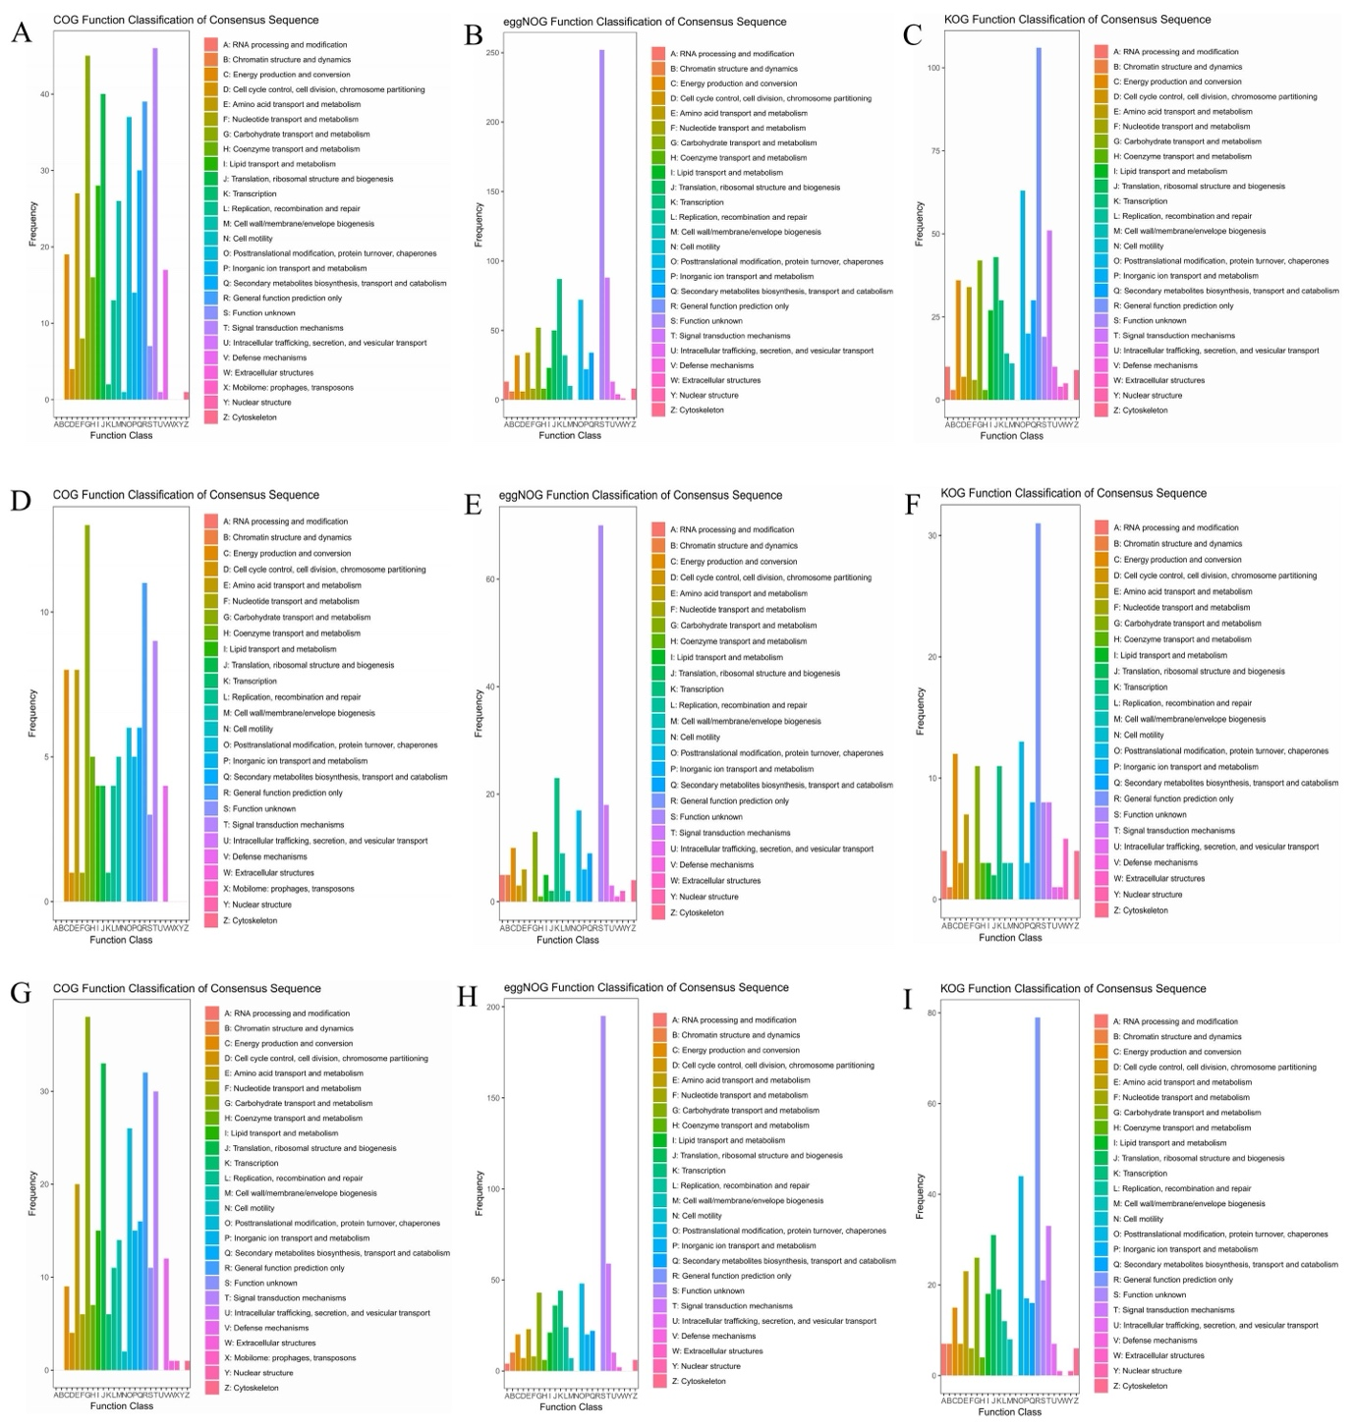
Figure S1. Distribution of unigenes in different orthologous classification according to COG, KOG and eggNOG databases. (A, D, G) represent COG classification for NoP_vs._Pi, NoP_vs._Po, and Pi_vs._Po, respectively. (B, E, H) represent eggNOG classification for NoP_vs._Pi, NoP_vs._Po, and Pi_vs._Po, respectively. (C, F, I) represent KOG classification for NoP_vs._Pi, NoP_vs._Po, and Pi_vs._Po, respectively.

