Supplemental Material for

Room-Temperature Hidden Order in Pyrochlore Iridate Eu₂Ir₂O₇
Shuai Xu¹, Xiaoran Liu^{1,†}, Xiaofeng Wu^{1,2}, Jiandong Guo^{1,2,†}, Kuijuan Jin^{1,2,†}
¹Beijing National Laboratory for Condensed Matter Physics, Institute of Physics, Chinese Academy of Sciences, Beijing 100190, China
²School of Physical Sciences, University of Chinese Academy of Sciences, Beijing 100049, China

† Corresponding authors
Email: xiaoran.liu@iphy.ac.cn; jdguo@iphy.ac.cn; kjjin@iphy.ac.cn

This PDF includes:
Sections S1 to S6
Figs. S1 to S3
References

Section S1 Methods
Film fabrications
The (111)-oriented Eu₂Ir₂O₇ single crystalline films were deposited on 5 × 5 mm² YSZ (111) substrates by pulsed laser deposition. The whole process of fabrication includes two stages. During the first stage of fabricating amorphous films, ceramic IrO₂ and Eu₂O₃ targets were sintered by solid state reaction and ablated alternatively inside the chamber using a KrF excimer laser (λ = 248 nm). The laser fluence was selected at 1.0 J/cm² with a fixed repetition rate of 1 Hz. The substrate temperature was maintained at 500 ℃ in an oxygen atmosphere of ~20 mTorr. The growth rate of each IrO₂ and Eu₂O₃ layer was calibrated individually in terms of pulses per nanometer, with the optimized number of pulses at 55 (30) for IrO₂ (Eu₂O₃). This is followed by the second stage of film crystallization, in which the amorphous films were cooled to room temperature and transferred into a muffle furnace and annealed at 950 ℃ in air for three hours.

Transport Measurements
The electrical and magnetic transport measurements were carried out using a 9-T physical property measurement system (PPMS, Quantum Design) using the 4-point contact method. The magnetic field was applied along the [111] direction and the current was driven along the [1-10] direction. Taking into account the rapidly increased magnetic coercivity below the Néel temperature, the Hall resistance was measured under the following procedures: (1) +9 T magnetic field was applied at 140 K and the sample was field cooled to the desired temperature; (2) The Hall resistance was measured along one branch of the hysteresis loop by sweeping field from +9 to -9 T; (3) The sample was heated to 140 K (to quench any magnetic domain) and then cooled back to the same temperature; (4) the Hall resistance was measured along the other branch of the hysteresis loop by sweeping field from -9 to +9 T.

Optical SHG measurements
The polarization anisotropic SHG and SHG measurements over a wide temperature range of Eu₂Ir₂O₇ films were performed in a typical reflection geometry, as shown in the schematic diagram in Fig. 2a. The incident laser beam was generated by the Maitai SP Ti:Sapphire oscillator produced by Spectra Physics, which produces a femtosecond pulsed laser with the incident light power kept at 80 mW and a center wavelength of 800 nm (pulse width 120 fs, frequency 82 MHz). Both the incident angle and the reflection angle are fixed at 45°, and the polarization direction $φ$ of the incident light field is adjusted by the rotation of the $\frac{λ}{2}$ waveplate driven by a rotating motor. The second-harmonic signal is collected by a photomultiplier tube and transmitted to a photon counter. The polarization configuration of the reflection light was fixed as p or s polarization, and the rotated anisotropy patterns under different reflection polarization configurations were obtained by rotating the incident light polarization angle $φ$.
The temperature-variable stage used in the WT-SHG measurement process was a Heating and Cooling Stage, that is, model HFS600E-PB4 produced by LINKAM, UK, with a long temperature range of 77 K to 873 K. The change in SHG intensity was measured from 90 K to 700 K, with the polarization configurations of the incident and reflection lights fixed at both p and p polarization. The wide-temperature-range polarization anisotropic SHG was measured every 50 K from 100 to 700 K. A corresponding SHG system was built.

Section S2 Functional forms of EQ SHG for Eu₂Ir₂O₇ thin films
The crystal structure of Eu₂Ir₂O₇ is the pyrochlore type, with its crystallographic point group being $Fd\overline{3}m$ and its magnetic point group being m$\overline{3}$m′. In the $Fd\overline{3}m$ space group [1], Eu₂Ir₂O₇ possesses three mirror planes and three rotational axes. However, the m$\overline{3}$m′ magnetic point group has three rotation axes and one inversion center [2].
To derive the polarization angle dependence of the electric quadrupole second harmonic generation in Eu₂Ir₂O₇, we consider cases in which the analyzer is set to p-polarization (0°) and s-polarization (90°).
Under the $m\overline{3}m$ point-group, the nonlinear susceptibility tensor $χ_{ijkl}^{\left(EQ\right)}$ has nonzero components for the electric quadrupole (EQ) contribution [2-5]:
$χ_{xxxx}=χ_{yyyy}​$, $χ_{zzzz}$
$$χ_{xxzz}=χ_{yyzz}​, χ_{yzzy}​​=χ_{xzzx}​,χ_{xxyy}​=χ_{yyxx}$$
$$χ_{zzyy}=χ_{zzxx}​,χ_{yzyz}​=χ_{xzxz},​χ_{xyxy}​=χ_{yxyx}$$
$$χ_{zyyz}=χ_{zxxz},​χ_{zyzy}​=χ_{zxzx}​,χ_{xyyx}​=χ_{yxxy}$$
where x, y, and z correspond to crystallographic coordinates.
The effective nonlinear polarization of the second harmonic generation $P_{i}\left(2ω\right)$ can be written as [6]:
$$P_{i}\left(2ω\right)=ε_{0}χ_{ijkl}^{\left(EQ\right)}E_{j}\left(ω\right)∇_{k}E_{l}\left(ω\right)$$
Finally, the functional forms for the EQ SHG intensity are derived from the equation [5]:
$$I_{2ω}(φ)∝{\left|P_{i}\left(2ω\right)\right|}^{2}={\left|{ε_{0}E}_{i}\left(2ω\right)χ_{ijkl}^{\left(EQ\right)}E_{j}\left(ω\right)∇_{k}E_{l}\left(ω\right)\right|}^{2}$$
Analyzing the polarization angle $φ$ dependence of SHG intensity $I(2ω)$ under p-polarization ($ϕ=0°$) and s-polarization ($ϕ=90°$) respectively, we can obtain:
$$I_{p-out}\left(φ\right)=I_{s-out}(φ)∝{\left(A\sin^{2}⁡(φ)+B\cos^{2}⁡(φ)+Ccos⁡(φ)sin⁡(φ)\right)}^{2}$$
Where A, B, and C are related to the value of non-zero nonlinear tensor elements.
This expression describes the polarization-angle dependence of the electric quadrupole SHG in Eu₂Ir₂O₇ at an incident angle of 45°. Owing to the contribution of EQ, the SHG intensity is related to the polarization angle $φ$ by the following formula:
$$I_{2ω}(φ)∝{\left(A\sin^{2}⁡(φ)+B\cos^{2}⁡(φ)+Ccos⁡(φ)sin⁡(φ)\right)}^{2}$$
where $φ$ is the polarization angle of the incident light. This formula represents the contribution of the electric quadrupole and shows the polarization-angle dependence of the EQ-SHG intensity.
For a crystal such as Eu₂Ir₂O₇, which possesses the $Fd\overline{3}m$ space group, its SHG polarization anisotropy pattern typically exhibits three-fold rotational symmetry under normal conditions, reflecting the symmetry of crystal. This symmetry arises from the presence of a threefold rotation axis (3) within the $Fd\overline{3}m$ space group, which is usually aligned with c-axis of the crystal. However, when the incident light is obliquely incident at an angle of 45°, the relative orientation of the incident light with respect to the symmetry axes of the crystal must be carefully considered. In such cases, the symmetry of the SHG polarization anisotropy pattern may be affected because the fact that the incident light is no longer aligned with the threefold rotation axis of crystal.
Specifically, if the incident light is at a 45° angle to the crystal's threefold rotation axis, the SHG polarization anisotropy pattern may not display the ordinary three-fold rotational symmetry. A 45° incidence could lead to incomplete repetition of the SHG signal upon rotation, thus reducing the symmetry of the pattern. In this scenario, the symmetry of the SHG polarization anisotropy pattern might be reduced to two-fold rotational symmetry if the incident light aligns with a two-fold rotation axis or even further reduced (if the incident light does not align with any higher-order rotation axes). The exact symmetry depends on the relative orientation of the incident light with respect to the crystal symmetry axes as well as the specific symmetry operations of the crystal.

Section S3 Polarization anisotropic SHG patterns of Eu₂Ir₂O₇ thin films and YSZ substrates
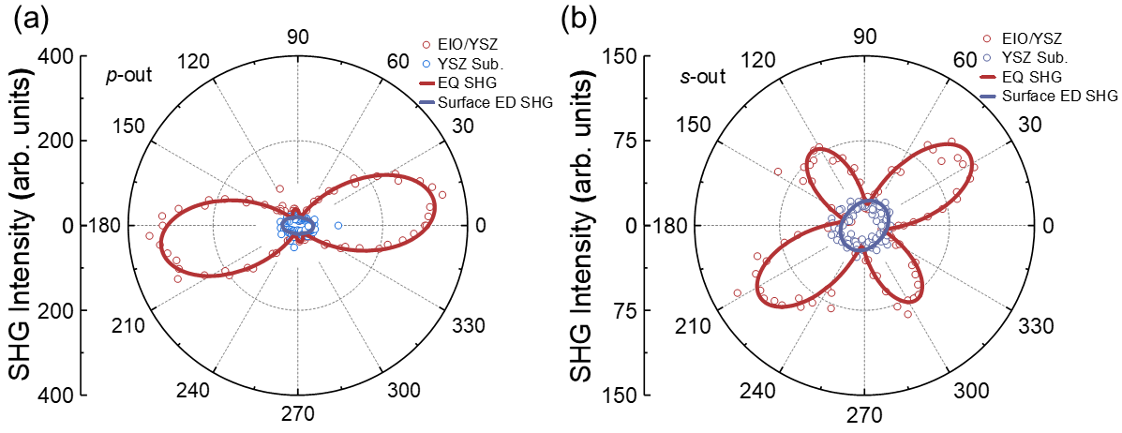
Fig. S1: (a) and (b) p-out and s-out polarization anisotropy of EQ-SHG response and surface ED-SHG response, respectively.
Both obtained at room temperature under oblique incidence at 45°. Here, p-out and s-out denote the selected polarization states of the reflected light, where p stands for parallel polarization and s stands for perpendicular polarization. The data were fitted to the simulated EQ-SHG response (red) for the m$\overline{3}$m′ magnetic point group and surface ED-SHG response (blue) for the trigonal crystal system.

Section S4 Functional forms of bulk MD SHG for Eu₂Ir₂O₇ thin films
The magnetic point group of Eu₂Ir₂O₇ thin films is m$\overline{3}$m′. In the m$\overline{3}$m′ magnetic point group, the second-order nonlinear tensor $χ_{ijk}^{\left(MD\right)}$​ is constrained by symmetry and there is no non-zero tensor element [2]. Here we choose the $\overline{3}$m′ magnetic point group with non-zero tensor elements for comparative analysis, because its symmetry is slightly lower than that of the m$\overline{3}$m′ magnetic point group. Then, the functional forms for the bulk MD SHG intensity of $\overline{3}$m′ magnetic point group under p-polarization and s-polarization can be derived and obtained as [5,6]:
$$I_{p-out}\left(φ\right)∝{\left(A\sin^{2}\left(φ\right)+B\cos^{2}\left(φ\right)\right)}^{2}$$
$$I_{s-out}(φ)∝{\left(Ccos⁡(φ)sin⁡(φ)\right)}^{2}$$
Where A, B, and C are related to the value of non-zero nonlinear tensor elements. This formula represents the contribution from bulk MD SHG of the $\overline{3}$m′ magnetic point group and shows the bulk MD SHG intensity dependence of the polarization-angle $φ$. All simulated polarization anisotropic SHG patterns (p-out and s-out) are displayed in Fig. S2.
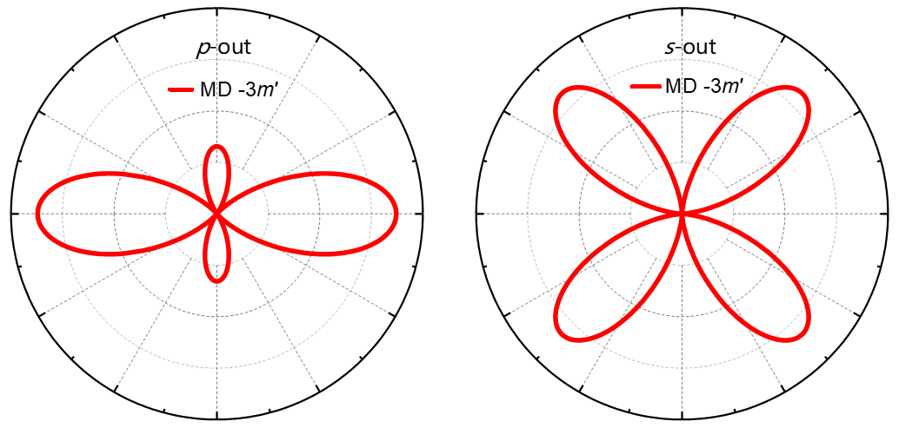
Fig. S2: Simulation of polarization anisotropic SHG pattern of MD contribution (red) under $\overline{3}$m′ point group. The polarization anisotropic SHG pattern of MD contribution shows the peak intensity under different values ​​of incident light polarization angle φ.

Section S5 Temperature dependence of the surface ED-SHG in YSZ substrates
Fig. S3: Temperature dependence of the surface ED-SHG in YSZ substrates.
The surface ED-SHG signal of the YSZ substrate is basically linear in the temperature range of 100 K to 650 K. This result is in sharp contrast to the temperature dependence of EQ-SHG of Eu₂Ir₂O₇ thin films, indicating that the abrupt change of SHG signal caused by the magnetic phase change in Eu₂Ir₂O₇ has nothing to do with the YSZ substrate.

References
[1] W. Witczak-Krempa, G. Chen, Y. B. Kim, and L. Balents, Annual Review of Condensed Matter Physics 5, 57 (2014).
[2] R. R. Birss, Symmetry and magnetism (North-Holland Publishing Company, 1964), Vol. 3.
[3] Y. Zhang et al., Phys. Rev. Lett. 122, 047401 (2019).
[4] H. Xia et al., Science Advances 10, eadp0575 (2024).
[5] Y. Ahn, X. Guo, R. Xue, K. Qu, K. Sun, D. Mandrus, and L. Zhao, Nature Photonics 18, 26 (2024).
[6] D. H. Torchinsky, H. Chu, L. Zhao, N. B. Perkins, Y. Sizyuk, T. Qi, G. Cao, and D. Hsieh, Phys. Rev. Lett. 114, 096404 (2015).

