Supplemental Material for

Room-Temperature Hidden Order in Pyrochlore Iridate Eu₂Ir₂O₇
Shuai Xu¹, Xiaoran Liu^{1,†}, Xiaofeng Wu^{1,2}, Jiandong Guo^{1,2,†}, Kui-juan Jin^{1,2,†}
¹Beijing National Laboratory for Condensed Matter Physics, Institute of Physics, Chinese Academy of Sciences, Beijing 100190, China
²School of Physical Sciences, University of Chinese Academy of Sciences, Beijing 100049, China

† Corresponding authors
Email: xiaoran.liu@iphy.ac.cn; jdguo@iphy.ac.cn; kjjin@iphy.ac.cn

This PDF includes:
Sections S1 to S4
Figs. S1 to S3
References

Section S1 Functional forms of EQ SHG for Eu₂Ir₂O₇ thin films
The crystal structure of Eu₂Ir₂O₇ is the pyrochlore type, with its crystallographic point group being $Fd\overline{3}m$ and its magnetic point group being m$\overline{3}$m′. In the $Fd\overline{3}m$ space group ¹, Eu₂Ir₂O₇ possesses three mirror planes and three rotational axes. However, the m$\overline{3}$m′ magnetic point group has three rotation axes and one inversion center ².
To derive the polarization angle dependence of the electric quadrupole second harmonic generation in Eu₂Ir₂O₇, we consider cases in which the analyzer is set to p-polarization (0°) and s-polarization (90°).
Under the $m\overline{3}m$ point-group, the nonlinear susceptibility tensor $χ_{ijkl}^{\left(EQ\right)}$ has nonzero components for the electric quadrupole (EQ) contribution ^{2, 3, 4, 5}:
$χ_{xxxx}=χ_{yyyy}​$, $χ_{zzzz}$
$$χ_{xxzz}=χ_{yyzz}​, χ_{yzzy}​​=χ_{xzzx}​,χ_{xxyy}​=χ_{yyxx}$$
$$χ_{zzyy}=χ_{zzxx}​,χ_{yzyz}​=χ_{xzxz},​χ_{xyxy}​=χ_{yxyx}$$
$$χ_{zyyz}=χ_{zxxz},​χ_{zyzy}​=χ_{zxzx}​,χ_{xyyx}​=χ_{yxxy}$$
where x, y, and z correspond to crystallographic coordinates.
The effective nonlinear polarization of the second harmonic generation $P_{i}\left(2ω\right)$ can be written as ⁶:
$$P_{i}\left(2ω\right)=ε_{0}χ_{ijkl}^{\left(EQ\right)}E_{j}\left(ω\right)∇_{k}E_{l}\left(ω\right)$$
Finally, the functional forms for the EQ SHG intensity are derived from the equation ⁵:
$$I_{2ω}(φ)∝{\left|P_{i}\left(2ω\right)\right|}^{2}={\left|{ε_{0}E}_{i}\left(2ω\right)χ_{ijkl}^{\left(EQ\right)}E_{j}\left(ω\right)∇_{k}E_{l}\left(ω\right)\right|}^{2}$$
Analyzing the polarization angle $φ$ dependence of SHG intensity $I(2ω)$ under p-polarization ($ϕ=0°$) and s-polarization ($ϕ=90°$) respectively, we can obtain:
$$I_{p-out}\left(φ\right)=I_{s-out}(φ)∝{\left(A\sin^{2}⁡(φ)+B\cos^{2}⁡(φ)+Ccos⁡(φ)sin⁡(φ)\right)}^{2}$$
Where A, B, and C are related to the value of non-zero nonlinear tensor elements.
This expression describes the polarization-angle dependence of the electric quadrupole SHG in Eu₂Ir₂O₇ at an incident angle of 45°. Owing to the contribution of EQ, the SHG intensity is related to the polarization angle $φ$ by the following formula:
$$I_{2ω}(φ)∝{\left(A\sin^{2}⁡(φ)+B\cos^{2}⁡(φ)+Ccos⁡(φ)sin⁡(φ)\right)}^{2}$$
where $φ$ is the polarization angle of the incident light. This formula represents the contribution of the electric quadrupole and shows the polarization-angle dependence of the EQ-SHG intensity.
For a crystal such as Eu₂Ir₂O₇, which possesses the $Fd\overline{3}m$ space group, its SHG polarization anisotropy pattern typically exhibits three-fold rotational symmetry under normal conditions, reflecting the symmetry of crystal. This symmetry arises from the presence of a threefold rotation axis (3) within the $Fd\overline{3}m$ space group, which is usually aligned with c-axis of the crystal. However, when the incident light is obliquely incident at an angle of 45°, the relative orientation of the incident light with respect to the symmetry axes of the crystal must be carefully considered. In such cases, the symmetry of the SHG polarization anisotropy pattern may be affected because the fact that the incident light is no longer aligned with the threefold rotation axis of crystal.
Specifically, if the incident light is at a 45° angle to the crystal's threefold rotation axis, the SHG polarization anisotropy pattern may not display the ordinary three-fold rotational symmetry. A 45° incidence could lead to incomplete repetition of the SHG signal upon rotation, thus reducing the symmetry of the pattern. In this scenario, the symmetry of the SHG polarization anisotropy pattern might be reduced to two-fold rotational symmetry if the incident light aligns with a two-fold rotation axis or even further reduced (if the incident light does not align with any higher-order rotation axes). The exact symmetry depends on the relative orientation of the incident light with respect to the crystal symmetry axes as well as the specific symmetry operations of the crystal.

Section S2 Polarization anisotropic SHG patterns of Eu₂Ir₂O₇ thin films and YSZ substrates
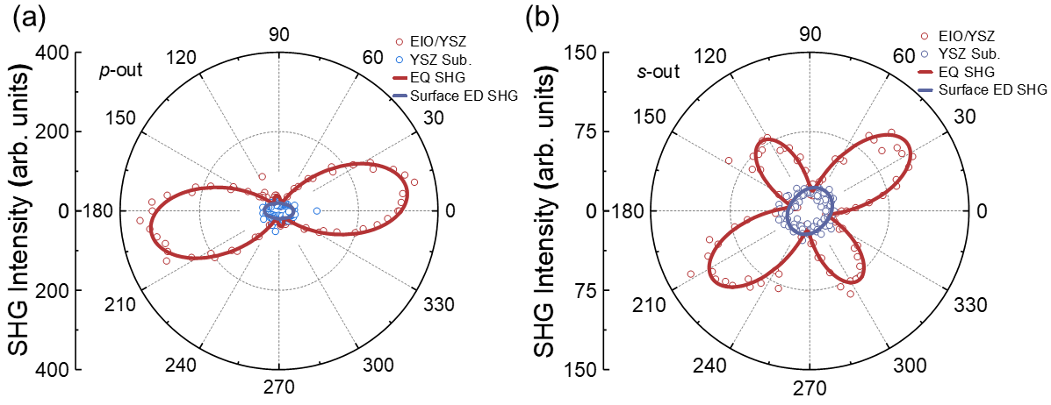
Fig. S1: (a) and (b) p-out and s-out polarization anisotropy of EQ-SHG response and surface ED-SHG response, respectively.
Both obtained at room temperature under oblique incidence at 45°. Here, p-out and s-out denote the selected polarization states of the reflected light, where p stands for parallel polarization and s stands for perpendicular polarization. The data were fitted to the simulated EQ-SHG response (red) for the m$\overline{3}$m′ magnetic point group and surface ED-SHG response (blue) for the trigonal crystal system.

Section S3 Functional forms of bulk MD SHG for Eu₂Ir₂O₇ thin films
The magnetic point group of Eu₂Ir₂O₇ thin films is m$\overline{3}$m′. In the m$\overline{3}$m′ magnetic point group, the second-order nonlinear tensor $χ_{ijk}^{\left(MD\right)}$​ is constrained by symmetry and there is no non-zero tensor element ². Here we choose the $\overline{3}$m′ magnetic point group with non-zero tensor elements for comparative analysis, because its symmetry is slightly lower than that of the m$\overline{3}$m′ magnetic point group. Then, the functional forms for the bulk MD SHG intensity of $\overline{3}$m′ magnetic point group under p-polarization and s-polarization can be derived and obtained as ^{5, 6}:
$$I_{p-out}\left(φ\right)∝{\left(A\sin^{2}\left(φ\right)+B\cos^{2}\left(φ\right)\right)}^{2}$$
$$I_{s-out}(φ)∝{\left(Ccos⁡(φ)sin⁡(φ)\right)}^{2}$$
Where A, B, and C are related to the value of non-zero nonlinear tensor elements. This formula represents the contribution from bulk MD SHG of the $\overline{3}$m′ magnetic point group and shows the bulk MD SHG intensity dependence of the polarization-angle $φ$. All simulated polarization anisotropic SHG patterns (p-out and s-out) are displayed in Fig. S2.
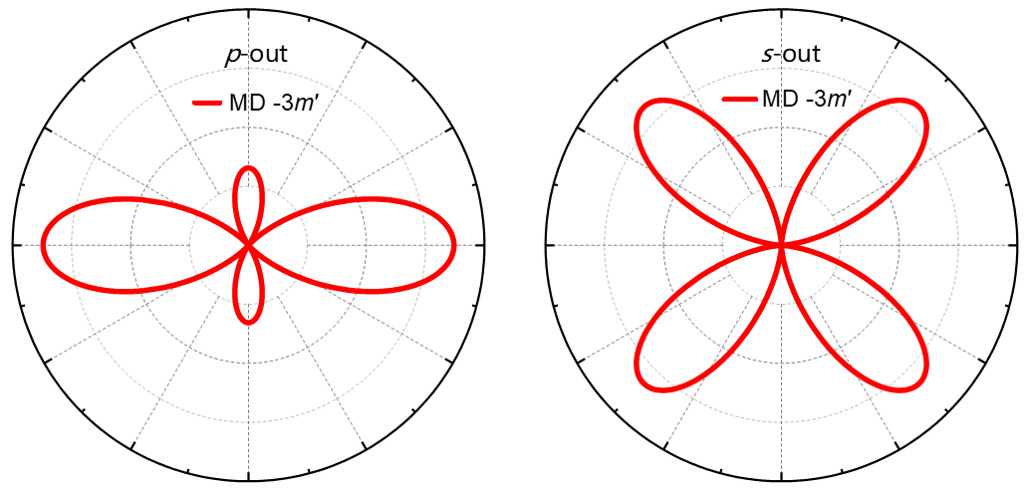
Fig. S2: Simulation of polarization anisotropic SHG pattern of MD contribution (red) under $\overline{3}$m′ point group. The polarization anisotropic SHG pattern of MD contribution shows the peak intensity under different values ​​of incident light polarization angle φ.

Section S4 Temperature dependence of the surface ED-SHG in YSZ substrates
Fig. S3: Temperature dependence of the surface ED-SHG in YSZ substrates.
The surface ED-SHG signal of the YSZ substrate is basically linear in the temperature range of 100 K to 650 K. This result is in sharp contrast to the temperature dependence of EQ-SHG of Eu₂Ir₂O₇ thin films, indicating that the abrupt change of SHG signal caused by the magnetic phase change in Eu₂Ir₂O₇ has nothing to do with the YSZ substrate.

References
1. Witczak-Krempa W, Chen G, Kim YB, Balents L. Correlated Quantum Phenomena in the Strong Spin-Orbit Regime. Annual Review of Condensed Matter Physics 5, 57-82 (2014).
2. Birss RR. Symmetry and magnetism. North-Holland Publishing Company (1964).
3. Zhang Y, et al. Doping-Induced Second-Harmonic Generation in Centrosymmetric Graphene from Quadrupole Response. Phys. Rev. Lett. 122, 047401 (2019).
4. Xia H, et al. Nonlinear optical signatures of topological Dirac fermion. Science Advances 10, eadp0575 (2024).
5. Ahn Y, et al. Electric quadrupole second-harmonic generation revealing dual magnetic orders in a magnetic Weyl semimetal. Nature Photonics 18, 26-31 (2024).
6. Torchinsky DH, et al. Structural Distortion-Induced Magnetoelastic Locking in Sr₂IrO₄ Revealed through Nonlinear Optical Harmonic Generation. Phys. Rev. Lett. 114, 096404 (2015).

