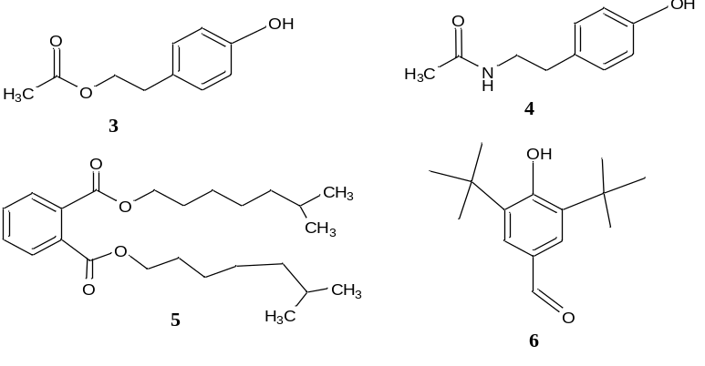
Scheme 1 The chemical structure of major compounds identified in maize leaf fungal extract
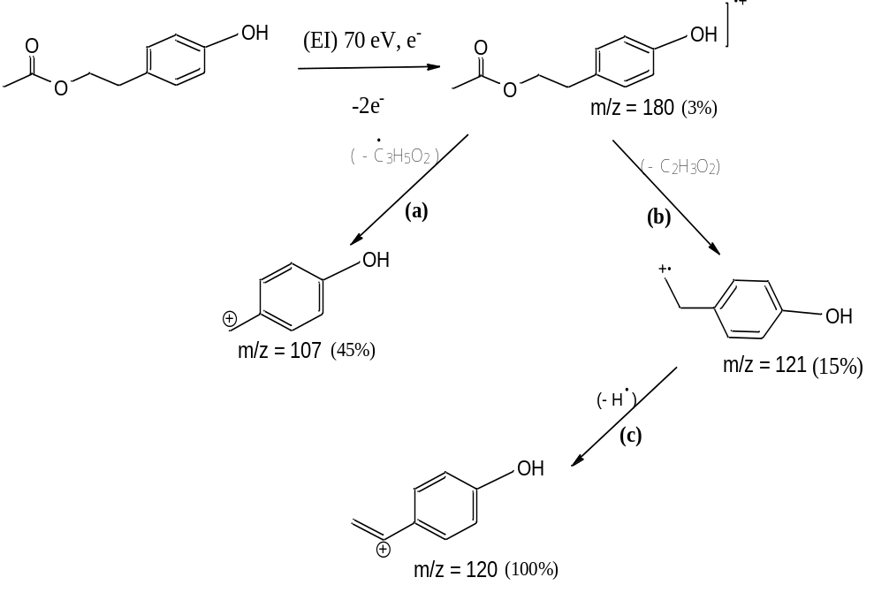
Scheme 2 Fragmentation pathway suggested for Tyrosol acetate
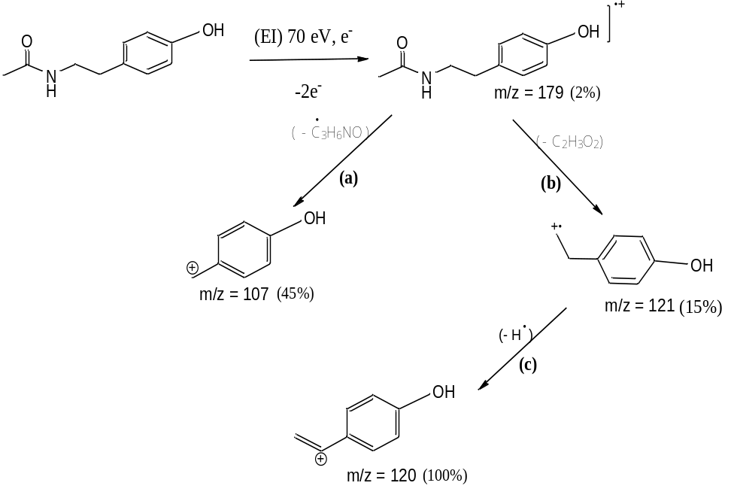
Scheme 3. Fragmentation pathway suggested for N-Acetyltyramine,
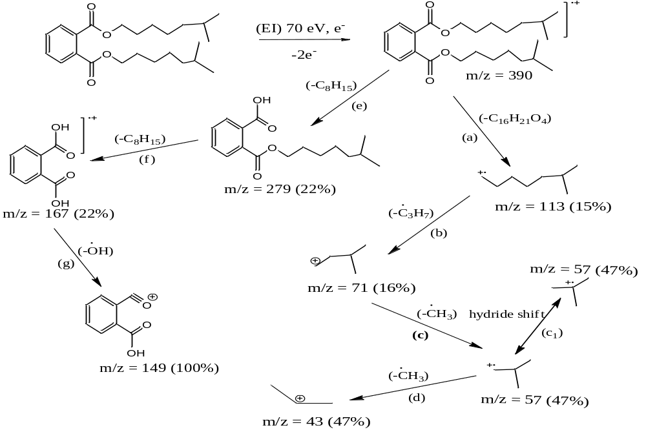
Scheme 4. Fragmentation pathway suggested for Diisooctyl phthalate

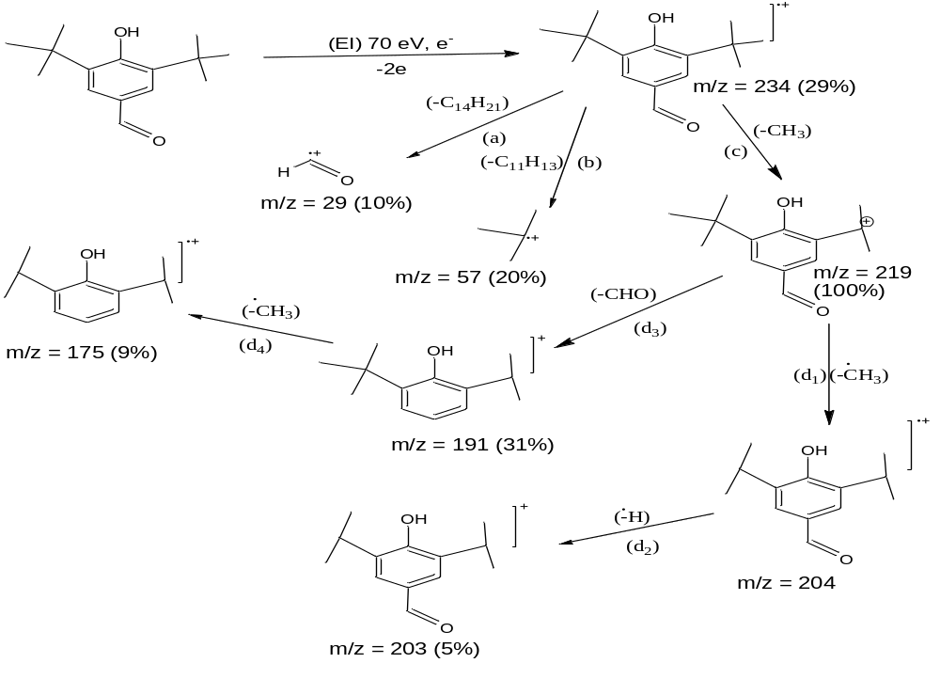
Scheme 5. Fragmentation pathway suggested for 3,5-Di-tert-butyl-4-hydroxybenzaldehyde

