Supplementary Figures

Pluripotent stem cell–derived extracellular vesicles for systemic immune modulation in diabetes therapy

Jana Zarubova^{1,2}, Mohammad Mahdi Hasani-Sadrabadi^{1,}^, Yutong Wu¹, Graciel Diamante³, Jenny Cheng^{3,4}, Xiao Han¹, Fatemeh Sadat Majedi^{1,}^, Li Yang^{5,#}, Olivia Wang⁶, In sook Ahn³, Jianyi Zhang⁷, Xiaojun Lance Lian⁸, Zhen Gu¹, Manish J. Butte^{9,10}, Reza Ardehali¹¹, Peter C Butler¹², Tony Ye Hu⁵, Louis-S. Bouchard^{1,6}, Xia Yang^{3,4,13}, Song Li^{1,14,15,16}*

¹ Department of Bioengineering, University of California Los Angeles, Los Angeles, CA 90095, USA.
² Department of Biomaterials and Tissue Engineering, Institute of Physiology of the Czech Academy of Sciences, Prague, 14220, Czech Republic.
³ Department of Integrative Biology and Physiology, University of California, Los Angeles, Los Angeles, CA, USA.
⁴ Molecular, Cellular, and Integrative Physiology Interdepartmental Program, University of California, Los Angeles, Los Angeles, CA, USA.
⁵ Department of Biochemistry and Molecular Biology, School of Medicine, Tulane University, New Orleans, LA 70112, USA.
⁶ Department of Chemistry and Biochemistry, University of California, Los Angeles, Los Angeles, CA 90095, USA.
⁷ Department of Biomedical Engineering, University of Alabama at Birmingham, Birmingham, AL, 35294-0019, USA
⁸ Department of Biomedical Engineering and Biology, Huck Institutes of the Life Sciences, Pennsylvania State University, PA, 16801, USA
⁹ Department of Pediatrics, Division of Immunology, Allergy, and Rheumatology, University of California Los Angeles, Los Angeles, CA 90095, USA.
¹⁰ Department of Microbiology, Immunology, and Molecular Genetics, University of California Los Angeles, Los Angeles, CA 90095, USA.
¹¹ Division of Cardiology, Department of Internal Medicine, David Geffen School of Medicine, University of California, Los Angeles, CA 90095, USA.
¹² Larry L. Hillblom Islet Research Center, David Geffen School of Medicine at UCLA, Los Angeles, CA 90089, USA.
¹³ Department of Molecular and Medical Pharmacology, University of California, Los Angeles, Los Angeles, CA, USA
¹⁴ Department of Medicine, University of California, Los Angeles, Los Angeles, CA, USA
¹⁵ Eli and Edythe Broad Center of Regenerative Medicine and Stem Cell Research, University of California, Los Angeles, Los Angeles, CA, USA.
¹⁶ Jonsson Comprehensive Cancer Center, David Geffen School of Medicine, University of California, Los Angeles, Los Angeles, CA, USA.
^ Current address: Sibley School of Mechanical and Aerospace Engineering, Cornell University, Ithaca, NY, 14853, USA
# Current address: Clinical Laboratory Medicine Research Center, West China Hospital, Sichuan University, Chengdu, 610041, China
* Corresponding author: songli@ucla.edu

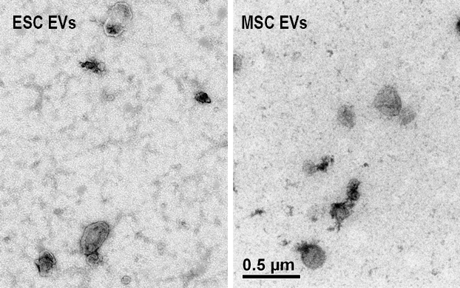

Supplementary Fig. 1. TEM images of EVs derived from embryonic stem cells (ESCs) (left) and mesenchymal stem cells (MSCs) (right). Both ESC- and MSC-derived EVs exhibit the typical cup-shaped morphology characteristic of EVs observed by TEM with uranyl acetate negative staining. Scale bar: 0.5 µm.

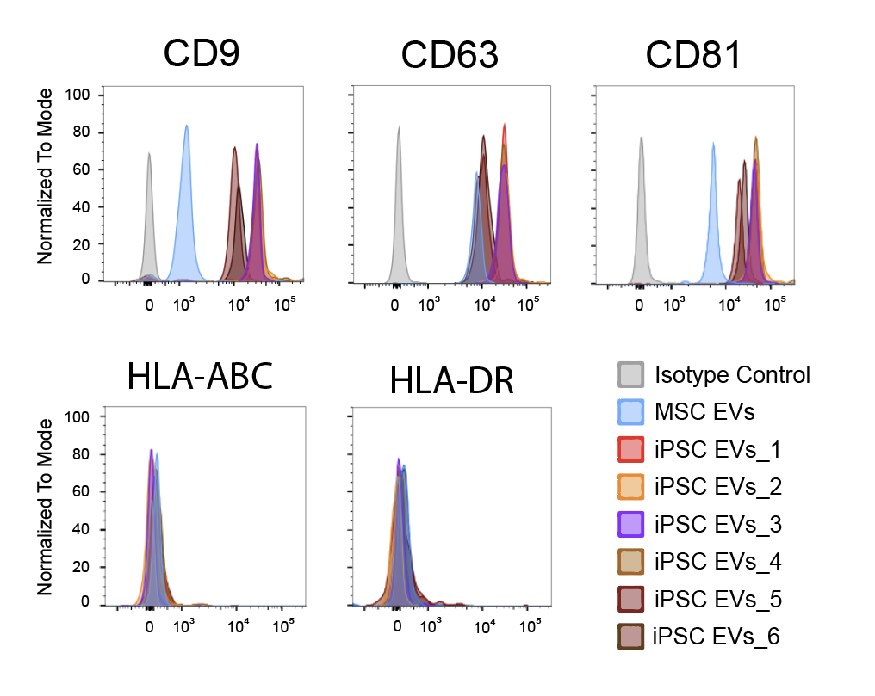
Supplementary Fig. 2. Flow cytometry analysis of EV surface markers and immunogenicity markers in multiple iPSC lines. Classical EV markers CD9, CD63, and CD81 were detected on MSC EVs (blue) and EVs from 6 iPSC lines: 1, red (iPS DF6-9-9T.B); 2, orange (HLA-I/II–knockout iPSC line); 3, purple (NH50191 iPSCs); 4, light brown (hiPSC 2); 5, dark red (hiPSC 23); and 6, dark brown (BSCRC 23F1i3), confirming the presence of these characteristic markers. Immunogenicity markers HLA-ABC and HLA-DR (MHC class I and II molecules, respectively) were minimally expressed on EVs from all tested iPSC lines, indicating a low immunogenic profile. Isotype controls are shown in gray.

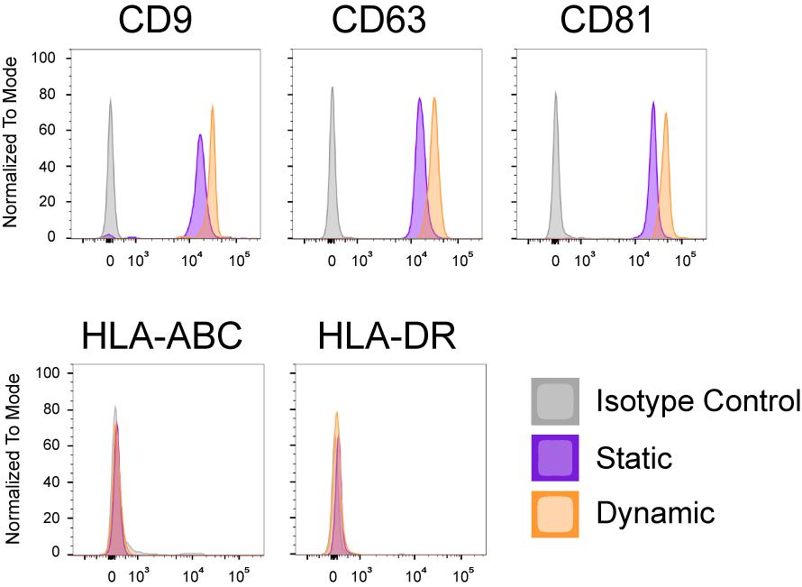

Supplementary Fig. 3. Similar expression of EV markers (CD9, CD63, and CD81) and minimal expression of immunogenicity markers (HLA-ABC and HLA-DR) in EVs derived from iPSCs cultured under static or dynamic conditions. Isotype controls are shown in gray, with static conditions represented by purple and dynamic conditions, orange.

Supplementary Table 1. List of lipid signals identified by NMR spectroscopy, including their corresponding meanings, and approximate chemical shifts in parts per million (ppm). Lipid assignments were based on published studies ^{1, 2, 3, 4} and the Human Metabolome Database ⁵. Identified lipids include total cholesterol (TChol), free cholesterol (FChol), various fatty acids (FA, ω3, MUFA, PUFA), phospholipids (PL, PC, PE), and sphingomyelin (SM), among others.

Label | Meaning | Approx ppm
TChol | Total cholesterol | 0.63
FA | Fatty acid terminal | 0.85
ω3 | Omega-3 FA | 0.95
FChol | Free cholesterol | 1.09
CH2 | Fatty acid chain | 1.20
CH2 C4+ | Fatty acid chain C4+ | 1.30
MUFA | Monounsaturated FA | 2.01
Linoleic | Linoleic acid | 2.02
PUFA | Polyunsaturated FA | 2.90
SM | Sphingomyelin | 3.19
Glyc | Glycerol | 3.5-3.8
PE | Phosphatidylethanolamine | 3.64
PC | Phosphatidylcholine | 3.66
PL | Phospholipid | 3.70

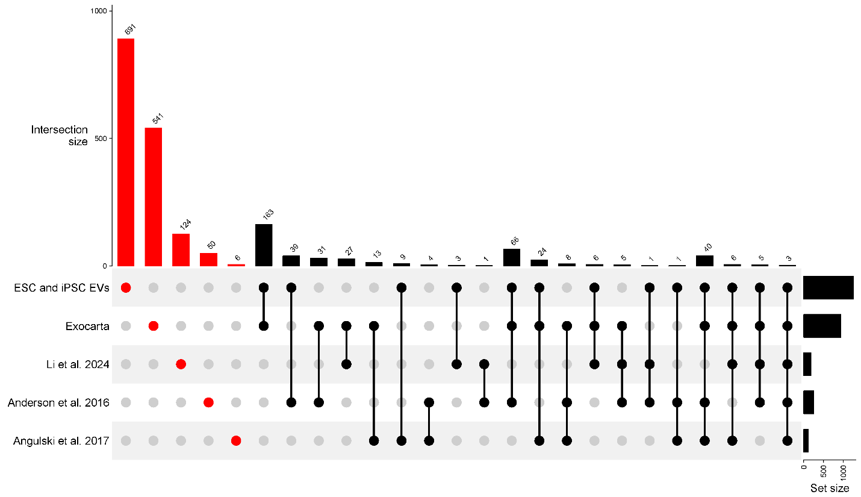
Supplementary Fig. 4. Upset plot illustrating the intersection of protein components from iPSC- and ESC-derived EVs, previously published MSC-EV datasets (three bottom rows) ^{6, 7, 8}, and the MSC EV proteins sourced from the ExoCarta database ⁹. The largest intersection (red bars) represents 891 proteins uniquely found in ESC/iPSC EVs, followed by 366 proteins shared between ESC/iPSC EVs and MSC EVs from ExoCarta database. Black bars indicate intersections among MSC-EV datasets or those excluding ESC/iPSC EVs. Each dot and connecting line beneath the bars denote dataset participation in an intersection, with filled dots indicating presence. The right-side bars display the total protein count per dataset, emphasizing both unique and shared EV protein profiles across sources.

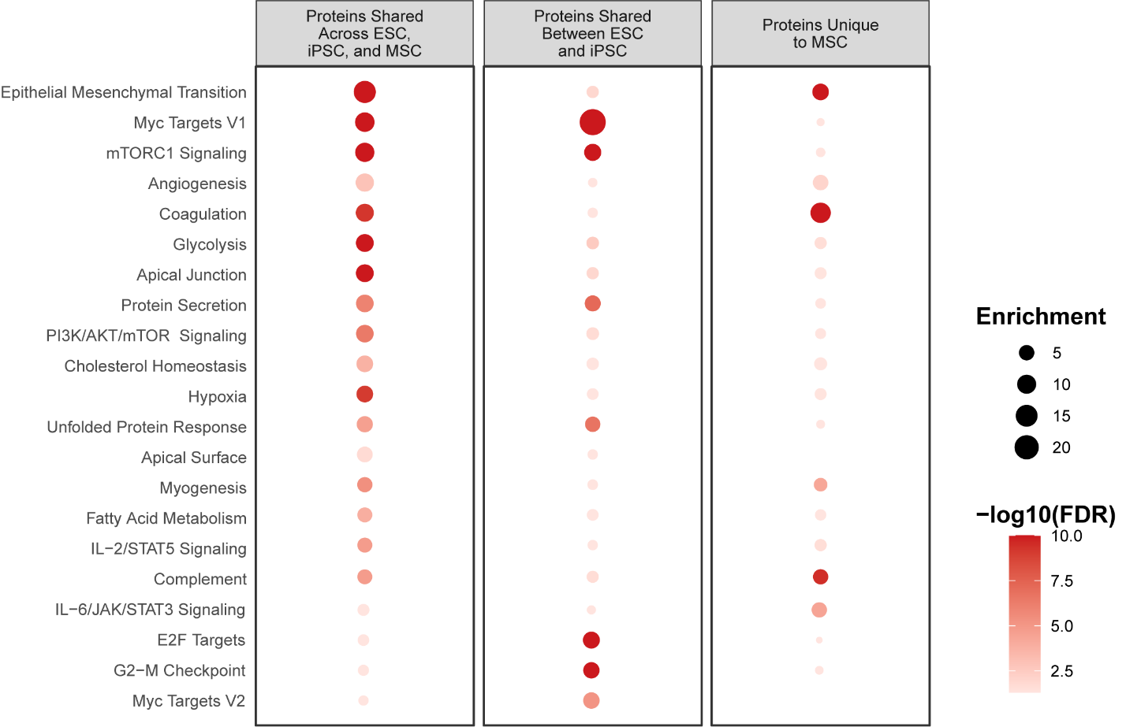

Supplementary Fig. 5. Pathway enrichment analysis of proteins in ESC, iPSC, and MSC EVs.
Proteins shared across all EV types (ESC, iPSC, and MSC) were enriched in pathways related to tissue remodeling, metabolism, and stress adaptation, including epithelial-mesenchymal transition (EMT), MYC targets, mTORC1 signaling, angiogenesis, glycolysis, and IL-2/STAT5 signaling. Proteins uniquely shared between ESC and iPSC EVs were enriched in biosynthetically active and proliferative pathways such as MYC and E2F targets, mTORC1 signaling, and the G2–M checkpoint. In contrast, proteins unique to MSC EVs were enriched in pathways associated with coagulation, IL-6/JAK/STAT3 signaling, complement, EMT, and angiogenesis—reflecting their stromal and regenerative origin. Dot size represents the number of overlapping proteins; color intensity indicates the adjusted –log₁₀(p-value).

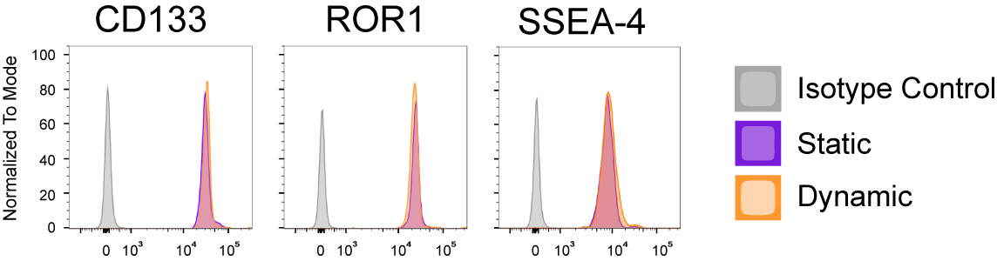

Supplementary Fig. 6. Comparison of surface marker expression (CD133, ROR1, and SSEA-4) on iPSC-derived EVs produced under static or dynamic culture conditions. No significant differences in the expression of these markers were observed between the 2 conditions, confirming that the dynamic culture process preserves the characteristic surface marker profiles of iPSC-derived EVs. Isotype controls are shown in gray; static conditions, in purple; and dynamic conditions, in orange.

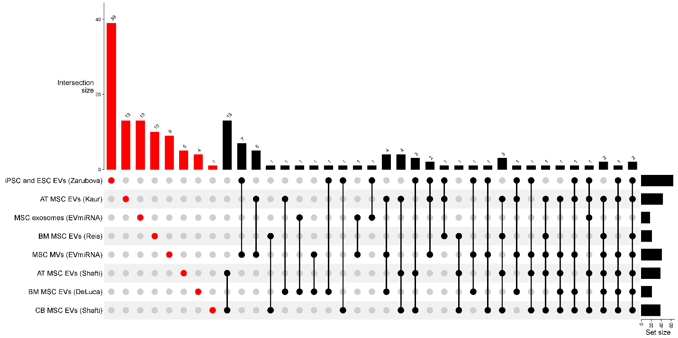

Supplementary Fig. 7. Upset plot comparing the miRNA profiles of iPSC- and ESC-derived EVs from this study with miRNA profiles of MSC EVs from 5 different sources ^{10, 11, 12, 13, 14}. The largest intersection represents miRNAs uniquely present in iPSC- and ESC-derived EVs, highlighting distinct miRNA signatures in these pluripotent stem cell–derived EVs compared to those of MSC EVs. Smaller intersections indicate shared miRNAs across EV types and datasets.

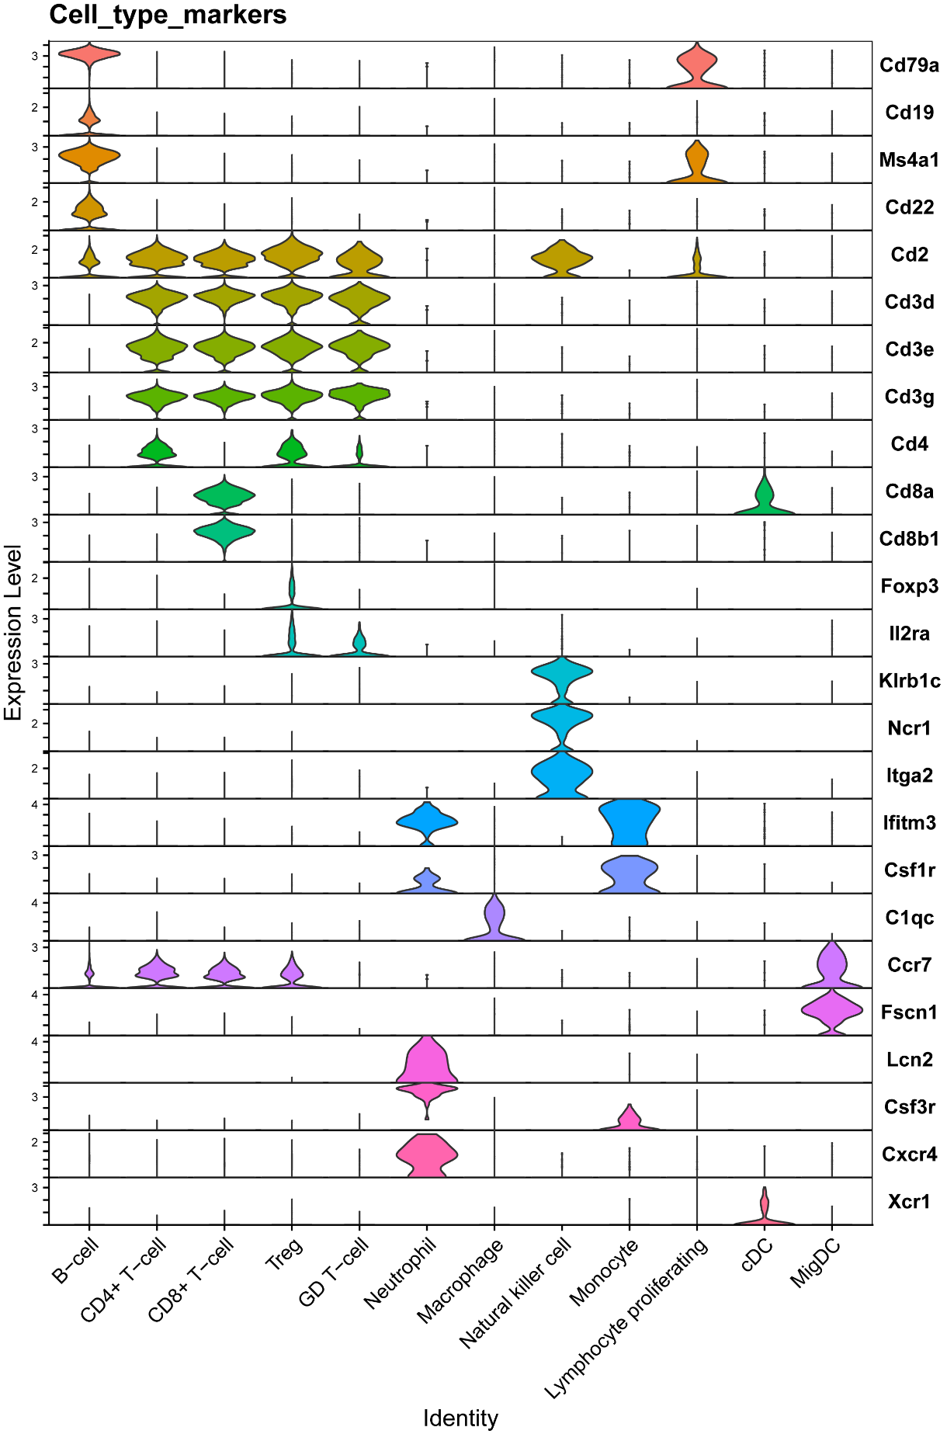
Supplementary Fig. 8. Identification of immune cell populations in mouse draining lymph nodes based on cell-type-specific markers. Violin plots showing expression levels of key cell type–specific markers across identified immune cell populations, confirming the classification of cell types within the lymph node.

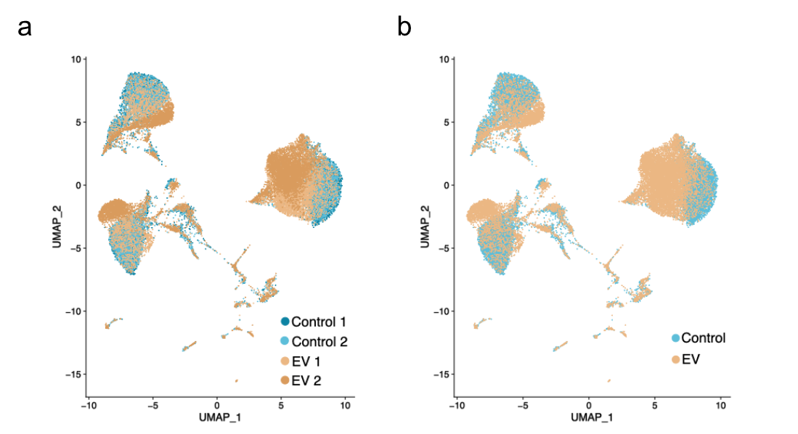

Supplementary Fig. 9. UMAP visualization of immune cells isolated from mouse draining lymph nodes following iPSC EV treatment. (a) UMAP embeddings of cell clusters colored by sample. (b) UMAP embeddings of cell clusters colored by treatment group. UMAP visualization of single-cell transcriptomic data comparing control (blue) and EV-treated (brown) samples. The plot reveals shifts in gene expression profiles across different cell populations, indicating that EV treatment induces distinct transcriptional changes.

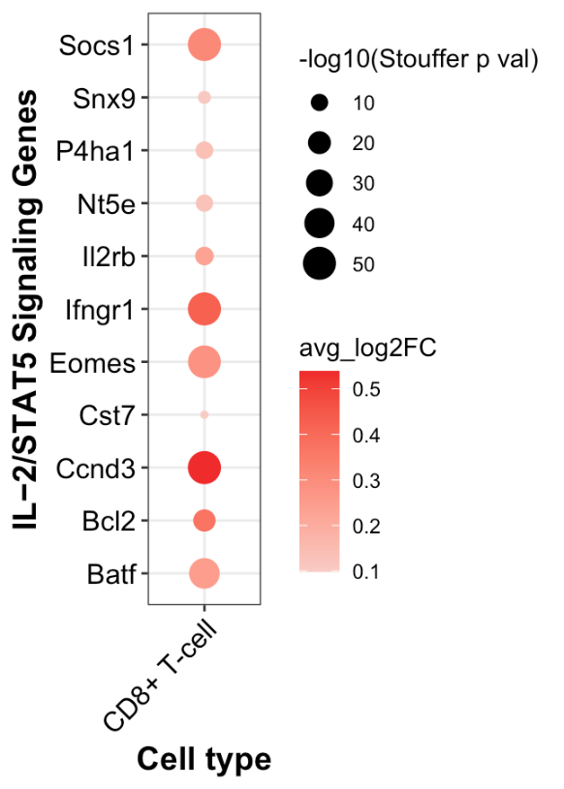

Supplementary Fig. 10. Selective upregulation of IL-2/STAT5-associated genes in CD8+ T cells following iPSC EV treatment. Dot plot showing significantly upregulated genes within the IL-2/STAT5 signaling pathway in CD8+ T cells from draining lymph nodes 5 days after iPSC EV injection. Dot size reflects the –log10 Stouffer-adjusted p-value, and color intensity represents the average log2 fold change (avg_log2FC).

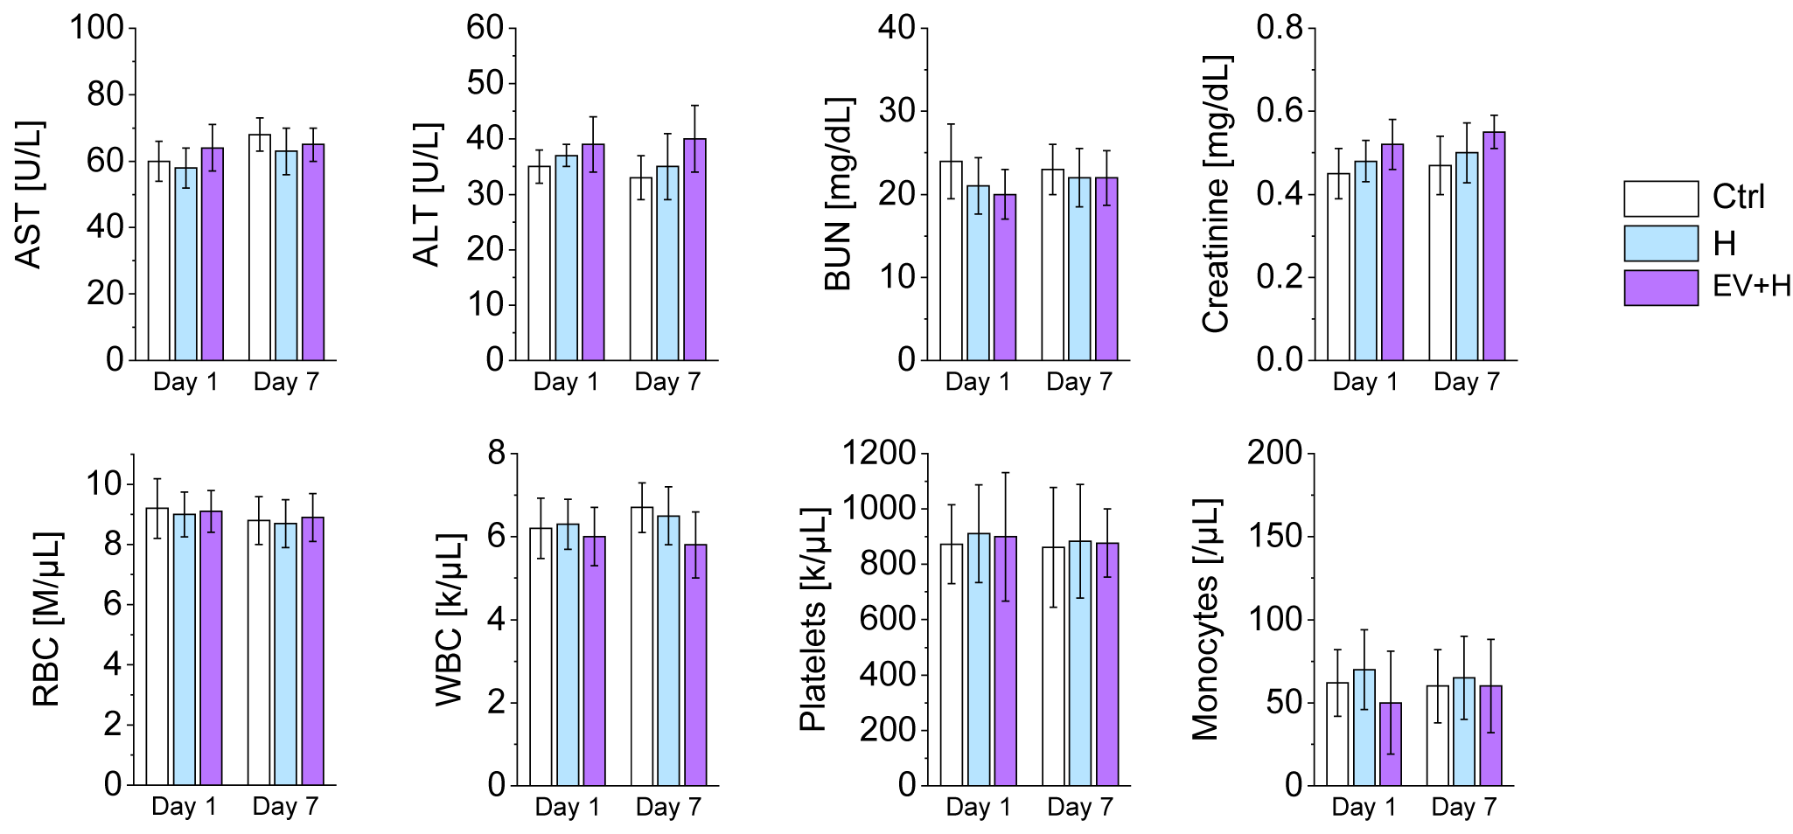

Supplementary Fig. 11. Hematological and clinical chemistry parameters evaluated in control (Ctrl), hydrogel only (H), and iPSC EV–loaded hydrogel (EV+H) groups at day 1 and day 7 post-injection. Liver function markers (AST, ALT), kidney function markers (BUN, creatinine), and hematological parameters (RBC, WBC, platelets, and monocytes) were measured. No significant differences were observed between the groups across time points, indicating no signs of systemic toxicity induced by the hydrogel or iPSC EV–loaded hydrogel treatment. Bars show means and SDs.

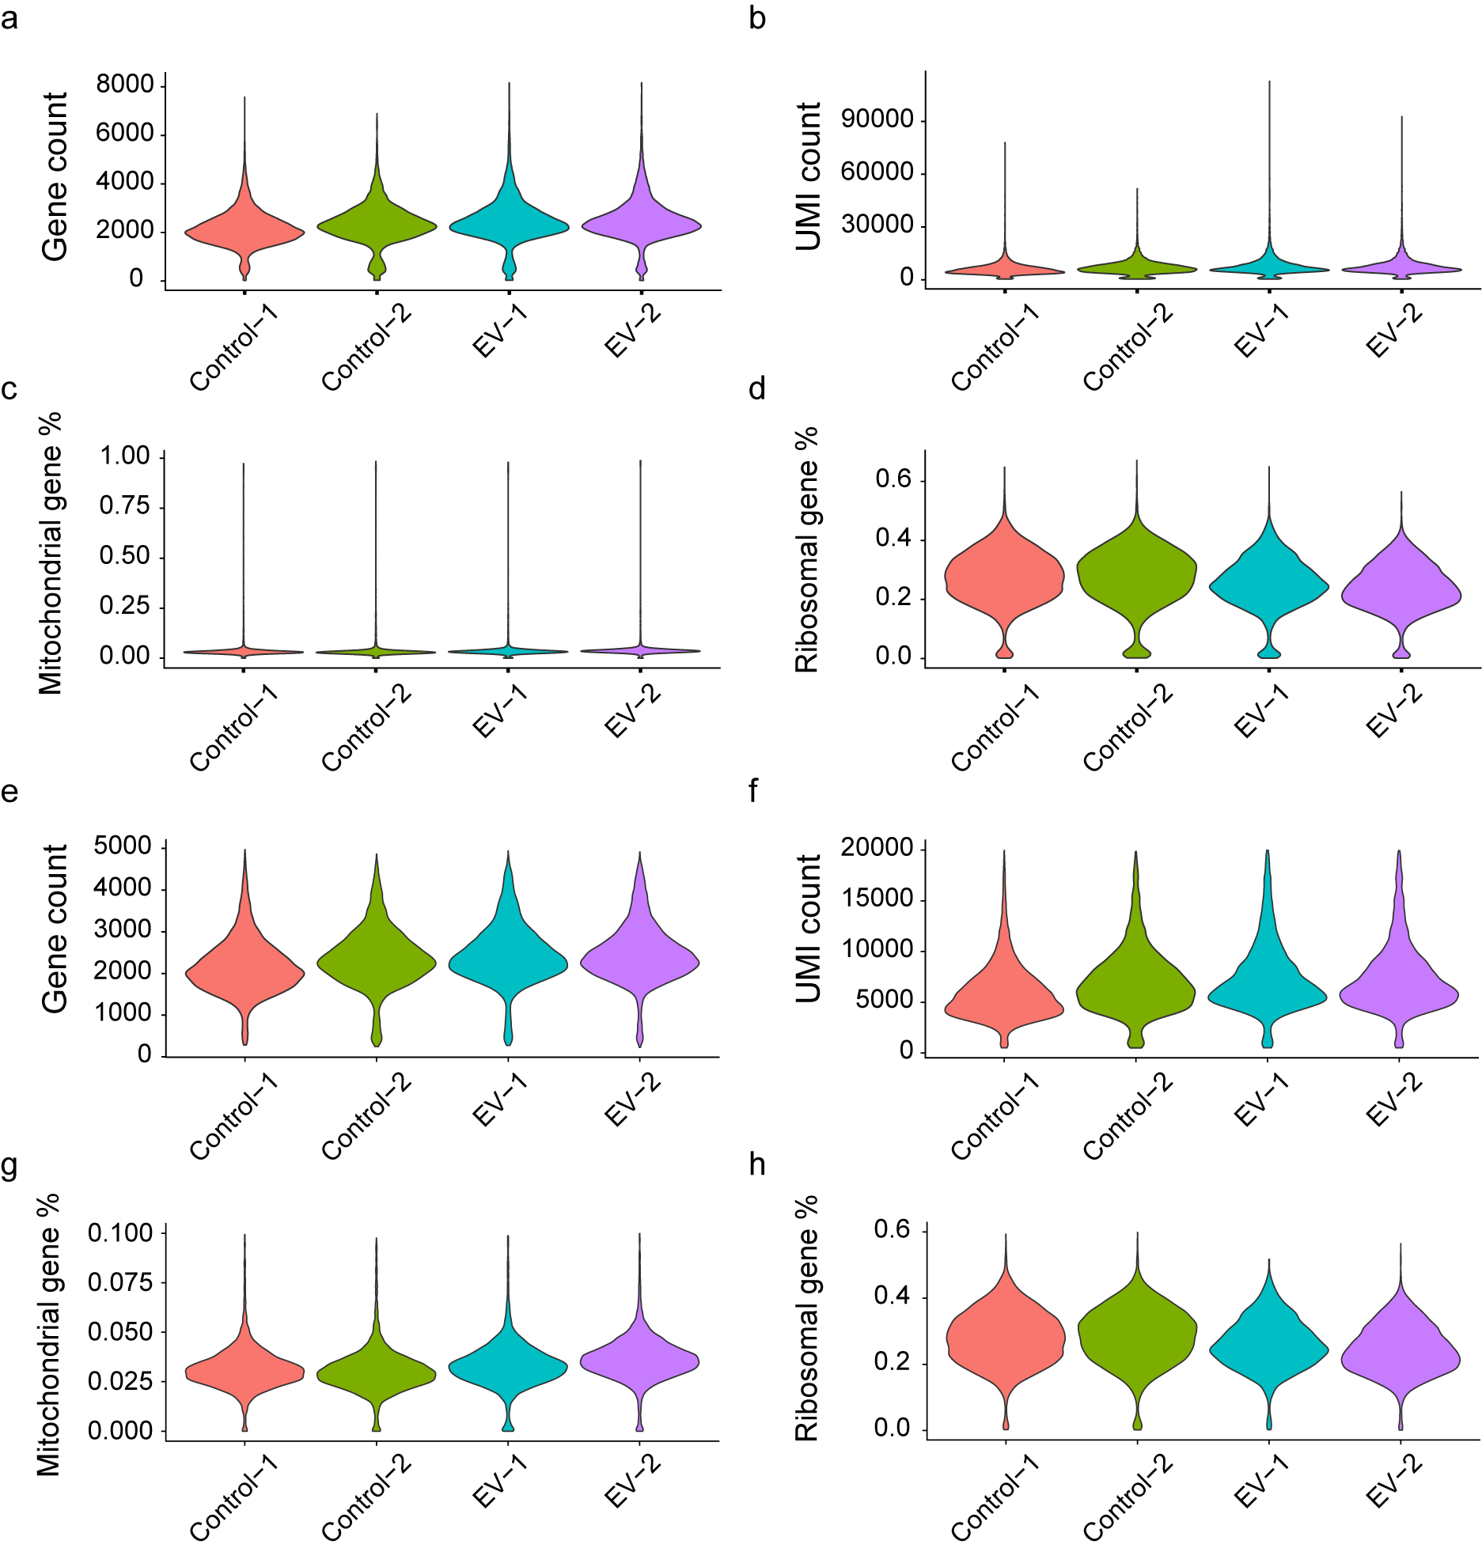
Supplementary Fig. 12. Single-cell library quality control (QC) features. (a–d) Violin plots showing the distribution of (a) the number of unique genes, (b) total unique molecular identifier (UMI) count, (c) the percentage of mitochondrial genes, and (d) the percentage of ribosomal genes detected per single cell in each sample before quality control filtering. (e–h) Violin plots showing the distribution of (e) the number of unique genes, (f) total UMI count, (g) the percentage of mitochondrial genes, and (h) the percentage of ribosomal genes detected per single cell in each sample after quality control filtering.

References
1. Zhu Q, Huang Y, Yang Q, Liu F. Recent technical advances to study metabolomics of extracellular vesicles. Microchemical Journal 2021, 171: 106816.

2. Pocsfalvi G, Stanly C, Vilasi A, Fiume I, Capasso G, Turiák L, et al. Mass spectrometry of extracellular vesicles. Mass Spectrometry Reviews 2016, 35(1): 3-21.

3. Palomo L, Casal E, Royo F, Cabrera D, van-Liempd S, Falcon-Perez JM. Considerations for Applying Metabolomics to the Analysis of Extracellular Vesicles. Frontiers in Immunology 2014, 5.

4. Lindon JC, Nicholson JK, Holmes E, Everett JR. Metabonomics: Metabolic processes studied by NMR spectroscopy of biofluids. Concepts in Magnetic Resonance 2000, 12(5): 289-320.

5. Wishart DS, Guo A, Oler E, Wang F, Anjum A, Peters H, et al. HMDB 5.0: the Human Metabolome Database for 2022. Nucleic acids research 2022, 50(D1): D622-d631.

6. Li S, Zhang J, Liu X, Wang N, Sun L, Liu J, et al. Proteomic characterization of hUC-MSC extracellular vesicles and evaluation of its therapeutic potential to treat Alzheimer’s disease. Scientific Reports 2024, 14(1): 5959.

7. Angulski AB, Capriglione LG, Batista M, Marcon BH, Senegaglia AC, Stimamiglio MA, et al. The Protein Content of Extracellular Vesicles Derived from Expanded Human Umbilical Cord Blood-Derived CD133(+) and Human Bone Marrow-Derived Mesenchymal Stem Cells Partially Explains Why both Sources are Advantageous for Regenerative Medicine. Stem cell reviews and reports 2017, 13(2): 244-257.

8. Anderson JD, Johansson HJ, Graham CS, Vesterlund M, Pham MT, Bramlett CS, et al. Comprehensive Proteomic Analysis of Mesenchymal Stem Cell Exosomes Reveals Modulation of Angiogenesis via Nuclear Factor-KappaB Signaling. Stem Cells 2016, 34(3): 601-613.

9. Mathivanan S, Simpson RJ. ExoCarta: A compendium of exosomal proteins and RNA. Proteomics 2009, 9(21): 4997-5000.

10. Reis M, Mavin E, Nicholson L, Green K, Dickinson AM, Wang XN. Mesenchymal Stromal Cell-Derived Extracellular Vesicles Attenuate Dendritic Cell Maturation and Function. Front Immunol 2018, 9: 2538.

11. De Luca L, Trino S, Laurenzana I, Simeon V, Calice G, Raimondo S, et al. MiRNAs and piRNAs from bone marrow mesenchymal stem cell extracellular vesicles induce cell survival and inhibit cell differentiation of cord blood hematopoietic stem cells: a new insight in transplantation. Oncotarget 2016, 7(6): 6676-6692.

12. Kaur S, Abu-Shahba AG, Paananen RO, Hongisto H, Hiidenmaa H, Skottman H, et al. Small non-coding RNA landscape of extracellular vesicles from human stem cells. Scientific Reports 2018, 8(1): 15503.

13. Nazari-Shafti TZ, Neuber S, Duran AG, Exarchos V, Beez CM, Meyborg H, et al. MiRNA Profiles of Extracellular Vesicles Secreted by Mesenchymal Stromal Cells-Can They Predict Potential Off-Target Effects? Biomolecules 2020, 10(9).

14. Liu T, Zhang Q, Zhang J, Li C, Miao YR, Lei Q, et al. EVmiRNA: a database of miRNA profiling in extracellular vesicles. Nucleic acids research 2019, 47(D1): D89-d93.

