Supplement

Section S1: Latent Dirichlet Allocation (LDA)
Latent Dirichlet Allocation (LDA) is a probabilistic clustering algorithm that identifies topics in a text corpus by modeling word co-occurrence patterns^{31,32}. Unlike predefined dictionaries, LDA infers topics directly from the data, allowing it to capture latent semantic structures. Each word is assigned probabilistically to one or more topics, iterating until an optimal balance between word distributions is reached. This process generates posterior probability distributions that estimate the likelihood of words appearing in specific topics, enabling LDA to account for contextual meanings and reduce word sense ambiguity.
To improve topic coherence and capture meaningful linguistic patterns, we applied LDA to one- to three-word phrases rather than individual words, ensuring that multi-word expressions (e.g., "summer camp") were treated as single units. We implemented LDA separately for nomothetic and idiographic analyses. The nomothetic model extracted a uniform set of topics across all participants, while the idiographic model identified personalized topics for each individual.
For topic extraction, we used the R package topicmodels (Grün & Hornik, 2011) and performed algorithmic tuning to determine the optimal number of topics (k) using ldatuning. The tuning process involved evaluating multiple model fit metrics, including Griffiths2004 (Griffiths et al., 2004), CaoJuan2009 (Cao et al., 2009), and Arun2010 (Arun et al., 2010). These metrics provide different optimization criteria: Griffiths2004 favors maximizing coherence, whereas CaoJuan2009 and Arun2010 minimize redundancy and overfitting. Additionally, we considered the Deveaud2014 reference point, which decreases linearly with the number of topics. Based on these criteria, we selected six topics as an optimal balance, as illustrated in Fig. S1.

Section S2: Prompt GPT
""" Evaluate the extent to which the participant experienced each of the following emotions: sadness, anger, nervousness, happiness, excitement, interest, boredom, general ratings of positive affect (pa), and general ratings of negative affect (na) based on their responses to three questions.

When evaluating emotions, consider the context of each question. For example, if a participant responds with "none" to the question about a stressful event, this may indicate lower negative emotions, whereas responding with "none" to a question about an enjoyable event may indicate lower positive emotions.

Provide ratings on a scale of 1 to 5 for each emotion and for the general scales, along with a confidence level from 0 to 100 for each rating. Ensure that the output includes the "time" variable from the input. Answer only with ratings and confidence levels; do not include explanations.

Parameters:

participant_id (str): The unique identifier for the participant.
time (str): The time point when the responses were recorded.
thought (str): The participant's response to what they were thinking just before.
stresstext (str): The participant's response to the most stressful event in the last few hours.
enjoytext (str): The participant's response to the most enjoyable event in the last few hours.
Returns:

dict: A dictionary containing the participant's ID, time, their responses, emotion ratings, and confidence levels.
Example:

Input:
participant_id = "K23101"
time = "5"
thought = "College applications"
stresstext = "Getting ditched by a friend"
enjoytext = "Hanging out with my friends at lunch"

Output:
{
'id': "K23101",
'time': "5",
'thought': "College applications",
'stresstext': "Getting ditched by a friend",
'enjoytext': "Hanging out with my friends at lunch",
'ratings': {
'Sad': 2,
'Nervous': 1,
'Angry': 2,
'na': 1.67
},
'confidence': {
'Sad': 90,
'Nervous': 70,
'Angry': 75,
}
} """

Section S3: Nested CV procedure
This method consists of two levels of cross-validation: 1. Outer loop: Evaluates the overall performance of the model by repeatedly training and testing on different subsets of the data. 2. Inner loop: Conducts model selection and hyperparameter tuning to optimize performance. We used 10-fold cross-validation in both the inner and outer loops. In the outer loop, the dataset was divided into ten folds. The model was trained on nine folds and tested on the remaining fold, with this process repeated ten times so that each fold served as the test set once. This iterative process ensures that performance metrics are evaluated across multiple train-test splits, providing a robust estimate of generalizability. Within the inner loop, models were trained on each training fold, and hyperparameter tuning was conducted by selecting the parameter combination that maximized performance on a validation set. The best-performing model was then applied to the corresponding outer loop test set. By separating hyperparameter optimization from performance evaluation, this approach prevents data leakage and mitigates the risk of overfitting. Nested cross-validation offers several advantages over a simple train-test split. It allows for efficient use of all available data for both training and validation while reducing the bias introduced by a single, potentially unrepresentative data split. Additionally, by incorporating multiple train-test iterations, this approach yields a more robust and reliable estimate of model performance, ensuring that the findings generalize beyond the specific dataset used in training.
After iterating through all outer folds, we aggregated the predictions from the left-out test sets and compared them against true values to compute overall predictive performance.

Section S4: Which Text Features Are Most Predictive in High- vs. Low-Performing Models?
Though feature importance varied across individuals, we also examined whether specific patterns emerged across high- and low-performing participant-specific models. Our goal was to determine if these patterns could reveal characteristics of participants for whom language is more or less predictive of emotional states. Participants were divided into groups based on model performance (R²), with the top 25% (n=25) classified as "High R2" and the bottom 25% (n=25) as "Low R2." Feature importance scores were analyzed separately for RF and ENR models. Importantly, participants with high- and low-performing models showed no significant difference in number of observations (RF: High_{mean} =72.84, Low_{mean}=60.64, t=1.69, p=0.09, CI=-2.31;26.71, ENR: High_{mean} =62.72, Low_{mean}=71.36, t=-1.26, p=0.21, CI=-22.38;5.10) or in mean negative affect (RF: High_{mean} =0.68, Low_{mean}=0.45, t=1.85, p=0.07, CI=-0.02;0.49, ENR: High_{mean} =0.77, Low_{mean}=0.65, t=0.72, p=0.47, CI=-0.20;0.43). For RF high and low performing models differed significantly in variability (RF: High_{mean} =0.61, Low_{mean}=0.40, t=3.26, p=0.002, CI=0.08;0.33), but not for ENR (High_{mean} =0.59, Low_{mean}=0.50, t=1.29, p=0.20, CI=-0.05;0.22).
As shown in Fig. S3, the top five most important variables for high-performing RF models (High R² group) included features from multiple approaches (LIWC, GPT, VADER, and LDA). Notably, three of the ten variables that differed the most between the High R² and Low R² groups were GPT-derived features (e.g., GPT ratings of negative affect, positive affect, and sadness) suggesting that GPT-based variables may have been particularly effective in enhancing model performance. In contrast, for high-performing ENR models, the most important predictive features were primarily from LIWC (e.g., Authentic, Analytic, Clout), with these variables also exhibiting the largest differences between high- and low-performing models. Interestingly, in high-performing ENR models, Authentic style (associated with perceived honesty and genuineness) contributed more to predictive accuracy, whereas in low-performing models, Analytic style (a metric of logical and formal thinking) played a more prominent role. This suggests that for participants with high-performing models, their emotions may have been more transparently reflected when they used authentic language. In contrast, participants with low-performing models may have expressed emotions through analytic language, which tends to be less transparent in conveying affective states.

Fig. S1. Estimation of the most preferable number of topics for LDA model

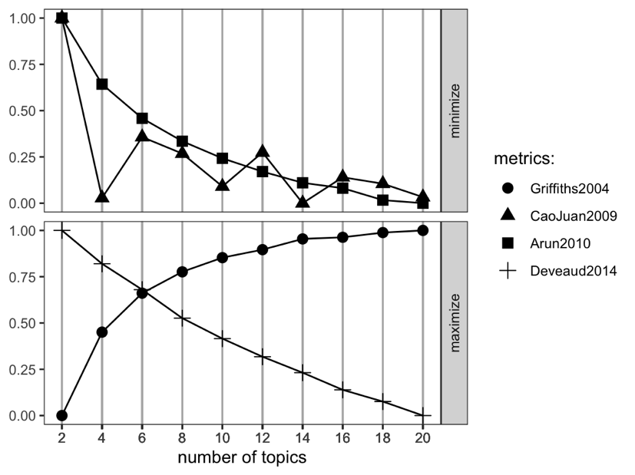
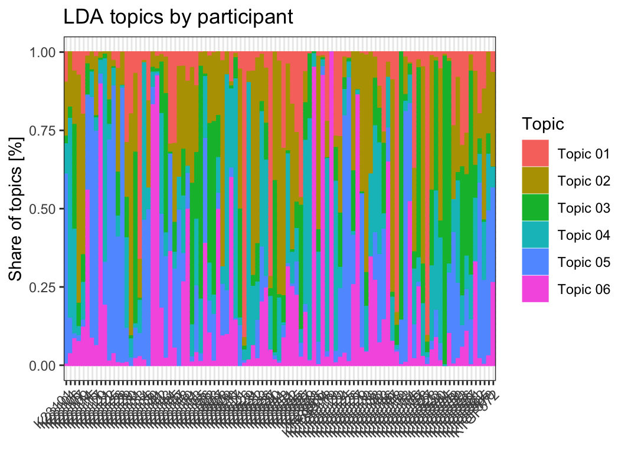
Participants
Fig. S2. Distribution of LDA-Derived Topics Across Participants

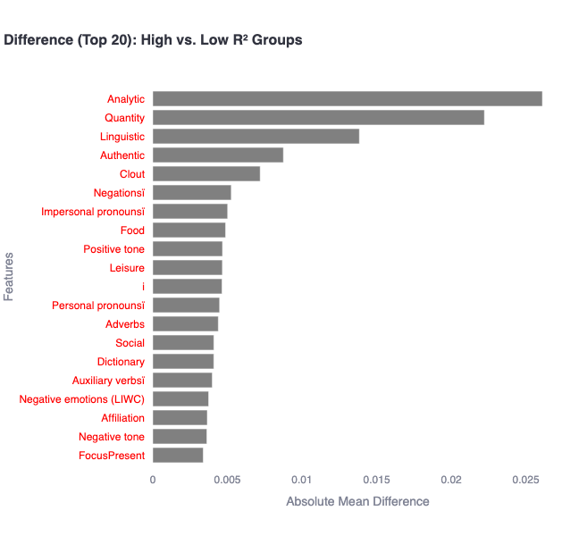
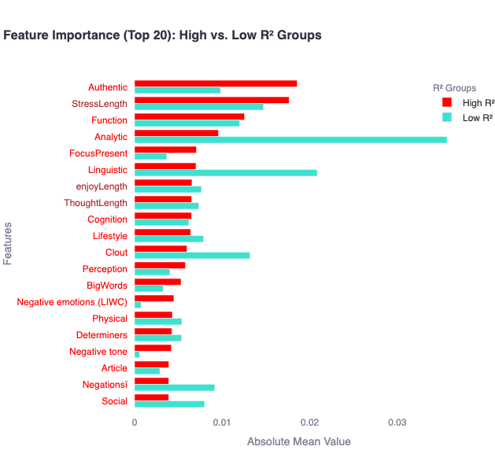
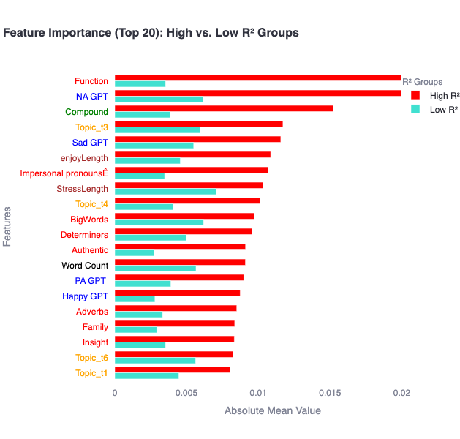
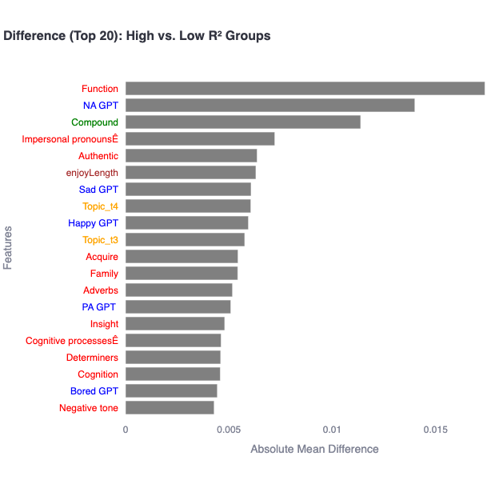
Random Forest
Elastic Net
Fig. S3. Group Differences in Feature Importance for Predicting Negative Affect Based on Predictive Performance (R²). The upper panels show results from the random forest (RF) model, and the lower panels show results from the elastic net regularization (ENR) model. The left panels present the absolute feature importance values calculated using SHAP, separately for each group (High vs. Low Predictive Performance).
The right panels display the differences in SHAP values between the two groups, calculated as:SHAP(High Predictive Performance) – SHAP(Low Predictive Performance).
Fig. S4. Box plots showing the distribution of R² values for matched and mismatched predictions across emotion outcomes (NA, Sad, Angry, Nervous) using Elastic Net model.

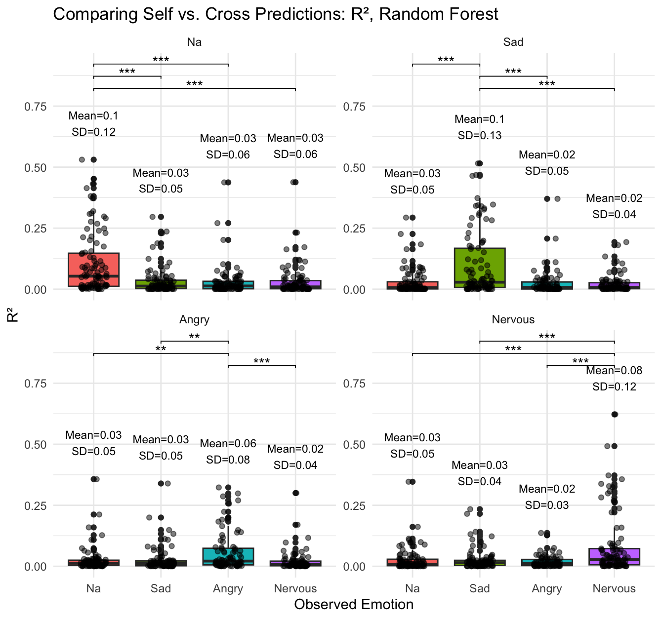
Negative affect

Fig. S5. Box plots showing the distribution of RMSE values for matched and mismatched predictions across emotion outcomes (NA, Sad, Angry, Nervous) using the Elastic Net model.

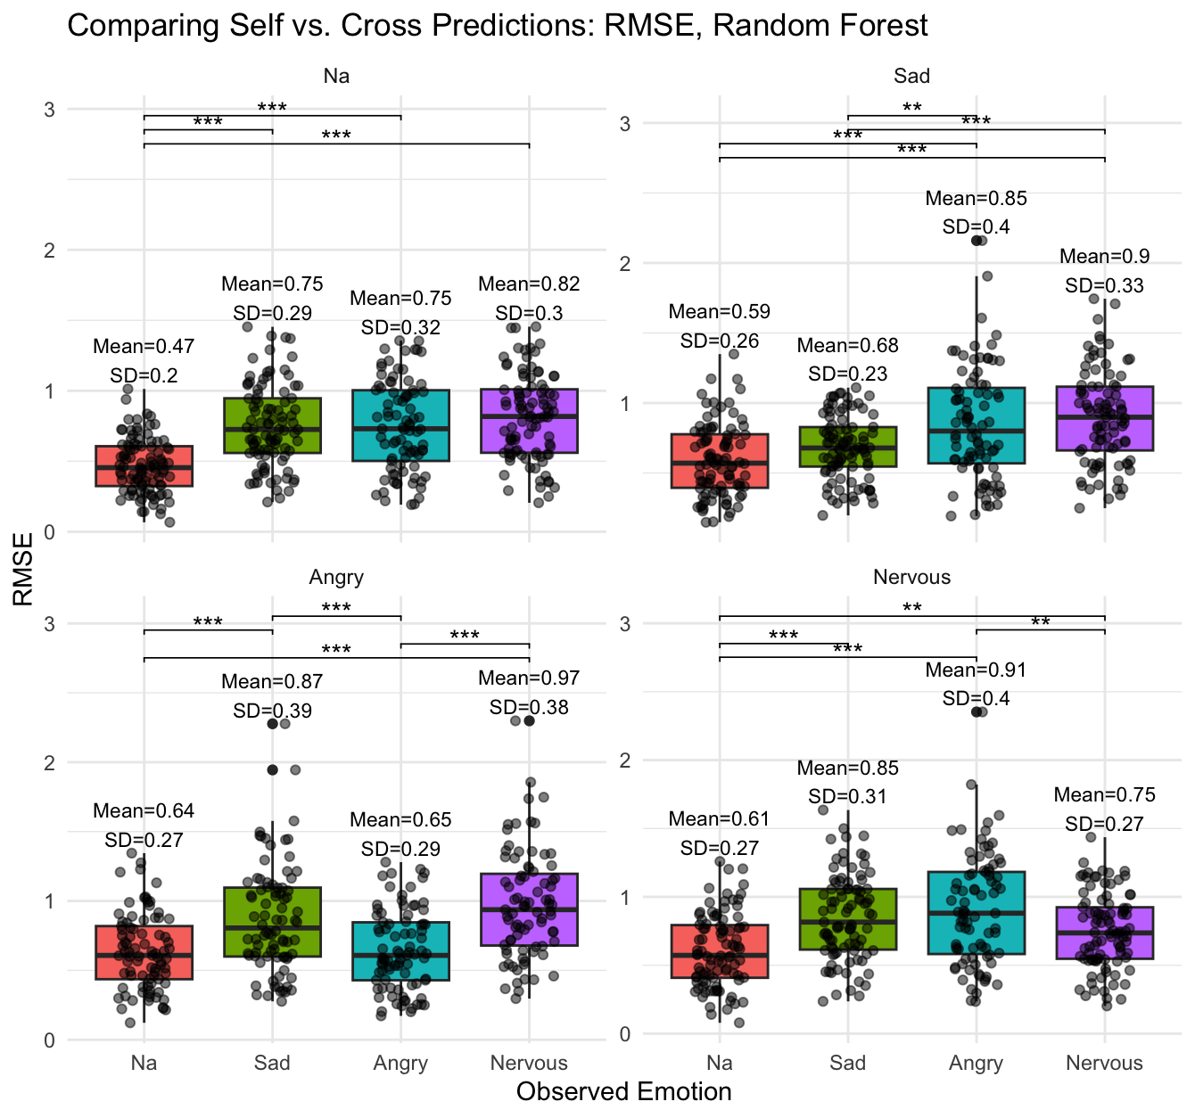
Negative affect
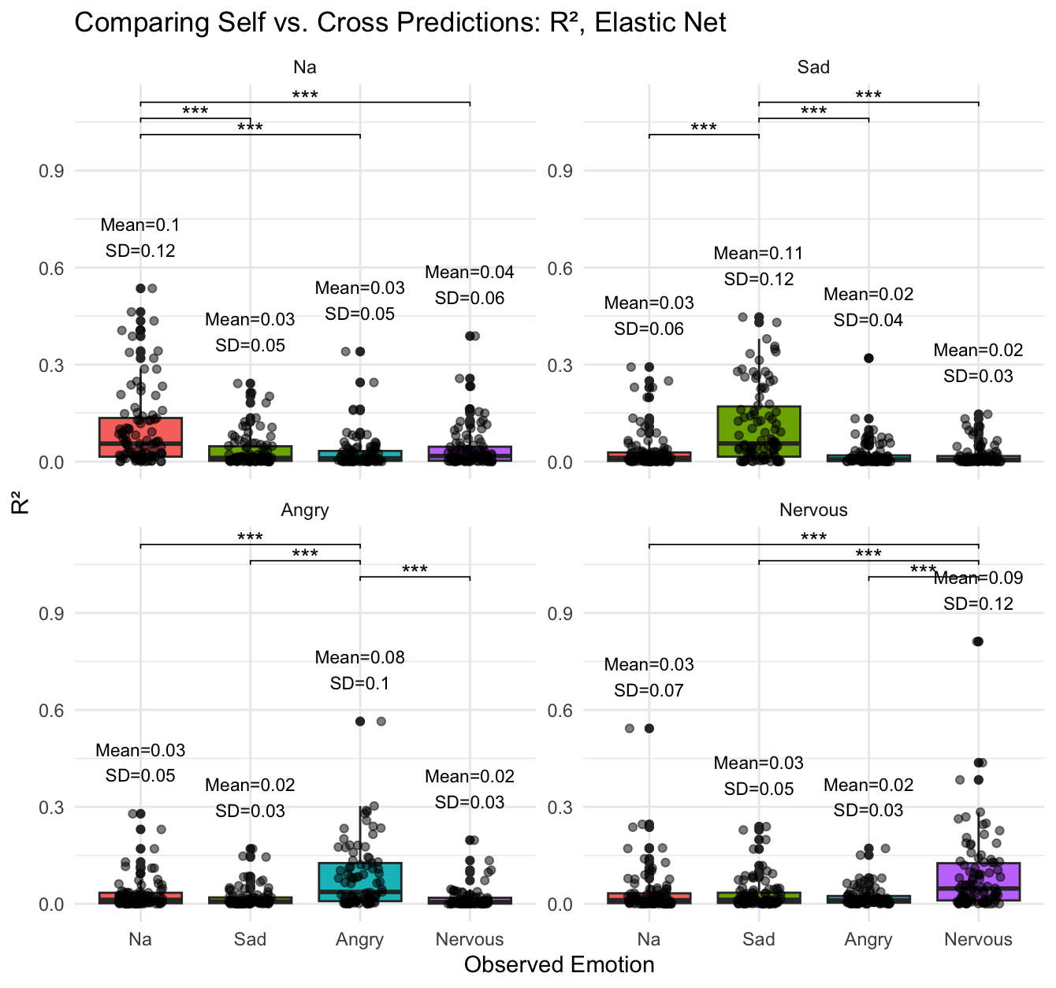
Fig. S6. Box plots showing the distribution of R² values for matched and mismatched predictions across emotion outcomes (NA, Sad, Angry, Nervous) using the Random Forest model.
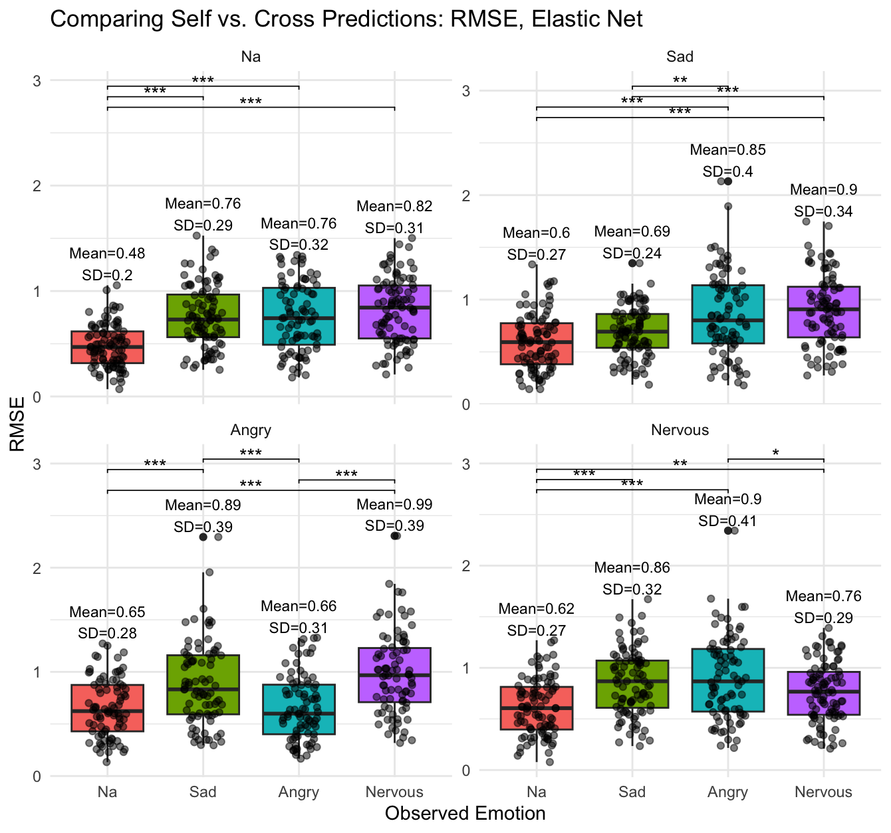
Fig. S7. Box plots showing the distribution of RMSE values for matched and mismatched predictions across emotion outcomes (NA, Sad, Angry, Nervous) using the Random Forest model.

