Supplementary Material for
Measuring emission intensity of jobs identifies distinct sector challenges for climate policy

Oskar Wood Hansen^{1, †} & Maximilian Koslowski^{2, ‡, ✉}

¹ Institute of Environmental Science and Technology (ICTA-UAB), Universitat Autònoma de Barcelona, 08193 Bellaterra, Spain
² Industrial Ecology Programme, Dept. of Energy and Process Engineering, Norwegian University of Science and Technology, Norway
✉ Corresponding author: maximilian.koslowski@ntnu.no
† 0009-0008-3459-1888
‡ 0000-0003-1060-8522

This file includes

- Alternative methods for linkage analysis
- Influence of capital goods on linkages
- Supplementary figures
  - Comparison with the emission intensity of value added
  - The emission intensity of employment in 67 global sectors
  - Domestic versus foreign backward linkages for 15 regions
  - As Fig 4 with subsector legend
  - As Fig 5 with production-based accounting
  - As Figure 5 with subsector legend
  - Regional correlation between jobs and emission intensity of jobs
- Results for all 15 world regions
  - Emissions and jobs in domestic backward linkages
- Supplementary table:
- Extended version of Table 1

Figures S1-S8
Table S1
SI References

S1 Alternative methods of linkage analysis
The Methods Section presents the derivation of linkages of a single sector group using HEM. Depending on which extractions are performed, different aspects of the chosen sector group’s linkages can be examined. We apply what has been described as case 1.II in Hertwich et al. (2024). Without accounting for any regional detail, we arrive at the expression:

$\left(\begin{matrix}D_{11} & D_{12} \\ D_{21} & D_{22}\end{matrix}\right)=\left(\begin{matrix}\hat{s_{1}} & 0 \\ 0 & \hat{s_{2}}\end{matrix}\right)\left(\begin{matrix}H & HA_{12}L_{22} \\ L_{22}A_{21}H & L_{22}A_{21}HA_{12}L_{22}\end{matrix}\right)\left(\begin{matrix}y_{1} & 0 \\ 0 & y_{2}\end{matrix}\right)$,

where $\left(\begin{matrix}y_{1} \\ y_{2}\end{matrix}\right)=\left(\begin{matrix}Y_{1} \\ Y_{2}\end{matrix}\right)i$.

The are other ways to derive the four linkages, MBLs $D_{11}$, NBLs $D_{21}$, NFLs $D_{12}$, and MFLs $D_{22}$ besides HEM, although the alternatives are less compact. Specifically, our MBLs, NBLs, and NFLs can be derived via what has been termed sales-based accounting (see e.g. Peters, 2008 and Kanemoto et al., 2012). We also note that, in the literature on trade in value-added, the MBLs have been termed VAX-P (the amount of value added used abroad for final production; see Los & Timmer, 2018). MFLs can then be derived via a small additional operation. The total linkages can be derived with total flow approach.
Sales-based accounting is an approach similar to consumption-based accounting. However, instead of attributing factor inputs to the final consumer of final goods, they are attributed to the producer of final goods - irrespective of where they are consumed. One may calculate such sales-based accounts for an entire country or just for one sector in a country. Without accounting for regional detail, the sales-based accounts of sector groups 1 and 2 can be calculated as follows.
The sales-based accounts of final good producer 1 resolved by factor origin can be calculated as:

$\left(\begin{matrix}{\overline{D}}_{11} \\ {\overline{D}}_{21}\end{matrix}\right)=\left(\begin{matrix}\hat{s_{1}} & 0 \\ 0 & \hat{s_{2}}\end{matrix}\right)\left(\begin{matrix}H & HA_{12}L_{22} \\ L_{22}A_{21}H & (L_{22}A_{21}HA_{12}+I)L_{22}\end{matrix}\right)\left(\begin{matrix}y_{1} \\ 0\end{matrix}\right)$,

where the central term on the right-hand side is the standard Leontief inverse (as defined in the Methods section). Likewise, one may calculate the residual sales-based account of the remaining economy as:

$$\left(\begin{matrix}{\overline{D}}_{12} \\ {\overline{D}}_{22}\end{matrix}\right)=\left(\begin{matrix}\hat{s_{1}} & 0 \\ 0 & \hat{s_{2}}\end{matrix}\right)\left(\begin{matrix}H & HA_{12}L_{22} \\ L_{22}A_{21}H & (L_{22}A_{21}HA_{12}+I)L_{22}\end{matrix}\right)\left(\begin{matrix}0 \\ y_{2}\end{matrix}\right)$$

We can combine these two expressions:

$$\left(\begin{matrix}{\overline{D}}_{11} & {\overline{D}}_{12} \\ {\overline{D}}_{21} & {\overline{D}}_{22}\end{matrix}\right)=\left(\begin{matrix}\hat{s_{1}} & 0 \\ 0 & \hat{s_{2}}\end{matrix}\right)\left(\begin{matrix}H & HA_{12}L_{22} \\ L_{22}A_{21}H & (L_{22}A_{21}HA_{12}+I)L_{22}\end{matrix}\right)\left(\begin{matrix}y_{1} & 0 \\ 0 & y_{2}\end{matrix}\right)$$

We observe that:

${\overline{D}}_{11}=D_{11}, {\overline{D}}_{21}=D_{21}, {\overline{D}}_{12}=D_{12}, {\overline{D}}_{22}≠D_{22}$

The MFLs can then be derived as:

$$D_{22}={\overline{D}}_{22}-\hat{s_{2}}L_{22}y_{2}$$

where the portion $\hat{s_{2}}L_{22}y_{2}$ describes the amount of a factor input embodied in supply chains pertaining to the rest of the economy that sector group 1 does not take any part in (or, have any agency over, from a policymaking perspective in the multiregional case). This portion plus a sector group’s total linkages equals the entire factor availability in the economy:

$$i_{1+2}'f= i_{1}'D_{11}+i_{1}'D_{12}+i_{2}'D_{21}+i_{2}'D_{22}+i_{2}'\hat{s_{2}}L_{22}y_{2}$$

where the $i$ vectors are summation vectors (i.e. vectors of ones) of appropriate lengths and $f∈F$ shows the production-based accounts of all sectors for one factor.
It is also worth noting that the sum of a sector or sector group’s MBL and NFL equals the direct factor input of a sector:

$$i_{1}'D_{11}+i_{1}'D_{12}=i_{1}'f_{1}$$

The total linkages of sector group 1 resolved by origin (i.e. MBL + NFL and NBL + MFL) can also be calculated with the total flow approach (cf. Szyrmer 1992, Gallego & Lenzen 2006, Temurshoev 2010):

$\left(\begin{matrix}D_{11} & D_{12} \\ D_{21} & D_{22}\end{matrix}\right)\left(\begin{matrix}ι_{1} \\ ι_{2}\end{matrix}\right)=\left(\begin{matrix}\hat{s_{1}} & 0 \\ 0 & \hat{s_{2}}\end{matrix}\right)L{\check{L}}^{-1}\left(\begin{matrix}x_{1} \\ 0\end{matrix}\right)$,

where $ι_{1}$ and $ι_{2}$ are summation vectors of appropriate length (in this case $ι_{1}=1$ and $ι_{2}=1$), $x_{1}$ is the total output originally observed for sector group 1, and $\check{L}$ is the diagonal matrix of $L$. The left-hand side shows the summation of the HEM results, and the right-hand side shows the total flow calculation.
The totality of forward and backward linkages as calculated here, are non-additive in their nature, as noted by Szyrmer (1992) in his treatment of total flows: the sum of the total flows (in terms of factor inputs) associated with each sector is larger than the sum of all production-based accounts. However, when extracting one-by-one all sectors of an economy using our HEM specification, the sum of all backward linkages equals the sum of all production-based accounts. That is, assuming there are n sectors in an economy and each sector i is extracted, where sector i is equivalent with notation 1 and the rest of the economy with notation 2, we note:

$$\sum_{i}^{n}{i_{1}'D_{11}^{i}+i_{2}'D_{21}^{i}}=i'f$$

The same is true in a multi-regional context such as ours and when extracting not only single sectors but instead sector groups. That is, extracting each sector group j from in total k sector groups and again assuming that sector group j is equivalent with notation 1 and the rest of the economy with notation 2, we note:

$$\sum_{j}^{k}{i_{1}'D_{11}^{j}+i_{2}'D_{21}^{j}}=i'f$$

Returning to the non-additivity of total flows, we want to highlight that we are interested in classifying each sector’s productive support network. Thus, the caveat highlighted by Szyrmer (1992) does not apply in our case, since we do not aggregate the linkage results.
We prefer HEM rather than the alternatives presented here, because it readily yields all four types of linkages. The total flow approach only provides the total of the four linkages, and while sales-based accounting can yield the MBLs, NBLs, and NFLs, it requires an additional step to get MFLs. Another reason is that we are interested in the origins of every sector group’s linkages, not only how one sector group is linked to the rest of the economy. To this end, we apply the HEM for every sector group. The repeated use of the HEM requires calculating the Leontief inverse once for each alternating sector of interest. Sales-based accounting is a faster way to calculate MBLs, NBLs, and NFLs, because it does not require re-calculating the Leontief inverse. However, calculating the MFLs would require recalculating $L_{22}$ for each sector group iteration. Despite its slight shortcoming in terms of computational efficiency, HEM provides a compact way to calculate the four linkage types for each sector group. Moreover, it is highly flexible when it comes to potential changes in the types of extractions to be performed (i.e. when aiming for cases other than what we focus on here, i.e. 1.II as per Hertwich et al., 2024).

S2 The influence of capital goods on linkages
Sectors use fixed capital in their production, such as factory buildings and machinery. The production and maintenance of these capital goods requires additional inputs of other goods and factors. Capital goods appear in two forms in input-output tables. Investments into capital (gross fixed capital formation, GFCF), denoted $Y_{k}$, is classified as final demand. In contrast, capital use (consumption of fixed capital, CFC), denoted $F_{k}$, classify as a primary factor. This means that CFC is accounted for as input to production, while GFCF is not.
To control for the effect of capital goods on our results, we tested to account for both CFC and GFCF to comprehensively trace production factors through global supply chains (Södersten et al., 2018; Chen et al., 2018; Hertwich, 2021; Wang et al., 2023). To this end, we employed the modified augmentation method (described in Hertwich & Wood, 2018; see also Lenzen & Treloar, 2004) to get a distributed measure of the CFC, based on a combination of both capital vectors. While the interindustry matrix $Z$ shows the requirements of each sector to produce non-capital goods, the capital flow matrix $Z_{k}$ then indicates the requirements to replace capital goods consumed by production processes (Hertwich & Wood, 2018).
We derive the capital flow matrix $Z_{k}$ for region s as the outer product of the normalized GFCF (over each region i and sector j) and the CFC:

$Z_{k}^{s}=\frac{Y_{k}^{s}}{\sum_{ri}{y_{k}^{ri,s}}}⊗F_{k}^{s}$.

Concatenating the $Z_{k}^{s}$ matrices column-wise yields the full capital flow matrix $Z_{k}$. The capital requirements per unit of output are derived by:

$A_{k}=Z_{k}{\hat{x}}^{-1}$.

To avoid double-counting of capital inputs, still following Hertwich & Wood (2018), we perform two corrective measures: first, we correct the final demand by replacing gross fixed capital formation $Y_{k}$ with net fixed capital formation $Y_{n}$. We derive $Y_{n}$ by subtracting the row sum of $Z_{k}$ from $Y_{k}$:

$y_{n}^{r}=y_{k}^{r}-\sum_{sj}{Z_{k}^{ri,sj}}$.

Then, we set the $F_{k}$ vector in $F$ to zero.
This two-step correction procedure guarantees that the total output and total input remain unchanged.

S3 Supplementary figures
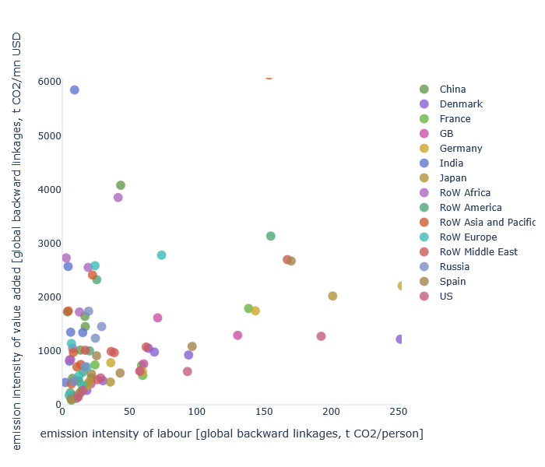
Figure S1: Comparison of emission intensity of jobs versus the emission intensity of value added. For readability, only the 95 % percentiles of values are shown.
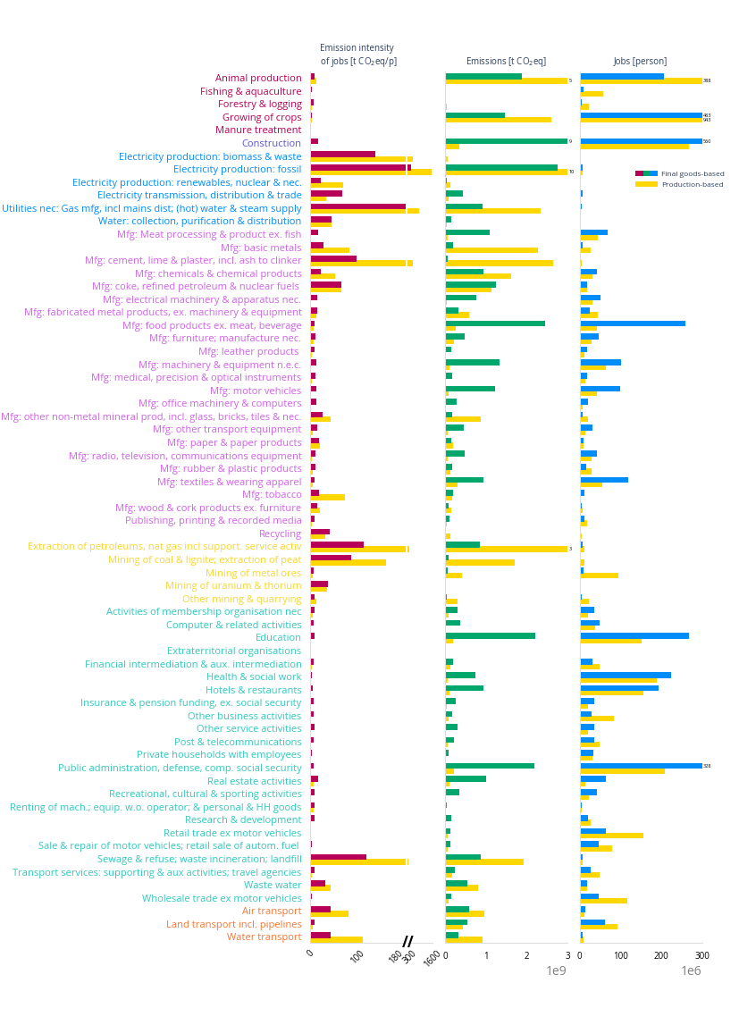
Figure S2: The emission intensity of employment in 67 global sectors

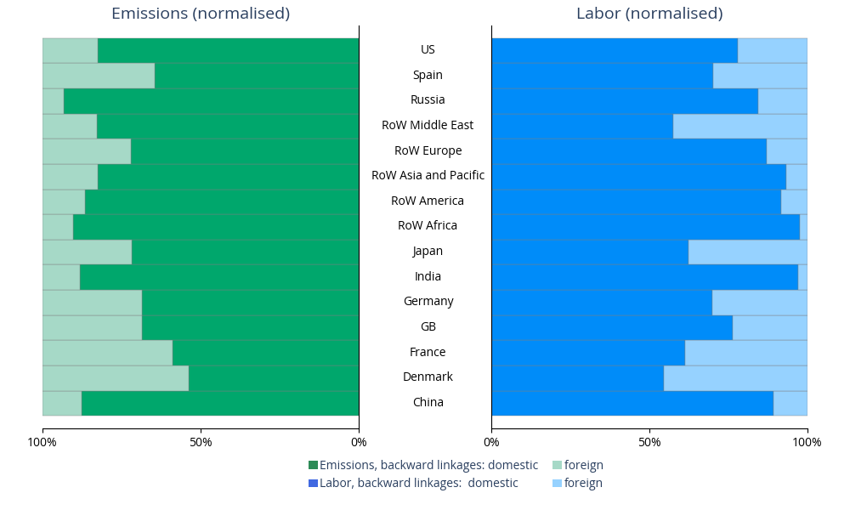
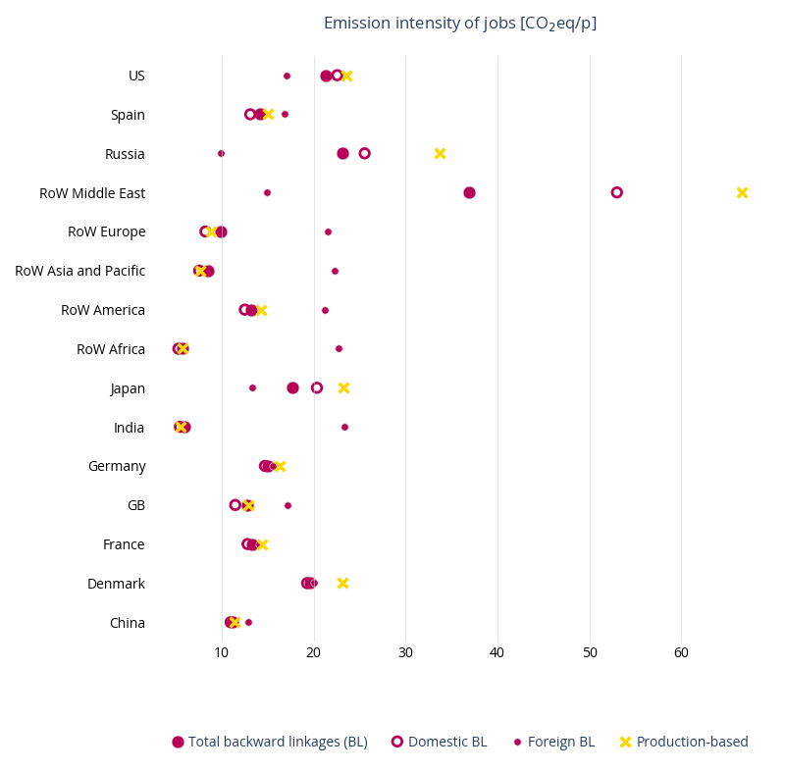
Figure S3a and S3b: Domestic versus foreign backward linkages for 15 regions

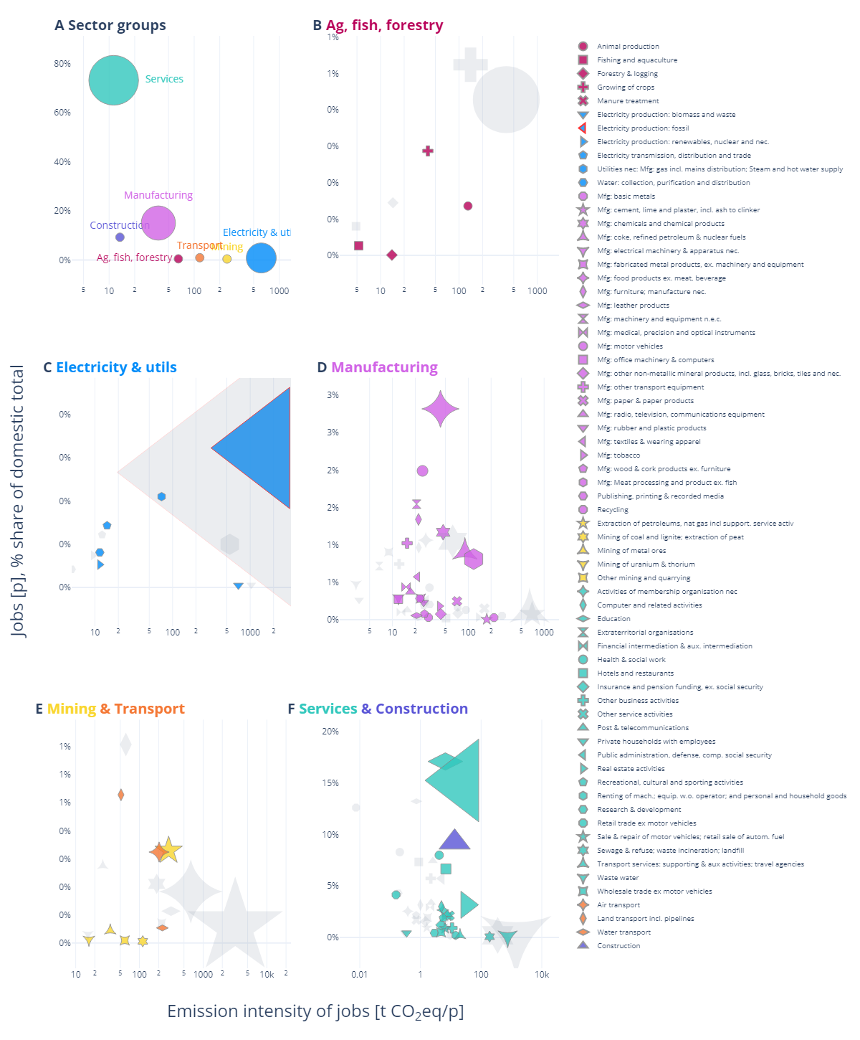
Figure S4: Emission intensities of labour by subsector in the Unites States. Colourblind-safe version with complete legend and marker symbols.

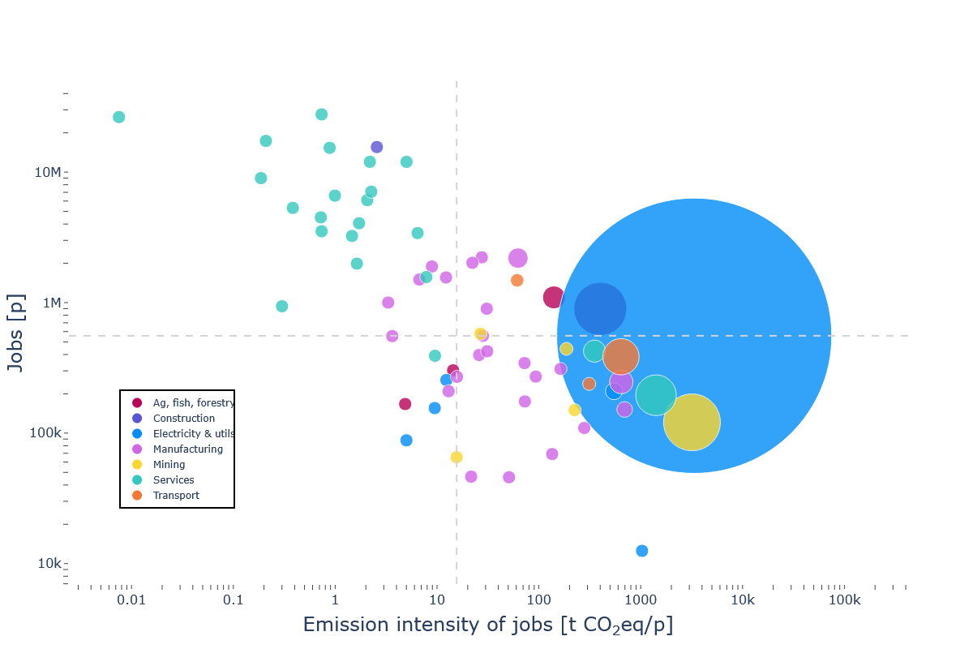
Figure S5: U.S. job generation and emission intensity of employment by production-based accounting.

Notes: The dashed lines indicate the median sector values. The size of the markers approximates the CO₂eq emissions, scaled relative to the second-largest sector – otherwise Electricity generation: fossil fuels dominates the visual. A minimum marker size ensures all sectors remain visible.

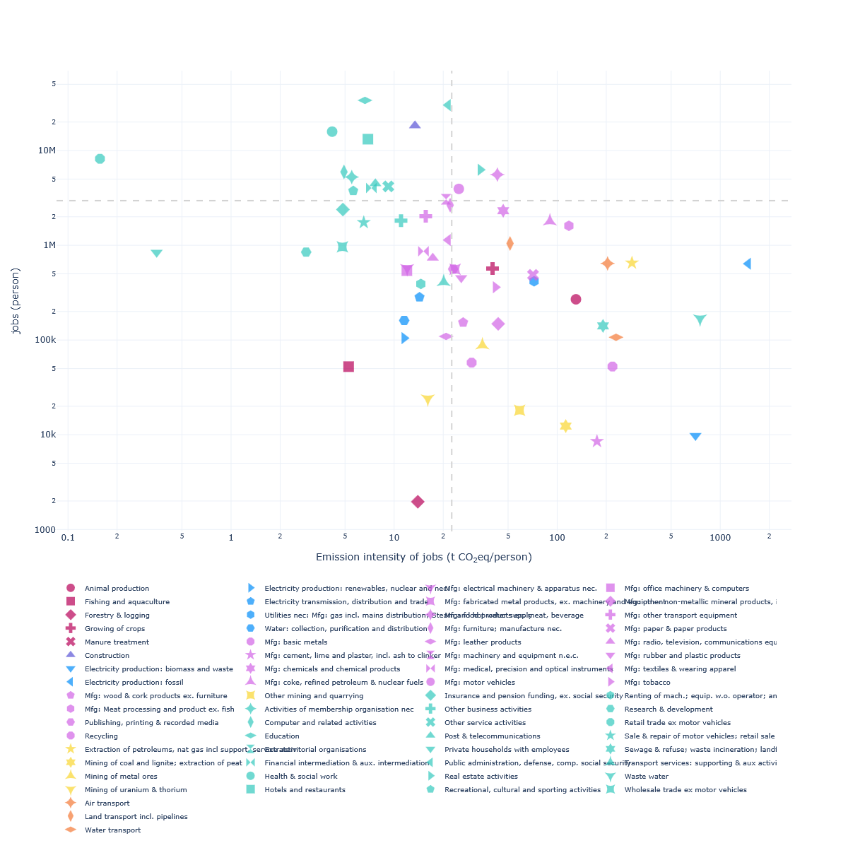
Figure S6: U.S. job generation and emission intensity of employment by backward linkages. Version with complete legend and marker symbols for colourblind people.

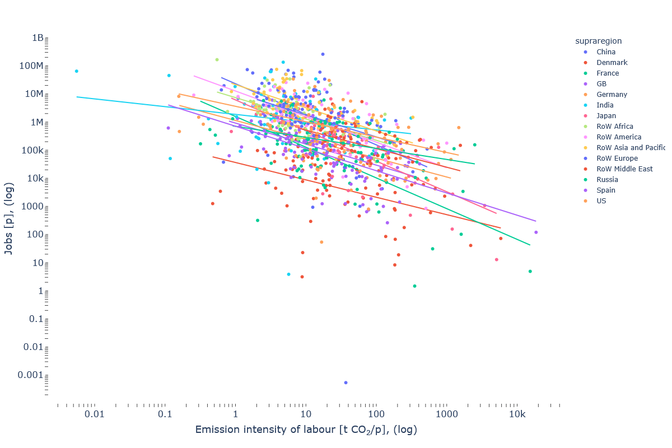
Figure S7: Regional correlation between employment and emission intensity of jobs.

S4 Figure 5 for all 15 world regions
Figures S8a-n. U.S. job generation and emission intensity of jobs by domestic backward linkages.
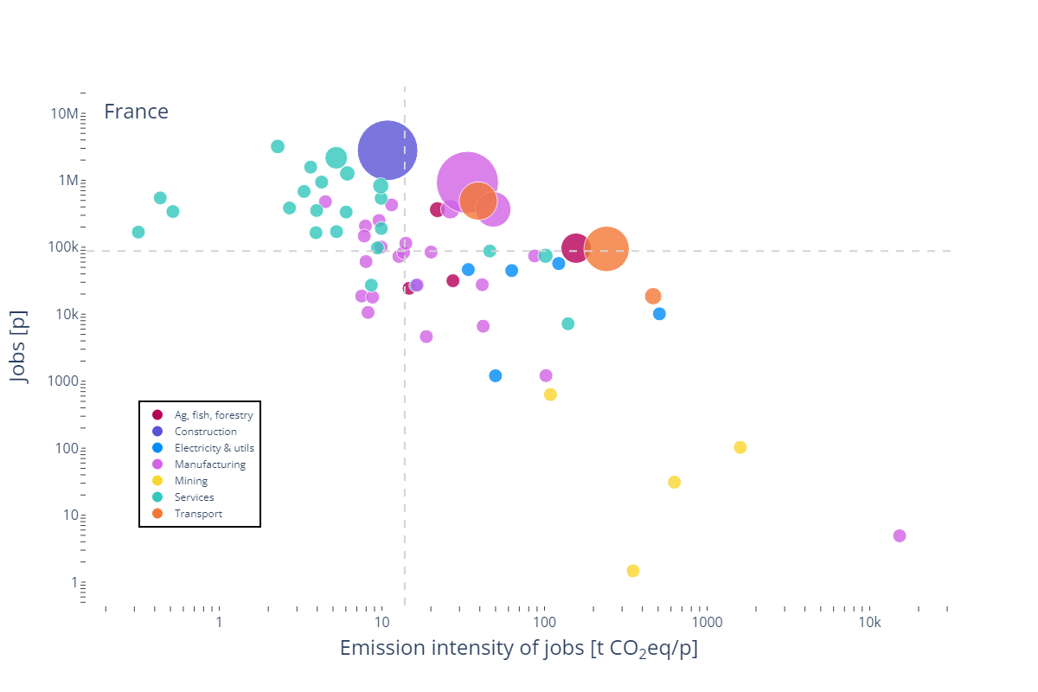
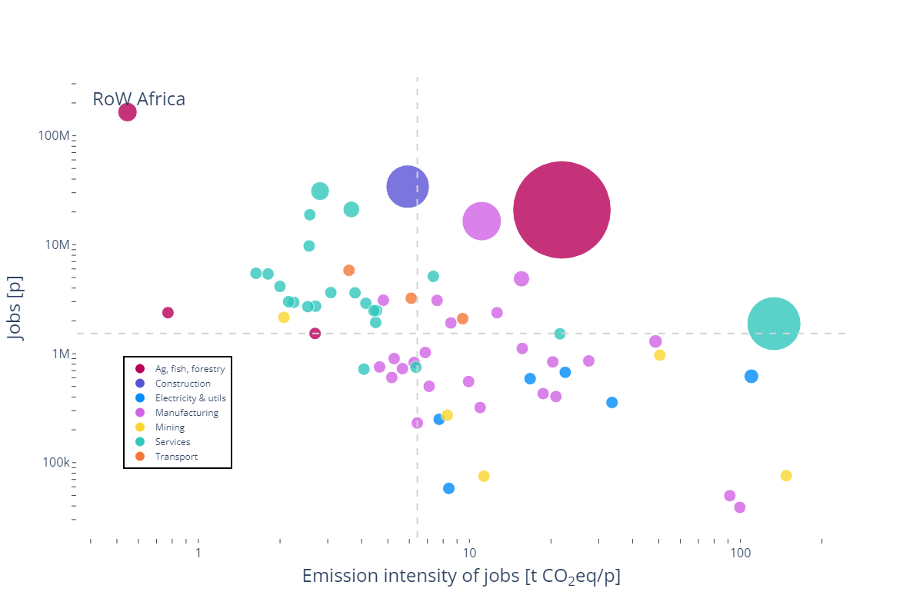
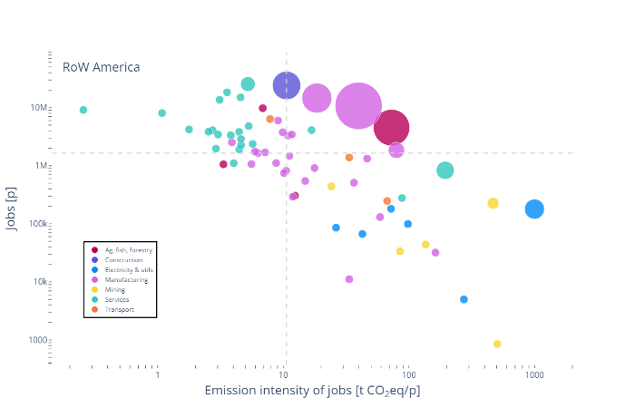
Notes: Both axes use logarithmic scales.
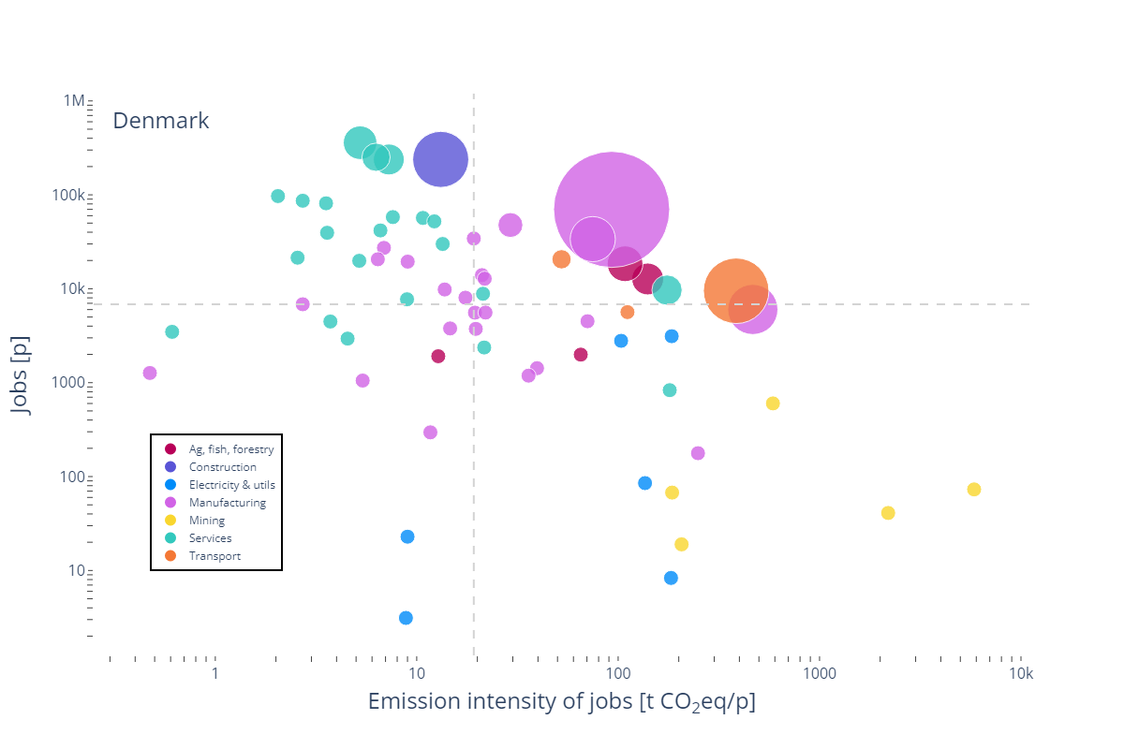
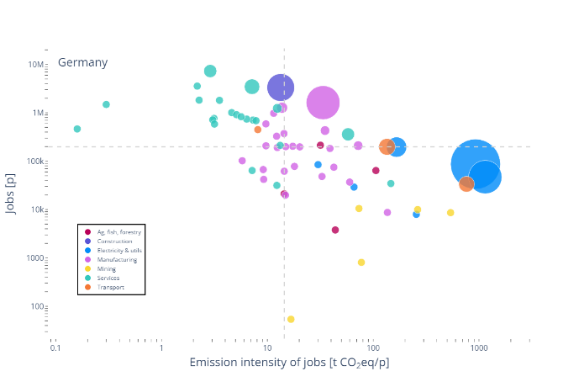
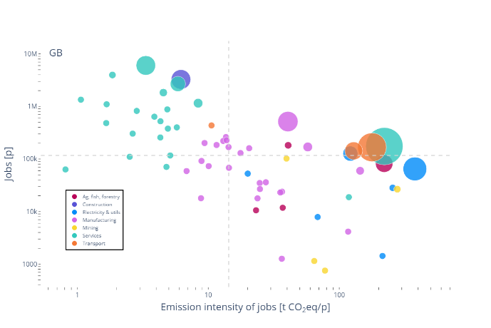
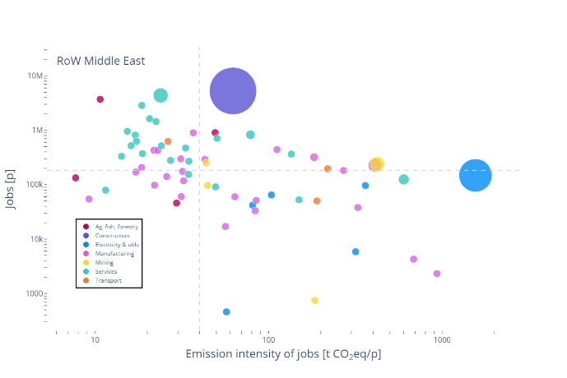
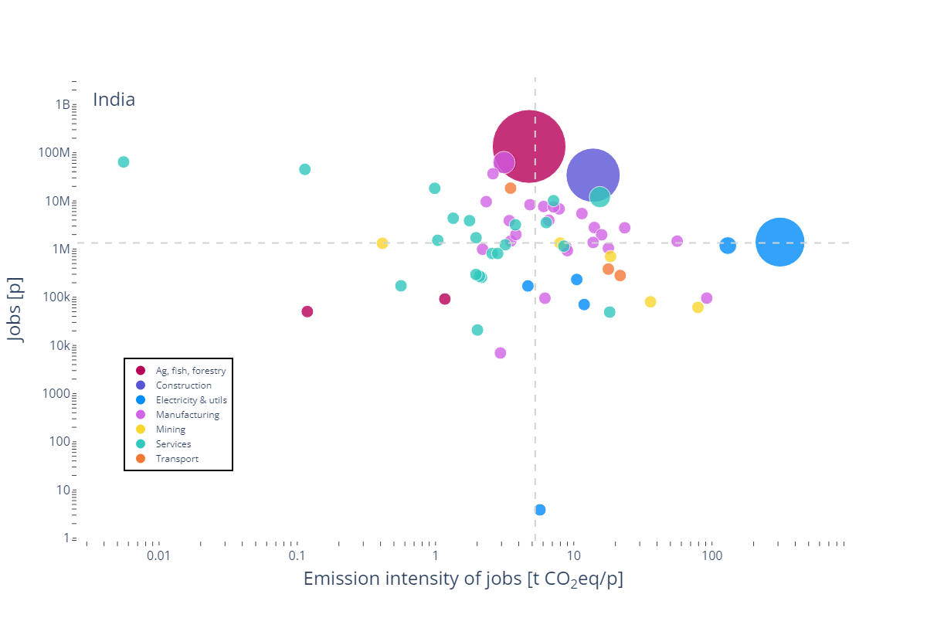
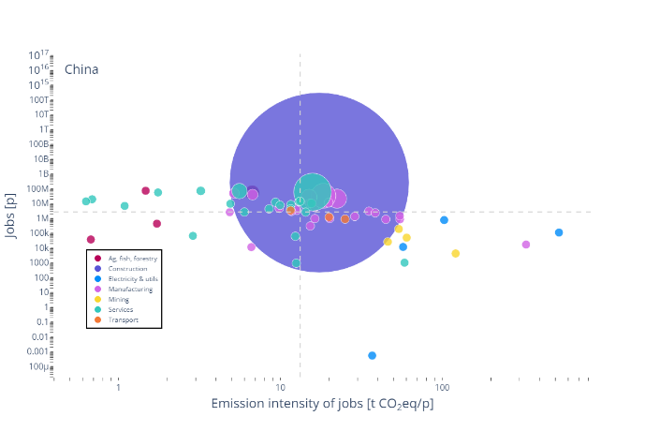
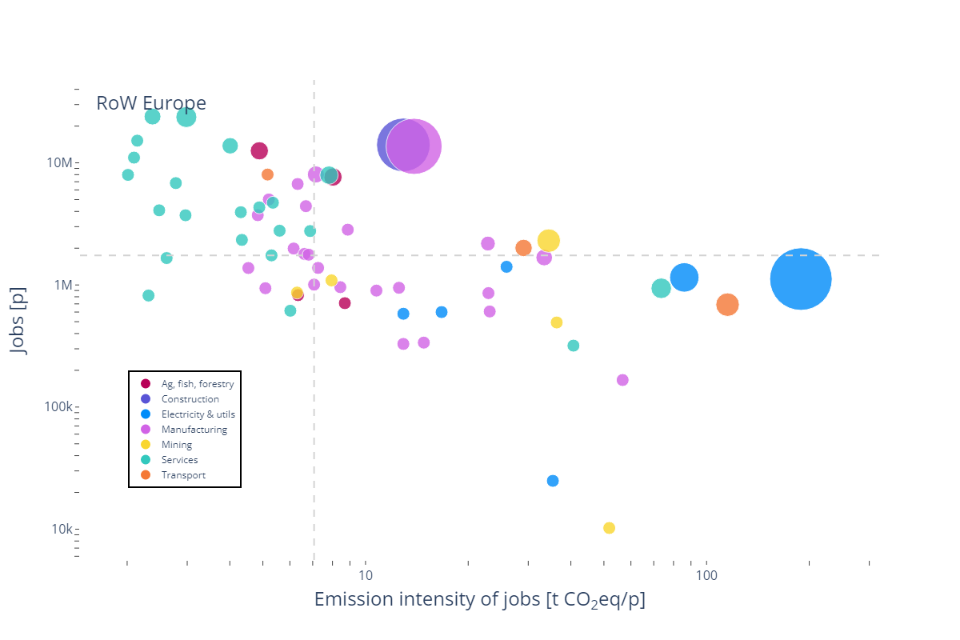
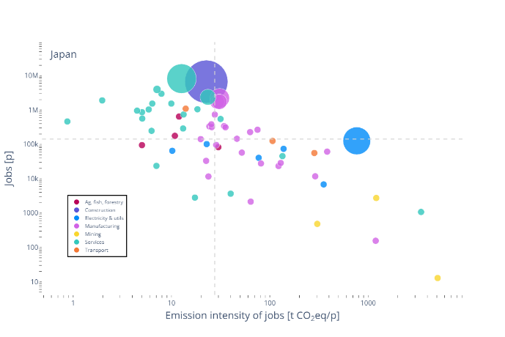
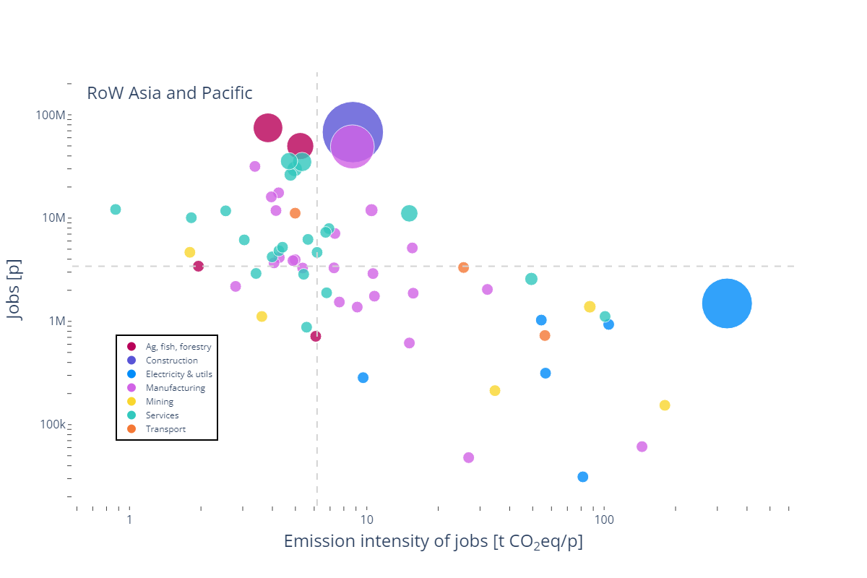
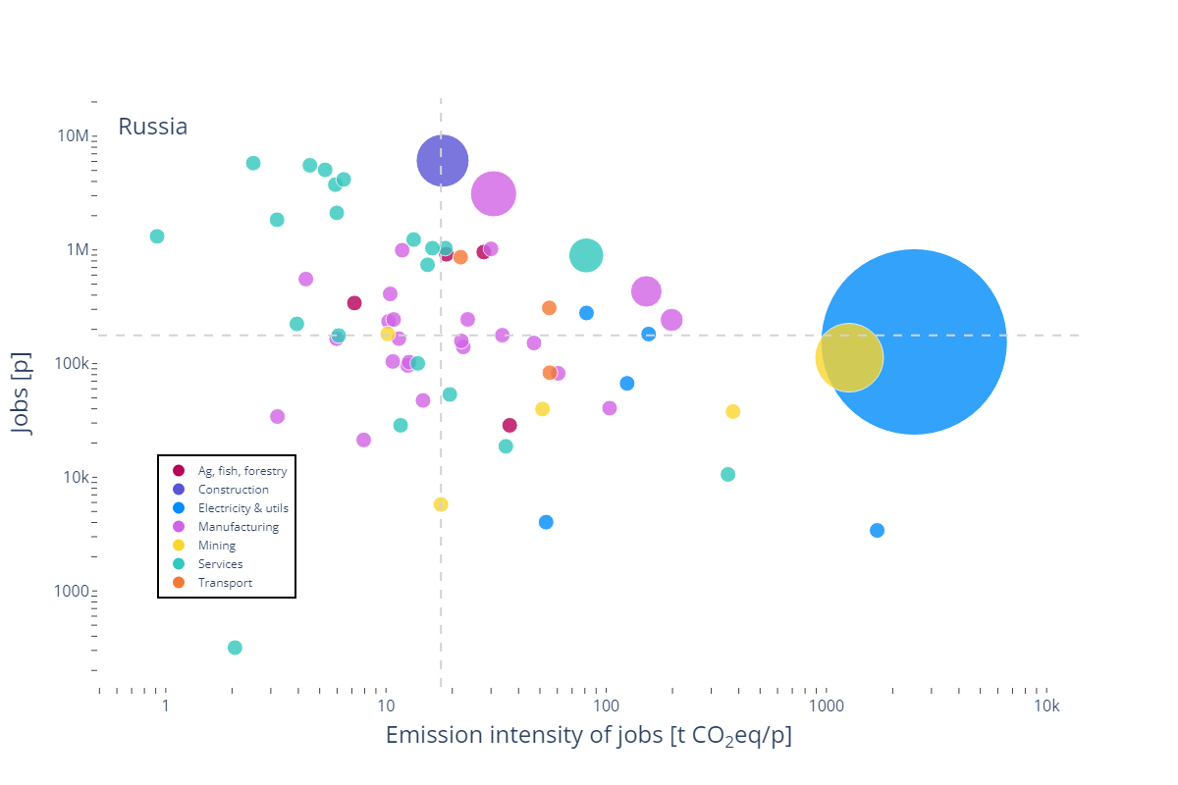
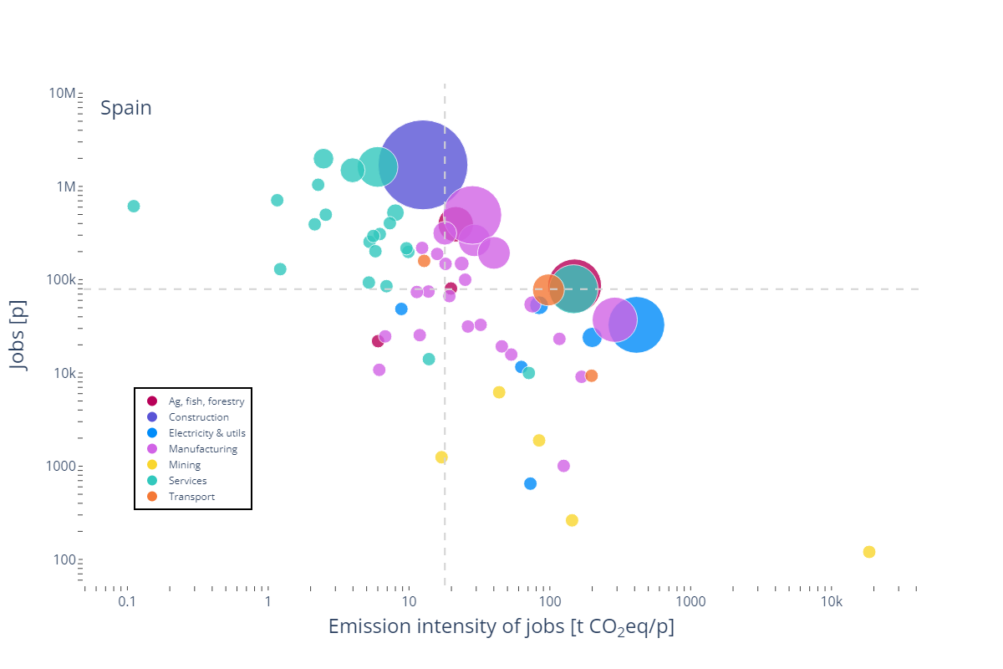

S5 Extended version of Table 1
Table S1: Sector challenges, policy strategies, and examples of policy instruments
Employment | Emission intensity of jobs | Policy strategy | Pure climate policy | Green industrial policies | Just transition policies
High | Low | Protect & proceed | Carbon pricing with direct revenue recycling | - Green public procurement  - Public investments in R&D&I (e.g. construction materials)  - Direct public investment (e.g. renewable energy deployment)  - Trade protection | - Re-skilling programs (e.g. low carbon construction),  - Relocation support
High | High | Keep & decarbonise | - Carbon pricing with recycling conditional on green earmarking  - Subsidies for industrial fuel switch | - Tax incentives & loan guarantees  Public investment in R&D&I (e.g. industrial heat pumps)  - Public investment in infrastructure (e.g. electricity grids) | —
Low | High | Decarbonise or decline | - Carbon pricing without recycling  - Regulation (e.g. emission standards) | - Regulation (e.g. labour content requirements) | - Re-skilling programs  - Relocation support  - Regional transition funds  - Worker compensation (e.g. early retirement)
Low | Low | Let live | Carbon tax with direct revenue recycling | — | —

SI References
Chen, Z.-M., Ohshita, S., Lenzen, M., Wiedmann, T., Jiborn, M., …, & Liu, Z. (2018). Consumption-based greenhouse gas emissions accounting with capital stock change highlights dynamics of fast-developing countries. Nature Communications, 9(1), 3581. doi:10.1038/s41467-018-05905-y
Gallego, B., & and Lenzen, M. (2005). A consistent input–output formulation of shared producer and consumer responsibility. Economic Systems Research, 17(4), 365–391. https://doi.org/10.1080/09535310500283492
Hertwich, E. G. (2021). Increased carbon footprint of materials production driven by rise in investments. Nature Geoscience, 14(3, 3), 151–155. doi:10.1038/s41561-021-00690-8
Kanemoto, K., Lenzen, M., Peters, G. P., Moran, D. D., & Geschke, A. (2012). Frameworks for Comparing Emissions Associated with Production, Consumption, And International Trade. Environmental Science & Technology, 46(1), 172–179. https://doi.org/10.1021/es202239t
Lenzen, M., & Treloar, G. J. (2004). Endogenising Capital: A comparison of Two Methods. Journal of Applied Input-Output Analysis, 10.
Los, B., & Timmer, M. P. (2018). Measuring Bilateral Exports of Value Added: A Unified Framework. NBER. doi:10.3386/w24896
Peters, G. P. (2008). From production-based to consumption-based national emission inventories. Ecological Economics, 65(1), 13–23. doi:10.1016/j.ecolecon.2007.10.014
Södersten, C.-J. H., Wood, R., & Hertwich, E. G. (2018). Endogenizing Capital in MRIO Models: The Implications for Consumption-Based Accounting. Environmental Science & Technology, 52(22), 13250–13259. doi:10.1021/acs.est.8b02791
Szyrmer, J. M. (1992). Input—Output Coefficients and Multipliers from a Total-Flow Perspective. Environment and Planning A, 24(7), 921–937. https://doi.org/10.1068/a240921
Temurshoev, U. (2010). Identifying Optimal Sector Groupings with the Hypothetical Extraction Method. Journal of Regional Science, 50(4), 872–890. https://doi.org/10.1111/j.1467-9787.2010.00678.x

