Supplementary Information

Consumer Sensory Preferences for Conventional versus Organic Ingredients Food Ingredients in the United States

Siyuan Sheng¹*, Erin M. Silva², Steven C. Ricke¹, and James R. Claus¹*

¹Department of Animal & Dairy Sciences, University of Wisconsin-Madison, Madison, Wisconsin, 53706, United States
²Department of Plant Pathology, University of Wisconsin-Madison, Madison, Wisconsin, 53706, United States
*Corresponding author emails: siyuan.sheng@outlook.com and jrclaus@wisc.edu

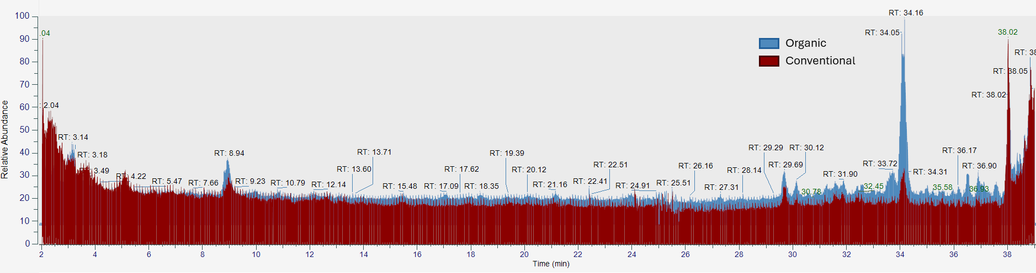
SI Figure 1. Comparison of total ionic compounds between pre-converted organic Swiss chard and conventional Swiss chard powder under positive (+) ionization mode. RT stands for retention time.

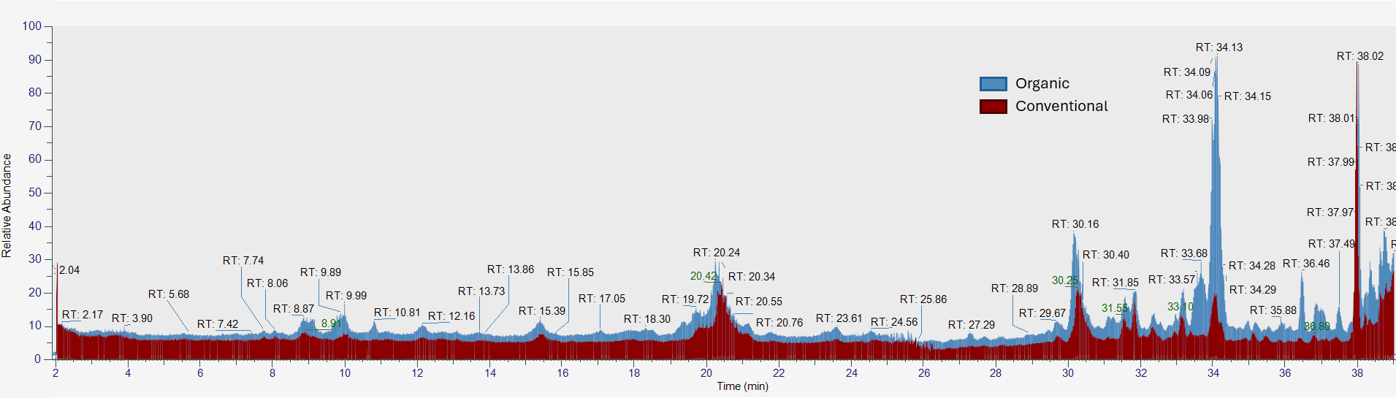
SI Figure 2. Comparison of total ionic compounds between pre-converted organic Swiss chard and conventional Swiss chard powder under negative (-) ionization mode. RT stands for retention time.

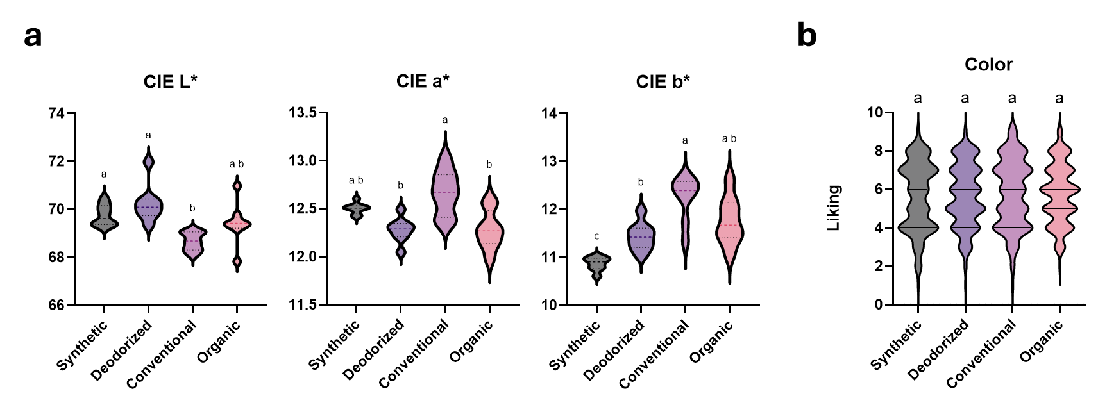
SI Figure 3. Color differences between organic and conventional frankfurters (day 15) along with comparison to those formulated with synthetic sodium nitrite. a. Instrumental analysis results of color differences, expressed in CIE L* (lightness), a* (redness), and b* (yellowness) values; b. Consumer preferences regarding color differences, evaluated through sensory liking scores (1= dislike extremely to 9=like extremely).

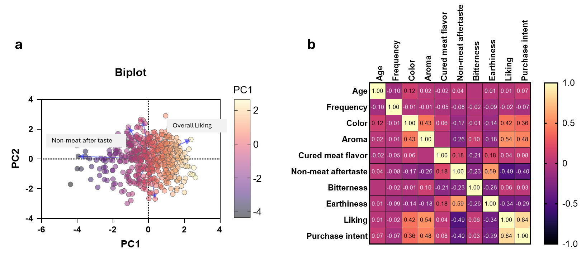
SI Figure 4. Correlation analyses on organic vs conventional cured processed meats. a, Principal component analysis. b, Pearson’s r correlation.

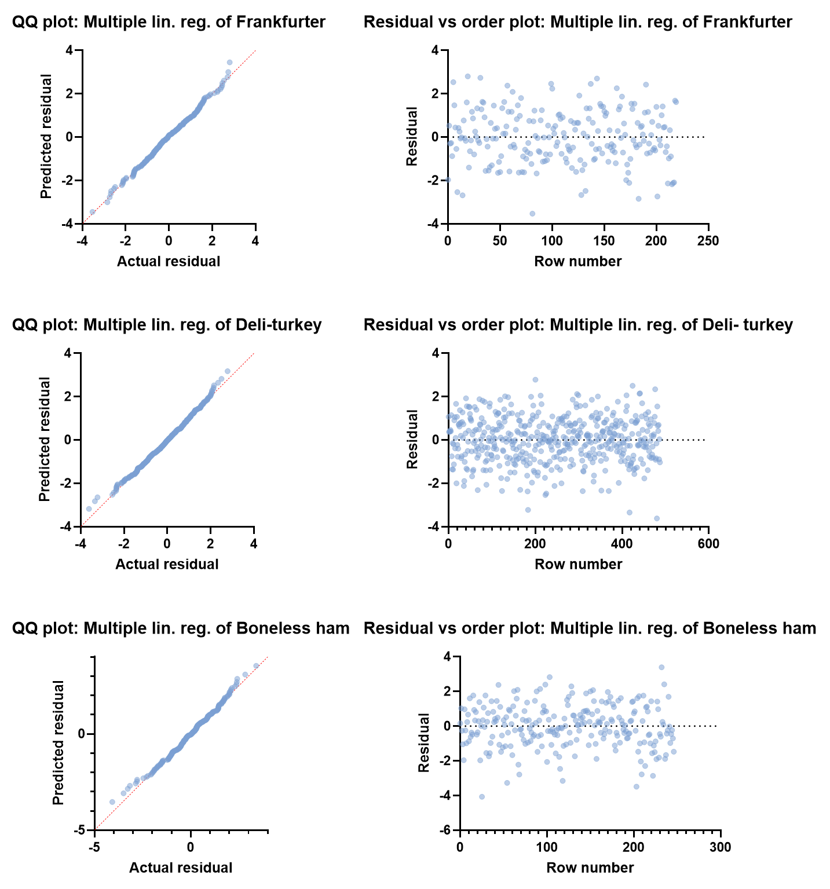
SI Figure 5. Residuals vs. Order Plot and Quantile-Quantile (Q-Q) Plot for the multilinear regression models.

Table S1. Concentration of selected active phytochemicals in organic vs conventional pre-converted Swiss chard powder (soybean excluded daidzein was used as standard for concentration measurement).
Groups | Compound Name | Observed m/z | Ionization mode | MS/MS Fragments | Concentration in -Organic (ppm) | Concentration in Conventional (ppm)
Flavonoid | Apigenin-6-C-galactoside-8-C-arabinoside | 563.1400 | Negative | 545.13, 503.11, 473.10, 443.09, 383.07, 353.06 | 94.56 | 11.65
Flavonoid | Quercetin-3-neohesperidoside | 609.1455 | Negative | 245.04, 205.05,151.04,137.02 | 7.71 | 32.95
Flavonoid | Apigenin 6,8-di-C-glucoside (Vicenin-2) | 593.1506 | Negative | 503.11,473.10, 383.07,353.06 | 3.02 | 10.41
Flavonoid | Isorhamnetin diglucoside | 639.1563 | Negative | 447.01, 315.01 | 8.02 | 166.08
Flavonoid | Isovitexin 7-O-xyloside-2''-O-glucoside | 565.1549 | Positive | 433.1130, 313.0706 | 77.17 | 773.54

