Supplementary Information for
Variations in Land-Atmosphere Coupling during Drought- Heatwave events
Donghyuck Yoon^{1*}, Jan–Huey Chen², Hsin Hsu¹ and Kirsten Findell²

¹Program in Atmospheric and Oceanic Sciences, Princeton University, New Jersey, U.S.A.
²Geophysical Fluid Dynamics Laboratory, National Oceanic and Atmospheric Administration, New Jersey, U.S.A.

Corresponding Author
Donghyuck Yoon (dy3794@princeton.edu)
Program in Atmospheric and Oceanic Sciences
Princeton University

Contents
Supplementary Table 1
Supplementary Figure 1
Supplementary Table 2
Supplementary Figure 2
Supplementary Figure 3
Supplementary Table 3
Supplementary Figure 4
Supplementary Figure 5
Supplementary Table 1. Geographic area and spatial correlation coefficient of six compound drought-heatwave events
Cases | Area of extentª (km²) | Spatial correlation coefficient between TMAX_{anom} and SM_{anom}^{b} (-)
2003 | 1,307,499 | -0.85
2010 | 3,629,125 | -0.74
2012 | 1,240,199 | -0.89
2021 | 2,572,901 | -0.77
2022 | 1,873,062 | -0.53
2023 | 2,414,932 | -0.84
ªBased on the area over 3-month mean TMAX_{anom} exceeding two standard deviations (non-hatched area in Fig. 1a)
^{b}Based on the entire domain
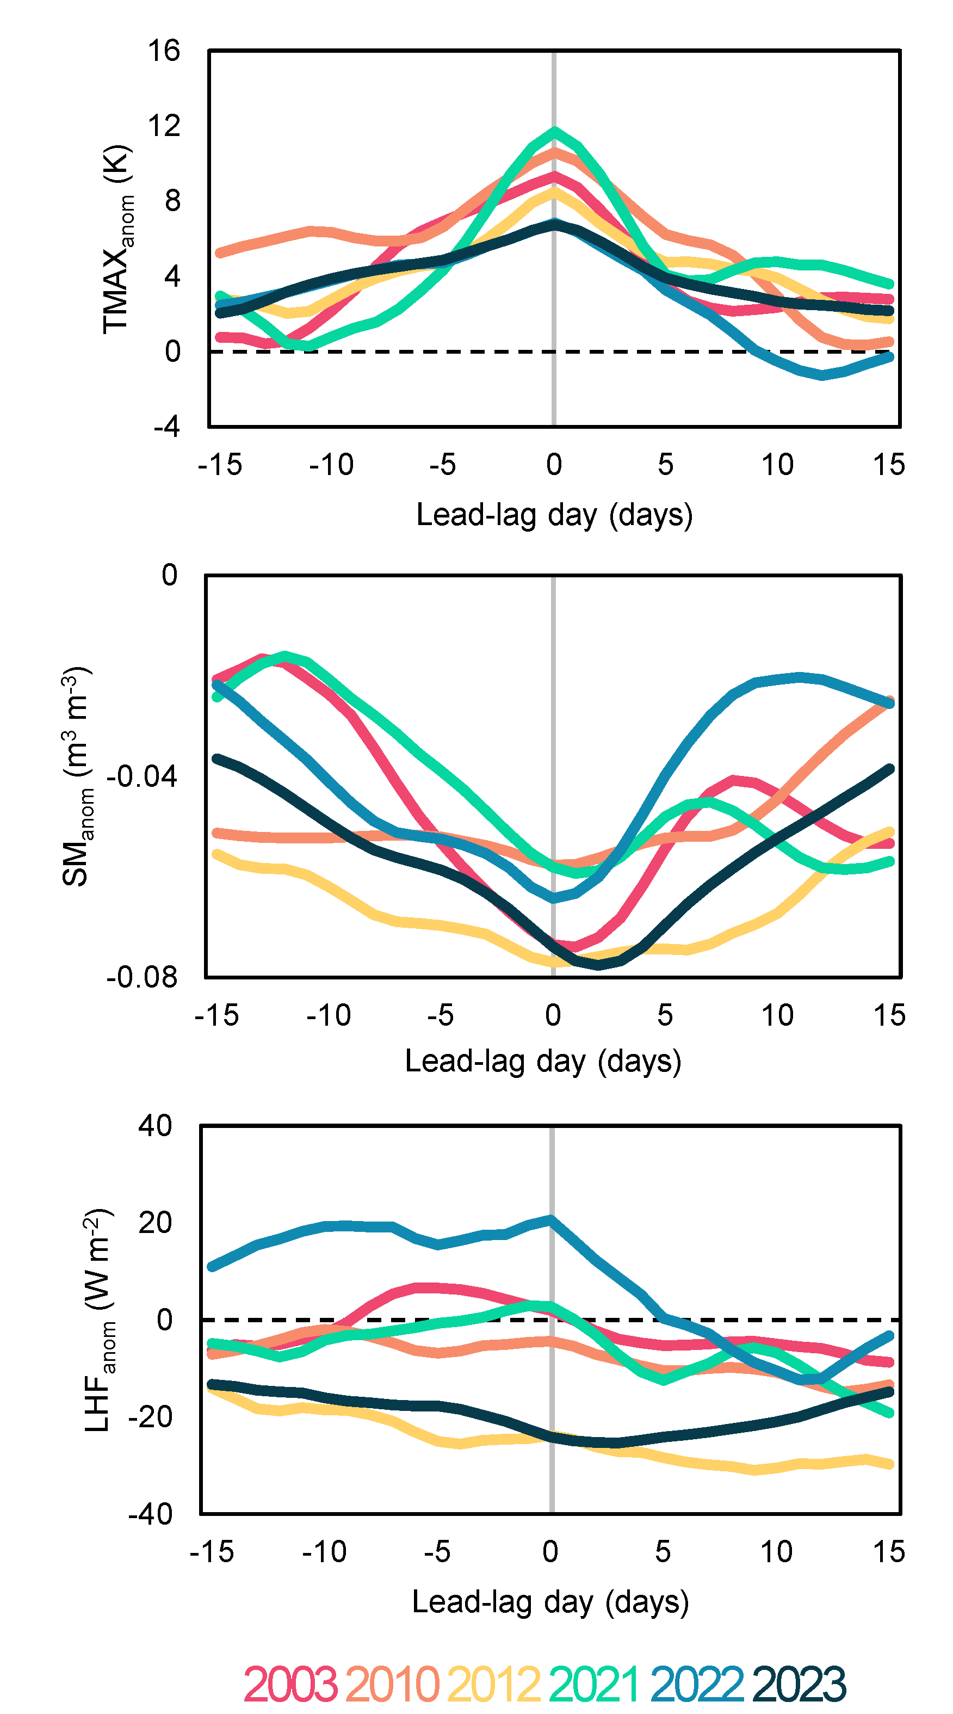
Supplementary Figure 1. Lead-lag time series of TMAX, SM, and LHF for six compound drought-heatwave events. Lead-lag time series of TMAX_{anom} (K; top), SM_{anom} (m³ m⁻³; middle), and LHF_{anom} (W m⁻²; bottom) within a 31-day time window, area-averaged over the non-hatched areas shown in Fig. 1a. The ordinate represents the raw (non-standardized) anomaly values for each variable. The abscissa represents the days relative to the peak day of the heatwave (day 0, marked with a gray line), and each colored line corresponds to a specific year, as indicated in the legend. TMAX_{anom} were derived from the ERA5-Land, and SM_{anom} and LHF_{anom} were derived from the reference data.
Supplementary Table 2. Actual values for ${TMAX}_{anom}^{p}$, ${SM}_{anom}^{p}$ and ${LHF}_{anom}^{p}$
Cases | ${TMAX}_{anom}^{p}$ (K) | ${SM}_{anom}^{p}$ (m³ m⁻³) | ${LHF}_{anom}^{p}$ (W m⁻²)
2003 | 9.3 | -0.073 | 2.1
2010 | 10.6 | -0.058 | -4.4
2012 | 8.5 | -0.077 | -24.0
2021 | 11.7 | -0.058 | 2.7
2022 | 6.8 | -0.064 | 20.6
2023 | 6.7 | -0.074 | -24.1

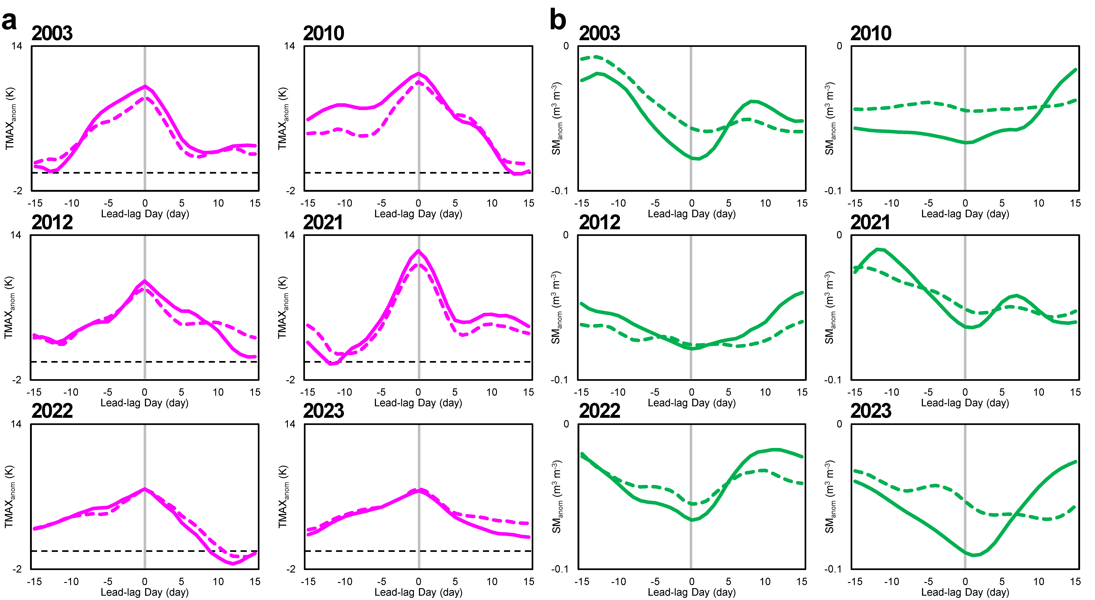
Supplementary Figure 2. Lead-lag time series of TMAX, SM, and PR anomalies for two different groups of grid cells. Lead-lag time series of a TMAX_{anom} (K) and b SM_{anom} (m³ m⁻³) within a 31-day time window. The ordinate represents the raw (non-standardized) anomaly values for each variable. Solid lines represent area-averaged values for grid cells where R(SM, TMAX) < -0.5 and p < 0.05 (i.e., colored dots in Fig. 2), while dashed lines represent values for all other grid cells (i.e., uncolored dots in Fig. 2). The abscissa indicates the days relative to the peak day of the heatwave (day 0; marked with a gray line). TMAX_{anom} were derived from the ERA5-Land and SM_{anom} were derived from the reference data.

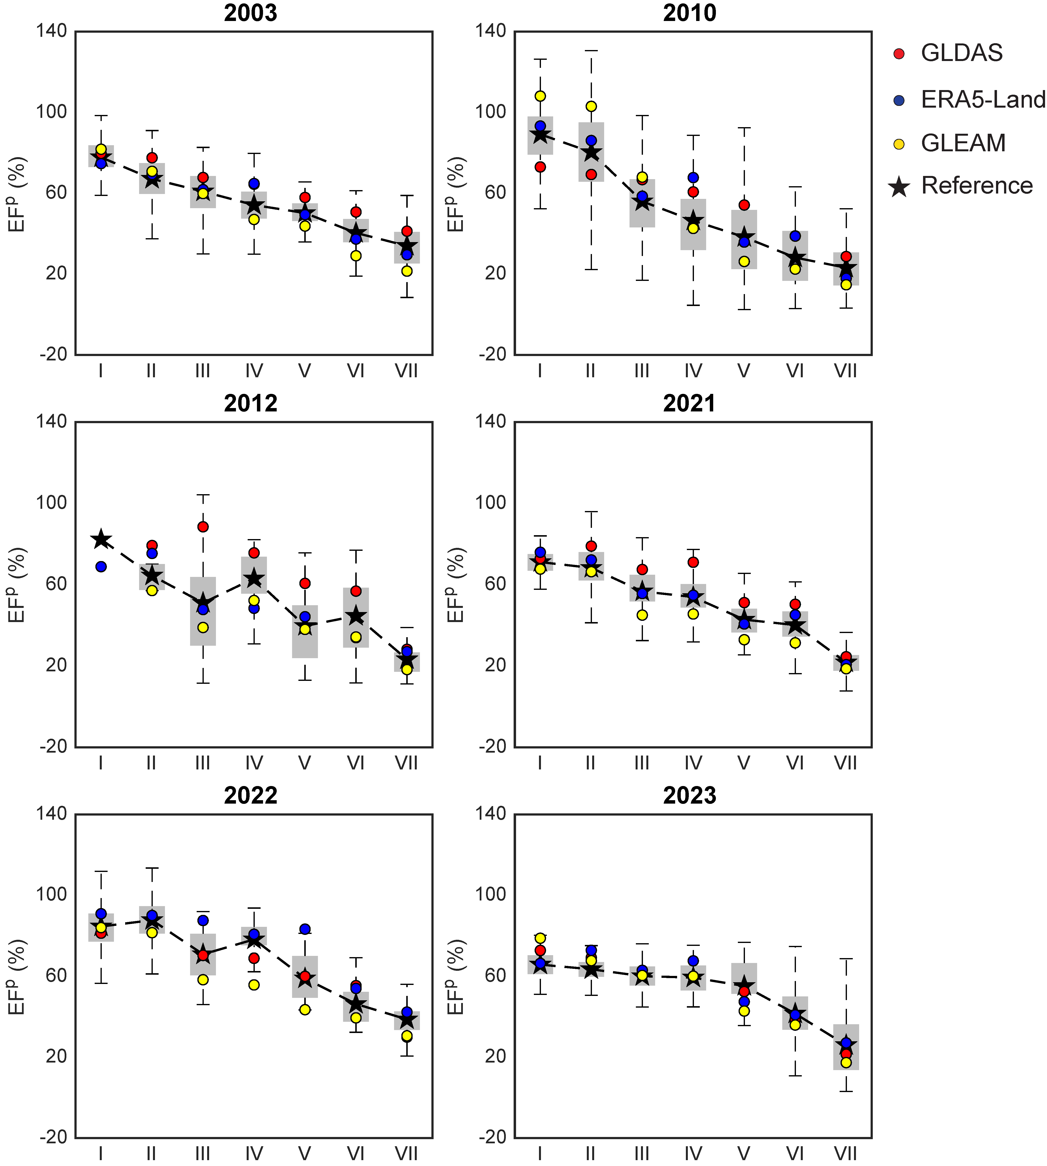
Supplementary Figure 3. Regime-dependent variations in EF for six compound drought-heatwave events. Box plot showing EF on day 0 (EF^{p}) (ordinate) across different land-atmosphere coupling regimes (Regime I–Regime VII; abscissa). Boxes represent the interquartile range (IQR) of EF^{p} from the reference data, with the lower and upper bounds of the box indicating the 25th and 75th percentiles, respectively. The whiskers extend to the data points within 1.5 times the IQR from the box edges, while any data points beyond this range are classified as outliers (not displayed). The mean EF_{p} values for each dataset are marked individually: red circles for GLDAS, blue circles for ERA5-Land, and yellow circles for GLEAM; black stars for the reference data (connected by a dashed line).
Supplementary Table 3. Actual values for ${TMAX}_{anom}^{p}$, ${SM}_{anom}^{p}$ ${LHF}_{anom}^{p}$ and ${SHF}_{anom}^{p}$ in each regime
Cases | ${TMAX}_{anom}^{p}$ (K) | ${SM}_{anom}^{p}$ (m³ m⁻³) | ${LHF}_{anom}^{p}$ (W m⁻²) | ${SHF}_{anom}^{p}$ (W m⁻²)
Regime I and Regime II
2003 | 9.6 | -0.081 | 11.7 | 5.1
2010 | 11.9 | -0.071 | 19.3 | -4.4
2012 | 7.9 | -0.069 | -5.8 | 14.2
2021 | 14.1 | -0.052 | 24.3 | -1.8
2022 | 6.9 | -0.066 | 24.1 | -0.2
2023 | 5.2 | -0.093 | 11.6 | 21.5
Regime III, Regime IV and Regime V
2003 | 9.3 | -0.077 | -6.6 | 15.0
2010 | 10.3 | -0.064 | -14.3 | 13.5
2012 | 8.7 | -0.079 | -20.6 | 30.8
2021 | 11.5 | -0.072 | -5.5 | 19.4
2022 | 6.5 | -0.073 | 7.7 | 9.6
2023 | 6.4 | -0.103 | -12.0 | 32.0
Regime VI and Regime VII
2003 | 9.3 | -0.065 | -18.3 | 17.7
2010 | 9.7 | -0.059 | -23.6 | 25.0
2012 | 9.1 | -0.077 | -39.0 | 35.4
2021 | 11.2 | -0.051 | -16.4 | 20.7
2022 | 7.2 | -0.050 | -10.2 | 19.3
2023 | 6.8 | -0.086 | -30.4 | 34.9

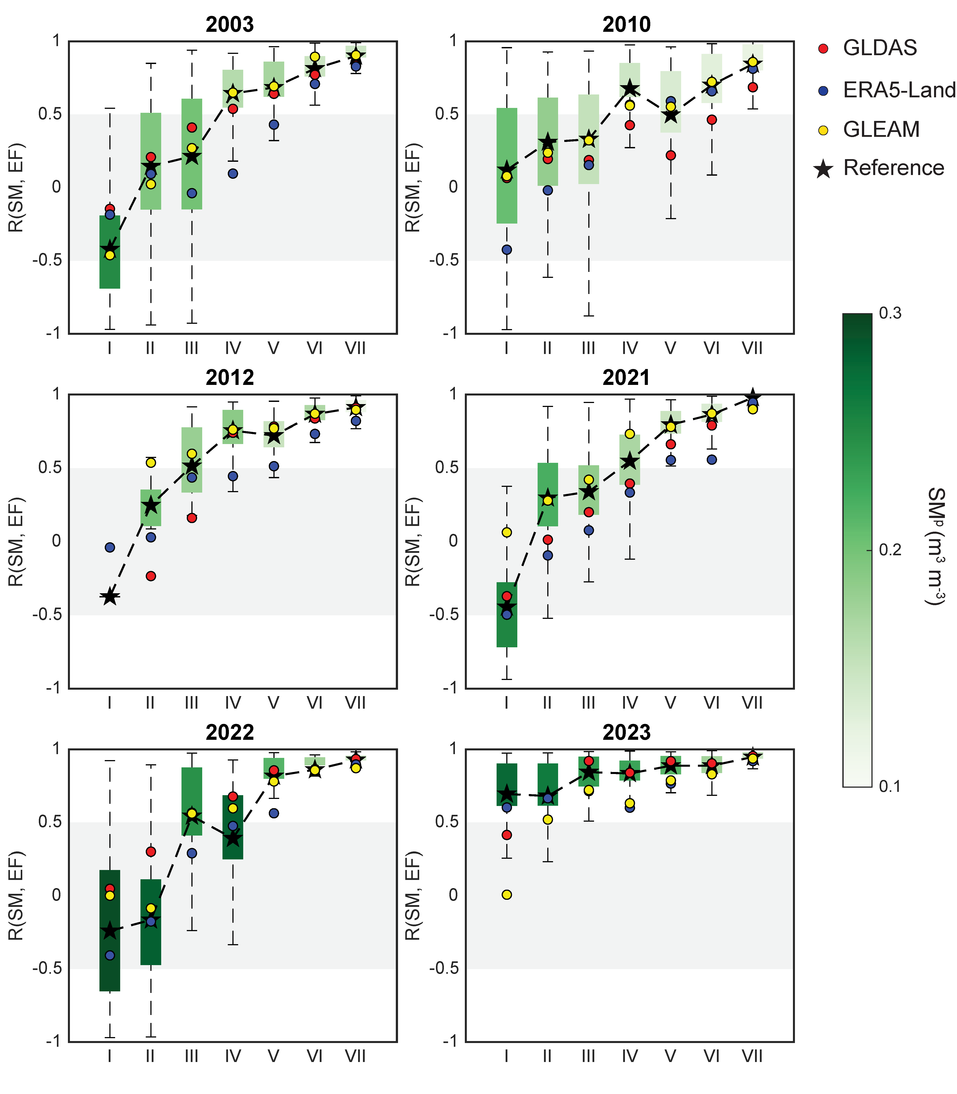
Supplementary Figure 4. Regime-dependent variations in SM and EF for six compound drought-heatwave events. Box plot showing the temporal correlation between SM and EF (R(SM, EF)) within a 31-day time window. The plot structure is identical to Supplementary Fig. 3, but the ordinate represents R(SM, EF), with the colors inside the boxes corresponding to the SM on day 0 (SM^{p}) for the respective regimes. The gray area indicates the range of R(SM, EF) from -0.5 to 0.5.

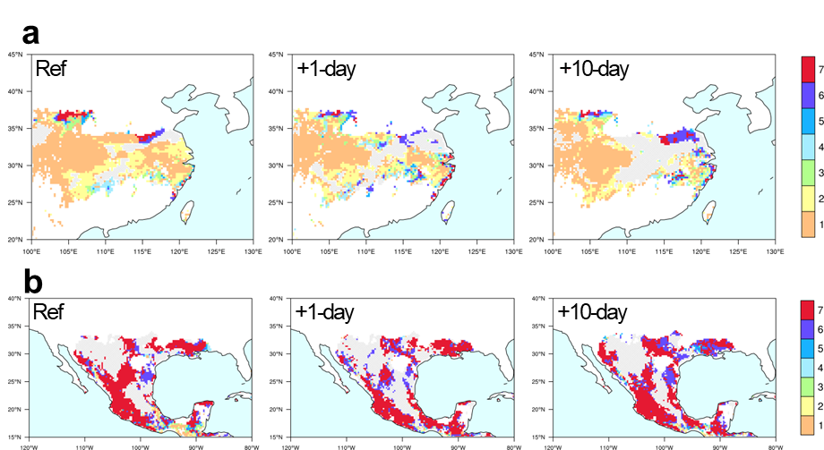Supplementary Figure 5. Spatial patterns of land-atmosphere coupling regimes for compound drought-heatwave events in 2022 and 2023. Spatial patterns of the land-atmosphere coupling regimes for the a 2022 and b 2023 cases. Color shadings represent the land-atmosphere coupling regimes, with hatched areas indicating regions not classified into Regime I–Regime VII (gray blocks in Fig. 4c and Fig. 4d). The legend on the right provides color reference for each regime. Each column corresponds to results derived from the reference dataset, +1-day forecast of SHiELD, and +10-day forecast of SHiELD, respectively.

