Appendix 1 – Graphical representation of the spread of data for each scale.
BMQ Scale Scores
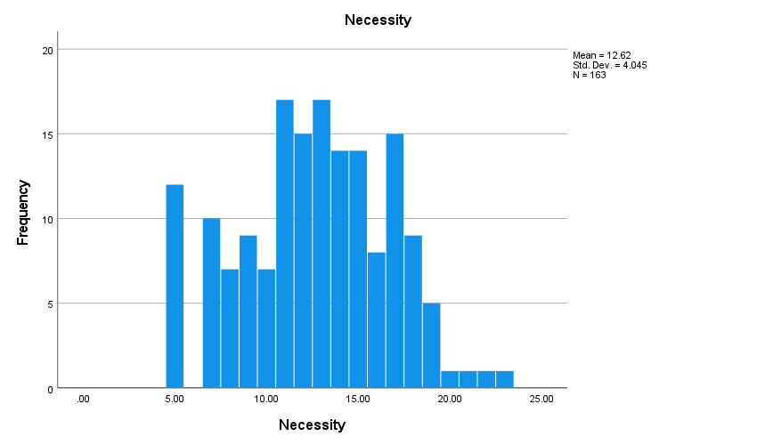
Figure A1. Distribution of BMQ-Necessity Scale Scores (n=163)

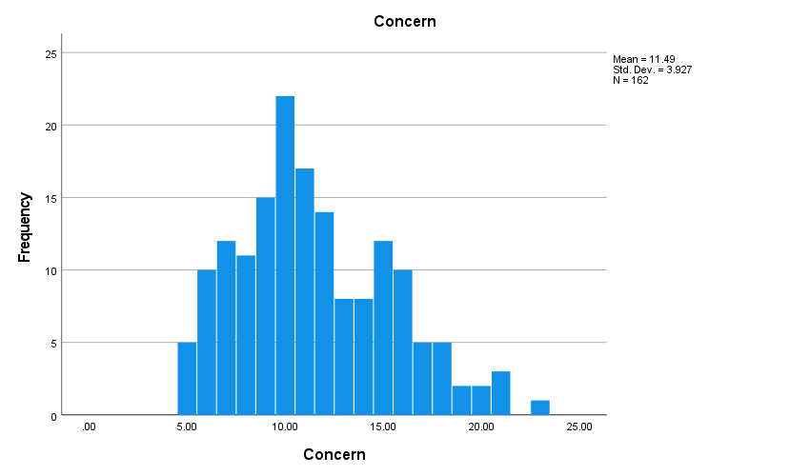
Figure A2. Distribution of BMQ-Concern Scale Scores (n=162)
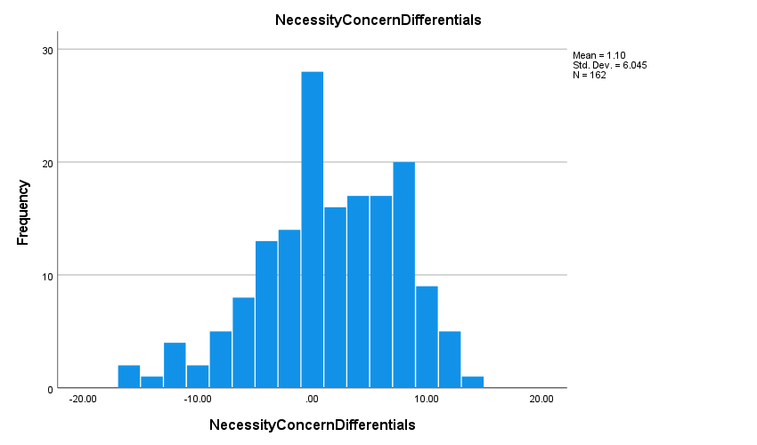
Figure A3. Necessity-Concern Differential Scale Scores (n=162)
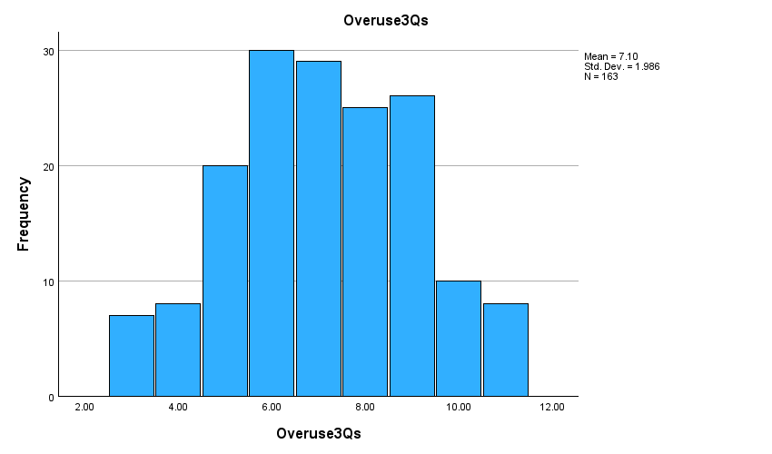
Figure A4. Distribution of BMQ-Overuse Scale Scores (n=162)

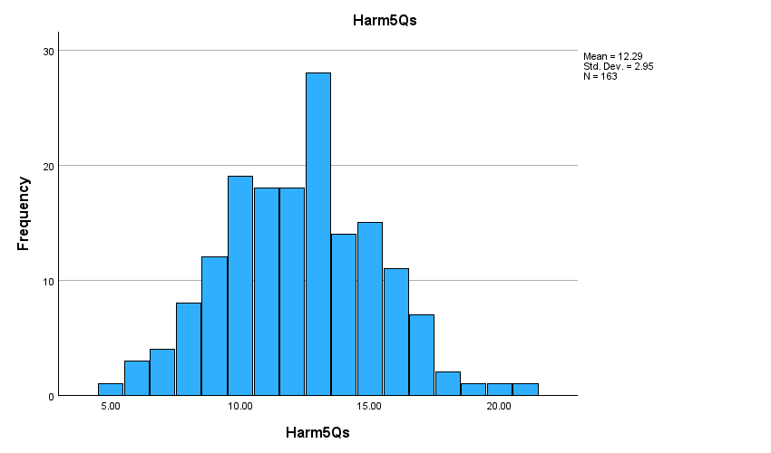
Figure A5. Distribution of BMQ-Harm Scale Scores (n=163)

Vaccine Conspiracy Mentality Scale Scores
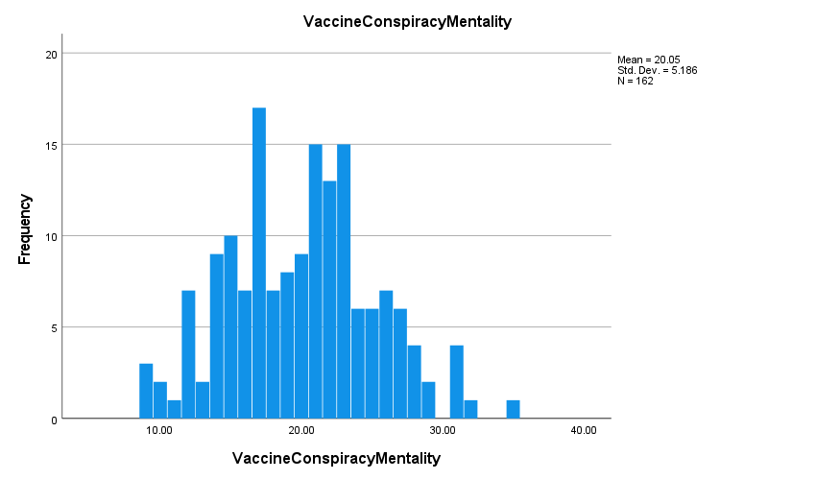
Figure A6. Distribution of Vaccine Conspiracy Mentality Scores

Oxford COVID-19 Vaccine Hesitancy Scores

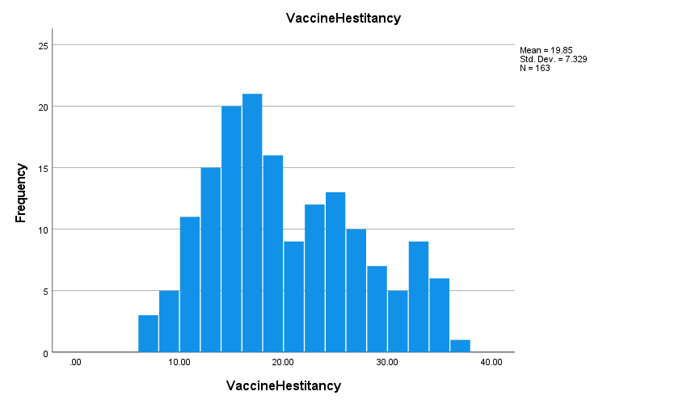
Figure A7. Distribution of Vaccine Hesitancy Scores (n=163)

COVID-19 Vaccine Uptake
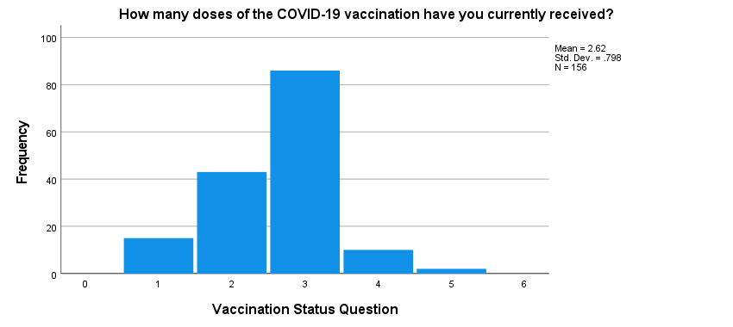
Figure A8. Distribution of Vaccine Uptake – Number of doses (n=156)

In summary, BMQ-Specific Necessity (Figure A1) and Necessity-Concern Differential scores (Figure A3) were normally distributed, the scores for BMQ-Concern (Figure A2), Vaccine Conspiracy Mentality (Figure A7), BMQ-Overuse (Figure A4), BMQ-Harm (Figure A5) and Vaccine Hesitancy (Figure A8) were positively skewed, meaning that lower scores were more common. Scores for Vaccine Uptake (Figure A6) were negatively skewed, meaning that higher scores were more common.
Table A1: Correlation Matrix for Vaccination Adherence Behaviours, Vaccination Beliefs and Conspiracy Mentality
 | Vaccine Hesitancy rho=,n=,p= | Vaccine Uptake rho=,n=p= | BMQ – Specific Necessity rho=,n=,p= | BMQ – Specific Concerns rho=,n=,p= | Necessity-Concerns Differential rho=,n=,p= | BMQ – General Harm  rho=,n=,p= | BMQ- General  Overuse  rho=,n=,p= | Conspiracy Mentality rho=,n=,p=
Vaccine  Hesitancy | 1
Vaccine  Uptake | -0.426  156  <0.001 | 1
BMQ –  Necessity | -0.630  163  <0.001 | 0.327  156  <0.001 | 1
BMQ -  Concerns | 0.576  160  <0.001 | -0.355  155  <0.001 | -0.125  162  =0.114 | 1
Necessity-Concerns  Differential | -0.823  162  p<0.001 | 0.476  155  <0.001 | 0.751  162  <0.001 | -0.721  162  <0.001 | 1
BMQ - Harm | 0.334  163  <0.001 | -0.092  156  0.256 | -0.184  163  =0.019 | 0.346  162  <0.001 | -0.344  162  <0.001 | 1
BMQ -  Overuse | 0.291  163  <0.001 | -0.124  156  0.124 | -0.200  163  =.010 | 0.326  162  <0.001 | -0.321  162  <0.001 | 0.619  163  <0.001 | 1
Conspiracy  Mentality | 0.651  162  p<0.001 | -0.310  155  <0.001 | -0.447  162  <0.001 | 0.561  161  <0.001 | -0.659  161  <0.001 | 0.372  162  <0.001 | 0.466  162  <0.001 | 1
Relationships between Vaccination Adherence Behaviours, Beliefs about Vaccination and Conspiracy Mentality
Vaccine Hesitancy scores were significantly positively correlated with BMQ-Concerns (rho = 0.576, n=160, p = <.001), BMQ- Harm (rho= 0.334, n=163, p<0.001), BMQ-Overuse (rho=0.291, n=163, p<0001) and Conspiracy Mentality (rho=0.651 , n=160, p<0.001) scores and highly negatively correlated with BMQ-Necessity (rho = -0.630, n=161, p = <.001) and Necessity-Concerns Differential scores (rho=-0.823, n=160, p <0.001). Vaccine Uptake was significantly negatively correlated with BMQ-Concerns (rho=0.355, n=153, p<0.001) and Conspiracy Mentality (rho=0.43, n=154, p<0.001) scores and positively correlated with BMQ-Necessity (rho = 0.33, n=154, p = <.001) and Necessity-Concern Differential (rho = 0.48, n=153, p<.001) scores. Reported Vaccine Uptake was not correlated with BMQ- Harm scores. Vaccine Hesitancy scores and self-reported Vaccine Uptake were significantly negatively correlated (rho = -0.43, n=153, p = <.001).

Inter-relationship between variables
Significantly positive correlations were found between BMQ-Concerns and BMQ-Overuse (rho=0.326, n=162, p<0.001), BMQ-Harm (rho=0.346, n=162, p<0.001) and Conspiracy Mentality (rho= 0.561, n=161, p<0.001) scores. BMQ-Overuse scores were also positive correlated with BMQ-Harm (rho=0.61, n=163, p<0.001) and Conspiracy Mentality (rho=0.466, n=161, p<0.001) scores.

