A New Class of Reference Material: Additivly Manufactured Monodisperse Number Accurate Microplastic Reference Material through Microextrusion
Maurice Hauffeª, Lucas Kurzweg^{b}, Robert Möhnª, Tilmann Priebe^{b}, Thomas Himmerª, Kathrin Harre^{b*}
ª Faculty of Mechanical Engineering, University of Applied Sciences Dresden, Friedrich-List-Platz 1, 01069 Dresden, Germany
^{b} Faculty of Agriculture, Environment and Chemistry, University of Applied Sciences Dresden, Friedrich-List-Platz 1, 01069 Dresden, Germany
* Correspondence:
Name: Kathrin Harre
E-Mail: kathrin.harre@htw-dresden.de
Address: University of Applied Sciences Dresden, Friedrich-List-Platz 1, 01069 Dresden, Germany

Supplementary Information

Supplementary Information SI 1: Properties of Polymer Filaments
Polymer | Name | Manufacturer | Diameter ± Deviation in mm | Recommended Nozzle Temperature in °C | Speciality/ Additive
PLA | PLA+ weiß | eSUN | 1.75 ± 0.03 | 210 - 230 | Tough Material
PLA | Luminous PLA glow green | eSUN | 1.75 ± 0.03 | 190 - 230 | Fluorescent
PCL | Facilan PCL100 | 3D4Makers | 1.75 ± n. s. | 190 - 170
PMMA | PMMA transparent | Material4Print | 1.75 ± 0.02 | 240 - 270
PA6/6.6 | PA6/66 (Nylon) | Flashforge | 1.75 ± n. s. | 220 - 260 | Polymer Blend
LDPE | CE20_LDPE-st_cl (Lupolen 2420K) | Self-Extruded, (Granulate by LyondellBasell) | 1.75 ± 0.03 | n. s.

Supplementary Information SI 2: Parameters for manufacturing of LDPE Filament on The Collin Teachline (CE20 Extruder + Collin Water Bath WB850 + Collin Filament-Rewinder BAW130)
Granulate | Lupolen 2420 K (Manufacturer: LyondellBasell)
Temperature Extruder  Zone 1 (Inlet):  Zone 2:  Zone 3:  Zone 4:  Zone 5 (Nozzle): | 35  170  180  185  190
Nozzle Opening Diameter in mm | 3
Filament Exit Angle in ° | 45
Speed of Extruder Screw in U/min | 28
Pressure on the nozzle in bar | 14
temperature water bath in °C | 60
Path length of Filament through water bath in m | 1,2
Take-Off Speed in m/min | 5,55
Winding Torque in Nm | 0,55

Supplementary Information SI 3: Results of Self-Extruded LDPE-Filament
Position | Diameter 1 in mm | Diameter 2 in mm | Ovality in %
1 | 1,75 | 1,71 | 2,29
2 | 1,75 | 1,73 | 1,15
3 | 1,71 | 1,75 | 2,29
4 | 1,74 | 1,80 | 3,44
5 | 1,78 | 1,73 | 2,86
6 | 1,74 | 1,77 | 1,72
7 | 1,72 | 1,75 | 1,72
8 | 1,72 | 1,72 | 0,00
9 | 1,78 | 1,78 | 0,00
10 | 1,76 | 1,73 | 1,72
11 | 1,75 | 1,77 | 1,15
12 | 1,77 | 1,71 | 3,44
13 | 1,72 | 1,73 | 0,57
14 | 1,74 | 1,78 | 2,29
Average (± standard deviation) | 1,75 ± 0,03 |  | 1,76

Supplementary Information SI 4: DSC-Measurement of LDPE-Self-Extruded Filament
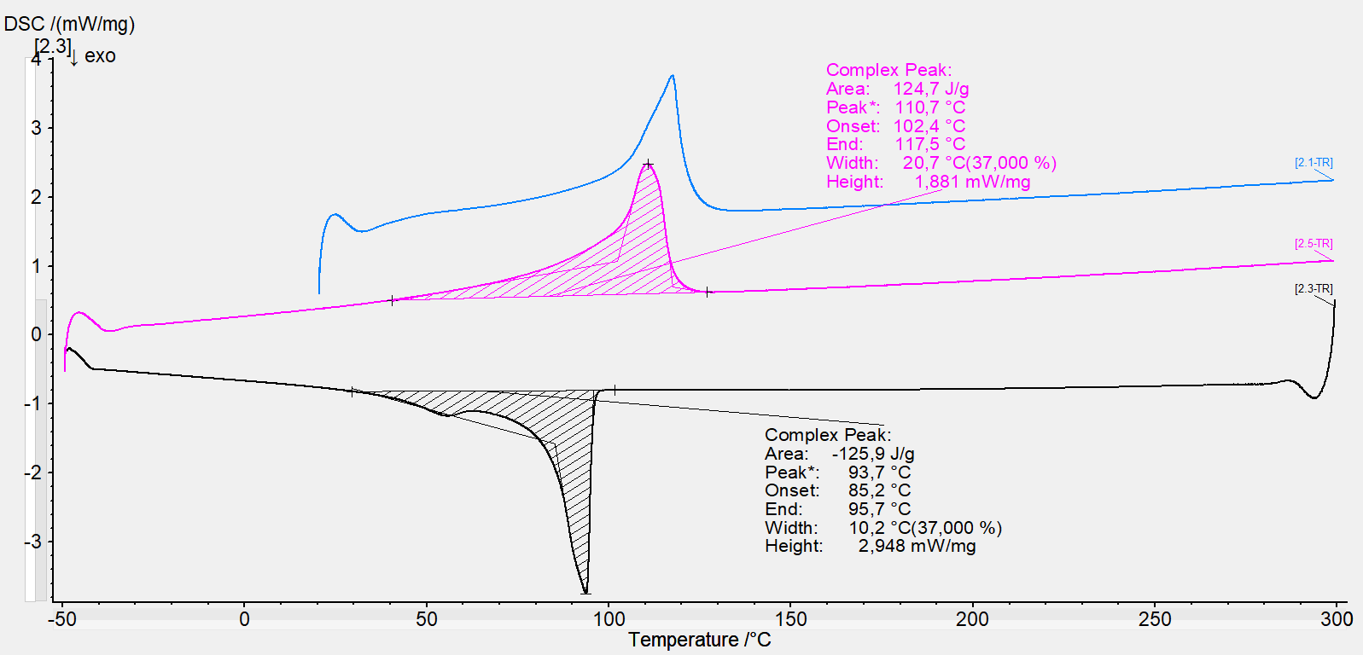

Supplementary Information SI 5: DTA-TGA Measurement of LDPE-Self-Extruded Filament

Supplementary Information SI 6: DTA-TGA Measurement of PA Filament from the Manufacturer Flashforge

Supplementary Information SI 7: Picture of the Shape of Additive Manufactured Particles from the Side
