Appendix
Appendix 1. Supportive Care Screening Tool questionnaire
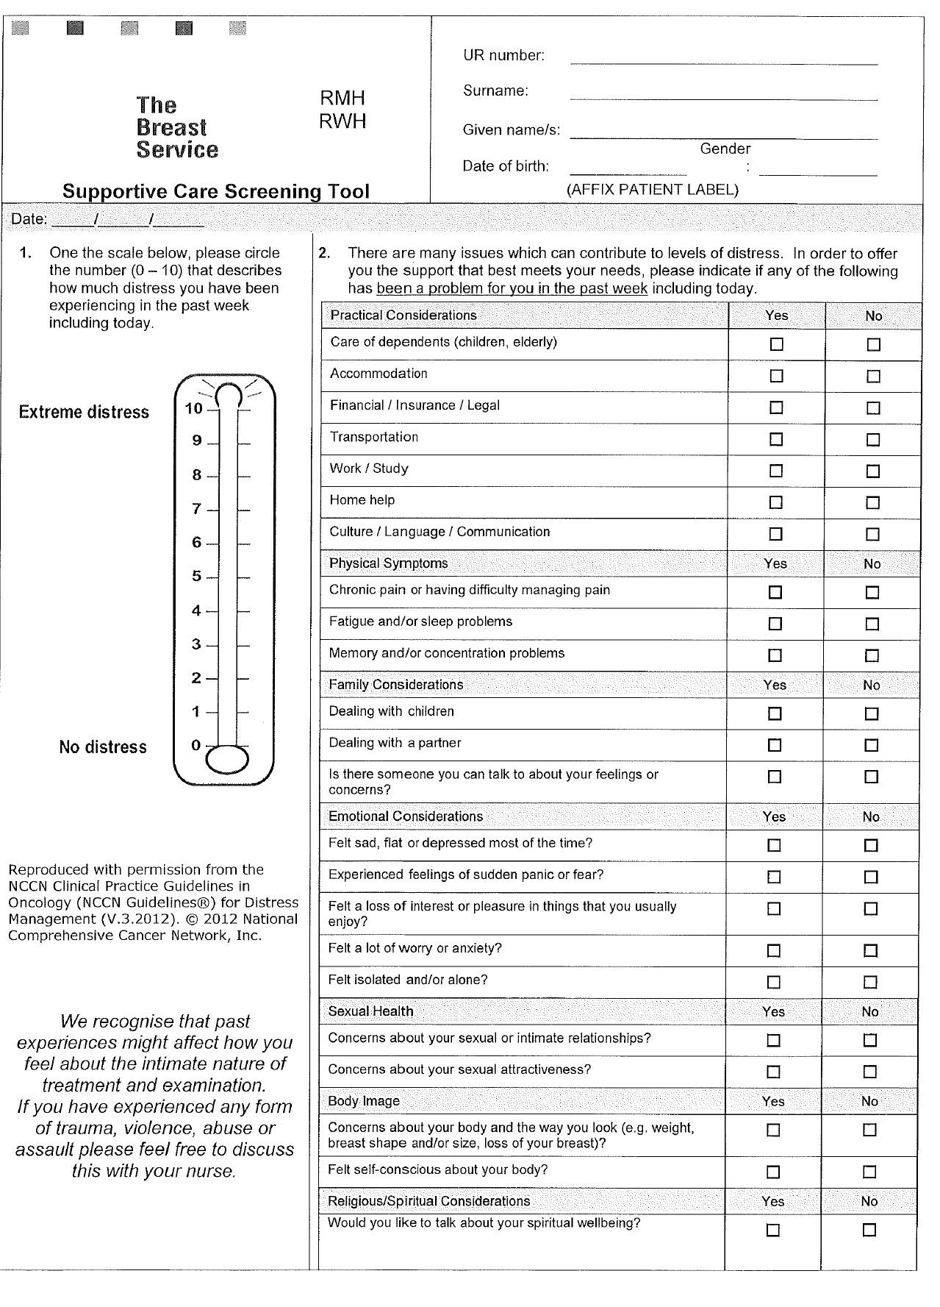
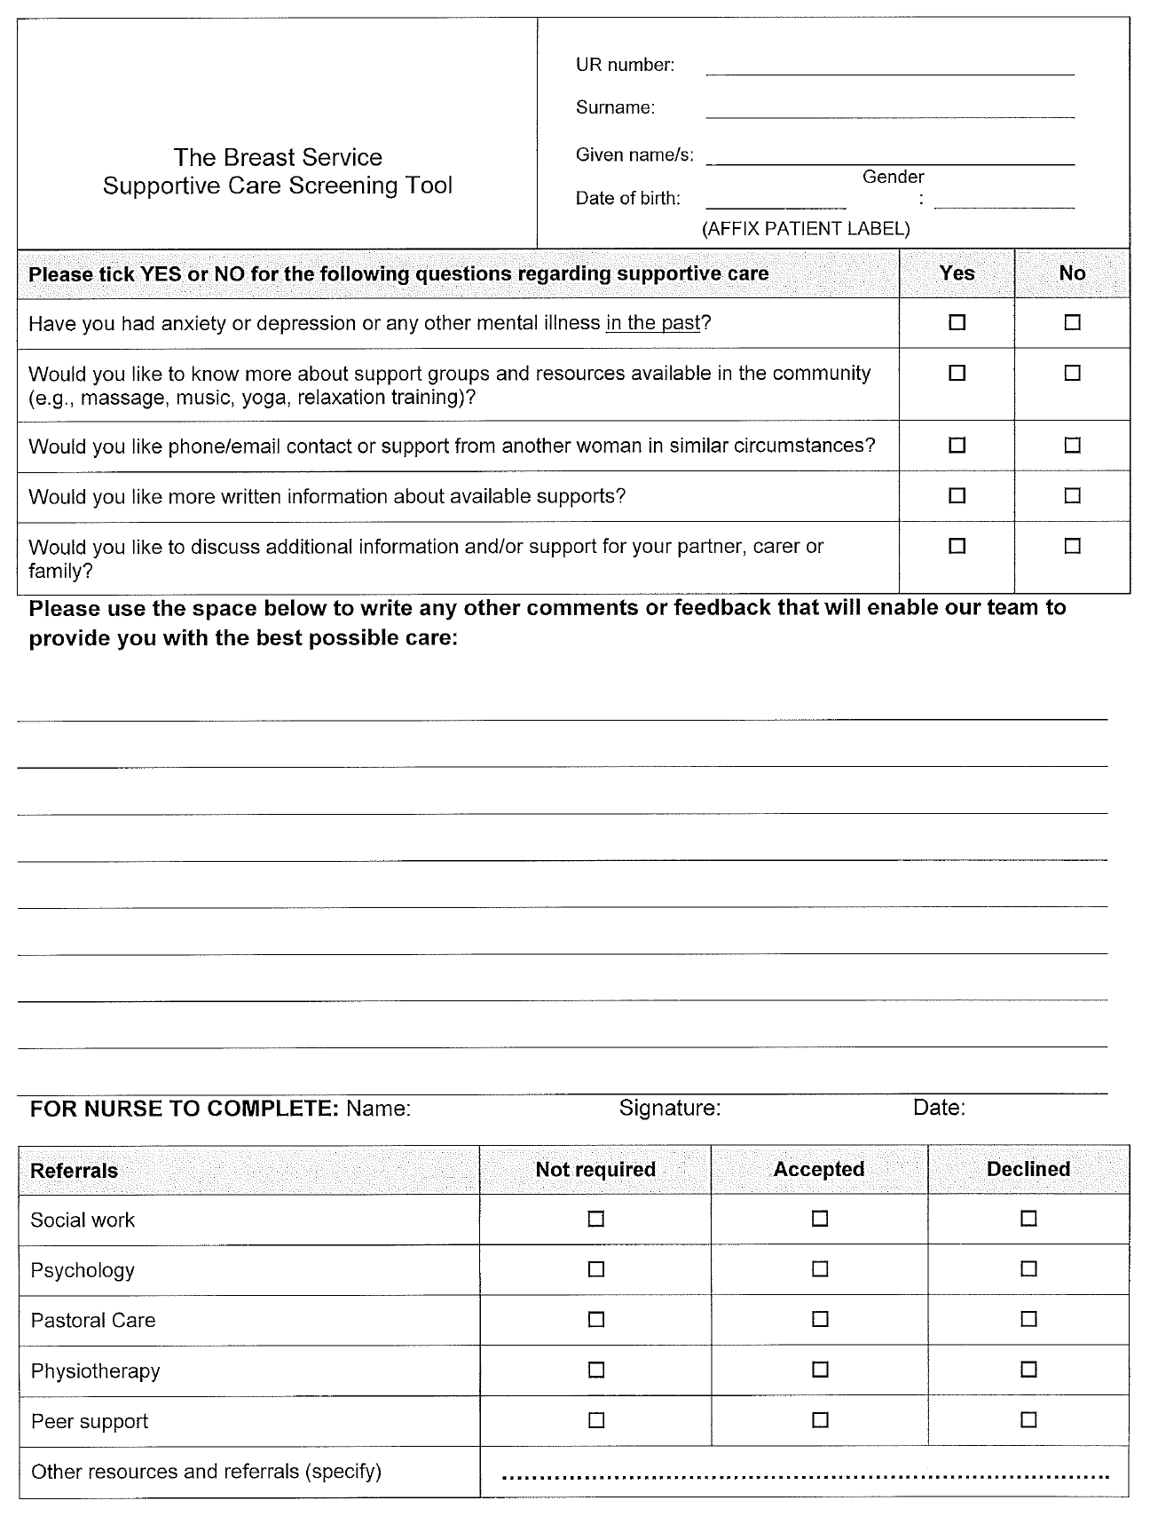

Appendix 2. Demographic characteristics of participants who have completed ePROMS and attended NLC
Total number of participants | N=47
Mean age of participants | 59 years old (S.d 9.3)
Interpreter | Yes:3(6.4%), No:44 (  93.6%)
Primary language | English: 42(89.4%)  Arabic: 2 (4.3%)  Vietnam: 2(4.3%)  Auslan: 1(2.1)
Country of birth | Australia: 27 (57.4%)  England: 5 (10.6%)  Lebanon: 3 (6.4%)  Turkey: 2 (4.3%)  Vietnam: 2 (4.3%)  Egypt: 2(4.3%)  Angola: 1 (2.1%)  Argeti:1(2.1%)  Germany: 1 (2.1%)  India:1(2.1%)  Indonesia: 1(2.1%)  New Zealand: 1 (2.1%)

November 26, 2024
To Whom It May Concern:
I am writing in response to the request to include the screenshot copied herein—which include Epic’s software—in an article entitled “Introduction of a digital care companion to facilitate PROMS and Breast Care Nurse-Led Survivorship” (Mao, et al.) to be published in Discover Public Health.
Epic Systems Corporation hereby grants ASCO Publications, as the publisher of the Patient-Patient-Centered Outcomes Research, limited permission to publish in all formats (i.e., print and digital) such screenshot as part of the journal referenced herein, provided that the screenshot is not subject to any Creative Commons or similar license and copyright attribution is provided to Epic Systems Corporation in conjunction with the screenshot.
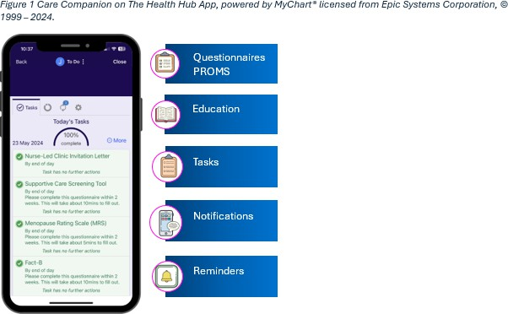

Thank you for your part in protecting Epic’s intellectual property. Please feel free to contact me at
trademarks@epic.com if you have any questions. Sincerely,

Patrick C. Harrigan
Patrick Harrigan Attorney
Epic Systems Corporation

1979 Milky Way | Verona, WI 53593 | 608.271.9000 | FAX: 608.271.7237 | www.epic.com

