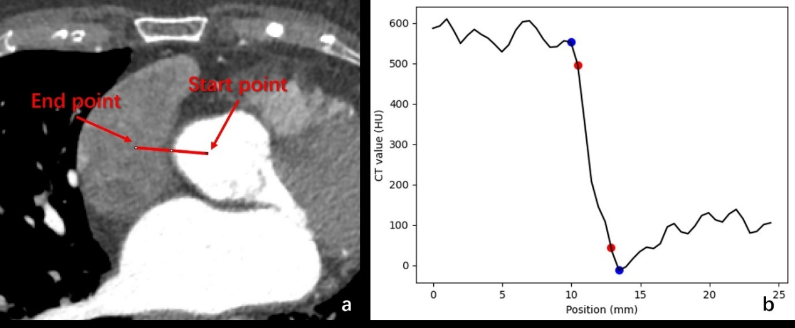
Figure S1 Examples of quantitative measurement used in the study.
(a) Draw a perpendicular line on the target vessel to generate a CT attenuation profile in panel b. (b) The blue dots are the last point of the profile before a rapid descent and the first point that tends to level off, and two red dots are 10% and 90% of the height difference between the blue points on the CT attenuation profile, respectively. The ERS is defined as the slope between two red dots, the ERD is defined as the change in the horizontal coordinate between two red dots.
ERS, edge-rise-slope; ERD, edge rise distance.

