Appendix.
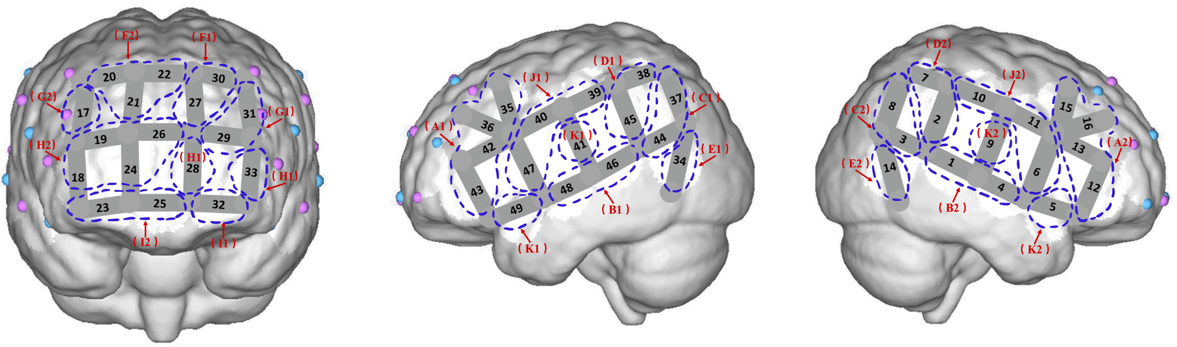
Brain regions division from the front-, left-, and right hemisphere angles

Brain regions, channels and brain areas
SD | channel |  |  | BA | Brin regions | Code for brain regions
S16-D14 | 35 |  |  | 44 | L-Broca | A1
S17-D14 | 36 |  |  | 45 | L-Broca | A1
S20-D14 | 42 |  |  | 45 | L-Broca | A1
S20-D16 | 43 |  |  | 45 | L-Broca | A1
S5-D2 | 12 |  |  | 45 | R-Broca | A2
S5-D4 | 13 |  |  | 45 | R-Broca | A2
S7-D4 | 15 |  |  | 44 | R-Broca | A2
S8-D4 | 16 |  |  | 45 | R-Broca | A2
S21-D15 | 46 |  |  | 22 | L-21,22 | B1
S22-D15 | 48 |  |  | 21 | L-21,22 | B1
S1-D1 | 1 |  |  | 22 | R-21,22 | B2
S2-D1 | 4 |  |  | 21 | R-21,22 | B2
S18-D12 | 37 |  |  | 39 | L-39 | C1
S21-D12 | 44 |  |  | 39 | L-39 | C1
S1-D5 | 3 |  |  | 39 | R-39 | C2
S3-D5 | 8 |  |  | 39 | R-39 | C2
S18-D13 | 38 |  |  | 40 | L-40 | D1
S21-D13 | 45 |  |  | 40 | L-40 | D1
S1-D3 | 2 |  |  | 40 | R-40 | D2
S3-D3 | 7 |  |  | 40 | R-40 | D2
S15-D12 | 34 |  |  | 37 | L-37 | E1
S6-D5 | 14 |  |  | 37 | R-37 | E2
S19-D13 | 39 |  |  | 2 | L-motorsensory | J1
S19-D14 | 40 |  |  | 6 | L-motorsensory | J1
S22-D14 | 47 |  |  | 6 | L-motorsensory | J1
S2-D4 | 6 |  |  | 6 | R-motorsensory | J2
S4-D3 | 10 |  |  | 1 | R-motorsensory | J2
S4-D4 | 11 |  |  | 6 | R-motorsensory | J2
S19-D15 | 41 |  |  | 43 | L-43 | K1
S22-D16 | 49 |  |  | 38 | L-38 | K1
S4-D1 | 9 |  |  | 43 | R-43 | K2
S2-D2 | 5 |  |  | 38 | R-38 | K2
S12-D9 | 27 |  |  | 9 | L-9 | F1
S13-D9 | 30 |  |  | 9 | L-9 | F1
S10-D9 | 22 |  |  | 9 | M-9 | F2
S10-D6 | 20 |  |  | 9 | R-9 | F2
S10-D8 | 21 |  |  | 9 | R-9 | F2
S12-D11 | 29 |  |  | 46 | L-46 | G1
S13-D11 | 31 |  |  | 46 | L-46 | G1
S9-D6 | 17 |  |  | 46 | R-46 | G2
S12-D10 | 28 |  |  | 10 | L-10 | H1
S14-D11 | 33 |  |  | 10 | L-10 | H1
S12-D8 | 26 |  |  | 10 | M-10 | H2
S9-D7 | 18 |  |  | 10 | R-10 | H2
S9-D8 | 19 |  |  | 10 | R-10 | H2
S11-D8 | 24 |  |  | 10 | R-10 | H2
S14-D10 | 32 |  |  | 11 | L-11 | I1
S11-D10 | 25 |  |  | 11 | M-11 | I2
S11-D7 | 23 |  |  | 11 | R-11 | I2

