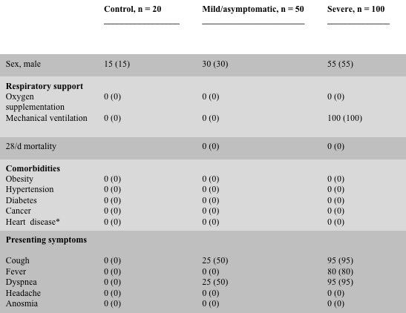
Table 1. Characteristics of COVID-19 patients and control subjects

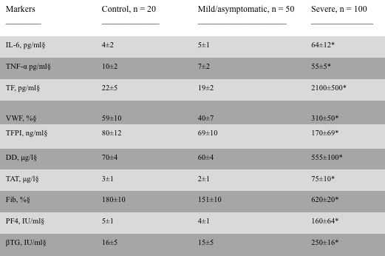
§Reference values of IL-6 (< 7.0 pg/ml), TNF-α (8-10 pg/ml), TF (15.6-1000 pg/ml), VWF (50-160%), TFPI (75-120 ng/ml), DD (50-200 μg/L), TAT (1.0-4.1 μg/L), Fib (170-400 mg/dL), PF4 (1-10 IU/ml), βTG (10-40 IU/ml)
Table 2. Inflammatory markers, endothelial markers, coagulation markers, platelet
markers in COVID-19 patients and control subjects
*P values: < .05 compared with controls

Table 3. PFA-100 parameters of COVID-19 patients and control subjects
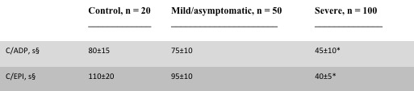
§Reference values of C(ADP (68-121 s), C/EPI (84-160 s)
*p values: <.05 compared with controls

Table 4. ROTEM parameters of COVID-19 patients and control subjects

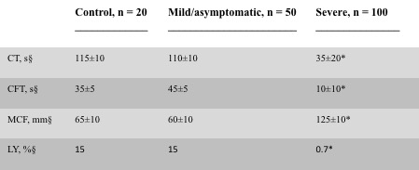
§Reference values of CT (100-240 s), CFT (30-160 s), MCF (50-72 mm), LY (15%)
*P values: < .05 compared with controls

