Supplementary Information

Supplementary Information 1. Retail price differences for electricity and gas.

Figure S1.Evolution of customer-weighted average retail electricity (bundled) and gas prices in the US (grey), California (green) and PG&E (orange). Data source from the US Energy Information Administration’s file [1], [2].

Supplementary Information 2. Bill impacts for different end-use electrification scenarios across household income groups and electricity tariffs.

Figure S2. Impact of various electricity rate structures and electrification scenarios on annual bill savings. Rate before electrification set to TOU-HVLF.
Supplementary Information 3. Bill impacts for different end-use electrification scenarios for households enrolled in different rate programs and electricity tariffs.
Figure S3. Impact of different electricity rates on annual bill savings across electrification scenarios, for customers enrolled in CARE, FERA or no low-income bill assistance programs. Rate before electrification set to TOU-HVLF.

Supplementary Information 4. NPV for different end-use electrification scenarios across household income levels. Default rate before electrification is TOU-HVLF.

Figure S4. Distribution of Net Present Value (NPV) of electrification across different scenarios (a-c) and income groups (colors). Median across all income groups shown in text. Rate before electrification set to TOU-HVLF.
Supplementary Information 5. Climate zones in California with increasing heat and cooling degree days (2025).

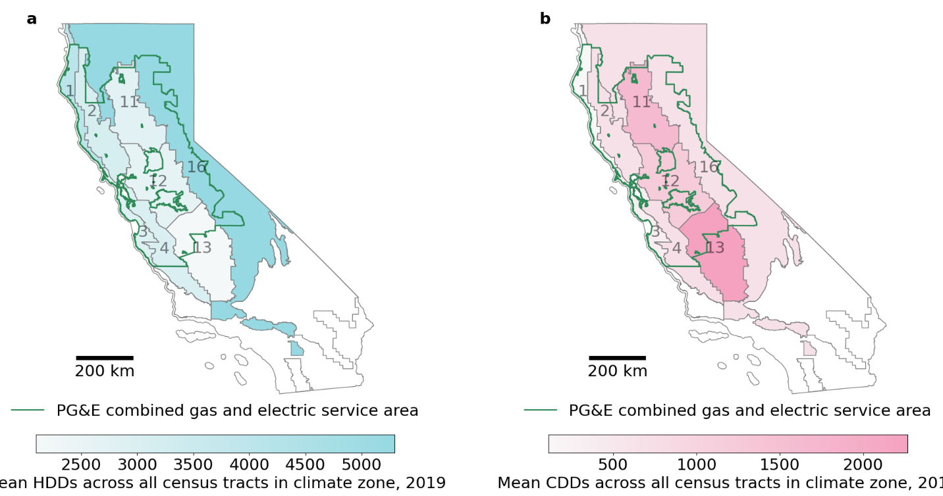

Figure S5. Distribution of heating degree days and cooling degree days per climate zones (numbered) that are part of the PG&E service territory (green outline).

Supplementary Information 6. Allocation of households according to electrification phasing strategy (2025-2050).
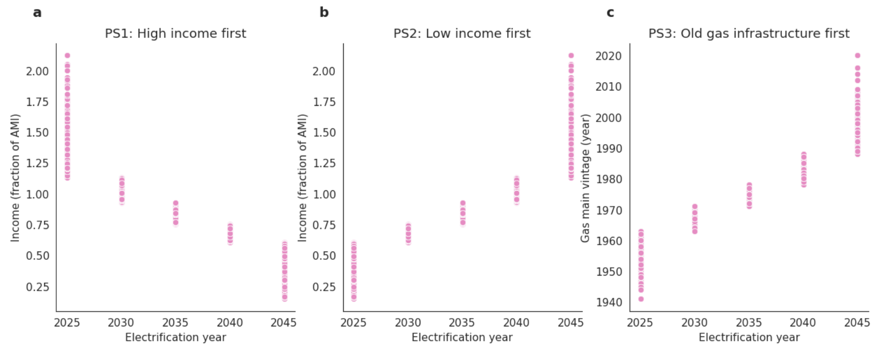

Figure S6. Assigned household incomes (based on 2019 median census block group income), or assigned mean year built of gas infrastructure (based on PG&E reported averages per census tract) for different phasing strategies: high income households electrify first (a) low income households electrify firs (b) and old gas infrastructure first (c).
Supplementary Information 7. Techno-economic parameters used to model electrification scenarios and phasing strategies.

Table S7. Values for techno-economic parameters for electrification scenarios and strategies (2025-2050).
 |  | Scenarios | Phasing Strategies
Year |  | 2025^{1/} | 2025 | 2030 | 2035 | 2040 | 2045
Electricity rate change factor (Increase) |  | - | 1.106 | 1.212 | 1.318 | 1.424 | 1.53
Electricity rate change factor (Decrease) |  | - | 0.894 | 0.788 | 0.682 | 0.576 | 0.47
Gas rate increases |  | - | 1.106 | 1.212 | 1.318 | 1.424 | 1.53
Heating demand scale factor | Z01 | - | 0.975 | 0.955 | 0.934 | 0.914 | 0.893
Heating demand scale factor | Z02 | - | 0.978 | 0.960 | 0.941 | 0.923 | 0.905
Heating demand scale factor | Z03 | - | 0.970 | 0.944 | 0.919 | 0.894 | 0.869
Heating demand scale factor | Z04 | - | 0.975 | 0.954 | 0.933 | 0.912 | 0.891
Heating demand scale factor | Z11 | - | 0.975 | 0.954 | 0.934 | 0.913 | 0.892
Heating demand scale factor | Z12 | - | 0.974 | 0.952 | 0.931 | 0.909 | 0.887
Heating demand scale factor | Z13 | - | 0.975 | 0.953 | 0.932 | 0.911 | 0.890
Heating demand scale factor | Z16 | - | 0.983 | 0.969 | 0.954 | 0.940 | 0.926
Cooling demand scale factor | Z01 | - | 1.248 | 1.454 | 1.660 | 1.866 | 2.073
Cooling demand scale factor | Z02 | - | 1.089 | 1.162 | 1.236 | 1.310 | 1.384
Cooling demand scale factor | Z03 | - | 1.079 | 1.145 | 1.211 | 1.277 | 1.342
Cooling demand scale factor | Z04 | - | 1.056 | 1.103 | 1.150 | 1.197 | 1.244
Cooling demand scale factor | Z11 | - | 1.035 | 1.064 | 1.093 | 1.122 | 1.151
Cooling demand scale factor | Z12 | - | 1.037 | 1.068 | 1.099 | 1.130 | 1.161
Cooling demand scale factor | Z13 | - | 1.028 | 1.052 | 1.076 | 1.099 | 1.123
Cooling demand scale factor | Z16 | - | 1.110 | 1.201 | 1.292 | 1.383 | 1.475
Inflation^{3/} |  | 5.6%  (2023-2025) | 2.5% | 2.5% | 2.5% | 2.5% | 2.5%
Gas cookstove cost^{4/} |  | $1600 | $1600 | $1600 | $1600 | $1600 | $1600
Gas furnace cost^{4/} |  | $4500 | $4500 | $4500 | $4500 | $4500 | $4500
Gas water heater cost^{4/} |  | $900 | $900 | $900 | $900 | $900 | $900
Gas furnace efficiency |  | 83% | 83% | 83% | 83% | 83% | 83%
Gas water heater efficiency |  | 83% | 83% | 83% | 83% | 83% | 83%
Gas stove to induction cookstove efficiency gain |  | 3 | 3 | 3 | 3 | 3 | 3
Centralized air-conditioning^{4/} unit cost |  | $5930 | $5930 | $5930 | $5930 | $5930 | $5930
Induction cookstove^{4/} |  | $2400 | $2400 | $2400 | $2400 | $2400 | $2400
Heat pump costs (ASHP – space heating) ^{5/} |  | $3753.78/ton | $3753.78/ton | $3593.10/ton | $3432.42/ton | $3271.75/ton | $3111.07/ton
Heat pump costs (WHHP – water heating) ^{5/} |  | $169.60/gal | $169.60/gal | $152.64/gal | $138.50/gal | $124.37/gal | $118.71/gal
Heat pump coefficient of performance (ASHP – space heating) |  | 3.375 | 3.375 | 3.750 | 4.000 | 4.250 | 4.323
Heat pump coefficient of performance (WHHP – water heating) |  | 3.250 | 3.250 | 3.500 | 3.625 | 3.750 | 3.750
Average emission for PG&E energy mix^{2/} |  | 0.12  tCO₂/MWh | 0.14  tCO₂/MWh | 0.09  tCO₂/MWh | 0.08  tCO₂/MWh | 0.04  tCO₂/MWh | 0.00005  tCO₂/MWh
^{1/}Load shapes are assumed to be kept equal from 2019-2025. Costs and bills are inflated to $2025 values.
^{2/} Emission factors are largely based on generator retirements and construction plans as well as state CO₂ emission targets. The uptake in marginal emissions in in the 2019-2025 timeframe derives from the fact that PG&E’s nuclear generation is projected to go offline by the end of 2024, so in 2025 that generation is being met by contracted imported fuels from outside of CA. In 2025, the model projects that the emissions from the “other” category will be higher than 2026 and thereafter (when imported electricity includes the retirement of a coal and a NG power plant a new nuclear plant) [3].
^{3/} Inflation derived from Consumer Price Index inflation calculator, with values of 3% from 2019-2024 and then the projected long-run inflation projection of 2.5%.
^{4/} These values are adjusted for inflation with the inflation scaling factor from 2023 to 2025 to reflect 2025 costs. They are then used directly in the NPV calculations, which internally account for inflation.
^{5/} These values are already inflation-adjusted to 2025. They are used directly in the NPV calculations, which apply internal inflation adjustments.
Supplementary Information 8. Month-hour variability of average electricity consumption and emissions reductions from electrification (2025-2050).

Figure S8. Heat maps showing changes in average month-hour profiles across for all homes electrified by 2045 (a). Median and 25-75th percentile change in annual emissions for households before and after electrification (b).

Supplementary Information 9. Summary of data used in the study.

Table S9. Description and sources of datasets used throughout the study.

Data | Description | Source
Metered gas and electricity use | Interval electricity data (hourly or 15-minute readings) and interval gas data (daily readings). | Pacific Gas and Electric Company  (PG&E) [4]
Local ambient temperatures | Daily average temperature from closest weather station. | National Oceanic and Atmospheric Administration  (NOAA) [5]
Hourly end-use shape for electric appliances | Normalized modeled ResStock hourly profile for air-sourced heat pumps, water heater heat pumps and induction cooking appliances. Averages computed for all modeled dwellings in the area of study. | National Renewable Energy Laboratory  (NREL) [6]
Current electricity and gas rates | Tariffs available and proposed for PG&E. | PG&E [7], [8]
Electricity and gas rates % decreases with diminishing customer pools | Empirical percentage gas rate increases for different levels of customers exiting the gas network, 2025-2050. Same percentage changes are applied to electricity to model increases and decreases in electricity rates, 2025-2050. Percentage changes are applied to variable costs of original flat rate gas and electricity tariffs. | Davis and Hausman (2021) [9]
Heating and cooling degree days | Projected heating and cooling degree days (HDDs and CDDs) in 5-year intervals from 2025 to 2050 for each census tract, calculated by averaging HDD and CDD projections across 10 downscaled General Circulation Models | Cal-Adapt (California’s climate adaptation data platform, managed by the California Energy  Commission) [10]
Heat pump costs and coefficient of performance | Upfront costs decline with increasing heat pump market penetration | Tech California [11], NREL [12]
Carbon emissions reduction potential | Average emission from energy mix decline with changing PG&E electric mix | Grubert (2021) [3]
Induction cooking stove, Gas stove, gas furnace and gas water heater costs | Upfront costs stay the same | California Air Resources Board  (CARB) [13]
Income and number of household members. | American Community Survey 5 year estimates of census-tract level estimates of median household income and median number of household members. | United States Census Bureau [14]
Income levels classification. | Area Median Income estimates based on the midpoint of a specific area’s (sub-county) income distribution. Estimates are used to classify average homes per census trat as low income (<80% AMI), moderate income (between 80% and 120% AMI),or high income (over 120% AMI). | United States Department of Housing and Urban Development  (HUD) [15]
Gas infrastructure vintage. | Census-tract average gas main installation date. | California Public Utilities Commission  (CPUC )[16]

Supplementary Information 10. Electricity and gas customers used in the study.

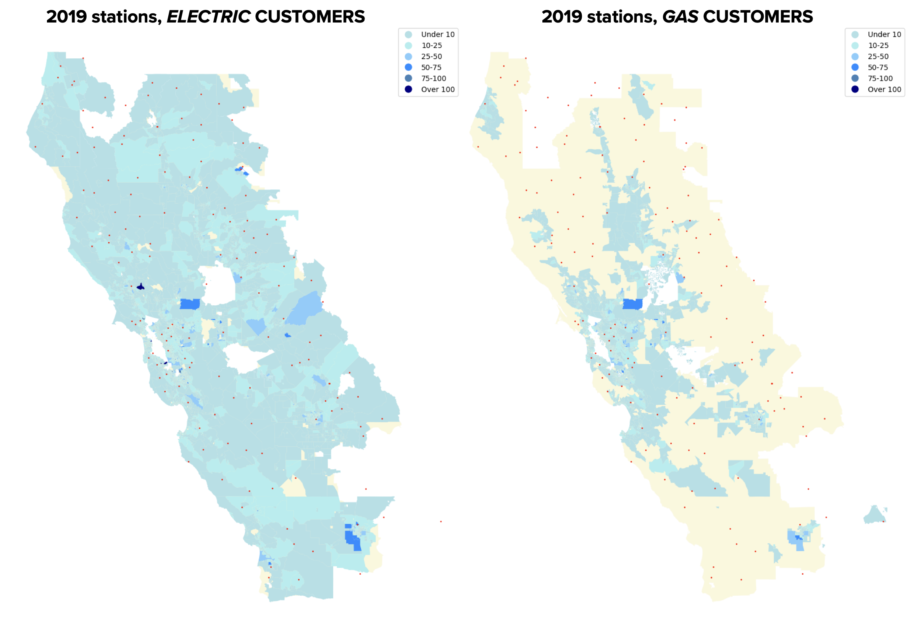
Figure S10. Count of 2019 PG&E customers per census block group for electricity (left) and gas (right) customers in the utility’s electric service territory. Red dots represent the weather stations used to match the closest weather station to the centroid of census block groups with customers used in the study.

Table S11. Number and distance of weather stations used in the study.
Year | Mean distance to 1st station (km) | Median distance to 1st station (km) | Number of unique stations matched
2019 | 14.48 | 12.43 | 144

Supplementary Information 11. Comparison of penetration of gas heating and space cooling in our initial dataset and California appliance saturation survey results.

Table S12. Penetration of heating and cooling appliances identified with 2019 PG&E usage data in this study and the California Energy Commission’s Residential Appliance Saturation Survey, 2019 (RASS) [17].

 | Fuel | Unit | Unit energy consumption^{1/}  RASS | Technology penetration PG&E (%)  RASS | Unit energy consumption^{1/}  Data in study | Technology penetration PG&E (%)  Data in study
All Household | Electricity | kWh | 6266 | 15967 homes | 7153 | 70181 homes^{2/}
Conv. Heat | Electricity | kWh | 1302 | 16 | 5190 all other | 30
Heat Pump | Electricity | kWh | 1163 | 3 | 5190 all other | 30
Central Air Conditioning | Electricity | kWh | 1132 | 51 | 1963 | 42
Water Heat | Electricity | kWh | 2071 | 7 | – | –
Range/Oven | Electricity | kWh | 344 | 58 | – | –
Electric vehicle | Electricity | kWh | 929 | 6 | – | –
All Household | Gas | therm | 416 | 10338 homes | 455 | 50414 homes^{2/}
Primary Heat | Gas | therm | 207 | 79 | 183 | 73
Conv. Gas Water Heat | Gas | therm | 259 | 89 | 270 all other | –
Range/Oven | Gas | therm | 22 | 63 | 270 all other | –
Dryer | Gas | therm | 13 | 30 | 270 all other | –
^{1/}Unit energy consumption here refers to the average amount of energy consumed by a specific appliance over a year.
^{2/}The PG&E data contains identifiers for different meters. We assume a perfect one-to-one mapping between usage meters and households. After quality checks and matching using customer account information we identify 28875 homes for which we have gas and electricity data in 2019, and are using gas for heating services.

Supplementary Information 12. Gas heating and electricity cooling identification based on daily energy use- temperature response graphs.

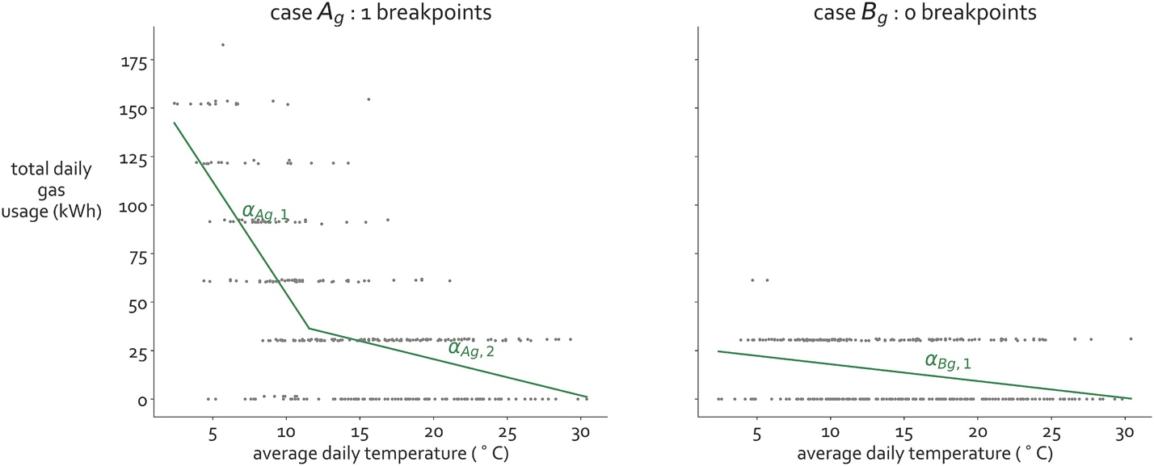

Figure S13. Examples of the two possible cases of gas usage-temperature piecewise regression results. Details on the cooling and heating identification methods can be found in Elmallah et al. (2024) [18].

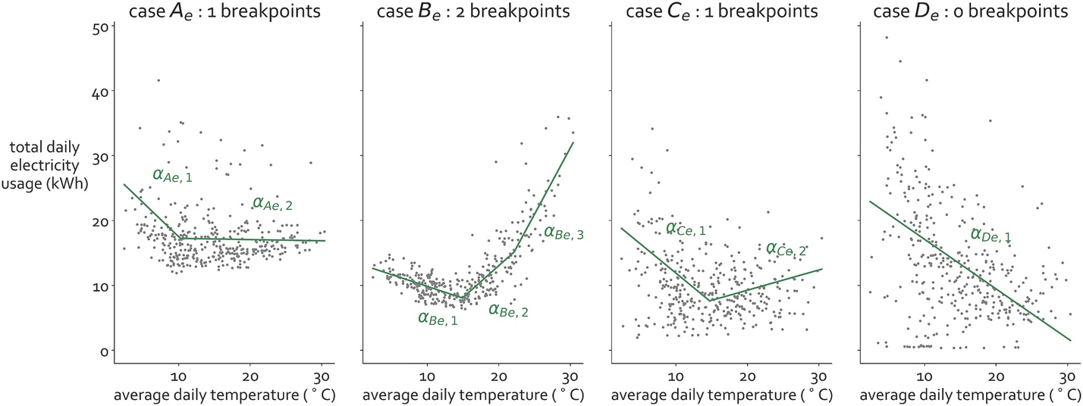

Figure S14. Examples of the four possible cases of electricity usage-temperature piecewise regression results. Details on the cooling and heating identification methods can be found in Elmallah et al. (2024) [18].

Supplementary Information 13. Overview of electrification scenarios and associated electricity tariffs in the study.

Table S15. Summary of end-use electrification scenarios and PG&E electricity tariffs (current or proposed as of September 2023). Gas tariffs used are always flat residential rates (PG&E’s G1 rate).

 | Flat rates (PG&E rate name: E1) | TOU-HVLF: Current time-of-use rates (PG&E rate name: TOU-C) | TOU-LVHF: PGE proposed time-of-use electrification rates  (PG&E rate name: E-ELEC) | TOU-LVHF-IB: Proposed Income Based Fixed Charge rate
SC0: Base case, pre-electrification | - | Original load shapes for gas and electricity.  TOU rates with 4-9pm peak hours, including weekends and low income rates applied. | - | -
SC1: Space heating electrification | Convert gas space heating usage to heat pump using average heat pump load profile in climate area.  Flat rates and low income rates applied. | Convert gas space heating usage to heat pump using average heat pump load profile in climate area.  TOU rates with 4-9pm peak hours, including weekends and low income rates applied. | Convert gas space heating usage to heat pump using average heat pump load profile in climate area.  Reduced variable costs TOU rates with 4-9pm peak hours, including weekends and low income rates applied | Convert gas space heating usage to heat pump using average heat pump load profile in climate area.  Reduced variable costs TOU rates with 4-9pm peak hours, including weekends and low income rates applied. Income-conditional fixed charges.
SC2: Full electrification | Convert gas usage to heat pumps using average heat pump load profiles in climate area.  Flat rates and low income rates applied. | Convert gas usage to heat pumps using average heat pump load profiles in climate area.  TOU rates with 4-9pm peak hours, including weekends and low income rates applied. | Convert gas usage to heat pumps using average heat pump load profiles in climate area.  Reduced variable costs TOU rates with 4-9pm peak hours, including weekends and low income rates applied. | Convert gas usage to heat pumps using average heat pump load profiles in climate area.  Reduced variable costs TOU rates with 4-9pm peak hours, including weekends and low income rates applied. Income-conditional fixed charges.
SC3: Increased cooling | Homes with no space cooling detected: Assign heat pump cooling load from median AC use in homes with cooling in same climate area.  Flat rates and low income rates applied. | Homes with no space cooling detected: Assign heat pump cooling load from median AC use in homes with cooling in same climate area.  TOU rates with 4-9pm peak hours, including weekends and low income rates applied. | Homes with no space cooling detected: Assign heat pump cooling load from median AC use in homes with cooling in same climate area.  Reduced variable costs TOU rates with 4-9pm peak hours, including weekends and low income rates applied. | Homes with no space cooling detected: Assign heat pump cooling load from median AC use in homes with cooling in same climate area.  Reduced variable costs TOU rates with 4-9pm peak hours, including weekends and low income rates applied. Income-conditional fixed charges.
Supplementary Information 14. Rate structures modeled to evaluate bill impacts of residential electrification.

Table S16. Modeled electricity rates based on PG&E’s current or proposed electricity time-of-use rate structures as of September 2023 [8].

Rate  Description | Delivery Minimum Amount  ($/meter/day) | Base services charge ($/meter/day) |  | Variable costs ($/kWh)^{5/} |  |  | Timing description
Residential Time-of-Use  Rate Schedule (E-TOU-C)^{1/}  (TOU-HVLF)^{2/} | $0.37612 |  |  | Summer | Peak | $0.53933 | 4:00 pm to 9:00 pm
 |  |  |  |  | Off-Peak | $0.45589 | Other times
 | $0.37612 |  |  | Winter | Peak | $0.43662 | 4:00 pm to 9:00 pm
 |  |  |  |  | Off-Peak | $0.40827 | Other times
Residential Time-of-Use Service  for Customers with Qualifying  Electric Technologies  (E-ELEC)^{1/}  (TOU-LVHF)^{2/} |  | $0.49281^{3/} |  | Summer | Peak | $0.56589 | 4:00 pm to 9:00 pm
 |  |  |  |  | Part-Peak | $0.40401 | 3:00 pm to 4:00 pm, 9:00 pm to 12:00 am
 |  |  |  |  | Off-Peak | $0.34733 | Other times
 |  |  |  | Winter | Peak | $0.33438 | 4:00 pm to 9:00 pm
 |  |  |  |  | Part-Peak | $0.31229 | 3:00 pm to 4:00 pm, 9:00 pm to 12:00 am
 |  |  |  |  | Off-Peak | $0.29843 | Other times
Income Based Fixed Charges  (TOU-LVHF-IB)^{2/} |  | CARE customer | $6^{4/} | Summer | Peak | $0.43700 | 4:00 pm to 9:00 pm
Income Based Fixed Charges  (TOU-LVHF-IB)^{2/} |  | FERA customer and <80% AMI | $12.08^{4/} | Summer | Off-Peak | $0.37300 | Other times
Income Based Fixed Charges  (TOU-LVHF-IB)^{2/} |  | Other customer | $24.15^{4/} | Winter | Peak | $0.34000 | 4:00 pm to 9:00 pm
Income Based Fixed Charges  (TOU-LVHF-IB)^{2/} |  |  |  | Winter | Off-Peak | $0.32200 | Other times
^{1/}Name given to the tariff by PG&E.
^{2/}Name given to the tariff by this study.
^{3/}Approximately $15 per month, irrespective of income group.
^{4/}Dollar amount charged per month.
^{5/}Customers enrolled in CARE receive a 35% discount on their electricity rates, for all tariffs. Customers enrolled in FERA receive a 18% discount on their electricity rates, for all tariffs.

Table S17. Modeled rates based on PG&E’s default electricity and gas flat rate structures as of September 2023 [7], [8].
Rate  Description | Delivery Minimum Amount  ($/meter/day) | Base services charge ($/meter/day) | Variable costs ($ per kWh or therm^{2/}) |  |  | Tier description
Flat electricity  rates  (E1)^{1/} | $0.37612 |  | Tier 1 | 0.35841 |  | usage $≤$ Baseline
Flat electricity  rates  (E1)^{1/} | $0.37612 |  | Tier 2 | 0.44692 |  | Baseline $<$ usage $≤4×Baseline$
Flat electricity  rates  (E1)^{1/} | $0.37612 |  | Tier 3 | 0.44692 |  | $4×Baseline <$ usage
Flat gas  rates  (G1)^{1/} | $0.13151 |  | Month  usage under/over Baseline | CARE customers | Other customers^{3/}
Flat gas  rates  (G1)^{1/} | $0.13151 |  | Under, month 1 | 2.14 | 2.68 | usage $≤$ Baseline
Flat gas  rates  (G1)^{1/} | $0.13151 |  | Under, month 2 | 2.20 | 2.75 | usage $≤$ Baseline
Flat gas  rates  (G1)^{1/} | $0.13151 |  | Under, month 3 | 1.69 | 2.11 | usage $≤$ Baseline
Flat gas  rates  (G1)^{1/} | $0.13151 |  | Under, month 4 | 1.24 | 1.55 | usage $≤$ Baseline
Flat gas  rates  (G1)^{1/} | $0.13151 |  | Under, month 5 | 1.18 | 1.48 | usage $≤$ Baseline
Flat gas  rates  (G1)^{1/} | $0.13151 |  | Under, month 6 | 1.23 | 1.54 | usage $≤$ Baseline
Flat gas  rates  (G1)^{1/} | $0.13151 |  | Under, month 7 | 1.28 | 1.60 | usage $≤$ Baseline
Flat gas  rates  (G1)^{1/} | $0.13151 |  | Under, month 8 | 1.31 | 1.64 | usage $≤$ Baseline
Flat gas  rates  (G1)^{1/} | $0.13151 |  | Under, month 9 | 1.46 | 1.82 | usage $≤$ Baseline
Flat gas  rates  (G1)^{1/} | $0.13151 |  | Under, month 10 | 1.59 | 1.99 | usage $≤$ Baseline
Flat gas  rates  (G1)^{1/} | $0.13151 |  | Under, month 11 | 1.65 | 2.06 | usage $≤$ Baseline
Flat gas  rates  (G1)^{1/} | $0.13151 |  | Under, month 12 | 1.80 | 2.25 | usage $≤$ Baseline
Flat gas  rates  (G1)^{1/} | $0.13151 |  | Over, month 1 | 2.45 | 3.06 | Baseline $<$usage
Flat gas  rates  (G1)^{1/} | $0.13151 |  | Over, month 2 | 2.51 | 3.14 | Baseline $<$ usage
Flat gas  rates  (G1)^{1/} | $0.13151 |  | Over, month 3 | 2.00 | 2.50 | Baseline $<$ usage
Flat gas  rates  (G1)^{1/} | $0.13151 |  | Over, month 4 | 1.55 | 1.94 | Baseline $<$ usage
Flat gas  rates  (G1)^{1/} | $0.13151 |  | Over, month 5 | 1.49 | 1.87 | Baseline $<$ usage
Flat gas  rates  (G1)^{1/} | $0.13151 |  | Over, month 6 | 1.54 | 1.93 | Baseline $<$ usage
Flat gas  rates  (G1)^{1/} | $0.13151 |  | Over, month 7 | 1.59 | 1.98 | Baseline $<$ usage
Flat gas  rates  (G1)^{1/} | $0.13151 |  | Over, month 8 | 1.63 | 2.04 | Baseline $<$ usage
Flat gas  rates  (G1)^{1/} | $0.13151 |  | Over, month 9 | 1.77 | 2.22 | Baseline $<$ usage
Flat gas  rates  (G1)^{1/} | $0.13151 |  | Over, month 10 | 1.91 | 2.39 | Baseline $<$ usage
Flat gas  rates  (G1)^{1/} | $0.13151 |  | Over, month 11 | 1.97 | 2.46 | Baseline $<$ usage
Flat gas  rates  (G1)^{1/} | $0.13151 |  | Over, month 12 | 2.12 | 2.65 | Baseline $<$ usage
^{1/}Name given to the tariff by PG&E.
^{2/}Customers enrolled in CARE and FERA receive a 35% and 18% discount on volumetric electricity rates, respectively. CARE customers also receive a 50% reduction in the minimum daily delivery amount.
^{3/}Customers enrolled in FERA do not receive discounts on gas rates.

Table S18. Seasonal residential baseline energy use allowances by PG\&E rate territory, reported for gas flat rate structures (therms) and electricity (kWh) flat rates and TOU-C rate as of September 2023. S = Summer (Electricity: June 1 - September 30; Gas: April 1 - October 31), W = Winter (Electricity: October 1 - May 31; Gas Off-Peak: November, February, March; Gas On-Peak: December and January).

Territory | Basic Electric (kWh/day) | All Electric  (kWh/day) | Residential Gas  (therm/day)
P | S: 13.5 | S: 15.2 | S: 0.39
P | W: 11.0 | W: 26.0 | W Off: 1.88
P |  |  | W On: 2.19
Q | S: 9.8 | S: 8.5 | S: 0.56
Q | W: 11.0 | W: 26.0 | W Off: 1.48
Q |  |  | W On: 2.00
R | S: 17.7 | S: 19.9 | S: 0.36
R | W: 10.4 | W: 26.7 | W Off: 1.24
R |  |  | W On: 1.81
S | S: 15.0 | S: 17.8 | S: 0.39
S | W: 10.2 | W: 23.7 | W Off: 1.38
S |  |  | W On: 1.94
T | S: 6.5 | S: 7.1 | S: 0.56
T | W: 7.5 | W: 12.9 | W Off: 1.31
T |  |  | W On: 1.68
V | S: 7.1 | S: 10.4 | S: 0.59
V | W: 8.1 | W: 19.1 | W Off: 1.51
V |  |  | W On: 1.71
W | S: 19.2 | S: 22.4 | S: 0.39
W | W: 9.8 | W: 19.0 | W Off: 1.14
W |  |  | W On: 1.68
X | S: 9.8 | S: 8.5 | S: 0.49
X | W: 9.7 | W: 14.6 | W Off: 1.48
X |  |  | W On: 2.00
Y | S: 10.5 | S: 12.0 | S: 0.72
Y | W: 11.1 | W: 24.0 | W Off: 2.22
Y |  |  | W On: 2.58
Z | S: 5.9 | S: 6.7 | N/A
Z | W: 7.8 | W: 15.7 | N/A

Supplementary Information 15. Calculating changes in marginal emissions, upfront costs efficiencies and climate projections in the 2025-2050 modeling.

To model end-use electrification strategies we use the raw electricity and gas usage data acquired through and NDA with PG&E, for 2019. To simulate bill savings, PG&E’s current and proposed gas rates and electricity rates are modeled in detail, as of September 2023. All techno-economic parameters are otherwise requires estimates for all parameters are modelled at 2025 levels.

To model electrification phasing strategies, we require estimates for all parameters in the 2025-2050 timeframe. We simulate bill savings using flat rates only, due to the complexity of forecasting changing dynamics of electricity rates. Gas rates increase according to [9], while electricity rate changes are supposed to either stay the same (increasing only with inflation) or increase or decrease according to the same percentage changes as gas rates. The rate of decline in costs are based on the National Renewable Energy Laboratory (NREL)’s End Use Load Profile (EULP) input data, which provides technology cost projections in 10-year intervals from 2015 to 2050 [19]; these values were linearly interpolated to obtain 5-year estimates. The 5-year estimates were then adjusted to 2025 dollars by first using the Consumer Price Index inflation calculator [20] to adjust from 2016 dollars (the unit provided in the original data) to 2024 dollars, and then the projected 2024-2028 long-run inflation projection of 2.5% [21] to adjust to projected 2025 dollars. For each year following 2025, a scaling factor was calculated to indicate how much costs were expected to decline relative to 2025. Finally, this scaling factor was applied to median actual installation costs as reported through a California state incentive program (adjusted to 2025 USD) to obtain estimated costs in 5-year intervals through 2050. To account for changes in heating and cooling loads due to climate change through 2050, using downscaled climate models [10]. Specifically, we obtain data from the 10 General Circulation Models (GCMs) recommended for use by state regulators for California energy utilities [22] that is statistically downscaled to a 0.04-degree grid by the state climate data repository Cal-Adapt. Using the modeled RCP 4.5 scenario, and assigning each grid cell in the GCM data to a census tract, we calculate projected heating and cooling degree days in each census tract by first averaging HDD and CDD projections across all 10 GCMs for the projection years 2048-2052 to obtain a 2050 estimate (a five-year average is taken to mitigate the impact of any outlier projections). Using this 2050 estimate along with actual observed 2019 HDDs/CDDs in each census tract, we use linear interpolation to project HDDs and CDDs in 5-year intervals from 2025 to 2050.

Supplementary Information 16. Calculating 15 minute peak from 60 minute maximum electricity use.

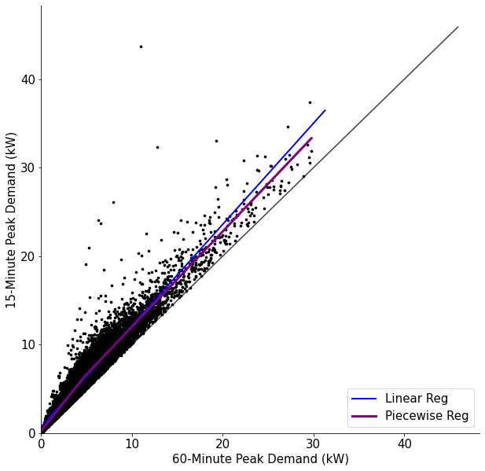
Figure S19. Conversion of 60-min peak demand to 15-min peak demand for 2019 electricity customers that have 15-min smart-meter data available (n = 23556). Piecewise linear regression function used to convert all electrifying customers’ hourly peak demand to 15-min peak.

References

[1] “Annual Electric Power Industry Report, Form EIA-861 detailed data files,” U.S. Energy Information Administration (EIA). Accessed: Jul. 24, 2024. [Online]. Available: https://www.eia.gov/electricity/data/eia861/
[2] “Natural Gas: Average Residential Price,” U.S. Energy Information Administration (EIA). Accessed: Jul. 24, 2024. [Online]. Available: https://www.eia.gov/dnav/ng/ng_pri_sum_a_EPG0_PRS_DMcf_a.htm
[3] E. Grubert, “Emissions projections for US utilities through 2050,” Environ. Res. Lett., vol. 16, no. 8, p. 084049, Aug. 2021, doi: 10.1088/1748-9326/ac1628.
[4] “PG&E’s Energy Data Request Portal.” Accessed: Jun. 18, 2024. [Online]. Available: https://www.pge-energydatarequest.com/
[5] “Global Historical Climatology Network daily (GHCNd),” NOAA National Center for Environmental Information. [Online]. Available: https://www.ncei.noaa.gov/products/land-based-station/global-historical-climatology-network-daily
[6] NREL, “End-Use Load Profiles for the U.S. Building Stock.” [Online]. Available: https://www.nrel.gov/buildings/end-use-load-profiles.html
[7] “PG&E Rate Information: Gas Rates.” [Online]. Available: https://www.pge.com/tariffs/en/rate-information/gas-rates.html#accordion-80734fc416-item-011aaaffe1
[8] “PG&E Rate Information: Electric Rates.” [Online]. Available: https://www.pge.com/tariffs/en/rate-information/electric-rates.html#accordion-a84c67dc1e-item-4eed88cb9a
[9] L. W. Davis and C. Hausman, “Who Will Pay for Legacy Utility Costs?,” NBER Working Paper Series, 2021, [Online]. Available: http://www.nber.org/papers/w28955
[10] “Cal-Adapt,” California Energy Commission. Accessed: Jun. 18, 2024. [Online]. Available: https://cal-adapt.org/
[11] “TECH Public Reporting Download Data.” Accessed: Aug. 28, 2024. [Online]. Available: https://techcleanca.com/heat-pump-data/download-data/
[12] E. Zhou and T. Mai, “Electrification Futures Study: Operational Analysis of U.S. Power Systems with Increased Electrification and Demand-Side Flexibility,” NREL/TP--6A20-79094, 1785329, MainId:33320, 2021. doi: 10.2172/1785329.
[13] “Residential Appliance Comparison,” California Air Resources Board. Accessed: Jun. 18, 2024. [Online]. Available: https://ww2.arb.ca.gov/our-work/programs/technology-clearinghouse/technology-clearinghouse-tools/residential-appliance-comparison
[14] U.S. Census Bureau, “American Community Survey, 5-year estimates 2016-2020,” 2020.
[15] Department of Housing and Urban Development, “Income Limits.” Accessed: Aug. 28, 2024. [Online]. Available: https://www.huduser.gov/Portal/datasets/il.html
[16] California Public Utilities Commission, “Long-Term Gas Planning Rulemaking.” Accessed: Aug. 28, 2024. [Online]. Available: https://www.cpuc.ca.gov/industries-and-topics/natural-gas/long-term-gas-planning-rulemaking
[17] “2019 California Residential Appliance Saturation Study (RASS),” California Energy Commission, 2021.
[18] S. Elmallah, C. Crespo Montañés, and D. Callaway, “Who heats and cools? Access to residential heating and cooling in Northern California and implications for energy transitions,” Energy Policy, vol. 191, p. 114169, Aug. 2024, doi: 10.1016/j.enpol.2024.114169.
[19] P. Jadun, C. McMillan, L. Vimmerstedt, and T. Mai, “Electrification Futures Study Technology Data. NREL Data Catalog.” National Renewable Energy Laboratory., Golden, CO, 2017. doi: 10.7799/1414279.
[20] “Consumer Price Index Inflation Calculator,” Bureau of Labor Statistics. Accessed: Jun. 25, 2024. [Online]. Available: https://data.bls.gov/cgi-bin/cpicalc.pl
[21] “Second Quarter 2024 Survey of Professional Forecasters.” Accessed: Jun. 25, 2024. [Online]. Available: https://www.philadelphiafed.org/surveys-and-data/real-time-data-research/spf-q2-2024
[22] A. M. Brockway and L. N. Dunn, “Weathering adaptation: Grid infrastructure planning in a changing climate,” Climate Risk Management, vol. 30, p. 100256, Jan. 2020, doi: 10.1016/j.crm.2020.100256.

