Extended Data
Closed State Structure of the Pore Revealed by Uncoupled Shaker K⁺ Channel
Authors and Affiliations
Yichen Liu^{1,5}, Carlos Bassetto^{2,5}, Gustavo Contreras^{3,5}, Eduardo Perozo^{3*,} Francisco Bezanilla^{3, 4*}
¹ Committee on Neurobiology, University of Chicago, Chicago, IL, USA.
² Department of Physics and Astronomy, The University of Texas at San Antonio, San Antonio, TX, USA.
³ Department of Biochemistry and Molecular Biology, University of Chicago, Chicago, IL, USA.
⁴ Centro Interdisciplinario de Neurociencias de Valparaiso, Valparaiso, Chile.
⁵ These authors contributed equally: Yichen Liu, Carlos Bassetto and Gustavo Contreras.
*Corresponding author: Francisco Bezanilla: fbezanilla@uchicago.edu, Eduardo Perozo: Eperozo@uchicago.edu

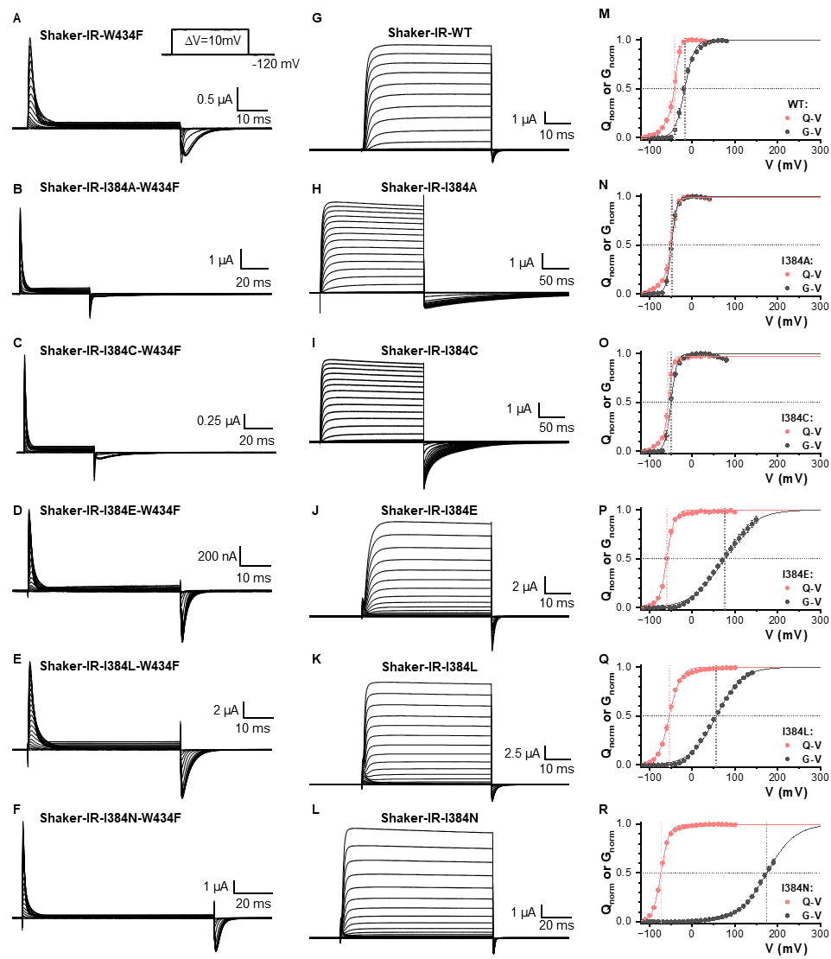
Extended Data Figure 1
Extended Data Figure 1. Gating current, ionic current and QV-GV curve comparison for all the I384 mutants in Shaker-IR potassium channel. Representative gating currents for WT (A), I384A (B), I384C (C), I384E (D), I384L (E), and I384N (F). Representative ionic currents for WT (G), I384A (H), I384C (I), I384E (J), I384L (K), and I384N (L). Note that the gating current experiments were conducted with W434F background. The comparison of the QV/GV WT (M) curve indicates that I384A (N) and I384C (O) strengthen the coupling while I384E (P), I384L (Q) and I384N (R) weaken the coupling.

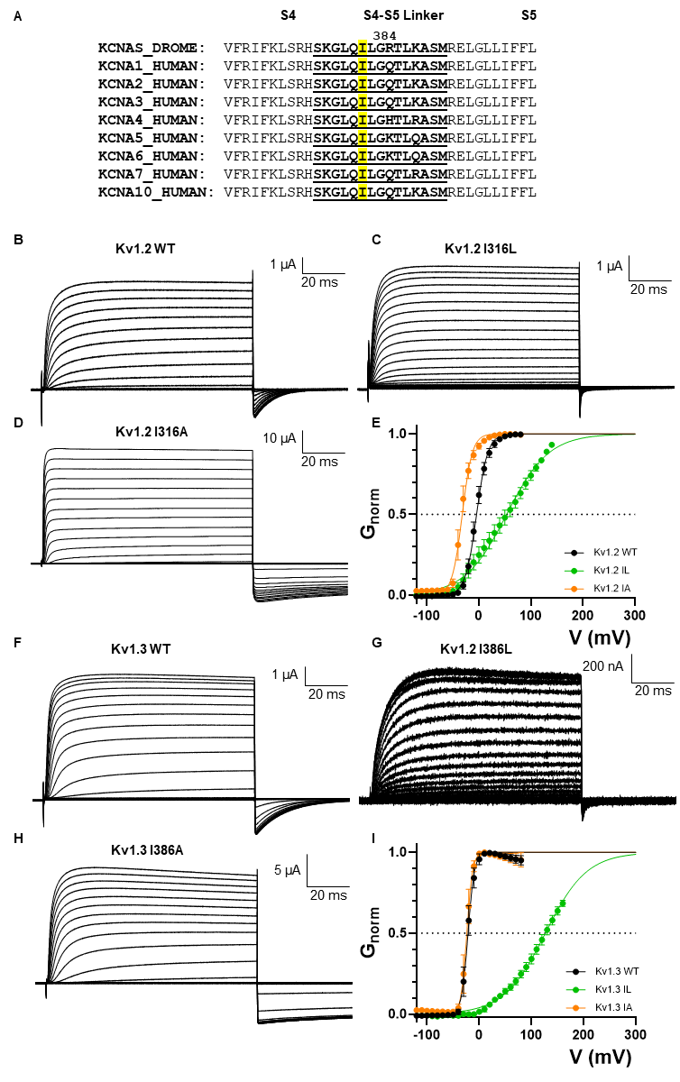
Extended Data Figure 2
Extended Data Figure 2. Conserved Isoleucine that controls EMC in Kv1 family. A) Sequence alignment of the Shaker potassium channel with human Kv1 channels. I384 is conserved across all the channels. B)-D) Results from hKv1.2 mutating the equivalent isoleucine. F)-I) Results from hKv1.3 mutating the equivalent isoleucine. Similar behaviors were seen on both channels.
Extended Data Figure 3
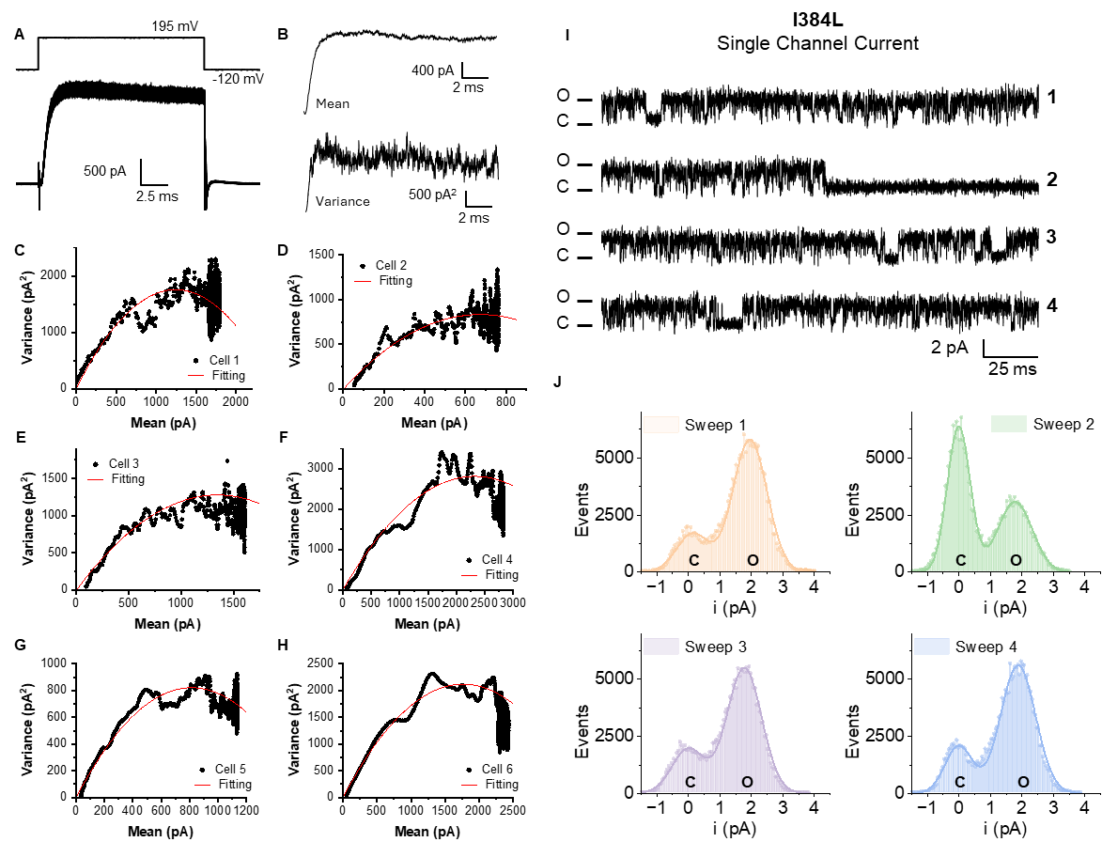
Extended Data Figure 3. Noise analysis and Single channel recording of I384L. Six independent noise analysis experiments were shown with their fitting parameters (A-H). Voltage protocol is inset in A. Representative 150 current traces overlapped are shown in A) and in B) is depicted the Mean and variance from those recordings. I) Four representative current traces for single channel records at 195mV, and increased flickering behavior was observed. J) Histogram of the single channel recording traces shown in I).

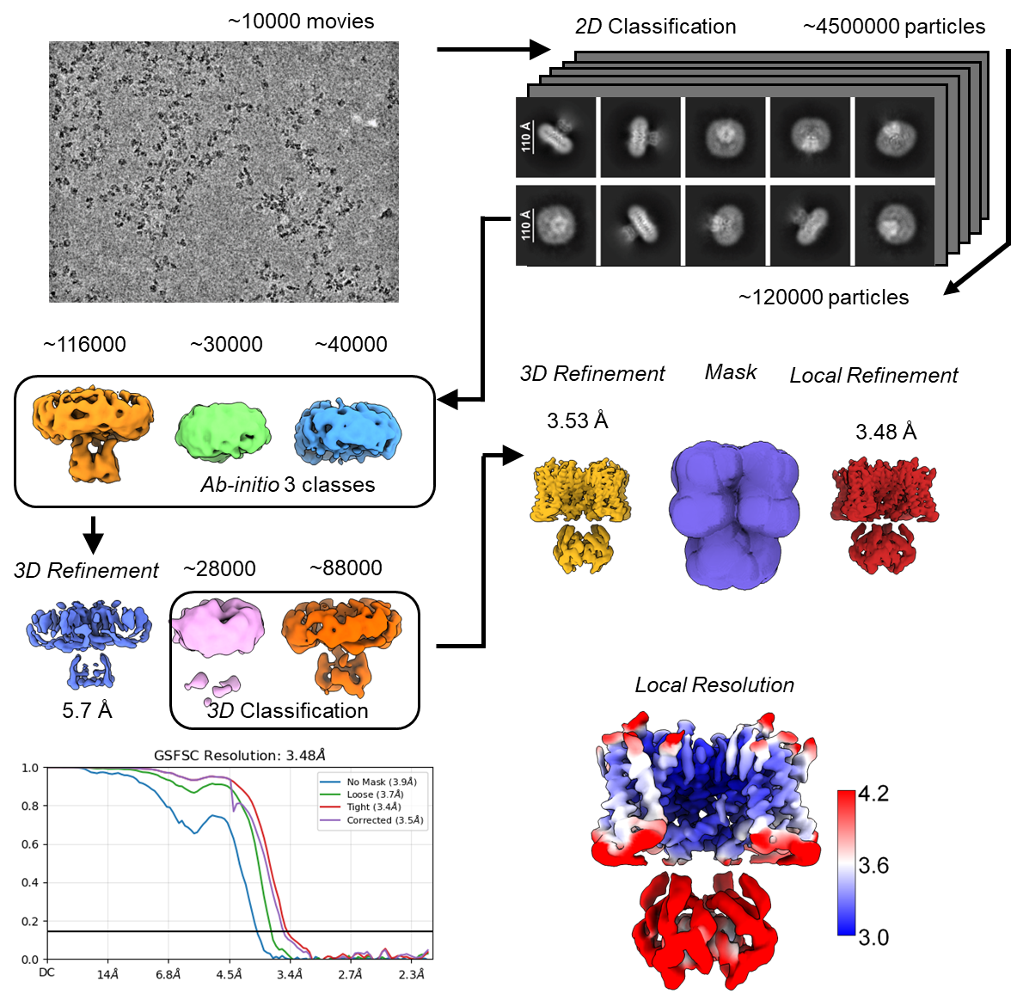
Extended Data Figure 4
Extended Data Figure 4. Pipeline of the structural determination for Shaker-IR-I384R. Resolution curve and local resolution map.

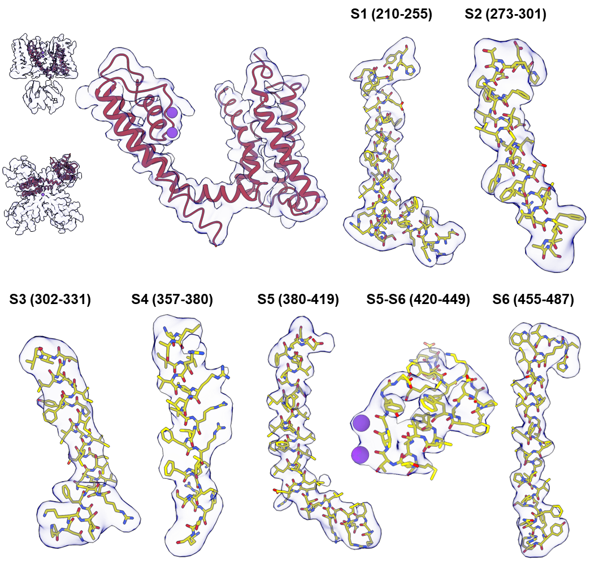
Extended Data Figure 5
Extended Data Figure 5. Comparison of atomic models and the densities.

Extended Data Figure 6
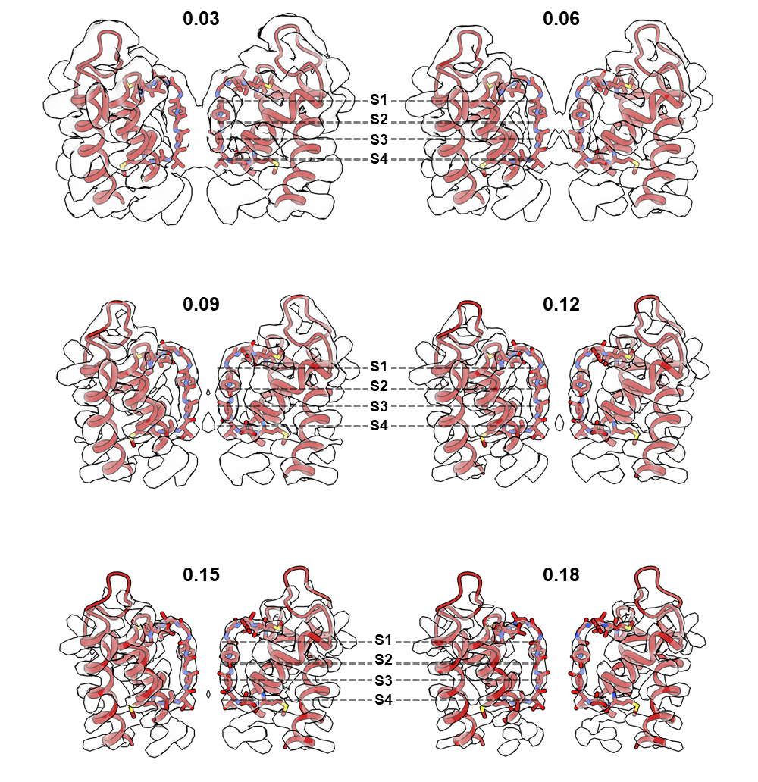
Extended Data Figure 6. Atomic model overlaid with the density map plotted with variable iso-surface value.

Extended Data Figure 7
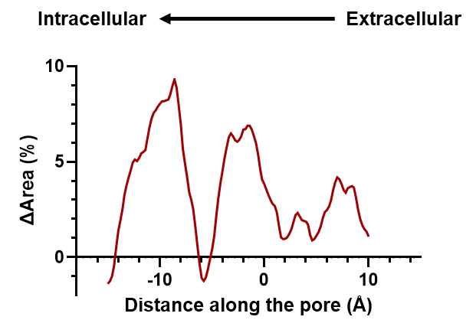
Extended Data Figure 7. Percent area increases the open state compared to the closed state along the membrane. Positive value indicates expansion in open state.
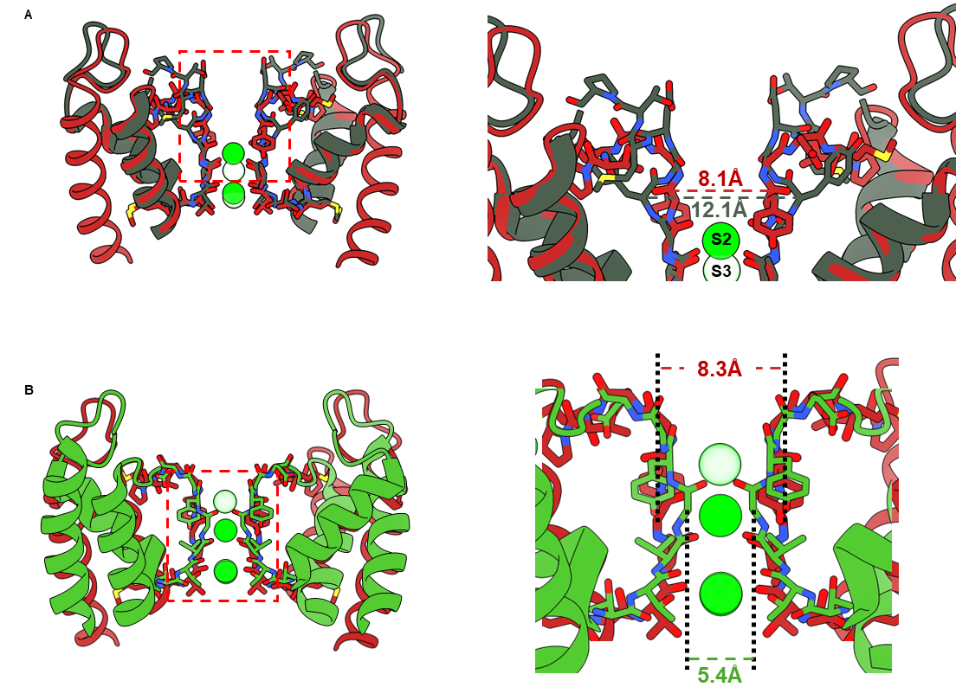
Extended Data Figure 8
Extended Data Figure 8. Comparison of the noncanonical filter with dilated filter (PDB:8ETO) A), B) and pinched filter (PDB:3F5W) C), D). Note that the noncanonical filter is different from both conformations.
Extended Data Tables
Extended Data Table 1: Fitting parameters for GV curves
 | V_{1/2} |  |  | z
WT | -17.70 | ± | 0.73 | 2.22 | ± | 0.13
I384A | -48.70 | ± | 0.26 | 4.01 | ± | 0.15
I384C | -49.80 | ± | 0.62 | 3.64 | ± | 0.29
I384E | 74.45 | ± | 0.91 | 0.70 | ± | 0.02
I384L | 56.12 | ± | 0.70 | 0.84 | ± | 0.02
I384N | 174.33 | ± | 0.25 | 0.76 | ± | 0.01

Extended Data Table 2: Fitting parameters for QV curves

 | V1 |  |  | z1 |  |  | v2 |  |  | z2 |  |  | N
WT | -62.20 | ± | 1.08 | 2.10 | ± | 0.14 | -39.26 | ± | 0.41 | 4.51 | ± | 0.22 | 0.15 | ± | 0.01
I384A | -63.81 | ± | 3.84 | 1.46 | ± | 0.29 | -49.09 | ± | 1.79 | 3.39 | ± | 0.34 | 0.20 | ± | 0.02
I384C | -69.31 | ± | 3.07 | 1.79 | ± | 0.30 | -56.26 | ± | 1.26 | 5.19 | ± | 0.80 | 0.14 | ± | 0.02

 | V_{1/2} |  |  | z
I384E | -59.92 | ± | 0.51 | 2.84 | ± | 0.14
I384L | -53.89 | ± | 0.56 | 1.92 | ± | 0.07
I384N | -73.32 | ± | 0.33 | 2.61 | ± | 0.08
I384R | -76.82 | ± | 0.24 | 2.85 | ± | 0.07

Extended Data Table 3: Fitting parameters for noise analysis
Cell |  | Fitting |  | Vm (mV) | Vrev (mV) | PoMax | Mean (pA) | Y (Single) | pS
 |  | Value | Error
I384L_04-04-24-001 | I (pA) | 2.01 | 0.03 | 160.00 | -57.00 | 0.70 | 1139.90 | 0.00 | 13.27
 | N | 809.71 | 24.69
I384L_04-04-24-002 | I (pA) | 2.40 | 0.03 | 160.00 | -57.00 | 0.69 | 2434.20 | 0.00 | 16.02
 | N | 1475.23 | 37.67
I384L_04-04-24-003 | I (pA) | 2.42 | 0.06 | 180.00 | -57.00 | 0.61 | 2835.10 | 0.00 | 16.75
 | N | 1922.18 | 98.98
I384L_04-04-24-005 | I (pA) | 1.89 | 0.07 | 180.00 | -57.00 | 0.60 | 1609.00 | 0.00 | 13.38
 | N | 1421.08 | 223.78
I384L_04-04-24-006 | I (pA) | 2.48 | 0.07 | 195.00 | -57.00 | 0.57 | 764.04 | 0.00 | 17.30
 | N | 543.38 | 39.13
I384L_04-04-24-009 | I (pA) | 2.75 | 0.04 | 195.00 | -57.00 | 0.64 | 500.06 | 0.00 | 17.12
 | N | 285.07 | 7.87
I384L_04-12-24-008 | I (pA) | 2.82 | 0.07 | 195.00 | -57.00 | 0.72 | 1798.00 | 0.00 | 15.50
 | N | 885.83 | 43.38

Extended Data Table 4: Fitting parameters for single channel analysis
 | Sweep 1 |  | Sweep 2 |  | Sweep 3 |  | Sweep 4
 | Value | error | Value | error | Value | error | Value | error
µ1 | 3.93 | 0.01 | 3.75 | 0.01 | 3.94 | 0.01 | 3.99 | 0.01
σ1 | 0.77 | 0.01 | 0.78 | 0.01 | 0.78 | 0.01 | 0.79 | 0.01
A1 | 22399.67 | 243.33 | 11969.20 | 182.66 | 21546.90 | 235.23 | 22217.59 | 255.66
µ2 | 2.11 | 0.02 | 1.97 | 0.00 | 2.16 | 0.02 | 2.11 | 0.02
σ2 | 0.73 | 0.03 | 0.51 | 0.01 | 0.73 | 0.03 | 0.62 | 0.03
A2 | 6187.80 | 238.43 | 16331.76 | 150.59 | 7126.41 | 229.39 | 6420.97 | 228.52

