Global, Regional, and National Burden of Atrial Fibrillation and Atrial Flutter in the Working-Age Population from 1990 to 2021: A Systematic Analysis Based on 2021 Global Burden of Disease Data
Context:
Supplementary Figure 1: EAPC of ASR in global, five SDI regions, and 21 GBD regions (A. ASIR; B. ASPR; C. ASMR; D. ASDR).
Supplementary Figure 2: EAPC of ASR in 204 countries and regions in 2021 (A. ASIR; B. ASPR; C. ASMR; D. ASDR).
Supplementary Figure 3: Age-period-cohort analysis results (A. ASIR; B. ASPR; C. ASMR; D. ASDR; E. ASIR; F. ASPR; G. ASMR; H. ASDR; I. ASIR; J. ASPR; K. ASMR; L. ASDR).
Supplementary Figure 4: Temporal trends of ASIR in global and five SDI regions.
Supplementary Figure 5: Temporal trends of ASPR in global and five SDI regions.
Supplementary Figure 6: Temporal trends of ASMR in global and five SDI regions.
Supplementary Figure 7: Temporal trends of ASDR in global and five SDI regions.
Supplementary Figure 8: Temporal trends of incidence rates across different age groups in global and five SDI regions.
Supplementary Figure 9: Temporal trends of prevalence rates across different age groups in global and five SDI regions.
Supplementary Figure 10: Temporal trends of mortality rates across different age groups in global and five SDI regions.
Supplementary Figure 11: Temporal trends of DALYs rates across different age groups in global and five SDI regions.
Supplementary Figure 12: Correlation between ASR and SDI in 204 countries and regions (A. ASIR; B. ASPR; C. ASMR; D. ASDR).
Supplementary Figure 13: Correlation between EAPC of ASR and SDI in 204 countries and regions (A. ASIR; B. ASPR; C. ASMR; D. ASDR).
Supplementary Figure 14: Slope index of inequality of DALYs.
Supplementary Figure 15: Concentration index of DALYs.
Supplementary Figure 16: Frontier analysis of DALYs.
Supplementary Figure 17: Decomposition analysis (A. ASIR; B. ASPR; C. ASMR; D. ASDR).
Supplementary Figure 18: Incidence rates by different age groups.
Supplementary Figure 19: Prevalence rates by different age groups.
Supplementary Figure 20: Mortality rates by different age groups.
Supplementary Figure 21: DALYs rates by different age groups.
Supplementary Figure 22: Attributable risk factors in 2021 for global and five SDI regions.
Supplementary Figure 23: Temporal trends of attributable risk factors in global and five SDI regions.
Supplementary Table 1: ASR and their EAPCs for 204 countries and regions in 1990 and 2021.
Supplementary Table 2: Results of Joinpoint regression analysis.
Supplementary Table 3: Correlation coefficients and p-values.
Supplementary Table 4: Results of decomposition analysis.
Supplementary Table 5: Results of predictive analysis.
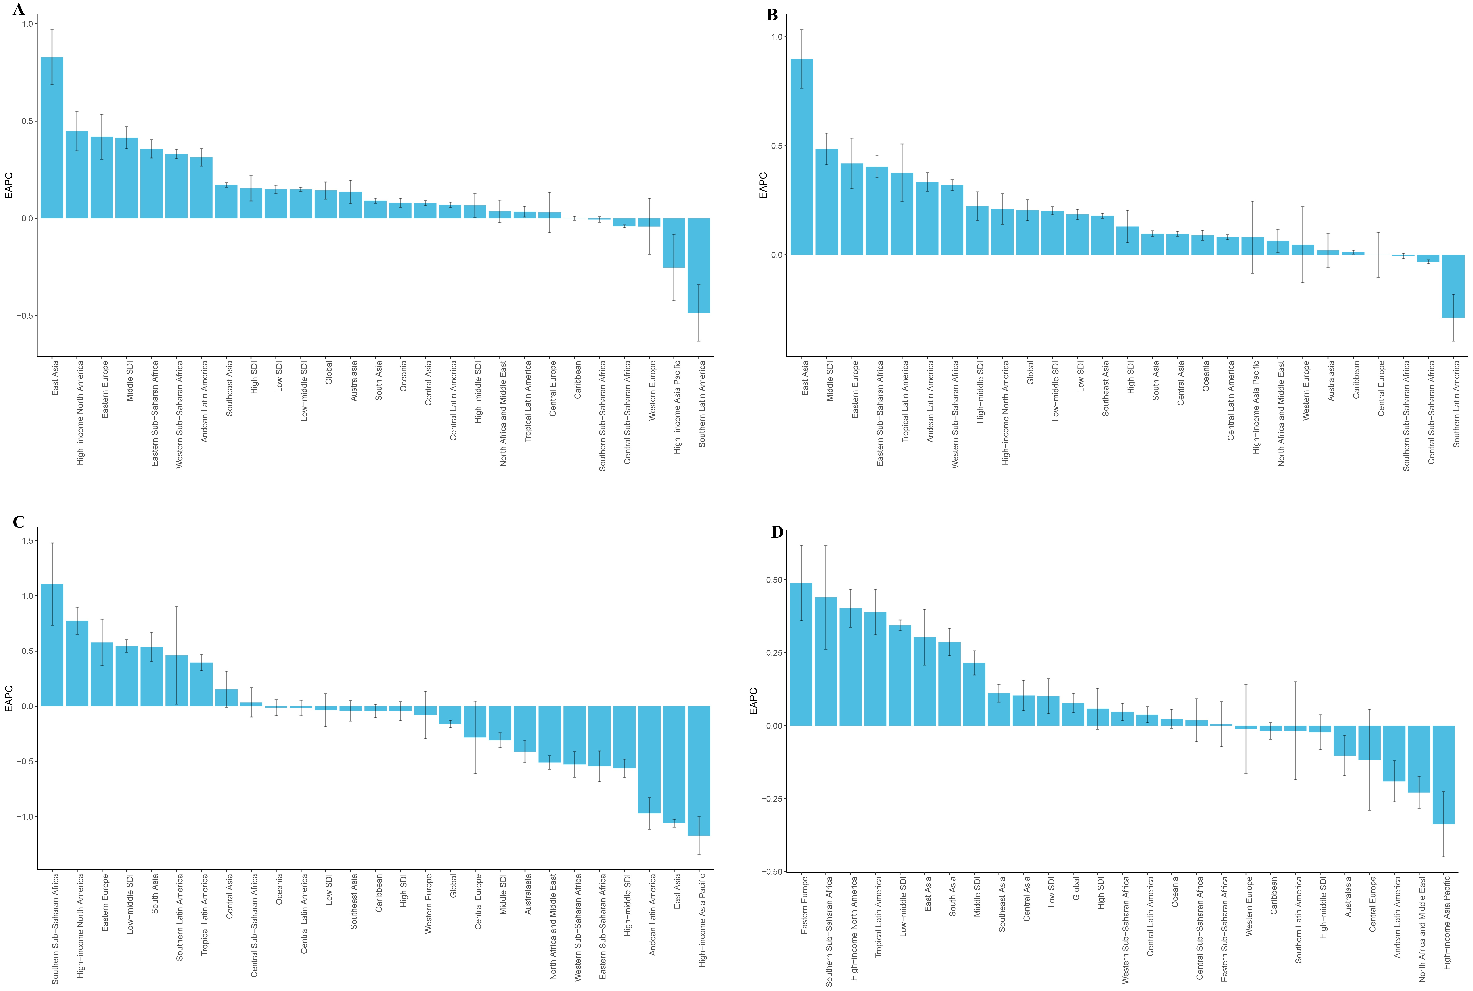
Supplementary Figure 1: EAPC of ASR in global, five SDI regions, and 21 GBD regions (A. ASIR; B. ASPR; C. ASMR; D. ASDR).

Supplementary Figure 2: EAPC of ASR in 204 countries and regions in 2021 (A. ASIR; B. ASPR; C. ASMR; D. ASDR).

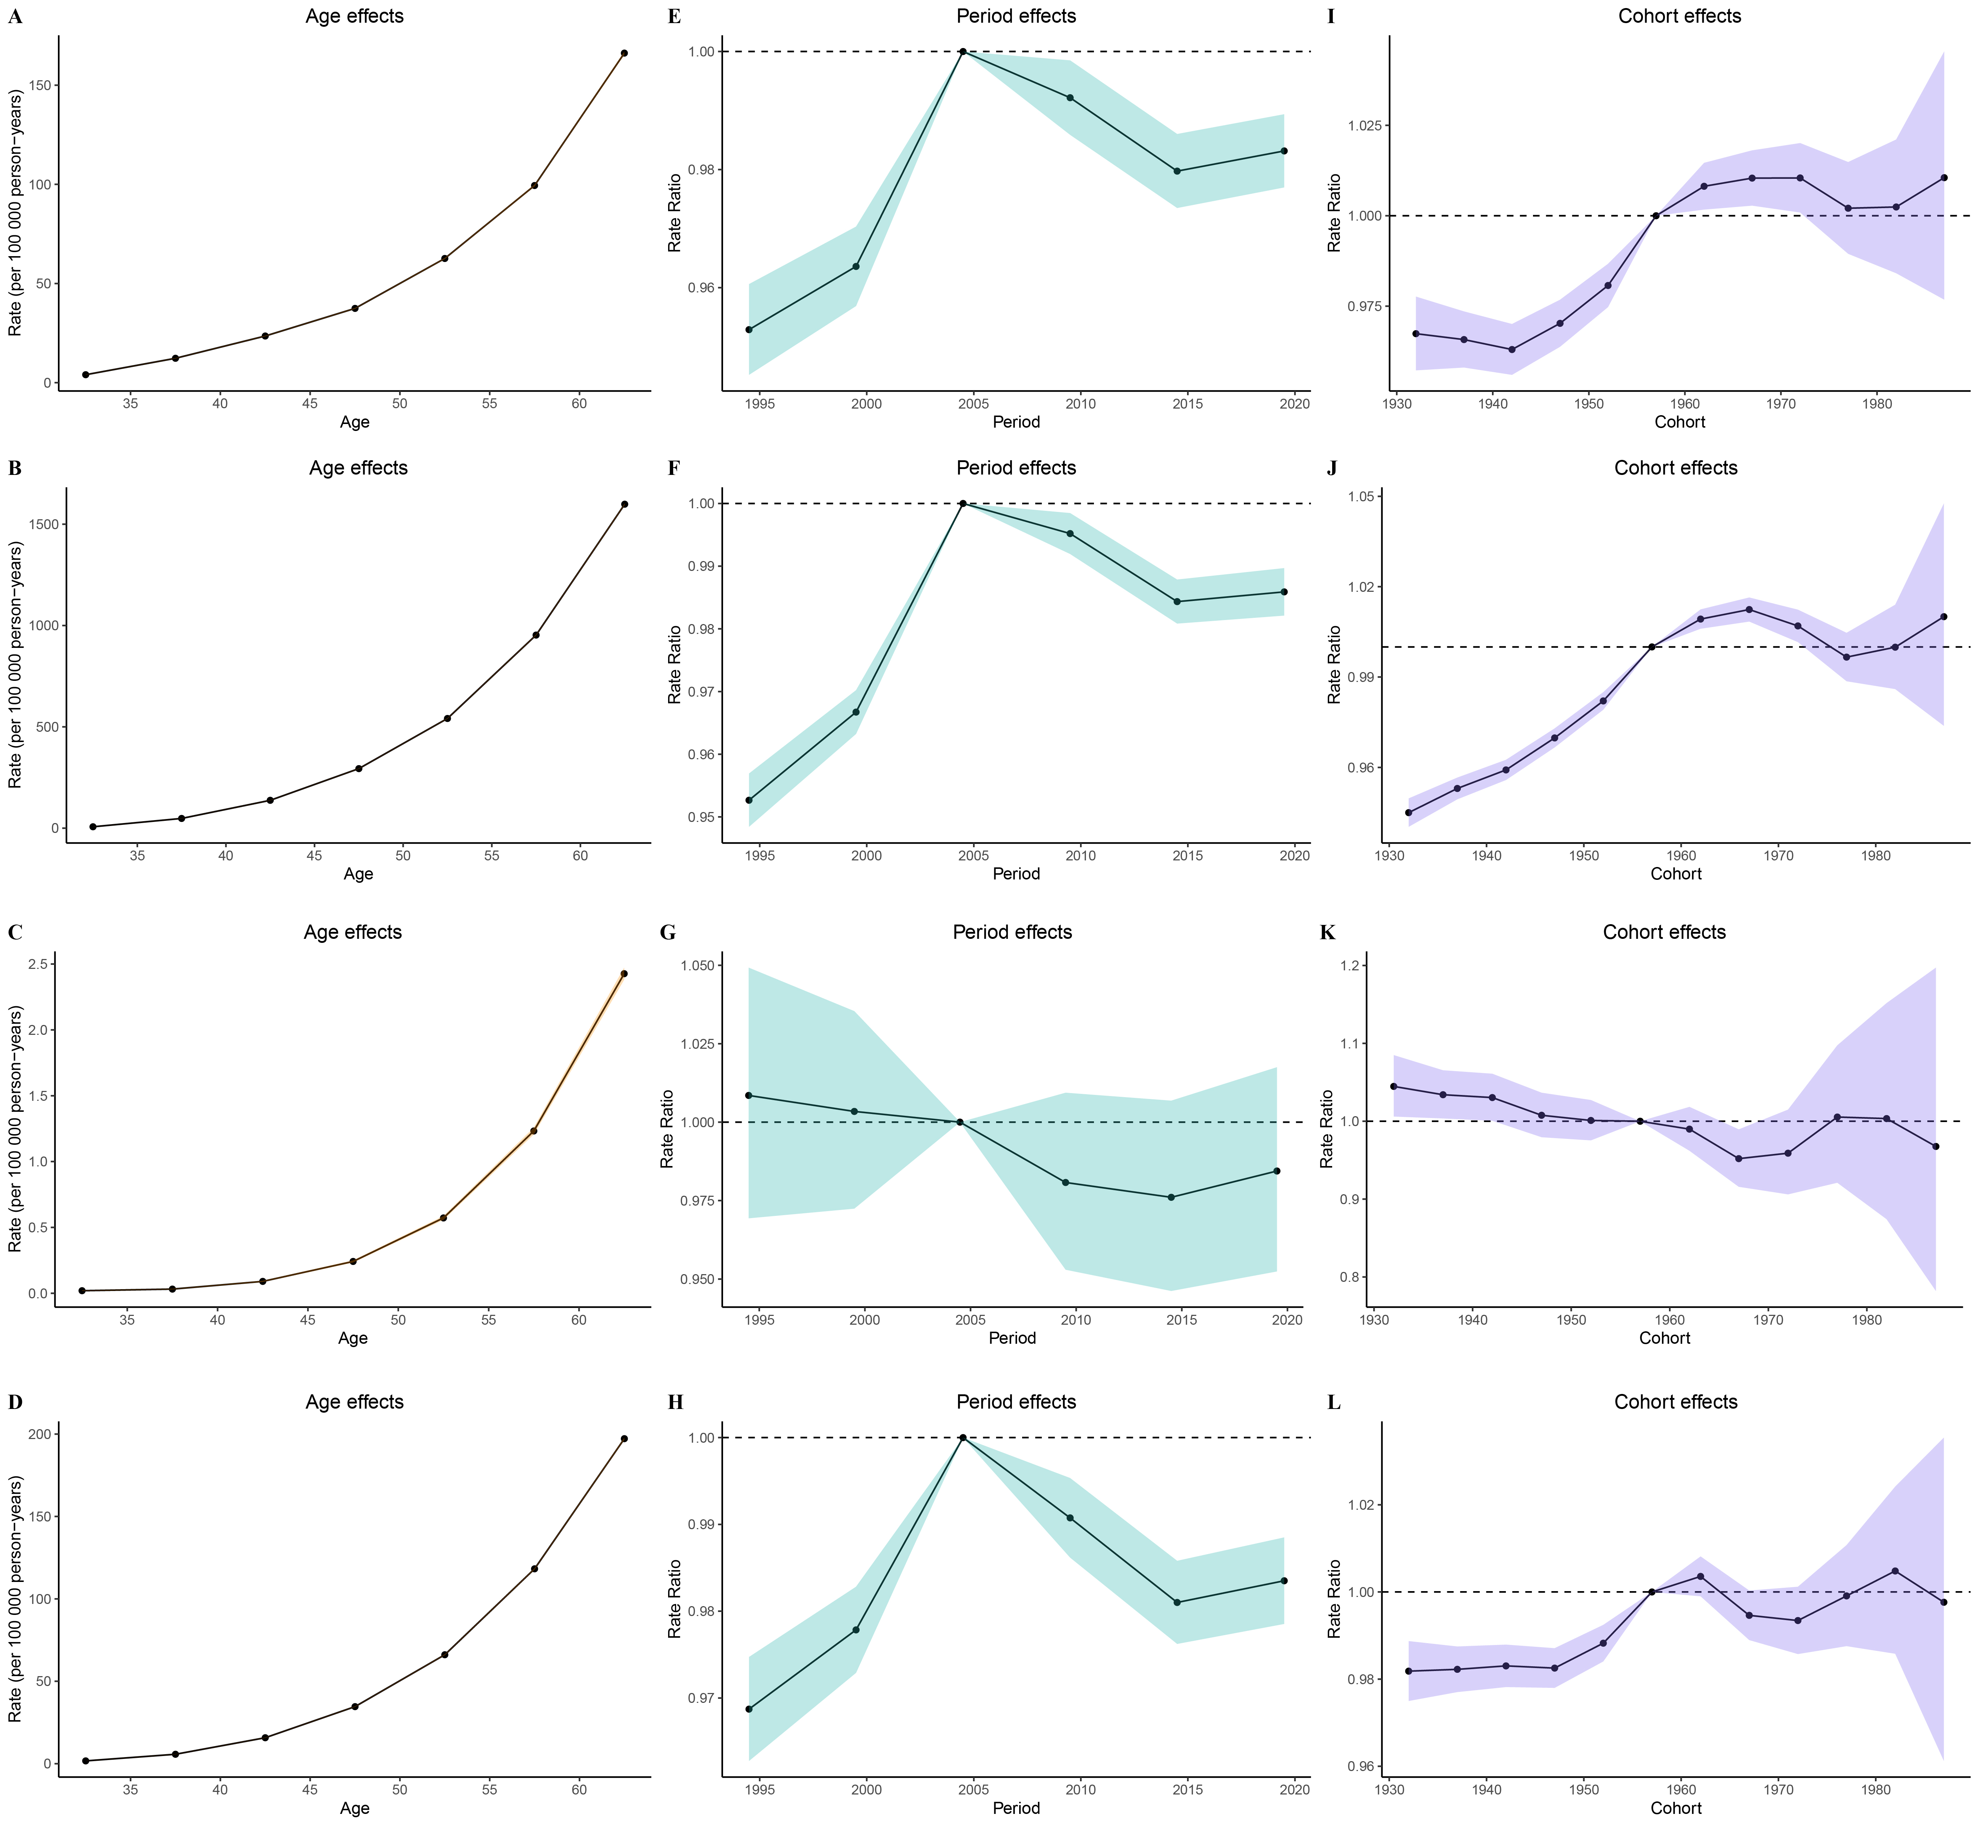
Supplementary Figure 3: Age-period-cohort analysis results (A. ASIR; B. ASPR; C. ASMR; D. ASDR; E. ASIR; F. ASPR; G. ASMR; H. ASDR; I. ASIR; J. ASPR; K. ASMR; L. ASDR).

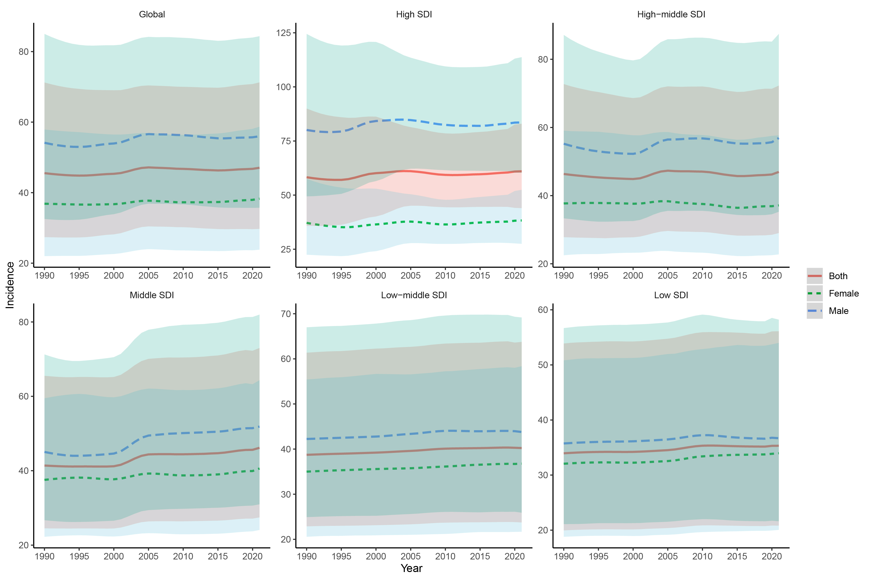
Supplementary Figure 4: Temporal trends of ASIR in global and five SDI regions.

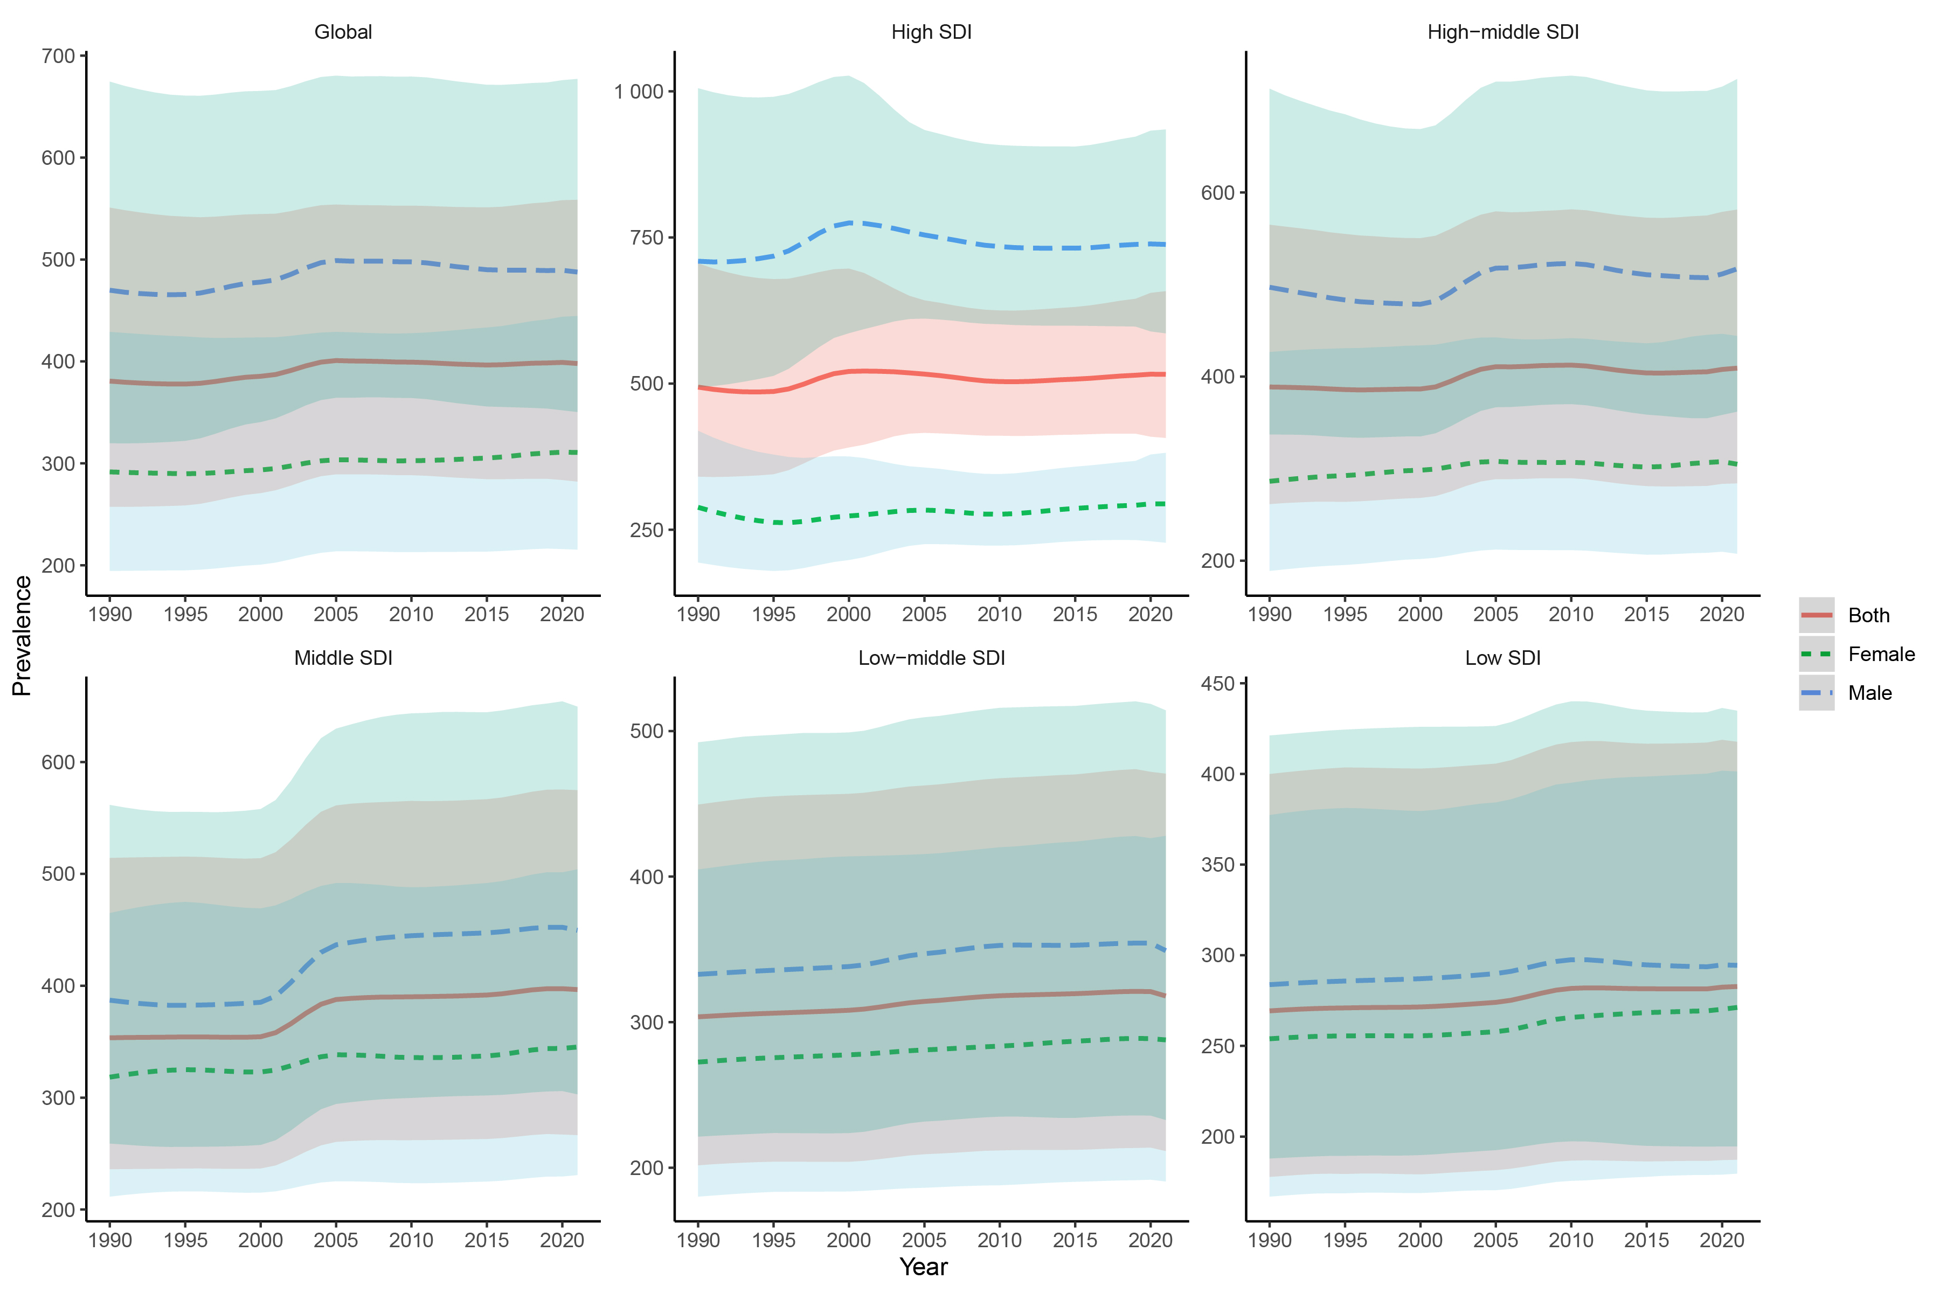
Supplementary Figure 5: Temporal trends of ASPR in global and five SDI regions.

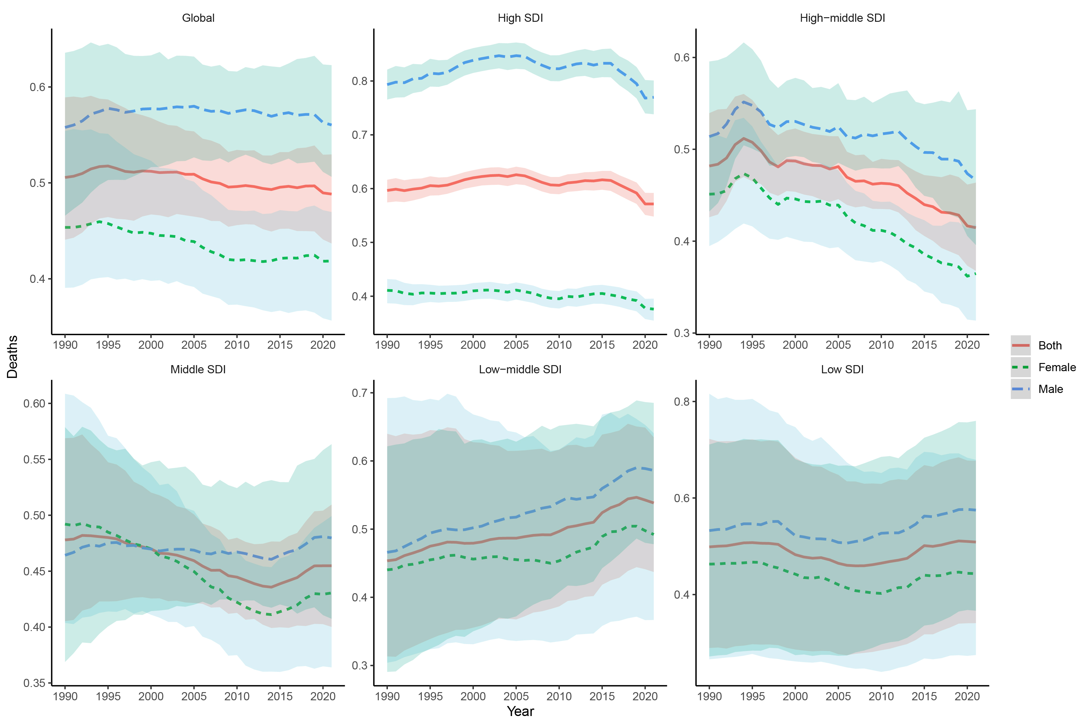
Supplementary Figure 6: Temporal trends of ASMR in global and five SDI regions.

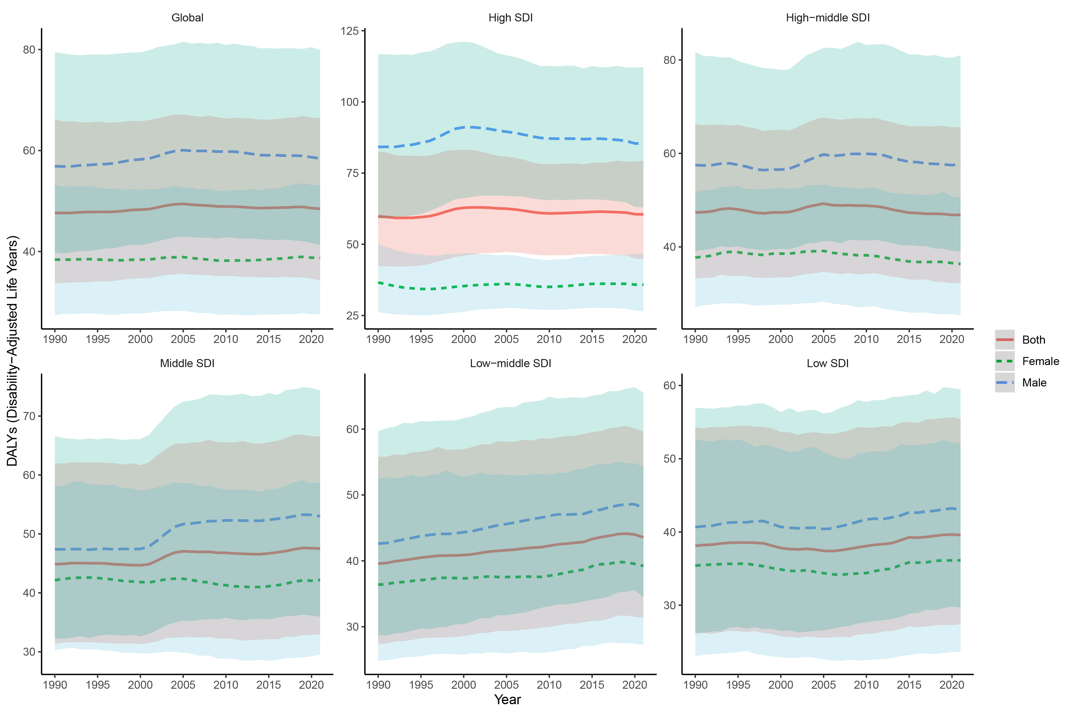
Supplementary Figure 7: Temporal trends of ASDR in global and five SDI regions.

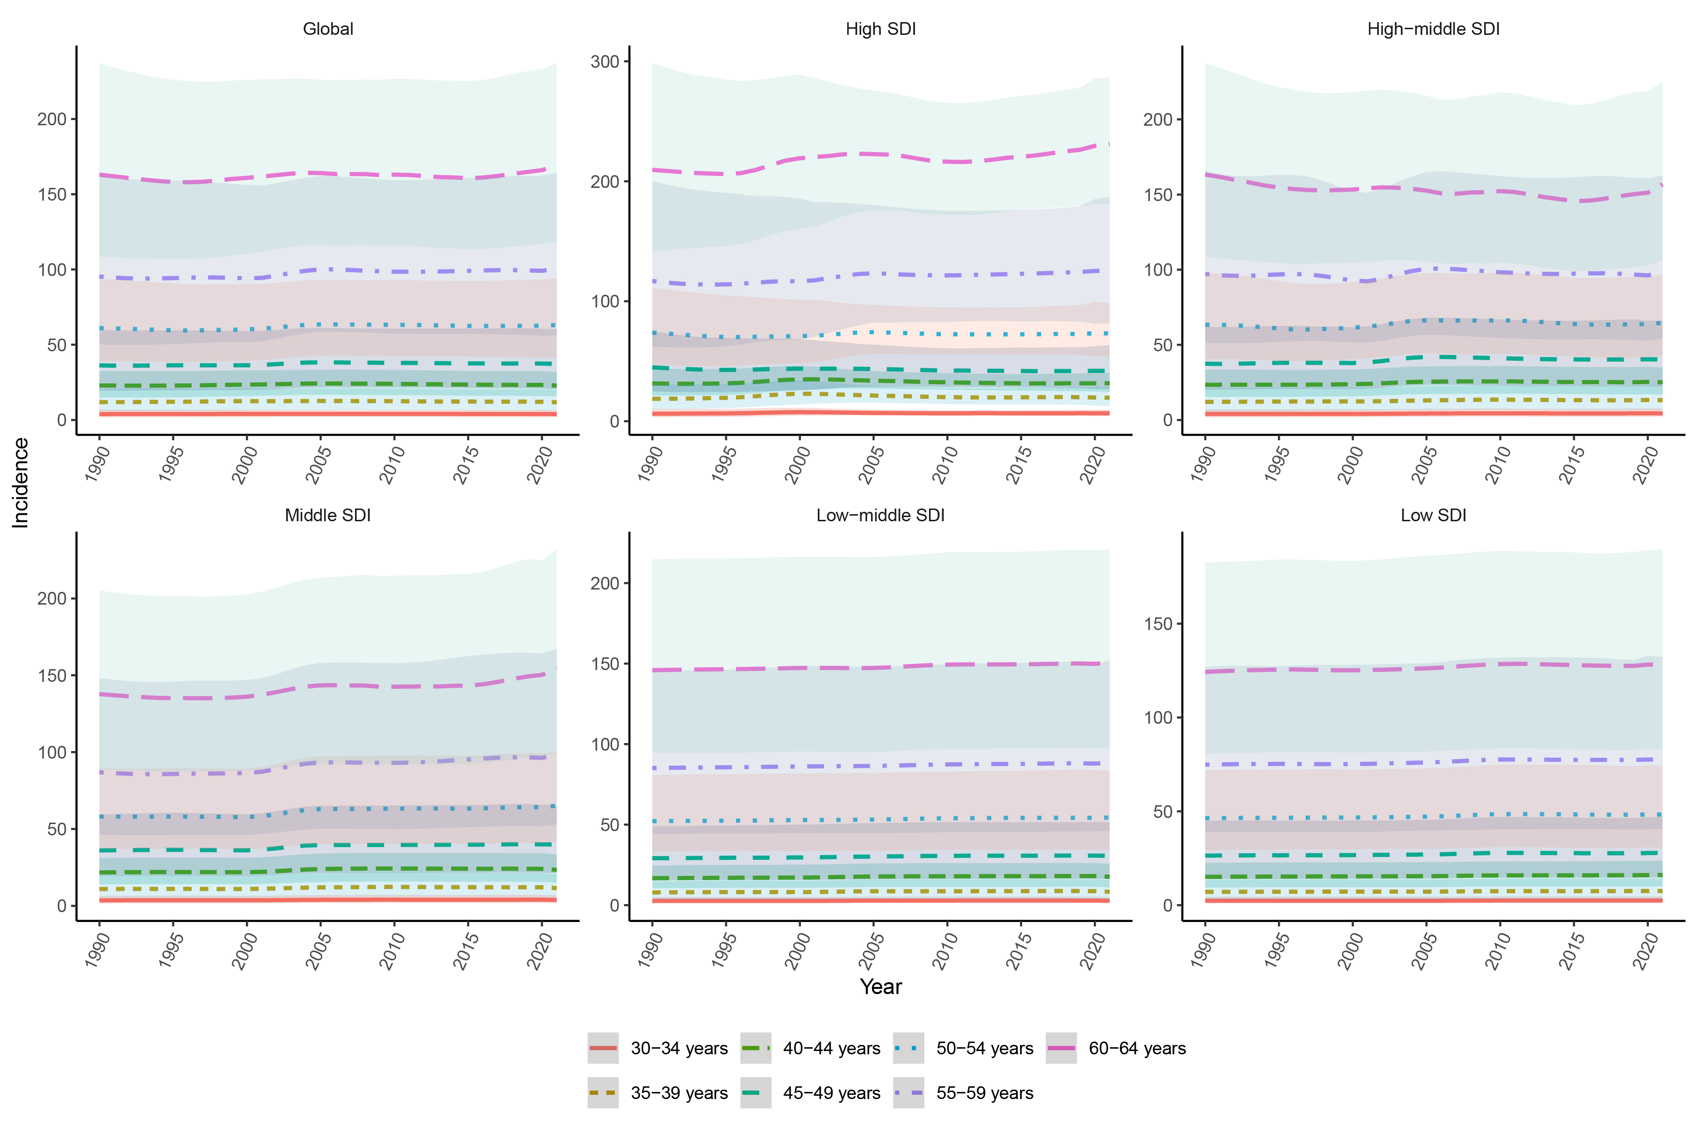
Supplementary Figure 8: Temporal trends of incidence rates across different age groups in global and five SDI regions.

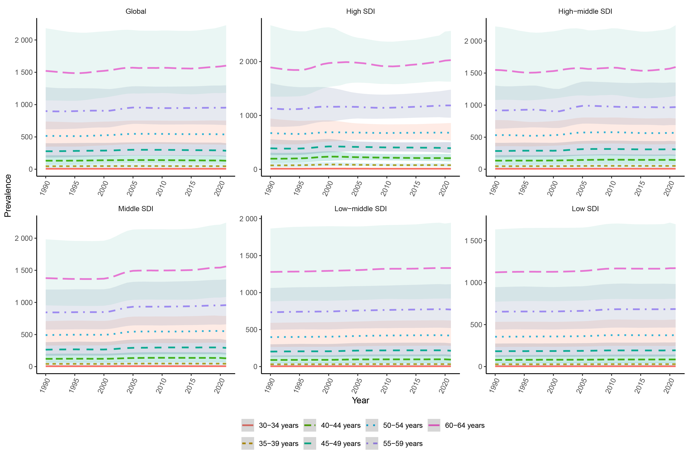
Supplementary Figure 9: Temporal trends of prevalence rates across different age groups in global and five SDI regions.

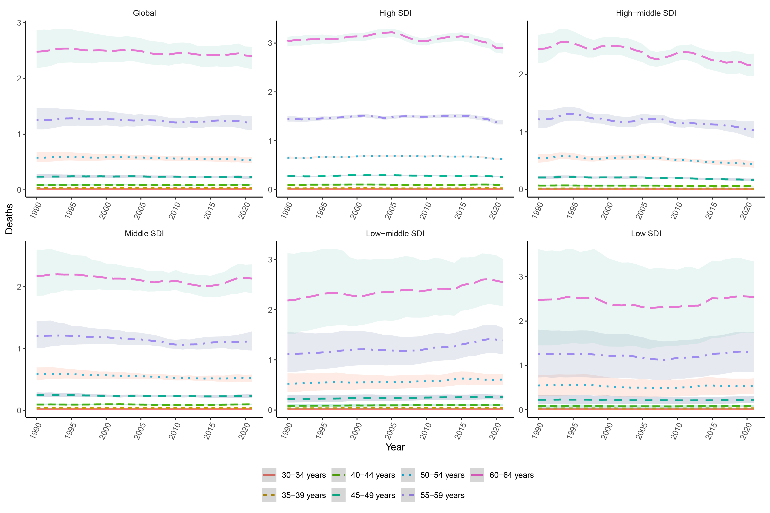
Supplementary Figure 10: Temporal trends of mortality rates across different age groups in global and five SDI regions.

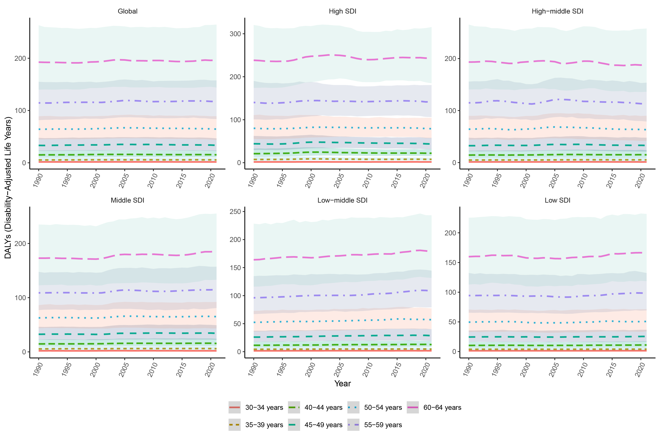
Supplementary Figure 11: Temporal trends of DALYs rates across different age groups in global and five SDI regions.

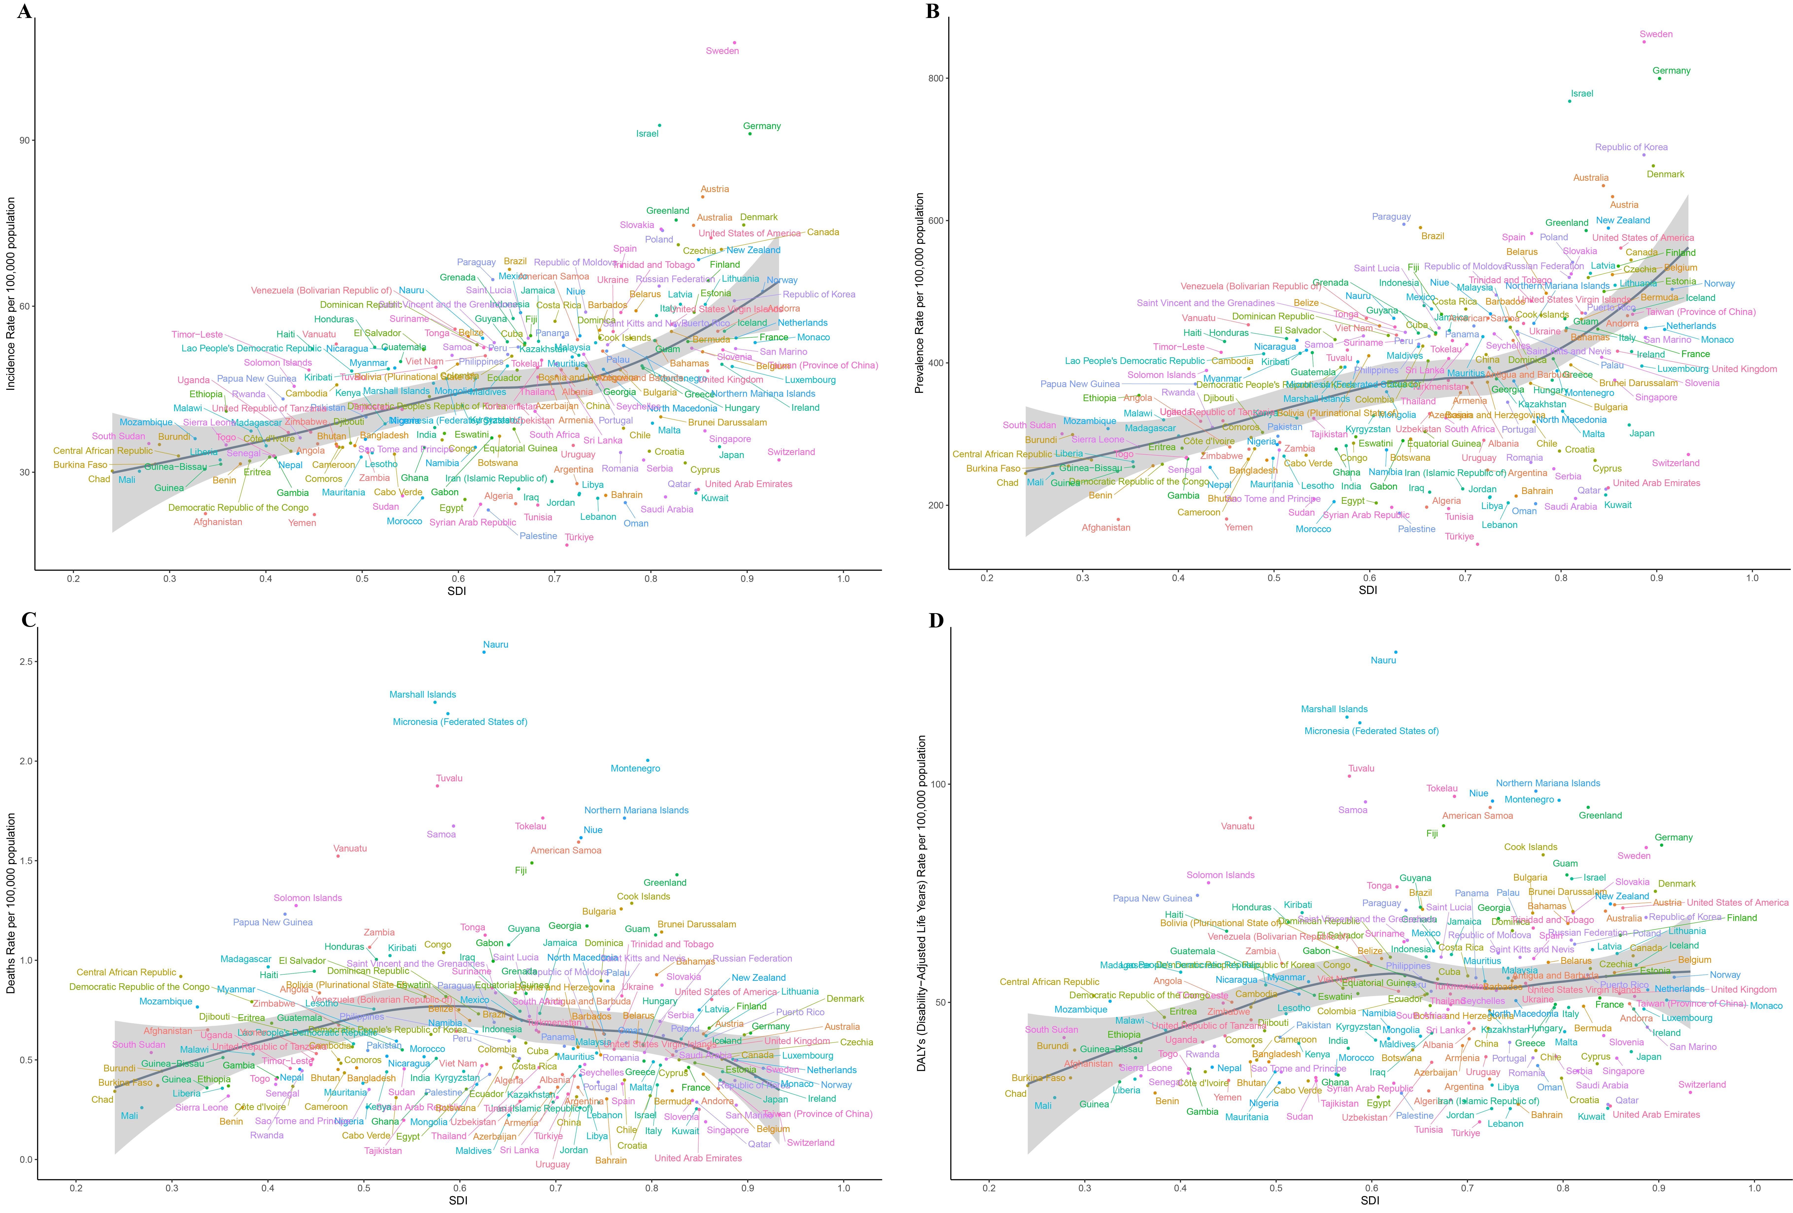
Supplementary Figure 12: Correlation between ASR and SDI in 204 countries and regions (A. ASIR; B. ASPR; C. ASMR; D. ASDR).

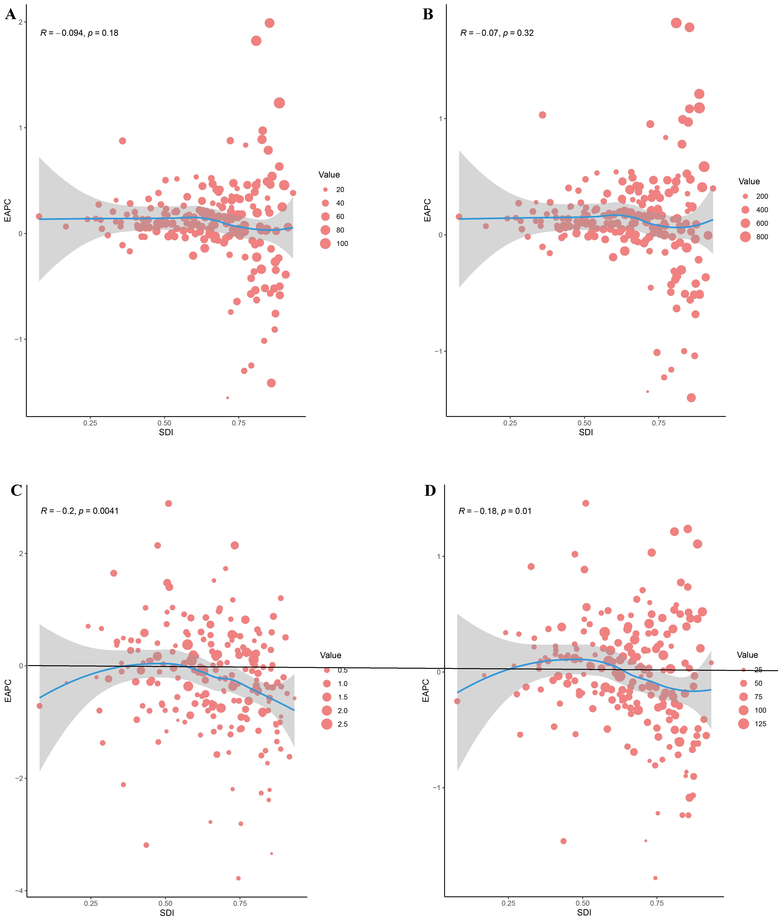
Supplementary Figure 13: Correlation between EAPC of ASR and SDI in 204 countries and regions (A. ASIR; B. ASPR; C. ASMR; D. ASDR).

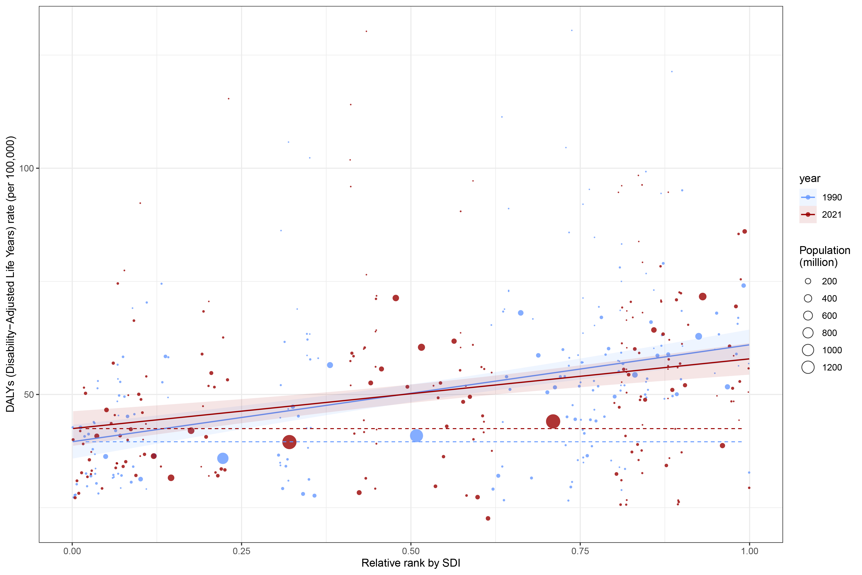
Supplementary Figure 14: Slope index of inequality of DALYs.

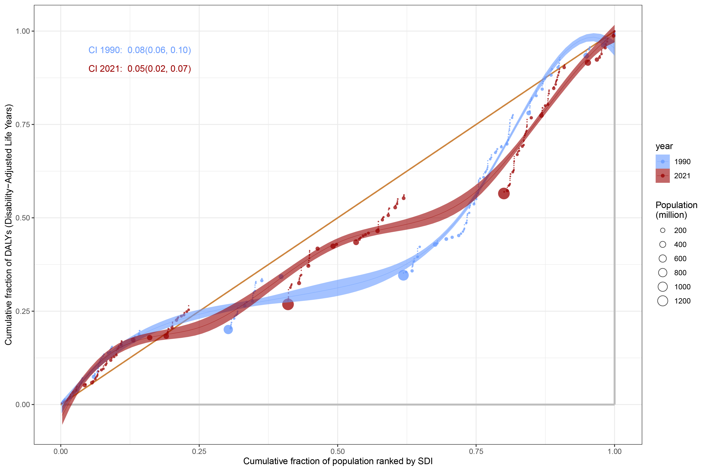
Supplementary Figure 15: Concentration index of DALYs.

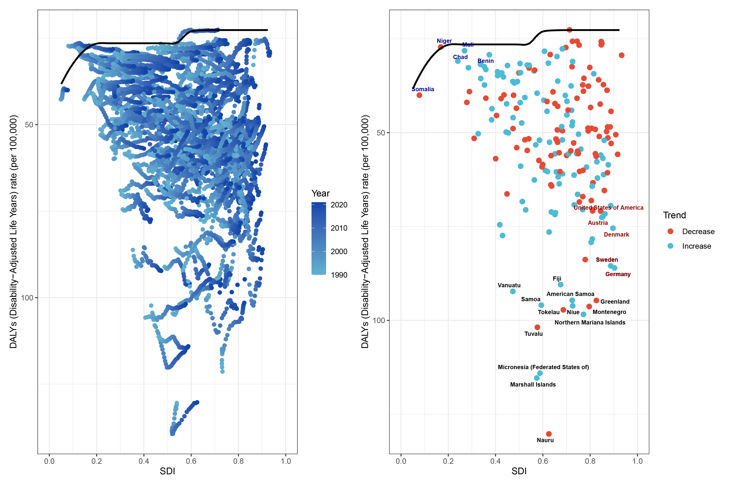 Supplementary Figure 16: Frontier analysis of DALYs.

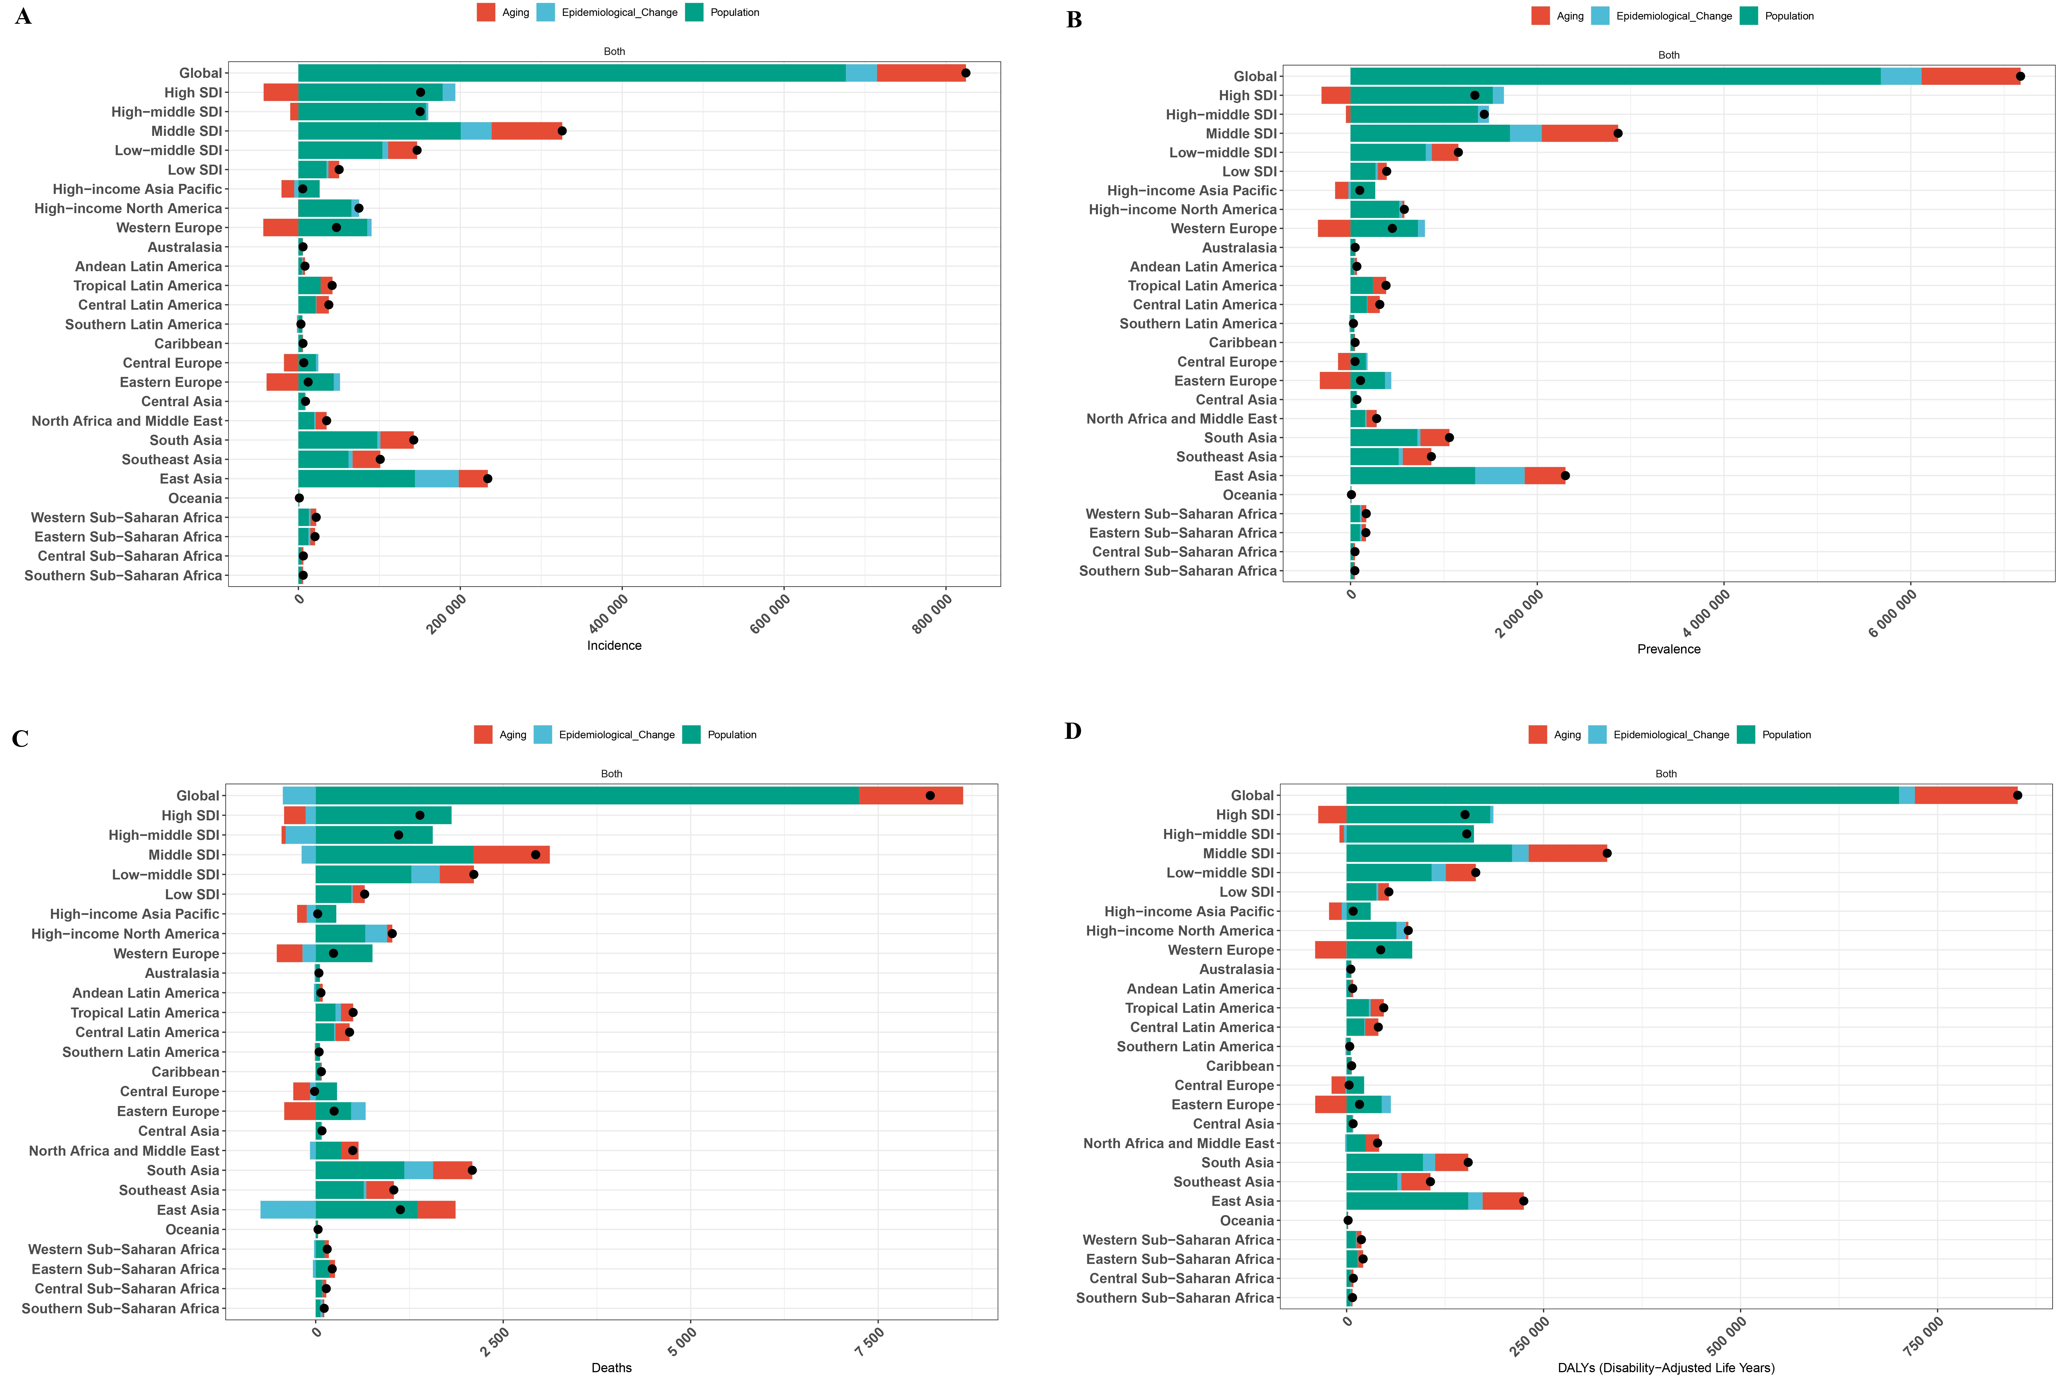 Supplementary Figure 17: Decomposition analysis (A. ASIR; B. ASPR; C. ASMR; D. ASDR).

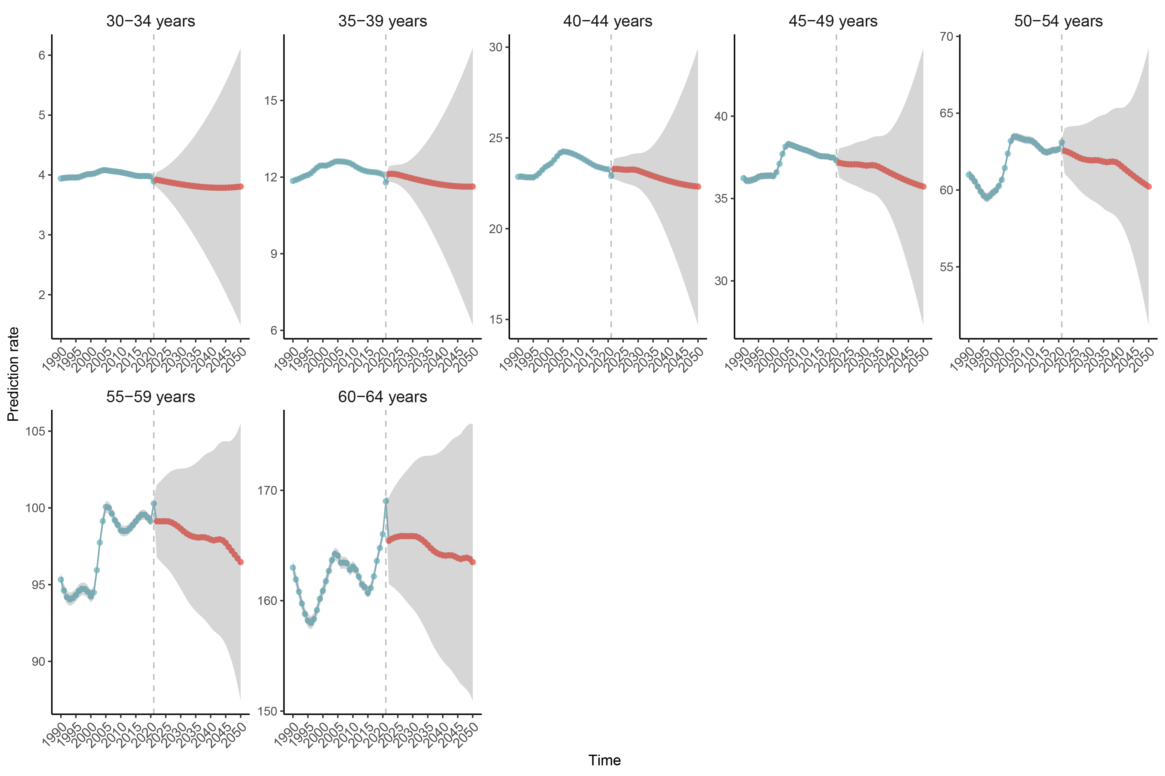 Supplementary Figure 18: Incidence rates by different age groups.

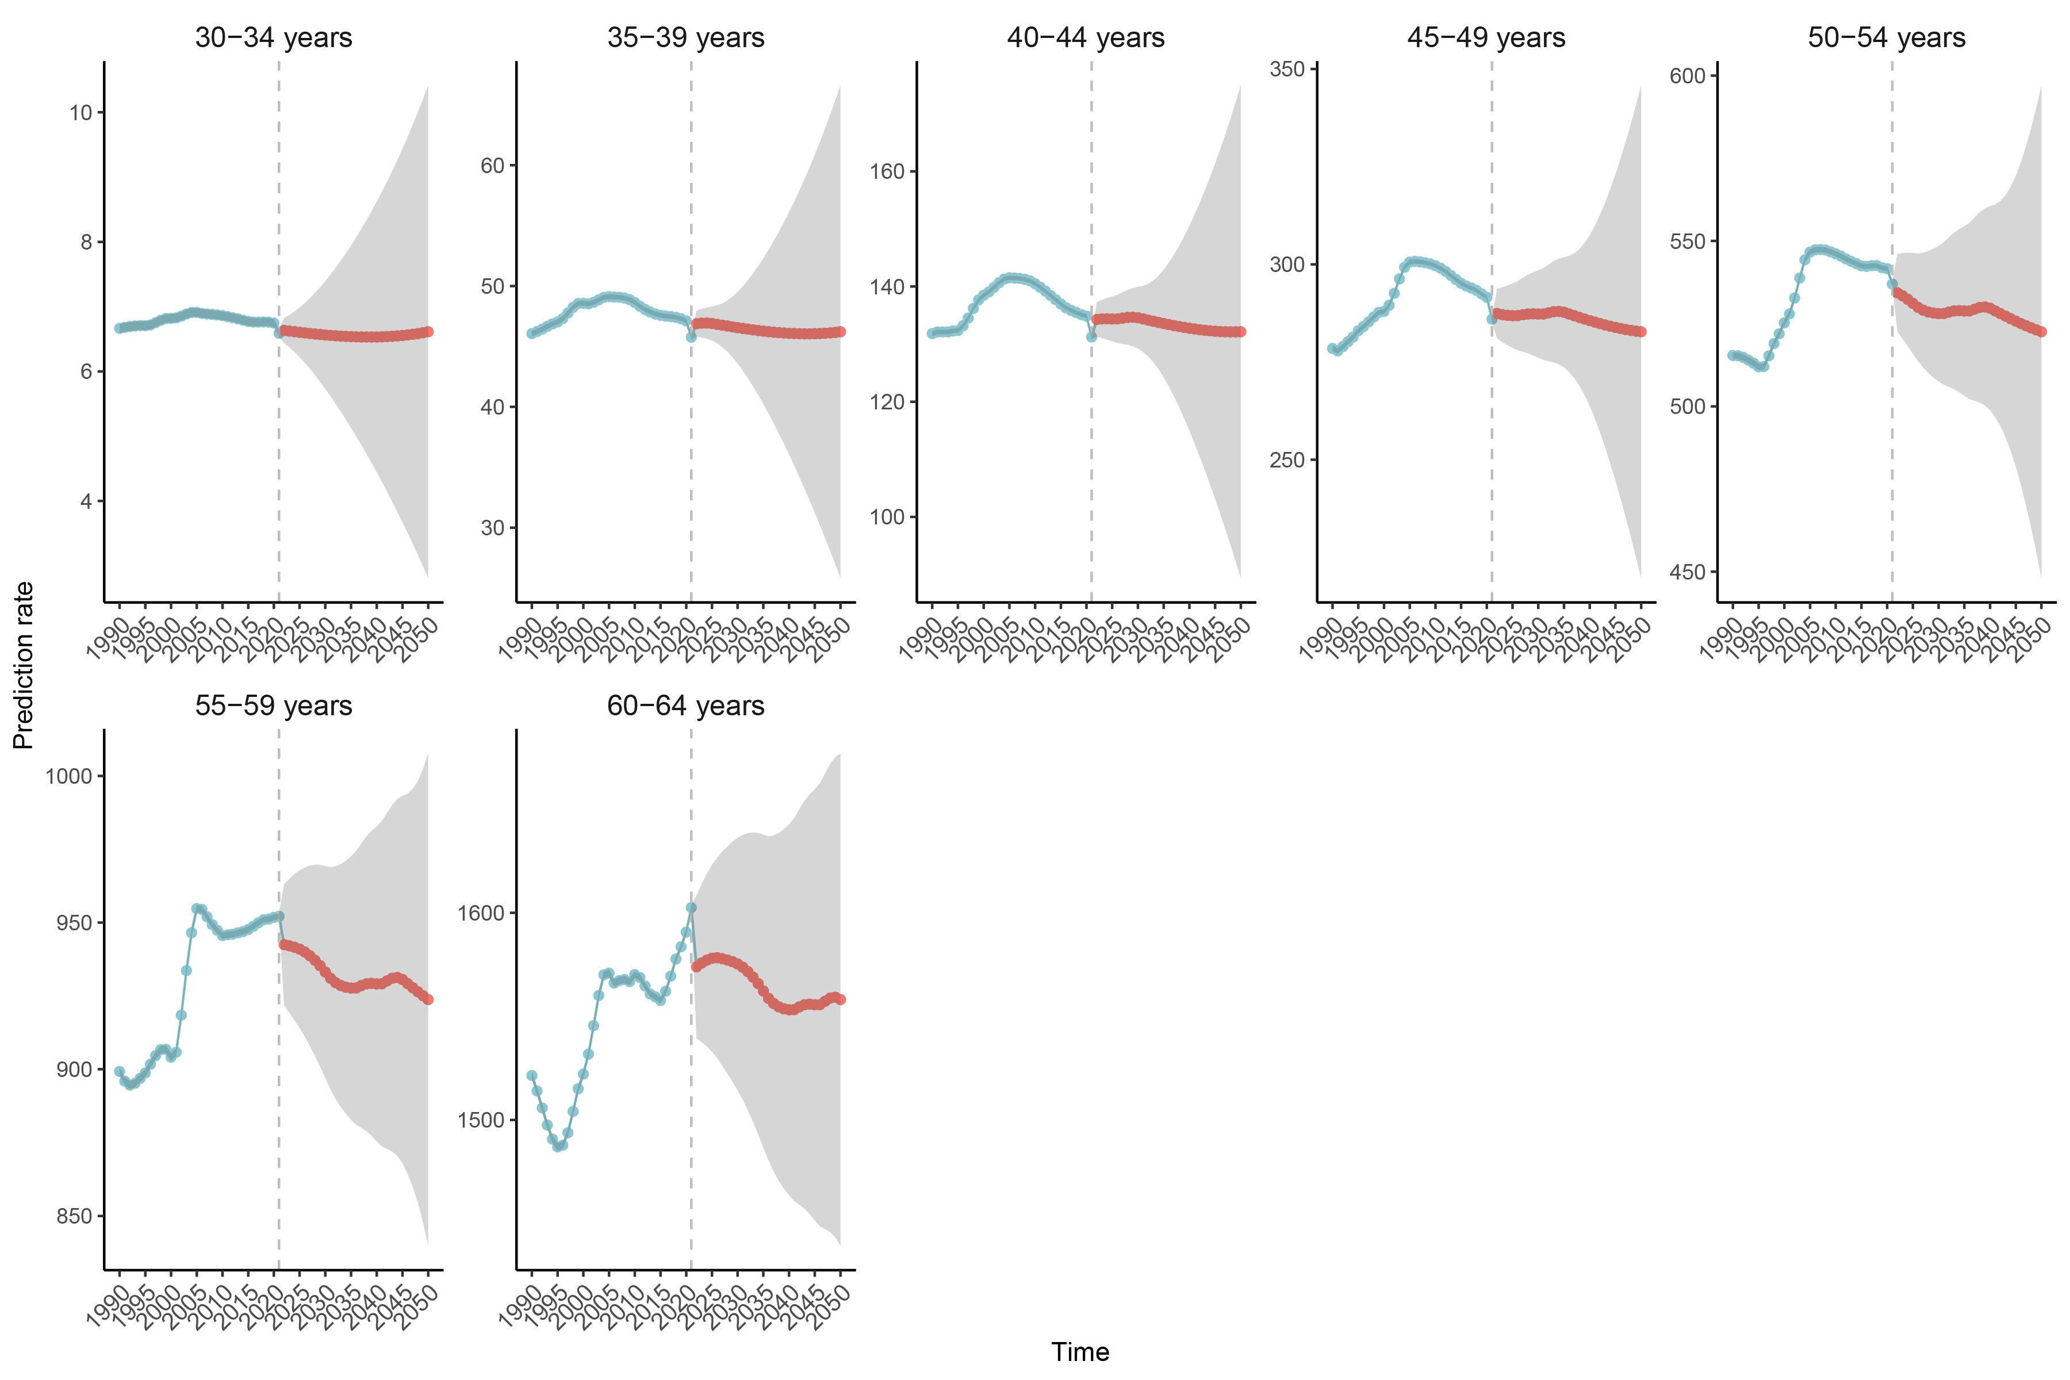 Supplementary Figure 19: Prevalence rates by different age groups.

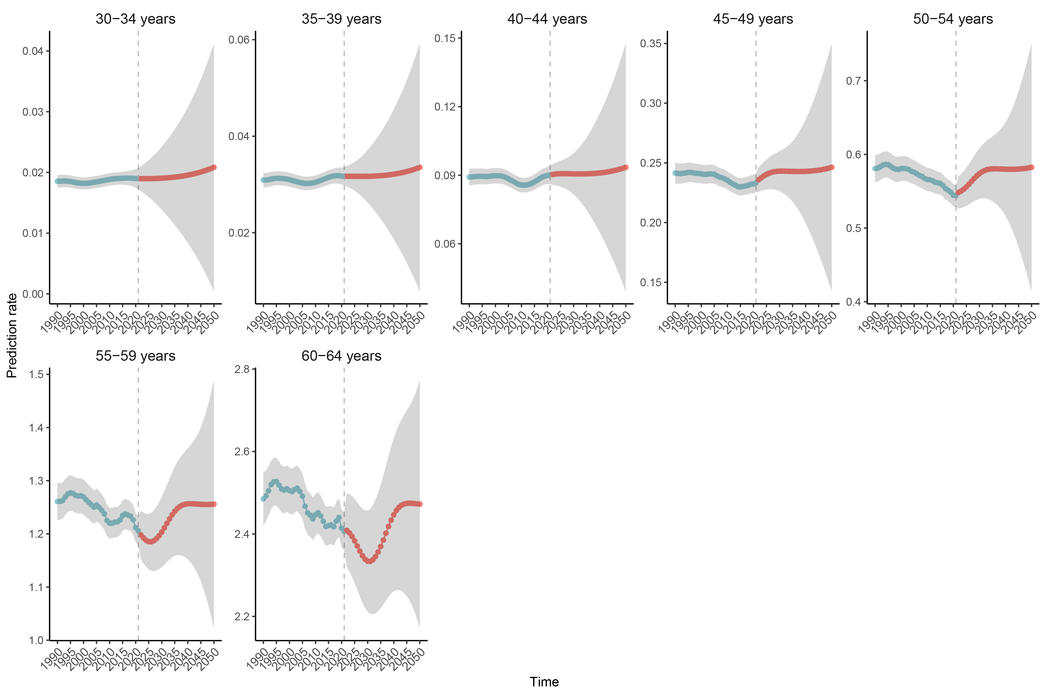 Supplementary Figure 20: Mortality rates by different age groups.

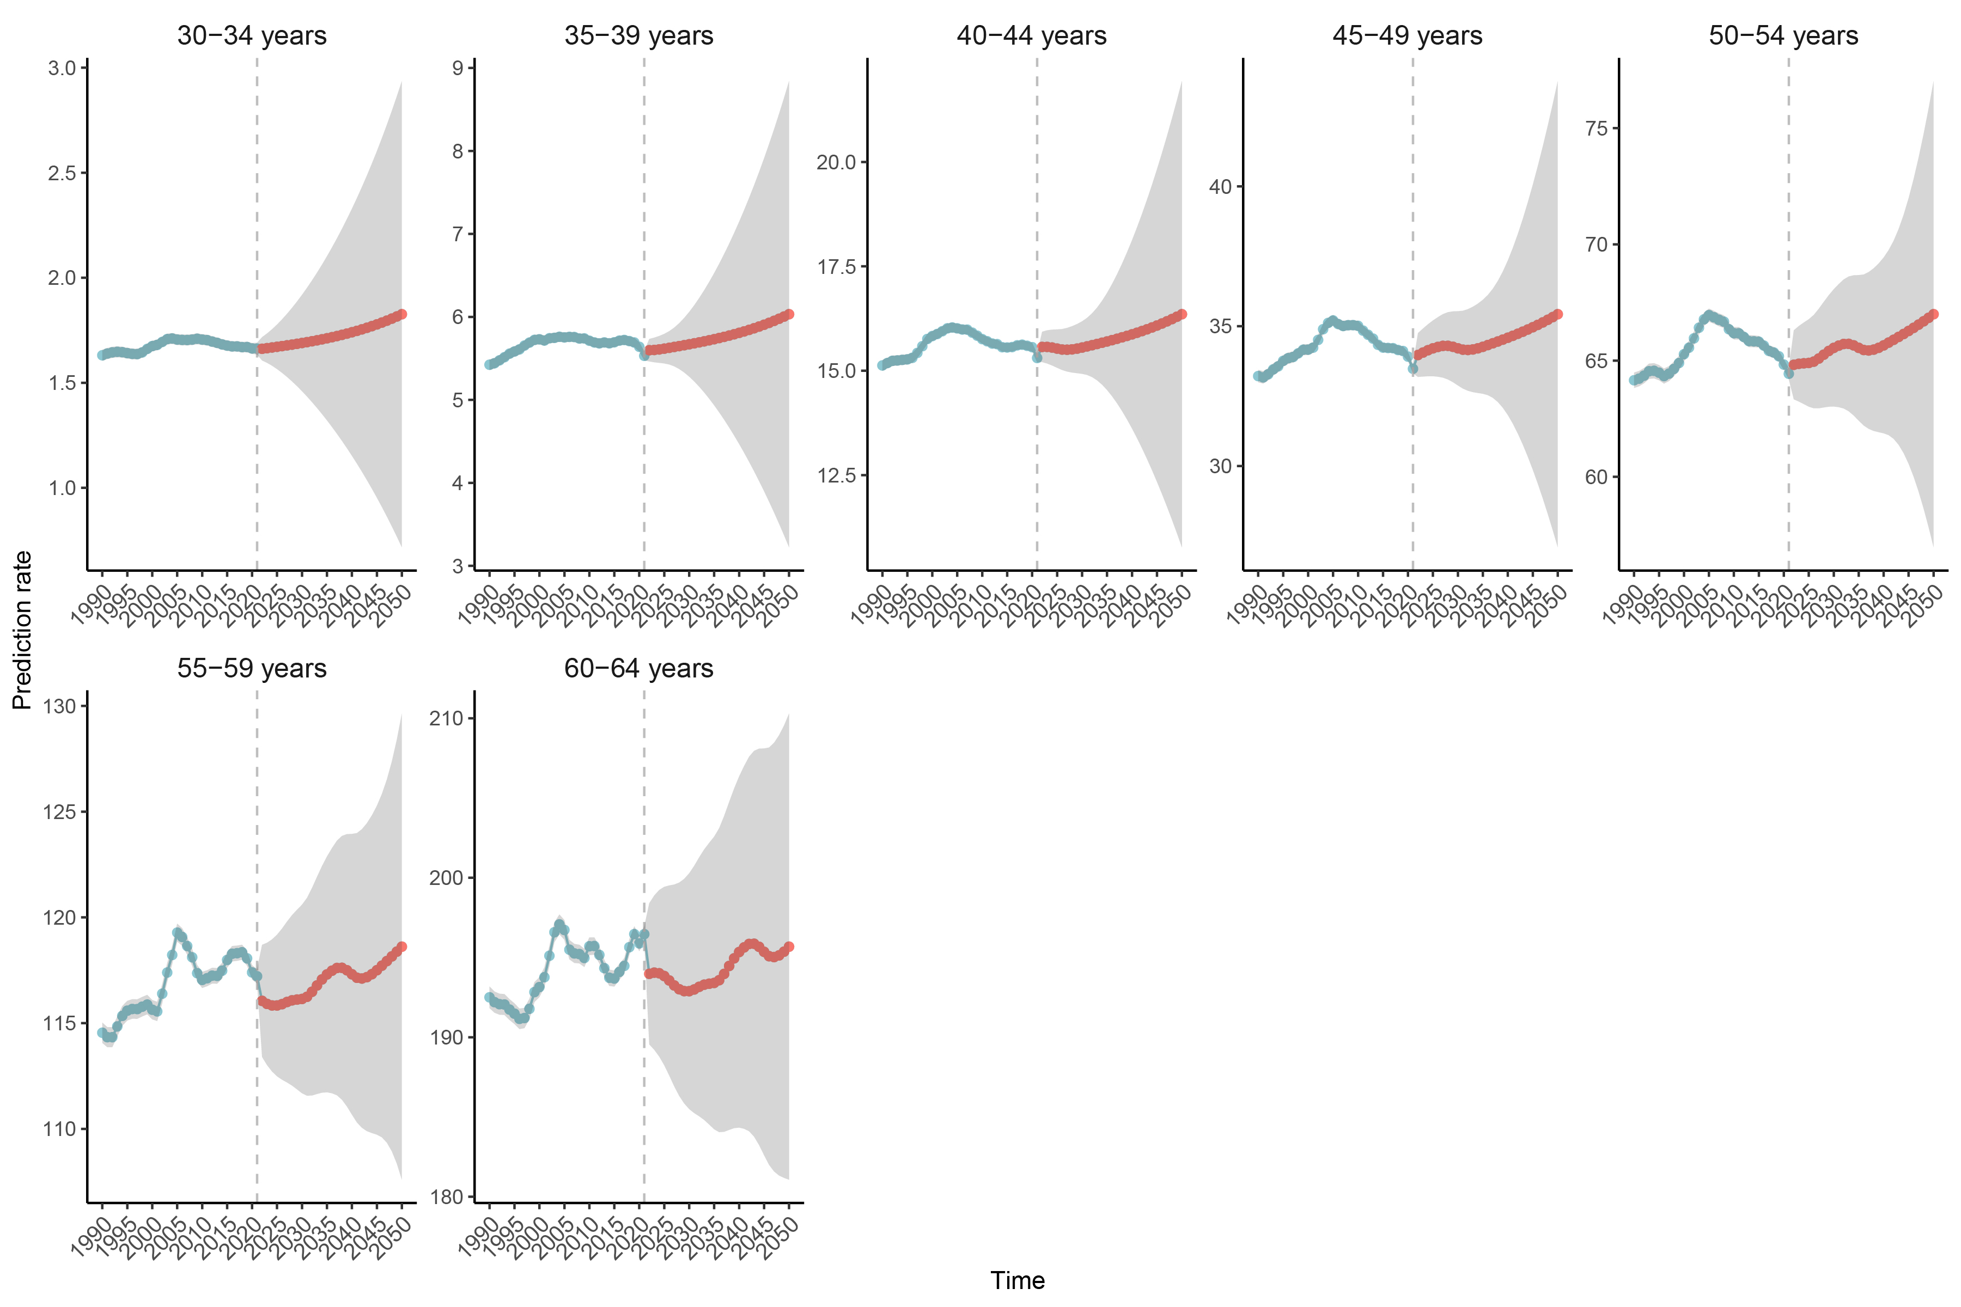 Supplementary Figure 21: DALYs rates by different age groups.

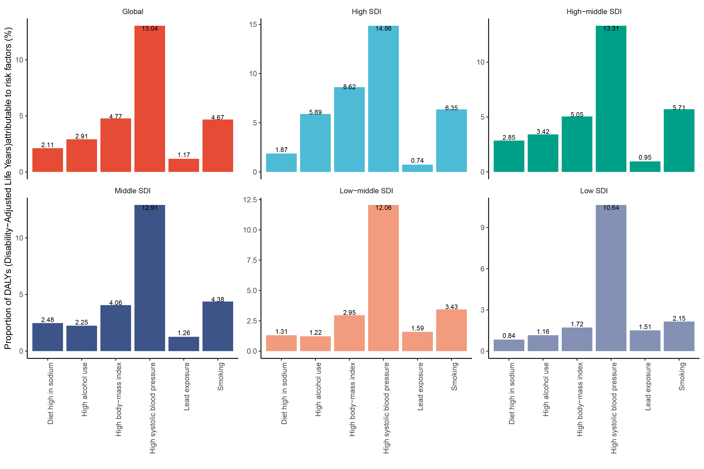 Supplementary Figure 22: Attributable risk factors in 2021 for global and five SDI regions.

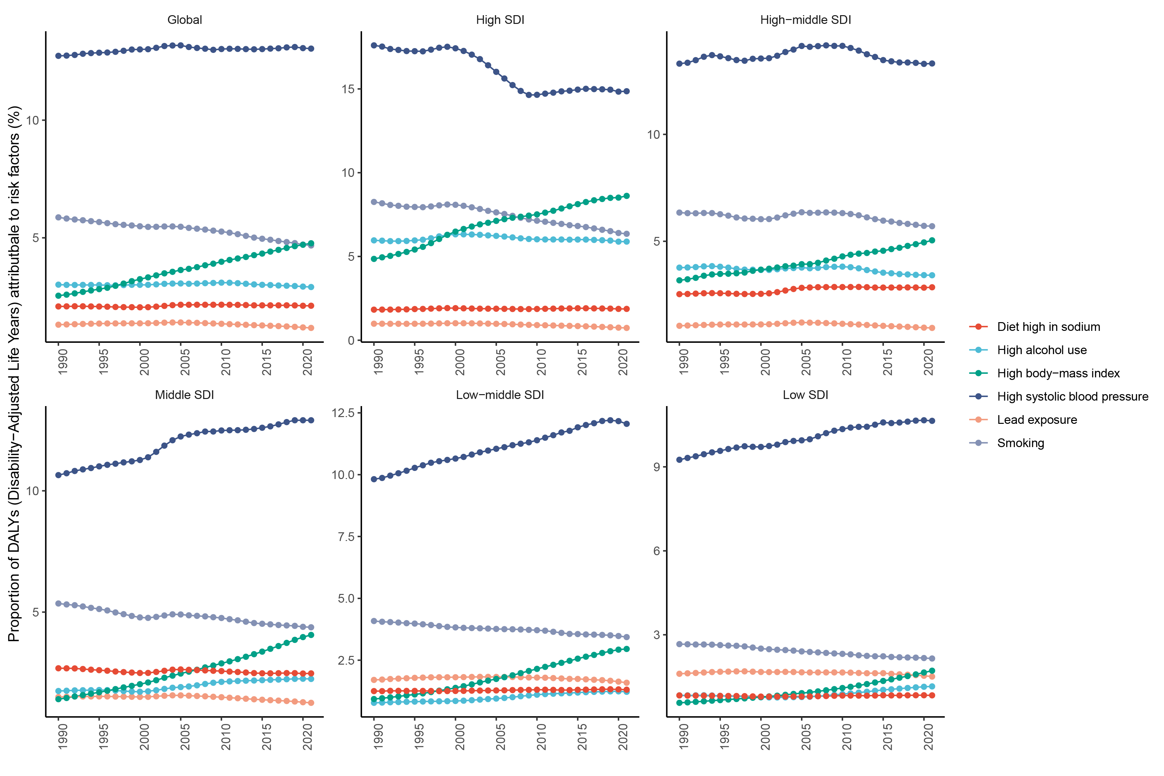
Supplementary Figure 23: Temporal trends of attributable risk factors in global and five SDI regions.

Supplementary Table 1: ASR and their EAPCs for 204 countries and regions in 1990 and 2021.
location | ASIR |  |  | ASPR |  |  | ASMR |  |  | ASDR
location | 1990-Female | 2021-Female | EAPCs | 1990-Female | 2021-Female | EAPCs | 1990-Female | 2021-Female | EAPCs | 1990-Female | 2021-Female | EAPCs
Afghanistan | 20.45(11.66,32.80) | 22.51(12.91,35.84) | 0.31(0.28,0.35) | 165.02(104.83,245.70) | 180.13(114.75,264.68) | 0.29(0.27,0.32) | 0.58(0.28,1.05) | 0.65(0.32,1.08) | 0.43(0.37,0.49) | 32.53(18.79,51.09) | 35.56(21.22,52.78) | 0.29(0.27,0.32)
Albania | 49.38(29.72,77.70) | 48.51(29.00,76.00) | -0.04(-0.07,-0.02) | 379.95(254.62,562.71) | 372.09(247.11,549.87) | 0.01(-0.04,0.07) | 0.42(0.34,0.54) | 0.43(0.23,0.76) | 0.06(-0.16,0.28) | 44.41(29.51,64.94) | 43.98(27.99,66.18) | 0.01(-0.04,0.07)
Algeria | 22.56(12.80,36.58) | 24.31(13.95,39.06) | 0.16(0.12,0.19) | 182.11(116.12,271.28) | 197.42(126.59,293.52) | 0.08(0.04,0.12) | 0.42(0.28,0.63) | 0.41(0.27,0.60) | 0.01(-0.10,0.12) | 29.09(19.78,41.98) | 29.71(20.20,42.04) | 0.08(0.04,0.12)
American Samoa | 49.49(29.15,79.13) | 53.97(31.63,86.31) | 0.21(0.17,0.24) | 423.22(283.08,622.26) | 462.84(307.98,676.45) | 0.42(0.38,0.45) | 1.41(1.02,1.91) | 1.59(1.09,2.23) | 0.55(0.48,0.63) | 84.72(62.19,112.85) | 94.67(68.14,126.44) | 0.42(0.38,0.45)
Andorra | 62.19(36.87,96.47) | 55.48(33.00,87.43) | -0.52(-0.57,-0.47) | 521.26(351.02,749.78) | 466.40(314.85,683.28) | -0.67(-0.73,-0.61) | 0.54(0.35,0.81) | 0.36(0.21,0.53) | -1.03(-1.23,-0.82) | 60.69(39.91,88.27) | 49.70(31.38,74.63) | -0.67(-0.73,-0.61)
Angola | 32.92(19.22,53.01) | 35.13(20.72,55.68) | 0.24(0.22,0.25) | 263.32(172.40,392.84) | 281.94(186.87,416.20) | -0.04(-0.08,0.01) | 0.87(0.52,1.36) | 0.84(0.53,1.25) | -0.26(-0.35,-0.16) | 49.78(33.23,71.32) | 50.05(33.32,70.97) | -0.04(-0.08,0.01)
Antigua and Barbuda | 51.15(30.25,80.75) | 51.89(30.89,82.42) | 0.05(0.03,0.06) | 422.31(281.88,618.83) | 431.63(288.71,625.27) | -0.48(-0.56,-0.41) | 0.92(0.81,1.04) | 0.63(0.55,0.71) | -1.13(-1.31,-0.95) | 65.25(48.31,87.89) | 55.57(39.14,78.14) | -0.48(-0.56,-0.41)
Argentina | 35.10(20.53,55.50) | 27.94(19.67,39.09) | -0.74(-0.99,-0.49) | 288.84(188.94,422.48) | 249.42(196.61,319.72) | -0.12(-0.30,0.05) | 0.38(0.35,0.42) | 0.36(0.32,0.40) | 0.45(0.08,0.83) | 36.47(24.94,51.82) | 32.44(23.81,44.09) | -0.12(-0.30,0.05)
Armenia | 43.34(25.62,69.44) | 47.40(28.30,75.83) | 0.31(0.29,0.34) | 335.16(220.58,500.89) | 365.70(243.29,546.62) | 0.71(0.55,0.87) | 0.25(0.23,0.28) | 0.36(0.30,0.42) | 1.73(1.21,2.25) | 35.49(22.50,53.26) | 41.64(26.99,60.92) | 0.71(0.55,0.87)
Australia | 75.88(60.60,91.24) | 74.62(44.29,119.19) | 0.04(-0.04,0.12) | 708.79(627.36,799.75) | 649.02(437.33,937.89) | -0.19(-0.27,-0.10) | 0.66(0.60,0.73) | 0.56(0.49,0.63) | -0.38(-0.44,-0.31) | 78.97(58.72,102.81) | 70.92(46.82,103.64) | -0.19(-0.27,-0.10)
Austria | 46.24(33.82,62.12) | 79.77(66.74,93.92) | 1.99(1.84,2.14) | 387.62(312.63,485.38) | 633.58(564.78,709.63) | 1.24(1.09,1.38) | 0.66(0.59,0.72) | 0.63(0.56,0.71) | 0.28(0.08,0.48) | 53.36(40.19,69.83) | 72.37(53.59,93.42) | 1.24(1.09,1.38)
Azerbaijan | 43.43(25.96,68.49) | 46.34(27.55,72.57) | 0.25(0.22,0.28) | 333.93(220.92,494.97) | 358.28(237.12,526.92) | 0.05(0.01,0.10) | 0.34(0.27,0.42) | 0.33(0.19,0.58) | -0.44(-0.61,-0.27) | 38.58(24.38,56.44) | 40.09(24.81,61.38) | 0.05(0.01,0.10)
Bahrain | 24.34(13.91,39.47) | 25.81(14.86,40.99) | 0.17(0.14,0.21) | 198.09(125.71,295.18) | 212.96(136.93,311.83) | -1.22(-1.34,-1.10) | 0.59(0.31,0.82) | 0.30(0.19,0.46) | -2.81(-3.08,-2.53) | 34.97(21.52,49.04) | 26.67(17.12,39.48) | -1.22(-1.34,-1.10)
Bangladesh | 33.58(19.72,53.26) | 34.80(20.52,55.70) | 0.13(0.07,0.18) | 252.59(164.89,377.20) | 263.39(171.69,394.24) | 0.11(0.07,0.15) | 0.48(0.27,0.78) | 0.46(0.29,0.72) | 0.03(-0.11,0.16) | 36.30(23.01,52.52) | 36.38(23.59,52.93) | 0.11(0.07,0.15)
Barbados | 53.12(31.25,84.09) | 55.67(33.14,87.94) | 0.15(0.13,0.18) | 437.56(289.98,634.07) | 461.36(309.50,676.45) | -0.13(-0.19,-0.08) | 0.64(0.57,0.72) | 0.53(0.38,0.68) | -0.62(-0.74,-0.51) | 57.33(40.51,80.39) | 54.93(36.92,79.46) | -0.13(-0.19,-0.08)
Belarus | 53.12(31.58,84.16) | 59.17(35.12,93.83) | 0.34(0.31,0.37) | 443.12(296.59,646.79) | 497.92(329.31,734.87) | 0.33(0.20,0.45) | 0.50(0.42,0.59) | 0.59(0.47,0.73) | 0.22(-0.10,0.54) | 51.82(34.94,75.56) | 59.17(40.03,85.26) | 0.33(0.20,0.45)
Belgium | 49.55(30.10,76.75) | 51.76(31.73,77.72) | 0.20(0.14,0.26) | 413.01(279.71,588.27) | 524.08(368.41,715.22) | 0.74(0.56,0.92) | 0.48(0.44,0.53) | 0.43(0.38,0.48) | -0.06(-0.32,0.21) | 49.65(34.28,70.65) | 56.82(38.16,81.01) | 0.74(0.56,0.92)
Belize | 53.45(31.64,85.68) | 54.56(32.23,86.67) | 0.09(0.06,0.11) | 440.24(296.50,649.75) | 451.93(300.66,651.42) | -0.01(-0.16,0.14) | 0.67(0.54,0.85) | 0.70(0.59,0.81) | -0.12(-0.46,0.23) | 58.63(40.83,82.48) | 60.05(42.83,82.93) | -0.01(-0.16,0.14)
Benin | 29.87(17.53,47.82) | 31.51(18.32,50.30) | 0.18(0.17,0.19) | 242.27(158.29,360.50) | 255.59(167.23,380.39) | 0.13(0.09,0.16) | 0.27(0.17,0.37) | 0.26(0.16,0.39) | -0.02(-0.12,0.09) | 28.13(17.73,42.24) | 29.24(18.49,43.63) | 0.13(0.09,0.16)
Bermuda | 56.50(33.26,90.33) | 55.43(32.85,88.05) | -0.09(-0.11,-0.07) | 467.48(310.58,690.91) | 461.26(308.66,668.38) | -0.72(-0.78,-0.65) | 0.66(0.53,0.78) | 0.34(0.28,0.43) | -2.26(-2.41,-2.12) | 60.20(40.67,84.97) | 49.12(31.58,72.81) | -0.72(-0.78,-0.65)
Bhutan | 34.13(20.16,54.51) | 35.07(20.73,55.90) | 0.10(0.07,0.13) | 256.38(168.29,384.01) | 264.74(173.06,397.15) | 0.24(0.22,0.26) | 0.39(0.19,0.67) | 0.45(0.26,0.74) | 0.40(0.35,0.45) | 33.64(21.24,50.60) | 36.38(23.33,53.84) | 0.24(0.22,0.26)
Bolivarian Republic of Venezuela | 59.43(34.98,95.04) | 55.87(33.21,88.69) | -0.21(-0.23,-0.19) | 488.57(323.77,719.98) | 462.66(310.92,670.20) | -0.15(-0.21,-0.10) | 0.60(0.55,0.66) | 0.64(0.46,0.87) | -0.08(-0.21,0.06) | 59.92(41.21,85.52) | 59.13(40.02,83.51) | -0.15(-0.21,-0.10)
Bosnia and Herzegovina | 46.79(27.83,74.09) | 48.75(29.03,76.55) | 0.16(0.13,0.19) | 355.05(234.96,523.47) | 373.00(245.55,551.28) | 0.03(-0.04,0.11) | 0.59(0.45,0.76) | 0.56(0.39,0.78) | -0.17(-0.32,-0.01) | 47.64(32.48,67.25) | 48.13(32.96,68.01) | 0.03(-0.04,0.11)
Botswana | 33.99(19.86,54.46) | 36.51(21.42,58.80) | 0.21(0.19,0.23) | 273.32(179.79,407.63) | 293.12(193.05,439.70) | -0.29(-0.41,-0.18) | 0.59(0.39,0.86) | 0.46(0.29,0.69) | -0.80(-1.04,-0.56) | 42.54(28.60,60.30) | 39.12(26.23,56.44) | -0.29(-0.41,-0.18)
Brazil | 67.16(40.03,106.48) | 66.66(39.74,105.71) | 0.04(0.01,0.07) | 590.51(398.40,858.40) | 590.08(398.92,852.79) | 0.40(0.32,0.48) | 0.61(0.58,0.63) | 0.71(0.67,0.74) | 0.38(0.31,0.46) | 68.03(47.04,95.59) | 71.32(49.98,98.77) | 0.40(0.32,0.48)
Brunei Darussalam | 47.17(27.55,74.98) | 40.00(23.54,63.39) | -0.63(-0.69,-0.57) | 469.54(313.65,672.93) | 397.24(265.83,563.04) | -0.50(-0.66,-0.34) | 1.34(0.90,1.95) | 1.14(0.89,1.45) | -0.44(-0.71,-0.17) | 83.25(57.84,113.86) | 70.83(52.63,93.33) | -0.50(-0.66,-0.34)
Bulgaria | 48.41(29.03,76.15) | 48.52(29.03,76.08) | 0.08(0.04,0.12) | 368.73(245.74,542.15) | 371.38(247.35,549.38) | 0.47(0.37,0.57) | 0.89(0.73,1.10) | 1.26(1.02,1.53) | 0.82(0.63,1.01) | 58.81(43.11,80.19) | 70.47(53.70,92.16) | 0.47(0.37,0.57)
Burkina Faso | 30.01(17.42,47.88) | 31.48(18.28,50.39) | 0.13(0.11,0.15) | 244.22(159.71,363.41) | 255.20(166.61,379.00) | 0.33(0.30,0.36) | 0.32(0.17,0.48) | 0.37(0.21,0.57) | 0.66(0.58,0.74) | 30.17(18.82,45.17) | 32.70(20.88,48.30) | 0.33(0.30,0.36)
Burundi | 34.63(20.09,55.64) | 35.00(20.29,55.82) | 0.05(0.03,0.06) | 295.20(193.78,440.69) | 299.28(197.97,444.91) | -0.54(-0.66,-0.43) | 0.60(0.27,1.04) | 0.44(0.21,0.79) | -1.37(-1.63,-1.11) | 43.91(26.73,66.43) | 39.07(23.59,59.98) | -0.54(-0.66,-0.43)
Cabo Verde | 31.34(18.16,49.70) | 33.27(19.49,53.27) | 0.20(0.19,0.21) | 254.66(167.33,377.14) | 270.30(179.33,402.35) | 0.24(0.19,0.29) | 0.26(0.18,0.36) | 0.31(0.21,0.43) | 0.36(0.17,0.55) | 29.33(18.71,43.58) | 32.00(20.65,46.73) | 0.24(0.19,0.29)
Cambodia | 44.71(26.32,71.44) | 45.78(27.22,72.81) | 0.05(0.03,0.07) | 380.88(253.61,557.92) | 391.82(262.13,568.38) | -0.08(-0.12,-0.03) | 0.54(0.35,0.80) | 0.50(0.34,0.71) | -0.31(-0.40,-0.23) | 49.53(32.87,70.42) | 48.90(32.22,71.07) | -0.08(-0.12,-0.03)
Cameroon | 30.31(17.62,48.78) | 34.50(20.27,55.20) | 0.38(0.30,0.47) | 246.47(161.21,370.18) | 279.41(183.37,413.11) | 0.20(0.11,0.29) | 0.44(0.27,0.63) | 0.44(0.26,0.67) | -0.11(-0.22,0.00) | 34.06(22.62,48.61) | 36.78(23.80,53.05) | 0.20(0.11,0.29)
Canada | 81.10(51.02,120.62) | 70.26(41.67,109.77) | -0.27(-0.39,-0.14) | 597.74(425.35,842.12) | 544.59(362.43,792.72) | -0.12(-0.25,0.00) | 0.59(0.54,0.64) | 0.50(0.45,0.56) | -0.31(-0.40,-0.22) | 67.98(46.06,95.87) | 60.67(39.62,88.12) | -0.12(-0.25,0.00)
Central African Republic | 32.93(19.20,52.55) | 32.94(19.24,52.71) | -0.02(-0.03,-0.01) | 263.18(173.95,389.64) | 263.65(172.71,392.54) | -0.13(-0.16,-0.10) | 0.97(0.51,1.61) | 0.92(0.48,1.50) | -0.23(-0.29,-0.18) | 52.98(32.83,78.52) | 51.51(31.79,76.46) | -0.13(-0.16,-0.10)
Chad | 28.96(17.03,46.47) | 30.21(17.70,48.45) | 0.13(0.12,0.14) | 235.06(153.31,350.65) | 244.76(160.53,362.51) | 0.34(0.29,0.39) | 0.27(0.15,0.44) | 0.34(0.21,0.53) | 0.70(0.57,0.84) | 27.78(17.03,41.94) | 30.93(19.72,45.88) | 0.34(0.29,0.39)
Chile | 39.20(22.87,62.75) | 37.95(22.16,60.52) | -0.22(-0.28,-0.17) | 321.28(210.90,471.54) | 317.31(210.37,464.73) | 0.01(-0.23,0.25) | 0.46(0.42,0.51) | 0.40(0.36,0.45) | 0.24(-0.38,0.87) | 41.41(28.76,58.32) | 38.95(26.48,56.35) | 0.01(-0.23,0.25)
China | 35.41(20.64,56.41) | 44.41(26.27,70.06) | 0.88(0.73,1.03) | 323.09(214.03,468.41) | 411.67(278.21,593.76) | 0.33(0.23,0.44) | 0.43(0.33,0.56) | 0.31(0.24,0.40) | -1.09(-1.13,-1.05) | 40.90(28.00,57.32) | 44.05(28.79,63.48) | 0.33(0.23,0.44)
Colombia | 51.16(30.60,81.01) | 50.98(30.13,80.92) | 0.02(-0.00,0.05) | 422.45(280.66,614.32) | 423.68(283.95,610.93) | -0.21(-0.26,-0.17) | 0.58(0.53,0.63) | 0.52(0.41,0.64) | -0.66(-0.78,-0.54) | 53.93(37.89,74.71) | 51.70(34.80,73.81) | -0.21(-0.26,-0.17)
Commonwealth of the Bahamas | 55.49(32.92,88.40) | 53.76(31.90,84.67) | -0.10(-0.12,-0.09) | 456.60(304.03,667.70) | 445.25(297.70,648.01) | -0.21(-0.29,-0.14) | 1.05(0.92,1.18) | 0.93(0.72,1.18) | -0.35(-0.53,-0.17) | 73.07(54.57,97.49) | 68.09(49.91,92.01) | -0.21(-0.29,-0.14)
Comoros | 33.26(19.36,53.28) | 34.52(20.15,54.78) | 0.11(0.09,0.12) | 284.26(186.42,416.83) | 295.32(196.48,433.80) | -0.54(-0.66,-0.42) | 0.67(0.33,1.07) | 0.48(0.24,0.80) | -1.36(-1.63,-1.08) | 45.36(27.66,66.95) | 40.03(24.63,60.63) | -0.54(-0.66,-0.42)
Congo | 34.05(20.01,54.30) | 35.84(20.98,57.45) | 0.18(0.16,0.19) | 272.48(179.08,406.08) | 287.32(189.64,428.43) | -0.49(-0.60,-0.39) | 1.25(0.79,1.98) | 1.04(0.62,1.52) | -0.88(-1.04,-0.72) | 63.40(43.56,91.18) | 57.39(38.85,79.59) | -0.49(-0.60,-0.39)
Cook Islands | 46.88(27.81,74.80) | 54.24(32.03,86.63) | 0.46(0.42,0.50) | 402.72(269.18,586.64) | 466.97(310.22,683.47) | -0.18(-0.29,-0.07) | 1.65(1.14,2.29) | 1.29(0.81,1.95) | -0.63(-0.81,-0.44) | 92.05(66.14,126.30) | 83.81(57.02,117.08) | -0.18(-0.29,-0.07)
Costa Rica | 58.36(34.54,93.20) | 57.27(33.67,91.97) | -0.08(-0.10,-0.07) | 481.96(322.75,709.69) | 475.69(318.52,703.11) | -0.13(-0.18,-0.09) | 0.51(0.46,0.57) | 0.53(0.44,0.61) | -0.22(-0.35,-0.09) | 56.36(37.80,82.00) | 56.06(37.66,80.32) | -0.13(-0.18,-0.09)
Cote d'Ivoire | 32.02(18.69,51.57) | 33.80(19.81,54.12) | 0.14(0.12,0.15) | 259.24(170.90,387.56) | 272.98(179.23,405.16) | 0.13(0.08,0.19) | 0.35(0.23,0.50) | 0.37(0.23,0.54) | 0.06(-0.08,0.19) | 32.10(21.11,47.02) | 34.09(22.29,50.46) | 0.13(0.08,0.19)
Croatia | 34.87(24.33,48.83) | 33.79(24.69,45.43) | 0.26(0.04,0.47) | 291.19(224.55,381.79) | 276.20(220.31,348.19) | 0.22(0.11,0.33) | 0.31(0.28,0.33) | 0.32(0.27,0.38) | 0.45(0.16,0.73) | 33.55(23.36,47.11) | 32.63(23.12,45.30) | 0.22(0.11,0.33)
Cuba | 53.71(32.08,86.29) | 53.00(31.59,83.79) | -0.05(-0.08,-0.03) | 444.67(295.85,657.25) | 440.29(297.22,641.72) | -0.09(-0.12,-0.05) | 0.61(0.54,0.69) | 0.58(0.49,0.69) | -0.07(-0.14,-0.00) | 57.09(39.31,78.87) | 55.35(38.36,78.85) | -0.09(-0.12,-0.05)
Cyprus | 47.93(28.67,74.87) | 31.68(20.07,47.12) | -1.01(-1.32,-0.71) | 398.75(267.44,575.78) | 263.05(182.93,365.78) | -1.24(-1.39,-1.08) | 0.76(0.57,1.04) | 0.45(0.34,0.59) | -1.51(-1.58,-1.44) | 57.47(40.70,80.21) | 35.94(25.26,50.17) | -1.24(-1.39,-1.08)
Czech Republic | 56.61(34.11,89.03) | 71.11(51.57,92.09) | 0.89(0.67,1.11) | 425.13(281.07,629.52) | 519.91(412.78,636.39) | 0.50(0.27,0.73) | 0.59(0.54,0.65) | 0.50(0.42,0.59) | -0.02(-0.40,0.35) | 53.50(37.25,75.68) | 57.76(40.99,77.73) | 0.50(0.27,0.73)
Democratic People's Republic of Korea | 43.76(25.64,69.65) | 43.67(25.34,69.46) | -0.04(-0.05,-0.03) | 395.18(264.66,575.75) | 393.96(264.38,572.91) | 0.21(0.17,0.24) | 0.56(0.35,0.82) | 0.63(0.42,0.87) | 0.60(0.49,0.71) | 51.13(33.81,73.74) | 53.24(35.48,76.09) | 0.21(0.17,0.24)
Democratic Republic of the Congo | 33.34(19.50,53.08) | 32.03(18.97,50.92) | -0.17(-0.18,-0.15) | 266.93(173.54,397.22) | 257.72(168.43,381.09) | 0.10(-0.00,0.19) | 0.73(0.41,1.18) | 0.79(0.46,1.33) | 0.27(0.09,0.46) | 45.16(29.15,66.64) | 46.59(28.90,69.98) | 0.10(-0.00,0.19)
Denmark | 62.14(37.74,96.60) | 74.68(46.84,112.89) | 0.25(0.04,0.47) | 541.33(368.03,771.17) | 676.85(490.14,933.03) | 0.20(-0.04,0.45) | 0.69(0.63,0.76) | 0.63(0.55,0.70) | -0.21(-0.52,0.11) | 66.93(47.43,94.33) | 75.45(51.29,106.62) | 0.20(-0.04,0.45)
Djibouti | 32.54(18.84,52.03) | 35.26(20.39,56.43) | 0.27(0.26,0.29) | 278.12(183.27,412.23) | 302.37(199.07,442.98) | -0.17(-0.19,-0.14) | 0.67(0.43,0.98) | 0.57(0.32,0.91) | -0.67(-0.73,-0.61) | 44.85(30.35,63.60) | 43.50(28.25,64.26) | -0.17(-0.19,-0.14)
Dominica | 52.07(30.83,82.07) | 54.27(31.89,86.61) | 0.18(0.16,0.20) | 426.28(286.58,615.76) | 450.16(301.62,661.86) | 0.20(0.17,0.23) | 0.87(0.65,1.14) | 0.90(0.65,1.19) | 0.19(0.14,0.24) | 63.56(44.43,87.72) | 66.43(46.60,90.89) | 0.20(0.17,0.23)
Dominican Republic | 52.51(31.09,83.62) | 53.02(31.32,84.51) | 0.02(0.01,0.03) | 431.80(287.27,635.33) | 438.60(288.76,640.50) | 0.25(0.20,0.30) | 0.66(0.51,0.82) | 0.73(0.54,0.96) | 0.60(0.49,0.71) | 57.75(39.42,80.94) | 60.36(42.27,84.49) | 0.25(0.20,0.30)
Ecuador | 47.89(28.35,75.97) | 48.45(28.80,76.87) | 0.08(0.06,0.10) | 394.74(261.78,575.56) | 402.73(268.65,587.85) | -0.31(-0.39,-0.23) | 0.64(0.57,0.71) | 0.50(0.37,0.65) | -0.90(-1.08,-0.71) | 54.02(38.70,74.33) | 49.27(32.61,70.66) | -0.31(-0.39,-0.23)
Egypt | 21.63(12.24,35.10) | 25.07(14.32,40.37) | 0.54(0.51,0.56) | 175.37(109.34,262.58) | 203.28(130.29,300.76) | 0.05(0.01,0.08) | 0.40(0.30,0.56) | 0.35(0.27,0.47) | -0.52(-0.62,-0.42) | 28.03(19.35,39.53) | 28.32(19.53,40.24) | 0.05(0.01,0.08)
El Salvador | 51.92(30.85,82.53) | 52.16(30.91,82.92) | 0.03(0.02,0.03) | 426.22(282.84,624.49) | 432.76(288.45,635.53) | 0.03(-0.04,0.11) | 0.79(0.62,0.99) | 0.82(0.58,1.12) | 0.04(-0.13,0.22) | 61.62(43.99,84.71) | 62.59(43.52,86.54) | 0.03(-0.04,0.11)
Equatorial Guinea | 32.50(19.06,51.82) | 37.80(22.06,60.45) | 0.52(0.50,0.54) | 260.03(171.18,385.29) | 303.42(199.89,453.07) | -0.17(-0.29,-0.04) | 0.99(0.56,1.71) | 0.84(0.43,1.40) | -0.73(-0.97,-0.50) | 53.44(34.26,80.51) | 51.94(33.07,75.48) | -0.17(-0.29,-0.04)
Eritrea | 31.40(18.23,50.06) | 32.75(19.18,52.24) | 0.15(0.14,0.16) | 268.23(176.86,397.46) | 280.28(185.25,412.49) | -0.47(-0.54,-0.41) | 0.88(0.50,1.37) | 0.68(0.36,1.15) | -0.96(-1.07,-0.85) | 51.37(32.79,74.49) | 45.45(28.40,67.92) | -0.47(-0.54,-0.41)
Estonia | 51.77(30.96,82.09) | 58.92(35.17,92.36) | 0.49(0.45,0.53) | 432.61(289.47,637.27) | 500.45(335.61,727.87) | 0.08(-0.02,0.18) | 0.56(0.46,0.69) | 0.49(0.41,0.56) | -0.79(-1.07,-0.52) | 52.79(36.46,75.07) | 55.95(36.80,81.21) | 0.08(-0.02,0.18)
Eswatini | 35.16(20.58,56.10) | 37.02(21.60,59.71) | 0.16(0.15,0.17) | 281.88(186.10,417.74) | 296.26(194.44,437.72) | 0.53(0.17,0.89) | 0.70(0.44,1.04) | 0.82(0.50,1.25) | 0.85(0.25,1.46) | 46.79(32.06,66.20) | 52.01(35.04,73.48) | 0.53(0.17,0.89)
Ethiopia | 33.38(19.48,53.37) | 41.04(24.03,64.87) | 0.88(0.74,1.01) | 279.01(184.22,413.96) | 354.39(237.00,515.89) | -0.15(-0.29,-0.01) | 0.61(0.30,0.95) | 0.37(0.19,0.61) | -2.11(-2.34,-1.89) | 42.70(27.39,62.03) | 40.82(25.97,60.63) | -0.15(-0.29,-0.01)
Federated States of Micronesia | 46.11(27.06,73.86) | 46.91(27.62,74.81) | 0.04(0.03,0.05) | 394.02(261.28,581.27) | 401.58(268.92,590.43) | 0.10(0.07,0.12) | 2.19(1.45,3.15) | 2.24(1.47,3.24) | 0.09(0.06,0.13) | 111.34(77.22,152.75) | 114.06(79.89,155.96) | 0.10(0.07,0.12)
Fiji | 48.38(28.28,76.69) | 54.67(32.40,87.31) | 0.42(0.39,0.44) | 413.47(275.56,601.43) | 468.36(314.22,681.03) | 0.28(0.20,0.36) | 1.47(1.10,1.96) | 1.49(1.02,2.07) | 0.20(0.07,0.33) | 85.80(63.19,113.28) | 90.47(64.71,120.10) | 0.28(0.20,0.36)
Finland | 99.62(61.25,141.01) | 64.60(48.87,81.87) | -1.41(-1.56,-1.27) | 836.80(582.29,1088.51) | 535.98(461.41,625.46) | -1.09(-1.23,-0.94) | 0.81(0.70,0.92) | 0.66(0.59,0.73) | -0.38(-0.58,-0.19) | 95.11(64.31,131.89) | 65.40(49.75,85.30) | -1.09(-1.23,-0.94)
France | 60.54(35.73,95.28) | 53.62(31.50,84.04) | -0.52(-0.58,-0.45) | 503.04(338.33,730.15) | 447.54(297.02,647.80) | -0.51(-0.54,-0.47) | 0.55(0.50,0.61) | 0.46(0.41,0.53) | -0.33(-0.43,-0.24) | 58.88(39.54,83.74) | 51.01(33.85,73.66) | -0.51(-0.54,-0.47)
Gabon | 33.85(19.83,54.30) | 36.20(21.29,58.40) | 0.21(0.20,0.21) | 271.32(178.89,401.55) | 290.77(192.79,434.26) | -0.22(-0.33,-0.12) | 1.10(0.75,1.68) | 1.00(0.62,1.40) | -0.50(-0.67,-0.33) | 58.01(40.23,81.66) | 56.12(38.04,76.18) | -0.22(-0.33,-0.12)
Gambia | 31.69(18.51,50.44) | 32.69(19.12,52.46) | 0.05(0.02,0.09) | 257.31(169.73,384.23) | 265.32(175.10,394.89) | 0.19(0.11,0.27) | 0.33(0.19,0.50) | 0.41(0.27,0.58) | 0.44(0.23,0.65) | 31.76(20.53,47.45) | 34.75(22.96,50.21) | 0.19(0.11,0.27)
Georgia | 48.25(28.51,77.12) | 49.23(29.41,77.85) | 0.01(-0.02,0.04) | 370.04(242.74,556.02) | 377.54(251.56,564.68) | 1.03(0.72,1.34) | 0.63(0.49,0.74) | 1.17(1.01,1.35) | 2.14(1.50,2.79) | 50.86(34.73,70.42) | 69.22(53.10,90.08) | 1.03(0.72,1.34)
Germany | 73.64(43.47,117.79) | 91.17(63.95,120.17) | 0.46(0.12,0.80) | 614.13(410.46,895.59) | 799.57(631.25,980.53) | 0.52(0.16,0.88) | 0.71(0.63,0.79) | 0.63(0.57,0.71) | 0.51(-0.09,1.10) | 74.07(50.54,105.21) | 86.04(60.40,116.91) | 0.52(0.16,0.88)
Ghana | 31.29(18.30,50.20) | 34.47(20.01,55.56) | 0.26(0.21,0.31) | 253.68(166.52,377.96) | 278.95(184.59,416.14) | -0.19(-0.26,-0.12) | 0.41(0.29,0.56) | 0.33(0.22,0.46) | -1.00(-1.18,-0.82) | 34.15(22.96,48.79) | 33.34(21.62,48.58) | -0.19(-0.26,-0.12)
Global | 45.53(27.40,71.23) | 47.05(29.73,71.26) | 0.14(0.10,0.19) | 380.67(257.38,550.83) | 397.94(282.14,558.51) | 0.08(0.04,0.11) | 0.51(0.44,0.59) | 0.49(0.44,0.53) | -0.16(-0.19,-0.13) | 47.66(33.69,66.17) | 48.46(34.29,66.42) | 0.08(0.04,0.11)
Greece | 51.92(34.08,75.36) | 48.81(29.06,76.68) | -0.42(-0.78,-0.07) | 437.97(323.75,585.70) | 405.82(272.83,594.59) | -0.41(-0.69,-0.14) | 0.44(0.40,0.47) | 0.49(0.44,0.54) | -0.44(-1.02,0.14) | 49.98(34.69,70.70) | 49.54(33.58,71.34) | -0.41(-0.69,-0.14)
Greenland | 85.67(51.02,134.89) | 75.58(45.13,118.36) | -0.34(-0.40,-0.27) | 658.44(442.36,966.53) | 585.95(394.64,850.47) | -0.60(-0.66,-0.55) | 2.03(1.56,2.58) | 1.43(1.04,1.94) | -0.82(-0.91,-0.74) | 121.35(90.08,160.51) | 94.70(68.63,129.43) | -0.60(-0.66,-0.55)
Grenada | 51.46(30.51,82.54) | 53.33(31.29,84.87) | 0.08(0.06,0.10) | 423.09(282.04,617.99) | 442.31(296.52,639.78) | 0.10(0.04,0.16) | 0.86(0.71,1.06) | 0.83(0.69,0.99) | 0.15(0.01,0.29) | 63.36(46.01,86.56) | 63.62(45.92,86.46) | 0.10(0.04,0.16)
Guam | 47.12(28.01,74.56) | 53.79(31.86,84.95) | 0.39(0.36,0.43) | 405.33(270.89,591.68) | 462.07(308.30,673.95) | 0.37(0.19,0.55) | 1.25(1.01,1.61) | 1.13(0.87,1.43) | 0.22(-0.19,0.63) | 76.73(57.05,101.76) | 79.20(58.65,106.15) | 0.37(0.19,0.55)
Guatemala | 48.24(28.44,76.83) | 50.00(29.65,78.93) | 0.21(0.17,0.25) | 396.58(265.49,577.92) | 414.47(278.72,596.77) | -0.11(-0.20,-0.02) | 0.60(0.51,0.70) | 0.55(0.44,0.67) | -0.56(-0.74,-0.37) | 52.70(36.91,72.70) | 51.63(35.69,72.82) | -0.11(-0.20,-0.02)
Guinea | 29.30(17.16,46.86) | 30.53(17.87,48.90) | 0.11(0.09,0.13) | 237.76(155.71,351.90) | 247.55(161.40,370.92) | 0.22(0.18,0.25) | 0.32(0.19,0.51) | 0.36(0.22,0.53) | 0.37(0.28,0.45) | 29.72(18.56,44.34) | 31.80(20.49,47.35) | 0.22(0.18,0.25)
Guinea-Bissau | 30.32(17.67,48.67) | 31.46(18.31,50.08) | 0.11(0.09,0.12) | 245.27(158.81,363.99) | 254.24(165.18,378.81) | 0.03(-0.00,0.06) | 0.52(0.32,0.82) | 0.51(0.33,0.74) | -0.10(-0.16,-0.05) | 36.80(24.44,52.94) | 37.30(24.81,53.76) | 0.03(-0.00,0.06)
Guyana | 53.78(31.72,84.58) | 53.57(31.51,86.01) | -0.01(-0.03,0.01) | 440.87(298.56,637.48) | 441.96(297.27,649.00) | 0.37(0.31,0.43) | 0.89(0.78,1.03) | 1.08(0.80,1.43) | 0.73(0.60,0.87) | 65.35(48.28,88.45) | 71.80(52.73,96.22) | 0.37(0.31,0.43)
Haiti | 52.02(30.65,83.00) | 52.28(30.89,82.80) | 0.06(0.03,0.08) | 424.57(280.69,625.28) | 430.15(286.75,632.36) | -0.10(-0.13,-0.07) | 1.07(0.62,1.81) | 0.95(0.56,1.48) | -0.29(-0.34,-0.24) | 70.33(45.87,102.11) | 66.32(44.39,96.08) | -0.10(-0.13,-0.07)
Honduras | 52.69(31.25,84.13) | 52.58(31.21,82.48) | -0.03(-0.04,-0.02) | 432.44(288.36,636.04) | 434.25(290.74,627.45) | 0.56(0.50,0.63) | 0.68(0.48,0.90) | 1.00(0.65,1.42) | 1.40(1.24,1.56) | 58.23(40.36,82.94) | 68.36(47.66,93.82) | 0.56(0.50,0.63)
Hungary | 57.83(34.58,90.90) | 49.23(29.56,77.28) | -0.57(-0.62,-0.52) | 432.48(284.89,643.64) | 375.78(250.18,556.67) | -0.34(-0.47,-0.22) | 0.62(0.57,0.68) | 0.57(0.48,0.67) | -0.09(-0.43,0.25) | 55.13(38.86,77.87) | 48.80(33.99,68.72) | -0.34(-0.47,-0.22)
Iceland | 49.74(30.43,75.88) | 55.48(35.28,81.13) | 0.02(-0.08,0.13) | 408.73(281.19,583.04) | 474.07(343.44,637.24) | -0.03(-0.11,0.05) | 0.64(0.58,0.71) | 0.59(0.51,0.68) | -0.29(-0.41,-0.18) | 54.70(39.21,75.82) | 58.56(42.10,80.18) | -0.03(-0.11,0.05)
India | 37.20(21.87,59.09) | 38.06(22.42,60.51) | 0.10(0.08,0.12) | 276.46(181.24,414.38) | 283.69(187.07,424.58) | 0.30(0.23,0.37) | 0.42(0.25,0.64) | 0.51(0.37,0.63) | 0.56(0.36,0.75) | 35.89(23.93,51.63) | 39.49(27.45,54.46) | 0.30(0.23,0.37)
Indonesia | 55.01(32.84,87.34) | 57.78(34.48,92.12) | 0.19(0.18,0.20) | 457.17(307.67,667.89) | 480.61(322.90,701.11) | 0.22(0.18,0.26) | 0.56(0.43,0.68) | 0.62(0.46,0.79) | 0.25(0.14,0.37) | 56.50(39.26,78.91) | 60.43(42.78,83.51) | 0.22(0.18,0.26)
Iraq | 24.68(14.04,39.81) | 26.98(15.51,43.77) | 0.29(0.27,0.30) | 198.99(125.79,291.44) | 218.48(140.58,326.53) | -0.36(-0.42,-0.30) | 0.84(0.58,1.16) | 0.74(0.49,1.07) | -0.69(-0.78,-0.60) | 45.21(32.07,60.47) | 42.97(30.07,58.03) | -0.36(-0.42,-0.30)
Ireland | 56.94(33.71,89.49) | 49.50(29.39,77.92) | -0.76(-0.85,-0.67) | 477.51(321.10,691.13) | 415.94(279.55,604.26) | -0.90(-0.97,-0.83) | 0.74(0.68,0.81) | 0.44(0.39,0.50) | -1.35(-1.49,-1.21) | 63.08(44.59,87.51) | 48.47(32.46,70.39) | -0.90(-0.97,-0.83)
Islamic Republic of Iran | 25.64(14.84,41.06) | 28.34(16.52,45.35) | 0.24(0.19,0.29) | 203.21(132.01,303.81) | 223.09(145.99,332.39) | -0.04(-0.07,0.00) | 0.34(0.28,0.43) | 0.29(0.22,0.33) | -0.46(-0.56,-0.36) | 27.65(19.78,38.47) | 27.32(18.97,38.55) | -0.04(-0.07,0.00)
Israel | 62.10(36.85,97.39) | 92.69(59.66,127.86) | 1.82(1.43,2.21) | 513.07(342.92,741.61) | 767.60(557.21,987.08) | 1.21(0.93,1.50) | 0.57(0.52,0.63) | 0.47(0.42,0.54) | -0.48(-0.60,-0.37) | 60.77(40.63,88.27) | 78.33(52.11,110.82) | 1.21(0.93,1.50)
Italy | 67.33(40.12,105.50) | 58.31(34.55,91.78) | -0.54(-0.63,-0.45) | 533.06(358.54,778.14) | 448.78(300.59,655.77) | -0.36(-0.49,-0.22) | 0.46(0.44,0.48) | 0.37(0.35,0.39) | -0.25(-0.42,-0.08) | 58.60(39.24,84.60) | 48.84(32.44,70.99) | -0.36(-0.49,-0.22)
Jamaica | 51.23(30.45,81.45) | 53.65(31.80,85.40) | 0.15(0.11,0.19) | 423.15(281.90,615.16) | 445.43(298.21,653.19) | 0.13(0.02,0.24) | 0.71(0.60,0.84) | 0.73(0.53,0.99) | 0.04(-0.26,0.33) | 58.10(41.49,81.70) | 60.97(43.12,84.63) | 0.13(0.02,0.24)
Japan | 46.21(27.19,73.15) | 34.60(20.42,54.99) | -0.91(-1.14,-0.67) | 435.97(293.31,632.48) | 312.87(207.44,455.95) | -1.07(-1.27,-0.87) | 0.48(0.46,0.50) | 0.40(0.38,0.41) | -1.05(-1.28,-0.83) | 51.69(35.66,72.79) | 38.71(27.18,53.96) | -1.07(-1.27,-0.87)
Jordan | 23.11(13.17,37.20) | 25.93(14.82,41.73) | 0.35(0.35,0.36) | 187.74(119.14,276.81) | 210.97(134.01,312.47) | -0.77(-0.93,-0.61) | 0.46(0.34,0.61) | 0.26(0.19,0.34) | -2.19(-2.58,-1.80) | 30.68(21.62,41.85) | 25.66(16.66,37.63) | -0.77(-0.93,-0.61)
Kazakhstan | 49.00(29.08,77.61) | 51.14(30.44,80.59) | 0.13(0.11,0.16) | 372.86(246.59,552.89) | 393.22(259.64,583.26) | -0.02(-0.15,0.10) | 0.43(0.37,0.49) | 0.47(0.39,0.55) | -0.30(-0.64,0.04) | 44.41(29.70,64.34) | 47.18(31.95,68.29) | -0.02(-0.15,0.10)
Kenya | 37.65(22.11,60.04) | 38.74(22.75,61.85) | 0.09(0.08,0.10) | 314.10(206.82,465.70) | 322.62(212.76,478.90) | 0.41(0.36,0.46) | 0.34(0.21,0.48) | 0.44(0.29,0.62) | 1.04(0.89,1.18) | 36.61(24.29,52.47) | 40.64(27.37,56.95) | 0.41(0.36,0.46)
Kiribati | 46.44(27.31,73.52) | 48.68(28.55,77.54) | 0.10(0.08,0.12) | 395.37(263.07,575.56) | 413.52(276.32,603.66) | 0.05(0.02,0.08) | 1.03(0.76,1.36) | 1.02(0.71,1.49) | -0.04(-0.08,0.01) | 68.88(50.17,93.03) | 70.56(49.91,97.43) | 0.05(0.02,0.08)
Kuwait | 24.27(13.71,38.87) | 26.22(14.91,42.30) | 0.22(0.18,0.27) | 200.53(127.92,294.90) | 214.54(138.16,320.41) | -0.17(-0.43,0.10) | 0.37(0.32,0.42) | 0.25(0.21,0.31) | -0.64(-1.26,-0.02) | 28.89(20.24,40.16) | 25.73(16.75,37.54) | -0.17(-0.43,0.10)
Kyrgyzstan | 41.43(24.67,66.15) | 42.06(25.25,65.29) | -0.00(-0.02,0.02) | 318.48(210.50,477.20) | 325.95(215.91,473.56) | 0.09(0.01,0.17) | 0.39(0.33,0.46) | 0.44(0.36,0.54) | 0.17(-0.06,0.41) | 38.80(26.54,55.90) | 41.36(28.13,59.15) | 0.09(0.01,0.17)
Lao People's Democratic Republic | 47.09(27.76,74.98) | 48.29(28.48,76.89) | 0.09(0.07,0.11) | 400.07(266.56,584.38) | 412.86(275.50,601.83) | -0.20(-0.22,-0.17) | 0.70(0.39,1.11) | 0.58(0.40,0.84) | -0.69(-0.75,-0.64) | 56.58(37.20,81.76) | 53.99(35.92,78.01) | -0.20(-0.22,-0.17)
Latvia | 49.21(29.16,78.47) | 60.35(40.98,83.36) | 0.97(0.80,1.14) | 412.25(272.65,606.11) | 525.94(404.09,669.94) | 0.77(0.69,0.85) | 0.51(0.44,0.59) | 0.60(0.52,0.69) | 0.35(0.09,0.61) | 49.38(33.95,70.74) | 62.08(44.60,83.55) | 0.77(0.69,0.85)
Lebanon | 22.40(12.63,36.22) | 25.30(14.53,40.34) | 0.43(0.40,0.45) | 181.79(114.06,270.78) | 203.44(131.67,298.83) | -1.78(-2.00,-1.56) | 0.82(0.48,1.31) | 0.29(0.21,0.38) | -3.78(-4.11,-3.44) | 42.53(27.62,61.98) | 25.66(17.18,37.33) | -1.78(-2.00,-1.56)
Lesotho | 31.62(18.50,50.25) | 33.51(19.62,53.31) | 0.17(0.16,0.18) | 254.35(166.55,377.32) | 269.02(177.15,397.96) | 1.46(1.14,1.78) | 0.40(0.26,0.59) | 0.76(0.45,1.16) | 2.89(2.23,3.54) | 34.34(22.52,50.07) | 47.42(30.95,67.06) | 1.46(1.14,1.78)
Liberia | 31.59(18.46,51.10) | 32.23(18.90,51.69) | 0.07(0.05,0.09) | 255.67(167.12,384.72) | 261.20(170.93,389.03) | 0.07(0.02,0.12) | 0.34(0.20,0.50) | 0.36(0.22,0.55) | 0.05(-0.07,0.17) | 31.58(20.52,46.48) | 32.41(21.14,48.13) | 0.07(0.02,0.12)
Libya | 24.09(13.66,39.00) | 26.15(15.10,42.06) | 0.25(0.22,0.27) | 195.77(123.91,291.05) | 211.79(136.55,313.47) | 0.60(0.53,0.67) | 0.32(0.20,0.49) | 0.42(0.21,0.69) | 1.17(1.03,1.32) | 26.56(17.05,38.77) | 31.05(18.97,44.47) | 0.60(0.53,0.67)
Lithuania | 53.19(31.80,84.22) | 60.33(35.97,95.94) | 0.46(0.42,0.51) | 444.45(296.34,652.93) | 509.14(340.29,747.87) | 0.52(0.39,0.64) | 0.50(0.42,0.61) | 0.62(0.53,0.71) | 0.60(0.30,0.90) | 52.02(34.87,75.21) | 61.19(41.74,87.74) | 0.52(0.39,0.64)
Luxembourg | 54.12(36.51,77.37) | 49.10(34.52,68.03) | -0.23(-0.37,-0.10) | 436.00(327.98,590.48) | 395.66(310.25,512.32) | -0.55(-0.64,-0.46) | 0.74(0.67,0.82) | 0.50(0.44,0.58) | -1.01(-1.18,-0.83) | 59.92(44.70,80.67) | 48.48(35.06,66.14) | -0.55(-0.64,-0.46)
Madagascar | 32.87(19.16,52.41) | 34.77(20.31,55.89) | 0.20(0.19,0.22) | 281.18(186.18,413.11) | 297.41(197.20,438.33) | -0.07(-0.15,0.00) | 1.05(0.63,1.49) | 0.97(0.60,1.44) | -0.28(-0.41,-0.16) | 58.32(38.85,80.96) | 56.93(38.51,79.90) | -0.07(-0.15,0.00)
Malawi | 34.26(19.88,54.87) | 37.44(21.83,60.12) | 0.28(0.25,0.31) | 292.93(192.38,434.28) | 319.99(213.06,473.47) | 0.37(0.30,0.45) | 0.43(0.22,0.66) | 0.53(0.32,0.81) | 0.45(0.28,0.62) | 37.90(23.84,56.69) | 43.62(28.20,64.13) | 0.37(0.30,0.45)
Malaysia | 50.19(29.59,79.96) | 53.40(31.52,85.58) | 0.34(0.29,0.39) | 429.12(286.64,624.28) | 459.30(306.23,672.61) | 0.34(0.28,0.40) | 0.50(0.38,0.63) | 0.53(0.41,0.67) | 0.27(0.12,0.42) | 51.84(34.43,74.91) | 55.56(37.40,80.22) | 0.34(0.28,0.40)
Maldives | 47.80(28.03,76.21) | 49.20(29.19,78.45) | 0.04(0.03,0.06) | 409.84(272.28,601.78) | 423.08(281.68,623.96) | -0.64(-0.69,-0.60) | 0.46(0.26,0.76) | 0.22(0.15,0.32) | -2.78(-2.94,-2.62) | 49.34(31.08,72.82) | 42.25(25.83,65.47) | -0.64(-0.69,-0.60)
Mali | 28.69(16.82,45.86) | 30.18(17.72,47.98) | 0.14(0.13,0.15) | 233.07(152.17,346.23) | 244.90(160.70,362.33) | 0.05(0.01,0.10) | 0.28(0.17,0.44) | 0.26(0.16,0.39) | -0.20(-0.33,-0.07) | 27.84(17.72,41.15) | 28.17(17.68,42.73) | 0.05(0.01,0.10)
Malta | 49.52(29.33,76.75) | 38.86(27.44,53.56) | -0.36(-0.66,-0.06) | 410.16(273.94,589.17) | 332.15(261.57,425.52) | -0.18(-0.40,0.04) | 0.57(0.51,0.63) | 0.49(0.43,0.56) | 0.00(-0.23,0.24) | 52.01(36.24,73.54) | 43.29(31.92,58.22) | -0.18(-0.40,0.04)
Marshall Islands | 43.35(25.76,68.16) | 46.08(27.11,73.33) | 0.16(0.14,0.18) | 370.24(246.99,539.06) | 394.12(262.82,570.73) | 0.34(0.23,0.46) | 2.02(1.40,2.89) | 2.30(1.42,3.43) | 0.38(0.24,0.51) | 102.29(73.24,139.79) | 115.37(77.89,161.29) | 0.34(0.23,0.46)
Mauritania | 30.61(17.90,49.20) | 32.75(19.21,52.32) | 0.19(0.17,0.21) | 248.37(162.66,367.68) | 266.11(173.43,395.92) | -0.18(-0.23,-0.13) | 0.46(0.32,0.63) | 0.38(0.24,0.58) | -0.79(-0.94,-0.65) | 34.93(23.72,49.73) | 34.08(22.15,50.44) | -0.18(-0.23,-0.13)
Mauritius | 49.15(28.98,78.37) | 50.83(30.06,81.98) | -0.02(-0.08,0.03) | 421.83(279.92,618.17) | 436.92(289.74,638.69) | -0.44(-0.62,-0.25) | 0.71(0.65,0.79) | 0.56(0.49,0.63) | -1.22(-1.63,-0.81) | 58.70(42.31,80.52) | 54.84(37.59,78.09) | -0.44(-0.62,-0.25)
Mexico | 57.13(33.98,90.90) | 58.83(34.89,93.76) | 0.15(0.13,0.17) | 459.05(308.35,677.07) | 475.82(318.21,698.02) | 0.16(0.13,0.19) | 0.65(0.63,0.67) | 0.70(0.60,0.79) | 0.18(0.10,0.25) | 58.65(42.11,80.25) | 61.78(43.88,84.21) | 0.16(0.13,0.19)
Monaco | 58.45(34.54,91.15) | 53.43(31.16,85.54) | -0.39(-0.44,-0.34) | 487.51(326.60,706.77) | 447.00(293.36,646.72) | -0.41(-0.46,-0.36) | 0.51(0.36,0.69) | 0.42(0.28,0.60) | -0.49(-0.70,-0.28) | 56.83(37.73,83.02) | 50.53(32.90,74.17) | -0.41(-0.46,-0.36)
Mongolia | 43.86(26.09,69.23) | 46.91(27.84,74.31) | 0.22(0.21,0.24) | 337.77(223.78,496.45) | 359.51(237.41,531.44) | -0.30(-0.39,-0.22) | 0.50(0.37,0.65) | 0.38(0.29,0.47) | -1.23(-1.46,-1.00) | 43.92(30.17,61.67) | 41.69(27.36,60.65) | -0.30(-0.39,-0.22)
Montenegro | 52.18(31.19,81.51) | 50.72(30.46,79.79) | -0.07(-0.10,-0.04) | 396.21(262.97,581.18) | 388.89(257.30,572.04) | 0.03(-0.10,0.15) | 2.04(1.62,2.58) | 2.00(1.43,2.70) | 0.11(-0.07,0.29) | 99.25(77.60,125.76) | 96.31(70.91,126.71) | 0.03(-0.10,0.15)
Morocco | 23.65(13.43,38.30) | 25.35(14.51,40.60) | 0.14(0.11,0.17) | 189.94(121.24,282.30) | 205.09(132.13,306.34) | 0.51(0.47,0.55) | 0.41(0.27,0.60) | 0.52(0.33,0.77) | 0.92(0.81,1.02) | 29.22(19.26,41.40) | 33.54(23.01,47.43) | 0.51(0.47,0.55)
Mozambique | 33.55(19.59,53.45) | 36.07(21.11,57.85) | 0.21(0.19,0.23) | 286.20(188.92,420.86) | 307.67(203.72,452.93) | 0.91(0.82,1.00) | 0.54(0.26,0.87) | 0.77(0.43,1.26) | 1.65(1.46,1.83) | 40.74(25.03,60.33) | 50.26(31.82,73.92) | 0.91(0.82,1.00)
Myanmar | 49.24(28.86,78.27) | 48.84(28.89,77.39) | -0.03(-0.03,-0.02) | 419.42(279.77,619.85) | 417.89(278.41,607.15) | -0.32(-0.37,-0.26) | 0.70(0.41,1.10) | 0.59(0.41,0.83) | -0.78(-0.92,-0.64) | 58.42(38.23,84.65) | 54.74(36.47,78.64) | -0.32(-0.37,-0.26)
Namibia | 33.85(19.94,53.71) | 34.50(20.36,55.09) | 0.02(0.01,0.04) | 271.85(179.88,401.82) | 277.84(184.27,413.00) | -0.01(-0.16,0.14) | 0.60(0.43,0.82) | 0.64(0.40,0.94) | -0.01(-0.30,0.27) | 42.65(29.61,59.17) | 44.30(30.83,62.24) | -0.01(-0.16,0.14)
Nauru | 51.60(30.33,82.90) | 54.22(31.74,85.88) | 0.06(0.03,0.09) | 441.58(293.91,650.55) | 462.74(308.49,675.28) | -0.03(-0.13,0.06) | 2.62(1.63,3.85) | 2.55(1.51,3.76) | -0.09(-0.22,0.04) | 130.45(87.72,181.48) | 130.25(83.97,181.31) | -0.03(-0.13,0.06)
Nepal | 34.04(19.97,54.30) | 33.40(19.45,52.81) | -0.03(-0.11,0.04) | 255.73(166.23,384.03) | 253.30(164.73,376.72) | 0.39(0.30,0.48) | 0.35(0.19,0.60) | 0.45(0.28,0.69) | 1.03(0.68,1.38) | 31.98(20.00,47.04) | 35.15(22.63,51.57) | 0.39(0.30,0.48)
Netherlands | 59.16(39.87,83.07) | 54.27(34.54,80.91) | -0.58(-0.71,-0.46) | 484.84(348.64,655.67) | 448.95(308.97,628.29) | -0.49(-0.59,-0.39) | 0.58(0.53,0.63) | 0.50(0.44,0.55) | -0.37(-0.54,-0.20) | 58.95(41.75,81.54) | 52.87(36.66,74.83) | -0.49(-0.59,-0.39)
New Zealand | 58.44(35.57,88.96) | 68.42(44.57,100.16) | 0.79(0.59,0.98) | 480.19(333.18,675.04) | 589.45(434.21,791.91) | 0.39(0.17,0.62) | 0.91(0.84,0.98) | 0.75(0.68,0.82) | -0.57(-0.95,-0.20) | 68.47(51.50,91.27) | 72.56(52.38,97.19) | 0.39(0.17,0.62)
Nicaragua | 52.49(30.91,83.17) | 52.23(31.00,83.37) | 0.00(-0.02,0.02) | 431.86(287.00,633.54) | 431.72(288.59,636.24) | 0.06(0.00,0.11) | 0.50(0.39,0.63) | 0.52(0.37,0.69) | 0.25(0.08,0.42) | 52.07(34.74,75.25) | 51.89(34.35,74.39) | 0.06(0.00,0.11)
Niger | 29.52(17.26,47.19) | 30.22(17.61,48.21) | 0.07(0.06,0.07) | 238.85(157.08,355.52) | 245.01(159.69,363.49) | -0.03(-0.07,0.02) | 0.24(0.12,0.39) | 0.23(0.10,0.41) | -0.30(-0.45,-0.16) | 27.27(16.68,41.20) | 27.19(16.03,42.22) | -0.03(-0.07,0.02)
Nigeria | 31.66(18.57,50.57) | 35.94(21.13,57.35) | 0.50(0.46,0.55) | 252.96(167.60,376.66) | 285.39(188.87,424.15) | -0.02(-0.05,0.02) | 0.34(0.22,0.46) | 0.26(0.16,0.38) | -1.17(-1.37,-0.96) | 31.30(21.24,44.70) | 31.59(20.28,45.81) | -0.02(-0.05,0.02)
Niue | 49.04(29.00,77.99) | 54.65(32.47,86.73) | 0.31(0.28,0.35) | 420.41(279.48,610.46) | 468.96(315.07,675.34) | -0.12(-0.16,-0.08) | 1.71(1.23,2.33) | 1.62(1.12,2.22) | -0.36(-0.42,-0.31) | 95.32(69.53,127.32) | 96.13(69.00,129.41) | -0.12(-0.16,-0.08)
North Macedonia | 49.42(29.68,76.85) | 48.60(29.26,76.62) | -0.01(-0.04,0.01) | 375.39(249.61,554.39) | 374.60(248.02,547.30) | 0.22(0.13,0.31) | 0.50(0.41,0.66) | 0.63(0.37,1.08) | 0.53(0.27,0.79) | 46.63(31.27,66.72) | 50.41(32.53,75.29) | 0.22(0.13,0.31)
Northern Mariana Islands | 50.68(29.74,80.80) | 52.90(30.93,84.10) | 0.08(0.05,0.11) | 435.81(292.92,636.95) | 455.62(301.94,664.90) | 0.15(0.04,0.25) | 1.65(1.19,2.26) | 1.71(1.19,2.47) | 0.24(0.07,0.41) | 94.43(69.52,124.73) | 98.41(70.64,137.55) | 0.15(0.04,0.25)
Norway | 62.47(37.18,98.33) | 62.68(37.74,98.34) | 0.06(-0.02,0.14) | 507.81(342.07,742.83) | 503.55(339.95,740.01) | -0.55(-0.67,-0.43) | 0.76(0.73,0.79) | 0.46(0.43,0.48) | -1.62(-1.94,-1.30) | 65.62(47.07,90.15) | 55.77(37.17,80.43) | -0.55(-0.67,-0.43)
Oman | 19.72(11.19,31.43) | 24.50(14.04,39.33) | 0.84(0.77,0.90) | 162.11(102.35,240.17) | 202.21(130.21,297.32) | -0.27(-0.39,-0.15) | 0.75(0.49,1.11) | 0.59(0.34,0.96) | -0.95(-1.16,-0.74) | 38.21(26.00,53.45) | 35.52(22.90,52.64) | -0.27(-0.39,-0.15)
Pakistan | 39.25(23.12,62.53) | 40.00(23.45,63.81) | 0.09(0.07,0.10) | 291.29(191.81,434.07) | 297.08(195.87,445.47) | 0.35(0.23,0.48) | 0.39(0.24,0.59) | 0.55(0.38,0.80) | 0.74(0.43,1.06) | 36.46(24.03,52.96) | 42.00(29.15,59.16) | 0.35(0.23,0.48)
Palau | 46.24(27.08,74.11) | 51.90(30.49,83.33) | 0.32(0.28,0.36) | 397.37(264.35,585.64) | 444.12(297.14,651.09) | -0.31(-0.33,-0.28) | 1.18(0.83,1.61) | 0.90(0.64,1.21) | -0.91(-0.95,-0.87) | 74.99(53.65,101.16) | 68.46(47.58,94.92) | -0.31(-0.33,-0.28)
Palestine | 21.34(11.96,34.11) | 23.17(13.21,37.22) | 0.23(0.21,0.24) | 171.44(107.93,253.62) | 188.82(119.19,278.87) | -0.25(-0.32,-0.18) | 0.51(0.35,0.75) | 0.43(0.33,0.55) | -0.69(-0.83,-0.55) | 30.96(21.34,43.52) | 29.20(20.75,40.89) | -0.25(-0.32,-0.18)
Panama | 53.44(31.63,84.82) | 54.40(32.28,86.58) | 0.10(0.07,0.12) | 440.98(292.82,636.95) | 451.93(302.54,654.56) | 0.19(0.16,0.22) | 0.50(0.45,0.56) | 0.57(0.43,0.70) | 0.37(0.30,0.45) | 52.68(35.99,75.84) | 55.63(37.87,78.50) | 0.19(0.16,0.22)
Papua New Guinea | 42.31(24.86,67.28) | 43.24(25.59,67.71) | 0.05(0.03,0.06) | 362.31(241.36,528.16) | 370.41(247.18,537.56) | -0.03(-0.08,0.01) | 1.25(0.64,1.97) | 1.23(0.71,1.90) | -0.08(-0.17,0.01) | 74.48(47.28,107.81) | 74.53(49.79,107.44) | -0.03(-0.08,0.01)
Paraguay | 67.12(39.33,106.18) | 64.81(38.25,103.27) | -0.14(-0.17,-0.11) | 612.48(412.21,882.08) | 594.81(399.43,860.41) | 0.13(0.11,0.16) | 0.54(0.42,0.70) | 0.69(0.49,0.95) | 0.86(0.76,0.96) | 68.32(44.98,99.41) | 71.12(47.66,100.03) | 0.13(0.11,0.16)
Peru | 47.29(28.19,74.41) | 52.63(31.11,83.28) | 0.47(0.41,0.53) | 388.95(259.79,569.87) | 437.65(290.04,640.33) | -0.13(-0.25,0.00) | 0.65(0.46,0.90) | 0.51(0.34,0.72) | -1.17(-1.47,-0.87) | 53.95(36.31,75.57) | 52.55(34.76,75.68) | -0.13(-0.25,0.00)
Philippines | 50.69(30.04,81.03) | 51.29(30.39,81.91) | 0.00(-0.01,0.02) | 421.23(282.74,619.69) | 426.36(285.88,626.93) | 0.21(0.18,0.25) | 0.49(0.42,0.57) | 0.60(0.48,0.71) | 0.55(0.46,0.63) | 51.58(35.76,72.19) | 55.64(39.11,76.27) | 0.21(0.18,0.25)
Plurinational State of Bolivia | 47.58(28.27,75.38) | 49.55(29.39,78.84) | 0.15(0.13,0.17) | 389.94(260.40,567.94) | 410.09(274.54,599.59) | -0.24(-0.28,-0.21) | 0.90(0.54,1.41) | 0.75(0.49,1.15) | -0.67(-0.72,-0.62) | 62.14(40.81,88.90) | 58.47(38.58,83.79) | -0.24(-0.28,-0.21)
Poland | 54.49(32.77,84.84) | 73.68(44.68,113.86) | 0.20(-0.12,0.52) | 408.80(272.28,605.24) | 541.37(363.37,792.52) | -0.37(-0.73,-0.01) | 1.06(1.01,1.13) | 0.62(0.56,0.69) | -1.16(-1.77,-0.53) | 67.04(52.02,86.45) | 63.34(43.73,89.78) | -0.37(-0.73,-0.01)
Portugal | 54.65(32.60,86.36) | 45.85(29.38,67.33) | -0.64(-0.74,-0.55) | 447.15(300.17,654.87) | 344.81(237.55,486.57) | -0.81(-0.94,-0.68) | 0.44(0.40,0.49) | 0.39(0.35,0.43) | -0.33(-0.45,-0.20) | 50.93(33.98,73.69) | 40.84(28.26,58.30) | -0.81(-0.94,-0.68)
Puerto Rico | 55.94(33.26,89.93) | 56.47(33.13,90.53) | 0.03(0.01,0.04) | 461.51(305.42,675.00) | 469.70(313.47,695.40) | -0.29(-0.35,-0.23) | 0.64(0.58,0.71) | 0.54(0.43,0.67) | -0.86(-1.02,-0.70) | 59.24(41.34,83.60) | 56.31(38.12,80.26) | -0.29(-0.35,-0.23)
Qatar | 23.99(13.58,38.83) | 26.76(15.23,43.11) | 0.33(0.29,0.37) | 199.80(127.16,292.50) | 222.69(143.26,329.61) | -0.90(-1.04,-0.75) | 0.55(0.32,0.79) | 0.29(0.12,0.63) | -2.39(-2.73,-2.04) | 33.93(21.55,48.06) | 26.61(14.98,43.79) | -0.90(-1.04,-0.75)
Republic of Korea | 54.48(31.93,87.23) | 60.98(40.05,88.29) | 0.63(0.45,0.82) | 545.59(366.04,785.98) | 692.24(530.60,886.62) | 0.46(0.24,0.68) | 0.63(0.43,0.92) | 0.40(0.29,0.55) | -1.48(-1.57,-1.39) | 66.00(44.73,94.90) | 69.46(46.43,99.00) | 0.46(0.24,0.68)
Republic of Moldova | 51.80(30.86,82.66) | 58.94(35.06,93.71) | 0.48(0.45,0.50) | 433.52(286.98,640.45) | 495.31(331.40,726.52) | 0.50(0.40,0.60) | 0.56(0.49,0.63) | 0.66(0.57,0.77) | 0.55(0.29,0.81) | 52.99(36.69,74.71) | 61.30(43.03,87.11) | 0.50(0.40,0.60)
Romania | 48.01(28.88,75.01) | 33.56(23.62,48.00) | -1.30(-1.64,-0.95) | 365.30(240.67,541.48) | 260.30(199.66,352.55) | -0.76(-0.95,-0.56) | 0.45(0.39,0.52) | 0.50(0.43,0.58) | -0.06(-0.23,0.10) | 44.15(30.24,63.51) | 37.29(28.00,50.56) | -0.76(-0.95,-0.56)
Russian Federation | 56.94(34.03,90.08) | 63.64(38.13,100.39) | 0.46(0.30,0.61) | 465.13(311.11,683.81) | 520.10(349.41,764.48) | 0.54(0.38,0.69) | 0.53(0.44,0.64) | 0.69(0.63,0.76) | 0.64(0.42,0.87) | 54.33(37.75,77.44) | 64.26(45.73,88.42) | 0.54(0.38,0.69)
Rwanda | 35.36(20.73,56.16) | 36.21(21.23,57.90) | 0.05(0.03,0.06) | 301.26(200.13,443.27) | 309.46(205.19,458.68) | -1.46(-1.73,-1.20) | 0.85(0.41,1.37) | 0.45(0.18,0.82) | -3.19(-3.69,-2.68) | 52.78(32.48,77.15) | 39.95(23.13,61.37) | -1.46(-1.73,-1.20)
Saint Kitts and Nevis | 52.75(31.21,84.28) | 53.03(31.41,83.70) | -0.02(-0.05,0.01) | 432.15(289.35,636.14) | 440.05(292.74,643.72) | -0.56(-0.64,-0.48) | 1.08(0.89,1.27) | 0.75(0.57,0.95) | -1.12(-1.28,-0.95) | 71.32(51.91,94.14) | 60.32(41.83,82.94) | -0.56(-0.64,-0.48)
Saint Lucia | 55.26(32.74,88.22) | 54.22(32.03,86.54) | -0.02(-0.05,0.00) | 453.19(303.88,661.65) | 449.07(299.74,656.57) | -0.69(-0.80,-0.58) | 1.08(0.94,1.24) | 0.72(0.57,0.90) | -1.58(-1.82,-1.33) | 72.99(53.76,97.00) | 60.38(42.22,83.03) | -0.69(-0.80,-0.58)
Saint Vincent and the Grenadines | 50.75(30.02,81.10) | 53.42(31.86,84.70) | 0.15(0.15,0.16) | 417.28(277.98,612.03) | 443.05(297.37,646.72) | -0.24(-0.32,-0.15) | 1.00(0.89,1.13) | 0.84(0.70,0.98) | -0.65(-0.81,-0.49) | 68.86(51.97,90.85) | 64.22(46.65,86.43) | -0.24(-0.32,-0.15)
Samoa | 48.81(28.88,78.21) | 51.12(30.22,81.69) | 0.09(0.06,0.11) | 417.90(278.25,611.08) | 437.98(295.18,638.55) | 0.19(0.11,0.26) | 1.60(1.05,2.33) | 1.67(1.12,2.35) | 0.19(0.06,0.32) | 91.08(63.60,125.65) | 95.94(69.19,129.69) | 0.19(0.11,0.26)
San Marino | 59.50(35.21,92.44) | 52.33(30.97,82.04) | -0.50(-0.53,-0.47) | 497.01(334.21,714.31) | 435.80(291.00,634.51) | -0.62(-0.69,-0.55) | 0.48(0.36,0.62) | 0.27(0.15,0.44) | -0.90(-1.21,-0.59) | 56.33(36.70,81.95) | 44.33(27.61,67.65) | -0.62(-0.69,-0.55)
Sao Tome and Principe | 31.53(18.49,50.51) | 34.26(20.07,55.13) | 0.23(0.21,0.26) | 255.62(167.68,381.17) | 277.66(182.43,413.96) | 0.46(0.39,0.52) | 0.25(0.17,0.36) | 0.35(0.25,0.48) | 0.96(0.78,1.13) | 29.11(18.47,44.21) | 34.04(22.43,49.78) | 0.46(0.39,0.52)
Saudi Arabia | 21.81(12.29,35.17) | 25.53(14.64,41.03) | 0.49(0.48,0.51) | 179.04(112.94,263.69) | 209.62(134.64,310.10) | 0.58(0.51,0.65) | 0.44(0.31,0.63) | 0.50(0.36,0.68) | 0.58(0.46,0.69) | 29.56(20.15,41.71) | 34.31(24.12,47.82) | 0.58(0.51,0.65)
Senegal | 32.11(18.75,51.17) | 32.93(19.17,52.72) | 0.08(0.04,0.11) | 260.28(171.17,385.88) | 266.63(175.75,398.06) | 0.15(0.12,0.19) | 0.35(0.21,0.53) | 0.38(0.25,0.53) | 0.28(0.15,0.40) | 32.21(20.78,47.98) | 33.78(22.29,48.74) | 0.15(0.12,0.19)
Serbia | 45.90(27.73,71.08) | 32.20(21.39,47.74) | -1.25(-1.62,-0.87) | 349.16(232.26,513.44) | 251.27(179.24,354.21) | -0.65(-0.83,-0.47) | 0.52(0.42,0.65) | 0.54(0.38,0.71) | 0.04(-0.11,0.20) | 45.10(31.44,64.97) | 37.63(26.11,51.59) | -0.65(-0.83,-0.47)
Seychelles | 50.20(29.54,79.92) | 51.32(30.42,82.05) | 0.04(0.02,0.06) | 429.14(286.83,622.27) | 440.86(294.44,651.71) | -0.20(-0.25,-0.14) | 0.62(0.48,0.83) | 0.48(0.36,0.62) | -0.62(-0.78,-0.46) | 57.10(39.27,80.72) | 52.73(35.38,76.35) | -0.20(-0.25,-0.14)
Sierra Leone | 35.40(20.65,56.64) | 34.93(20.39,56.25) | -0.11(-0.14,-0.08) | 286.11(188.46,423.37) | 282.35(185.29,423.21) | 0.09(0.08,0.11) | 0.29(0.16,0.45) | 0.32(0.19,0.48) | 0.49(0.41,0.58) | 32.47(20.32,48.76) | 33.16(21.05,48.97) | 0.09(0.08,0.11)
Singapore | 42.82(25.35,68.33) | 37.47(21.86,59.35) | -0.57(-0.65,-0.48) | 427.95(287.29,607.83) | 375.84(249.08,533.36) | -1.24(-1.36,-1.11) | 0.48(0.44,0.52) | 0.19(0.17,0.21) | -3.34(-3.59,-3.09) | 51.03(35.13,72.21) | 37.22(22.74,56.38) | -1.24(-1.36,-1.11)
Slovakia | 77.77(52.30,108.18) | 73.93(49.54,105.37) | -0.22(-0.34,-0.11) | 584.73(427.27,767.17) | 525.05(385.97,715.68) | -0.27(-0.40,-0.14) | 0.95(0.77,1.22) | 0.88(0.61,1.24) | -0.13(-0.31,0.04) | 78.07(56.42,103.92) | 70.52(50.09,96.80) | -0.27(-0.40,-0.14)
Slovenia | 51.98(31.30,82.38) | 52.42(37.32,70.69) | 0.02(-0.02,0.07) | 391.85(260.26,582.88) | 407.94(321.28,516.88) | -0.49(-0.66,-0.32) | 0.54(0.50,0.59) | 0.30(0.24,0.35) | -1.73(-2.30,-1.16) | 49.05(33.63,70.44) | 42.40(28.82,59.83) | -0.49(-0.66,-0.32)
Socialist Republic of Viet Nam | 45.92(27.09,72.78) | 51.04(30.04,81.72) | 0.45(0.40,0.50) | 392.68(261.70,574.16) | 439.12(292.06,638.76) | 0.47(0.42,0.52) | 0.44(0.31,0.62) | 0.48(0.33,0.68) | 0.47(0.41,0.53) | 47.30(31.00,68.48) | 52.55(33.98,75.97) | 0.47(0.42,0.52)
Solomon Islands | 43.89(25.82,69.54) | 45.53(26.78,72.06) | 0.08(0.06,0.09) | 374.90(250.47,548.98) | 389.39(261.27,566.22) | 0.39(0.32,0.46) | 1.08(0.51,1.82) | 1.27(0.73,1.97) | 0.59(0.44,0.73) | 69.08(41.92,102.69) | 77.41(51.57,109.26) | 0.39(0.32,0.46)
Somalia | 31.47(18.44,50.21) | 33.05(19.31,52.58) | 0.16(0.15,0.17) | 268.67(178.03,396.57) | 282.37(186.18,413.65) | -0.25(-0.32,-0.19) | 0.63(0.27,1.08) | 0.52(0.17,1.12) | -0.71(-0.86,-0.57) | 42.73(24.86,64.22) | 40.02(22.36,66.92) | -0.25(-0.32,-0.19)
South Africa | 41.27(24.38,65.46) | 41.00(24.22,65.38) | -0.06(-0.08,-0.05) | 324.57(214.90,481.95) | 322.84(213.58,482.34) | 0.33(0.17,0.49) | 0.50(0.41,0.63) | 0.65(0.53,0.79) | 0.97(0.63,1.31) | 44.52(31.82,61.13) | 48.37(35.73,64.77) | 0.33(0.17,0.49)
South Sudan | 32.55(19.01,52.24) | 35.18(20.66,55.98) | 0.27(0.26,0.29) | 278.37(184.33,410.10) | 300.47(199.30,440.24) | -0.19(-0.35,-0.03) | 0.65(0.30,1.04) | 0.54(0.24,0.92) | -0.80(-1.17,-0.42) | 43.67(26.17,64.89) | 41.93(25.88,62.85) | -0.19(-0.35,-0.03)
Spain | 63.81(38.84,99.80) | 67.22(46.06,93.24) | 0.02(-0.22,0.25) | 532.61(357.40,767.07) | 581.93(449.05,748.15) | -0.22(-0.39,-0.06) | 0.51(0.46,0.56) | 0.38(0.34,0.42) | -0.91(-1.05,-0.77) | 60.13(40.15,87.53) | 60.05(41.01,83.69) | -0.22(-0.39,-0.06)
Sri Lanka | 47.37(27.95,75.39) | 49.56(29.23,78.95) | 0.16(0.14,0.17) | 406.38(271.14,593.45) | 426.04(285.65,623.30) | 0.04(-0.01,0.09) | 0.34(0.27,0.43) | 0.31(0.18,0.47) | -0.25(-0.43,-0.06) | 45.06(28.53,66.21) | 45.28(28.13,68.06) | 0.04(-0.01,0.09)
Sudan | 22.22(12.60,36.18) | 25.73(14.75,41.47) | 0.52(0.50,0.54) | 179.54(113.35,269.73) | 208.85(132.42,311.95) | 0.15(0.10,0.20) | 0.48(0.28,0.78) | 0.46(0.27,0.69) | -0.22(-0.32,-0.12) | 30.62(19.48,44.22) | 32.05(20.80,45.26) | 0.15(0.10,0.20)
Suriname | 52.69(31.23,83.53) | 52.24(31.06,83.56) | -0.05(-0.07,-0.04) | 433.13(288.51,629.38) | 431.49(287.36,631.85) | -0.15(-0.25,-0.06) | 0.92(0.73,1.12) | 0.86(0.62,1.14) | -0.25(-0.46,-0.05) | 66.70(48.37,90.52) | 63.90(45.43,86.97) | -0.15(-0.25,-0.06)
Sweden | 71.68(43.93,109.74) | 107.64(64.61,170.24) | 1.24(1.11,1.36) | 616.89(428.50,868.12) | 851.01(567.93,1226.51) | 1.11(0.92,1.30) | 0.40(0.37,0.43) | 0.50(0.42,0.57) | 1.20(0.89,1.52) | 63.30(40.89,92.50) | 85.47(53.42,129.58) | 1.11(0.92,1.30)
Switzerland | 33.62(21.37,50.17) | 32.22(23.08,44.71) | 0.38(-0.06,0.83) | 283.62(194.40,392.92) | 271.33(215.93,354.41) | 0.08(-0.18,0.34) | 0.29(0.26,0.33) | 0.23(0.20,0.25) | -0.58(-0.79,-0.36) | 32.75(22.07,46.50) | 29.37(20.01,41.41) | 0.08(-0.18,0.34)
Syrian Arab Republic | 22.66(12.86,36.59) | 24.21(13.87,38.80) | 0.19(0.18,0.20) | 183.48(116.34,272.93) | 197.17(126.68,291.17) | -0.19(-0.31,-0.07) | 0.49(0.32,0.70) | 0.47(0.32,0.68) | -0.54(-0.77,-0.31) | 31.23(21.07,43.93) | 31.48(21.54,44.18) | -0.19(-0.31,-0.07)
Taiwan (Province of China) | 54.00(31.97,83.88) | 52.11(30.89,81.36) | -0.35(-0.44,-0.25) | 493.78(337.96,696.26) | 468.32(317.18,670.81) | -0.62(-0.74,-0.50) | 0.49(0.45,0.54) | 0.39(0.34,0.44) | -1.18(-1.52,-0.83) | 56.83(37.74,80.36) | 51.37(33.63,75.63) | -0.62(-0.74,-0.50)
Tajikistan | 40.89(24.31,64.13) | 41.34(24.59,65.37) | 0.05(0.02,0.07) | 316.84(209.88,466.92) | 322.22(213.92,478.59) | -0.18(-0.22,-0.14) | 0.25(0.18,0.31) | 0.20(0.15,0.26) | -0.97(-1.12,-0.81) | 34.08(21.21,51.49) | 32.77(19.75,51.00) | -0.18(-0.22,-0.14)
Thailand | 45.23(26.64,71.67) | 47.21(27.55,75.23) | 0.16(0.14,0.18) | 388.31(258.76,563.22) | 406.12(270.89,599.51) | -0.27(-0.37,-0.17) | 0.55(0.39,0.76) | 0.46(0.32,0.64) | -1.09(-1.34,-0.85) | 50.48(33.71,72.45) | 49.48(33.14,71.72) | -0.27(-0.37,-0.17)
Timor-Leste | 46.94(27.53,74.29) | 48.47(28.70,76.62) | 0.13(0.11,0.15) | 400.30(266.43,588.18) | 414.92(278.71,601.52) | 0.12(0.04,0.20) | 0.47(0.27,0.74) | 0.48(0.33,0.68) | 0.10(-0.11,0.30) | 48.48(31.74,70.90) | 49.84(32.97,72.08) | 0.12(0.04,0.20)
Togo | 32.18(18.82,51.97) | 32.95(19.27,52.84) | 0.07(0.06,0.09) | 260.35(171.39,388.45) | 267.25(174.97,398.85) | 0.22(0.19,0.26) | 0.35(0.23,0.52) | 0.40(0.25,0.59) | 0.44(0.37,0.51) | 32.49(20.92,47.81) | 34.80(22.34,50.80) | 0.22(0.19,0.26)
Tokelau | 44.02(25.81,70.20) | 50.26(29.94,79.75) | 0.42(0.39,0.44) | 377.94(248.90,549.78) | 431.35(289.31,632.73) | -0.33(-0.36,-0.30) | 2.07(1.37,3.07) | 1.71(1.07,2.68) | -0.75(-0.80,-0.70) | 104.56(73.54,146.65) | 97.20(66.91,138.55) | -0.33(-0.36,-0.30)
Tonga | 47.27(28.05,75.23) | 52.51(31.07,84.16) | 0.31(0.28,0.33) | 405.35(268.72,589.53) | 450.44(300.21,661.95) | 0.10(0.07,0.14) | 1.12(0.72,1.62) | 1.13(0.71,1.71) | -0.06(-0.12,0.01) | 72.80(51.44,99.59) | 76.47(53.24,107.60) | 0.10(0.07,0.14)
Trinidad and Tobago | 57.11(33.71,91.53) | 58.87(34.79,94.01) | 0.07(0.05,0.09) | 469.01(313.51,691.94) | 486.92(326.64,715.77) | -0.29(-0.39,-0.19) | 0.93(0.83,1.04) | 0.82(0.60,1.07) | -0.77(-0.99,-0.56) | 69.36(51.85,93.45) | 67.03(46.70,93.47) | -0.29(-0.39,-0.19)
Tunisia | 21.97(12.39,35.26) | 24.07(13.76,38.94) | 0.27(0.26,0.29) | 177.99(112.90,263.35) | 195.42(126.15,290.11) | 0.04(-0.00,0.07) | 0.37(0.25,0.52) | 0.36(0.23,0.56) | -0.23(-0.31,-0.14) | 26.64(18.01,37.63) | 27.68(18.28,39.79) | 0.04(-0.00,0.07)
Turkey | 23.79(13.67,37.80) | 16.83(11.91,23.14) | -1.55(-1.85,-1.25) | 195.11(125.17,289.60) | 145.25(115.78,185.46) | -1.46(-1.73,-1.18) | 0.48(0.34,0.66) | 0.33(0.24,0.44) | -1.54(-1.85,-1.24) | 32.04(22.38,44.53) | 22.62(16.46,30.67) | -1.46(-1.73,-1.18)
Turkmenistan | 43.36(25.85,68.71) | 48.89(28.91,76.97) | 0.39(0.38,0.40) | 333.38(220.61,491.85) | 375.40(250.45,559.45) | 0.63(0.56,0.70) | 0.45(0.41,0.52) | 0.64(0.45,0.87) | 1.02(0.84,1.20) | 42.20(28.83,59.97) | 51.93(35.32,72.25) | 0.63(0.56,0.70)
Tuvalu | 43.58(25.70,69.33) | 48.97(29.05,77.31) | 0.35(0.33,0.37) | 372.02(246.41,540.63) | 418.09(280.09,608.19) | -0.13(-0.16,-0.11) | 2.09(1.39,3.05) | 1.88(1.34,2.53) | -0.36(-0.40,-0.33) | 105.77(74.60,146.52) | 101.84(73.42,134.92) | -0.13(-0.16,-0.11)
Uganda | 36.56(21.34,58.53) | 37.18(21.55,59.57) | -0.03(-0.07,0.02) | 312.31(205.59,461.60) | 318.08(209.97,473.22) | -0.27(-0.36,-0.19) | 0.49(0.20,0.83) | 0.46(0.23,0.79) | -0.71(-0.89,-0.53) | 41.25(24.68,61.04) | 40.92(24.92,61.85) | -0.27(-0.36,-0.19)
Ukraine | 52.88(31.75,83.81) | 55.42(33.03,87.46) | 0.18(0.15,0.21) | 433.11(289.68,635.02) | 455.43(304.97,664.34) | 0.24(0.15,0.33) | 0.46(0.42,0.52) | 0.55(0.40,0.73) | 0.33(0.09,0.57) | 49.53(33.23,71.50) | 54.39(35.74,76.84) | 0.24(0.15,0.33)
United Arab Emirates | 25.42(14.53,41.55) | 26.88(15.32,43.39) | 0.24(0.18,0.30) | 210.09(133.25,314.09) | 224.60(143.73,332.16) | -0.86(-1.16,-0.56) | 0.56(0.29,0.91) | 0.25(0.18,0.39) | -2.21(-2.95,-1.46) | 35.40(21.50,51.83) | 26.25(16.00,39.75) | -0.86(-1.16,-0.56)
United Kingdom of Great Britain and Northern Ireland | 47.33(29.57,71.98) | 48.31(31.01,72.00) | -0.15(-0.28,-0.01) | 382.54(265.76,542.31) | 416.49(298.86,570.09) | 0.03(-0.08,0.14) | 0.58(0.57,0.59) | 0.56(0.54,0.58) | 0.01(-0.09,0.12) | 50.06(36.84,67.26) | 52.05(38.03,69.71) | 0.03(-0.08,0.14)
United Republic of Tanzania | 32.50(19.07,51.56) | 37.24(21.77,60.00) | 0.33(0.17,0.49) | 278.09(183.59,408.99) | 318.70(210.47,473.82) | -0.11(-0.20,-0.01) | 0.59(0.32,0.94) | 0.50(0.26,0.85) | -0.80(-0.91,-0.69) | 42.01(26.82,61.38) | 42.32(26.15,62.81) | -0.11(-0.20,-0.01)
United States of America | 65.29(38.99,103.16) | 72.37(58.09,88.66) | 0.54(0.42,0.66) | 537.00(362.18,783.09) | 561.42(484.92,652.79) | 0.46(0.39,0.54) | 0.59(0.58,0.61) | 0.80(0.77,0.84) | 0.88(0.75,1.01) | 62.86(43.62,88.69) | 71.64(56.77,89.57) | 0.46(0.39,0.54)
United States Virgin Islands | 55.64(32.93,89.02) | 56.75(33.40,89.81) | 0.07(0.06,0.07) | 458.57(305.71,673.47) | 470.20(313.16,681.24) | -0.60(-0.66,-0.53) | 0.92(0.70,1.18) | 0.52(0.35,0.75) | -1.59(-1.79,-1.40) | 68.58(48.85,93.05) | 55.62(36.46,79.96) | -0.60(-0.66,-0.53)
Uruguay | 36.03(20.95,57.63) | 34.85(20.37,55.65) | -0.20(-0.24,-0.16) | 296.70(195.76,437.57) | 291.32(193.50,429.04) | 0.19(0.11,0.27) | 0.36(0.32,0.39) | 0.42(0.37,0.47) | 0.83(0.59,1.07) | 36.08(24.48,51.71) | 37.54(25.99,53.06) | 0.19(0.11,0.27)
Uzbekistan | 39.47(23.46,62.49) | 42.28(25.32,67.26) | 0.17(0.15,0.19) | 305.31(201.29,446.98) | 328.79(216.77,487.86) | 0.49(0.43,0.55) | 0.20(0.16,0.25) | 0.29(0.24,0.35) | 1.52(1.27,1.77) | 31.55(19.38,47.62) | 36.27(23.48,54.68) | 0.49(0.43,0.55)
Vanuatu | 51.86(30.43,83.69) | 53.17(31.54,84.18) | 0.02(-0.01,0.05) | 442.80(293.01,657.22) | 453.60(302.33,655.87) | 0.12(0.05,0.18) | 1.40(0.79,2.16) | 1.52(0.99,2.16) | 0.17(0.04,0.29) | 86.22(56.47,122.60) | 92.28(65.29,126.84) | 0.12(0.05,0.18)
Yemen | 20.85(11.84,33.63) | 22.34(12.84,35.47) | 0.24(0.23,0.25) | 168.96(105.56,252.34) | 180.70(115.37,265.60) | 0.15(0.11,0.18) | 0.50(0.27,0.84) | 0.53(0.32,0.80) | 0.09(0.03,0.16) | 30.36(18.75,45.40) | 32.11(20.95,45.48) | 0.15(0.11,0.18)
Zambia | 32.47(18.99,52.05) | 33.60(19.72,53.58) | 0.11(0.10,0.13) | 277.21(183.69,408.65) | 288.28(191.29,419.20) | 0.89(0.69,1.09) | 0.69(0.47,0.96) | 1.07(0.47,2.17) | 1.48(1.14,1.82) | 45.64(32.06,62.93) | 58.93(34.04,102.51) | 0.89(0.69,1.09)
Zimbabwe | 33.47(19.66,53.17) | 34.70(20.18,55.60) | 0.07(0.05,0.09) | 269.60(176.52,398.82) | 278.86(181.54,416.61) | 1.02(0.71,1.33) | 0.40(0.29,0.55) | 0.68(0.42,0.98) | 2.14(1.50,2.78) | 35.67(23.75,51.18) | 45.99(30.89,63.38) | 1.02(0.71,1.33)

 | row.names | APCs
ASIR | slope1 | -0.191(-0.274,-0.108)
ASIR | slope2 | 0.702(0.618,0.785)
ASIR | slope3 | -0.188(-0.247,-0.129)
ASIR | slope4 | 0.278(0.149,0.407)
ASPR | slope1 | -0.152(-0.264,-0.040)
ASPR | slope2 | 0.656(0.604,0.708)
ASPR | slope3 | -0.113(-0.174,-0.052)
ASPR | slope4 | 0.090(0.001,0.179)
ASMR | slope1 | 0.577(0.238,0.917)
ASMR | slope2 | -0.140(-0.212,-0.068)
ASMR | slope3 | -0.625(-0.960,-0.289)
ASMR | slope4 | -0.080(-0.136,-0.024)
ASDR | slope1 | 0.094(0.047,0.141)
ASDR | slope2 | 0.487(0.400,0.575)
ASDR | slope3 | -0.177(-0.233,-0.121)
ASDR | slope4 | -0.014(-0.061,0.033)
Supplementary Table 2: Results of Joinpoint regression analysis.

Supplementary Table 3: Correlation coefficients and p-values.
 | 21 region r value | 21 region p value | 204 country r value | 204 country p value
ASIR | 0.5717 | 0 | 0.5124 | 0
ASPR | 0.6132 | 0 | 0.5106 | 0
ASMR | 0.0479 | 0.204 | -0.0314 | 0.655
ASDR | 0.4016 | 0 | 0.288 | 0.00003185

Supplementary Table 4: Results of decomposition analysis.
 | location_name | Overall_Difference | Aging | Population | Epidemiological_Change | Aging_Percentage | Population_Percentage | Epidemiological_Change_Percentage
ASIR | Southeast Asia | 101080.38 | 34238.11 | 61852.55 | 4989.72 | 33.87 | 61.19 | 4.94
ASIR | Central Asia | 8764.33 | 359.52 | 8001.5 | 403.31 | 4.1 | 91.3 | 4.6
ASIR | Global | 824635.14 | 109783.24 | 676401.42 | 38450.49 | 13.31 | 82.02 | 4.66
ASIR | Central Europe | 6700.92 | -17842.84 | 21630.94 | 2912.83 | -266.27 | 322.81 | 43.47
ASIR | Oceania | 1151.36 | 429.92 | 685.46 | 35.98 | 37.34 | 59.53 | 3.12
ASIR | East Asia | 233968.19 | 36040.16 | 144093.86 | 53834.16 | 15.4 | 61.59 | 23.01
ASIR | Western Europe | 47010.25 | -43314.95 | 85133.06 | 5192.14 | -92.14 | 181.09 | 11.04
ASIR | Australasia | 5704.14 | 445.93 | 5157.99 | 100.22 | 7.82 | 90.43 | 1.76
ASIR | Eastern Europe | 12061.04 | -39327.24 | 43819.28 | 7569 | -326.07 | 363.31 | 62.76
ASIR | High-income Asia Pacific | 5367.55 | -15772.19 | 26225.81 | -5086.08 | -293.84 | 488.6 | -94.76
ASIR | Southern Latin America | 3128.59 | -585.51 | 4880.28 | -1166.18 | -18.71 | 155.99 | -37.27
ASIR | High-income North America | 74810.57 | -213.96 | 65571.18 | 9453.34 | -0.29 | 87.65 | 12.64
ASIR | Caribbean | 5655.31 | 861.02 | 4793.68 | 0.62 | 15.22 | 84.76 | 0.01
ASIR | Andean Latin America | 8121.74 | 2987.53 | 4561.57 | 572.65 | 36.78 | 56.16 | 7.05
ASIR | Central Latin America | 37588.12 | 15456.33 | 21736.68 | 395.11 | 41.12 | 57.83 | 1.05
ASIR | Central Sub-Saharan Africa | 6110.84 | 2364.27 | 3787.21 | -40.64 | 38.69 | 61.98 | -0.67
ASIR | Tropical Latin America | 41693.67 | 14689.67 | 27373.69 | -369.68 | 35.23 | 65.65 | -0.89
ASIR | North Africa and Middle East | 34867.84 | 13750.15 | 19681.86 | 1435.83 | 39.44 | 56.45 | 4.12
ASIR | South Asia | 142455.77 | 41175.9 | 97522.61 | 3757.27 | 28.9 | 68.46 | 2.64
ASIR | Eastern Sub-Saharan Africa | 20514.11 | 5949.67 | 12358.63 | 2205.81 | 29 | 60.24 | 10.75
ASIR | Western Sub-Saharan Africa | 21974.71 | 7017.49 | 12893.89 | 2063.33 | 31.93 | 58.68 | 9.39
ASIR | Southern Sub-Saharan Africa | 5905.7 | 1494.04 | 4337.79 | 73.86 | 25.3 | 73.45 | 1.25
ASIR | High SDI | 150959.96 | -42896.03 | 178347.82 | 15508.17 | -28.42 | 118.14 | 10.27
ASIR | Low SDI | 50321.63 | 13212.51 | 34634.05 | 2475.08 | 26.26 | 68.83 | 4.92
ASIR | Middle SDI | 325879 | 87292.19 | 200604.21 | 37982.6 | 26.79 | 61.56 | 11.66
ASIR | High-middle SDI | 150309.42 | -10060.97 | 157645.96 | 2724.43 | -6.69 | 104.88 | 1.81
ASIR | Low-middle SDI | 146636.26 | 35802.57 | 103892.05 | 6941.64 | 24.42 | 70.85 | 4.73
ASPR | Central Asia | 68346.44 | 2576.85 | 61859.8 | 3909.79 | 3.77 | 90.51 | 5.72
ASPR | Southeast Asia | 865593.51 | 306078.2 | 515901.79 | 43613.52 | 35.36 | 59.6 | 5.04
ASPR | East Asia | 2301023.16 | 436555.76 | 1334258.17 | 530209.23 | 18.97 | 57.99 | 23.04
ASPR | Oceania | 9582.62 | 3577.39 | 5677.77 | 327.46 | 37.33 | 59.25 | 3.42
ASPR | Global | 7175884.22 | 1060087.09 | 5679562.3 | 436234.82 | 14.77 | 79.15 | 6.08
ASPR | High-income Asia Pacific | 98712.27 | -142137.74 | 263942.88 | -23092.87 | -143.99 | 267.39 | -23.39
ASPR | Central Europe | 48033.5 | -133897.26 | 164335.12 | 17595.64 | -278.76 | 342.13 | 36.63
ASPR | Eastern Europe | 106691.62 | -328943.33 | 369977.57 | 65657.38 | -308.31 | 346.77 | 61.54
ASPR | Western Europe | 447643.23 | -348899.87 | 722647.65 | 73895.45 | -77.94 | 161.43 | 16.51
ASPR | Australasia | 49425.1 | 6462.29 | 46477.5 | -3514.69 | 13.07 | 94.04 | -7.11
ASPR | Southern Latin America | 30947.41 | -4414.07 | 41317.09 | -5955.61 | -14.26 | 133.51 | -19.24
ASPR | Caribbean | 48612.12 | 8686.98 | 39537.22 | 387.93 | 17.87 | 81.33 | 0.8
ASPR | High-income North America | 575908.37 | 22385.75 | 522007.65 | 31514.97 | 3.89 | 90.64 | 5.47
ASPR | Central Latin America | 313170.44 | 133038.72 | 175090.48 | 5041.24 | 42.48 | 55.91 | 1.61
ASPR | Andean Latin America | 67738.64 | 25347.31 | 37101.82 | 5289.51 | 37.42 | 54.77 | 7.81
ASPR | North Africa and Middle East | 279519.5 | 109831.95 | 156811.75 | 12875.8 | 39.29 | 56.1 | 4.61
ASPR | Tropical Latin America | 380167.91 | 141549.53 | 239113.42 | -495.04 | 37.23 | 62.9 | -0.13
ASPR | South Asia | 1059086.31 | 310706.35 | 716968.84 | 31411.12 | 29.34 | 67.7 | 2.97
ASPR | Eastern Sub-Saharan Africa | 164331.23 | 45049.99 | 100238.87 | 19042.36 | 27.41 | 61 | 11.59
ASPR | Southern Sub-Saharan Africa | 46000.1 | 11836.55 | 33560.53 | 603.03 | 25.73 | 72.96 | 1.31
ASPR | Central Sub-Saharan Africa | 47162.64 | 17773.81 | 29510.58 | -121.75 | 37.69 | 62.57 | -0.26
ASPR | Western Sub-Saharan Africa | 168188.09 | 52533.81 | 100242.8 | 15411.47 | 31.24 | 59.6 | 9.16
ASPR | Middle SDI | 2865647.81 | 817762.89 | 1707143.35 | 340741.57 | 28.54 | 59.57 | 11.89
ASPR | Low-middle SDI | 1154612 | 284405.81 | 805450.8 | 64755.39 | 24.63 | 69.76 | 5.61
ASPR | High-middle SDI | 1432395.68 | -49505.46 | 1364240.59 | 117660.54 | -3.46 | 95.24 | 8.21
ASPR | Low SDI | 387336.61 | 96297.82 | 268035.71 | 23003.09 | 24.86 | 69.2 | 5.94
ASPR | High SDI | 1331453.92 | -310996.02 | 1524391.35 | 118058.59 | -23.36 | 114.49 | 8.87
ASMR | Central Asia | 83.7 | 1.46 | 69.95 | 12.29 | 1.74 | 83.57 | 14.69
ASMR | High-income Asia Pacific | 26.49 | -128.78 | 273.39 | -118.11 | -486.18 | 1032.07 | -445.89
ASMR | High-income North America | 1020.89 | 69.54 | 660.72 | 290.63 | 6.81 | 64.72 | 28.47
ASMR | Central Sub-Saharan Africa | 140.76 | 49.43 | 87.35 | 3.97 | 35.12 | 62.06 | 2.82
ASMR | Global | 8195.05 | 1387.62 | 7245 | -437.57 | 16.93 | 88.41 | -5.34
ASMR | Andean Latin America | 69.74 | 37.78 | 55.32 | -23.36 | 54.17 | 79.32 | -33.49
ASMR | Tropical Latin America | 499.06 | 162.41 | 265.5 | 71.15 | 32.54 | 53.2 | 14.26
ASMR | Western Sub-Saharan Africa | 153.52 | 57.16 | 117.65 | -21.3 | 37.23 | 76.64 | -13.87
ASMR | Australasia | 42.78 | 9.52 | 47.02 | -13.75 | 22.25 | 109.9 | -32.15
ASMR | East Asia | 1128.99 | 503.02 | 1361.81 | -735.83 | 44.55 | 120.62 | -65.18
ASMR | Oceania | 31.51 | 12.14 | 19.66 | -0.29 | 38.54 | 62.38 | -0.91
ASMR | Low SDI | 652.84 | 159.39 | 477.15 | 16.31 | 24.41 | 73.09 | 2.5
ASMR | Western Europe | 237.29 | -344.09 | 756.59 | -175.21 | -145.01 | 318.85 | -73.84
ASMR | Eastern Europe | 245.74 | -419.08 | 472 | 192.83 | -170.54 | 192.07 | 78.47
ASMR | Caribbean | 75.58 | 14.74 | 64.06 | -3.22 | 19.51 | 84.76 | -4.27
ASMR | Southeast Asia | 1041.57 | 368.09 | 641.48 | 32 | 35.34 | 61.59 | 3.07
ASMR | North Africa and Middle East | 494.45 | 230.13 | 340.53 | -76.21 | 46.54 | 68.87 | -15.41
ASMR | High-middle SDI | 1105.86 | -54.92 | 1560.39 | -399.61 | -4.97 | 141.1 | -36.14
ASMR | High SDI | 1389.56 | -286.97 | 1810.83 | -134.3 | -20.65 | 130.32 | -9.66
ASMR | Southern Sub-Saharan Africa | 113.12 | 21.65 | 62.83 | 28.63 | 19.14 | 55.55 | 25.31
ASMR | Low-middle SDI | 2108.53 | 454.73 | 1276.08 | 377.73 | 21.57 | 60.52 | 17.91
ASMR | Central Europe | -15.03 | -223.88 | 283.74 | -74.9 | 1489.16 | -1887.36 | 498.2
ASMR | Southern Latin America | 45.57 | -5.79 | 56.74 | -5.39 | -12.71 | 124.53 | -11.83
ASMR | Central Latin America | 451.24 | 189.54 | 244.59 | 17.11 | 42 | 54.2 | 3.79
ASMR | Eastern Sub-Saharan Africa | 220.21 | 75.79 | 181.11 | -36.68 | 34.42 | 82.24 | -16.66
ASMR | South Asia | 2087.88 | 522.03 | 1181.18 | 384.67 | 25 | 56.57 | 18.42
ASMR | Middle SDI | 2933 | 1018.71 | 2101.94 | -187.65 | 34.73 | 71.67 | -6.4
ASDR | Global | 851747.28 | 130532.97 | 701105.36 | 20108.95 | 15.33 | 82.31 | 2.36
ASDR | Tropical Latin America | 47199.32 | 16607.33 | 28269.97 | 2322.01 | 35.19 | 59.89 | 4.92
ASDR | South Asia | 154341.56 | 41924.96 | 96935.1 | 15481.51 | 27.16 | 62.81 | 10.03
ASDR | High-income North America | 78309.86 | 3153.1 | 63401.14 | 11755.63 | 4.03 | 80.96 | 15.01
ASDR | Central Latin America | 40247.06 | 16914.03 | 22443.71 | 889.32 | 42.03 | 55.76 | 2.21
ASDR | Central Europe | 3223.78 | -17934.84 | 22222.3 | -1063.68 | -556.33 | 689.32 | -32.99
ASDR | High-income Asia Pacific | 8339.01 | -16116.66 | 30556.76 | -6101.1 | -193.27 | 366.43 | -73.16
ASDR | East Asia | 224871.21 | 52324.83 | 154448.53 | 18097.85 | 23.27 | 68.68 | 8.05
ASDR | Middle SDI | 330760.05 | 99771.69 | 210108.59 | 20879.77 | 30.16 | 63.52 | 6.31
ASDR | Central Asia | 8278.67 | 278.92 | 7317.53 | 682.22 | 3.37 | 88.39 | 8.24
ASDR | North Africa and Middle East | 39331.71 | 16906.56 | 24319.24 | -1894.09 | 42.98 | 61.83 | -4.82
ASDR | Eastern Europe | 16410.37 | -39746.34 | 44549.61 | 11607.1 | -242.2 | 271.47 | 70.73
ASDR | Eastern Sub-Saharan Africa | 21002.49 | 6365.89 | 14291.53 | 345.07 | 30.31 | 68.05 | 1.64
ASDR | Southeast Asia | 106432 | 37024.94 | 64557.94 | 4849.12 | 34.79 | 60.66 | 4.56
ASDR | High-middle SDI | 152527.83 | -5662.75 | 161531.11 | -3340.53 | -3.71 | 105.9 | -2.19
ASDR | Western Sub-Saharan Africa | 18814.78 | 6220.52 | 12015.53 | 578.73 | 33.06 | 63.86 | 3.08
ASDR | Oceania | 1953.16 | 741.84 | 1191.68 | 19.64 | 37.98 | 61.01 | 1.01
ASDR | Caribbean | 6421.76 | 1156.82 | 5383.7 | -118.76 | 18.01 | 83.84 | -1.85
ASDR | Australasia | 5355.98 | 798.06 | 5282.17 | -724.26 | 14.9 | 98.62 | -13.52
ASDR | High SDI | 150326.49 | -35912.36 | 182292.51 | 3946.35 | -23.89 | 121.26 | 2.63
ASDR | Western Europe | 43335.78 | -39730.11 | 83224.86 | -158.97 | -91.68 | 192.05 | -0.37
ASDR | Low SDI | 53662.34 | 13446.47 | 37690.53 | 2525.34 | 25.06 | 70.24 | 4.71
ASDR | Low-middle SDI | 163932.3 | 38030.13 | 108018.66 | 17883.51 | 23.2 | 65.89 | 10.91
ASDR | Central Sub-Saharan Africa | 8554.46 | 3132.21 | 5281.97 | 140.28 | 36.61 | 61.75 | 1.64
ASDR | Southern Sub-Saharan Africa | 7549.18 | 1709.67 | 4968.54 | 870.97 | 22.65 | 65.82 | 11.54
ASDR | Southern Latin America | 3985.38 | -564.22 | 5245.49 | -695.89 | -14.16 | 131.62 | -17.46
ASDR | Andean Latin America | 7789.76 | 3317.31 | 4914.27 | -441.81 | 42.59 | 63.09 | -5.67

Supplementary Table 5: Results of predictive analysis.
 | val | Time | low_95 | up_95
ASIR | 46.64417686 | 2022 | 45.93614597 | 47.35220775
ASIR | 46.64326673 | 2023 | 45.78900599 | 47.49752746
ASIR | 46.6334127 | 2024 | 45.64982663 | 47.61699876
ASIR | 46.61569009 | 2025 | 45.51315788 | 47.71822229
ASIR | 46.59365161 | 2026 | 45.37757144 | 47.80973178
ASIR | 46.56778121 | 2027 | 45.24026823 | 47.89529419
ASIR | 46.53858767 | 2028 | 45.10350179 | 47.97367356
ASIR | 46.50389878 | 2029 | 44.96487619 | 48.04292137
ASIR | 46.46291842 | 2030 | 44.821986 | 48.10385085
ASIR | 46.41832511 | 2031 | 44.67495157 | 48.16169865
ASIR | 46.37635352 | 2032 | 44.52754022 | 48.22516682
ASIR | 46.32973141 | 2033 | 44.37391899 | 48.28554384
ASIR | 46.27369408 | 2034 | 44.20906736 | 48.33832081
ASIR | 46.20891452 | 2035 | 44.03183985 | 48.38598918
ASIR | 46.14295059 | 2036 | 43.84669725 | 48.43920394
ASIR | 46.0928724 | 2037 | 43.66712828 | 48.51861653
ASIR | 46.0443136 | 2038 | 43.47929281 | 48.6093344
ASIR | 45.98917931 | 2039 | 43.27398646 | 48.70437215
ASIR | 45.926649 | 2040 | 43.04762447 | 48.80567353
ASIR | 45.86447344 | 2041 | 42.803824 | 48.92512289
ASIR | 45.82027277 | 2042 | 42.55567706 | 49.08486847
ASIR | 45.76980349 | 2043 | 42.27907932 | 49.26052767
ASIR | 45.70171789 | 2044 | 41.9609127 | 49.44252308
ASIR | 45.6169612 | 2045 | 41.59833982 | 49.63558258
ASIR | 45.52735627 | 2046 | 41.19789136 | 49.85682117
ASIR | 45.45383 | 2047 | 40.77501776 | 50.13264225
ASIR | 45.37770614 | 2048 | 40.31026206 | 50.44515021
ASIR | 45.28785742 | 2049 | 39.78991877 | 50.78579608
ASIR | 45.18037537 | 2050 | 39.20595464 | 51.15479609
ASPR | 394.9153915 | 2022 | 389.0274862 | 400.8032968
ASPR | 394.9009658 | 2023 | 387.739327 | 402.0626046
ASPR | 394.8176722 | 2024 | 386.5372977 | 403.0980467
ASPR | 394.6425601 | 2025 | 385.3403772 | 403.9447431
ASPR | 394.3897308 | 2026 | 384.1196946 | 404.659767
ASPR | 394.1269378 | 2027 | 382.9115287 | 405.3423469
ASPR | 393.8444478 | 2028 | 381.7234568 | 405.9654388
ASPR | 393.506707 | 2029 | 380.5213294 | 406.4920847
ASPR | 393.0963449 | 2030 | 379.2779742 | 406.9147156
ASPR | 392.6546968 | 2031 | 378.0155533 | 407.2938403
ASPR | 392.3253234 | 2032 | 376.8550133 | 407.7956336
ASPR | 391.9969169 | 2033 | 375.7043094 | 408.2895245
ASPR | 391.5997701 | 2034 | 374.4983469 | 408.7011934
ASPR | 391.1306144 | 2035 | 373.2247709 | 409.036458
ASPR | 390.680448 | 2036 | 371.9521719 | 409.408724
ASPR | 390.4796719 | 2037 | 370.879729 | 410.0796148
ASPR | 390.3417637 | 2038 | 369.8343822 | 410.8491453
ASPR | 390.1647841 | 2039 | 368.7121189 | 411.6174493
ASPR | 389.9310841 | 2040 | 367.4770767 | 412.3850914
ASPR | 389.7163376 | 2041 | 366.1713154 | 413.2613599
ASPR | 389.7258723 | 2042 | 364.956271 | 414.4954735
ASPR | 389.7054285 | 2043 | 363.5809545 | 415.8299025
ASPR | 389.5337046 | 2044 | 361.9079103 | 417.159499
ASPR | 389.2076524 | 2045 | 359.8967862 | 418.5185185
ASPR | 388.8284817 | 2046 | 357.5934195 | 420.0635439
ASPR | 388.5996217 | 2047 | 355.1392368 | 422.0600065
ASPR | 388.3641799 | 2048 | 352.3626322 | 424.3657277
ASPR | 388.0222944 | 2049 | 349.1323902 | 426.9121985
ASPR | 387.5321685 | 2050 | 345.3591549 | 429.7051821
ASMR | 0.490035996 | 2022 | 0.477794709 | 0.502277283
ASMR | 0.489309291 | 2023 | 0.475805151 | 0.502813431
ASMR | 0.488541096 | 2024 | 0.473834969 | 0.503247223
ASMR | 0.487803925 | 2025 | 0.471926522 | 0.503681329
ASMR | 0.487205253 | 2026 | 0.47014825 | 0.504262256
ASMR | 0.486838573 | 2027 | 0.468568705 | 0.505108441
ASMR | 0.48675528 | 2028 | 0.467262496 | 0.506248063
ASMR | 0.487022973 | 2029 | 0.466292433 | 0.507753513
ASMR | 0.487699063 | 2030 | 0.465694561 | 0.509703564
ASMR | 0.48883382 | 2031 | 0.465490608 | 0.512177032
ASMR | 0.49036263 | 2032 | 0.465596626 | 0.515128634
ASMR | 0.492152409 | 2033 | 0.465892447 | 0.518412371
ASMR | 0.494089473 | 2034 | 0.466257224 | 0.521921723
ASMR | 0.496100414 | 2035 | 0.46659248 | 0.525608347
ASMR | 0.498123941 | 2036 | 0.466801951 | 0.529445931
ASMR | 0.500087799 | 2037 | 0.466780616 | 0.533394982
ASMR | 0.501871153 | 2038 | 0.466396576 | 0.53734573
ASMR | 0.503402195 | 2039 | 0.465545002 | 0.541259389
ASMR | 0.504628712 | 2040 | 0.464122443 | 0.545134982
ASMR | 0.505549515 | 2041 | 0.46206182 | 0.54903721
ASMR | 0.506165578 | 2042 | 0.459297858 | 0.553033297
ASMR | 0.506521297 | 2043 | 0.455817767 | 0.557224828
ASMR | 0.506658905 | 2044 | 0.451596481 | 0.561721329
ASMR | 0.506640778 | 2045 | 0.446624826 | 0.56665673
ASMR | 0.506514256 | 2046 | 0.44088898 | 0.572139532
ASMR | 0.506327222 | 2047 | 0.434393402 | 0.578261042
ASMR | 0.506097745 | 2048 | 0.427146512 | 0.585048978
ASMR | 0.505854587 | 2049 | 0.41916798 | 0.592541194
ASMR | 0.505600905 | 2050 | 0.410462515 | 0.600739295
ASDR | 48.29407968 | 2022 | 47.55876526 | 49.02939411
ASDR | 48.30347702 | 2023 | 47.42469139 | 49.18226265
ASDR | 48.30463971 | 2024 | 47.29835649 | 49.31092292
ASDR | 48.29723554 | 2025 | 47.17339997 | 49.4210711
ASDR | 48.29046835 | 2026 | 47.05404836 | 49.52688834
ASDR | 48.29510438 | 2027 | 46.94761284 | 49.64259591
ASDR | 48.30542554 | 2028 | 46.85089965 | 49.75995142
ASDR | 48.31808052 | 2029 | 46.76063277 | 49.87552828
ASDR | 48.33527905 | 2030 | 46.67738047 | 49.99317763
ASDR | 48.36833515 | 2031 | 46.6097674 | 50.12690291
ASDR | 48.4244431 | 2032 | 46.56280585 | 50.28608035
ASDR | 48.47931162 | 2033 | 46.51500638 | 50.44361686
ASDR | 48.52057584 | 2034 | 46.4544888 | 50.58666288
ASDR | 48.55174949 | 2035 | 46.38309564 | 50.72040335
ASDR | 48.59052487 | 2036 | 46.31532856 | 50.86572119
ASDR | 48.65462718 | 2037 | 46.26578933 | 51.04346502
ASDR | 48.72168264 | 2038 | 46.21349902 | 51.22986625
ASDR | 48.77846354 | 2039 | 46.1444554 | 51.41247168
ASDR | 48.82257897 | 2040 | 46.05341834 | 51.5917396
ASDR | 48.86148093 | 2041 | 45.94339341 | 51.77956845
ASDR | 48.90751807 | 2042 | 45.82191003 | 51.9931261
ASDR | 48.94548632 | 2043 | 45.67267048 | 52.21830216
ASDR | 48.97243604 | 2044 | 45.4890116 | 52.45586049
ASDR | 48.99321677 | 2045 | 45.26983926 | 52.71659429
ASDR | 49.02073608 | 2046 | 45.02059856 | 53.0208736
ASDR | 49.06887743 | 2047 | 44.74800888 | 53.38974599
ASDR | 49.13263974 | 2048 | 44.44379406 | 53.82148542
ASDR | 49.20860936 | 2049 | 44.09972795 | 54.31749076
ASDR | 49.29198975 | 2050 | 43.70531262 | 54.87866688

