Supplementary Table 1. The specific parameters of structural multiparametric MRI
 | Dataset
MRI Sequence | TCIA | Institution 1 | Institution 2
T1CE | TR/TE, 4.9–3285 ms/2.1–20 ms; slice thickness, 1–5 mm; spacing slice, 0.6–7.5 mm | TR/TE, 7.98 ms/2.57 ms; FOV, 220 x 220 mm; matrix, 512 x 512; slice thickness, 1 mm | TR/TE, 6.82 ms/2.16 ms; FOV, 320 x 320 mm; matrix, 512 x 512; slice thickness, 1.6 mm
T1WI | TR/TE, 352–3379 ms/2.75–19 ms; slice thickness, 1–5 mm; spacing slice, 2–7.5 mm. | TR/TE, 5.98 ms/1.83 ms; FOV, 220 x 220 mm; matrix, 512 x 512; slice thickness, 1.6 mm | TR/TE, 680 ms/7.63 ms; FOV, 320 x 320 mm; matrix, 512 x 512; slice thickness, 5 mm
T2WI | TR/TE, 700–6370 ms/15–120 ms; slice thickness, 1.5–5 mm; spacing slice, 1.5–7.5 mm | TR/TE, 5220 ms/96.12 ms; FOV, 220 x 220 mm; matrix, 512 x 512; slice thickness, 5 mm. | TR/TE, 4322 ms/124.25 ms; FOV, 256 x 256 mm; matrix, 512 x 512; slice thickness, 4.4 mm
FLAIR | TR/TE, 6000–11,000 ms/34.6–155 ms; slice thickness, 2.5–5 mm; spacing slice, 2–7.5 mm. The matrix size of all the MRI sequences was either 256 × 256 or 512 × 512. | TR/TE, 11000 ms/142.43 ms; FOV, 220 x 220 mm; matrix, 512 x 512; slice thickness, 4 mm | FLAIR : TR/TE, 9350 ms/142.56 ms; FOV, 320 x 224 mm; matrix, 512 x 512; slice thickness, 4 mm
TCIA = The Cancer Image Archive, T1WI = T1-weighted image, T1CE = contrast-enhanced T1WI, T2WI= T2-weighted image, FLAIR = Fluid-attenuated inversion recovery, TR = repetition time, TE= echo time, FOV = field of view.

Supplementary Table 2. Radiomic features description
Feature Family | Specific Features
Intensity Features  (First-Order Statistics) | Minimum  Maximum  Mean  Standard Deviation  Variance  Skewness  Kurtosis
Histogram -based | Bin Frequency
Volumetric | Volume/Area
Morphologic | Elongation  Perimeter  Roundness  Eccentricity  Ellipse Diameter  Equivalent Spherical Radius
Grey Level  Co-occurrence  Matrix  (GLCM) | Energy (Angular Second Moment)  Contrast (Inertia)  Joint Entropy  Homogeneity (Inverse Difference Moment)  Correlation  Variance  SumAverage  Auto  Correlation
Grey Level  Run-Length  Matrix  (GLRLM) | SRE  LRE  GLN  RLN  LGRE  HGRE  SRLGE  SRHGE  LRLGE  LRHGE
Neighborhood  Grey-Tone  Difference  Matrix  (NGTDM) | Coarseness  Contrast  Busyness  Complexity  Strength
Grey Level  Size-Zone  Matrix  (GLSZM) | SZE  LZE  GLN  ZSN  ZP  LGZE  HGZE  SZLGE  SZHGE  LZLGE  LZHGE  GLV  ZLV
Lattice -based | Selected features  Feature Maps

Supplementary Table 3. Radiomic features ranked by different scoring methods for short-term survival prediction
Filter
Information Gain | Gini Index | FCBF
T1CE_ED_Lattice_Histogram_Bins-20_Radius-1_Bins-20_NinetyFifthPercentile_Skewness | T1CE_ET_Lattice_Histogram_Bins-20_Radius-1_Bins-20_Range_Max | T1CE_ED_Lattice_Histogram_Bins-20_Radius-1_Bins-20_NinetyFifthPercentile_Skewness
T1CE_ED_Lattice_Histogram_Bins-20_Radius-1_Bins-20_NinetyFifthPercentile_Kurtosis | T1CE_ED_Lattice_Histogram_Bins-20_Radius-1_Bins-20_NinetyFifthPercentile_Kurtosis | T2WI_ED_Lattice_Intensity_Bins-20_Radius-1_QuartileCoefficientOfVariation_StdDev
T1CE_ET_Lattice_Histogram_Bins-20_Radius-1_Bins-20_Range_Max | T1CE_ED_Lattice_Histogram_Bins-20_Radius-1_Bins-20_NinetyFifthPercentile_Skewness | T1CE_ET_Lattice_Histogram_Bins-20_Radius-1_Bins-20_Energy_Skewness
T2WI_ED_Lattice_Intensity_Bins-20_Radius-1_QuartileCoefficientOfVariation_StdDev | FLAIR_ET_Lattice_Morphologic_EquivalentSphericalRadius_Variance | T1CE_ED_Lattice_Histogram_Bins-20_Radius-1_Bins-20_NinetyFifthPercentile_Kurtosis
FLAIR_ET_Lattice_Morphologic_EquivalentSphericalPerimeter_Variance | FLAIR_ET_Lattice_Morphologic_EquivalentSphericalPerimeter_Variance | T1CE_ET_Lattice_Histogram_Bins-20_Radius-1_Bins-20_Range_Max
FLAIR_ET_Lattice_Morphologic_EquivalentSphericalRadius_Variance | FLAIR_NET_Lattice_Histogram_Bins-20_Bins-20_Bin-12_Frequency_Median | FLAIR_ET_Lattice_Morphologic_EquivalentSphericalPerimeter_Variance
FLAIR_NET_Lattice_Histogram_Bins-20_Radius-1_Bins-20_InterQuartileRange_StdDev | T2WI_ED_Lattice_Intensity_Bins-20_Radius-1_Mean_Skewness | FLAIR_ET_Lattice_Morphologic_EquivalentSphericalRadius_Variance
FLAIR_NET_Lattice_Histogram_Bins-20_Radius-1_Bins-20_InterQuartileRange_Variance | T2WI_ED_Lattice_Intensity_Bins-20_Radius-1_QuartileCoefficientOfVariation_StdDev | FLAIR_NET_Lattice_Histogram_Bins-20_Radius-1_Bins-20_InterQuartileRange_StdDev
FLAIR_NET_Lattice_Histogram_Bins-20_Bins-20_Uniformity_Min | FLAIR_NET_Lattice_Histogram_Bins-20_Bins-20_Uniformity_Min | FLAIR_NET_Lattice_Histogram_Bins-20_Bins-20_Bin-12_Frequency_Median
A10824  FLAIR_NET_Lattice_Histogram_Bins-20_Bins-20_Bin-12_Frequency_Median | FLAIR_NET_Lattice_Histogram_Bins-20_Radius-1_Bins-20_InterQuartileRange_Variance | FLAIR_NET_Lattice_Histogram_Bins-20_Radius-1_Bins-20_InterQuartileRange_Variance
FCBF, fast correlation based filter, T1CE = contrast-enhanced T1-weighted images, T2WI = T2 weighted images, FLAIR = Fluid-attenuated inversion recovery, ET = enhancing tumor, NET = non-enhancing tumor, ED = edema

Supplementary Table 4. Model performance grouped by feature selection filter and machine learning classifier on training dataset
Classifier | Filter | AUC | CA | Precision | F1
Naive Bayes | Information Gain | 0.884 | 0.818 | 0.883 | 0.837
Naive Bayes | Gini Index | 0.886 | 0.825 | 0.877 | 0.842
Naive Bayes | FCBF | 0.885 | 0.804 | 0.879 | 0.826
k-Nearest Neighbor | Information Gain | 0.925 | 0.902 | 0.902 | 0.886
k-Nearest Neighbor | Gini Index | 0.929 | 0.895 | 0.895 | 0.876
k-Nearest Neighbor | FCBF | 0.904 | 0.902 | 0.895 | 0.893
Neural Network | Information Gain | 0.906 | 0.902 | 0.912 | 0.882
Neural Network | Gini Index | 0.911 | 0.909 | 0.918 | 0.892
Neural Network | FCBF | 0.894 | 0.902 | 0.897 | 0.890
Random Forest | Information Gain | 0.978 | 0.944 | 0.948 | 0.939
Random Forest | Gini Index | 0.985 | 0.972 | 0.973 | 0.971
Random Forest | FCBF | 0.983 | 0.937 | 0.937 | 0.932
Support Vector Machine | Information Gain | 0.802 | 0.853 | 0.828 | 0.803
Support Vector Machine | Gini Index | 0.817 | 0.867 | 0.885 | 0.821
Support Vector Machine | FCBF | 0.842 | 0.860 | 0.846 | 0.817
AUC: area under the curve; CA: classification accuracy; FCBC: fast correlation based filter.

Supplementary Table 5. Radiomic features selected by the variable hunting algorithm for Random Forest Survival prediction
Nº | Feature
1 | T1CE_NET_Lattice_GLSZM_Bins-20_Radius-1_LargeZoneHighGreyLevelEmphasis_Mean
2 | FLAIR_ED_Lattice_NGTDM_Busyness_Max
3 | T1CE_NET_Lattice_GLSZM_Bins-20_Radius-1_LargeZoneHighGreyLevelEmphasis_Median
4 | FLAIR_NET_Lattice_Histogram_Bins-20_Radius-1_Bins-20_Bin-14_Frequency_Max
5 | FLAIR_NET_Lattice_Intensity_Bins-20_Radius-1_NinetiethPercentile_Mean
6 | T1CE_ET_Lattice_Intensity_Bins-20_Radius-1_StandardDeviation_StdDev
7 | FLAIR_NET_Lattice_Morphologic_PixelsOnBorder_Variance
8 | T1CE_ET_Lattice_Histogram_Bins-20_Radius-1_Bins-20_Bin-0_Probability_Kurtosis
9 | T1CE_ET_Lattice_Histogram_Bins-20_Radius-1_Bins-20_Bin-9_Probability_Median
10 | T1CE_ET_Lattice_GLSZM_Bins-20_Radius-1_ZoneSizeMean_Variance
11 | T2WI_ED_Lattice_Intensity_Bins-20_Radius-1_Mean_Skewness
12 | FLAIR_ET_Lattice_Morphologic_Perimeter_Skewness
13 | FLAIR_NET_Lattice_Histogram_Bins-20_Radius-1_Bins-20_FifthPercentileMean_Max
14 | FLAIR_ET_Lattice_Morphologic_EquivalentSphericalRadius_Variance
15 | T1CE_ET_Lattice_GLRLM_Bins-20_Radius-1_RunLengthNonuniformity_Kurtosis
16 | FLAIR_ED_Lattice_Intensity_Bins-20_Radius-1_InterQuartileRange_Median
17 | FLAIR_ED_Lattice_Histogram_Bins-20_Radius-1_Bins-20_Sum_Max
T1CE = contrast-enhanced T1-weighted images, T2WI = T2 weighted images, FLAIR = Fluid-attenuated inversion recovery, ET = enhancing tumor, NET = non-enhancing tumor, ED = edema, GLSZM = Gray Level Size-Zone Matrix, NGTDM = Neighborhood Gray-Tone Difference Matrix, GLRLM = Gray Level Run-Length Matrix.

Supplementary Table 6. Kaplan-Meier analysis based on Random Forest Survival risk groups
Sample | OOB-CHF  Cutpoint | Risk groups and number of cases | Median OS (IQR)  days | Log-rank Test
 |  |  |  | χ² | p
Training datset | 0.6836856 | Low = 86 | 466 (283) | 19.9 | < .001
 |  | High = 57 | 331 (236) | 19.9 | < .001
Testing dataset | 0.6836856 | Low = 43 | 486 (314) | 7 | .008
 |  | High = 17 | 155 (236) | 7 | .008
OS= Overall survival. IQR= interquartile range, OOB-CHF = out of bag cumulative hazard function.

Supplementary Table 7. Methodologic quality evaluation of our study by the Radiomic Quality Score
Scoring item | Points
Image protocol quality | 1
Multiple segmentations | 1
Phantom study on all scanners | 0
Imaging at multiple time points | 0
Feature reduction or adjustment for multiple testing | 3
Multivariate analysis with nonradiomic features | 1
Detect and discuss biologic correlates | 0
Cutoff analysis | 1
Discrimination statistics | 2
Calibration statistics | 1
Prospective study registered in trial data base | 0
Validation | 5
Comparison with criterion standard | 0
Potential clinical utility | 2
Cost-effectiveness analysis | 0
Open science and data | 2
Total points | 19/36 (53 %)

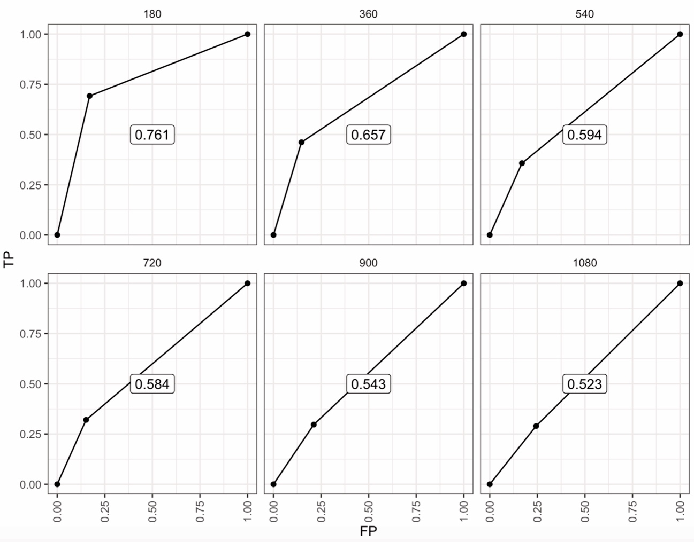
Supplementary Figure S1. Time-dependent receiver operating characteristics (ROC) curve of the Random Survival Forest survival model in the testing data set. Time in days appears at the top of each panel. TP = true positives, FP = False positives.

