Supplementary Information
You L, Zhang S, et al. Integrated analyses of miRNA and mRNA profiles in leukocytes and serums in traditional Chinese medicine (TCM)-defined Pi-qi-deficiency syndrome and Pi-wei damp-heat syndrome resulting from chronic atrophic gastritis.

Contents
Supplementary methods 2
Inclusion and exclusion criteria for participants 2
The experimental design and route 3
miRNA sequencing 4
RNA sequencing 4
Supplemental Tables 5
Table S1 List of leukocytes and serum samples from the clinical participants. 5
Table S2 List of the differentially expressed genes identified in blood leukocytes in PDHS. 6
Table S3 List of the differentially expressed genes identified in blood leukocytes in PQDS. 11
Table S4 List of the differentially expressed miRNAs in blood leukocytes in PDHS. 16
Table S5 List of the differentially expressed miRNAs identified in blood leukocytes in PQDS. 19
Table S6 List of the differentially expressed miRNAs in serums in PDHS. 22
Table S7 List of the differentially expressed miRNAs in serum in PQDS 24
Table S8 The detailed interaction relationships among the PDHS-specific genes 27
Table S9 The detailed interaction relationships among the PQDS-specific genes 29
Table S10 The experimental evidences supporting the PDHS-specific miRNA-gene interaction pairs 32
Table S11 The experimental evidences supporting the PQDS-specific miRNA-gene interaction pairs 33
Table S12 The experimentally-supported direct targets of the exosome-contained has-miR-122-5p 34
Supplemental Figures 37
Figure S1 Glutamatergic synapse pathway (hsa04724). 37
Figure S2 Serotonergic/Dopaminergic synapse pathway (hsa04726). 38
Figure S3 Dopaminergic synapse pathway (hsa04728). 39
Figure S4 NOD-like receptor signaling pathway (hsa04621). 40
Figure S5 ECM-receptor interaction (hsa04512). 41
Figure S6 Cell adhesion molecules (CAMs) (hsa04514). 42
Figure S7 MAPK signaling pathway (hsa04010). 43
Figure S8 Th1 and Th2 cell differentiation (hsa04658). 44
Figure S9 IL-17 signaling pathway (hsa04657). 45
Figure S10 Th17 cell differentiation pathway (hsa04659). 46
Figure S11 Cytokine-cytokine receptor interaction pathway (hsa04060). 47
Figure S12 Arachidonic acid metabolism (hsa590). 48
Figure S13 The network detailing the interaction relationships of the PDHS-specific genes in leukocytes. 49
Figure S14 The network detailing the interaction relationships of the PQDS-specific genes in leukocytes. 50

Supplementary methods

Inclusion and exclusion criteria for participants
(1) The modern medical gastroscopy and pathological examination verified the diagnosis of chronic atrophic gastritis (CAG) according to the pathological diagnosis and grading standards “China Chronic Gastritis Consensus”, proposed in Shanghai, 2012 (1).
Endoscopic Diagnosis According to endoscopic diagnosis criteria, CAG manifests in mucosal inflammatory changes observed by the naked eye or by special imaging methods, which include alternating red and white mucosa with white predominant, flattened or even disappeared rugae, exposed blood vessels and may be accompanied with granular or nodular mucosa in some cases.
Pathological Diagnosis The fundamental manifestations of pathology are mainly atrophy and intestinal metaplasia. Degree of atrophy is evaluated by how many 1/3 of the appropriate glands is lost; the details are as follows: 0. no loss of the appropriate glands; 1. the loss of the appropriate glands is less than 1/3 of the original; 2. the loss of the appropriate glands is between1/3 and 2/3 of the original; 3. the loss of the appropriate glands is more than 2/3 of the original, in this case few glands are remained, or even completely disappear. And the degree of intestinal metaplasia includes: 0. no intestinal metaplasia; 1. the intestinal metaplasia area accounts for less than 1/3 of the glands and whole superficial epithelium; 2. the intestinal metaplasia area accounts for 1/3 to 2/3 of the glands and whole superficial epithelium; 3. the intestinal metaplasia area accounts for more than 2/3 of the glands and whole superficial epithelium.
No abnormality was found in blood, urine, stool routine, biochemical tests, chest X-ray and electrocardiogram.
(2) Two senior TCM practitioners confirmed the CAG patients with the TCM-defined Pi-qi-deficiency syndrome (PQDS) or Pi-wei damp-heat syndrome (PDHS) according to “Guiding Principle for Clinical Research on New Drugs of Traditional Chinese Medicine” published in 2002 (2).
TCM syndrome diagnosis According to the consensus on TCM diagnosis and treatment of chronic atrophic gastritis (CAG) (1, 2), the CAG patients with the TCM-defined PDHS or PQDS were selected.
The diagnosis criteria of PQDS: primary symptoms include loss of appetite, fatigue, weakness, abdominal distention after eating or noontime, abnormal stool (loose stool, shapeless stool, sometimes loose stool or sometimes dry stool); secondary symptoms include lassitude, and no desire to talk, bland in mouth and absence of thirst, continuous mild abdominal pain, nausea and vomiting, fullness in the stomach, borborygmus, sallow complexion, edema, lack of strength in defecating, pale tongue, enlarged and teeth-printed tongue, thin-white tongue coating and weak pulse. A diagnosis of PQDS should include two of primary symptoms or one of primary symptoms with two of secondary symptoms simultaneously.
The diagnostic criteria of PDHS: primary symptoms include fullness and distention of gastric cavity, loss of appetite, loose stool with discomforting evacuation, red tongue with yellow greasy tongue coating; secondary symptoms include fatigued body and limbs, reversal heat, abdominal distension, nausea with vomiting, bright yellowish and soft skin and sclera, and rapid pulse. A diagnosis of PDHS should include three of primary symptoms (tongue and pulse included) or two of primary symptoms (tongue and pulse included) and two of secondary symptoms simultaneously.
(3) Exclusion criteria
Patients would be excluded if they meet one of the following criteria: (1) Being under 18 years old or over 65 years old; (2) Being accompanied with gastric ulcer, duodenal ulcer, special types of gastritis or gastrointestinal hemorrhage; (3) With histopathological examination showing atrophic changes, dysplasia or suspected malignant changes in gastric mucosa; (4) Not PQDS according to syndrome differentiation in TCM; (5) Varied diagnosis of syndrome differentiation in TCM before treatment; (6) With unclear diagnosis of syndrome differentiation in TCM; (7) With history of gastric surgery; (8) Currently being accompanied with H. pylori infection; (9) With serious comorbidities of heart, lung, liver, kidney or blood system (such as cardiac function above grade II, value of alanine aminotransferase (ALT) and/or aspartate aminotransferase (AST) 1.5 times higher than the upper normal limit, creatinine (Cr) higher than the upper normal limit, etc.) or having a life-threatening illness (such as tumor or AIDS); (10) With psychiatric disorders or a history of alcohol or drug abuse; (11) Female patients preparing for a baby, pregnant or lactating.
(4) Age, between 18 and 65 years. Subjects voluntarily participated in the research and signed the informed consent.

The experimental design and route

Experimental design and route of the study. CAG, chronic atrophic gastritis; PDHS, Pi-wei damp-heat syndrome; PQDS, Pi-qi-deficiency syndrome.

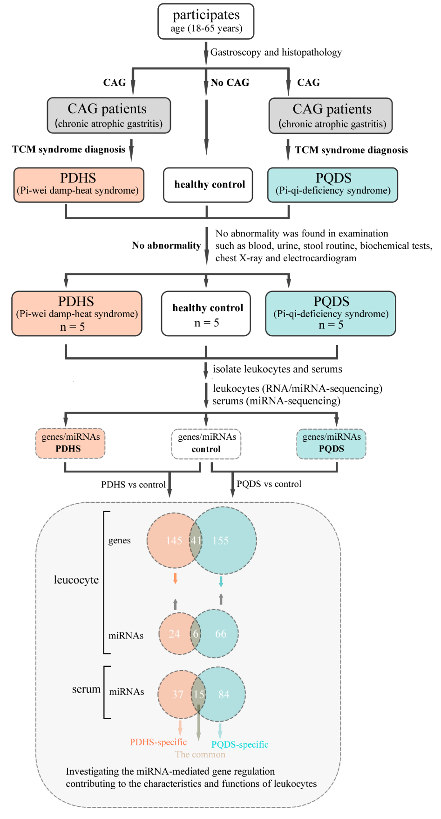

miRNA sequencing
miRNA sequencing (miRNA-seq) was performed by OEbiotech company (Shanghai, China). In short, the miRNA sequencing libraries were constructed using the RNAs isolated from the lymphocyte and serum samples according to instructions. High throughput miRNA-seq was performed using the Illumina HiSeq 4000 Sequencer (Illumina; San Diego, CA). The adapter sequences of generated RAW reads were removed using the popular Cutadapt software (https://cutadapt.readthedocs.io/en/stable), and the obtained sequences were filtered to remove sequences that were less than 15 bp or more than 41 bp in length. The Q20 quality control of the filtered sequences was performed by the Fastx_Toolkit (version 0.0.13, http://hannonlab.cshl.edu/fastx_toolkit) and NGSQC Toolkit (version 2.3.2) was used to filter out the reads containing N bases (3). The BLASTN software was used to compare the clean reads with the Rfam database (version 10.0, http://rfam.xfam.org), a web-accessible interface for annotating families of non-coding RNA sequences (4, 5). The results (E-value ≤ 0.01) were extracted, and the annotated mRNA, rRNA, snRNA, snoRNA and tRNA were removed. The extracted sequences were compared with the repeat database to identify and remove the repeated sequences using the RepeatMasker web server (http://www.repeatmasker.org/cgi-bin/WEBRepeatMasker). Finally, the high quantity clean reads obtained were used for subsequent annotating analysis of the mature miRNAs, and the small RNAs which were not annotated were used for the prediction of new miRNAs using Mirdeep2 (a software package developed for the identification of new and known miRNAs in deep sequencing data) (6).

RNA sequencing
RNA sequencing (RNA-seq) was performed by OEbiotech company (Shanghai, China). Briefly, total RNAs of leukocytes were extracted using the RNA isolation Kit (Ambion) following the manufacturer’s instructions, and stored at -80 ℃. RNA integrity Number (RIN) was detected using the popular Agilent 2100 Bioanalyzer. RNA samples (RIN ≥7) were subjected to the subsequent high throughput sequencing analysis. The whole transcriptomic sequencing libraries were constructed using the commercial kit (Illumina, RS-122-2301) termed “TruSeq Stranded Total RNA with Ribo-Zero Globin” (this kit keeps an efficient work flow enabling removal of ribosomal RNA and globin mRNA in a single step). These resultant sequencing libraries were sequenced by the well-known Illumina sequencing platform (HiSeqTM 2500) and 150 bp/125bp paired-end raw reads were generated. The obtained raw reads were filtered and processed for the subsequent annotation and differential expression analyses of lncRNAs and mRNAs.

Supplemental Tables

Table S1 List of leukocytes and serum samples from the clinical participants.
Id | Sex | Age | Group | Leukocytes ª |  |  | Serum ^{b} | TCM-based diagnosis | Clinical diagnosis
 |  |  |  | RNA-seq ^{c} | miRNA-seq ^{c} |  | miRNA-seq ^{c} | TCM-based diagnosis | Clinical diagnosis
A_1 | Male | 26 | Control | SRR10513209 | SRR11483205 | SRR11548322 |  | Balanced constitution | Health
A_2 | Female | 28 | Control | SRR10513208 | SRR11483204 | SRR11548321 |  | Balanced constitution | Health
A_3 | Female | 24 | Control | SRR10513204 | SRR11483203 | SRR11548320 |  | Balanced constitution | Health
A_4 | Male | 25 | Control | SRR10513203 | SRR11483202 | / |  | Balanced constitution | Health
A_5 | Male | 26 | Control | SRR10513202 | SRR11483201 | / |  | Balanced constitution | Health
F_1 | Female | 65 | PQDS | SRR11548312 | SRR11548310 | SRR11548329 |  | Pi-qi deficiency syndrome | CAG
F_2 | Male | 65 | PQDS | SRR11548311 | SRR11548339 | SRR11548328 |  | Pi-qi deficiency syndrome | CAG
F_3 | Female | 30 | PQDS | SRR11548330 | SRR11548338 | SRR11548327 |  | Pi-qi deficiency syndrome | CAG
F_4 | Male | 49 | PQDS | SRR11548319 | SRR11548337 | SRR11548326 |  | Pi-qi deficiency syndrome | CAG
F_7 | Male | 56 | PQDS | SRR11548318 | SRR11548336 | / |  | Pi-qi deficiency syndrome | CAG
G_1 | Male | 64 | PDHS | SRR11548317 | SRR11548335 | SRR11548325 |  | Pi-wei damp-heat syndrome | CAG
G_2 | Male | 49 | PDHS | SRR11548316 | SRR11548334 | SRR11548324 |  | Pi-wei damp-heat syndrome | CAG
G_3 | Male | 60 | PDHS | SRR11548315 | SRR11548333 | SRR11548323 |  | Pi-wei damp-heat syndrome | CAG
G_4 | Female | 61 | PDHS | SRR11548314 | SRR11548332 | / |  | Pi-wei damp-heat syndrome | CAG
G_5 | Male | 65 | PDHS | SRR11548313 | SRR11548331 | / |  | Pi-wei damp-heat syndrome | CAG
Notes: TCM, traditional Chinese medicine; CAG, chronic atrophic gastritis; PQDS, Pi-qi deficiency syndrome; PDHS, Pi-wei damp-heat syndrome.
ª The accession numbers for the leukocyte RNA-seq and miRNA-seq raw data deposited in the NCBI Sequence Read Archive (SRA).
^{b} The accession numbers for the serum miRNA-seq raw data deposited in the NCBI Sequence Read Archive (SRA).
^{c} The link for the corresponding NCBI bioProject: https://www.ncbi.nlm.nih.gov/bioproject/PRJNA591186.

Table S2 List of the differentially expressed genes identified in blood leukocytes in PDHS.
gene_id ª | baseMean_control_A ^{b} | baseMean_case_G ^{b} | foldChange ^{c}  G(n=5)/A(n=5) | log2FoldChange | P-value | padj ^{d} | up_down
ABCA13 | 275.716 | 646.2977 | 2.344071 | 1.229016 | 0.012265 | 1 | Up
ACOT4 | 16.55354 | 37.86469 | 2.287407 | 1.193713 | 0.012123 | 1 | Up
ACSBG1 | 9.077615 | 30.62451 | 3.37363 | 1.754302 | 0.046573 | 1 | Up
ADAM23 | 54.67518 | 224.1983 | 4.10055 | 2.035817 | 0.044643 | 1 | Up
ADAMTSL5 | 8.970107 | 27.18937 | 3.031109 | 1.599846 | 0.006693 | 0.872731 | Up
ADGRA3 | 105.0588 | 46.4162 | 0.441812 | -1.1785 | 0.00971 | 1 | Down
AK5 | 412.0303 | 153.5605 | 0.372692 | -1.42394 | 0.031951 | 1 | Down
AKAP3 | 7.599507 | 18.92414 | 2.49018 | 1.31625 | 0.048206 | 1 | Up
ALPK2 | 18.3133 | 79.54459 | 4.343541 | 2.118872 | 0.023236 | 1 | Up
APOBEC3H | 29.96517 | 61.29014 | 2.045379 | 1.032368 | 0.008802 | 1 | Up
AQP1 | 2.809829 | 12.63861 | 4.498 | 2.169284 | 0.026631 | 1 | Up
ARG1 | 142.2308 | 344.252 | 2.420375 | 1.275231 | 0.013954 | 1 | Up
ARHGEF4 | 42.2774 | 17.87232 | 0.422739 | -1.24216 | 0.009059 | 1 | Down
AZU1 | 25.2988 | 71.46713 | 2.824922 | 1.498211 | 0.018999 | 1 | Up
BAAT | 9.51777 | 2.159931 | 0.226937 | -2.13964 | 0.042008 | 1 | Down
BEGAIN | 5.683745 | 44.37676 | 7.807663 | 2.964891 | 0.00057 | 0.257583 | Up
BFSP1 | 32.95152 | 66.81122 | 2.027561 | 1.019745 | 0.036337 | 1 | Up
BHLHA15 | 8.723618 | 0.98284 | 0.112664 | -3.1499 | 0.011404 | 1 | Down
BPI | 92.95817 | 272.791 | 2.934556 | 1.553142 | 0.025647 | 1 | Up
BRSK1 | 36.4962 | 17.51782 | 0.47999 | -1.05892 | 0.029322 | 1 | Down
C19orf33 | 8.463068 | 25.95278 | 3.066592 | 1.616636 | 0.008897 | 1 | Up
C4orf48 | 12.67652 | 32.03176 | 2.526857 | 1.337344 | 0.028758 | 1 | Up
C4orf50 | 79.37741 | 233.4437 | 2.940933 | 1.556274 | 0.000116 | 0.198247 | Up
CACHD1 | 93.02277 | 31.93452 | 0.343298 | -1.54247 | 0.000822 | 0.295156 | Down
CAMP | 134.5573 | 347.4161 | 2.581918 | 1.368443 | 0.004761 | 0.782052 | Up
CASP5 | 1036.441 | 504.1428 | 0.486418 | -1.03973 | 0.022395 | 1 | Down
CCL3 | 67.884 | 160.1708 | 2.359478 | 1.238468 | 0.00704 | 0.904212 | Up
CCL4L2 | 175.8133 | 584.8203 | 3.326371 | 1.733949 | 0.031358 | 1 | Up
CD248 | 41.74714 | 4.471088 | 0.107099 | -3.22298 | 2.68E-08 | 0.000458 | Down
CEACAM6 | 41.49064 | 101.6223 | 2.449283 | 1.292359 | 0.030967 | 1 | Up
CEACAM8 | 102.5896 | 265.2344 | 2.585393 | 1.370383 | 0.02714 | 1 | Up
CFAP97D2 | 65.04992 | 30.90856 | 0.475151 | -1.07354 | 0.011592 | 1 | Down
CHN1 | 26.11023 | 54.65272 | 2.093153 | 1.065678 | 0.009005 | 1 | Up
CHST13 | 35.67079 | 78.31901 | 2.195606 | 1.134619 | 0.020095 | 1 | Up
CNTNAP2 | 107.6092 | 46.61549 | 0.433192 | -1.20692 | 0.010993 | 1 | Down
COL27A1 | 0 | 4.394717 | Inf | Inf | 0.014694 | 1 | Up
CORO2B | 22.7384 | 5.1588 | 0.226876 | -2.14002 | 0.001337 | 0.380641 | Down
CR2 | 289.0588 | 117.9221 | 0.407952 | -1.29353 | 1.15E-06 | 0.009843 | Down
CRYBG2 | 20.27435 | 41.11603 | 2.027983 | 1.020046 | 0.039765 | 1 | Up
CTSG | 10.34176 | 49.59173 | 4.795289 | 2.261618 | 0.014309 | 1 | Up
CXCL5 | 158.2314 | 373.6737 | 2.361565 | 1.239743 | 0.003972 | 0.743624 | Up
CYP27A1 | 533.4147 | 1246.379 | 2.336604 | 1.224413 | 0.001029 | 0.325467 | Up
CYP4F12 | 163.3724 | 351.6951 | 2.15272 | 1.106161 | 0.021575 | 1 | Up
DAB2IP | 32.80124 | 9.413901 | 0.286998 | -1.80089 | 0.002816 | 0.646625 | Down
DCANP1 | 66.02467 | 23.42978 | 0.354864 | -1.49466 | 0.000137 | 0.198247 | Down
DEFA1 | 10.56105 | 40.52313 | 3.837035 | 1.939992 | 0.011988 | 1 | Up
DEFA1B | 2.110959 | 12.13152 | 5.746922 | 2.522789 | 0.012443 | 1 | Up
DEFA3 | 162.4123 | 589.7444 | 3.631156 | 1.860429 | 0.006417 | 0.856396 | Up
DNAJC6 | 63.92629 | 130.3459 | 2.039003 | 1.027864 | 0.003122 | 0.666608 | Up
EDA | 76.95072 | 187.5652 | 2.437472 | 1.285386 | 2.01E-06 | 0.011461 | Up
EGR1 | 73.68869 | 272.3079 | 3.695382 | 1.885723 | 0.030478 | 1 | Up
EGR3 | 77.837 | 463.1177 | 5.949839 | 2.572851 | 0.017306 | 1 | Up
EMILIN1 | 12.2452 | 29.66519 | 2.422598 | 1.276555 | 0.02005 | 1 | Up
EML6 | 256.5916 | 120.9826 | 0.471499 | -1.08467 | 0.000252 | 0.198247 | Down
EPHX3 | 4.045448 | 15.17714 | 3.751659 | 1.907529 | 0.018374 | 1 | Up
ESPN | 9.027588 | 25.88601 | 2.867433 | 1.51976 | 0.018814 | 1 | Up
F2RL3 | 15.5054 | 35.81255 | 2.309682 | 1.207694 | 0.02666 | 1 | Up
FAM229A | 28.19566 | 64.8768 | 2.30095 | 1.202229 | 0.046644 | 1 | Up
FBLN2 | 62.43507 | 13.71273 | 0.219632 | -2.18684 | 0.000303 | 0.19894 | Down
FCRL5 | 452.9548 | 157.6077 | 0.347955 | -1.52303 | 0.02591 | 1 | Down
FGF2 | 9.485178 | 34.59379 | 3.647142 | 1.866767 | 0.004172 | 0.750164 | Up
FIGN | 1.19341 | 19.24091 | 16.12263 | 4.011015 | 9.97E-06 | 0.034063 | Up
FLT4 | 157.7723 | 68.15327 | 0.431972 | -1.21099 | 0.00528 | 0.804233 | Down
FOSB | 165.1327 | 396.2914 | 2.399835 | 1.262936 | 0.001522 | 0.419288 | Up
FOXJ1 | 15.82554 | 3.463902 | 0.21888 | -2.19179 | 0.018624 | 1 | Down
FSTL1 | 127.6534 | 386.8588 | 3.030541 | 1.599575 | 0.045972 | 1 | Up
FXYD1 | 1.704634 | 8.82484 | 5.176971 | 2.372108 | 0.04311 | 1 | Up
GATA6 | 3.619265 | 14.49113 | 4.003888 | 2.001402 | 0.039444 | 1 | Up
GATM | 50.77706 | 22.28351 | 0.43885 | -1.1882 | 0.007938 | 0.968609 | Down
GJB6 | 2.242715 | 11.24459 | 5.013831 | 2.325913 | 0.033423 | 1 | Up
GNAI1 | 42.72393 | 14.10747 | 0.330201 | -1.59859 | 0.001272 | 0.368318 | Down
GNAO1 | 68.42428 | 150.4375 | 2.198598 | 1.136584 | 0.021525 | 1 | Up
GNG10 | 13.5499 | 30.73436 | 2.268235 | 1.18157 | 0.022513 | 1 | Up
GOLGA6L10 | 46.47304 | 22.7784 | 0.490142 | -1.02873 | 0.015487 | 1 | Down
GPAT2 | 44.9451 | 9.461306 | 0.210508 | -2.24805 | 0.000201 | 0.198247 | Down
GPM6A | 20.09366 | 4.500827 | 0.223992 | -2.15848 | 0.00297 | 0.653354 | Down
GPR20 | 1.98701 | 10.5823 | 5.325743 | 2.412983 | 0.017903 | 1 | Up
HEY1 | 44.81386 | 102.2956 | 2.282678 | 1.190727 | 0.002989 | 0.653354 | Up
HIC1 | 28.6039 | 100.374 | 3.509102 | 1.811102 | 0.005848 | 0.832526 | Up
IFI27 | 13.1291 | 2.297132 | 0.174965 | -2.51486 | 0.026967 | 1 | Down
IFNG | 54.96152 | 119.2121 | 2.16901 | 1.117037 | 0.000198 | 0.198247 | Up
IGFBP2 | 3.319228 | 11.96254 | 3.604013 | 1.849604 | 0.046004 | 1 | Up
IGFBP3 | 55.48547 | 132.2581 | 2.383652 | 1.253174 | 0.000285 | 0.19894 | Up
IGLL5 | 760.265 | 373.3189 | 0.491038 | -1.02609 | 0.048287 | 1 | Down
IL23R | 86.9386 | 25.55117 | 0.293899 | -1.76661 | 0.004085 | 0.743624 | Down
INHBB | 10.34491 | 23.5857 | 2.279933 | 1.188992 | 0.046794 | 1 | Up
IQCA1 | 11.92147 | 0.837494 | 0.070251 | -3.83134 | 0.000698 | 0.265128 | Down
ISM1 | 16.75151 | 37.31688 | 2.227672 | 1.155537 | 0.016573 | 1 | Up
JAKMIP1 | 307.0487 | 615.9576 | 2.006059 | 1.004364 | 0.004025 | 0.743624 | Up
KCNMB4 | 117.3995 | 58.36471 | 0.497146 | -1.00826 | 0.016468 | 1 | Down
KIAA1217 | 10.60884 | 1.210195 | 0.114074 | -3.13196 | 0.00489 | 0.789235 | Down
KLHL14 | 235.5996 | 106.4499 | 0.451826 | -1.14616 | 4.21E-05 | 0.103088 | Down
LDB2 | 34.82531 | 12.64375 | 0.363062 | -1.46171 | 0.031291 | 1 | Down
LGALS9B | 65.24479 | 26.22771 | 0.401989 | -1.31477 | 0.032812 | 1 | Down
LOC100996693 | 0 | 3.528654 | Inf | Inf | 0.036652 | 1 | Up
LOC101927245 | 0.997275 | 7.544291 | 7.564909 | 2.919323 | 0.024839 | 1 | Up
LOC102724843 | 17.54949 | 6.157709 | 0.350877 | -1.51096 | 0.041873 | 1 | Down
LOC107986351 | 225.5466 | 91.78467 | 0.406943 | -1.2971 | 0.01317 | 1 | Down
LOC644090 | 12.40041 | 3.034964 | 0.244747 | -2.03064 | 0.028701 | 1 | Down
LOC644249 | 0.200481 | 4.753246 | 23.70921 | 4.567376 | 0.03488 | 1 | Up
LOC646652 | 28.35157 | 2.979687 | 0.105098 | -3.2502 | 0.013951 | 1 | Down
LRFN2 | 76.13787 | 185.9778 | 2.442645 | 1.288444 | 0.049069 | 1 | Up
LRRN3 | 555.2191 | 263.6136 | 0.474792 | -1.07463 | 0.026519 | 1 | Down
LTK | 425.3373 | 207.618 | 0.488126 | -1.03468 | 0.019422 | 1 | Down
MATN2 | 27.88452 | 12.48531 | 0.447751 | -1.15923 | 0.036245 | 1 | Down
MET | 5.524399 | 0.610253 | 0.110465 | -3.17834 | 0.046895 | 1 | Down
METTL24 | 49.96592 | 22.32735 | 0.446852 | -1.16213 | 0.038963 | 1 | Down
MLF1 | 10.07457 | 28.18329 | 2.797469 | 1.484122 | 0.036487 | 1 | Up
MPO | 94.78693 | 212.6677 | 2.243639 | 1.165841 | 0.01605 | 1 | Up
MPPED2 | 24.15779 | 7.091409 | 0.293545 | -1.76834 | 0.039712 | 1 | Down
MTCL1 | 39.12838 | 17.68234 | 0.451906 | -1.14591 | 0.046791 | 1 | Down
MXRA8 | 23.24433 | 5.460993 | 0.234939 | -2.08964 | 0.005309 | 0.804233 | Down
MYL4 | 10.81431 | 33.83494 | 3.12872 | 1.645572 | 0.002628 | 0.639516 | Up
MYO18B | 16.57143 | 5.080121 | 0.306559 | -1.70576 | 0.023848 | 1 | Down
N4BP3 | 136.9251 | 50.91185 | 0.371823 | -1.42731 | 0.000248 | 0.198247 | Down
NBEA | 538.2538 | 227.2318 | 0.422165 | -1.24412 | 8.21E-06 | 0.034063 | Down
NEFL | 14.45437 | 77.37703 | 5.353194 | 2.4204 | 0.034018 | 1 | Up
NETO1 | 62.90031 | 30.67074 | 0.487609 | -1.0362 | 0.00817 | 0.983725 | Down
NLGN4Y | 18.73371 | 53.93648 | 2.879114 | 1.525625 | 0.023525 | 1 | Up
NLRP14 | 3.682088 | 0 | 0 | -Inf | 0.034396 | 1 | Down
NR4A2 | 116.0311 | 239.5754 | 2.064751 | 1.045968 | 0.000898 | 0.306813 | Up
NRCAM | 229.8042 | 41.23486 | 0.179435 | -2.47847 | 0.000335 | 0.204312 | Down
OCA2 | 15.74357 | 1.532048 | 0.097313 | -3.36123 | 0.000485 | 0.243793 | Down
OLFM4 | 68.09493 | 215.7902 | 3.168962 | 1.66401 | 0.045236 | 1 | Up
OLR1 | 14.04735 | 41.69609 | 2.968253 | 1.569614 | 0.004351 | 0.768398 | Up
ORM1 | 102.319 | 235.0838 | 2.297557 | 1.200101 | 0.035007 | 1 | Up
OSM | 287.8392 | 626.6467 | 2.177072 | 1.122389 | 0.025625 | 1 | Up
PARD6G | 3.474008 | 13.62206 | 3.921136 | 1.971272 | 0.03587 | 1 | Up
PLGLB2 | 76.03641 | 214.1402 | 2.816285 | 1.493793 | 0.00017 | 0.198247 | Up
PMEPA1 | 70.37189 | 28.52287 | 0.405316 | -1.30288 | 0.000656 | 0.265128 | Down
PRR29 | 29.08142 | 12.45092 | 0.42814 | -1.22385 | 0.028343 | 1 | Down
PTPRF | 16.81995 | 36.38605 | 2.163268 | 1.113212 | 0.02176 | 1 | Up
PTPRK | 212.2907 | 97.62671 | 0.459873 | -1.12069 | 0.003234 | 0.667057 | Down
RAB5IF | 89.1319 | 239.0271 | 2.681723 | 1.42316 | 0.031348 | 1 | Up
RBMS3 | 35.18804 | 12.1191 | 0.34441 | -1.5378 | 0.004452 | 0.772868 | Down
RCAN2 | 14.87675 | 49.93907 | 3.356854 | 1.74711 | 0.030922 | 1 | Up
RDH14 | 6.225904 | 23.65259 | 3.799061 | 1.925643 | 0.04467 | 1 | Up
REG4 | 9.638806 | 1.154808 | 0.119808 | -3.0612 | 0.009656 | 1 | Down
RHD | 21.12457 | 45.19095 | 2.13926 | 1.097112 | 0.03313 | 1 | Up
RMI2 | 38.84966 | 17.15668 | 0.441617 | -1.17913 | 0.009125 | 1 | Down
RNF17 | 0.200481 | 80.7261 | 402.6621 | 8.653426 | 0.041955 | 1 | Up
ROBO3 | 75.26366 | 29.99104 | 0.39848 | -1.32742 | 0.000267 | 0.198247 | Down
RPH3A | 47.1122 | 102.2031 | 2.169356 | 1.117267 | 0.039937 | 1 | Up
SCN3A | 165.0429 | 65.90029 | 0.399292 | -1.32448 | 0.002818 | 0.646625 | Down
SCN8A | 27.09238 | 61.88524 | 2.284231 | 1.191708 | 0.032627 | 1 | Up
SHANK1 | 8.687087 | 1.207542 | 0.139004 | -2.8468 | 0.022959 | 1 | Down
SHISA2 | 8.442514 | 1.340542 | 0.158785 | -2.65486 | 0.035748 | 1 | Down
SLC16A10 | 187.5747 | 82.3382 | 0.438962 | -1.18783 | 0.035763 | 1 | Down
SLC18A1 | 9.951132 | 1.44115 | 0.144823 | -2.78764 | 0.011626 | 1 | Down
SLC24A2 | 5.172633 | 0.383012 | 0.074046 | -3.75544 | 0.03936 | 1 | Down
SLC4A10 | 1120.786 | 292.7928 | 0.261239 | -1.93656 | 0.000165 | 0.198247 | Down
SLX1B | 12.48291 | 157.3108 | 12.60209 | 3.655591 | 0.003426 | 0.696738 | Up
SMARCA1 | 19.3566 | 4.019747 | 0.207668 | -2.26765 | 0.002664 | 0.639516 | Down
SORCS3 | 19.88047 | 66.24208 | 3.332017 | 1.736396 | 0.032685 | 1 | Up
SPTSSB | 63.88324 | 27.04645 | 0.423373 | -1.24 | 0.011645 | 1 | Down
STYK1 | 41.47957 | 91.29897 | 2.201059 | 1.138198 | 0.028059 | 1 | Up
TARM1 | 1.984448 | 16.06028 | 8.09307 | 3.016687 | 0.047219 | 1 | Up
TEAD3 | 7.699547 | 1.365852 | 0.177394 | -2.49497 | 0.046716 | 1 | Down
TENM4 | 14.98534 | 55.21458 | 3.684574 | 1.881498 | 0.027599 | 1 | Up
THBS1 | 2253.689 | 4575.172 | 2.030081 | 1.021537 | 0.015578 | 1 | Up
TIMD4 | 45.65206 | 21.18162 | 0.46398 | -1.10787 | 0.013524 | 1 | Down
TMEM160 | 28.58304 | 86.47845 | 3.025516 | 1.597181 | 0.043269 | 1 | Up
TMEM178B | 3.042855 | 16.20145 | 5.324423 | 2.412625 | 0.009009 | 1 | Up
TMEM220 | 59.05886 | 27.6077 | 0.467461 | -1.09708 | 0.004944 | 0.789235 | Down
TMEM255A | 20.33276 | 49.2914 | 2.424236 | 1.27753 | 0.01031 | 1 | Up
TMIGD2 | 152.1956 | 73.71303 | 0.484331 | -1.04594 | 0.000829 | 0.295156 | Down
TNFRSF17 | 62.19309 | 25.19967 | 0.405184 | -1.30335 | 0.037064 | 1 | Down
TNIP3 | 39.1221 | 103.2395 | 2.638906 | 1.39994 | 0.005388 | 0.804233 | Up
TRIB1 | 1777.797 | 3569.842 | 2.008015 | 1.00577 | 0.033312 | 1 | Up
TRIM2 | 64.0956 | 129.0261 | 2.013025 | 1.009365 | 0.000692 | 0.265128 | Up
TTC24 | 162.0303 | 78.24812 | 0.482923 | -1.05014 | 0.000435 | 0.233568 | Down
TTC28 | 166.0421 | 82.73717 | 0.49829 | -1.00494 | 0.000191 | 0.198247 | Down
TXNRD3 | 38.84632 | 17.54653 | 0.451691 | -1.14659 | 0.018863 | 1 | Down
ULBP3 | 10.72663 | 25.9225 | 2.416649 | 1.273008 | 0.027222 | 1 | Up
VAMP7 | 121.2683 | 10.81914 | 0.089217 | -3.48654 | 0.017713 | 1 | Down
VSTM4 | 117.7477 | 18.4395 | 0.156602 | -2.67483 | 0.013271 | 1 | Down
VWDE | 15.5141 | 45.05351 | 2.904036 | 1.538059 | 0.00094 | 0.311005 | Up
WASF3 | 48.59079 | 113.2279 | 2.330234 | 1.220475 | 0.044064 | 1 | Up
XKRX | 102.421 | 35.60868 | 0.34767 | -1.52421 | 0.000545 | 0.257583 | Down
ZNF285 | 57.4492 | 27.04588 | 0.470779 | -1.08688 | 0.019598 | 1 | Down
ZNF404 | 69.92717 | 32.58873 | 0.466038 | -1.10148 | 0.003672 | 0.709965 | Down
ZNF415 | 100.7853 | 43.92059 | 0.435784 | -1.19832 | 0.001602 | 0.434445 | Down
ZNF610 | 31.62954 | 12.87262 | 0.406981 | -1.29697 | 0.013396 | 1 | Down
ZNF660 | 69.79472 | 34.37155 | 0.492466 | -1.0219 | 0.038776 | 1 | Down
ZNF662 | 83.25893 | 33.1456 | 0.398103 | -1.32879 | 0.000724 | 0.26896 | Down
ZNF704 | 21.71608 | 3.170716 | 0.146008 | -2.77588 | 0.000265 | 0.198247 | Down
Note: TCM, traditional Chinese medicine; CAG, chronic atrophic gastritis; PDHS: Pi-wei damp-heat syndrome; PQDS: Pi-qi-deficiency syndrome.
ª The genes marked in brown font denoted the common differential genes observed both in PDHS and PQDS, compared with the healthy control.
^{b} normalized mean count value;
^{c} normalized mean count value (CAG with TCM-defined PDHS, n=5) / normalized mean count value (healthy control, n=5);
^{d} the adjusted P-value.

Table S3 List of the differentially expressed genes identified in blood leukocytes in PQDS.
gene_id ª | baseMean_control_A ^{b} | baseMean_case_F ^{b} | foldChange ^{c}  F(n=5)/A(n=5) | log2FoldChange | P-value | padj ^{d} | up_down
A1BG | 25.37172 | 52.10125 | 2.053517 | 1.038097 | 0.017124 | 0.709883 | Up
AATK | 1633.299 | 3571.874 | 2.186908 | 1.128893 | 3.60E-08 | 0.000619 | Up
ABCG2 | 46.86124 | 22.75381 | 0.485557 | -1.04229 | 0.047296 | 0.929754 | Down
ACCSL | 4.012176 | 15.0441 | 3.749612 | 1.906741 | 0.035186 | 0.85594 | Up
ACSBG1 | 9.000092 | 38.64806 | 4.294185 | 2.102384 | 0.000201 | 0.108294 | Up
ADGRA3 | 104.2085 | 50.71002 | 0.486621 | -1.03913 | 0.013115 | 0.680128 | Down
AKAP17A | 23.46549 | 59.69953 | 2.544141 | 1.347179 | 0.037071 | 0.862169 | Up
AKAP6 | 131.6842 | 62.12601 | 0.47178 | -1.08381 | 0.00251 | 0.363464 | Down
AKR1C1 | 13.53736 | 30.25495 | 2.234922 | 1.160224 | 0.033645 | 0.849057 | Up
ALK | 0 | 3.902276 | Inf | Inf | 0.038911 | 0.875496 | Up
ANKRD20A4 | 48.19412 | 15.31402 | 0.317757 | -1.654 | 0.015606 | 0.690816 | Down
ANO2 | 8.104625 | 24.5269 | 3.026285 | 1.597548 | 0.017926 | 0.716184 | Up
AREG | 15.8172 | 75.15952 | 4.751759 | 2.248462 | 0.003667 | 0.414982 | Up
ARMCX1 | 33.30823 | 14.83782 | 0.44547 | -1.1666 | 0.028421 | 0.811331 | Down
ARSJ | 15.71596 | 2.031386 | 0.129256 | -2.95169 | 0.006823 | 0.549023 | Down
ATG2A | 2511.648 | 5034.223 | 2.00435 | 1.003135 | 7.28E-05 | 0.061265 | Up
B4GALNT3 | 17.84713 | 57.72345 | 3.234328 | 1.693466 | 0.046475 | 0.929754 | Up
BAIAP3 | 229.8096 | 517.6476 | 2.252507 | 1.171531 | 0.00071 | 0.200482 | Up
BTNL9 | 36.94227 | 11.6332 | 0.314902 | -1.66703 | 0.022131 | 0.751439 | Down
C2orf27A | 141.8485 | 60.30734 | 0.425153 | -1.23394 | 5.39E-05 | 0.054569 | Down
C4orf48 | 12.58154 | 34.08901 | 2.709447 | 1.437998 | 0.011644 | 0.665487 | Up
CACNB2 | 0.198422 | 8.114647 | 40.89596 | 5.353886 | 0.003117 | 0.388943 | Up
CALD1 | 88.07739 | 218.3764 | 2.47937 | 1.309974 | 0.000199 | 0.108294 | Up
CAPN5 | 88.51645 | 41.6758 | 0.470825 | -1.08674 | 0.00159 | 0.310205 | Down
CAVIN2 | 4040.977 | 8877.67 | 2.196912 | 1.135477 | 0.013246 | 0.680128 | Up
CBS | 25.28159 | 9.603072 | 0.379845 | -1.39652 | 0.032361 | 0.836077 | Down
CCDC194 | 16.31057 | 36.21433 | 2.220299 | 1.150754 | 0.036019 | 0.862169 | Up
CCL23 | 2.227648 | 18.38572 | 8.253422 | 3.044992 | 0.012822 | 0.680128 | Up
CCL3 | 67.3418 | 180.1074 | 2.674526 | 1.419283 | 0.027923 | 0.806381 | Up
CCL4L2 | 174.3991 | 377.6033 | 2.165168 | 1.114479 | 0.006093 | 0.524643 | Up
CD300H | 406.9959 | 71.6802 | 0.17612 | -2.50537 | 4.34E-06 | 0.007474 | Down
CD300LD | 54.91486 | 11.78826 | 0.214664 | -2.21985 | 0.001161 | 0.2739 | Down
CD99 | 504.0727 | 129.3213 | 0.256553 | -1.96267 | 0.037153 | 0.862169 | Down
CFAP161 | 35.76517 | 103.4709 | 2.893063 | 1.532598 | 0.003785 | 0.414982 | Up
CFAP97D2 | 64.56219 | 20.09575 | 0.311262 | -1.6838 | 0.000563 | 0.173213 | Down
CHADL | 12.17638 | 27.42376 | 2.25221 | 1.171341 | 0.045164 | 0.921469 | Up
CHRNA2 | 4.735083 | 18.72029 | 3.953529 | 1.983141 | 0.014434 | 0.684685 | Up
CLBA1 | 11.51603 | 30.94983 | 2.687544 | 1.426288 | 0.01956 | 0.730506 | Up
CLEC4F | 117.0757 | 35.41912 | 0.302532 | -1.72484 | 0.036354 | 0.862169 | Down
CLVS1 | 31.01364 | 10.34775 | 0.333652 | -1.58359 | 0.006737 | 0.544646 | Down
CNTD2 | 4.193884 | 15.65895 | 3.733758 | 1.900629 | 0.029422 | 0.819065 | Up
CNTNAP2 | 106.7539 | 35.31488 | 0.330806 | -1.59594 | 0.00031 | 0.133364 | Down
COL10A1 | 3.010075 | 15.96619 | 5.304251 | 2.407149 | 0.007431 | 0.553282 | Up
COL13A1 | 81.75623 | 19.8154 | 0.242372 | -2.04471 | 0.048178 | 0.929754 | Down
COL26A1 | 0 | 6.039845 | Inf | Inf | 0.013409 | 0.680128 | Up
COL27A1 | 0 | 4.722369 | Inf | Inf | 0.028086 | 0.807358 | Up
COL4A2 | 4.140912 | 17.81921 | 4.303208 | 2.105413 | 0.014391 | 0.684503 | Up
COL4A4 | 192.7129 | 67.29386 | 0.349192 | -1.51791 | 2.01E-07 | 0.000863 | Down
COL5A3 | 212.7356 | 55.2891 | 0.259896 | -1.94399 | 0.032937 | 0.840204 | Down
CPXM1 | 14.1594 | 2.065782 | 0.145895 | -2.777 | 0.018507 | 0.723979 | Down
CSF2RA | 237.3582 | 105.1637 | 0.443059 | -1.17443 | 0.00588 | 0.51849 | Down
CXCL5 | 156.9502 | 349.7556 | 2.228449 | 1.15604 | 0.038952 | 0.875496 | Up
CXCL6 | 26.08976 | 56.06496 | 2.148926 | 1.103616 | 0.011115 | 0.653231 | Up
CYP2E1 | 36.41824 | 9.592364 | 0.263394 | -1.9247 | 0.005427 | 0.497021 | Down
DAB2IP | 32.56448 | 5.613655 | 0.172386 | -2.53629 | 9.80E-05 | 0.070321 | Down
DCSTAMP | 0.633084 | 8.021371 | 12.6703 | 3.663379 | 0.014633 | 0.685801 | Up
DDTL | 72.12243 | 30.09388 | 0.417261 | -1.26098 | 0.039652 | 0.879662 | Down
DNAJB5 | 72.8186 | 163.0684 | 2.239378 | 1.163098 | 0.003832 | 0.414982 | Up
EDA | 76.39647 | 195.0268 | 2.552826 | 1.352095 | 1.49E-05 | 0.02339 | Up
EGF | 198.3878 | 417.1668 | 2.102785 | 1.072301 | 0.002476 | 0.363464 | Up
EGR1 | 73.17035 | 482.9303 | 6.600082 | 2.722484 | 0.003872 | 0.416713 | Up
EGR3 | 77.30966 | 335.1382 | 4.335011 | 2.116036 | 0.024196 | 0.772925 | Up
EPS8 | 102.8874 | 44.52365 | 0.432742 | -1.20842 | 0.000233 | 0.117894 | Down
F2RL3 | 15.38295 | 38.97034 | 2.533346 | 1.341044 | 0.00891 | 0.592383 | Up
FGF2 | 9.410159 | 34.04051 | 3.617421 | 1.854961 | 0.001227 | 0.281304 | Up
FHL2 | 12.04384 | 27.47898 | 2.28158 | 1.190033 | 0.040913 | 0.888633 | Up
FIGN | 1.183809 | 11.0603 | 9.34297 | 3.223881 | 0.012708 | 0.680128 | Up
FKBP1B | 23.80123 | 48.44174 | 2.035262 | 1.025214 | 0.017657 | 0.709883 | Up
FLT4 | 156.5636 | 69.13928 | 0.441605 | -1.17917 | 0.006176 | 0.526451 | Down
FOS | 8237.116 | 26497.5 | 3.216842 | 1.685645 | 0.002838 | 0.383337 | Up
FOSB | 163.8777 | 848.5717 | 5.17808 | 2.372417 | 0.016738 | 0.706407 | Up
FOXD4L4 | 7.058487 | 0 | 0 | -Inf | 0.00249 | 0.363464 | Down
FSTL1 | 126.6474 | 349.3877 | 2.758743 | 1.464011 | 0.00372 | 0.414982 | Up
G0S2 | 140.5156 | 983.1955 | 6.997057 | 2.806748 | 0.002123 | 0.341976 | Up
GADD45G | 20.89376 | 46.82993 | 2.241336 | 1.164359 | 0.011603 | 0.665487 | Up
GJC2 | 10.63759 | 26.33951 | 2.476078 | 1.308057 | 0.035032 | 0.85594 | Up
GLIPR1L2 | 22.95497 | 7.831017 | 0.341147 | -1.55153 | 0.034283 | 0.849316 | Down
GP1BB | 266.4784 | 571.4878 | 2.144594 | 1.100704 | 0.030488 | 0.819614 | Up
GPC1 | 4.070195 | 14.92834 | 3.667721 | 1.874884 | 0.038399 | 0.875496 | Up
GPR157 | 61.10546 | 122.9077 | 2.011403 | 1.008202 | 0.001934 | 0.326416 | Up
GRHL1 | 54.06247 | 123.9844 | 2.293354 | 1.197459 | 0.012149 | 0.673464 | Up
HBG2 | 50.33362 | 212.1642 | 4.215159 | 2.075587 | 0.045332 | 0.922629 | Up
HIP1 | 2536.781 | 5551.817 | 2.188529 | 1.129961 | 4.38E-07 | 0.00151 | Up
HLA-DQB1 | 417.9968 | 2300.678 | 5.504056 | 2.460495 | 0.003237 | 0.395766 | Up
HLA-DRB5 | 681.282 | 1918.208 | 2.815586 | 1.493435 | 0.010513 | 0.640233 | Up
HOXA9 | 15.83021 | 4.670251 | 0.295021 | -1.76111 | 0.048617 | 0.929754 | Down
HRASLS | 8.175833 | 23.4832 | 2.87227 | 1.522191 | 0.023402 | 0.761721 | Up
IL17RE | 34.51839 | 15.26834 | 0.442325 | -1.17682 | 0.018794 | 0.723979 | Down
IL23R | 86.26338 | 17.14087 | 0.198704 | -2.33131 | 7.47E-05 | 0.061265 | Down
INHBB | 10.26309 | 24.06026 | 2.34435 | 1.229188 | 0.048132 | 0.929754 | Up
IQCA1 | 11.82008 | 1.981241 | 0.167616 | -2.57676 | 0.015966 | 0.696005 | Down
JAG2 | 11.05355 | 27.838 | 2.518467 | 1.332546 | 0.027848 | 0.806381 | Up
KIAA1217 | 10.5262 | 0.654114 | 0.062142 | -4.0083 | 0.002143 | 0.341976 | Down
KRT17 | 0 | 3.75648 | Inf | Inf | 0.047246 | 0.929754 | Up
LOC100289279 | 157.6612 | 378.3106 | 2.399516 | 1.262744 | 0.02578 | 0.786977 | Up
LOC101929599 | 28.49104 | 10.05327 | 0.352857 | -1.50284 | 0.036929 | 0.862169 | Down
LOC102724642 | 53.00436 | 12.47598 | 0.235377 | -2.08696 | 0.047812 | 0.929754 | Down
LOC107986351 | 223.9658 | 74.16801 | 0.331158 | -1.59441 | 0.004524 | 0.448161 | Down
LOC388282 | 0.37569 | 9.260335 | 24.6489 | 4.623451 | 0.043864 | 0.907815 | Up
LOC390937 | 11.10277 | 29.17016 | 2.627287 | 1.393574 | 0.019487 | 0.730506 | Up
LOC646652 | 28.15919 | 1.338452 | 0.047532 | -4.39497 | 0.003666 | 0.414982 | Down
LTK | 422.0167 | 154.5522 | 0.366223 | -1.44921 | 8.37E-05 | 0.062666 | Down
MATN2 | 27.66341 | 10.83074 | 0.391519 | -1.35285 | 0.019803 | 0.730506 | Down
ME1 | 78.86561 | 33.38444 | 0.423308 | -1.24022 | 0.000865 | 0.225762 | Down
MEF2B | 6.845679 | 23.14038 | 3.38029 | 1.757147 | 0.020577 | 0.73214 | Up
MFSD2B | 48.7528 | 109.5972 | 2.248019 | 1.168654 | 0.009835 | 0.623922 | Up
MINDY4 | 33.80835 | 16.49812 | 0.487989 | -1.03508 | 0.047814 | 0.929754 | Down
MKI67 | 505.0215 | 237.2314 | 0.469745 | -1.09005 | 0.02678 | 0.794858 | Down
MMP1 | 2.579692 | 12.24652 | 4.74728 | 2.247101 | 0.023652 | 0.764335 | Up
MMRN1 | 353.0193 | 752.8408 | 2.132577 | 1.092598 | 0.005498 | 0.499402 | Up
MUC1 | 5.04557 | 17.11684 | 3.392448 | 1.762327 | 0.034405 | 0.849544 | Up
MXRA8 | 23.05285 | 6.966914 | 0.302215 | -1.72635 | 0.013169 | 0.680128 | Down
MYL4 | 10.72595 | 75.05973 | 6.997955 | 2.806933 | 0.000106 | 0.072704 | Up
MYOF | 1168.929 | 543.7164 | 0.465141 | -1.10426 | 0.012837 | 0.680128 | Down
MYRFL | 32.36655 | 15.61467 | 0.482432 | -1.0516 | 0.045925 | 0.925974 | Down
NAP1L3 | 35.23237 | 73.00882 | 2.072209 | 1.051169 | 0.00495 | 0.468352 | Up
NECTIN2 | 52.02088 | 121.0264 | 2.326496 | 1.218159 | 0.001018 | 0.254065 | Up
NEK2 | 11.1681 | 2.630131 | 0.235504 | -2.08618 | 0.048664 | 0.929754 | Down
NFIB | 10.57102 | 27.79674 | 2.629522 | 1.394801 | 0.016503 | 0.704211 | Up
NHSL1 | 116.7014 | 55.78619 | 0.478025 | -1.06484 | 0.01526 | 0.685801 | Down
NR4A2 | 115.149 | 384.2744 | 3.337191 | 1.738634 | 0.008411 | 0.581186 | Up
NRGN | 813.9603 | 1839.38 | 2.259791 | 1.176189 | 0.020337 | 0.73214 | Up
NRXN1 | 33.78087 | 83.93754 | 2.484765 | 1.313109 | 0.014566 | 0.685277 | Up
OCA2 | 15.61834 | 3.598224 | 0.230385 | -2.11788 | 0.016032 | 0.696446 | Down
OR1J2 | 1.726322 | 9.886239 | 5.726764 | 2.51772 | 0.037049 | 0.862169 | Up
OR2W3 | 23.82259 | 50.89017 | 2.136214 | 1.095057 | 0.038994 | 0.875496 | Up
OR6N2 | 2.18436 | 10.5996 | 4.852495 | 2.278727 | 0.042155 | 0.901259 | Up
OSM | 285.6389 | 657.8819 | 2.303195 | 1.203636 | 0.006324 | 0.531143 | Up
PARD6G | 3.44675 | 12.36641 | 3.587846 | 1.843118 | 0.047951 | 0.929754 | Up
PCDHGB1 | 9.883761 | 1.784204 | 0.180519 | -2.46978 | 0.036779 | 0.862169 | Down
PCDHGC5 | 0.627083 | 7.470221 | 11.91264 | 3.574421 | 0.029136 | 0.814468 | Up
PCSK6 | 205.6827 | 423.9098 | 2.060989 | 1.043337 | 0.045467 | 0.922629 | Up
PDZK1 | 16.10957 | 4.497027 | 0.279152 | -1.84087 | 0.026454 | 0.79219 | Down
PDZK1IP1 | 49.18684 | 151.6182 | 3.082494 | 1.624098 | 0.001906 | 0.326416 | Up
PF4 | 1288.636 | 4100.423 | 3.181987 | 1.669928 | 0.003602 | 0.414982 | Up
PGRMC1 | 745.3633 | 1600.353 | 2.147078 | 1.102375 | 0.0293 | 0.817689 | Up
PHF24 | 31.98652 | 72.42917 | 2.264366 | 1.179107 | 0.008016 | 0.570376 | Up
PLA2G4B | 26.93357 | 54.89191 | 2.038048 | 1.027188 | 0.016491 | 0.704211 | Up
PLA2G4C | 105.881 | 48.91548 | 0.461986 | -1.11408 | 0.014987 | 0.685801 | Down
PLOD2 | 30.4428 | 86.42661 | 2.838984 | 1.505375 | 0.030499 | 0.819614 | Up
PODXL | 46.26814 | 21.43223 | 0.463218 | -1.11024 | 0.018222 | 0.722959 | Down
PROCR | 40.55863 | 18.93055 | 0.466745 | -1.09929 | 0.028651 | 0.811413 | Down
PROS1 | 186.4283 | 470.697 | 2.524815 | 1.336178 | 0.032671 | 0.836077 | Up
PRR29 | 28.86153 | 13.17322 | 0.456428 | -1.13154 | 0.048823 | 0.929754 | Down
PTGES | 4.234113 | 16.08221 | 3.798246 | 1.925334 | 0.020393 | 0.73214 | Up
PTGES3L | 1.962134 | 12.03168 | 6.131937 | 2.616343 | 0.017001 | 0.709883 | Up
PTPRB | 37.44342 | 10.42185 | 0.278336 | -1.8451 | 0.008266 | 0.577804 | Down
PVALB | 12.09238 | 49.03144 | 4.054738 | 2.019609 | 0.036175 | 0.862169 | Up
RAB6C | 1.570417 | 10.36642 | 6.601059 | 2.722698 | 0.024085 | 0.772296 | Up
RARRES1 | 0 | 4.149929 | Inf | Inf | 0.029478 | 0.819065 | Up
RBMS3 | 34.91978 | 10.51168 | 0.301023 | -1.73205 | 0.001857 | 0.326416 | Down
REEP1 | 3.995649 | 20.61847 | 5.160231 | 2.367436 | 0.002018 | 0.337369 | Up
RHD | 20.94813 | 51.40381 | 2.453862 | 1.295054 | 0.01521 | 0.685801 | Up
RNF222 | 7.79106 | 22.55859 | 2.895445 | 1.533785 | 0.030178 | 0.819185 | Up
ROR2 | 34.36478 | 2.021608 | 0.058828 | -4.08736 | 1.58E-07 | 0.000863 | Down
RORC | 351.6689 | 163.8318 | 0.465869 | -1.102 | 0.011056 | 0.652663 | Down
RPP25 | 54.22656 | 18.30323 | 0.337533 | -1.5669 | 0.000492 | 0.156871 | Down
RPS16 | 4210.82 | 2067.463 | 0.490988 | -1.02624 | 0.026635 | 0.793986 | Down
SASH1 | 287.1542 | 131.875 | 0.459248 | -1.12265 | 0.015588 | 0.690816 | Down
SCRN1 | 1199.63 | 592.7097 | 0.494077 | -1.01719 | 6.53E-07 | 0.001873 | Down
SEMA5A | 16.65477 | 38.609 | 2.318195 | 1.213002 | 0.017404 | 0.709883 | Up
SH3BGRL2 | 1441.312 | 3081.02 | 2.137649 | 1.096025 | 0.013555 | 0.680128 | Up
SH3RF1 | 134.2555 | 63.01974 | 0.469402 | -1.09111 | 0.018965 | 0.724547 | Down
SKOR1 | 12.20731 | 27.76976 | 2.274846 | 1.185769 | 0.046888 | 0.929754 | Up
SLC24A3 | 103.1031 | 235.7399 | 2.286449 | 1.193109 | 0.049787 | 0.930825 | Up
SLC28A3 | 21.21041 | 8.229666 | 0.388001 | -1.36587 | 0.047048 | 0.929754 | Down
SLC47A1 | 59.97103 | 23.21114 | 0.387039 | -1.36945 | 0.014027 | 0.680128 | Down
SLC4A10 | 1111.77 | 202.4863 | 0.18213 | -2.45696 | 2.47E-06 | 0.005322 | Down
SOGA3 | 18.37004 | 47.25321 | 2.572298 | 1.363058 | 0.003246 | 0.395766 | Up
SOX5 | 98.7077 | 42.54856 | 0.431056 | -1.21405 | 0.030982 | 0.823277 | Down
SPACA6 | 110.0495 | 231.6224 | 2.10471 | 1.073622 | 0.000127 | 0.084288 | Up
SPP1 | 7.261698 | 30.21997 | 4.161557 | 2.057123 | 0.001496 | 0.302983 | Up
SPTB | 175.4557 | 415.9918 | 2.370923 | 1.245449 | 0.043104 | 0.906246 | Up
SPX | 71.64646 | 152.1275 | 2.123308 | 1.086314 | 0.045166 | 0.921469 | Up
TAS2R31 | 189.695 | 91.7694 | 0.483773 | -1.0476 | 6.56E-05 | 0.059436 | Down
TBC1D3B | 18.12458 | 4.756618 | 0.26244 | -1.92994 | 0.018585 | 0.723979 | Down
TGFB1I1 | 17.04074 | 45.27734 | 2.657006 | 1.409801 | 0.01952 | 0.730506 | Up
THBS1 | 2236.367 | 5544.716 | 2.479341 | 1.309956 | 0.000506 | 0.158289 | Up
TMEM171 | 20.09325 | 3.079466 | 0.153259 | -2.70596 | 0.006695 | 0.54381 | Down
TMEM191B | 5.932638 | 26.9004 | 4.534307 | 2.180882 | 0.035063 | 0.85594 | Up
TMEM51 | 17.4709 | 3.315714 | 0.189785 | -2.39756 | 0.004824 | 0.461706 | Down
TMEM56 | 15.42382 | 40.45458 | 2.622864 | 1.391143 | 0.008692 | 0.589236 | Up
TMIGD3 | 21.61198 | 51.75313 | 2.39465 | 1.259815 | 0.027356 | 0.801093 | Up
TNFRSF13B | 36.40679 | 15.71746 | 0.431718 | -1.21184 | 0.022562 | 0.751439 | Down
TNFRSF17 | 61.695 | 21.56263 | 0.349504 | -1.51662 | 0.021691 | 0.744004 | Down
TRIM73 | 7.368828 | 20.63508 | 2.80032 | 1.485592 | 0.038515 | 0.875496 | Up
TRPC6 | 32.10915 | 66.24717 | 2.063187 | 1.044875 | 0.039698 | 0.879662 | Up
TTC26 | 200.7313 | 94.26735 | 0.46962 | -1.09044 | 0.028563 | 0.811331 | Down
VEPH1 | 67.78615 | 149.1759 | 2.200684 | 1.137952 | 0.004002 | 0.426047 | Up
VIL1 | 62.53394 | 125.8181 | 2.011997 | 1.008628 | 0.01067 | 0.643846 | Up
WASF3 | 48.19716 | 112.0506 | 2.324838 | 1.21713 | 0.020629 | 0.732387 | Up
WNT10A | 14.4247 | 32.31248 | 2.24008 | 1.16355 | 0.030602 | 0.820781 | Up
ZFP57 | 0 | 30.83981 | Inf | Inf | 0.001065 | 0.261958 | Up
ZMAT4 | 126.9164 | 44.58156 | 0.351267 | -1.50936 | 0.020422 | 0.73214 | Down
ZNF556 | 0.198422 | 5.090902 | 25.65698 | 4.681279 | 0.036742 | 0.862169 | Up
ZNF704 | 21.54368 | 5.002037 | 0.232181 | -2.10668 | 0.004036 | 0.426047 | Down
Note: TCM, traditional Chinese medicine; CAG, chronic atrophic gastritis; PDHS: Pi-wei damp-heat syndrome; PQDS: Pi-qi-deficiency syndrome.
ª The genes marked in brown font denoted the common differential genes observed both in PDHS and PQDS, compared with the healthy control.
^{b} normalized mean count value;
^{c} normalized mean count value (CAG with TCM-defined PQDS, n=5) / normalized mean count value (healthy control, n=5);
^{d} the adjusted P-value.

Table S4 List of the differentially expressed miRNAs in blood leukocytes in PDHS.
miRNA_id ª | Sequence (5’-3’) | Length | BaseMean_control_A ^{b} | BaseMean_case_F ^{b} | FoldChange ^{c}  G(n=5)/A(n=5) | log2FoldChange | P-value | q-value ^{d} | Regulation
hsa-miR-124-5p | CGTGTTCACAGCGGACCTTGAT | 22 | 0 | 1.455029494 | Inf | Inf | 0.036654894 | 1 | Up
hsa-miR-125a-3p | ACAGGTGAGGTTCTTGGGAGCC | 22 | 9.948313121 | 23.30657314 | 2.342766342 | 1.228213073 | 0.010600568 | 1 | Up
hsa-miR-1297 | TTCAAGTAATTCAGGTG | 17 | 23.00024862 | 8.698229828 | 0.378179818 | -1.402855722 | 0.004224144 | 1 | Down
hsa-miR-133a-3p | TTTGGTCCCCTTCAACCAGCTG | 22 | 0.709157152 | 3.821075753 | 5.388193216 | 2.429801585 | 0.02142001 | 1 | Up
hsa-miR-133a-5p | AGCTGGTAAAATGGAACCAAAT | 22 | 0.757227261 | 3.287683955 | 4.341740086 | 2.118273363 | 0.029310571 | 1 | Up
hsa-miR-1827 | TGAGGCAGTAGATTGAAT | 18 | 1.017834876 | 3.983340712 | 3.913543156 | 1.968475354 | 0.049036426 | 1 | Up
hsa-miR-3186-3p | TCACGCGGAGAGATGGCTTTG | 21 | 2.058968011 | 0.245004017 | 0.1189936 | -3.071044108 | 0.027525693 | 1 | Down
hsa-miR-3192-5p | TCTGGGAGGTTGTAGCAGTGGAA | 23 | 1.325594904 | 0 | 0 | -Inf | 0.036174092 | 1 | Down
hsa-miR-375-3p | TTTGTTCGTTCGGCTCGCGTGA | 22 | 0.839435198 | 6.102186173 | 7.269395168 | 2.861835333 | 0.000821612 | 1 | Up
hsa-miR-451b | TAGCAAGAGAACCATTACCATT | 22 | 37.43457426 | 77.22923468 | 2.063045626 | 1.044775728 | 0.025427029 | 1 | Up
hsa-miR-452-5p | AACTGTTTGCAGAGGAAACTGA | 22 | 4.163747881 | 12.25502044 | 2.943266689 | 1.55741827 | 0.030349085 | 1 | Up
hsa-miR-508-5p | TACTCCAGAGGGCGTCACTCATG | 23 | 0 | 1.36518944 | Inf | Inf | 0.040857255 | 1 | Up
hsa-miR-509-3-5p | TACTGCAGACGTGGCAATCATG | 22 | 4.873568321 | 19.80540598 | 4.06384084 | 2.0228439 | 0.021901406 | 1 | Up
hsa-miR-548ay-5p | AAAAGTAATTGTGGTTTTTGC | 21 | 9.98618692 | 58.44669681 | 5.852754137 | 2.549115675 | 0.028793796 | 1 | Up
hsa-miR-6783-5p | TAGGGGAAAAGTCCTGATCCGG | 22 | 3.277118283 | 0.738423637 | 0.225327124 | -2.149907107 | 0.04487387 | 1 | Down
hsa-miR-6853-3p | TGTTCATTGGAACCCTGCGCAG | 22 | 1.904101931 | 0 | 0 | -Inf | 0.014313806 | 1 | Down
hsa-miR-6855-5p | TTGGGGTTTGGGGTGCAGACATTGC | 25 | 3.6555128 | 0.625063542 | 0.170992027 | -2.547999041 | 0.026694046 | 1 | Down
novel105_mature | TCTCTACCCCTCTCCTCACAGA | 22 | 9.141904702 | 3.058529207 | 0.334561484 | -1.579656727 | 0.017068419 | 1 | Down
novel1287_mature | TGAGCTACCACGCCAGGCCGATCT | 24 | 0.30795338 | 3.139404291 | 10.19441414 | 3.349706963 | 0.041931195 | 1 | Up
novel1292_mature | GGCGGCGGCGGCGGCGGCGGCGGGA | 25 | 0.992649703 | 3.359878147 | 3.384757118 | 1.759052313 | 0.047668314 | 1 | Up
novel1632_mature | TTTCCTTCCCCTTGCACCCAGA | 22 | 1.525834617 | 0 | 0 | -Inf | 0.03390798 | 1 | Down
novel1852_mature | AATTACTTTTAATACCACTGTACA | 24 | 0.283492551 | 2.371906421 | 8.366732785 | 3.064664359 | 0.040102577 | 1 | Up
novel193_star | TTGGTAACTGTACCCAGGGTCC | 22 | 1.444351025 | 0 | 0 | -Inf | 0.026067524 | 1 | Down
novel1945_mature | TCCGGTTCTCAAGGCTCCAT | 20 | 12.95315805 | 5.70963479 | 0.440790946 | -1.181833504 | 0.043952649 | 1 | Down
novel224_mature | AAGAGTTACTAGAACTATTCA | 21 | 0.14217205 | 2.575106569 | 18.11260775 | 4.178922367 | 0.012334027 | 1 | Up
novel396_mature | TTGTATCAGTGGCTTTAATTCC | 22 | 3.039310388 | 0.268401692 | 0.088310063 | -3.501278344 | 0.024708895 | 1 | Down
novel579_star | TTCTCCCAACGTAAACCCAGC | 21 | 5.984851383 | 1.138360903 | 0.190207046 | -2.394357404 | 0.009456174 | 1 | Down
novel769_mature | TTAGGGCCCTGGCTCCATCC | 20 | 0.721530625 | 3.777244579 | 5.235044011 | 2.388201666 | 0.047202607 | 1 | Up
novel78_mature | TTCGCTGGGAATTCAGCCTCT | 21 | 1.290412176 | 5.437984034 | 4.214145011 | 2.075239959 | 0.020270934 | 1 | Up
novel93_mature | TAGGCCATTTTGGAAGCTGTTT | 22 | 3.203129121 | 7.548643933 | 2.356646781 | 1.236735541 | 0.021700131 | 1 | Up
hsa-miR-124-5p | CGTGTTCACAGCGGACCTTGAT | 22 | 0 | 1.455029494 | Inf | Inf | 0.036654894 | 1 | Up
hsa-miR-125a-3p | CGTGTTCACAGCGGACCTTGAT | 22 | 9.948313121 | 23.30657314 | 2.342766342 | 1.228213073 | 0.010600568 | 1 | Up
hsa-miR-1297 | ACAGGTGAGGTTCTTGGGAGCC | 22 | 23.00024862 | 8.698229828 | 0.378179818 | -1.402855722 | 0.004224144 | 1 | Down
hsa-miR-133a-3p | TTCAAGTAATTCAGGTG | 17 | 0.709157152 | 3.821075753 | 5.388193216 | 2.429801585 | 0.02142001 | 1 | Up
hsa-miR-133a-5p | TTTGGTCCCCTTCAACCAGCTG | 22 | 0.757227261 | 3.287683955 | 4.341740086 | 2.118273363 | 0.029310571 | 1 | Up
hsa-miR-1827 | AGCTGGTAAAATGGAACCAAAT | 22 | 1.017834876 | 3.983340712 | 3.913543156 | 1.968475354 | 0.049036426 | 1 | Up
hsa-miR-3186-3p | TGAGGCAGTAGATTGAAT | 18 | 2.058968011 | 0.245004017 | 0.1189936 | -3.071044108 | 0.027525693 | 1 | Down
hsa-miR-3192-5p | TCACGCGGAGAGATGGCTTTG | 21 | 1.325594904 | 0 | 0 | -Inf | 0.036174092 | 1 | Down
hsa-miR-375-3p | TCTGGGAGGTTGTAGCAGTGGAA | 23 | 0.839435198 | 6.102186173 | 7.269395168 | 2.861835333 | 0.000821612 | 1 | Up
hsa-miR-451b | TTTGTTCGTTCGGCTCGCGTGA | 22 | 37.43457426 | 77.22923468 | 2.063045626 | 1.044775728 | 0.025427029 | 1 | Up
hsa-miR-452-5p | TAGCAAGAGAACCATTACCATT | 22 | 4.163747881 | 12.25502044 | 2.943266689 | 1.55741827 | 0.030349085 | 1 | Up
hsa-miR-508-5p | AACTGTTTGCAGAGGAAACTGA | 22 | 0 | 1.36518944 | Inf | Inf | 0.040857255 | 1 | Up
hsa-miR-509-3-5p | TACTCCAGAGGGCGTCACTCATG | 23 | 4.873568321 | 19.80540598 | 4.06384084 | 2.0228439 | 0.021901406 | 1 | Up
hsa-miR-548ay-5p | TACTGCAGACGTGGCAATCATG | 22 | 9.98618692 | 58.44669681 | 5.852754137 | 2.549115675 | 0.028793796 | 1 | Up
hsa-miR-6783-5p | AAAAGTAATTGTGGTTTTTGC | 21 | 3.277118283 | 0.738423637 | 0.225327124 | -2.149907107 | 0.04487387 | 1 | Down
hsa-miR-6853-3p | TAGGGGAAAAGTCCTGATCCGG | 22 | 1.904101931 | 0 | 0 | -Inf | 0.014313806 | 1 | Down
hsa-miR-6855-5p | TGTTCATTGGAACCCTGCGCAG | 22 | 3.6555128 | 0.625063542 | 0.170992027 | -2.547999041 | 0.026694046 | 1 | Down
novel105_mature | TTGGGGTTTGGGGTGCAGACATTGC | 25 | 9.141904702 | 3.058529207 | 0.334561484 | -1.579656727 | 0.017068419 | 1 | Down
novel1287_mature | TCTCTACCCCTCTCCTCACAGA | 22 | 0.30795338 | 3.139404291 | 10.19441414 | 3.349706963 | 0.041931195 | 1 | Up
novel1292_mature | TGAGCTACCACGCCAGGCCGATCT | 24 | 0.992649703 | 3.359878147 | 3.384757118 | 1.759052313 | 0.047668314 | 1 | Up
novel1632_mature | GGCGGCGGCGGCGGCGGCGGCGGGA | 25 | 1.525834617 | 0 | 0 | -Inf | 0.03390798 | 1 | Down
novel1852_mature | TTTCCTTCCCCTTGCACCCAGA | 22 | 0.283492551 | 2.371906421 | 8.366732785 | 3.064664359 | 0.040102577 | 1 | Up
novel193_star | AATTACTTTTAATACCACTGTACA | 24 | 1.444351025 | 0 | 0 | -Inf | 0.026067524 | 1 | Down
novel1945_mature | TTGGTAACTGTACCCAGGGTCC | 22 | 12.95315805 | 5.70963479 | 0.440790946 | -1.181833504 | 0.043952649 | 1 | Down
novel224_mature | TCCGGTTCTCAAGGCTCCAT | 20 | 0.14217205 | 2.575106569 | 18.11260775 | 4.178922367 | 0.012334027 | 1 | Up
novel396_mature | AAGAGTTACTAGAACTATTCA | 21 | 3.039310388 | 0.268401692 | 0.088310063 | -3.501278344 | 0.024708895 | 1 | Down
novel579_star | TTGTATCAGTGGCTTTAATTCC | 22 | 5.984851383 | 1.138360903 | 0.190207046 | -2.394357404 | 0.009456174 | 1 | Down
novel769_mature | TTCTCCCAACGTAAACCCAGC | 21 | 0.721530625 | 3.777244579 | 5.235044011 | 2.388201666 | 0.047202607 | 1 | Up
novel78_mature | TTAGGGCCCTGGCTCCATCC | 20 | 1.290412176 | 5.437984034 | 4.214145011 | 2.075239959 | 0.020270934 | 1 | Up
novel93_mature | TTCGCTGGGAATTCAGCCTCT | 21 | 3.203129121 | 7.548643933 | 2.356646781 | 1.236735541 | 0.021700131 | 1 | Up
Note: TCM, traditional Chinese medicine; CAG, chronic atrophic gastritis; PDHS: Pi-wei damp-heat syndrome; PQDS: Pi-qi-deficiency syndrome.
ª The miRNAs marked in brown font denoted the common differential miRNAs observed both in PDHS and PQDS, compared with the healthy control.
^{b} normalized mean count value;
^{c} normalized mean count value (CAG with TCM-defined PDHS, n=5) / normalized mean count value (healthy control, n=5);
^{d} the adjusted P-value.

Table S5 List of the differentially expressed miRNAs identified in blood leukocytes in PQDS.
miRNA_id a | Sequence (5’-3’) | Length | BaseMean_control_A ^{b} | BaseMean_case_F ^{b} | FoldChange ^{c}  F(n=5)/A(n=5) | log2FoldChange | P-value | q-value ^{d} | Regulation
hsa-miR-122-5p | TGGAGTGTGACAATGGTGTTTG | 22 | 3.541765 | 241.9149 | 68.3035 | 6.093888 | 0.00166 | 1 | Up
hsa-miR-125a-3p | ACAGGTGAGGTTCTTGGGAGCC | 22 | 9.779214 | 28.13562 | 2.877084 | 1.524608 | 0.014186 | 1 | Up
hsa-miR-126-3p | TCGTACCGTGAGTAATAATGCG | 22 | 45442.28 | 105352.5 | 2.318381 | 1.213118 | 0.034927 | 1 | Up
hsa-miR-1260b | ATCCCACCACTGCCACCAT | 19 | 9.000838 | 23.24618 | 2.582668 | 1.368862 | 0.040237 | 1 | Up
hsa-miR-1297 | TTCAAGTAATTCAGGTG | 17 | 22.66883 | 4.476239 | 0.197462 | -2.34035 | 0.000847 | 1 | Down
hsa-miR-133a-3p | TTTGGTCCCCTTCAACCAGCTG | 22 | 0.692149 | 22.95864 | 33.17009 | 5.051811 | 0.008733 | 1 | Up
hsa-miR-133b | TTTGGTCCCCTTCAACCAGCTA | 22 | 1.254933 | 8.609528 | 6.86055 | 2.778324 | 0.041725 | 1 | Up
hsa-miR-136-5p | ACTCCATTTGTTTTGATGATGGA | 23 | 14.076 | 33.5581 | 2.384066 | 1.253424 | 0.043738 | 1 | Up
hsa-miR-1910-5p | CCAGTCCTGTGCCTGCCGCCT | 21 | 1.454216 | 0 | 0 | -Inf | 0.031801 | 1 | Down
hsa-miR-205-5p | TCCTTCATTCCACCGGAGTCTG | 22 | 16.03169 | 0.377651 | 0.023557 | -5.40773 | 0.027346 | 1 | Down
hsa-miR-299-5p | TGGTTTACCGTCCCACATACAT | 22 | 2.06622 | 8.07903 | 3.910054 | 1.967188 | 0.025791 | 1 | Up
hsa-miR-337-3p | CTCCTATATGATGCCTTTCTTC | 22 | 30.56926 | 110.1613 | 3.603664 | 1.849465 | 0.046851 | 1 | Up
hsa-miR-375-3p | TTTGTTCGTTCGGCTCGCGTGA | 22 | 0.822789 | 4.343459 | 5.278948 | 2.400251 | 0.014716 | 1 | Up
hsa-miR-449a | TGGCAGTGTATTGTTAGCTGGT | 22 | 0.558875 | 2.755649 | 4.930704 | 2.301794 | 0.034553 | 1 | Up
hsa-miR-4701-5p | TTGGCCACCACACCTACCCCTT | 22 | 0.571456 | 3.50866 | 6.139859 | 2.618205 | 0.019945 | 1 | Up
hsa-miR-495-3p | AAACAAACATGGTGCACTTCTT | 22 | 165.199 | 780.9101 | 4.727088 | 2.240952 | 0.04125 | 1 | Up
hsa-miR-548ay-5p | AAAAGTAATTGTGGTTTTTGC | 21 | 9.752576 | 36.72075 | 3.765236 | 1.91274 | 0.022415 | 1 | Up
hsa-miR-548d-5p | AAAAGTAATTGTGGTTTTTGCC | 22 | 138.3397 | 50.09009 | 0.36208 | -1.46562 | 0.004377 | 1 | Down
hsa-miR-548i | AAAAGTAATTGCGGATTTTGCC | 22 | 3.043883 | 0.54791 | 0.180004 | -2.4739 | 0.040521 | 1 | Down
hsa-miR-551b-3p | GCGACCCATACTTGGTTTCAG | 21 | 0 | 1.29602 | Inf | Inf | 0.031221 | 1 | Up
hsa-miR-5680 | GAGAAATGCTGGACTAATCTGC | 22 | 1.484213 | 0 | 0 | -Inf | 0.021676 | 1 | Down
hsa-miR-574-3p | CACGCTCATGCACACACCCACA | 22 | 398.0662 | 821.1694 | 2.062897 | 1.044672 | 0.035913 | 1 | Up
hsa-miR-643 | ACTTGTATGCTAGCTCAGGTAG | 22 | 1.376928 | 0 | 0 | -Inf | 0.032419 | 1 | Down
hsa-miR-6509-3p | TTCCACTGCCACTACCTAATTT | 22 | 0.468959 | 3.476099 | 7.412367 | 2.889934 | 0.015087 | 1 | Up
hsa-miR-6513-5p | TTTGGGATTGACGCCACATGTCT | 23 | 12.94552 | 4.505367 | 0.348025 | -1.52274 | 0.035934 | 1 | Down
hsa-miR-655-3p | ATAATACATGGTTAACCTCTTT | 22 | 12.94224 | 31.70756 | 2.449928 | 1.292739 | 0.044286 | 1 | Up
hsa-miR-6802-3p | TTCACCCCTCTCACCTAAGCAG | 22 | 0.373252 | 2.501546 | 6.702023 | 2.744597 | 0.039947 | 1 | Up
hsa-miR-6873-3p | TTCTCTCTGTCTTTCTCTCTCAG | 23 | 6.205678 | 1.929201 | 0.310877 | -1.68559 | 0.047787 | 1 | Down
hsa-miR-7110-3p | TCTCTCTCCCACTTCCCTGCAG | 22 | 0.349094 | 2.889862 | 8.278182 | 3.049314 | 0.020912 | 1 | Up
hsa-miR-877-5p | GTAGAGGAGATGGCGCAGGG | 20 | 6.503221 | 16.72183 | 2.571315 | 1.362506 | 0.046849 | 1 | Up
hsa-miR-944 | AAATTATTGTACATCGGATGAG | 22 | 1.954247 | 0 | 0 | -Inf | 0.048266 | 1 | Down
novel1022_mature | GAGCTGGGTTTAGAACGC | 18 | 0.141167 | 34.84311 | 246.8226 | 7.947331 | 0.002918 | 1 | Up
novel1029_mature | CCGGAGGAAGGTGGGGAC | 18 | 0 | 12.2771 | Inf | Inf | 0.004912 | 1 | Up
novel1152_mature | ATGTGCTGTTAAGGGTGG | 18 | 0.324935 | 2.640403 | 8.125936 | 3.022534 | 0.02875 | 1 | Up
novel1238_mature | TTCCCCGCTTCCCCCCTAGGGG | 22 | 1.200853 | 4.698562 | 3.912688 | 1.96816 | 0.029463 | 1 | Up
novel1316_mature | CCCACCTGACCCCATGCT | 18 | 0 | 10.8898 | Inf | Inf | 0.006733 | 1 | Up
novel134_mature | AACTGGGCATGTTGGAACTAAGCT | 24 | 5.892368 | 1.319633 | 0.223956 | -2.15871 | 0.010955 | 1 | Down
novel1381_mature | AAGGCGGCCCCCTGGAAG | 18 | 0 | 5.482911 | Inf | Inf | 0.022367 | 1 | Up
novel145_star | AAACCGTAATTACTTGTGTACA | 22 | 0 | 1.984512 | Inf | Inf | 0.011351 | 1 | Up
novel1495_mature | TCGGCCGCCGCTTTCCCTCGGA | 22 | 0.514419 | 3.74106 | 7.272401 | 2.862432 | 0.011573 | 1 | Up
novel1519_mature | TTACTGTGATGAACTTCTGAGGGT | 24 | 7.602652 | 2.427537 | 0.319301 | -1.64701 | 0.041825 | 1 | Down
novel1621_mature | CCTGTGAGGGCTGCTGGC | 18 | 0 | 7.80467 | Inf | Inf | 0.013017 | 1 | Up
novel1646_mature | CCGCCGGGCCAAGATGGCTGCA | 22 | 1.300468 | 0 | 0 | -Inf | 0.049299 | 1 | Down
novel1678_mature | TTGGTGGGGCTTGCTCTGG | 19 | 0 | 4.609576 | Inf | Inf | 0.004636 | 1 | Up
novel1679_mature | ACTATCTGCCGTGGGCGC | 18 | 0 | 6.082619 | Inf | Inf | 0.038911 | 1 | Up
novel1687_star | ATATAGTAACAAGCTGGATAAAG | 23 | 0.186626 | 2.25582 | 12.08737 | 3.595429 | 0.014523 | 1 | Up
novel1702_mature | CAGGTGCTGCATGGCTGCC | 19 | 0.360671 | 69.72484 | 193.3195 | 7.594844 | 0.001545 | 1 | Up
novel1796_mature | CTGGCTCCTCCCCCCACCCAGG | 22 | 0.141167 | 2.865935 | 20.3018 | 4.343535 | 0.044548 | 1 | Up
novel1800_mature | GTCTGCACCAGGATGGCT | 18 | 0 | 5.46115 | Inf | Inf | 0.02017 | 1 | Up
novel1803_mature | TCGGCCGTGTATCTCTGTGCC | 21 | 2.60407 | 8.095469 | 3.108775 | 1.636346 | 0.047659 | 1 | Up
novel1854_mature | CCGAGAGGCTGAAGGAGC | 18 | 0 | 5.680516 | Inf | Inf | 0.022656 | 1 | Up
novel2005_mature | AGCTGGTCTGAGAGGATG | 18 | 0 | 3.684313 | Inf | Inf | 0.027197 | 1 | Up
novel214_mature | TCCTCCACCACCTCCTCCTGC | 21 | 0.162468 | 1.731539 | 10.65775 | 3.413831 | 0.046923 | 1 | Up
novel224_mature | AAGAGTTACTAGAACTATTCA | 21 | 0.141167 | 2.136294 | 15.13314 | 3.91964 | 0.021217 | 1 | Up
novel255_mature | CCCGCCCCTCCGCGCCCCCCC | 21 | 0.557824 | 3.321704 | 5.95475 | 2.574041 | 0.035001 | 1 | Up
novel26_star | AGGTAGGATTAGATCATTAGCTCA | 24 | 7.254237 | 1.945881 | 0.268241 | -1.8984 | 0.030984 | 1 | Down
novel275_star | CTCCCCCAGAAGGCTGTCCTGAGG | 24 | 1.638788 | 0 | 0 | -Inf | 0.020647 | 1 | Down
novel27_star | AGGCCACTCCTCATGCCCCCAGT | 23 | 0.480537 | 2.937121 | 6.112164 | 2.611683 | 0.046314 | 1 | Up
novel35_star | TTCCTTGGGAGGGAGCATGTAGC | 23 | 0.327793 | 3.739366 | 11.40772 | 3.511938 | 0.008365 | 1 | Up
novel47_mature | AGCCTCCCAGTCTGGCCTGAGT | 22 | 2.570112 | 8.175885 | 3.181139 | 1.669544 | 0.041761 | 1 | Up
novel55_star | TCAGGGAGAAAGAAGGGTTATT | 22 | 1.53932 | 5.741149 | 3.729666 | 1.899046 | 0.024117 | 1 | Up
novel567_mature | CATCTTCCCAAGCCTCCTCCATC | 23 | 0.688464 | 4.678149 | 6.79505 | 2.764484 | 0.009126 | 1 | Up
novel653_mature | TGCCTTGCCCTCTCCCTCTAGG | 22 | 5.769173 | 15.2602 | 2.645128 | 1.403337 | 0.029714 | 1 | Up
novel803_mature | GTAGGTGGGTGGTTTTGG | 18 | 0 | 4.494887 | Inf | Inf | 0.025401 | 1 | Up
novel846_mature | CCTGTCTGAGCGCCGCTC | 18 | 9.602415 | 3.973322 | 0.413784 | -1.27305 | 0.043792 | 1 | Down
novel908_mature | TTGGGAGTAAAGTGGGGGG | 19 | 0 | 8.581303 | Inf | Inf | 0.008502 | 1 | Up
novel919_mature | GGTGGTTCAGGCAGGGGAC | 19 | 0 | 36.45573 | Inf | Inf | 0.001059 | 1 | Up
novel92_mature | ACATGTTGACTCTCCTACCTGG | 22 | 2.805859 | 0.39521 | 0.140852 | -2.82775 | 0.030253 | 1 | Down
novel942_mature | TGTTGTTGGGTAGGGGAGG | 19 | 0 | 159.1787 | Inf | Inf | 7.19E-05 | 0.27544 | Up
novel955_mature | AATTTGGTGGCCACTGCTTCAGT | 23 | 1.609841 | 0 | 0 | -Inf | 0.03072 | 1 | Down
novel982_mature | AGGAAGGTGGGGATGACGG | 19 | 0 | 6.223831 | Inf | Inf | 0.009948 | 1 | Up
novel987_mature | TGGCCTTGTTGGTCTGAGACTTGT | 24 | 0.53572 | 3.320544 | 6.198283 | 2.631869 | 0.026291 | 1 | Up
Note: TCM, traditional Chinese medicine; CAG, chronic atrophic gastritis; PDHS: Pi-wei damp-heat syndrome; PQDS: Pi-qi-deficiency syndrome.
ª The miRNAs marked in brown font denoted the common differential miRNAs observed both in PDHS and PQDS, compared with the healthy control.
^{b} normalized mean count value;
^{c} normalized mean count value (CAG with TCM-defined PQDS, n=5) / normalized mean count value (healthy control, n=5);
^{d} the adjusted P-value.

Table S6 List of the differentially expressed miRNAs in serums in PDHS.
miRNA_id ª | Sequence | Length | FoldChange ^{b}  G(n=3)/A(n=3) | log2FoldChange | P-value | q-value ^{c} | Regulation
hsa-miR-10b-3p | ACAGATTCGATTCTAGGGGAAT | 22 | 0.002974 | -8.39346 | 0.000962 | 0.063013 | Down
hsa-miR-1249-3p | ACGCCCTTCCCCCCCTTCTTCA | 22 | 0.006734 | -7.21429 | 0.006166 | 0.161551 | Down
hsa-miR-130a-3p | CAGTGCAATGTTAAAAGGGCAT | 22 | 0.012804 | -6.28725 | 0.03323 | 0.356212 | Down
hsa-miR-132-3p | TAACAGTCTACAGCCATGGTCG | 22 | 0.009551 | -6.71015 | 0.035408 | 0.356212 | Down
hsa-miR-142-3p | TGTAGTGTTTCCTACTTTATGGA | 23 | 0.003011 | -8.37555 | 0.002353 | 0.095906 | Down
hsa-miR-152-3p | TCAGTGCATGACAGAACTTGG | 21 | 0.014856 | -6.07282 | 0.040391 | 0.356212 | Down
hsa-miR-181c-5p | AACATTCAACCTGTCGGTGAGT | 22 | 0.010266 | -6.60601 | 0.037657 | 0.356212 | Down
hsa-miR-181d-5p | AACATTCATTGTTGTCGGTGGGT | 23 | 0.007892 | -6.98538 | 0.027844 | 0.331597 | Down
hsa-miR-191-3p | GCTGCGCTTGGATTTCGTCCCC | 22 | 0.010205 | -6.61452 | 0.037472 | 0.356212 | Down
hsa-miR-29c-3p | TAGCACCATTTGAAATCGGTTA | 22 | 0.008753 | -6.83606 | 0.017847 | 0.269759 | Down
hsa-miR-302c-3p | TAAGTGCTTCCATGTTTCAGTGG | 23 | 3577699 | 21.7706 | 1.92E-09 | 4.62E-07 | Up
hsa-miR-369-3p | AATAATACATGGTTGATCTTT | 21 | 0.015252 | -6.03484 | 0.042232 | 0.356212 | Down
hsa-miR-409-5p | AGGTTACCCGAGCAACTTTGCAT | 23 | 0.002426 | -8.68717 | 0.002873 | 0.095906 | Down
hsa-miR-411-3p | TATGTAACACGGTCCACTAACC | 22 | 0.006397 | -7.28828 | 0.023446 | 0.307143 | Down
hsa-miR-421 | ATCAACAGACATTAATTGGGCGC | 23 | 0.009131 | -6.77505 | 0.007301 | 0.167332 | Down
hsa-miR-429 | TAATACTGTCTGGTAAAACCGT | 22 | 47.65909 | 5.57468 | 0.041417 | 0.356212 | Up
hsa-miR-433-3p | ATCATGATGGGCTCCTCGGTGT | 22 | 0.003231 | -8.274 | 0.008965 | 0.176162 | Down
hsa-miR-450a-5p | TTTTGCGATGTGTTCCTAATAT | 22 | 0.008907 | -6.81084 | 0.009684 | 0.181229 | Down
hsa-miR-543 | AAACATTCGCGGTGCACTTCTT | 22 | 0.011978 | -6.38342 | 0.046246 | 0.356212 | Down
hsa-miR-548d-5p | AAAAGTAATTGTGGTTTTTGCC | 22 | 144.4755 | 7.174681 | 0.046842 | 0.356212 | Up
hsa-miR-656-3p | AATATTATACAGTCAACCTCT | 21 | 0.004313 | -7.85716 | 0.015037 | 0.256929 | Down
hsa-miR-6749-3p | CTCCTCCCCTGCCTGGCCCAG | 21 | 144.4755 | 7.174681 | 0.046842 | 0.356212 | Up
hsa-miR-885-3p | AGGCAGCGGGGTGTAGTGGATA | 22 | 42.59598 | 5.412646 | 0.047132 | 0.356212 | Up
hsa-miR-9-5p | TCTTTGGTTATCTAGCTGTATGA | 23 | 0.002839 | -8.46048 | 0.00765 | 0.167332 | Down
novel10_mature | TCCTGTTTCCTGGCACCC | 18 | 238.2659 | 7.896428 | 0.01756 | 0.269759 | Up
novel119_mature | ATAGGCCAGGTGTGGAAGCA | 20 | 155.2042 | 7.278023 | 0.025991 | 0.329496 | Up
novel163_mature | CCATGGATATCTAGGCTCC | 19 | 234.8302 | 7.875474 | 0.001729 | 0.095906 | Up
novel177_mature | GGCTGATGGCTGGGGTGA | 18 | 3.07E-07 | -21.6373 | 2.87E-09 | 4.62E-07 | Down
novel282_mature | CAAAGAACTTTGAAAAGAG | 19 | 33.4585 | 5.064301 | 0.045968 | 0.356212 | Up
novel377_mature | GAGGGTTGGAGGGGTGAC | 18 | 747.6329 | 9.546186 | 0.002608 | 0.095906 | Up
novel380_mature | GGAGGGCGGCGGCGGCGC | 18 | 157.3721 | 7.298036 | 0.043046 | 0.356212 | Up
novel38_mature | TAGGAGGGCGTGGAGGTC | 18 | 152.2135 | 7.249952 | 0.044489 | 0.356212 | Up
novel399_mature | GAGCCCGGGCTGCGGCAC | 18 | 345.7633 | 8.433641 | 0.005424 | 0.152247 | Up
novel401_mature | GTCCTGTCGGTGTCGCCT | 18 | 189.5781 | 7.566649 | 0.008509 | 0.176002 | Up
novel415_mature | AGAGCTTATGAGGGAGGA | 18 | 3.35E-07 | -21.511 | 3.53E-09 | 4.62E-07 | Down
novel473_mature | AACAGTATAGATGAAGTAC | 19 | 0.00402 | -7.95873 | 0.013845 | 0.247327 | Down
novel518_mature | GCCTACAAGCAGTCGGAGC | 19 | 0.005442 | -7.52155 | 0.019476 | 0.273353 | Down
novel545_mature | ATCCTGGCAGTGGGACCA | 18 | 36.82664 | 5.202678 | 0.02696 | 0.3311 | Up
novel548_mature | AAATGGGGAACGTGAGCT | 18 | 0.007623 | -7.03535 | 0.038988 | 0.356212 | Down
novel558_mature | GAAGCTCCTGCGATTTGT | 18 | 55.86528 | 5.80388 | 0.01629 | 0.266756 | Up
novel616_mature | TGAGAATTGAATTCCATAGAT | 21 | 0.013306 | -6.23177 | 0.032607 | 0.356212 | Down
novel632_mature | TGGCCCTGGGAAGAGTTCA | 19 | 112.9634 | 6.819711 | 0.002928 | 0.095906 | Up
novel642_mature | AGACAGGTGCTGCATGGA | 18 | 0.005675 | -7.46118 | 0.022087 | 0.299318 | Down
novel650_mature | TCCTGGTGCTAGTAGCAC | 18 | 69.69663 | 6.123017 | 0.018896 | 0.273353 | Up
novel673_mature | TCAGCTGTGTATCTCTGTGCC | 21 | 466.3387 | 8.865234 | 0.004824 | 0.145818 | Up
novel687_mature | AGTGGGGGTAGAGCACTG | 18 | 1490.71 | 10.54178 | 0.000945 | 0.063013 | Up
novel689_mature | TCCTTGGGTGGAAGCTGTG | 19 | 154.7928 | 7.274195 | 0.043756 | 0.356212 | Up
novel693_mature | TTCACAGTCTGGGCACCT | 18 | 130.7825 | 7.031026 | 0.002642 | 0.095906 | Up
novel701_mature | GGAGGCAGCAGTGGGGAA | 18 | 26.57156 | 4.731811 | 0.038023 | 0.356212 | Up
novel703_star | CGGCGGCGGAGGCGGCGGTGG | 21 | 115.0233 | 6.845782 | 0.038744 | 0.356212 | Up
novel759_mature | AGGGATCACCTGGGAACT | 18 | 1570.19 | 10.61672 | 0.000362 | 0.035551 | Up
novel851_mature | CTTGGGTGTGCTGGTGAAGT | 20 | 103.1655 | 6.688816 | 0.007664 | 0.167332 | Up
Note: TCM, traditional Chinese medicine; CAG, chronic atrophic gastritis; PDHS: Pi-wei damp-heat syndrome; PQDS: Pi-qi-deficiency syndrome.
ª The miRNAs marked in brown font denoted the common differential miRNAs observed both in PDHS and PQDS, compared with the healthy control.
^{b} normalized mean count value (CAG with TCM-defined PDHS, n=3) / normalized mean count value (healthy control, n=3).
^{c} the adjusted P-value.

Table S7 List of the differentially expressed miRNAs in serum in PQDS
miRNA_id | Sequence | Length | FoldChange ª  F(n=4)/A(n=3) | log2FoldChange | p-value | q-value ^{b} | Regulation
hsa-let-7a-3p | CTATACAATCTACTGTCTTTC | 21 | 0.006102 | -7.35661 | 0.016244 | 0.114342 | Down
hsa-let-7b-3p | CTATACAACCTACTGCCTTCCC | 22 | 0.009631 | -6.69814 | 0.025724 | 0.144296 | Down
hsa-miR-10b-3p | ACAGATTCGATTCTAGGGGAAT | 22 | 0.001655 | -9.23936 | 0.000986 | 0.020817 | Down
hsa-miR-122-5p | TGGAGTGTGACAATGGTGTTTG | 22 | 51.92444 | 5.698342 | 0.006296 | 0.066177 | Up
hsa-miR-1226-3p | TCACCAGCCCTGTGTTCCCTAG | 22 | 0.008894 | -6.81295 | 0.034637 | 0.155434 | Down
hsa-miR-1275 | GTGGGGGAGAGGCTGTC | 17 | 105.9995 | 6.727914 | 0.049242 | 0.190086 | Up
hsa-miR-1306-5p | CCACCTCCCCTGCAAACGTCCA | 22 | 0.01205 | -6.37488 | 0.048531 |  | Down
hsa-miR-132-3p | TAACAGTCTACAGCCATGGTCG | 22 | 0.010169 | -6.61967 | 0.04158 | 0.175612 | Down
hsa-miR-142-3p | TGTAGTGTTTCCTACTTTATGGA | 23 | 0.016816 | -5.89403 | 0.017761 | 0.122622 | Down
hsa-miR-1468-5p | CTCCGTTTGCCTGTTTCGCTG | 21 | 282.2879 | 8.141023 | 0.012988 | 0.099209 | Up
hsa-miR-148a-3p | TCAGTGCACTACAGAACTTTGT | 22 | 23.45089 | 4.551571 | 0.032609 | 0.154032 | Up
hsa-miR-148a-5p | AAAGTTCTGAGACACTCCGACT | 22 | 0.004976 | -7.65065 | 0.004459 | 0.055984 | Down
hsa-miR-149-5p | TCTGGCTCCGTGTCTTCACTCCC | 23 | 0.006006 | -7.37934 | 0.003223 | 0.052593 | Down
hsa-miR-151a-3p | CTAGACTGAAGCTCCTTGAGG | 21 | 100.2374 | 6.647277 | 0.003703 | 0.055388 | Up
hsa-miR-181d-5p | AACATTCATTGTTGTCGGTGGGT | 23 | 0.01545 | -6.01625 | 0.047538 | 0.187541 | Down
hsa-miR-1843 | TATGGAGGTCTCTGTCTGGC | 20 | 95.74041 | 6.581056 | 0.04153 | 0.175612 | Up
hsa-miR-18a-3p | ACTGCCCTAAGTGCTCCTTCTGG | 23 | 0.01065 | -6.55301 | 0.028054 | 0.149424 | Down
hsa-miR-19a-3p | TGTGCAAATCTATGCAAAACTGA | 23 | 0.005889 | -7.40783 | 0.004522 | 0.055984 | Down
hsa-miR-206 | TGGAATGTAAGGAAGTGTGTGG | 22 | 36.78798 | 5.201163 | 0.031554 | 0.153079 | Up
hsa-miR-25-5p | AGGCGGAGACTTGGGCAATTG | 21 | 9313147 | 23.15084 | 5.78E-11 | 2.59E-09 | Up
hsa-miR-26b-3p | CCTGTTCTCCATTACTTGGCT | 21 | 0.015539 | -6.00794 | 0.04404 | 0.178091 | Down
hsa-miR-29b-3p | TAGCACCATTTGAAATCAGTGTT | 23 | 0.009452 | -6.72517 | 0.039298 | 0.172048 | Down
hsa-miR-29c-3p | TAGCACCATTTGAAATCGGTTA | 22 | 0.0167 | -5.90404 | 0.031068 | 0.152788 | Down
hsa-miR-3158-3p | AAGGGCTTCCTCTCTGCAGGAC | 22 | 449.1616 | 8.811091 | 0.009053 | 0.073865 | Up
hsa-miR-3173-5p | TGCCCTGCCTGTTTTCTCCTTT | 22 | 0.017217 | -5.85998 | 0.046504 |  | Down
hsa-miR-3184-5p | TGAGGGGCCTCAGACCGAGCTTTT | 24 | 32.02877 | 5.001297 | 0.043201 | 0.178091 | Up
hsa-miR-32-5p | TATTGCACATTACTAAGTTGCA | 22 | 0.011158 | -6.48572 | 0.044695 |  | Down
hsa-miR-329-3p | AACACACCTGGTTAACCTCTTT | 22 | 0.005233 | -7.5782 | 0.003593 | 0.055388 | Down
hsa-miR-331-3p | GCCCCTGGGCCTATCCTAGAA | 21 | 0.021343 | -5.55008 | 0.030483 | 0.151992 | Down
hsa-miR-331-5p | CTAGGTATGGTCCCAGGGATCC | 22 | 0.005994 | -7.38226 | 0.022109 | 0.139628 | Down
hsa-miR-3613-3p | ACAAAAAAAAAAGCCCAACCCTTC | 24 | 0.016694 | -5.90455 | 0.046197 |  | Down
hsa-miR-369-3p | AATAATACATGGTTGATCTTT | 21 | 0.016293 | -5.93964 | 0.046545 |  | Down
hsa-miR-375-3p | TTTGTTCGTTCGGCTCGCGTGA | 22 | 64.23087 | 6.005195 | 0.006388 | 0.066177 | Up
hsa-miR-3940-3p | CAGCCCGGATCCCAGCCCACTT | 22 | 0.017612 | -5.82732 | 0.047775 |  | Down
hsa-miR-409-5p | AGGTTACCCGAGCAACTTTGCAT | 23 | 0.00258 | -8.59831 | 0.00387 | 0.055573 | Down
hsa-miR-421 | ATCAACAGACATTAATTGGGCGC | 23 | 0.02259 | -5.46819 | 0.03307 | 0.154181 | Down
hsa-miR-532-5p | CATGCCTTGAGTGTAGGACCGT | 22 | 32.74121 | 5.033036 | 0.019551 | 0.132434 | Up
hsa-miR-654-5p | TGGTGGGCCGCAGAACATGTGC | 22 | 69.93383 | 6.127919 | 0.029135 | 0.149424 | Up
hsa-miR-6721-5p | TGGGCAGGGGCTTATTGTAGGAG | 23 | 92.62224 | 6.533287 | 0.044151 | 0.178091 | Up
hsa-miR-6780a-5p | TTGGGAGGGAAGACAGCTGGAGA | 23 | 7631790 | 22.86359 | 8.05E-11 | 2.80E-09 | Up
hsa-miR-6842-3p | TTGGCTGGTCTCTGCTCCGCAG | 22 | 13636740 | 23.701 | 1.65E-11 | 1.18E-09 | Up
hsa-miR-7706 | TGAAGCGCCTGTGCTCTGCCGAGA | 24 | 94.93745 | 6.568905 | 0.035444 | 0.15709 | Up
hsa-miR-95-3p | TTCAACGGGTATTTATTGAGCA | 22 | 108.7757 | 6.765213 | 0.033859 | 0.155434 | Up
novel101_mature | TCATGGTTTGCCTGGGACTA | 20 | 212.6714 | 7.732482 | 0.023746 | 0.139628 | Up
novel108_mature | ATCCTGGGGCTGGAGGAGG | 19 | 466.7207 | 8.866416 | 0.005393 | 0.062455 | Up
novel10_mature | TCCTGTTTCCTGGCACCC | 18 | 163.1163 | 7.349757 | 0.032295 | 0.154032 | Up
novel114_mature | TCCTGTGCTGAGCTGCCCT | 19 | 36.9255 | 5.206546 | 0.029696 | 0.150151 | Up
novel130_mature | TAGCAGTGAGACTGTGGGG | 19 | 317.3324 | 8.309851 | 0.006518 | 0.066177 | Up
novel132_mature | TGAGGGGTAGAGAGAGAGA | 19 | 106.7756 | 6.738439 | 0.02309 | 0.139628 | Up
novel133_mature | CAGAGGAAGGTGGGGATG | 18 | 536.2668 | 9.066807 | 0.000876 | 0.020817 | Up
novel144_mature | TGTGAGCACTCGAAGATA | 18 | 52.2421 | 5.707141 | 0.027403 | 0.149054 | Up
novel154_mature | CGACTGGGGGACTGCCTA | 18 | 437.3364 | 8.7726 | 0.012117 | 0.094565 | Up
novel161_mature | ACTTGGGACTGGCTCAGAG | 19 | 336.5119 | 8.394514 | 0.015892 | 0.114107 | Up
novel221_mature | CTAGACTGGAGTTCCTTGAGG | 21 | 987.636 | 9.947836 | 0.001322 | 0.026373 | Up
novel249_mature | TGAGGGGCAGGGAGTGAGA | 19 | 258.1022 | 8.011798 | 0.011133 | 0.088819 | Up
novel267_mature | AGAATTGTAGTCTATGGA | 18 | 943.5036 | 9.881884 | 0.004876 | 0.058345 | Up
novel278_mature | GCGGATGTGGCTCAGAGG | 18 | 39184022 | 25.22376 | 3.01E-12 | 1.08E-09 | Up
novel322_mature | GGGGACGACGGCGGGGGC | 18 | 562.5239 | 9.135771 | 0.004266 | 0.055984 | Up
novel33_mature | TCCGCTGCAGCCCCTCGACGT | 21 | 15311824 | 23.86814 | 1.10E-11 | 1.18E-09 | Up
novel349_mature | TTGGGAGTGGGCGGGCGG | 18 | 125.1111 | 6.967066 | 0.048969 | 0.190086 | Up
novel365_mature | TGAGCACCCCAGGACCTGCGCT | 22 | 0.006263 | -7.31897 | 0.024114 | 0.139628 | Down
novel374_mature | TGGGGGGCAGAGGGCGAG | 18 | 150.132 | 7.230088 | 0.034246 | 0.155434 | Up
novel379_mature | TGCCCTGTGGCTCCACCA | 18 | 17025666 | 24.02121 | 1.37E-11 | 1.18E-09 | Up
novel401_mature | GTCCTGTCGGTGTCGCCT | 18 | 728.0614 | 9.507916 | 0.006636 | 0.066177 | Up
novel425_mature | TCAGACGTCTCGAGGCTCGCG | 21 | 12710736 | 23.59954 | 3.04E-11 | 1.56E-09 | Up
novel429_mature | GGTGGCTGTAGCTCAGTG | 18 | 5223461 | 22.31657 | 2.77E-10 | 7.64E-09 | Up
novel43_mature | TGGGGCGTCGCCAAGTGG | 18 | 99.42477 | 6.635533 | 0.026877 | 0.148445 | Up
novel441_mature | TGAAGGCTCGGGACTGTG | 18 | 7835443 | 22.90158 | 8.09E-11 | 2.80E-09 | Up
novel475_mature | GACAGCAGGAAGGTGGCT | 18 | 246.8047 | 7.947226 | 0.007846 | 0.068701 | Up
novel476_mature | CGGGGGCCCTGGGAAGAG | 18 | 946.8747 | 9.88703 | 0.001467 | 0.027715 | Up
novel47_mature | TCCCTGTCCTCCAGGAGCTCA | 21 | 0.00935 | -6.74078 | 0.013924 | 0.10286 | Down
novel481_mature | TCCTGTGCTGAGCTGACCCG | 20 | 47.93664 | 5.583057 | 0.028525 | 0.149424 | Up
novel502_mature | AGACAGCGTCAGGTGTGG | 18 | 158.4716 | 7.308081 | 0.024005 | 0.139628 | Up
novel503_mature | TGAGGTACAGAGAGCGAGA | 19 | 149.6402 | 7.225354 | 0.020941 | 0.139216 | Up
novel518_mature | GCCTACAAGCAGTCGGAGC | 19 | 0.00572 | -7.44976 | 0.023595 | 0.139628 | Down
novel550_mature | GGTGATAAAGGAGGTGGGA | 19 | 53.88858 | 5.751908 | 0.023052 | 0.139628 | Up
novel557_mature | GATGAGATGTGGGTAGGGG | 19 | 338.7121 | 8.403916 | 0.007335 | 0.066586 | Up
novel572_mature | GCTGACTTGATTTTGCTTTT | 20 | 683.7394 | 9.417303 | 0.007057 | 0.066586 | Up
novel580_mature | GGCTGACTTGATTTTGCTTTT | 21 | 7776428 | 22.89068 | 8.57E-11 | 2.80E-09 | Up
novel596_mature | GTGTGTGTCGTGATAGGT | 18 | 12483359 | 23.5735 | 2.84E-11 | 1.56E-09 | Up
novel5_mature | ACACGTGAAACCCTGTCT | 18 | 61.45891 | 5.94155 | 0.043611 | 0.178091 | Up
novel632_mature | TGGCCCTGGGAAGAGTTCA | 19 | 173.3796 | 7.43779 | 0.014039 | 0.10286 | Up
novel641_mature | TGACGAGTGGTGGACGGGC | 19 | 175.6139 | 7.456263 | 0.029136 | 0.149424 | Up
novel668_mature | GGGACGTGTAGCTGGAAAA | 19 | 792.9693 | 9.631121 | 0.005993 | 0.066177 | Up
novel673_mature | TCAGCTGTGTATCTCTGTGCC | 21 | 13993919 | 23.7383 | 1.55E-11 | 1.18E-09 | Up
novel689_mature | TCCTTGGGTGGAAGCTGTG | 19 | 911.1163 | 9.831491 | 0.002388 | 0.040826 | Up
novel705_mature | TGAGAGCAGAGAGCGAGAC | 19 | 125.7384 | 6.974282 | 0.040298 | 0.1743 | Up
novel709_mature | AGTTTGGCTGGGGCGGTC | 18 | 106.1816 | 6.73039 | 0.022353 | 0.139628 | Up
novel737_mature | AGAGGGACTGTGTGATGT | 18 | 449.3445 | 8.811678 | 0.001831 | 0.03287 | Up
novel756_mature | CTGGGGTCGGGGGACAGC | 18 | 5372945 | 22.35728 | 2.70E-10 | 7.64E-09 | Up
novel778_mature | GTGGAATTCCGAGTGTGGA | 19 | 1014.397 | 9.986406 | 0.004424 | 0.055984 | Up
novel803_mature | TGCTGTGGCTGGGTTGTG | 18 | 679.0952 | 9.40747 | 0.007213 | 0.066586 | Up
novel817_mature | ATGCCCTGGGGCGGGCTG | 18 | 624.3495 | 9.28621 | 0.008166 | 0.0698 | Up
novel82_mature | TGAGGGGCAGAGAGCAGGA | 19 | 59.80024 | 5.902079 | 0.046607 | 0.18591 | Up
novel851_mature | CTTGGGTGTGCTGGTGAAGT | 20 | 286.4355 | 8.162066 | 0.000529 | 0.013567 | Up
novel862_mature | TGCAGATCTTGGTGGTAGC | 19 | 309.7569 | 8.274993 | 0.000965 | 0.020817 | Up
novel866_mature | CCAGATCTCAGATTAAGC | 18 | 387.4077 | 8.597709 | 0.008728 | 0.072865 | Up
novel889_mature | TCAGCTTTGGATGTTAGG | 18 | 194.8849 | 7.606479 | 0.025686 | 0.144296 | Up
novel89_mature | TGGAGGGTGTTTCTGAGACAGTG | 23 | 666.1635 | 9.379732 | 0.007419 | 0.066586 | Up
Note: TCM, traditional Chinese medicine; CAG, chronic atrophic gastritis; PQDS: Pi-qi-deficiency sydrome.
ª normalized mean count value (CAG with TCM-defined PQDS, n=4) / normalized mean count value (healthy control, n=3);
^{b} the adjusted P-value.

Table S8 The detailed interaction relationships among the PDHS-specific genes

node1 | node2 | Homology ª | Co-expression ^{b} | Experimentally determined interaction ^{c} | Database annotated ^{d} | Automated textmining ^{e} | Combined score ^{f}
CEACAM8 | CEACAM6 | 0.977 | 0.323 | 0.87 | 0.9 | 0.752 | 0.99
MPO | CTSG | 0 | 0.612 | 0.061 | 0.9 | 0.737 | 0.989
AZU1 | MPO | 0 | 0.673 | 0.061 | 0.9 | 0.594 | 0.985
BPI | MPO | 0 | 0.54 | 0 | 0.9 | 0.669 | 0.983
BPI | AZU1 | 0 | 0.32 | 0 | 0.9 | 0.759 | 0.982
BPI | CTSG | 0 | 0.221 | 0 | 0.9 | 0.7 | 0.974
CAMP | BPI | 0 | 0.327 | 0 | 0.9 | 0.647 | 0.974
GNG10 | GNAI1 | 0 | 0.061 | 0.659 | 0.9 | 0.297 | 0.974
DEFA1 | DEFA3 | 0.983 | 0.771 | 0.87 | 0 | 0.74 | 0.969
AZU1 | CTSG | 0.794 | 0.559 | 0 | 0.9 | 0.731 | 0.964
GNAI1 | GNAO1 | 0.974 | 0.085 | 0.561 | 0.9 | 0.598 | 0.957
NRCAM | SCN8A | 0 | 0.118 | 0 | 0.9 | 0.557 | 0.957
GNG10 | GNAO1 | 0 | 0.049 | 0.31 | 0.9 | 0.426 | 0.957
DEFA1B | DEFA3 | 0.983 | 0.771 | 0.8 | 0 | 0.736 | 0.952
GATM | ARG1 | 0 | 0 | 0 | 0.9 | 0.495 | 0.948
IGFBP3 | CTSG | 0 | 0 | 0.379 | 0.9 | 0.186 | 0.945
HEY1 | GATA6 | 0 | 0 | 0.156 | 0.9 | 0.373 | 0.942
ARG1 | MPO | 0 | 0.102 | 0 | 0.9 | 0.39 | 0.94
BPI | OLFM4 | 0 | 0.114 | 0 | 0.9 | 0.285 | 0.931
ARG1 | ORM1 | 0 | 0.22 | 0 | 0.9 | 0.1 | 0.923
ARG1 | BPI | 0 | 0.146 | 0 | 0.9 | 0.163 | 0.922
NRCAM | SCN3A | 0 | 0.116 | 0 | 0.9 | 0.185 | 0.921
ARG1 | CTSG | 0 | 0.091 | 0 | 0.9 | 0.197 | 0.92
ABCA13 | CEACAM8 | 0 | 0.076 | 0 | 0.9 | 0.199 | 0.919
ARG1 | CAMP | 0 | 0.137 | 0 | 0.9 | 0.121 | 0.917
ABCA13 | CEACAM6 | 0 | 0 | 0 | 0.9 | 0.173 | 0.913
OLR1 | CEACAM8 | 0 | 0.077 | 0 | 0.9 | 0.138 | 0.913
CAMP | OLFM4 | 0 | 0.115 | 0 | 0.9 | 0.086 | 0.912
CAMP | ORM1 | 0 | 0.101 | 0 | 0.9 | 0.097 | 0.911
DEFA1 | DEFA1B | 0.983 | 0.522 | 0.82 | 0 | 0 | 0.91
ACOT4 | BAAT | 0.903 | 0 | 0 | 0.9 | 0.637 | 0.909
DNAJC6 | VAMP7 | 0 | 0.092 | 0 | 0.9 | 0.056 | 0.906
ORM1 | OLFM4 | 0 | 0 | 0 | 0.9 | 0.105 | 0.906
ARG1 | AZU1 | 0 | 0 | 0 | 0.9 | 0.084 | 0.904
BPI | ORM1 | 0 | 0.069 | 0 | 0.9 | 0.043 | 0.903
TARM1 | OLR1 | 0 | 0.061 | 0 | 0.9 | 0 | 0.902
TARM1 | CEACAM8 | 0 | 0.065 | 0 | 0.9 | 0 | 0.902
ARG1 | OLFM4 | 0 | 0 | 0 | 0.9 | 0.056 | 0.901
GPR20 | GNG10 | 0 | 0 | 0 | 0.9 | 0 | 0.9
BPI | CEACAM8 | 0 | 0.727 | 0 | 0 | 0.329 | 0.808
CAMP | CTSG | 0 | 0.194 | 0.379 | 0 | 0.635 | 0.801
CHN1 | ROBO3 | 0 | 0.061 | 0 | 0 | 0.757 | 0.762
DNAJC6 | CACHD1 | 0 | 0 | 0 | 0 | 0.74 | 0.74
MTCL1 | EML6 | 0 | 0.063 | 0 | 0 | 0.689 | 0.696
SLX1B | RMI2 | 0 | 0.058 | 0 | 0 | 0.69 | 0.696
CEACAM8 | MPO | 0 | 0.316 | 0 | 0 | 0.57 | 0.693
CAMP | MPO | 0 | 0.252 | 0 | 0 | 0.577 | 0.67
CAMP | AZU1 | 0 | 0.137 | 0 | 0 | 0.63 | 0.667
CAMP | CEACAM8 | 0 | 0.56 | 0 | 0 | 0.252 | 0.656
NEFL | TRIM2 | 0 | 0.153 | 0.299 | 0 | 0.462 | 0.653
REG4 | OLFM4 | 0 | 0.14 | 0 | 0 | 0.576 | 0.62
DEFA1 | CAMP | 0 | 0.314 | 0 | 0 | 0.441 | 0.6
TNIP3 | MLF1 | 0 | 0.063 | 0 | 0 | 0.59 | 0.599
SCN8A | GNAO1 | 0 | 0.156 | 0.379 | 0 | 0.292 | 0.596
DEFA1B | CAMP | 0 | 0.334 | 0 | 0 | 0.418 | 0.595
DEFA3 | CTSG | 0 | 0.302 | 0 | 0 | 0.429 | 0.584
IFNG | MPO | 0 | 0 | 0 | 0 | 0.581 | 0.581
FBLN2 | CD248 | 0.552 | 0.528 | 0 | 0 | 0.266 | 0.578
DEFA3 | BPI | 0 | 0.299 | 0 | 0 | 0.418 | 0.574
DEFA1 | CTSG | 0 | 0.312 | 0 | 0 | 0.399 | 0.569
DEFA1 | MPO | 0 | 0.306 | 0 | 0 | 0.377 | 0.549
DEFA3 | CAMP | 0 | 0.35 | 0 | 0 | 0.314 | 0.535
LRRN3 | NRCAM | 0 | 0.098 | 0.137 | 0 | 0.448 | 0.532
ARG1 | CEACAM8 | 0 | 0.152 | 0 | 0 | 0.47 | 0.531
ARG1 | IFNG | 0 | 0 | 0 | 0 | 0.529 | 0.529
DEFA1 | BPI | 0 | 0.238 | 0 | 0 | 0.399 | 0.522
MLF1 | ADAM23 | 0 | 0 | 0 | 0 | 0.515 | 0.515
CHN1 | ARHGEF4 | 0 | 0.107 | 0.315 | 0 | 0.269 | 0.514
RCAN2 | TMEM220 | 0 | 0 | 0 | 0 | 0.508 | 0.508
DEFA3 | MPO | 0 | 0.333 | 0 | 0 | 0.291 | 0.506
REG4 | GATA6 | 0 | 0 | 0.08 | 0 | 0.484 | 0.505
CHN1 | GPM6A | 0 | 0.158 | 0 | 0 | 0.436 | 0.505
SHANK1 | N4BP3 | 0 | 0 | 0 | 0 | 0.502 | 0.502
DEFA1B | BPI | 0 | 0.214 | 0 | 0 | 0.389 | 0.499
CEACAM8 | CTSG | 0 | 0.284 | 0 | 0 | 0.327 | 0.497
DEFA1B | CTSG | 0 | 0.229 | 0 | 0 | 0.374 | 0.496
BAAT | CYP27A1 | 0 | 0 | 0 | 0 | 0.491 | 0.491
HEY1 | LDB2 | 0 | 0.061 | 0 | 0 | 0.477 | 0.488
ZNF610 | SORCS3 | 0 | 0 | 0 | 0 | 0.474 | 0.474
DEFA1B | MPO | 0 | 0.214 | 0 | 0 | 0.358 | 0.473
CEACAM8 | AZU1 | 0 | 0.322 | 0 | 0 | 0.25 | 0.469
SLC24A2 | GPM6A | 0 | 0.462 | 0 | 0 | 0.05 | 0.468
IGFBP2 | IFNG | 0 | 0 | 0 | 0 | 0.453 | 0.453
ESPN | KCNMB4 | 0 | 0 | 0 | 0 | 0.45 | 0.45
DEFA3 | AZU1 | 0 | 0.115 | 0 | 0 | 0.404 | 0.449
ZNF285 | LRRN3 | 0 | 0 | 0.053 | 0 | 0.442 | 0.448
EMILIN1 | CD248 | 0 | 0.448 | 0 | 0 | 0 | 0.448
IGLL5 | CR2 | 0 | 0.088 | 0 | 0 | 0.416 | 0.444
SHANK1 | GNAO1 | 0 | 0.145 | 0.073 | 0 | 0.346 | 0.436
DEFA3 | OLFM4 | 0 | 0.096 | 0 | 0 | 0.4 | 0.434
DEFA1 | AZU1 | 0 | 0.098 | 0 | 0 | 0.398 | 0.433
HEY1 | FOXJ1 | 0 | 0.061 | 0.058 | 0 | 0.407 | 0.43
ABCA13 | TRIM2 | 0 | 0.055 | 0.054 | 0 | 0.413 | 0.429
OLFM4 | CEACAM6 | 0 | 0.16 | 0 | 0 | 0.347 | 0.428
CEACAM8 | OLFM4 | 0 | 0.185 | 0 | 0 | 0.32 | 0.422
AQP1 | IFNG | 0 | 0 | 0 | 0 | 0.417 | 0.417
SCN8A | SCN3A | 0.976 | 0.107 | 0 | 0.36 | 0.897 | 0.416
ADAMTSL5 | CAMP | 0 | 0 | 0 | 0 | 0.417 | 0.416
FOXJ1 | GATA6 | 0 | 0 | 0.153 | 0 | 0.335 | 0.413
XKRX | SLC24A2 | 0 | 0 | 0 | 0 | 0.404 | 0.404
LRFN2 | SHANK1 | 0 | 0.158 | 0.105 | 0 | 0.267 | 0.4
Note: PDHS: Pi-wei damp-heat syndrome.
ª Cooccurrence, Gene families whose occurrence patterns across genomes show similarities;
^{b} Co-expression, Proteins whose genes are observed to be correlated in expression, across a large number of experiments;
^{c} Experiments, Co-purification, co-crystallization, Yeast2Hybrid, Genetic Interactions, etc ... as imported from primary sources;
^{d} Database, Known metabolic pathways, protein complexes, signal transduction pathways, etc ... from curated databases;
^{e} Textmining, Automated, unsupervised textmining - searching for proteins that are frequently mentioned together;
^{f} The value determines the thickness of edge between nudes in a created interaction network cartoon, indicating the interaction strength of all the support data.

Table S9 The detailed interaction relationships among the PQDS-specific genes

node1 | node2 | Homology ª | Co-expression ^{b} | Experimentally determined interaction ^{c} | Database annotated ^{d} | Automated textmining ^{e} | Combined score ^{f}
COL4A2 | COL10A1 | 0.703 | 0.061 | 0.55 | 0.9 | 0.217 | 0.961
PROS1 | PROCR | 0 | 0.06 | 0 | 0.9 | 0.547 | 0.953
NEK2 | ANAPC1 | 0 | 0.109 | 0.369 | 0.9 | 0.135 | 0.944
COL4A2 | PLOD2 | 0 | 0.158 | 0.185 | 0.9 | 0.278 | 0.943
EPS8 | EGF | 0 | 0 | 0 | 0.9 | 0.429 | 0.94
PF4 | EGF | 0 | 0 | 0 | 0.9 | 0.423 | 0.939
COL4A2 | COL5A3 | 0.658 | 0.12 | 0 | 0.9 | 0.523 | 0.933
HLA-DRB5 | HLA-DQB1 | 0.963 | 0.311 | 0 | 0.9 | 0.769 | 0.93
MMRN1 | PF4 | 0 | 0.079 | 0 | 0.9 | 0.291 | 0.929
EGF | A1BG | 0 | 0 | 0 | 0.9 | 0.322 | 0.929
PF4 | CXCL6 | 0.869 | 0.055 | 0.221 | 0.9 | 0.805 | 0.928
COL13A1 | COL4A2 | 0.694 | 0.139 | 0 | 0.9 | 0.32 | 0.926
PF4 | PROCR | 0 | 0.062 | 0 | 0.9 | 0.275 | 0.926
REEP1 | OR2W3 | 0 | 0 | 0 | 0.9 | 0.285 | 0.925
COL4A2 | COL26A1 | 0 | 0 | 0 | 0.9 | 0.077 | 0.924
COL4A4 | COL5A3 | 0.679 | 0 | 0 | 0.9 | 0.428 | 0.922
COL13A1 | COL5A3 | 0.712 | 0.076 | 0 | 0.9 | 0.371 | 0.921
COL4A4 | PLOD2 | 0 | 0.061 | 0.185 | 0.9 | 0.085 | 0.92
COL13A1 | COL4A4 | 0.722 | 0.061 | 0 | 0.9 | 0.335 | 0.918
COL13A1 | PLOD2 | 0 | 0.069 | 0.093 | 0.9 | 0.151 | 0.918
CYP2E1 | AKR1C1 | 0 | 0.062 | 0 | 0.9 | 0.187 | 0.917
COL10A1 | COL5A3 | 0.743 | 0 | 0 | 0.9 | 0.29 | 0.916
COL4A4 | COL10A1 | 0.737 | 0.061 | 0 | 0.9 | 0.169 | 0.915
PROS1 | EGF | 0.555 | 0 | 0 | 0.9 | 0.348 | 0.914
COL4A4 | COL26A1 | 0.605 | 0 | 0 | 0.9 | 0.216 | 0.914
COL4A4 | COL4A2 | 0.878 | 0.061 | 0 | 0.9 | 0.743 | 0.914
COL26A1 | COL5A3 | 0.589 | 0 | 0 | 0.9 | 0.161 | 0.914
COL13A1 | COL10A1 | 0.705 | 0 | 0 | 0.9 | 0.088 | 0.913
PROS1 | A1BG | 0 | 0 | 0 | 0.9 | 0.164 | 0.912
MMRN1 | EGF | 0 | 0 | 0 | 0.9 | 0.145 | 0.91
PLOD2 | COL5A3 | 0 | 0.061 | 0.093 | 0.9 | 0.067 | 0.909
MMRN1 | PROS1 | 0 | 0 | 0 | 0.9 | 0.132 | 0.909
COL10A1 | COL26A1 | 0.596 | 0 | 0 | 0.9 | 0 | 0.908
AREG | EGF | 0 | 0.061 | 0 | 0 | 0.905 | 0.908
PROS1 | PF4 | 0 | 0 | 0 | 0.9 | 0.111 | 0.907
COL10A1 | PLOD2 | 0 | 0 | 0 | 0.9 | 0.11 | 0.907
HIP1 | EGF | 0 | 0 | 0.053 | 0.9 | 0.073 | 0.904
RPP25 | RPS16 | 0 | 0.088 | 0 | 0.9 | 0 | 0.904
PF4 | A1BG | 0 | 0 | 0 | 0.9 | 0.078 | 0.903
COL13A1 | COL26A1 | 0.595 | 0.061 | 0 | 0.9 | 0 | 0.902
ADORA3 | CXCL6 | 0 | 0 | 0 | 0.9 | 0.064 | 0.902
TAS2R31 | ADORA3 | 0 | 0 | 0 | 0.9 | 0 | 0.9
ANAPC1 | SH3RF1 | 0 | 0 | 0 | 0.9 | 0 | 0.9
COL26A1 | PLOD2 | 0 | 0 | 0 | 0.9 | 0.043 | 0.9
MMRN1 | A1BG | 0 | 0 | 0 | 0.9 | 0.049 | 0.9
REEP1 | OR6N2 | 0 | 0 | 0 | 0.9 | 0 | 0.9
ADORA3 | PF4 | 0 | 0 | 0 | 0.9 | 0 | 0.9
PTPRB | PGRMC1 | 0 | 0 | 0 | 0.9 | 0.05 | 0.9
REEP1 | OR1J2 | 0 | 0 | 0 | 0.9 | 0 | 0.9
TAS2R31 | CXCL6 | 0 | 0 | 0 | 0.9 | 0 | 0.9
TAS2R31 | PF4 | 0 | 0 | 0 | 0.9 | 0 | 0.9
MKI67 | NEK2 | 0 | 0.813 | 0 | 0 | 0.348 | 0.873
FOS | EGF | 0 | 0 | 0 | 0 | 0.862 | 0.863
MMP1 | FOS | 0 | 0 | 0.379 | 0 | 0.723 | 0.821
MMP1 | EGF | 0 | 0 | 0 | 0 | 0.77 | 0.771
FOS | DCSTAMP | 0 | 0 | 0 | 0 | 0.769 | 0.769
PDZK1 | PDZK1IP1 | 0 | 0.063 | 0.379 | 0 | 0.627 | 0.764
FKBP1B | AKAP6 | 0 | 0 | 0 | 0 | 0.743 | 0.743
MYRFL | PTPRB | 0 | 0.062 | 0 | 0 | 0.731 | 0.737
EGF | ABCG2 | 0 | 0 | 0 | 0 | 0.724 | 0.724
CSF2RA | CD99 | 0 | 0 | 0 | 0 | 0.71 | 0.71
SLC47A1 | ABCG2 | 0 | 0 | 0.051 | 0 | 0.671 | 0.675
RNF222 | ANAPC1 | 0 | 0 | 0 | 0.54 | 0.284 | 0.656
CYP2E1 | PLA2G4B | 0 | 0 | 0 | 0.65 | 0 | 0.65
PLA2G4C | CYP2E1 | 0 | 0 | 0 | 0.65 | 0 | 0.65
FOS | PVALB | 0 | 0 | 0.104 | 0 | 0.619 | 0.644
NRGN | PVALB | 0 | 0.262 | 0.064 | 0 | 0.525 | 0.643
CSF2RA | EGF | 0 | 0 | 0 | 0.6 | 0.127 | 0.636
CALD1 | COL4A2 | 0 | 0.35 | 0 | 0 | 0.446 | 0.625
AKAP17A | PGRMC1 | 0 | 0 | 0 | 0 | 0.625 | 0.625
SOX5 | COL10A1 | 0 | 0 | 0 | 0 | 0.612 | 0.612
SPP1 | ABCG2 | 0 | 0.059 | 0 | 0 | 0.559 | 0.567
KRT17 | EGF | 0 | 0 | 0 | 0 | 0.56 | 0.56
ALK | EGF | 0 | 0.05 | 0.05 | 0 | 0.552 | 0.56
MUC1 | EGF | 0 | 0 | 0 | 0 | 0.559 | 0.559
SPP1 | EGF | 0 | 0 | 0 | 0 | 0.559 | 0.559
CCL23 | CXCL6 | 0 | 0.05 | 0 | 0 | 0.548 | 0.552
MKI67 | EGF | 0 | 0 | 0 | 0 | 0.552 | 0.552
PDZK1 | ABCG2 | 0 | 0.061 | 0.056 | 0 | 0.516 | 0.533
SPP1 | MMP1 | 0 | 0.049 | 0 | 0 | 0.516 | 0.52
MMP1 | PF4 | 0 | 0 | 0 | 0 | 0.519 | 0.519
SPP1 | COL10A1 | 0 | 0 | 0 | 0 | 0.513 | 0.513
TGFB1I1 | FOS | 0 | 0.05 | 0 | 0 | 0.509 | 0.513
CCL23 | HBG2 | 0 | 0 | 0 | 0 | 0.508 | 0.508
TBC1D3B | RAB6C | 0 | 0.062 | 0.129 | 0 | 0.428 | 0.492
JAG2 | EGF | 0 | 0 | 0 | 0 | 0.488 | 0.488
NRXN1 | PVALB | 0 | 0.157 | 0 | 0 | 0.404 | 0.476
SPP1 | FOS | 0 | 0 | 0 | 0 | 0.473 | 0.473
SPP1 | HOXA9 | 0 | 0 | 0 | 0 | 0.466 | 0.467
REEP1 | ANO2 | 0 | 0.055 | 0 | 0 | 0.458 | 0.466
PODXL | TRPC6 | 0 | 0 | 0 | 0 | 0.454 | 0.454
ARSJ | GPC1 | 0 | 0.076 | 0.093 | 0 | 0.398 | 0.451
TMEM171 | PDZK1 | 0 | 0 | 0 | 0 | 0.448 | 0.448
FHL2 | NFIB | 0 | 0 | 0 | 0 | 0.443 | 0.443
EPS8 | PVRL2 | 0 | 0 | 0 | 0 | 0.426 | 0.426
MUC1 | KRT17 | 0 | 0.112 | 0 | 0 | 0.376 | 0.422
COL4A4 | TRPC6 | 0 | 0 | 0 | 0 | 0.421 | 0.42
MUC1 | SPP1 | 0 | 0 | 0 | 0 | 0.42 | 0.42
EGF | GPC1 | 0 | 0 | 0 | 0 | 0.42 | 0.42
ALK | CALD1 | 0 | 0 | 0 | 0 | 0.416 | 0.416
IL17RE | RORC | 0 | 0 | 0 | 0 | 0.417 | 0.416
HLA-DRB5 | AKAP17A | 0 | 0 | 0 | 0 | 0.415 | 0.414
NRXN1 | SEMA5A | 0 | 0.065 | 0 | 0 | 0.398 | 0.413
CCL23 | PF4 | 0 | 0.085 | 0 | 0 | 0.38 | 0.409
EGF | WNT10A | 0 | 0.054 | 0.126 | 0 | 0.339 | 0.405
ENSG00000214338 | DNAJB5 | 0 | 0 | 0 | 0 | 0.402 | 0.402
GPC1 | WNT10A | 0 | 0 | 0.184 | 0 | 0.297 | 0.402
ENSG00000214338 | SASH1 | 0 | 0.079 | 0 | 0 | 0.377 | 0.401
Note: PQDS: Pi-qi-deficiency syndrome.
ª Cooccurrence, Gene families whose occurrence patterns across genomes show similarities;
^{b} Co-expression, Proteins whose genes are observed to be correlated in expression, across a large number of experiments;
^{c} Experiments, Co-purification, co-crystallization, Yeast2Hybrid, Genetic Interactions, etc ... as imported from primary sources;
^{d} Database, Known metabolic pathways, protein complexes, signal transduction pathways, etc ... from curated databases;
^{e} Textmining, Automated, unsupervised textmining - searching for proteins that are frequently mentioned together;
^{f} The value determines the thickness of edge between nudes in a created interaction network cartoon, indicating the interaction strength of all the support data.

Table S10 The experimental evidences supporting the PDHS-specific miRNA-gene interaction pairs

geneId | geneName ª | Mirna ª | species | cell_line | tissue | category | method | positive_negative | direct_indirect | up_down | condition
ENSG00000172915 | NBEA | hsa-miR-124-5p | H. sapiens | BETA Cells | Pancreas | Normal/Primary | HITS-CLIP | POSITIVE | DIRECT | DOWN | NA
ENSG00000168502 | MTCL1 | hsa-miR-452-5p | H. sapiens | BETA Cells | Pancreas | Normal/Primary | HITS-CLIP | POSITIVE | DIRECT | DOWN | NA
ENSG00000173334 | TRIB1 | hsa-miR-508-5p | H. sapiens | HS5 | Bone Marrow | Normal/Primary | HITS-CLIP | POSITIVE | DIRECT | DOWN | NA
Notes: PDHS: Pi-wei damp-heat syndrome
ª The PDHS-specific miRNAs and genes matched in the miRNA-gene interactions collected in the released Tarbase v7.0 (7).

Table S11 The experimental evidences supporting the PQDS-specific miRNA-gene interaction pairs

geneId | geneName ª | mirna ª | species | cell_line | tissue | category | method | positive_negative | direct_indirect | up_down | condition
ENSG00000122786 | CALD1 | hsa-miR-122-5p | H. sapiens | HEPG2 | Liver | Cancer/Malignant | Biotin-Microarrays | POSITIVE | INDIRECT | DOWN | NA
ENSG00000122786 | CALD1 | hsa-miR-122-5p | H. sapiens | NA | NA | NA | pSILAC | POSITIVE | INDIRECT | NA | NA
ENSG00000134871 | COL4A2 | hsa-miR-122-5p | H. sapiens | HEPG2 | Liver | Cancer/Malignant | Biotin-Microarrays | POSITIVE | INDIRECT | DOWN | NA
ENSG00000184916 | JAG2 | hsa-miR-122-5p | H. sapiens | HEPG2 | Liver | Cancer/Malignant | Biotin-Microarrays | POSITIVE | INDIRECT | DOWN | NA
ENSG00000138119 | MYOF | hsa-miR-122-5p | H. sapiens | HEPG2 | Liver | Cancer/Malignant | Biotin-Microarrays | POSITIVE | INDIRECT | DOWN | NA
ENSG00000140479 | PCSK6 | hsa-miR-122-5p | H. sapiens | HEPG2 | Liver | Cancer/Malignant | Biotin-Microarrays | POSITIVE | INDIRECT | DOWN | NA
ENSG00000154447 | SH3RF1 | hsa-miR-122-5p | H. sapiens | HEPG2 | Liver | Cancer/Malignant | Biotin-Microarrays | POSITIVE | INDIRECT | DOWN | NA
ENSG00000078399 | HOXA9 | hsa-miR-126-3p | H. sapiens | 293S | Kidney | NA | HITS-CLIP | POSITIVE | DIRECT | DOWN | treatment: emetine
ENSG00000101000 | PROCR | hsa-miR-126-3p | H. sapiens | HUVEC | Umbilical Vein | Normal/Primary | HITS-CLIP | POSITIVE | DIRECT | DOWN | NA
ENSG00000118785 | SPP1 | hsa-miR-126-3p | H. sapiens | A375M | Skin | Cancer/Malignant | Luciferase Reporter Assay | NEGATIVE | DIRECT | NA | NA
ENSG00000118785 | SPP1 | hsa-miR-126-3p | H. sapiens | A375M | Skin | Cancer/Malignant | Western Blot | POSITIVE | INDIRECT | DOWN | NA
ENSG00000118785 | SPP1 | hsa-miR-126-3p | H. sapiens | ME665/1 | Skin | Cancer/Malignant | Western Blot | POSITIVE | INDIRECT | DOWN | NA
ENSG00000170345 | FOS | hsa-miR-136-5p | H. sapiens | HS5 | Bone Marrow | Normal/Primary | HITS-CLIP | POSITIVE | DIRECT | DOWN | NA
ENSG00000111961 | SASH1 | hsa-miR-136-5p | H. sapiens | HS5 | Bone Marrow | Normal/Primary | HITS-CLIP | POSITIVE | DIRECT | DOWN | NA
ENSG00000154447 | SH3RF1 | hsa-miR-136-5p | H. sapiens | HS5 | Bone Marrow | Normal/Primary | HITS-CLIP | POSITIVE | DIRECT | DOWN | NA
ENSG00000109321 | AREG | hsa-miR-205-5p | H. sapiens | CASKI | Cervix | Cancer/Malignant | AGO-IP | POSITIVE | INDIRECT | DOWN | miR-205 mimic transfection
ENSG00000128567 | PODXL | hsa-miR-205-5p | H. sapiens | CASKI | Cervix | Cancer/Malignant | AGO-IP | POSITIVE | INDIRECT | DOWN | miR-205 mimic transfection
ENSG00000136193 | SCRN1 | hsa-miR-205-5p | H. sapiens | CASKI | Cervix | Cancer/Malignant | AGO-IP | POSITIVE | INDIRECT | DOWN | miR-205 mimic transfection
ENSG00000171729 | TMEM51 | hsa-miR-205-5p | H. sapiens | CASKI | Cervix | Cancer/Malignant | AGO-IP | POSITIVE | INDIRECT | DOWN | miR-205 mimic transfection
ENSG00000115641 | FHL2 | hsa-miR-299-5p | H. sapiens | HS27A | Bone Marrow | Normal/Primary | HITS-CLIP | POSITIVE | DIRECT | DOWN | NA
ENSG00000115641 | FHL2 | hsa-miR-449a | H. sapiens | BETA Cells | Pancreas | Normal/Primary | HITS-CLIP | POSITIVE | DIRECT | DOWN | NA
ENSG00000184916 | JAG2 | hsa-miR-449a | H. sapiens | 293S | Kidney | NA | HITS-CLIP | POSITIVE | DIRECT | DOWN | treatment:emetine
ENSG00000148773 | MKI67 | hsa-miR-449a | H. sapiens | 293S | Kidney | NA | HITS-CLIP | POSITIVE | DIRECT | DOWN | no treatment (control)
ENSG00000140682 | TGFB1I1 | hsa-miR-449a | H. sapiens | HS5 | Bone Marrow | Normal/Primary | HITS-CLIP | POSITIVE | DIRECT | DOWN | NA
ENSG00000148773 | MKI67 | hsa-miR-548d-5p | H. sapiens | HELA | Cervix | Cancer/Malignant | HITS-CLIP | POSITIVE | DIRECT | DOWN | Hela cells were treated with control shRNA
ENSG00000152078 | TMEM56 | hsa-miR-548d-5p | H. sapiens | EF3DAGO2 | NA | Normal/Primary | PAR-CLIP | POSITIVE | DIRECT | DOWN | NA
ENSG00000160963 | COL26A1 | hsa-miR-551b-3p | H. sapiens | 293S | Kidney | NA | HITS-CLIP | POSITIVE | DIRECT | DOWN | treatment:emetine
ENSG00000138119 | MYOF | hsa-miR-877-5p | H. sapiens | HMSC | Bone Marrow | Stem/Progenitor | HITS-CLIP | POSITIVE | DIRECT | DOWN | NA
ENSG00000147862 | NFIB | hsa-miR-877-5p | H. sapiens | 293S | Kidney | NA | HITS-CLIP | POSITIVE | DIRECT | DOWN | treatment: emetine
ENSG00000147862 | NFIB | hsa-miR-877-5p | H. sapiens | 293S | Kidney | NA | HITS-CLIP | POSITIVE | DIRECT | DOWN | treatment:hippuristanol
Notes: PQDS: Pi-qi deficiency syndrome
ª The PQDS-specific miRNAs and genes matched with the miRNA-gene interactions collected in the released Tarbase v7.0 (7).

Table S12 The experimentally-supported direct targets of the exosome-contained has-miR-122-5p

geneId | geneName ª | mirna ª | species | cell_line | tissue | category | method | positive_negative | direct_indirect | up_down
ENSG00000143322 | ABL2 | hsa-miR-122-5p | H. sapiens | BETA Cells | Pancreas | Normal/Primary | HITS-CLIP | POSITIVE | DIRECT | DOWN
ENSG00000172493 | AFF1 | hsa-miR-122-5p | H. sapiens | EF3DAGO2 | NA | Normal/Primary | PAR-CLIP | POSITIVE | DIRECT | DOWN
ENSG00000174574 | AKIRIN1 | hsa-miR-122-5p | H. sapiens | BETA Cells | Pancreas | Normal/Primary | HITS-CLIP | POSITIVE | DIRECT | DOWN
ENSG00000149925 | ALDOA | hsa-miR-122-5p | H. sapiens | BETA Cells | Pancreas | Normal/Primary | HITS-CLIP | POSITIVE | DIRECT | DOWN
ENSG00000198925 | ATG9A | hsa-miR-122-5p | H. sapiens | BETA Cells | Pancreas | Normal/Primary | HITS-CLIP | POSITIVE | DIRECT | DOWN
ENSG00000116459 | ATP5F1 | hsa-miR-122-5p | H. sapiens | BETA Cells | Pancreas | Normal/Primary | HITS-CLIP | POSITIVE | DIRECT | DOWN
ENSG00000114439 | BBX | hsa-miR-122-5p | H. sapiens | BC3 | NA | Cancer/Malignant | PAR-CLIP | POSITIVE | DIRECT | DOWN
ENSG00000173068 | BNC2 | hsa-miR-122-5p | H. sapiens | BC3 | NA | Cancer/Malignant | PAR-CLIP | POSITIVE | DIRECT | DOWN
ENSG00000118961 | C2orf43 | hsa-miR-122-5p | H. sapiens | BC3 | NA | Cancer/Malignant | PAR-CLIP | POSITIVE | DIRECT | DOWN
ENSG00000126247 | CAPNS1 | hsa-miR-122-5p | H. sapiens | BETA Cells | Pancreas | Normal/Primary | HITS-CLIP | POSITIVE | DIRECT | DOWN
ENSG00000135387 | CAPRIN1 | hsa-miR-122-5p | H. sapiens | BC3 | NA | Cancer/Malignant | PAR-CLIP | POSITIVE | DIRECT | DOWN
ENSG00000113328 | CCNG1 | hsa-miR-122-5p | H. sapiens | HEP3B | Liver | Cancer/Malignant | Luciferase Reporter Assay | POSITIVE | DIRECT | DOWN
ENSG00000135446 | CDK4 | hsa-miR-122-5p | H. sapiens | HEPG2 | Liver | Cancer/Malignant | Luciferase Reporter Assay | POSITIVE | DIRECT | DOWN
ENSG00000111276 | CDKN1B | hsa-miR-122-5p | H. sapiens | BC3 | NA | Cancer/Malignant | PAR-CLIP | POSITIVE | DIRECT | DOWN
ENSG00000169504 | CLIC4 | hsa-miR-122-5p | H. sapiens | BETA Cells | Pancreas | Normal/Primary | HITS-CLIP | POSITIVE | DIRECT | DOWN
ENSG00000153551 | CMTM7 | hsa-miR-122-5p | H. sapiens | BC3 | NA | Cancer/Malignant | PAR-CLIP | POSITIVE | DIRECT | DOWN
ENSG00000036257 | CUL3 | hsa-miR-122-5p | H. sapiens | EF3DAGO2 | NA | Normal/Primary | PAR-CLIP | POSITIVE | DIRECT | DOWN
ENSG00000013563 | DNASE1L1 | hsa-miR-122-5p | H. sapiens | BC3 | NA | Cancer/Malignant | PAR-CLIP | POSITIVE | DIRECT | DOWN
ENSG00000156171 | DRAM2 | hsa-miR-122-5p | H. sapiens | EF3DAGO2 | NA | Normal/Primary | PAR-CLIP | POSITIVE | DIRECT | DOWN
ENSG00000205250 | E2F4 | hsa-miR-122-5p | H. sapiens | EF3DAGO2 | NA | Normal/Primary | PAR-CLIP | POSITIVE | DIRECT | DOWN
ENSG00000107581 | EIF3A | hsa-miR-122-5p | H. sapiens | BETA Cells | Pancreas | Normal/Primary | HITS-CLIP | POSITIVE | DIRECT | DOWN
ENSG00000084623 | EIF3I | hsa-miR-122-5p | H. sapiens | BETA Cells | Pancreas | Normal/Primary | HITS-CLIP | POSITIVE | DIRECT | DOWN
ENSG00000062598 | ELMO2 | hsa-miR-122-5p | H. sapiens | BETA Cells | Pancreas | Normal/Primary | HITS-CLIP | POSITIVE | DIRECT | DOWN
ENSG00000197930 | ERO1L | hsa-miR-122-5p | H. sapiens | EF3DAGO2 | NA | Normal/Primary | PAR-CLIP | POSITIVE | DIRECT | DOWN
ENSG00000164142 | FAM160A1 | hsa-miR-122-5p | H. sapiens | BETA Cells | Pancreas | Normal/Primary | HITS-CLIP | POSITIVE | DIRECT | DOWN
ENSG00000125740 | FOSB | hsa-miR-122-5p | H. sapiens | BETA Cells | Pancreas | Normal/Primary | HITS-CLIP | POSITIVE | DIRECT | DOWN
ENSG00000128573 | FOXP2 | hsa-miR-122-5p | H. sapiens | BC3 | NA | Cancer/Malignant | PAR-CLIP | POSITIVE | DIRECT | DOWN
ENSG00000104290 | FZD3 | hsa-miR-122-5p | H. sapiens | EF3DAGO2 | NA | Normal/Primary | PAR-CLIP | POSITIVE | DIRECT | DOWN
ENSG00000115339 | GALNT3 | hsa-miR-122-5p | H. sapiens | BETA Cells | Pancreas | Normal/Primary | HITS-CLIP | POSITIVE | DIRECT | DOWN
ENSG00000165219 | GAPVD1 | hsa-miR-122-5p | H. sapiens | BETA Cells | Pancreas | Normal/Primary | HITS-CLIP | POSITIVE | DIRECT | DOWN
ENSG00000145990 | GFOD1 | hsa-miR-122-5p | H. sapiens | EF3DAGO2 | NA | Normal/Primary | PAR-CLIP | POSITIVE | DIRECT | DOWN
ENSG00000108262 | GIT1 | hsa-miR-122-5p | H. sapiens | BETA Cells | Pancreas | Normal/Primary | HITS-CLIP | POSITIVE | DIRECT | DOWN
ENSG00000169347 | GP2 | hsa-miR-122-5p | H. sapiens | BETA Cells | Pancreas | Normal/Primary | HITS-CLIP | POSITIVE | DIRECT | DOWN
ENSG00000140443 | IGF1R | hsa-miR-122-5p | H. sapiens | Breast Cancer Cell Lines | Mammary Gland | Cancer/Malignant | Luciferase Reporter Assay | POSITIVE | DIRECT | DOWN
ENSG00000168264 | IRF2BP2 | hsa-miR-122-5p | H. sapiens | BETA Cells | Pancreas | Normal/Primary | HITS-CLIP | POSITIVE | DIRECT | DOWN
ENSG00000182149 | IST1 | hsa-miR-122-5p | H. sapiens | EF3DAGO2 | NA | Normal/Primary | PAR-CLIP | POSITIVE | DIRECT | DOWN
ENSG00000171988 | JMJD1C | hsa-miR-122-5p | H. sapiens | BC3 | NA | Cancer/Malignant | PAR-CLIP | POSITIVE | DIRECT | DOWN
ENSG00000143603 | KCNN3 | hsa-miR-122-5p | H. sapiens | EF3DAGO2 | NA | Normal/Primary | PAR-CLIP | POSITIVE | DIRECT | DOWN
ENSG00000130518 | KIAA1683 | hsa-miR-122-5p | H. sapiens | BETA Cells | Pancreas | Normal/Primary | HITS-CLIP | POSITIVE | DIRECT | DOWN
ENSG00000176619 | LMNB2 | hsa-miR-122-5p | H. sapiens | BC3 | NA | Cancer/Malignant | PAR-CLIP | POSITIVE | DIRECT | DOWN
ENSG00000123066 | MED13L | hsa-miR-122-5p | H. sapiens | BC3 | NA | Cancer/Malignant | PAR-CLIP | POSITIVE | DIRECT | DOWN
ENSG00000116604 | MEF2D | hsa-miR-122-5p | H. sapiens | EF3DAGO2 | NA | Normal/Primary | PAR-CLIP | POSITIVE | DIRECT | DOWN
ENSG00000147649 | MTDH | hsa-miR-122-5p | H. sapiens | BETA Cells | Pancreas | Normal/Primary | HITS-CLIP | POSITIVE | DIRECT | DOWN
ENSG00000169894 | MUC3A | hsa-miR-122-5p | H. sapiens | BETA Cells | Pancreas | Normal/Primary | HITS-CLIP | POSITIVE | DIRECT | DOWN
ENSG00000184956 | MUC6 | hsa-miR-122-5p | H. sapiens | BETA Cells | Pancreas | Normal/Primary | HITS-CLIP | POSITIVE | DIRECT | DOWN
ENSG00000173848 | NET1 | hsa-miR-122-5p | H. sapiens | BC3 | NA | Cancer/Malignant | PAR-CLIP | POSITIVE | DIRECT | DOWN
ENSG00000197183 | NOL4L | hsa-miR-122-5p | H. sapiens | BC3 | NA | Cancer/Malignant | PAR-CLIP | POSITIVE | DIRECT | DOWN
ENSG00000137497 | NUMA1 | hsa-miR-122-5p | H. sapiens | BC3 | NA | Cancer/Malignant | PAR-CLIP | POSITIVE | DIRECT | DOWN
ENSG00000125450 | NUP85 | hsa-miR-122-5p | H. sapiens | BC3 | NA | Cancer/Malignant | PAR-CLIP | POSITIVE | DIRECT | DOWN
ENSG00000119900 | OGFRL1 | hsa-miR-122-5p | H. sapiens | BC3 | NA | Cancer/Malignant | PAR-CLIP | POSITIVE | DIRECT | DOWN
ENSG00000101104 | PABPC1L | hsa-miR-122-5p | H. sapiens | BETA Cells | Pancreas | Normal/Primary | HITS-CLIP | POSITIVE | DIRECT | DOWN
ENSG00000041880 | PARP3 | hsa-miR-122-5p | H. sapiens | BETA Cells | Pancreas | Normal/Primary | HITS-CLIP | POSITIVE | DIRECT | DOWN
ENSG00000197329 | PELI1 | hsa-miR-122-5p | H. sapiens | EF3DAGO2 | NA | Normal/Primary | PAR-CLIP | POSITIVE | DIRECT | DOWN
ENSG00000025293 | PHF20 | hsa-miR-122-5p | H. sapiens | BETA Cells | Pancreas | Normal/Primary | HITS-CLIP | POSITIVE | DIRECT | DOWN
ENSG00000143393 | PI4KB | hsa-miR-122-5p | H. sapiens | BC3 | NA | Cancer/Malignant | PAR-CLIP | POSITIVE | DIRECT | DOWN
ENSG00000105851 | PIK3CG | hsa-miR-122-5p | H. sapiens | Breast Cancer Cell Lines | Mammary Gland | Cancer/Malignant | Luciferase Reporter Assay | POSITIVE | DIRECT | DOWN
ENSG00000065243 | PKN2 | hsa-miR-122-5p | H. sapiens | BETA Cells | Pancreas | Normal/Primary | HITS-CLIP | POSITIVE | DIRECT | DOWN
ENSG00000143850 | PLEKHA6 | hsa-miR-122-5p | H. sapiens | BETA Cells | Pancreas | Normal/Primary | HITS-CLIP | POSITIVE | DIRECT | DOWN
ENSG00000198805 | PNP | hsa-miR-122-5p | H. sapiens | EF3DAGO2 | NA | Normal/Primary | PAR-CLIP | POSITIVE | DIRECT | DOWN
ENSG00000180228 | PRKRA | hsa-miR-122-5p | H. sapiens | HEPG2 | Liver | Cancer/Malignant | Luciferase Reporter Assay | POSITIVE | DIRECT | DOWN
ENSG00000132300 | PTCD3 | hsa-miR-122-5p | H. sapiens | BETA Cells | Pancreas | Normal/Primary | HITS-CLIP | POSITIVE | DIRECT | DOWN
ENSG00000146676 | PURB | hsa-miR-122-5p | H. sapiens | BETA Cells | Pancreas | Normal/Primary | HITS-CLIP | POSITIVE | DIRECT | DOWN
ENSG00000112531 | QKI | hsa-miR-122-5p | H. sapiens | BETA Cells | Pancreas | Normal/Primary | HITS-CLIP | POSITIVE | DIRECT | DOWN
ENSG00000070950 | RAD18 | hsa-miR-122-5p | H. sapiens | BC3 | NA | Cancer/Malignant | PAR-CLIP | POSITIVE | DIRECT | DOWN
ENSG00000144468 | RHBDD1 | hsa-miR-122-5p | H. sapiens | EF3DAGO2 | NA | Normal/Primary | PAR-CLIP | POSITIVE | DIRECT | DOWN
ENSG00000171490 | RSL1D1 | hsa-miR-122-5p | H. sapiens | BETA Cells | Pancreas | Normal/Primary | HITS-CLIP | POSITIVE | DIRECT | DOWN
ENSG00000010803 | SCMH1 | hsa-miR-122-5p | H. sapiens | BC3 | NA | Cancer/Malignant | PAR-CLIP | POSITIVE | DIRECT | DOWN
ENSG00000093183 | SEC22C | hsa-miR-122-5p | H. sapiens | BC3 | NA | Cancer/Malignant | PAR-CLIP | POSITIVE | DIRECT | DOWN
ENSG00000105281 | SLC1A5 | hsa-miR-122-5p | H. sapiens | BC3 | NA | Cancer/Malignant | PAR-CLIP | POSITIVE | DIRECT | DOWN
ENSG00000164209 | SLC25A46 | hsa-miR-122-5p | H. sapiens | BC3 | NA | Cancer/Malignant | PAR-CLIP | POSITIVE | DIRECT | DOWN
ENSG00000100036 | SLC35E4 | hsa-miR-122-5p | H. sapiens | BC3 | NA | Cancer/Malignant | PAR-CLIP | POSITIVE | DIRECT | DOWN
ENSG00000175387 | SMAD2 | hsa-miR-122-5p | H. sapiens | EF3DAGO2 | NA | Normal/Primary | PAR-CLIP | POSITIVE | DIRECT | DOWN
ENSG00000077312 | SNRPA | hsa-miR-122-5p | H. sapiens | BC3 | NA | Cancer/Malignant | PAR-CLIP | POSITIVE | DIRECT | DOWN
ENSG00000126091 | ST3GAL3 | hsa-miR-122-5p | H. sapiens | BC3 | NA | Cancer/Malignant | PAR-CLIP | POSITIVE | DIRECT | DOWN
ENSG00000055070 | SZRD1 | hsa-miR-122-5p | H. sapiens | BETA Cells | Pancreas | Normal/Primary | HITS-CLIP | POSITIVE | DIRECT | DOWN
ENSG00000141002 | TCF25 | hsa-miR-122-5p | H. sapiens | BETA Cells | Pancreas | Normal/Primary | HITS-CLIP | POSITIVE | DIRECT | DOWN
ENSG00000135966 | TGFBRAP1 | hsa-miR-122-5p | H. sapiens | EF3DAGO2 | NA | Normal/Primary | PAR-CLIP | POSITIVE | DIRECT | DOWN
ENSG00000057704 | TMCC3 | hsa-miR-122-5p | H. sapiens | BETA Cells | Pancreas | Normal/Primary | HITS-CLIP | POSITIVE | DIRECT | DOWN
ENSG00000170348 | TMED10 | hsa-miR-122-5p | H. sapiens | EF3DAGO2 | NA | Normal/Primary | PAR-CLIP | POSITIVE | DIRECT | DOWN
ENSG00000181284 | TMEM102 | hsa-miR-122-5p | H. sapiens | EF3DAGO2 | NA | Normal/Primary | PAR-CLIP | POSITIVE | DIRECT | DOWN
ENSG00000170006 | TMEM154 | hsa-miR-122-5p | H. sapiens | BC3 | NA | Cancer/Malignant | PAR-CLIP | POSITIVE | DIRECT | DOWN
ENSG00000124208 | TMEM189-UBE2V1 | hsa-miR-122-5p | H. sapiens | BC3 | NA | Cancer/Malignant | PAR-CLIP | POSITIVE | DIRECT | DOWN
ENSG00000149582 | TMEM25 | hsa-miR-122-5p | H. sapiens | BC3 | NA | Cancer/Malignant | PAR-CLIP | POSITIVE | DIRECT | DOWN
ENSG00000103460 | TOX3 | hsa-miR-122-5p | H. sapiens | BC3 | NA | Cancer/Malignant | PAR-CLIP | POSITIVE | DIRECT | DOWN
ENSG00000171103 | TRMT61B | hsa-miR-122-5p | H. sapiens | BC3 | NA | Cancer/Malignant | PAR-CLIP | POSITIVE | DIRECT | DOWN
ENSG00000104447 | TRPS1 | hsa-miR-122-5p | H. sapiens | BC3 | NA | Cancer/Malignant | PAR-CLIP | POSITIVE | DIRECT | DOWN
ENSG00000033178 | UBA6 | hsa-miR-122-5p | H. sapiens | EF3DAGO2 | NA | Normal/Primary | PAR-CLIP | POSITIVE | DIRECT | DOWN
ENSG00000127481 | UBR4 | hsa-miR-122-5p | H. sapiens | BETA Cells | Pancreas | Normal/Primary | HITS-CLIP | POSITIVE | DIRECT | DOWN
ENSG00000130477 | UNC13A | hsa-miR-122-5p | H. sapiens | BETA Cells | Pancreas | Normal/Primary | HITS-CLIP | POSITIVE | DIRECT | DOWN
ENSG00000162607 | USP1 | hsa-miR-122-5p | H. sapiens | BC3 | NA | Cancer/Malignant | PAR-CLIP | POSITIVE | DIRECT | DOWN
ENSG00000152484 | USP12 | hsa-miR-122-5p | H. sapiens | BETA Cells | Pancreas | Normal/Primary | HITS-CLIP | POSITIVE | DIRECT | DOWN
ENSG00000106346 | USP42 | hsa-miR-122-5p | H. sapiens | BC3 | NA | Cancer/Malignant | PAR-CLIP | POSITIVE | DIRECT | DOWN
ENSG00000160131 | VMA21 | hsa-miR-122-5p | H. sapiens | BC3 | NA | Cancer/Malignant | PAR-CLIP | POSITIVE | DIRECT | DOWN
ENSG00000062716 | VMP1 | hsa-miR-122-5p | H. sapiens | BC3 | NA | Cancer/Malignant | PAR-CLIP | POSITIVE | DIRECT | DOWN
ENSG00000062716 | VMP1 | hsa-miR-122-5p | H. sapiens | EF3DAGO2 | NA | Normal/Primary | PAR-CLIP | POSITIVE | DIRECT | DOWN
ENSG00000048707 | VPS13D | hsa-miR-122-5p | H. sapiens | BETA Cells | Pancreas | Normal/Primary | HITS-CLIP | POSITIVE | DIRECT | DOWN
ENSG00000133316 | WDR74 | hsa-miR-122-5p | H. sapiens | BC3 | NA | Cancer/Malignant | PAR-CLIP | POSITIVE | DIRECT | DOWN
ENSG00000137207 | YIPF3 | hsa-miR-122-5p | H. sapiens | BC3 | NA | Cancer/Malignant | PAR-CLIP | POSITIVE | DIRECT | DOWN
ENSG00000177888 | ZBTB41 | hsa-miR-122-5p | H. sapiens | EF3DAGO2 | NA | Normal/Primary | PAR-CLIP | POSITIVE | DIRECT | DOWN
ENSG00000169554 | ZEB2 | hsa-miR-122-5p | H. sapiens | BETA Cells | Pancreas | Normal/Primary | HITS-CLIP | POSITIVE | DIRECT | DOWN
ENSG00000106261 | ZKSCAN1 | hsa-miR-122-5p | H. sapiens | BC3 | NA | Cancer/Malignant | PAR-CLIP | POSITIVE | DIRECT | DOWN
ENSG00000085644 | ZNF213 | hsa-miR-122-5p | H. sapiens | EF3DAGO2 | NA | Normal/Primary | PAR-CLIP | POSITIVE | DIRECT | DOWN
Notes:
ª The validated miRNA-gene interactions collected in the released Tarbase v7.0 (7).

Supplemental Figures

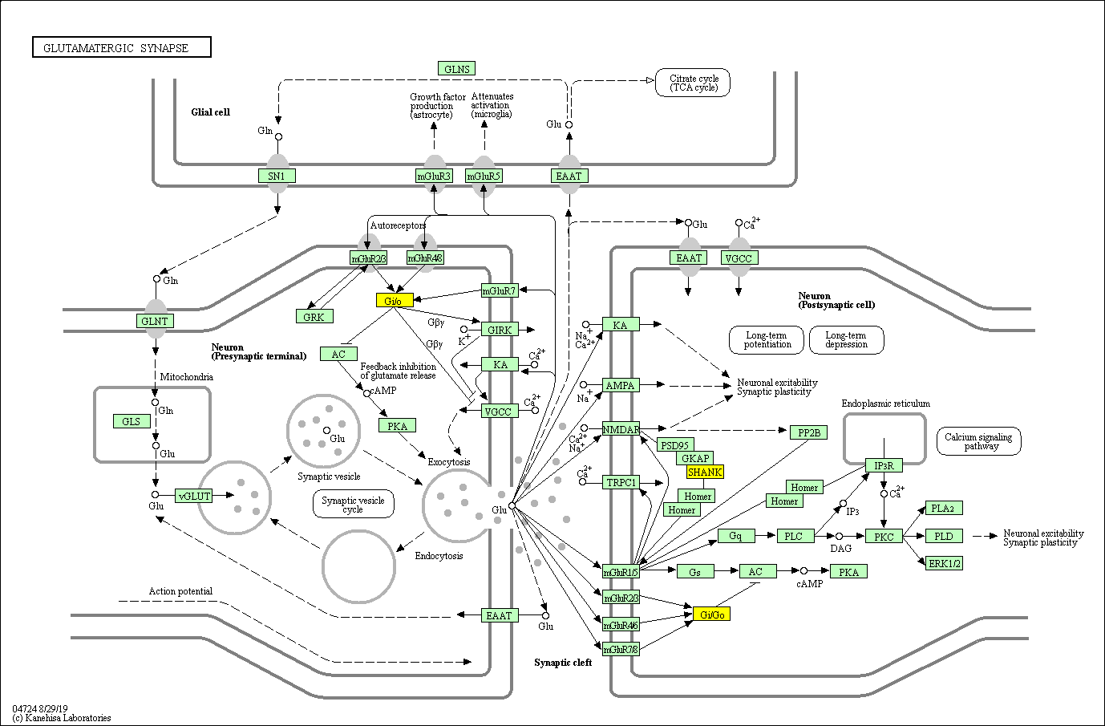

Figure S1 Glutamatergic synapse pathway (hsa04724).
The PDHS-specific genes (yellow) in this pathway containing the SHANK1, GNAI1, GNG10, GNAO1. For the detailed overview of the pathway, it is referred to the web address below.
https://www.genome.jp/kegg-bin/show_pathway?hsa04724/hsa:50944%20yellow/hsa:2770%20yellow/hsa:2790%20yellow/hsa:2775%20yellow
Description: Glutamate is the major excitatory neurotransmitter in the mammalian central nervous system(CNS). Glutamate is packaged into synaptic vesicles in the presynaptic terminal. Once released into the synaptic cleft, glutamate acts on postsynaptic ionotropic glutamate receptors (iGluRs) to mediate fast excitatory synaptic transmission. Glutamate can also act on metabotropic glutamate receptors (mGluRs) and exert a variety of modulatory effects through their coupling to G proteins and the subsequent recruitment of second messenger systems. Presynaptically localized Group II and Group III mGluRs are thought to represent the classical inhibitory autoreceptor mechanism that suppresses excess glutamate release. After its action on these receptors, glutamate can be removed from the synaptic cleft by EAATs located either on the presynaptic terminal, neighboring glial cells, or the postsynaptic neuron. In glia, glutamate is converted to glutamine, which is then transported back to the presynaptic terminal and converted back to glutamate.

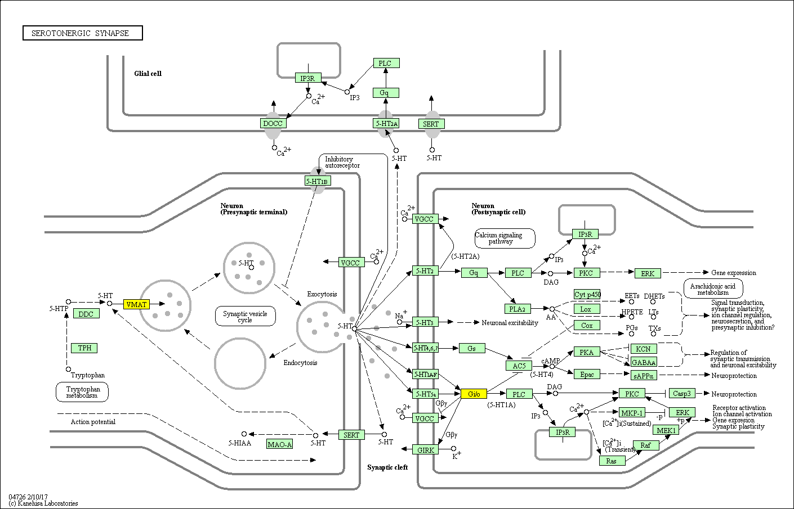

Figure S2 Serotonergic/Dopaminergic synapse pathway (hsa04726).
The PDHS-specific genes (yellow) in this pathway containing the SLC18A1, GNAI1, GNG10, GNAO1. For the detailed overview of the pathway, it is referred to the web address below.
https://www.genome.jp/kegg-bin/show_pathway?hsa04726/hsa:6570%20yellow/hsa:2770%20yellow/hsa:2790%20yellow/hsa:2775%20yellow
Description: Serotonin (5-Hydroxytryptamine, 5-HT) is a monoamine neurotransmitter that plays important roles in physiological functions such as learning and memory, emotion, sleep, pain, motor function and endocrine secretion, as well as in pathological states including abnormal mood and cognition. Once released from presynaptic axonal terminals, 5-HT binds to receptors, which have been divided into 7 subfamilies on the basis of conserved structures and signaling mechanisms. These families include the ionotropic 5-HT3 receptors and G-protein-coupled 5-HT receptors, the 5-HT1 (Gi /Go -coupled), 5-HT2(Gq-coupled), 5-HT4/6/7 (Gs-coupled) and 5-HT5 receptors. Presynaptically localized 5-HT1B receptors are thought to be the autoreceptors that suppress excess 5-HT release. 5-HT's actions are terminated by transporter- mediated reuptake into neurons, leading to catabolism by monoamine oxidase.

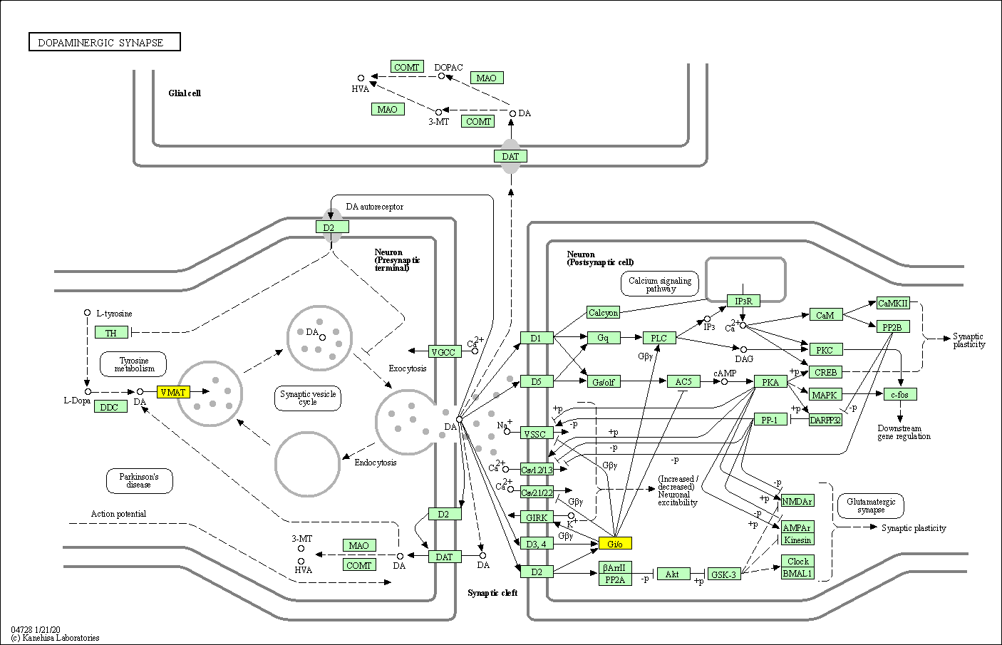

Figure S3 Dopaminergic synapse pathway (hsa04728).
The PDHS-specific genes (yellow) in this pathway containing the SLC18A1, GNAI1, GNG10, GNAO1. For the detailed overview of the pathway, it is referred to the web address below.
https://www.genome.jp/kegg-bin/show_pathway?hsa04728/hsa:6570%20yellow/hsa:2770%20yellow/hsa:2790%20yellow/hsa:2775%20yellow
Description: Dopamine (DA) is an important and prototypical slow neurotransmitter in the mammalian brain, where it controls a variety of functions including locomotor activity, motivation and reward, learning and memory, and endocrine regulation. Once released from presynaptic axonal terminals, DA interacts with at least five receptor subtypes in the central nervous system (CNS), which have been divided into two groups: the D1-like receptors (D1Rs), comprising D1 and D5 receptors, both positively coupled to adenylyl cyclase and cAMP production, and the D2-like receptors (D2Rs), comprising D2, D3, and D4 receptors, whose activation results in inhibition of adenylyl cyclase and suppression of cAMP production. In addition, D1Rs and D2Rs modulate intracellular Ca2+ levels and a number of Ca2+ -dependent intracellular signaling processes. Through diverse cAMP- and Ca2+-dependent and - independent mechanisms, DA influences neuronal activity, synaptic plasticity, and behavior. Presynaptically localized D2Rs regulate synthesis and release of DA as the main autoreceptor of the dopaminergic system.

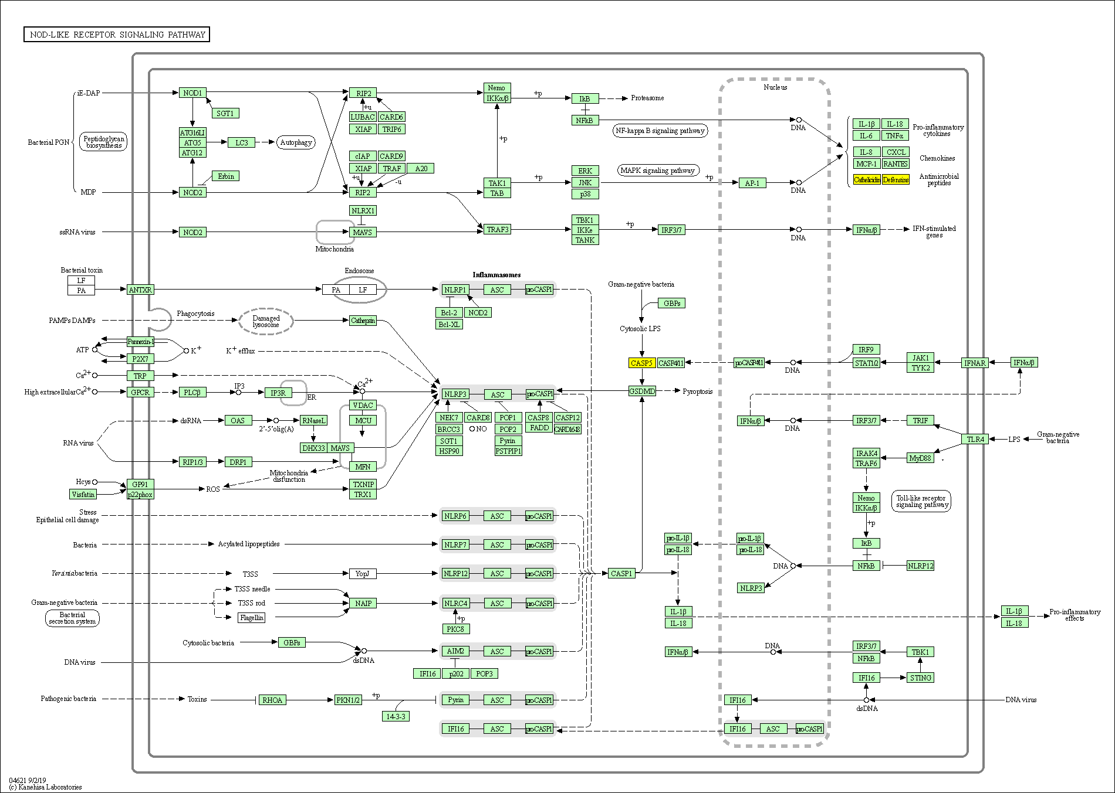

Figure S4 NOD-like receptor signaling pathway (hsa04621).
The PDHS-specific genes (yellow) in this pathway containing the DEFA3, CASP5, DEFA1B, CAMP, DEFA1. For the detailed overview of the pathway, it is referred to the web address below.
https://www.genome.jp/kegg-bin/show_pathway?hsa04621/hsa:1668%20yellow/hsa:838%20yellow/hsa:728358%20yellow/hsa:820%20yellow/hsa:1667%20yellow
Description: Specific families of pattern recognition receptors are responsible for detecting various pathogens and generating innate immune responses. The intracellular NOD-like receptor (NLR) family contains more than 20 members in mammals and plays a pivotal role in the recognition of intracellular ligands. NOD1 and NOD2, two prototypic NLRs, sense the cytosolic presence of the bacterial peptidoglycan fragments that escaped from endosomal compartments, driving the activation of NF-{kappa}B and MAPK, cytokine production and apoptosis. On the other hand, a different set of NLRs induces caspase-1 activation through the assembly of multiprotein complexes called inflammasomes. The activated of caspase-1 regulates maturation of the pro-inflammatory cytokines IL-1B, IL-18 and drives pyroptosis.

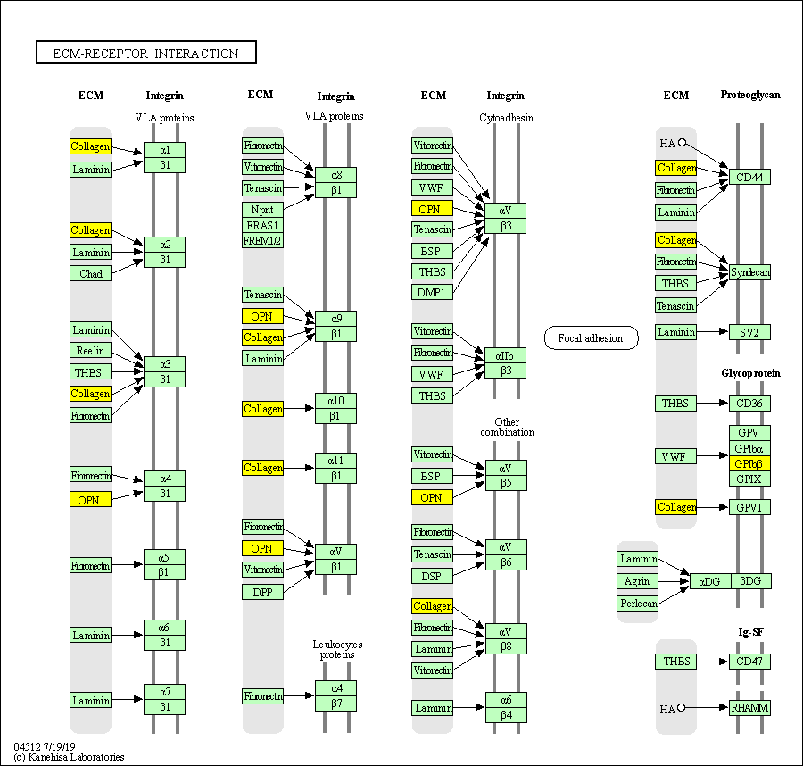

Figure S5 ECM-receptor interaction (hsa04512).
The PQDS-specific genes (yellow) in this pathway containing the COL4A2, SPP1, GP1BB, COL4A4. For the detailed overview of the pathway, it is referred to the web address below.
https://www.genome.jp/kegg-bin/show_pathway?hsa04512/hsa:1284%20yellow/hsa:6696%20yellow/hsa:2812%20yellow/hsa:1286%20yellow.
Description: The extracellular matrix (ECM) consists of a complex mixture of structural and functional macromolecules and serves an important role in tissue and organ morphogenesis and in the maintenance of cell and tissue structure and function. Specific interactions between cells and the ECM are mediated by transmembrane molecules, mainly integrins and perhaps also proteoglycans, CD36, or other cell-surface-associated components. These interactions lead to a direct or indirect control of cellular activities such as adhesion, migration, differentiation, proliferation, and apoptosis. In addition, integrins function as mechanoreceptors and provide a force-transmitting physical link between the ECM and the cytoskeleton. Integrins are a family of glycosylated, heterodimeric transmembrane adhesion receptors that consist of noncovalently bound alpha- and beta-subunits.

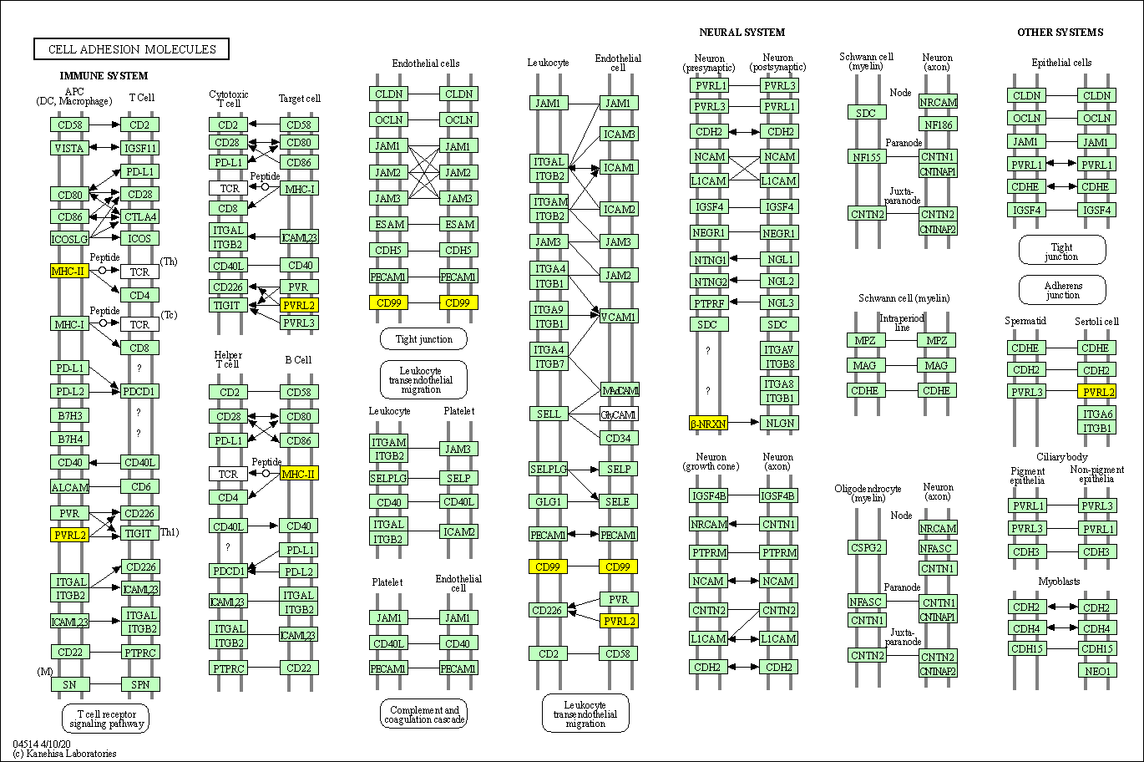

Figure S6 Cell adhesion molecules (CAMs) (hsa04514).
The PQDS-specific genes (yellow) in this pathway containing the HLA-DRB5, NECTIN2, NRXN1, CD99, HLA-DQB1. For the detailed overview of the pathway, it is referred to the web address below.
https://www.genome.jp/kegg-bin/show_pathway?hsa04514/hsa:3127%20yellow/hsa:5819%20yellow/hsa:9378%20yellow/hsa:4267%20yellow/hsa:3119%20yellow.
Description: Cell adhesion molecules are (glyco)proteins expressed on the cell surface and play a critical role in a wide array of biologic processes that include hemostasis, the immune response, inflammation, embryogenesis, and development of neuronal tissue. There are four main groups: the integrin family, the immunoglobulin superfamily, selectins, and cadherins. Membrane proteins that mediate immune cell–cell interactions fall into different categories, namely those involved in antigen recognition, costimulation and cellular adhesion. Furthermore cell-cell adhesions are important for brain morphology and highly coordinated brain functions such as memory and learning. During early development of the nervous system, neurons elongate their axons towards their targets and establish and maintain synapses through formation of cell-cell adhesions. Cell-cell adhesions also underpin axon-axon contacts and link neurons with supporting schwann cells.

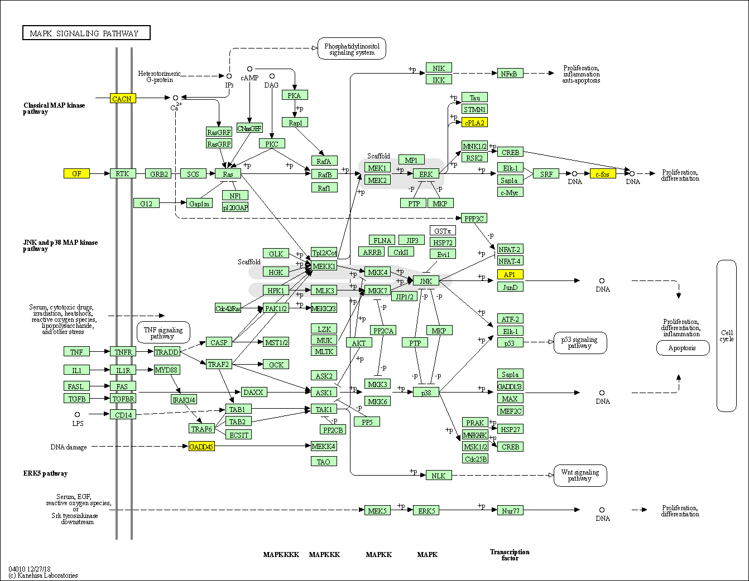

Figure S7 MAPK signaling pathway (hsa04010).
The PQDS-specific genes (yellow) in this pathway containing the EGF, GADD45G, PLA2G4C, FOS, PLA2G4B, AREG, CACNB2. For the detailed overview of the pathway, it is referred to the web address below.
https://www.genome.jp/kegg-bin/show_pathway?hsa04010/hsa:1950%20yellow/hsa:10912%20yellow/hsa:8605%20yellow/hsa:2353%20yellow/hsa:100137049%20yellow/hsa:374%20yellow/hsa:783%20yellow
Description: The mitogen-activated protein kinase (MAPK) cascade is a highly conserved module that is involved in various cellular functions, including cell proliferation, differentiation and migration. Mammals express at least four distinctly regulated groups of MAPKs, extracellular signal-related kinases (ERK)-1/2, Jun amino-terminal kinases (JNK1/2/3), p38 proteins (p38alpha/beta/gamma/delta) and ERK5, that are activated by specific MAPKKs: MEK1/2 for ERK1/2, MKK3/6 for the p38, MKK4/7 (JNKK1/2) for the JNKs, and MEK5 for ERK5. Each MAPKK, however, can be activated by more than one MAPKKK, increasing the complexity and diversity of MAPK signalling. Presumably each MAPKKK confers responsiveness to distinct stimuli. For example, activation of ERK1/2 by growth factors depends on the MAPKKK c-Raf, but other MAPKKKs may activate ERK1/2 in response to pro-inflammatory stimuli.

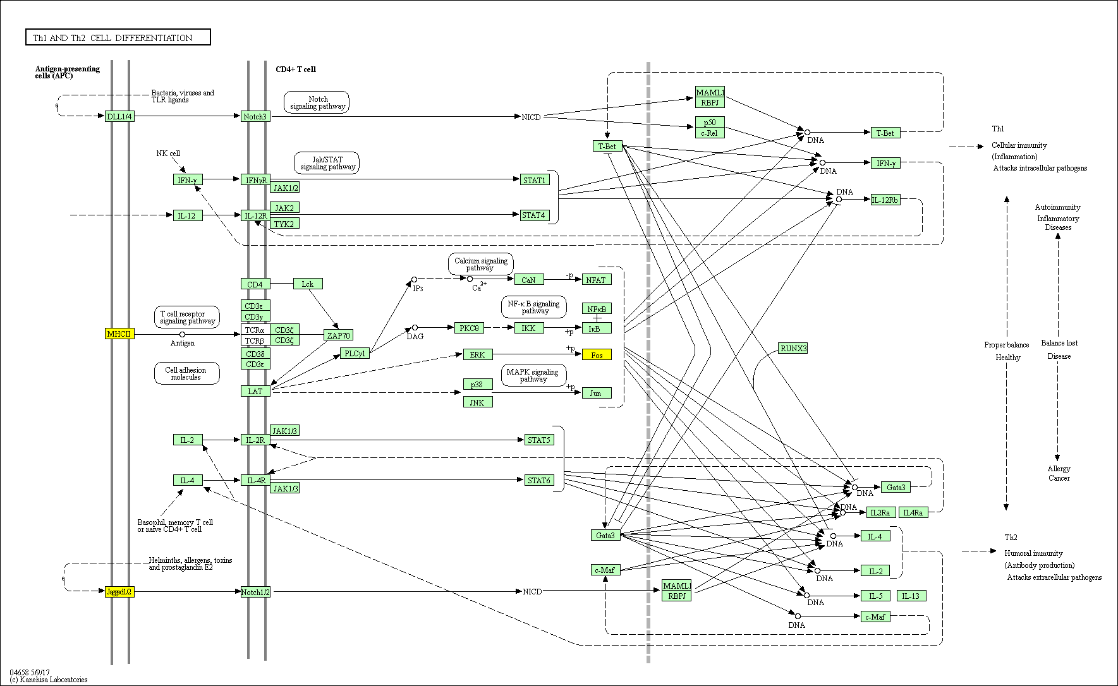

Figure S8 Th1 and Th2 cell differentiation (hsa04658).
The PQDS-specific genes (yellow) in this pathway containing the JAG2, HLA-DRB5, FOS, HLA-DQB1. For the detailed overview of the pathway, it is referred to the web address below.
https://www.genome.jp/kegg-bin/show_pathway?hsa04658/hsa:3714%20yellow/hsa:3127%20yellow/hsa:2353%20yellow/hsa:3119%20yellow
Description: Immunity to different classes of microorganisms is orchestrated by separate lineages of effector T helper (TH)-cells, which differentiate from naive CD4+ precursor cells in response to cues provided by antigen presenting cells (APC) and include T helper type 1 (Th1) and Th2. Th1 cells are characterized by the transcription factor T-bet and signal transducer and activator of transcription (STAT) 4, and the production of IFN-gamma. These cells stimulate strong cell-mediated immune responses, particularly against intracellular pathogens. On the other hand, transcription factors like GATA-3 and STAT6 drive the generation of Th2 cells that produce IL-4, IL-5 and IL-13 and are necessary for inducing the humoral response to combat parasitic helminths (type 2 immunity) and isotype switching to IgG1 and IgE. The balance between Th1/Th2 subsets determines the susceptibility to disease states, where the improper development of Th2 cells can lead to allergy, while an overactive Th1 response can lead to autoimmunity.
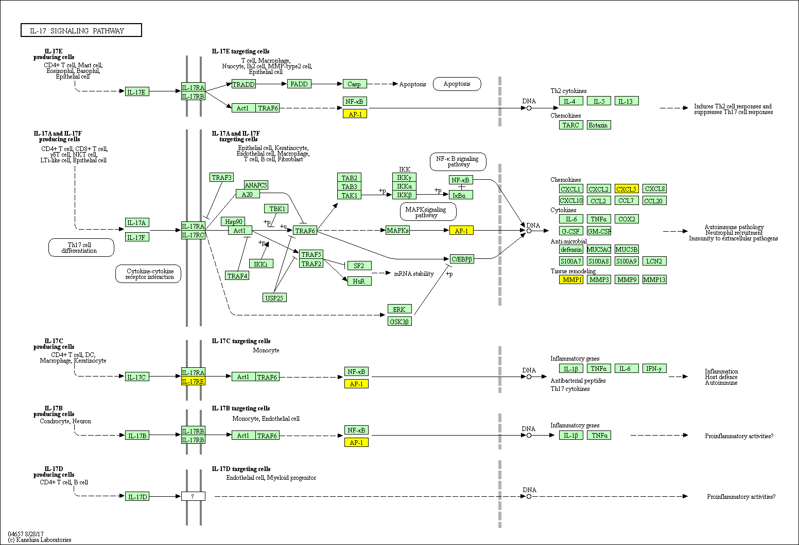

Figure S9 IL-17 signaling pathway (hsa04657).
The PQDS-specific genes (yellow) in this pathway containing the CXCL6, FOS, MMP1, IL17RE. For the detailed overview of the pathway, it is referred to the web address below.

https://www.genome.jp/kegg-bin/show_pathway?hsa04657/hsa:6372%20yellow/hsa:2353%20yellow/hsa:4312%20yellow/hsa:132014%20yellow

Description: The interleukin 17 (IL-17) family, a subset of cytokines consisting of IL-17A-F, plays crucial roles in both acute and chronic inflammatory responses. IL-17A, the hallmark cytokine of the newly defined T helper 17 (TH17) cell subset, has important roles in protecting the host against extracellular pathogens, but also promotes inflammatory pathology in autoimmune disease, whereas IL-17F is mainly involved in mucosal host defense mechanisms. IL-17E (IL-25) is an amplifier of Th2 immune responses. IL-17C has biological functions similar to those of IL-17A. The functions of IL-17B and IL-17D remain largely elusive. The IL-17 family signals via their correspondent receptors and activates downstream pathways that include NF-kappaB, MAPKs and C/EBPs to induce the expression of antimicrobial peptides, cytokines and chemokines. The receptor proximal adaptor Act1 (an NF-kappaB activator 1) is considered as the master mediator in IL-17A signaling. It is likely that Act1 is a common signal adaptor also shared by other members mediated signalings in this family.

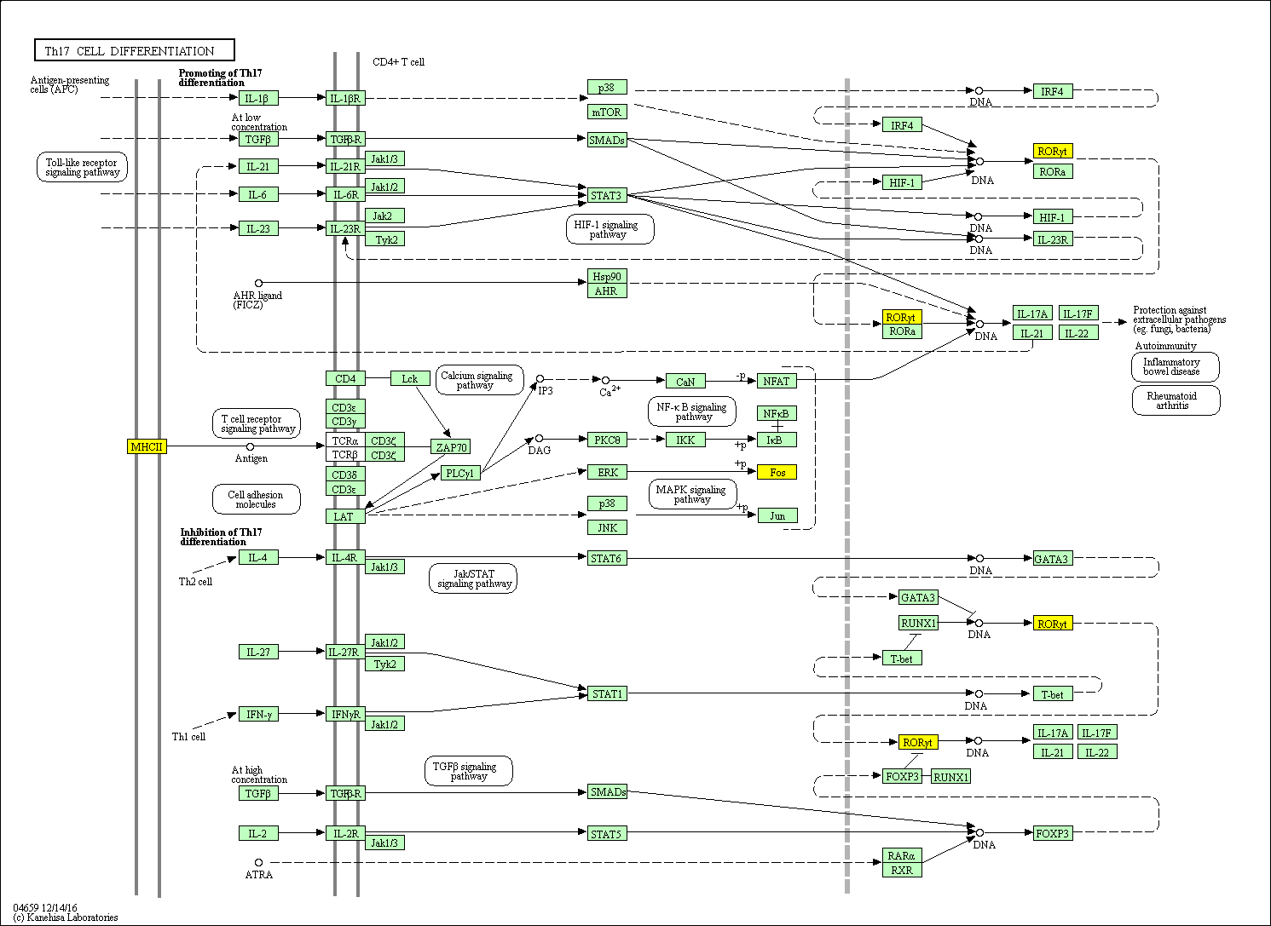

Figure S10 Th17 cell differentiation pathway (hsa04659).
The PQDS-specific genes (yellow) in this pathway containing the HLA-DRB5, RORC, FOS, HLA-DQB1. For the detailed overview of the pathway, it is referred to the web address below.
https://www.genome.jp/kegg-bin/show_pathway?hsa04659/hsa:3127%20yellow/hsa:6097%20yellow/hsa:2353%20yellow/hsa:3119%20yellow
Description: Interleukin (IL)-17-producing helper T (Th17) cells serve as a subset of CD4+ T cells involved in epithelial cell- and neutrophil mediated immune responses against extracellular microbes and in the pathogenesis of autoimmune diseases. In vivo, Th17 differentiation requires antigen presentation and co-stimulation, and activation of antigen presenting-cells (APCs) to produce TGF-beta, IL-6, IL-1, IL-23 and IL-21. This initial activation results in the activation and up-regulation of STAT3, ROR(gamma)t and other transcriptional factors in CD4+ T cells, which bind to the promoter regions of the IL-17, IL-21 and IL-22 genes and induce IL-17, IL-21 and IL-22. In contrast, the differentiation of Th17 cells and their IL-17 expression are negatively regulated by IL-2, Th2 cytokine IL-4, IL-27 and Th1 cytokine IFN-gamma through STAT5, STAT6 and STAT1 activation, respectively. Retinoid acid and the combination of IL-2 and TGF-beta upregulate Foxp3, which also downregulates cytokines like IL-17 and IL-21. The inhibition of Th17 differentiation may serve as a protective strategy to 'fine-tune' the expression IL-17 so it does not cause excessive inflammation. Thus, balanced differentiation of Th cells is crucial for immunity and host protection.
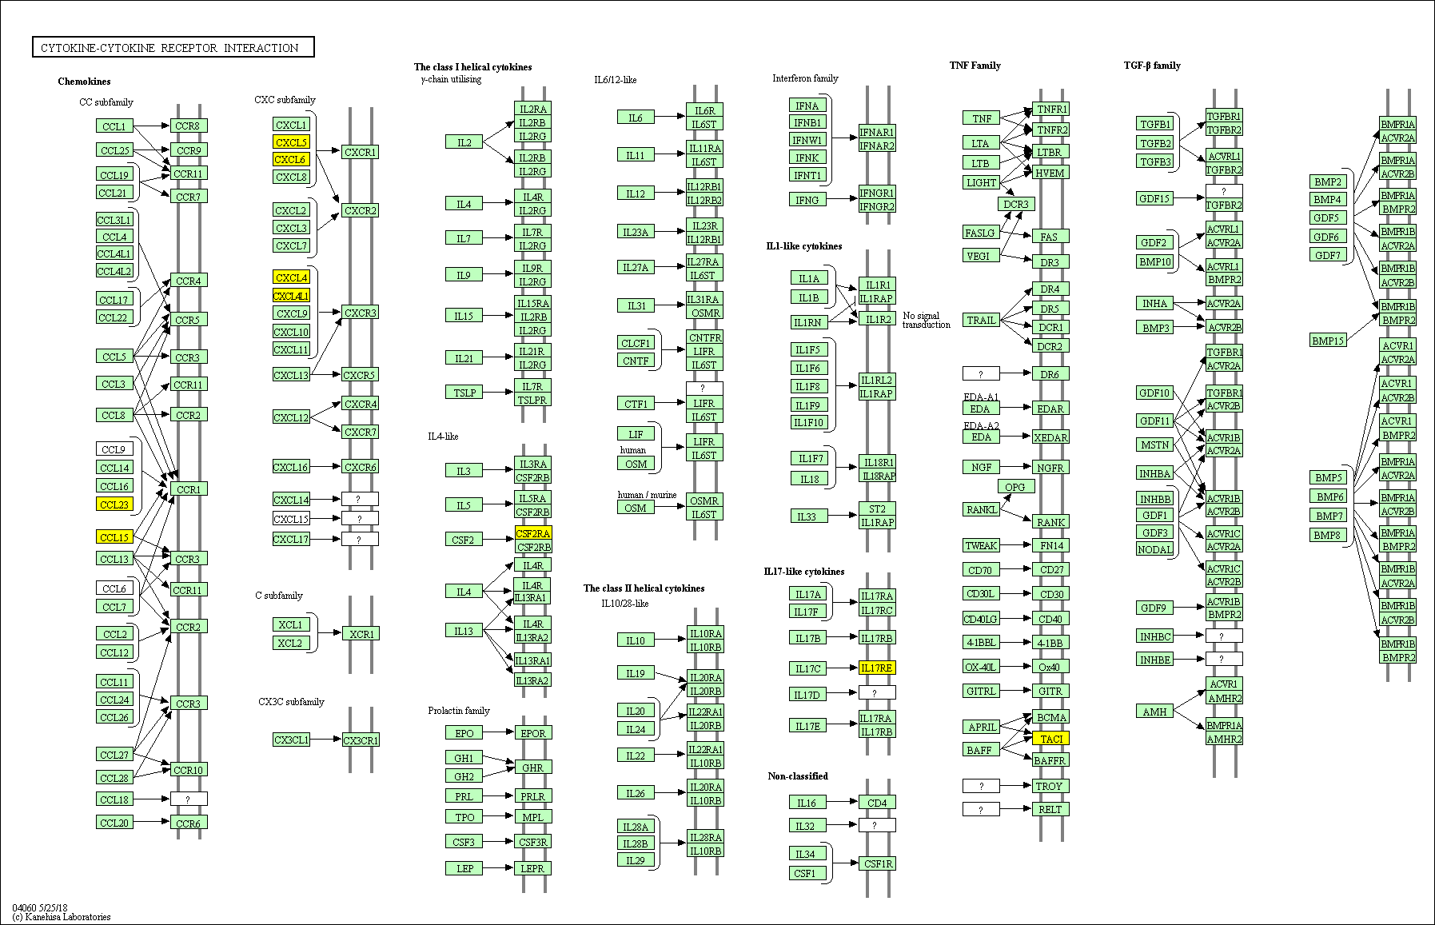

Figure S11 Cytokine-cytokine receptor interaction pathway (hsa04060).
The PQDS-specific genes (yellow) in this pathway containing the TNFRSF13B, CCL23, CXCL6, CSF2RA, PF4, IL17RE. For the detailed overview of the pathway, it is referred to the web address below.
https://www.genome.jp/kegg-bin/show_pathway?hsa04060/hsa:23495%20yellow/hsa:6368%20yellow/hsa:6372%20yellow/hsa:1438%20yellow/hsa:5196%20yellow/hsa:132014%20yellow
Description: Cytokines are soluble extracellular proteins or glycoproteins that are crucial intercellular regulators and mobilizers of cells engaged in innate as well as adaptive inflammatory host defenses, cell growth, differentiation, cell death, angiogenesis, and development and repair processes aimed at the restoration of homeostasis. Cytokines are released by various cells in the body, usually in response to an activating stimulus, and they induce responses through binding to specific receptors on the cell surface of target cells. Cytokines can be grouped by structure into different families and their receptors can likewise be grouped.

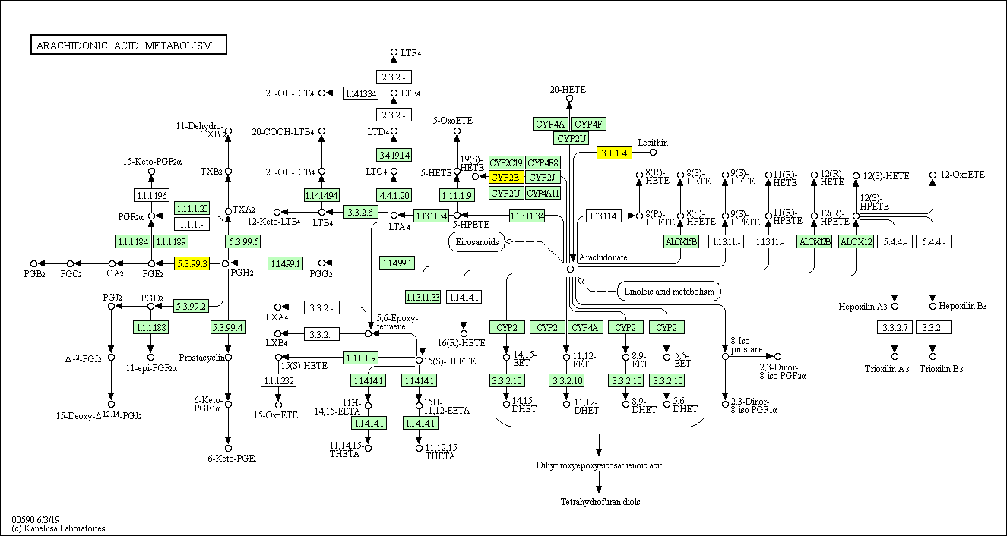

Figure S12 Arachidonic acid metabolism (hsa590).
The PQDS-specific genes (yellow) in this pathway containing the PLA2G4C, CYP2E1, PLA2G4B, PTGES. For the detailed overview of the pathway, it is referred to the web address below.
https://www.genome.jp/kegg-bin/show_pathway?hsa00590/hsa:8605%20yellow/hsa:1571%20yellow/hsa:100137049%20yellow/hsa:9536%20yellow

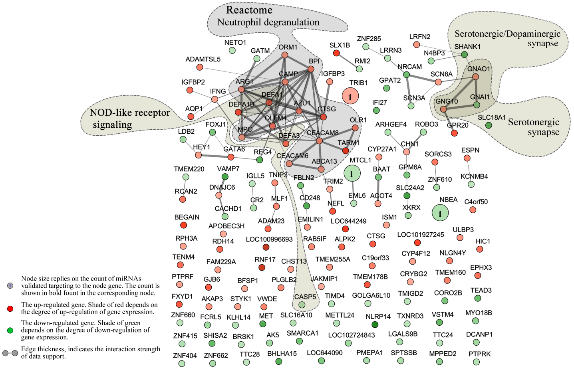

Figure S13 The network detailing the interaction relationships of the PDHS-specific genes in leukocytes.
The blue number marked in a node indicates the count of the PDHS-specific miRNAs which were validated targeting to the corresponding node gene. The node genes-enriched pathways were specially marked in the generated interaction network. Abbreviations: PDHS, chronic atrophic gastritis patients with Pi-wei damp-heat syndrome.

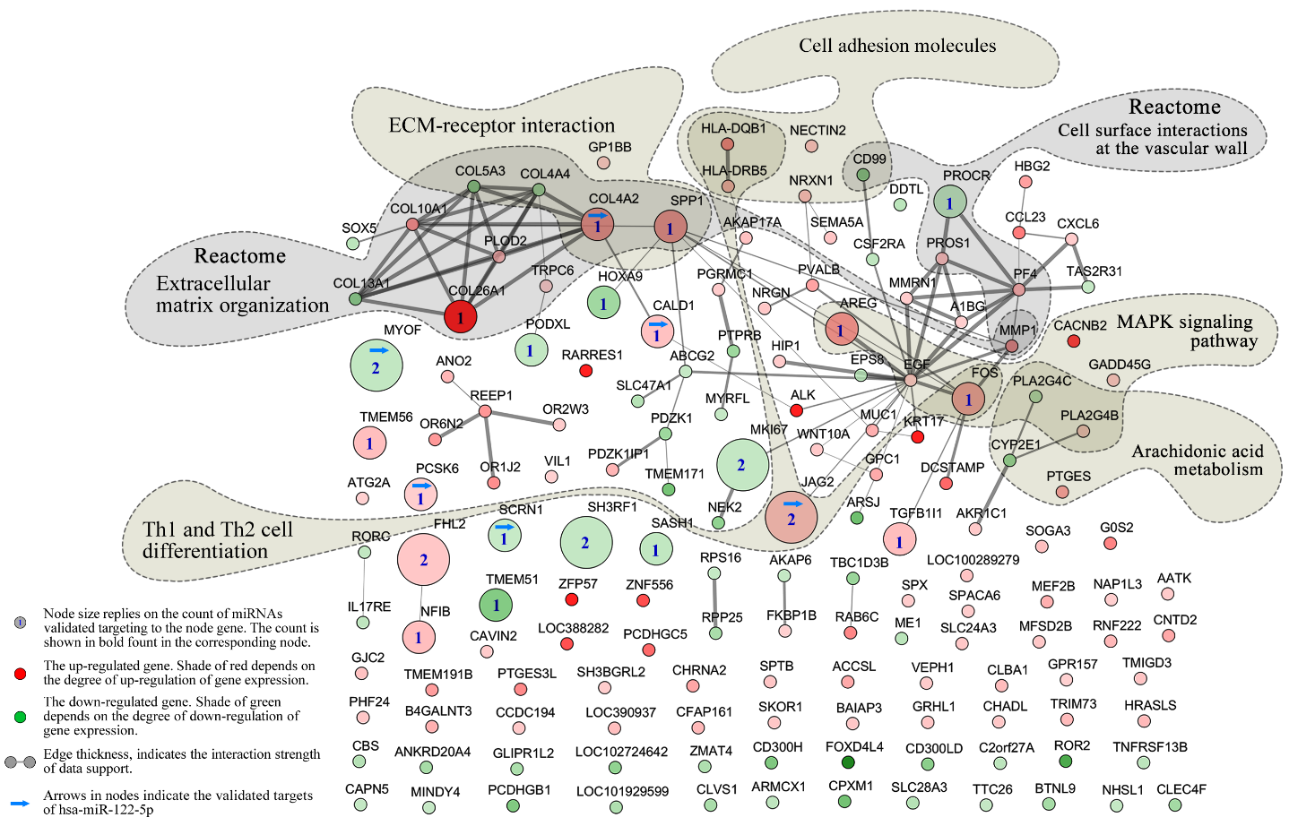

Figure S14 The network detailing the interaction relationships of the PQDS-specific genes in leukocytes.
The blue number marked in a node indicates the count of the PQDS-specific miRNAs which were validated targeting to the corresponding node gene. The node genes-enriched pathways were specially marked in the generated interaction network. Abbreviations: PQDS, chronic atrophic gastritis patients with Pi-qi-deficiency syndrome.

References:
1. Fang JY, Liu WZ, Li ZK, et al: China Chronic Gastritis Consensus (2012, Shanghai). Chin J Front Med Sci 5: 44-55, 2013.
2. Zheng XY: Guiding Principle for Clinical Research on New Drugs of Traditional Chinese Medicine. China Medical Science Press, Beijing, 2002.
3. Patel RK and Jain M: NGS QC Toolkit: a toolkit for quality control of next generation sequencing data. Plos One 7: e30619, 2012.
4. Altschul SF, Madden TL, Schäffer AA, et al: Gapped BLAST and PSI-BLAST: a new generation of protein database search programs. Nucleic acids research 25: 3389-3402, 1997.
5. Daub J, Eberhardt RY, Tate JG and Burge SW: Rfam: annotating families of non-coding RNA sequences. Methods in molecular biology (Clifton, N.J.) 1269: 349-363, 2015.
6. An JY, Lai J, Lehman ML and Nelson CC: miRDeep*: an integrated application tool for miRNA identification from RNA sequencing data. Nucleic acids research 41: 727-737, 2013.
7. Vlachos IS, Paraskevopoulou MD, Karagkouni D, et al: DIANA-TarBase v7.0: indexing more than half a million experimentally supported miRNA:mRNA interactions. Nucleic Acids Res. 43: D153-159, 2015.

