Negative emissions pose trade-offs among human health, planetary boundaries and mineral resources

Supplementary Information

Selene Cobo^{1*}, Ángel Galán Martín² and Gonzalo Guillén-Gosálbez³*
¹Department of Chemical and Biomolecular Engineering, University of Cantabria, Spain
²Department of Chemical, Environmental and Materials Engineering, Institute of Biorefineries Research (I3B), University of Jaén, Spain
³Department of Chemistry and Applied Biosciences, Institute for Chemical and Bioengineering, ETH Zürich, Switzerland.
*cobos@unican.es, gonzalo.guillen.gosalbez@chem.ethz.ch

This document provides additional information on the methodology, life cycle models, assumptions and limitations, and results described in the main manuscript.
Table of contents

1. Nomenclature 3
2. Methods 9
2.1 Removal efficiency 9
2.2 Health and ecosystem impacts 11
2.3 Impacts on the Earth system 13
2.4 Mineral resource extraction 15
3. Life cycle models 18
3.1 Direct Air Carbon Capture and Storage 18
3.2 Ocean liming 19
3.3 Enhanced weathering 20
3.4 Bioenergy with Carbon Capture and Storage 23
3.5 Forestation 25
3.6 Biochar 26
4. Summary of assumptions and limitations 28
4.1 Modeling framework 28
4.2 NETPs models 29
5. Supplementary results 31
6. References 40

1. Nomenclature
This section provides the definition of the sets, parameters and variables used to estimate the greenhouse gas removal efficiency (Supplementary Table 1), health and ecosystem impacts (Supplementary Table 2), Earth system impacts (Supplementary Table 3), mineral resource extraction (Supplementary Table 4) and enhanced weathering life cycle inventories (Supplementary Table 5).

We defined these main sets:
$$A$$ | $$≔$$ | {a: Activities}
$$C$$ | $$≔$$ | {c: Supply chain stages}
$$D$$ | $$≔$$ | {d: Enhanced weathering datasets}
$$E$$ | $$≔$$ | {e: Endpoint areas of protection}
$$G$$ | $$≔$$ | {g: Global carbon sinks}
$$I$$ | $$≔$$ | {i: Negative Emissions Technologies or Practices (NETPs)}
$$K$$ | $$≔$$ | {k: Earth-system processes}
$$L$$ | $$≔$$ | {l: Locations}
$$M$$ | $$≔$$ | {m: Midpoint impact categories}
$$N$$ | $$≔$$ | {n: Type of rocks}
$$P$$ | $$≔$$ | {p: Rock particle size}
$$R$$ | $$≔$$ | {r: Mineral resources}
$$S$$ | $$≔$$ | {s: Elementary flows}
$$T$$ | $$≔$$ | {t: Number of years after CDR deployment}
$$T^{P}$$ | $$≔$$ | {t^{p}: Number of years after pulse emission}
$$Y$$ | $$≔$$ | {y: Years of deployment}

We derived the following subsets from the sets above.
Subsets of set $A$:
$$F$$ | $$≔$$ | {a: Fertilizer production activities}
$$IN$$ | $$≔$$ | {a: Infrastructure activities}
$$OP$$ | $$≔$$ | {a: Operating activities}

Subsets of set $I$:
$$BECCS$$ | $$≔$$ | {i: Bioenergy with Carbon Capture and Storage systems}
$$EW$$ | $$≔$$ | {i: Enhanced weathering systems}
$$FOREST$$ | $$≔$$ | {i: Forestation systems}
$$HTLS$$ | $$≔$$ | {i: High Temperature Liquid Sorbent Direct Air Carbon Capture Systems}
$$TERR$$ | $$≔$$ | {i: Terrestrial NETPs systems}

Subsets of set $S$:
$$FE$$ | $$≔$$ | {s: Non-greenhouse gas emissions due to forest fires}
$$J$$ | $$≔$$ | {s: Greenhouse gases}
$$RE$$ | $$≔$$ | {s: Emissions due to the rock dissolution}

Supplementary Table 1. Parameters and variables used to estimate
the greenhouse gas removal efficiency.
Symbol | Description | Unit
$$a_{0}$$ | CO₂ fraction that remains in the atmosphere for an infinite number of years after a pulse emission | –
$$a_{g}$$ | CO₂ fraction transferred to carbon sink g an infinite number of years after a pulse emission. | –
$$AGWP_{CO_{2}}^{TH}$$ | Absolute global warming potential of CO₂ over a 20-year period | W·year/m²/kg
$$AGWP_{s,t}^{TH^{'}}$$ | Absolute global warming potential of greenhouse gas s emitted or removed in year t and quantified over period $TH^{'}$ | W·year/m²/kg
$$C_{s,t^{p}}$$ | Fraction of greenhouse gas s that remains in the atmosphere $t^{p}$ years after being emitted | –
$$CDR_{i,s,t,y}$$ | Gross amount of CO₂ removed by NETP i t years after deployment in year y | kg/functional unit
$$GGRη_{i,t,y}$$ | Greenhouse gas removal efficiency of Negative Emissions Technology or Practice i t years after deployment in year y | –
$$GHG_{i,s,t,y}$$ | Gross amount of greenhouse gas s emitted by NETP i t years after deployment in year y | kg/functional unitª
$$GWP_{s,t}$$ | Global warming potential of greenhouse gas s emitted in year t | kgCO₂eq/kg
$$RF_{s}$$ | Radiative forcing of greenhouse gas s | W/m²/kg
$$t$$ | Number of years after CDR deployment | year
$$t^{p}$$ | Number of years after pulse emission | year
$$τ_{g}$$ | Lifetime of CO₂ perturbation in carbon sink g | year
$$τ_{s}$$ | Lifetime of greenhouse gas s in the atmosphere | year
$$TH$$ | Time horizon | year
$$TH^{'}$$ | Time horizon spanning from the year of the emission to the final year of $TH$ | year

Supplementary Table 2. Parameters and variables used to estimate
health and ecosystem impacts.
Symbol | Description | Unit
$$CDR_{i,s,t,y}$$ | Gross amount of CO₂ removed by NETP i t years after deployment in year y | kg/functional unitª
$$CF_{m,s,t}^{MID}$$ | Characterization factor quantifying the impacts of elementary flow s exchanged with the environment t years after CDR in terms of midpoint impact category m | unit of midpoint impact/unit of elementary flow
$$F_{m,e,s}$$ | Factor converting impacts of elementary flow s in terms of midpoint impact category m to impacts on endpoint impact category e | unit of endpoint impact/unit of midpoint impact^{b}
$$GHG_{i,s,t,y}$$ | Gross amount of greenhouse gas s emitted by NETP i t years after deployment in year y | kg/functional unitª
$$GWP_{s,t}$$ | Global warming potential of greenhouse gas s emitted in year t | kgCO₂eq/kg
$$I_{i,e,y}^{END}$$ | Endpoint impact e of NETP i deployed in year y | unit of endpoint impact^{d}/functional unitª
$$k_{CFC11}$$ | Inverse of CFC-11 atmospheric lifetime | year⁻¹
$$k_{N_{2}O}$$ | Inverse of N₂O atmospheric lifetime | year⁻¹
$$NR_{i,s,t,y}$$ | Amount of natural resource s exchanged between NETP i and the environment t years after deployment in year y | unit of elementary flow^{c}/functional unitª
$$ODP∞_{N_{2}O}$$ | N₂O ozone depletion potential for an infinite time horizon | kgCFC-11/kg
$$P_{i,s,t,y}$$ | Amount of pollutant s (excluding greenhouse gases) emitted by NETP i t years after deployment in year y | unit of elementary flow^{c}/functional unitª
$$PEF_{i,s,t,y}$$ | Amount of elementary flow s prevented from being exchanged with the environment by NETP i t years after deployment in year y | unit of elementary flow^{c}/functional unitª
$$Q_{i,s,t,y}$$ | Amount of elementary flow s exchanged between NETP i and the environment t years after deployment in year y | unit of elementary flow^{c}/functional unitª
$$TH$$ | Time horizon | year
$$TH'$$ | Time horizon spanning from the year of the emission to the final year of $TH$ | year

Supplementary Table 3. Parameters and variables used to estimate
Earth-system impacts.
Symbol | Description | Unit
$$A_{a,c,i,y}$$ | Amount of activity a produced in the supply chain link c of NETP i deployed in year y | unit of activity/ functional unitª
$$CDR_{i,s,t,y}$$ | Gross amount of CO₂ removed by NETP i t years after deployment in year y | kg/functional unitª
$$CF_{k,s}^{ESP}$$ | Characterization factor quantifying the impacts of elementary flow s on Earth-system process k | unit of control variable/unit of elementary flow^{c}
$$GHG_{i,s,t,y}$$ | Gross amount of greenhouse gas s emitted by NETP i t years after deployment in year y | kg/functional unitª
$$GWP_{s,t}$$ | Global warming potential of greenhouse gas s emitted in year t | kgCO₂eq/kg
$$HolNPP$$ | Holocene annual net primary productivity | kgC
$$I_{i,k,y}^{ESP}$$ | Impact of NETP i deployed in year y on Earth-system process k | % of $SOS_{k,y}$/ functional unitª
$$NB_{k}$$ | Natural background level of Earth-system process k | unit of control variable^{f}
$$PB_{k}$$ | Planetary boundary for Earth-system process k | unit of control variable^{f}
$$Q_{i,s,t,y}$$ | Amount of elementary flow s exchanged between NETP i and the environment t years after deployment in year y | unit of elementary flow^{c}/functional unitª
$$SOS_{k,y}$$ | Safe operating space of Earth-system process k in year y | unit of control variable^{f}
$$TH$$ | Time horizon | year
$$x_{a}^{NF}$$ | Fraction of nitrogen in fertilizers produced in activity a | –

Supplementary Table 4. Parameters and variables used to estimate
mineral resource extraction.
Symbol | Description | Unit
$$A_{a,c,i,y}$$ | Amount of activity a produced in the supply chain link c of NETP i deployed in year y | unit of activity^{e}/ functional unitª
$$AT$$ | Annual time of infrastructure use | year
$$CDR_{i,s,t,y}$$ | Gross amount of CO₂ removed by NETP i t years after deployment in year y | kg/functional unitª
$${EF}_{a,s}^{BG}$$ | Amount of elementary flow s exchanged between activity a and the environment | unit of elementary flow^{c} /unit of activity^{e}
$$EF_{i,s,t,y}^{FG}$$ | Amount of elementary flow s exchanged between the foreground system of NETP i and the environment t years after deployment in year y | unit of elementary flow^{c}/functional unitª
$$LT$$ | Infrastructure lifetime | year
$$M_{i,r,y}$$ | Annualized amount of mineral resource r associated with the deployment of NETP i in year y | kg/functional unitª
$$Q_{i,s,t,y}$$ | Amount of elementary flow s exchanged between NETP i and the environment t years after deployment in year y | unit of elementary flow^{c}/functional unitª
$$R_{i,r,y}$$ | Annual amount of mineral resource r extracted by NETP i in year y | kg/functional unitª
$$x_{r,s}^{MR}$$ | Fraction of mineral resource r in elementary flow s | –

Supplementary Table 5. Parameters and variables used to estimate
the enhanced weathering life cycle inventories.
Symbol | Description | Unit
$$C_{n}^{ALK}$$ | Alkalinity concentration in rock n | mol/g
$$CDR^{EW}$$ | Gross amount of CO₂ removed in the enhanced weathering scenarios within one year | g/year
$$MM^{CO_{2}}$$ | CO₂ molecular mass | g/mol
$$RM_{d,l,n,p}^{0}$$ | Mass of rock that must be initially applied to the soil, dependent on the type of data d, location l, rock n and particle size p | g
$$RM_{d,l,n,p}^{A}$$ | Mass of rock applied annually after the initial year of deployment, dependent on the type of data d, location l, rock n and particle size p | g
$$P_{n}$$ | Theoretical CDR potential of rock n | gCO₂/g rock
$$spy$$ | Number of seconds in a year | s/year
$$SSA_{d,n,p}$$ | Specific surface area, dependent on the type of data d, rock n and particle size p | m²/g
$$w$$ | CDR efficiency factor | –
$$WR_{d,l,n}^{ALK}$$ | Alkalinity dissolution rate, dependent on the type of data d, location l and rock n | mol/m²/s
$$WR_{d,l,n}^{ROCK}$$ | Rock weathering rate, dependent on the type of data d, location l and rock n | g/m²/s

2. Methods
Here we describe the greenhouse gas removal (GGR) efficiency and the applied life cycle impact assessment methods.

2.1 Removal efficiency
We defined $GGRη_{i,t,y}$, the GGR efficiency of Negative Emissions Technology or Practice (NETP) i, as the ratio between the net amount of CO₂eq removed (calculated as the difference between the total CO₂eq removed and emitted) and the total amount of CO₂ removed from the atmosphere t years after deployment in year y (between 2030 and 2050). $GGRη_{i,t,y}$ is estimated with Equation (1), where $CDR_{i,s,t,y}$ and $GHG_{i,s,t,y}$ represent the gross amount of elementary flow s within the set J of greenhouse gases that is removed (negative value) and emitted (positive value) by NETP i t years after deployment in year y.
$$GGRη_{i,t,y}=\frac{\sum_{t^{'}=0}^{t^{'}=t}{\sum_{s∈J}{(\left|CDR_{i,s=CO_{2},t^{'},y}\right|-GHG_{i,s,t^{'},y})·GWP_{s,t^{'}}}}}{\sum_{t^{'}=0}^{t^{'}=t}{\left|CDR_{i,s=CO_{2},t^{'},y}\right|}} ∀ i∈I, t∈T,y∈Y$$ | (1)
The goal of our analysis is to evaluate the effects of Carbon Dioxide Removal (CDR) in year y; hence, Equation (1) only accounts for the CDR happening that year ($t=0$) in the Direct Air Carbon Capture and Storage (DACCS), ocean liming, Bioenergy with Carbon Capture and Storage (BECCS) and terrestrial NETPs scenarios (Equation (2)). As we discussed in the main text, greenhouse gas emissions offset the CDR occurring the year of deployment in some of the studied enhanced weathering ($EW$) systems (where CDR occurs gradually over time), leading to a negative GGR efficiency the initial year. Thus, we evaluated how the CDR occurring in the years following the rock deployment improves the GGR efficiency of the enhanced weathering scenarios (relation (3)).
$$CDR_{i,s,t,y}=0 ∀ t>0, i∉EW,s=CO_{2}, y∈Y$$ | (2)
$$\left|CDR_{i,s,t,y}\right|>0 ∀ t>0, i∈EW, s=CO_{2}, y∈Y$$ | (3)
The greenhouse gas emissions linked to the infrastructure and operating activities are assumed to take place the year of deployment in all the NETPs scenarios. Only terrestrial NETPs ($TERR$, including biochar and forestation) emit greenhouse gases after the year of deployment due to the mineralization of the biochar carbon and forest fires, which release part of the removed carbon (Equation (4) and Inequality (5)). Note that $GHG_{i,s,t,y}$ does not include the greenhouse gas emissions prevented from being emitted due to the integration of the secondary products or services provided by NETPs into the economy, i.e., phosphate fertilizers (enhanced weathering scenarios), heat (biochar scenarios), electricity (combustion-BECCS) and hydrogen (gasification-BECCS).
$$GHG_{i,s,t,y}=0 ∀ t>0, i∉TERR,s∈J, y∈Y$$ | (4)
$$GHG_{i,s,t,y}>0 ∀ t>0, i∈TERR,s∈J, y∈Y$$ | (5)
The $GWP_{s,t}$ in Equation (1) is the time-dependent Global Warming Potential (GWP) of greenhouse gas s emitted in year t, expressed in kg CO₂eq per kg of gas. It is derived from the methodology proposed by Levasseur et al.¹ to estimate dynamic characterization factors for variable time horizons. With this method, the greenhouse gases emitted (or removed) t years after the initial deployment will only contribute to (or prevent) global warming during a time horizon $TH^{'}$ contained within the studied 20-year time horizon ($TH$), estimated as $TH^{'}=TH-t$.
$GWP_{s,t}$ is computed with Equation (6) as the ratio between the absolute GWP of greenhouse gas s emitted or removed in year t and quantified over period $TH^{'}$ ($AGWP_{s,t}^{TH^{'}}$, Equation (7)), and the absolute GWP of CO₂ over a 20-year period ($AGWP_{CO_{2}}^{TH}$, Equation (8)), both expressed in W·year/m²/kg. These are calculated with the radiative forcing of the specific greenhouse gas ($RF_{s}$, in W/m²/kg, taken from ²) and the share of CO₂ (Equation (9)) and other greenhouse gases (Equation (10)) that remains in the atmosphere $t^{p}$ years after a pulse emission ($C_{s,t^{p}}$). The parameters needed to estimate $C_{s,t^{p}}$ ($a_{0}$, $a_{g}$, $τ_{g}$ and $τ_{s}$) are taken from Millar et al.³
$$GWP_{s,t}=\frac{AGWP_{s,t}^{TH^{'}}}{AGWP_{CO_{2}}^{TH}} ∀ s∈J, t∈T$$ | (6)
$$AGWP_{s,t}^{TH^{'}}=\int_{t^{p}=0}^{t^{p}=TH-t}{RF_{s}·C_{s,t^{p}}·dt^{p}} ∀ s∈J, t∈T$$ | (7)
$$AGWP_{CO_{2}}^{TH}=\int_{t^{p}=0}^{t^{p}=TH}{RF_{s}·C_{s,t^{p}}·dt^{p}} ∀ s=CO_{2}$$ | (8)
$$C_{s,t^{p}}=a_{0}+\sum_{g=1}^{3}{a_{g}·e^{-\frac{t^{p}}{ τ_{g}}}} ∀ s=CO_{2},t^{p}∈T^{P}$$ | (9)
$$C_{s,t^{p}}=e^{-\frac{t^{p}}{τ_{s}}} ∀ s≠CO_{2}, t^{p}∈T^{P}$$ | (10)
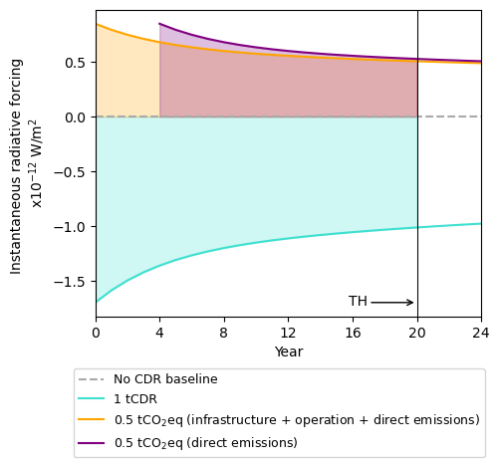
Supplementary Figure 1 illustrates how the dynamic dimension of the greenhouse gas emissions is accounted for in a hypothetical scenario where 1 tCDR and 0.5 tCO₂eq occur at $t=0$, and 0.5 tCO₂eq are released after four years. The curves in the figure represent the instantaneous radiative forcing of the CDR and emission pulses, i.e., the global warming impacts (expressed in W·year/m²) are estimated as the sum of the colored areas between the curves and the x axis, which are negative for CDR and positive for the CO₂ emissions. As the figure shows, the impacts of the second pulse emission are only quantified for the last 16 years of the considered 20-year timeframe and are therefore lower than the impacts of the pulse emission of the same magnitude occurring at the beginning of the time horizon.

Supplementary Fig. 1. Instantaneous radiative forcing due Carbon Dioxide Removal (CDR) and greenhouse gas pulse emissions. The areas under the curves represent the global warming impacts (in W·year/m²) over a 20-year time horizon (TH).

2.2 Health and ecosystem impacts
We estimated the impacts of our scenarios on human health and ecosystems with the ReCiPe 2016⁴ impact assessment method, which establishes a linear relationship between the damage to these endpoint areas of protection and the elementary flows (natural resources and emissions) in the life cycle inventories.
We quantified the impacts at the midpoint level–i.e., those related to environmental mechanisms such as particulate matter formation or land use–by multiplying the amount of elementary flow s exchanged with the environment by NETP i t years after deployment in year y to meet y’s CDR target ($Q_{i,s,t,y}$) by the elementary flow’s characterization factor for midpoint impact category m and year t within the considered time horizon ($CF_{m,s,t}^{MID}$).
We subsequently applied a factor $F_{m,e,s}$ to transform these midpoint impacts into impacts on the endpoint area of protection e (damage to human health or ecosystems). As Equation (11) indicates, we calculate the endpoint impacts of the CDR deployed in year y with NETP i,
$I_{i,e,y}^{END}$, as the sum of the endpoint impacts linked to each midpoint impact category and elementary flow throughout the considered time horizon–20 years in accordance with the individualist perspective of the ReCiPe method, which considers value choices based on undisputed short-term impact mechanisms and optimistic technological developments to adapt to the environmental impacts.
$$I_{i,e,y}^{END}=\sum_{s⋲S}{\sum_{m⋲M}{\sum_{t=0}^{t=TH}{Q_{i,s,t,y}·CF_{m,s,t}^{MID}·F_{m,e,s}}}} ∀ i∈I, e∈E, y∈Y$$ | (11)
The elementary flows $Q_{i,s,t,y}$ include those associated with the foreground and background activities and are calculated as the sum of $CDR_{i,s,t,y}$, $GHG_{i,s,t,y}$, amount of pollutants different from greenhouse gases ($P_{i,s,t,y}$) and amount of natural resources ($NR_{i,s,t,y}$) exchanged with the environment throughout the NETPs’ life cycle, plus the elementary flows prevented from being emitted or extracted due to the substitution effect of the secondary products or services provided by NETPs ($PEF_{i,s,t,y}$), as Equation (12) shows. Note that the values of the elementary flows removed or prevented ($CDR_{i,s,t,y}$ and $PEF_{i,s,t,y}$) are ≤0.
Consistent with our goal of quantifying the impacts of the CDR occurring in year y, we only consider the CDR happening that year ($t=0$, Equation (13)), although some of the greenhouse gas emissions linked to that year’s CDR can happen in the following years (Equation (4) and Inequality (5)). Similarly, non-greenhouse gas pollutants only occur after the year of deployment in the enhanced weathering and forestation scenarios (Inequality (14)), which release pollutants related to the rock dissolution (rock emissions, $RE$) and fires (fire emissions, $FE$), respectively. In our inventories, the extraction of natural resources is linked to the infrastructure and operating activities happening the year of deployment (Equation (15)), while the secondary products and services delivered by NETPs are also assumed to replace the incumbent ones the year of CDR (Equation (16)).
$$Q_{i,s,t,y}=CDR_{i,s,t,y}+GHG_{i,s,t,y}+P_{i,s,t,y}+NR_{i,s,t,y}+PEF_{i,s,t,y}$$  $$∀ i∈I,s∈S, t∈T, y∈Y$$ | (12)
$$CDR_{i,s,t,y}=0 ∀ t>0, i∈I,s=CO_{2}, y∈Y$$ | (13)
$$P_{i,s,t,y}>0 ∀ t>0, y∈Y$$  $$∀ i,s | (\left(i∈EW\right) ⋀ (s∈RE)) ⋁ (\left(i∈FOREST)\right) ⋀ \left(s∈FE\right))$$ | (14)
$${NR}_{i,s,t,y}=0 ∀ t>0, i∈I, s∈S, y∈Y$$ | (15)
$$PEF_{i,s,t,y}=0 ∀ t>0, i∈I, s∈S, y∈Y$$ | (16)
All the characterization factors are constant over time except those associated with CO₂, CH₄, and N₂O emissions, which can occur after the year of CDR deployment in the terrestrial NETPs scenarios. When the health and ecosystem damage linked to global warming ($m=GW$) is estimated, the characterization factor $CF_{m,s,t}^{MID}$ in Equation (11) equals the $GWP_{s,t}$ defined in Equation (6). The endpoint impacts due to the Stratospheric Ozone Depletion (SOD) caused by N₂O emissions are estimated with the characterization factor defined in Equation (17), computed with the inverse of the N₂O and CFC-11 atmospheric lifetimes ($k_{N_{2}O}$ and $k_{CFC11}$) and the N₂O ozone depletion potential for an infinite time horizon ($ODP∞_{N_{2}O}$), taken from ⁴. The SOD characterization factor of N₂O is calculated for a reduced time horizon $TH^{'}$ (Equation (18)), spanning from the year t when it was emitted to the end of the 20-year period starting the year of deployment.
$$CF_{m,s,t}^{MID}=ODP∞_{N_{2}O}·\frac{1-e^{-\left(TH'+3\right)·k_{N_{2}O}}}{1-e^{-\left(TH'+3\right)·k_{CFC11}}} ∀ m=SOD, s=N_{2}O, t∈T$$ | (17)
$$TH^{'}=TH-t ∀ t∈T$$ | (18)
The health impacts are expressed in Disability-Adjusted Life Years (DALYs), which represent the years of life lost due to disability or premature death. The damage to ecosystem quality is quantified as the local species loss aggregated over space and time, i.e., it does not indicate the risk of global species extinction.

2.3 Impacts on the Earth system
We quantified the environmental impacts of our scenarios on the Earth system relative to the maximum level of anthropogenic perturbation that would allow humanity to operate within the Safe Operating Space (SOS) defined by the planetary boundaries framework^{5,6}. Specifically, we investigated the impacts on six of the nine Earth-system processes identified as critical for the stability and resilience of the Earth system, excluding ocean acidification, atmospheric aerosol loading and novel entities.
CDR addresses the root cause of ocean acidification, i.e., high CO₂ atmospheric concentrations, and is therefore expected to have a positive effect on this Earth-system process⁷. Moreover, geochemical NETPs adding alkalinity to the seawater would further mitigate ocean acidification^{8,9}, but we could not calculate the extent of the prevented consequences because current impact assessment methods do not account for this effect. Similarly, existing methods do not express impacts in terms of the control variables of the atmospheric aerosol loading and novel entities Earth-system processes–the latter driven by the release of synthetic substances into the environment.
Multiple operationalization approaches can be used to harmonize the metrics of the control variables of the planetary boundaries with those of the life cycle impact assessment methods¹⁰. To quantify the impacts on the climate change Earth-system process (cc), we opted for a dynamic approach, taking the annual CO₂ emissions of the considered climate change mitigation scenario (derived from REMIND 2.1¹¹ and aligned with SSP2-2.6^{12,13}) as the time-dependent climate change SOS (Equation (19)). For the remaining Earth-system processes, we used time-independent life cycle impact assessment metrics consistent with the values of the control variables of the planetary boundaries and computed the SOS of Earth system process k for every year y ($SOS_{k,y}$) with Equation (19) as the absolute difference between the value of the control variable of the planetary boundaries ($PB_{k}$) and the natural background level ($NB_{k}$), taken from ^{5,6}.
$$SOS_{k,y}=⃓PB_{k}-NB_{k}⃓ ∀ k≠cc, y∈Y$$ | (19)
Equation (20) computes $I_{i,k,y}^{ESP}$, the impacts of deploying NETP i in year y on Earth-system process k–excluding nitrogen biogeochemical flows (N) and climate change ($cc$)–as a percentage of its SOS with the characterization factors linking impacts to elementary flows ($CF_{k,s}^{ESP})$. We estimated the impacts on the $cc$ Earth-system process with Equation (21), based on the $GWP_{s,t}$ calculated with Equation (6). The elementary flows are calculated with relations (4), (5) and (12-16). Equation (22) quantifies the impacts on the N Earth-system process as the share of its SOS associated with the industrial and intentional nitrogen fixation driven by NETPs. Here, $A_{a,c,i,y}$ (taken from the database activities) represents the amount of activity a (within the subset $F$ of fertilizer production activities) produced in the supply chain link c of NETP i deployed in year y, and $x_{a}^{NF}$ is the fraction of nitrogen in the fertilizers produced by those activities. A factor of 10⁻⁹ is applied to convert kg to Tg (the unit of the control variable of the nitrogen biogeochemical flows).
$$I_{i,k,y}^{ESP}=\frac{\sum_{t=0}^{t=TH}{\sum_{s⋲S}{CF_{k,s}^{ESP}·Q_{i,s,t,y}}}}{SOS_{k,y}}·100 ∀ k≠cc ⋁ N,i∈I, y∈Y$$ | (20)
$$I_{i,k,y}^{ESP}=\frac{\sum_{t=0}^{t=TH}{\sum_{s∈J}{(\left|CDR_{i,s=CO_{2},t,y}\right|-GHG_{i,s,t,y})·GWP_{s,t}}}}{SOS_{k,y}}·100 ∀ k=cc, i∈I, y∈Y$$ | (21)
$$I_{i,k,y}^{ESP}=\frac{\sum_{c⋲C}{\sum_{a⋲F}{A_{a,c,i,y}·x_{a}^{NF}·{10}^{-9}}}}{SOS_{k,y}}·100 ∀ k=N, i∈I, y∈Y$$ | (22)
We defined a new characterization factor (Equation (23)) to quantify the impacts on the functional component of terrestrial biosphere integrity ($bi$) in terms of the control variable recently proposed for this planetary boundary⁶–the human appropriation of the biosphere’s Net Primary Productivity (NPP), expressed as a percentage of the Holocene NPP ($HolNPP$, in ⁶). The characterization factors applied to the carbon taken up by the biomass ($bioC$) that is eventually harvested or eliminated (including all the biogenic carbon elementary flows considered in the background activities of our inventories) have a positive value, meaning that they generate impact. By contrast, we applied a negative characterization factor to the net biogenic carbon that remains within forests during the considered 20-year time horizon, which implies that the additional biomass contributes to combatting the pressure on the biosphere integrity planetary boundary.
$$⃓CF_{k,s,t}^{ESP}⃓=\frac{1}{HolNPP}·100 ∀ k=bi, s=bioC, t∈T$$ | (23)
We took the characterization factors quantifying the impacts on the other Earth-system processes from Ryberg et al.¹⁴, which express impacts in terms of the control variables introduced in ⁵–although the control variables and SOS of the freshwater use Earth-system process were recently updated ⁶.

2.4 Mineral resource extraction
Equation (24) quantifies the annualized amount of mineral resource r associated with the deployment of NETP i in year y ($M_{i,r,y}$). $Q_{i,s,t,y}$ represents the amount of elementary flow s happening t years after deployment of NETP i in year y, and $x_{r,s}^{MR}$ is the fraction of mineral resource r in that elementary flow. We used the code in ¹⁵ to estimate $M_{i,r,y}$.
$$M_{i,r,y}=\sum_{s⋲S}{Q_{i,s,t,y}·x_{r,s}^{MR}} ∀ t=0, i∈I, r∈R, y∈Y$$ | (24)
The year of deployment ($t=0$), $Q_{i,s,t,y}$–comprising the elementary flows described in Equation (12)–is calculated with Equation (25) as the sum of the amount of direct elementary flow s exchanged between the foreground system of NETP i and the environment t years after deployment in year y ($EF_{i,s,t,y}^{FG}$), and the amount of elementary flow s associated with the infrastructure (IN) and operating (OP) activities in the foreground of NETP i's system. The total infrastructure requirements are annualized considering the ratio between the annual time of infrastructure use ($AT$, 1 year) and the infrastructure lifetime ($LT$, assumed to be 20 years), consistent with the method followed by the Ecoinvent database¹⁶ to allocate infrastructure across all the goods and services produced during its lifetime. $A_{a,c,i,y}$ represents the amount of activity a needed in the foreground system (considered here as the final supply chain stage, c=end) of NETP i deployed in year y to meet y’s CDR target, and ${EF}_{a,s}^{BG}$ is the amount of elementary flow s exchanged with the environment throughout the activity a’s life cycle, modeled in the background of the studied NETP systems. Note that ${EF}_{a,s}^{BG}$ is taken from the database, which considers time-independent life cycle elementary flows.
The infrastructure and operating activities are assumed to occur the year of deployment, hence $Q_{i,s,t,y}$ is calculated with Equation (26) the following years ($t>0$), considering only the direct elementary flows happening in the foreground system ($EF_{i,s,t,y}^{FG})$. Since all our life cycle inventories consider that the extraction of mineral resources is associated with infrastructure and operating activities happening the year of deployment (Equation (15)), $M_{i,r,y}$ is calculated only for the year of deployment ($t=0$).
$$Q_{i,s,t,y}=EF_{i,s,t,y}^{FG}+\sum_{a∈IN}{A_{a,c,i,y}·{EF}_{a,s}^{BG}}·\frac{AT}{LT}+\sum_{a∈OP}{A_{a,c,i,y}·{EF}_{a,s}^{BG}}$$  $$∀ t=0, c=end, i∈I, s∈S, y∈Y$$ | (25)
$$Q_{i,s,t,y}=EF_{i,s,t,y}^{FG} ∀ t>0, i∈I, s∈S, y∈Y$$ | (26)
Although the modeling framework of both the foreground and background systems consider virtual flows of annualized infrastructure-related materials that occur every year of deployment ($t=0 ∀ y∈Y$), raw materials must be extracted prior to the construction of the capital goods. Therefore, the estimated $M_{i,r,y}$ does not reflect the actual resource extraction in year y. We use Equations (27) and (28) to overcome this limitation and estimate the annual quantities of mineral resources extracted ($R_{i,r,y}$), which were subsequently assessed against the 2022 global mine production taken from ¹⁷. Equation (27) computes the annual extraction of all mineral resources linked to capital goods across all the life cycle stages, i.e., including the infrastructure activities in the background of the foreground operating activities. It assumes that we must extract every year the resources needed to expand the CDR capacity of NETP i with respect to the global capacity installed the previous year, and that all the infrastructure activities in the foreground and background systems have equal lifetimes.
$${R_{i,r,y}=M}_{i,r,y}·\frac{LT}{AT}·\left|\frac{CDR_{i,s,t,y}-CDR_{i,s,t,y-1}}{CDR_{i,s,t,y}}\right| ∀ s=CO_{2}, t=0, y∈Y$$  $$∀ i,r | \left(\left(( r≠K, P, Mg\right) ⋀ \left(i ∉BECCS, TERR\right)\right) ⋁ (r≠K ⋀ i∉HTLS))$$ | (27)
Mineral resources not related to infrastructural materials are estimated with Equation (28), only applied to quantify the extraction of potassium ($K$), phosphorus ($P$) and magnesium ($Mg$) in the Bioenergy with Carbon Capture and Storage ($BECCS$) and terrestrial NETPs ($TERR$) scenarios (which demand these nutrients to meet the crop fertilizer requirements), and the extraction of $K$ in the High Temperature Liquid Sorbent ($HTLS$) DACCS scenarios consuming KOH solvent. Notably, the distinction we make between the resources related to infrastructure and operating activities is based on the modeled foreground system; therefore, we could be miscalculating the extraction of mineral resources in some of the background activities, e.g., the mineral resources linked to the fertilizers used for bioenergy production in the background activities of the chemical NETPs scenarios will be quantified as infrastructure-related resources. However, this error is likely to be marginal since most mineral resources are linked to capital goods.
$$R_{i,r,y}=\sum_{s∈S}{\sum_{a∈OP}{A_{a,c,i,y}·{EF}_{a,s}^{BG}·x_{r,s}^{MR}} ∀ c=end, y∈Y}$$  $$∀ i,r | \left(\left(( r=K, P, Mg\right) ⋀ \left(i ∈BECCS, TERR\right)\right) ⋁ (r=K ⋀ i∈HTLS))$$ | (28)

3. Life cycle models
In this section we describe the studied NETPs, and the assumptions and data sources used in our models. The life cycle inventories, based on global market activities, are compiled in the Supplementary Data file.

3.1 Direct Air Carbon Capture and Storage
We focus on two DACCS archetypes: High Temperature Liquid Sorbent (HTLS) and Low Temperature Solid Sorbent (LTSS) because they currently dominate the DACCS market and have achieved the highest Technology Readiness Levels (TRLs) among DACCS technologies¹⁸.
The HTLS-DACCS system is modeled after the company Carbon Engineering’s process based on two connected chemical loops¹⁹. Here, CO₂ is absorbed into a potassium hydroxide solution, thereby generating potassium carbonate that subsequently reacts with calcium hydroxide to form calcium carbonate. This is later decomposed in a calcination process releasing the captured CO₂. We consider two systems for the high temperature (≈900 ºC) calcination: oxy-fired with natural gas (emissions data from ^{20,21}) or electric. The electricity-to-heat efficiencies in the latter are assumed to range from 80%²² in 2020 to 90% in 2050, which correspond to an annual improvement of 0.39% (Table 2.1 in the Supplementary Data file). While the process can operate continuously, we assume that the HTLS-DACCS plants have the capacity to store the intermediate chemical products during periods of renewable energy intermittency. We considered start-up times of 1-3 hours for the HTLS-DACCS systems, during which the facility is not operating continuously, and the limestone and potassium hydroxide needed to start the chemical loop must available. The initial amounts of these reactants are annualized over the assumed plant lifetime (20 years). Moreover, we consider that make-up limestone and potassium hydroxide must be continuously supplied²³.
The modeled LTSS DACCS relies on the CO₂ adsorption-desorption system developed by the company Climeworks, operating at a regeneration temperature of 80-120 ºC²⁴. We take the adsorbent requirements and composition from ^{25,26}. The current energy demand²⁵ is assumed to progressively improve over time to meet the technology’s estimated optimization potential in 2050, which implies a decrease in the electricity and heat demand of 1.1 and 2.6% per year, respectively (Table 2.2 in the Supplementary Data file). Heat pumps are assumed to have a coefficient of performance of 2.2 and use R1234ze(E) as a working fluid.
We consider the land occupation and the ranges in the infrastructure requirements (Table 1.1 in the Supplementary Data file) provided by ²⁷ for all DACCS systems. We assume that all the DACCS plants are located next to the sequestration site and the captured CO₂ is compressed to 150 bar (which entails an electricity consumption of 132 kwh/tCO₂)¹⁹ prior to being injected into the geological reservoir. The compressor fugitive emissions are taken from ²⁸. Regarding the energy sources, HTLS-DACCS can 1) be entirely powered by natural gas, 2) use natural gas to meet the heat demand and take electricity from the global average grid mix or renewable energy sources (solar photovoltaic or wind) to cover the power demand, or 3) rely only on electricity from the grid or renewables. LTSS-DACCS uses either a heat pump powered by electricity or excess geothermal energy to provide heat, while the grid or renewable energy sources supply electricity.

3.2 Ocean liming
This NETP relies on the addition of calcium oxide particles to the open ocean surface. These react with the dissolved CO₂ to form bicarbonate anions, thereby enhancing the ocean’s CO₂ uptake rates. The limestone calciner needed to produce calcium oxide–located next to the shore–is either oxy-fired or electric (as that used in the HTLS-DACCS scenarios), and the CO₂ generated in the calcination process is sent to a geological reservoir located 200-600 km from the industrial site. The electricity requirements for the CO₂ compression and recompression, and the CO₂ fugitive emissions associated with the CO₂ compression and pipeline transport are taken from ²⁸. The electricity needed in the particle grinding operations is provided in ²⁹.
Container ships with a load capacity of 43 kt¹⁶ progressively release the alkaline material in the seawater during their round-trip from the port to a maximum distance of 200 nautical miles (i.e., within the exclusive economic zone) and a minimum distance of 179 nautical miles (which corresponds to a particle release rate of 0.5 t/s in a round trip at a speed of 15 knots). We consider that 1.4-1.7 mol CO₂ are drawn into the ocean per mol calcium oxide released³⁰. Since CDR occurs less than one year after the alkalinity addition (depending on the local oceanographic properties)³¹ our model does not consider dynamic characterization factors to account for CDR delays.

3.3 Enhanced weathering
The enhanced weathering scenarios accelerate natural weathering processes by grinding rocks containing silicate minerals (dunite and basalt) and spreading them over coastal or inland areas. For the latter, we assume an equal distribution (50/50%) between croplands and forestlands. The rock materials are dissolved in the presence of water, reacting with CO₂ (reaction below, where $Me$ represents a divalent metal) and driving the transfer of additional atmospheric CO₂ to the water^{32,33}. Runoff transports the produced bicarbonate anions to the oceans, where their residence time exceeds 100,000 years³⁴.
$$Me_{2}SiO_{4}+4CO_{2}+{4H}_{2}O→2Me^{2+}+4HCO_{3}^{-}+H_{4}SiO_{4}$$
The enhanced weathering life cycle inventories are estimated with two sets of data ($d$): experimental ($exp$) and theoretical ($th$), differentiating between the type of rock n (basalt or dunite) and the location l of the rock application (inland or coastal). To calculate the mass of rock that must be initially applied to the soil ($RM_{d,l,n,p}^{0}$) in the inland and coastal enhanced weathering scenarios based on experimental data, we used Equation (29), where $CDR^{EW}$ represents the amount of CO₂ to be removed within one year (g/year), $WR_{d,l,n}^{ALK}$ is the alkalinity dissolution rate (mol/m²/s), $SSA_{d,n,p}$ is the rock specific surface area (m²/g), $spy$ is the number of seconds in a year, and $MM^{CO_{2}}$ is the CO₂ molecular mass (g/mol). Previous studies have found that the dissolution of the silicate minerals is the rate limiting step of the weathering reactions³⁵; hence, we assumed that the dissolved minerals can immediately react with the dissolved CO₂. We adjusted the stoichiometric CDR (one mole of atmospheric CO₂ reacts with one mole of alkalinity released from the rock) with a CDR efficiency factor ($w$) of 0.80^{36,37}, which accounts for the conversion of some bicarbonate anions to carbonate anions that occurs under conditions of excess alkalinity and releases part of the sequestered CO₂³³.
In the scenarios based on theoretical data, we estimated $RM_{d,l,n,p}^{0}$ with Equation (30), dividing the annual CDR target by the product of the rock fraction that is weathered in one year (calculated with the rock weathering rate, $WR_{d,l,n}^{ROCK}$, expressed in g/m²/s) and the theoretical rock CDR potential $P_{n}$ (gCO₂/g rock), which is based on the rock chemical composition and accounts for the CDR efficiency factor³⁸.
Since the amount of alkalinity dissolved is directly proportional to the $SSA_{d,n,p}$, we must keep the total rock surface area constant to maintain the same CDR rate over time. Hence, we assume that the amount of rock applied annually after the initial year of deployment ($RM_{d,l,n,p}^{A}$) equals the amount of rock that weathered the previous year (Equation (31)), estimated with $WR_{d,l,n}^{ROCK}$. In the scenarios based on experimental data, $WR_{d,l,n}^{ROCK}$ is calculated with Equation (32) based on the alkalinity concentration in the rock, $C_{n}^{ALK}$ (mol/g).
$$RM_{d,l,n,p}^{0}=\frac{\left|CDR^{EW}\right|}{WR_{d,l,n}^{ALK}·SSA_{d,n,p}·spy·w·MM^{CO_{2}}} ∀ d=exp, l∈L, n∈N, p∈P$$ | (29)
$$RM_{d,l,n,p}^{0}=\frac{\left|CDR^{EW}\right|}{WR_{d,l,n}^{ROCK}·SSA_{d,n,p}·spy·P_{n}} ∀ d=th, l∈L, n∈N,p∈P$$ | (30)
$$RM_{d,l,n,p}^{A}=RM_{d,l,n}^{0}·WR_{d,l,n}^{ROCK}·SSA_{d,n,p}·spy ∀ d∈D, l∈L, n∈N,p∈P$$ | (31)
$$WR_{d,l,n}^{ROCK}=\frac{WR_{d,l,n}^{ALK}}{C_{n}^{ALK}} ∀ d=exp, l∈L, n∈N$$ | (32)
The coastal enhanced weathering scenarios are based on the total alkalinity dissolution rates derived from the experiments conducted by Montserrat et al.³⁹, who added olivine particles (median size: 143 μm, $SSA_{d,n,p}$: 0.295 m²/g) to seawater and subjected them to continuous rotation movements to simulate the weathering conditions in coastal environments. We calculated the amount of dunite applied considering that olivine makes up 90%³⁶ of the rock and an alkalinity content of 3.75 mol/mol olivine³⁹, and assessed the uncertainty in our results based on the standard deviation of the total alkalinity dissolution rates (Table 1.4 in the Supplementary Data file)³⁹.
For the inland enhanced weathering scenarios, we took the experimental olivine weathering rates in ³⁶ (Table 1.4 in the Supplementary Data file), estimated from the amount of magnesium initially contained in the rock that is dissolved during the experiments. The authors of this study designed two experimental setups based on fine and coarse dunite grains with a 90% olivine content (dominating particle size: 25.5 and 720 μm, with an $SSA_{d,n,p}$ of 12.1 and 1.3 m²/g, respectively), applying 22 kg/m² to the soil. We considered these two systems as the extreme case scenarios and modeled an intermediate system with an average particle size of 372.75 μm and 2.1 m²/g, assuming an average weathering rate and a logarithmic relationship between the $SSA_{d,n,p}$ and the particle size³⁸.
The mass of rock needed in the basalt scenarios is computed based on the calcium, potassium, magnesium and sodium dissolution rates quantified in Buckinhgam et al.’s³⁷ experimental study simulating an inland environment (Table 1.5 in the Supplementary Data file). This work considered the application of 10 kg/m² of basalt particles with a size of 125-250 μm and an $SSA_{d,n,p}$ of 16.3 m²/g. We assumed an average particle size of 187.5 μm and analyzed the influence of the uncertainty in the cation release rate³⁷ on our results.
Ideally, the performance of enhanced weathering trials deploying dunite and basalt should be assessed under equal experimental conditions to enable a fair comparison. This was not possible due to the limited body of experimental results reported in the literature. However, the inclusion of the scenarios based on experimental data allowed us to illustrate the vast performance gap between the theoretical and experimental weathering rates (discussed in the main text). Moreover, despite the difference in the experimental parameters, our conclusions regarding the relative performance of the rocks (dunite showing a better environmental profile than basalt) are aligned with the results obtained for the theoretical weathering rates (described in the main text), considering the same operating parameters for both types of rocks.
We took the theoretical weathering rates estimated by Strefler et al.³⁸ for warm and temperate regions, and averaged them using the global available areas with these climates³⁸. The CDR potential $P_{d,n}$ of dunite and basalt is 1.1 and 0.3 tCO₂/t, respectively³⁸. We considered the application of 15 kg/m² of rock particles with sizes of 25 and 250 μm and estimated the $SSA_{d,n,p}$ with the power function provided by ³⁸.
To estimate the metal emissions to the soil (inland scenarios) and seawater (coastal scenarios), we considered the average, minimum and maximum metal concentrations in basalt reported in ^{40–42}, and took those of dunite from ³⁶ (Tables 1.7 and 1.8 in the Supplementary Data file, respectively). Although some experiments simulating inland enhanced weathering conditions found slower dissolution rates for certain elements relative to the alkaline metals driving the CDR^{36,37}, they did not quantify the accumulation of metals in the soil surface, which could be substantial⁴³. Furthermore, metals can potentially be released due to changes in the soil pH or redox conditions^{44,45}, hard to control in an open field. Thus, we assumed that all the elements in the rock are dissolved at the same rate as the alkaline metals, and allocate the impacts of the elementary flows occurring on a given year to that year’s CDR.
On the other hand, we consider that the release of phosphorus contributes to biomass fertilization, and therefore, when rocks are applied to croplands, it prevents the production of an equivalent amount of phosphate industrial fertilizers. Our model does not account for the potential implications of concurrently applying nitrogen fertilizers and rock particles to the soil; while the latter could partially abate the fertilizer-derived N₂O emissions, the weathering could be driven by HNO₃ instead of the dissolved CO₂, undermining the CDR efficiency^{46,47}. Furthermore, enhanced weathering could lead to CDR through an increase in soil organic carbon, which we did not quantify here⁴⁸.
We estimated the electricity demand for the rock crushing and grinding operations using the correlation between the particle size and the energy consumption provided by Strefler et al.³⁸. Our inventories do not include land occupation or transformation elementary flows in the foreground system because croplands, forestlands and coastal areas continue providing the same services as prior to the implementation of the enhanced weathering practices. We considered an average distance from the rock source to the application areas of 300 km, which has been estimated to be sufficient to reach 80 and 95% of temperate and warm regions, respectively³⁸. Our sensitivity analysis considered ±50% changes in the transportation distance.

3.4 Bioenergy with Carbon Capture and Storage
In the BECCS scenarios, atmospheric CO₂ is absorbed by biomass during photosynthesis, released in the bioenergy production process, captured, and finally injected into a geological reservoir, with all these stages happening within the year of CDR deployment. The biomass feedstock consists of forest residues and two crops: a short rotation woody crop (poplar) and a perennial grass (Miscanthus)–both with a broad geographical distribution worldwide^{49,50}.
We focus on forest residues instead of other biogenic carbon sources (such as agricultural residues, manure, or municipal organic wastes) because they offer a more consistent and predictable biomass supply. Their relatively uniform properties (e.g., moisture content or energy density) simplify processing activities in bioenergy facilities, enabling stable operating conditions. Moreover, decentralized feedstocks like agricultural residues would further complicate the logistics of biomass supply chains, potentially increasing the greenhouse gas emissions linked to transportation.
The deployment potential of biomass residues is limited due to their role in maintaining soil carbon stocks and soil fertility^{51–53}. We use a conservative estimate of the amount of forest residues that could be sustainably collected (3 EJ/year⁵⁴) and the higher heating value and carbon content reported in ⁵⁵ to estimate that 0.24-0.26 GtCO₂/year could be removed between 2030 and 2050 through combustion-BECCS fed with forest residues (0.11-0.13 GtCO₂/year with gasification-BECCS). The remaining biomass demand is met with poplar and Miscanthus (50/50%). Tables 2.7-2.15 of the Supplementary Data file show the distribution of biomass sources in the BECCS scenarios.
Estimates of the future availability of marginal land for energy crops vary widely^{56–61}. Here we assume that energy crops are cultivated on abandoned croplands and grasslands in equal shares, considering ±50% changes for the sensitivity analysis (Table 1.9 in the Supplementary Data file). We consider that the yields of crops planted on grasslands are equal to those obtained for optimal soil conditions (reported in ¹⁶ and ⁶²). On abandoned croplands, we assume a 33-66% reduction in the crop yields, consistent with ⁶³ (Table 1.10 in the Supplementary Data file).
Natural grasslands must be cleared and replaced with the biomass plantations the initial year of BECCS deployment. This change in the original land cover can lead to variations in the soil organic carbon levels, contributing to either additional CO₂ emissions or soil carbon sequestration; we vary the land-use change emissions in our scenarios in accordance with Qin et al.⁶⁴ (Table 1.11 in the Supplementary Data file). We assume that the biomass planted on abandoned croplands does not lead to land-use change emissions. Our models do not include the biophysical effects of biomass plantations on evapotranspiration or albedo, which could induce additional cooling^{65,66}.
The life cycle inventories of Miscanthus and poplar are taken from ¹⁶ and ⁶², respectively. Both crops are irrigated, with the annual water requirements of Miscanthus taken from ⁶⁷. The poplar composition and properties are provided by ^{62,68}, and those of Miscanthus by ^{16,69}. The impacts of the forest residues are only linked to the collection and transport life cycle stages (data from ¹⁶).
The combustion-BECCS scenarios deploy a 250 MW circulating fluidized bed boiler, modeled with the data provided by the IEA⁷⁰. We take the biomass emissions factors from ²¹. The scenarios based on post-combustion CO₂ capture rely on a monoethanolamine (MEA) absorption-desorption system. The heat required in the CO₂ desorption stage–3.8 GJ/tCO₂⁷¹–is provided by part of the low-pressure steam generated in the combustion process, which can no longer be used to generate electricity in the turbines, thereby reducing the power plant’s electricity generation. The material requirements and waste and emissions generated in the post-combustion capture process are taken from^{28,72,73}.
Oxy-combustion BECCS requires an air separation unit to supply the boiler with the pure oxygen needed in the combustion process, which consumes 0.2 kwh/kg oxygen and 3 kg cooling water per kwh waste heat⁷⁴. The energy required in the CO₂ compression and purification unit of the oxy-combustion BECCS scenarios, 119 kwh/tCO₂, is taken from ⁷⁵. We consider that the oxy-combustion process requires a 3.3% excess oxygen⁷⁵, and 75% of the flue gas is recycled back to the boiler to maintain the flame temperature and the oxygen concentration^{76,77}. In both the post-combustion and oxy-combustion scenarios, we assume that the CO₂ capture efficiency gradually increases from 80% in 2020 to 90% in 2050, considering an annual improvement of 0.4% (Table 2.3 in the Supplementary Data file). While these values are conservative relative to the technically feasible CO₂ capture rates (up to 98%^{78,79}), current commercial CO₂ capture plants do not exceed 80% capture rates over their lifetimes⁸⁰, and values above the selected upper bound could lead to higher costs⁷⁸ or lower CO₂ purities⁷⁹.
The gasification-BECCS scenarios are based on the life cycle inventory provided by Susmozas et al.⁸¹, who modeled an indirect gasification process deploying two fluidized bed reactors. In the first one, biomass reacts with steam to produce syngas and char. The latter is burned in the second reactor to generate the heat needed in the gasification process. The concentration of hydrogen in the syngas in raised through the water-gas-shift reaction (catalyst composition in ⁸²), and a pressure swing adsorption unit is subsequently used to separate the produced hydrogen from the other syngas compounds, which are burned to generate heat and electricity, used within the plant. The CO₂ generated in this step is captured with a Polyactive® polymeric membrane (materials and energy required in the production process derived from ^{83–85}). The CO₂ separation efficiency of the membrane is assumed to increase from 70% in 2020⁸³ to 79% in 2050, considering the same annual improvement as that in the combustion processes (Table 2.4 in the Supplementary Data file). All the BECCS plants are located 50-150 km from the biomass plantations, while the captured CO₂ is compressed and transported by pipeline 200-600 km to the final injection site (energy requirements and fugitive emissions derived from ²⁸).

3.5 Forestation
We estimate the CDR in the forestation scenarios as the sum of the CO₂ embodied in the biomass, litter, and soil carbon stocks. We compute inventories for temperate, tropical and boreal forest plantations, and average the inventory entries based on the share of global forest area occupied by each biome, considering a planting density of 0.15 trees/m², ⁸⁶.
We calculate the biome-specific carbon uptake with the time-dependent growth curves presented in ⁸⁶, which do not consider management options like tree thinning or fertilization that could improve the carbon uptake rates. We consider that 84% of the aboveground wood is in the tree stem ⁸⁶, while the ratio belowground/aboveground biomass and the litter carbon stocks of each biome are taken from ^{87,88}. The changes in the soil organic carbon levels associated with the transition from grassland or pastureland to forests are derived from Powers et al.⁸⁹ (Table 1.11 in the Supplementary Data file).
We consider that the fire risk increases by 34-42% by 2069 (final year of the selected time horizon for CDR deployment in 2050) with respect to the period 2010-2020⁹⁰ (projected annual ranges in Table 2.6 of the Supplementary Data file). We take the percentage of forest area affected by fire in each biome in 2015 from ⁹¹. The biome-dependent combustion factor (share of biomass burned if affected by fire) and CO₂, CO, CH₄, N₂O and NO_{X} fire emission factors are taken from ⁸⁸, while the NMVOC, SO_{X}, NH₃, PM₁₀ and PM_{2.5} fire emissions are those reported in ⁹².
Our model does not account for other potential causes for the release of the sequestered carbon (i.e., pests, diseases, or droughts), or the indirect consequences of planting trees in pastureland, e.g., cattle displacement. Notably, our life cycle inventories do not capture the effects of potential albedo changes, which could offset at least 20% of CDR in 66% of locations⁹³.

3.6 Biochar
In the biochar scenarios, the carbon captured by biomass is sequestered in the biochar and in a geological reservoir if Carbon Capture and Storage (CCS) is considered. The characteristics and types of the original land where the crops are planted (abandoned croplands and grasslands) and the biomass feedstocks (forest residues, Miscanthus and poplar) are the same as in the BECCS scenarios. However, the ratio of forest residues to energy crops has been adjusted based on the estimated CDR potential of forest residues through biochar (0.12-0.14 GtCO₂/year between 2030 and 2050 in the scenarios without CCS, and 0.24-0.27 GtCO₂/year if CCS is coupled to the pyrolysis process). Tables 2.16-2.27 of the Supplementary Data file show the distribution of biomass sources in the biochar scenarios.
We adapt the inventory data of the biochar scenarios from Peters et al.⁶². Biomass is harvested and subjected to a slow pyrolysis process at 450 ºC to generate biochar containing 50% of the carbon captured during the biomass cultivation phase. The remaining carbon (in the gas and tar byproducts) is burned to supply heat to the pyrolysis process, generating excess heat. The scenarios considering CCS use part of the excess heat to desorb the CO₂ generated in the combustion process from the MEA solution. In the base scenario, 50% of the remaining excess energy is used for industrial or residential heating, with heat use rates of 0 and 100% considered for the sensitivity analysis (share of heat sources in Table 2.5 of the Supplementary Data file, taken from the REMIND 2.1 integrated assessment model¹¹, SSP2-2.6^{12,13}). The biomass, biochar, and CO₂ transportation distances are compiled in Table 1.15 of the Supplementary Data file.
We analyze two end uses for the produced biochar: application to the soil of the biomass plantation or use as an aggregate in building materials. In the latter, we consider that the biogenic carbon remains sequestered during the entire studied timeframe. By contrast, the biochar carbon is mineralized at a rate of 0.28 (0.18, 0.37)%/year⁹⁴ in the soil amendment scenarios, where the application of biochar along with inorganic fertilizers improves the biomass yield by 9.85% (95% confidence interval: 5.3-14.4%)⁹⁵ relative to a scenario where only inorganic fertilizers are applied. This increase in yield is translated into a reduction in the inputs (fertilizers, land, water, etc.) required to grow the energy crops. We estimate the forest plantation area over which the biochar derived from forest residues is applied considering a plantation lifetime of 30 years, standing stock of 93 t/ha and a residue generation factor of 0.3⁵⁴. Our analysis does not consider the effects of the biomass plantation or the biochar application on the land surface albedo, which could substantially affect the net cooling effect of CDR^{96,97}.

4. Summary of assumptions and limitations
The accuracy of our results depends on the quality of the life cycle inventory data and the robustness of the applied impact assessment methods. The main assumptions and limitations regarding the modeling framework and the developed life cycle models are detailed here.

4.1 Modeling framework
We assessed the uncertainty in our models by changing the foreground data, considering more optimistic and pessimistic sets of values (see Tables 1.1-1.15 in the Supplementary Data file). We did not evaluate how the uncertainty in the background system would affect our results because this is subject to the assumptions of the selected climate change mitigation scenario, i.e., making changes in the background system without recalculating the results of the integrated assessment model could lead to a scenario with a different temperature increase by the end of the century. Moreover, our inventories are not regionalized (i.e., they are based on global market activities), which implies that the deployment of NETPs in specific locations could lead to different results.
There is a temporal mismatch in the infrastructure activities of our inventories. The temporal emissions profile of the infrastructure activities is currently not available in the Ecoinvent database, despite some recent work in this area^{98–100}. Hence, both the background and foreground systems assume that mineral resource extraction and the infrastructure construction and decommissioning activities happen the year that infrastructure is used. The consequences of this simplification on the life cycle impacts are unclear: the impacts of resource extraction and infrastructure construction are likely to be higher because the activities throughout the supply chain are more dependent on fossil fuels if they happen in previous years, while the opposite is true for the decommissioning activities.
On the other hand, consistent with the standard life cycle assessment practices and the methodology used to model the background activities in the database, our life cycle inventories annualize the infrastructure needs based on its lifetime, i.e., we allocate the total infrastructure requirements to the annual CDR happening every year that the infrastructure is used. To operationalize this approach, we modeled the infrastructure activities allocated to the CDR occurring in a given year based on the background activities corresponding to that year, even though part of the infrastructure should have already been built to meet the CDR targets of previous years. However, as Supplementary Figures 5 and 6 show, the infrastructure activities do not contribute to a significant share of the life cycle impacts; therefore, we do not think that these inconsistencies in the infrastructure modeling approach could alter the conclusions of the life cycle impact assessment.
Nevertheless, this modeling approach does not allow us to directly calculate the actual amounts of mineral resources extracted annually. We adjusted our life cycle inventories to accurately quantify the increase in the annual mineral resource extraction linked to the infrastructure requirements, following the methodology described in section 2.4 of the Supplementary Information. The proposed method has two main shortcomings: first, we considered the same lifetime for all the infrastructure activities, which–despite reflecting the lifespan of the infrastructure in the foreground system–may not be true for all the capital goods in the background. Second, our approach requires differentiating between resources used for infrastructure and operating activities. Since evaluating the resources used in all the background activities would be extremely time consuming, we only do it for the activities in the foreground. As a result, we could be mislabeling (and therefore miscalculating) some of the resources used in the background system. Notwithstanding this, we think that the potential error will be marginal because, as expected, most resources in the foreground are related to the infrastructure requirements.
Finally, given the lack of reliable projections, we do not make any assumptions about the future evolution of metal recycling activities, nor does premise¹⁰¹. All metal-related activities in the background reflect the current markets as modeled by the Ecoinvent database¹⁶, including both primary and secondary sources.

4.2 NETPs models
Given the novel nature of NETPs, the most uncertain assumptions and limitations of our models concern the interaction between scaled-up NETPs systems and the environment, which are predominantly location-dependent. We summarize the main ones below.
NETPs relying on biological processes are susceptible to disturbances that could unexpectedly release the carbon sequestered in the biomass, such as pests, diseases, or extreme weather events that our models do not consider. Furthermore, we did not quantify the potential consequences of indirect land use changes due to large-scale biomass plantations, such as the relocation of cattle from their grazing areas. Finally, our model does not include climate effects due to evapotranspiration or albedo, dependent on the location characteristics, which could either offset the climate benefits of CDR or contribute to further cooling^{65,66,93,96,97}.
Regarding the chemical NETPs cluster, the performance of DACCS is sensitive to regional weather conditions (temperature and humidity), not considered in this study^{102,103}. In the ocean liming scenarios, we did not quantify the benefits of counteracting ocean acidification because of the lack of adequate impact assessment methods. The potential side-effects of the added alkalinity on marine ecosystems, still poorly understood^{104,105}, were not assessed either.
Finally, the results of the enhanced weathering scenarios are the most uncertain due to the lack of long-term experimental data. Notably, the parameters derived from specific experimental studies are location-specific and may not be universally applicable. We took a conservative approach and assumed that all the elements in the rock leach at the same rate as the alkaline materials. While this is not necessarily true, metals could be suddenly released due to changes in the he soil pH or redox conditions^{44,45}. Moreover, we did not consider the potential effects of simultaneously applying nitrogen fertilizers and rock particles to the soil, which could alter the enhanced weathering performance⁴⁶, or the potential increase in soil organic carbon ⁴⁸.

5. Supplementary results
Supplementary Figure 2 shows how the GGR efficiencies of terrestrial NETPs decline 20 years after CDR due to the partial release of the sequestered carbon, except for the scenarios where biochar is used as sand replacement and therefore the carbon remains sequestered. The GGR efficiencies improve with later deployments because of the progressive decarbonization of multiple economic sectors. Supplementary Figure 3 illustrates the GGR efficiencies of NETPs where CDR occurs the year of deployment and the CO₂ sequestration is assumed to be permanent. Here, GGR efficiencies vary with the year of deployment (because the impacts of the foreground and background activities change over time) but remain constant after deployment.
We show the health and ecosystem impacts of deploying DACCS, Ocean liming, BECCS and terrestrial NETPs between 2030 and 2050 (Supplementary Figure 4), and the contribution of the environmental mechanisms and unit processes integrating NETPs to the total human health and ecosystem damage caused by the CDR deployment in 2050 (Supplementary Figures 5 and 6, respectively). Note that the endpoint damage caused by coastal enhanced weathering is associated with only 10% of the 2050 CDR target (309 MtCO₂) due to the limited deployment potential of this NETP: we estimated that meeting this 10% target would require applying 29 kg/m²/month of dunite rock over a 50 m distance throughout the world’s total coastal areas (3.65·10⁵ km¹⁰⁶). We consider two coastal enhanced weathering scenarios: one where the initial rock deployment starts in 2050, and another one where the application of the rock needed to achieve 10% of the 2050 CDR target started before 2050, i.e., only the amount of rock that was dissolved the previous year must be applied in 2050 to maintain the CDR rate. In Supplementary Figures 5 and 6, we do not show the upper error bar of the coastal enhanced weathering scenario with deployment starting in 2050 because the considered worst-case parameters lead to a negative GGR efficiency, i.e., net CDR is not attained.
The Earth-system impacts of each scenario in 2050 are disaggregated in Supplementary Figure 7, while Supplementary Figure 8 indicates the impacts of the four NETP clusters over time on these Earth-system processes: phosphorus biogeochemical flows, stratospheric ozone depletion and land system change, which amount to ≤0.8% of their safe operating space. Finally, Supplementary Figure 9 shows the contribution of unit processes and materials integrating NETPs to the extraction of key resources in 2050.

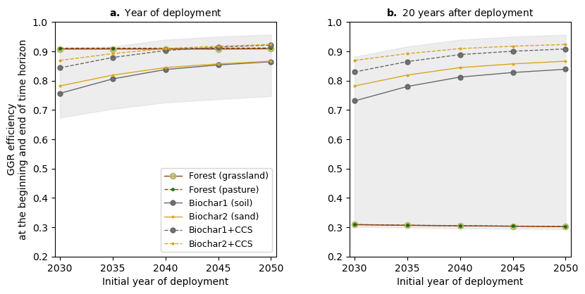 Supplementary Fig. 2. Greenhouse gas removal (GGR) efficiencies of terrestrial Negative Emissions Technologies and Practices, considering that CDR occurs the initial year of deployment (between 2030 and 2050). Scenarios include forestation (on pasturelands and grasslands) and biochar applied to the soil (Biochar1) or used as sand substitute (Biochar2). Pyrolysis modeled with and without Carbon Capture and Storage (CCS). Grey-shaded areas represent the uncertainty of the results (lowest values correspond to the scenarios with the worst GGR efficiencies obtained with the most pessimistic foreground parameters and highest values derived from the best scenarios considering the most favorable foreground parameters). a GGR efficiencies during the initial year of deployment. b GGR efficiencies after 20 years of deployment.

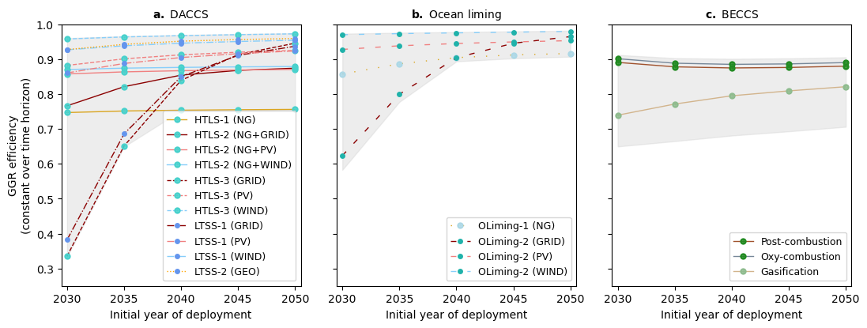
Supplementary Fig. 3. Greenhouse gas removal (GGR) efficiencies of Negative Emissions Technologies and Practices where CDR occurs the initial year of deployment (between 2030 and 2050) and CO₂ remains sequestered over the considered time horizon (20 years). Grey-shaded areas represent the uncertainty of the results (lowest values correspond to the scenarios with the worst GGR efficiencies obtained with the most pessimistic foreground parameters and highest values derived from the best scenarios considering the most favorable foreground parameters). a Direct Air Carbon Capture and Storage (DACCS): High Temperature Liquid Sorbent (HTLS) and Low Temperature Solid Sorbent (LTSS). HTLS-1 is powered by natural gas (NG). NG supplies the heat of HTLS-2, while the electricity comes from the global average grid mix (GRID), solar photovoltaic (PV) or wind energy. HTLS-3 is powered by the GRID, PV or wind. LTSS is powered by the GRID, PV, wind or geothermal electricity (GEO). The heating demand of LTSS is supplied by heat pumps (LTSS-1) or excess geothermal heat (LTSS-2) generated in the production of GEO. b Ocean liming (OLiming). The calciner of OLiming-1 uses NG, in OLiming-2, it is powered by the GRID, PV, or wind. c Bioenergy with Carbon Capture and Storage (BECCS): combustion w/ post-combustion capture, oxy-combustion and gasification.

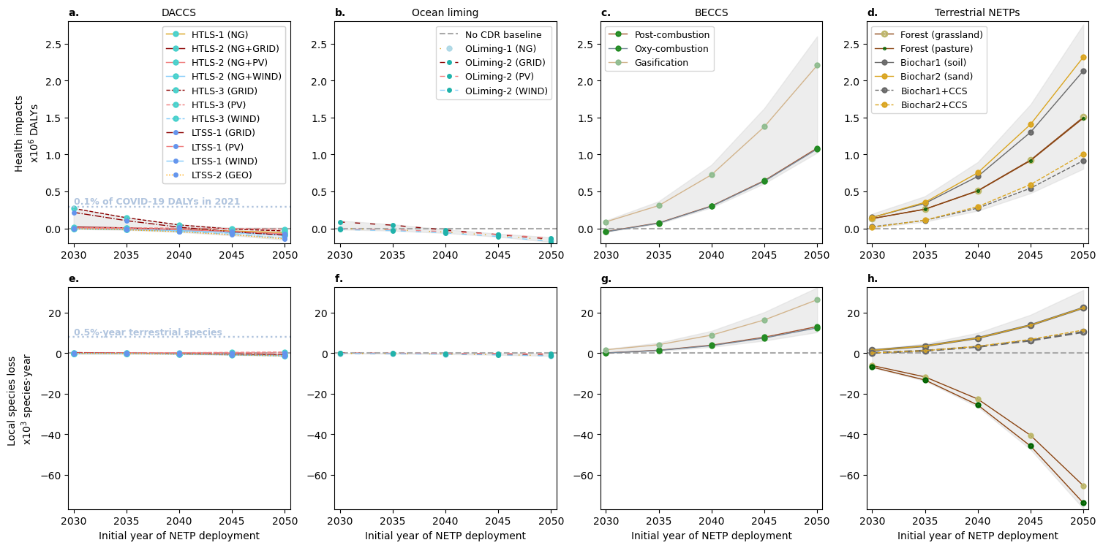

Supplementary Fig. 4. Human health and ecosystem damage due to the deployment of Negative Emissions Technologies or Practices (NETPs) between 2030 and 2050. Results expressed in million Disability-Adjusted Life Years (x10⁶ DALYs) and local species loss integrated over space and time (x10³ species·year), and relative to a baseline without Carbon Dioxide Removal (CDR). Grey-shaded areas represent the uncertainty of the results (lowest values correspond to the scenarios generating the least damage with the most favorable foreground parameters and highest values derived from the worst-performing scenarios considering the most pessimistic foreground parameters). a Health impacts of Direct Air Carbon Capture and Storage (DACCS): High Temperature Liquid Sorbent (HTLS) and Low Temperature Solid Sorbent (LTSS). HTLS-1 is powered by natural gas (NG). NG supplies the heat of HTLS-2, while the electricity comes from the global average grid mix (GRID), solar photovoltaic (PV) or wind energy. HTLS-3 is powered by the GRID, PV or wind. LTSS is powered by the GRID, PV, wind or geothermal electricity (GEO). The heating demand of LTSS is supplied by heat pumps (LTSS-1) or excess geothermal heat (LTSS-2) generated in the production of GEO. b Health impacts of ocean liming (OLiming). The calciner of OLiming-1 uses NG, in OLiming-2, it is powered by the GRID, PV, or wind. c Health impacts of Bioenergy with Carbon Capture and Storage (BECCS): combustion w/ post-combustion capture, oxy-combustion and gasification. d Health impacts of terrestrial NETPs: forestation (forest) and biochar. Forestation occurs on grasslands or pasturelands. Biochar is applied to the soil (Biochar1) or used as sand substitute (Biochar2). Pyrolysis modeled with and without Carbon Capture and Storage (CCS). e Ecosystem impacts of DACCS. f Ecosystem impacts of OLiming. g Ecosystem impacts of BECCS. h Ecosystem impacts of terrestrial NETPs.

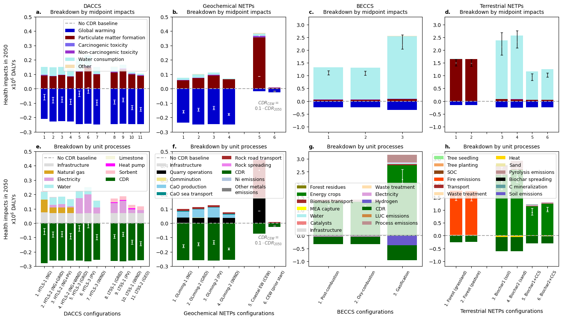

Supplementary Fig. 5. Breakdown of human health damage due to the deployment of Negative Emissions Technologies or Practices (NETPs) in 2050. Results expressed in million Disability-Adjusted Life Years (x10⁶ DALYs) and relative to a baseline without Carbon Dioxide Removal (CDR). Error bars represent the uncertainty of the results, considering best and worst foreground parameters. Contribution of midpoint impacts to the health damage caused by a Direct Air Carbon Capture and Storage (DACCS): High Temperature Liquid Sorbent (HTLS) and Low Temperature Solid Sorbent (LTSS). HTLS-1 is powered by natural gas (NG). NG supplies the heat of HTLS-2, while the electricity comes from the global average grid mix (GRID), solar photovoltaic (PV) or wind energy. HTLS-3 is powered by the GRID, PV or wind. LTSS is powered by the GRID, PV, wind, or geothermal electricity (GEO). The heating demand of LTSS is supplied by heat pumps (LTSS-1) or excess geothermal heat (LTSS-2) generated in the production of GEO. b Geochemical NETPs: Ocean liming (OLiming) and Coastal Enhanced Weathering (CEW). The calciner of OLiming-1 uses NG, in OLiming-2, it is powered by the GRID, PV, or wind. The CEW scenarios remove 10% of the 2050 CDR target and consider 2050 and a previous year as the initial time for the rock application. c Bioenergy with Carbon Capture and Storage (BECCS): combustion w/ post-combustion capture, oxy-combustion and gasification. d Terrestrial NETPs: forestation (forest) and biochar. Forestation occurs on grasslands or pasturelands. Biochar is applied to the soil (Biochar1) or used as sand substitute (Biochar2). Pyrolysis modeled with and without Carbon Capture and Storage (CCS). Contribution of unit processes to the health damage caused by e DACCS. f Geochemical NETPs. g BECCS. h Terrestrial NETPs.
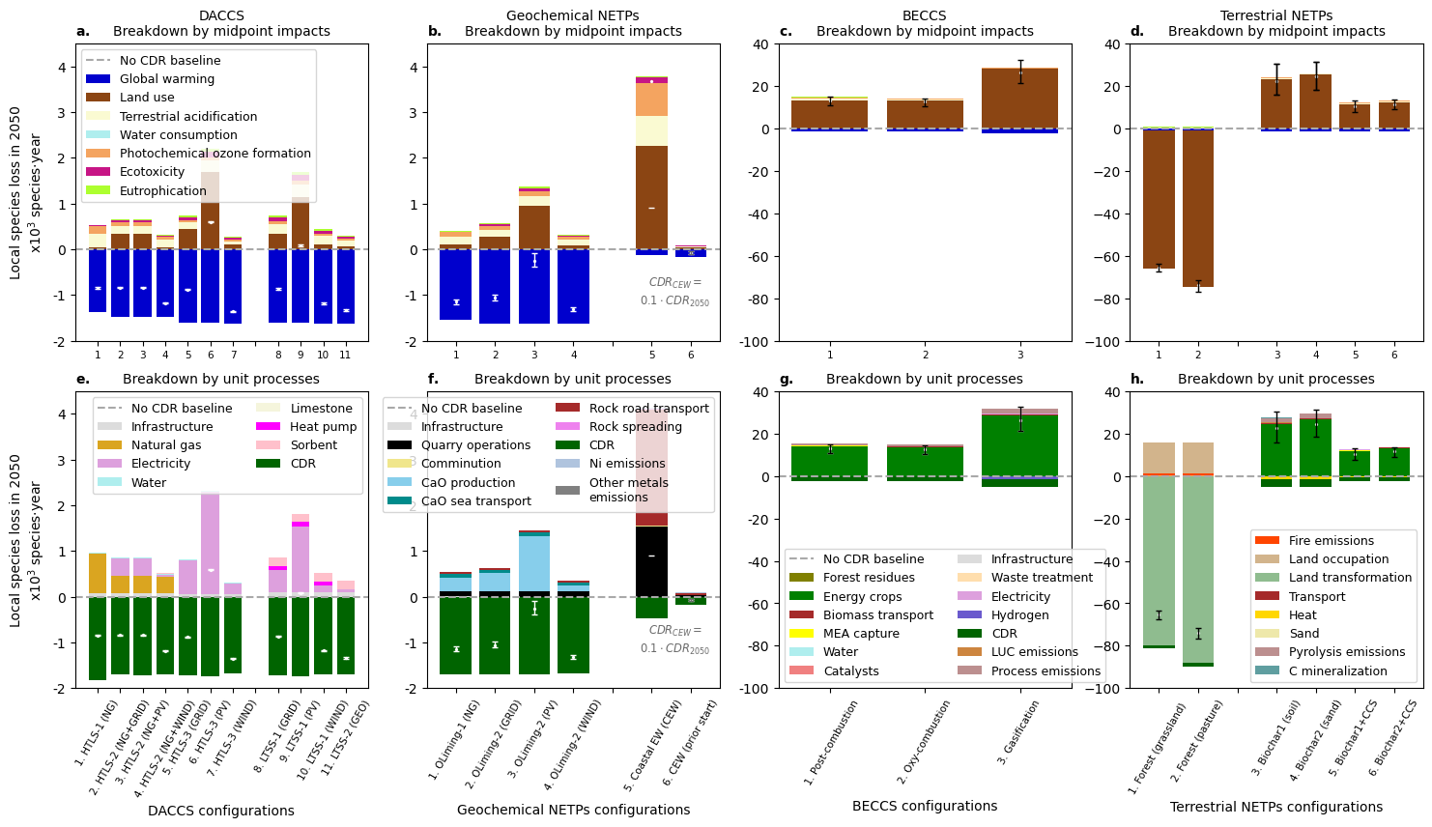

Supplementary Fig. 6. Breakdown of ecosystem damage due to the deployment of Negative Emissions Technologies or Practices (NETPs) in 2050. Results expressed as the local species loss aggregated over space and time (x10³ species·year) and relative to a baseline without Carbon Dioxide Removal (CDR). Error bars represent the uncertainty of the results, considering best and worst foreground parameters. Contribution of midpoint impacts to the ecosystem damage caused by a Direct Air Carbon Capture and Storage (DACCS): High Temperature Liquid Sorbent (HTLS) and Low Temperature Solid Sorbent (LTSS). HTLS-1 is powered by natural gas (NG). NG supplies the heat of HTLS-2, while the electricity comes from the global average grid mix (GRID), solar photovoltaic (PV) or wind energy. HTLS-3 is powered by the GRID, PV or wind. LTSS is powered by the GRID, PV, wind, or geothermal electricity (GEO). The heating demand of LTSS is supplied by heat pumps (LTSS-1) or excess geothermal heat (LTSS-2) generated in the production of GEO. b Geochemical NETPs: Ocean liming (OLiming) and Coastal Enhanced Weathering (CEW). The calciner of OLiming-1 uses NG, in OLiming-2, it is powered by the GRID, PV, or wind. The CEW scenarios remove 10% of the 2050 CDR target and consider 2050 and a previous year as the initial time for the rock application. c Bioenergy with Carbon Capture and Storage (BECCS): combustion w/ post-combustion capture, oxy-combustion and gasification. d Terrestrial NETPs: forestation (forest) and biochar. Forestation occurs on grasslands or pasturelands. Biochar is applied to the soil (Biochar1) or used as sand substitute (Biochar2). Pyrolysis modeled with and without Carbon Capture and Storage (CCS). Contribution of unit processes to the ecosystem damage caused by e DACCS. f Geochemical NETPs. g BECCS. h Terrestrial NETPs.
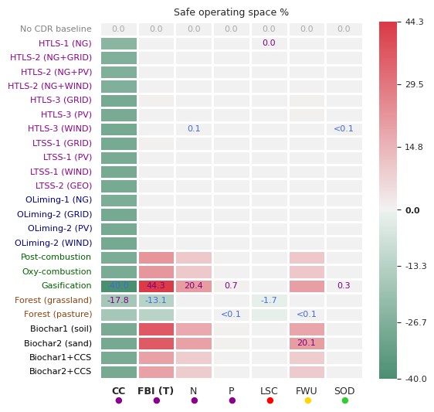
Supplementary Fig. 7. Impacts of deploying Negative Emissions Technologies or Practices (NETPs) in 2050 on the Earth system. The impacts on the following Earth-system processes (expressed as a share of their safe operating space)were assessed: climate change (CC), functional component of the terrestrial biosphere integrity (FTBI), biogeochemical flows–considering the industrial and intentional fixation of nitrogen (N) and phosphorus flows from freshwater into the ocean (P) as control variables–, land system change (LSC), global freshwater use (FWU), stratospheric ozone depletion (SOD). The scenarios considered include: 1) a baseline without Carbon Dioxide Removal (CDR), 2) Direct Air Carbon Capture and Storage (DACCS, in purple): High Temperature Liquid Sorbent (HTLS) and Low Temperature Solid Sorbent (LTSS). HTLS-1 is powered by natural gas (NG). NG supplies the heat of HTLS-2, while the electricity comes from the global average grid mix (GRID), solar photovoltaic (PV) or wind energy. HTLS-3 is powered by the GRID, PV or wind. LTSS is powered by the GRID, PV, wind, or geothermal electricity (GEO). The heating demand of LTSS is supplied by heat pumps (LTSS-1) or excess geothermal heat (LTSS-2) generated in the production of GEO. 3) Ocean liming (OLiming, in blue). The calciner of OLiming-1 uses NG, in OLiming-2, it is powered by the GRID, PV, or wind. 4) Bioenergy with Carbon Capture and Storage (BECCS, in green): combustion w/ post-combustion capture, oxy-combustion, and gasification. 5) Terrestrial NETPs: forestation (forest, in brown) and biochar (in black). Forestation occurs on grasslands or pasturelands. Biochar is applied to the soil (Biochar1) or used as sand substitute (Biochar2). Pyrolysis modeled with and without Carbon Capture and Storage (CCS).

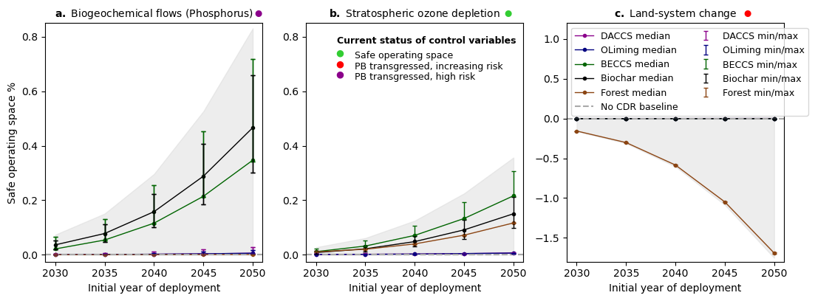
Supplementary Fig. 8. Impacts of Negative Emissions Technologies or Practices (NETPs) on three Earth-system processes between 2030 and 2050, consistent with the Planetary Boundaries (PBs) framework. The results represent the median impacts, expressed as a percentage of the safe operating space and relative to a baseline without Carbon Dioxide Removal (CDR), across the studied NETPs scenarios within each of these subgroups: Direct Air Carbon Capture and Storage (DACCS), Ocean liming (OLiming), Bioenergy with Carbon Capture and Storage (BECCS), forestation (Forest) and biochar. Error bars indicate maximum (max) and minimum (min) impacts within each subgroup. Grey-shaded areas represent the uncertainty of the results (lowest values correspond to the scenarios generating the least impact with the most favorable foreground parameters and highest values derived from the worst-performing scenarios considering the most pessimistic foreground parameters). The impacts on these Earth-system processes are assessed: a Phosphorus biogeochemical flows, b Stratospheric ozone depletion, and c Land-system change.

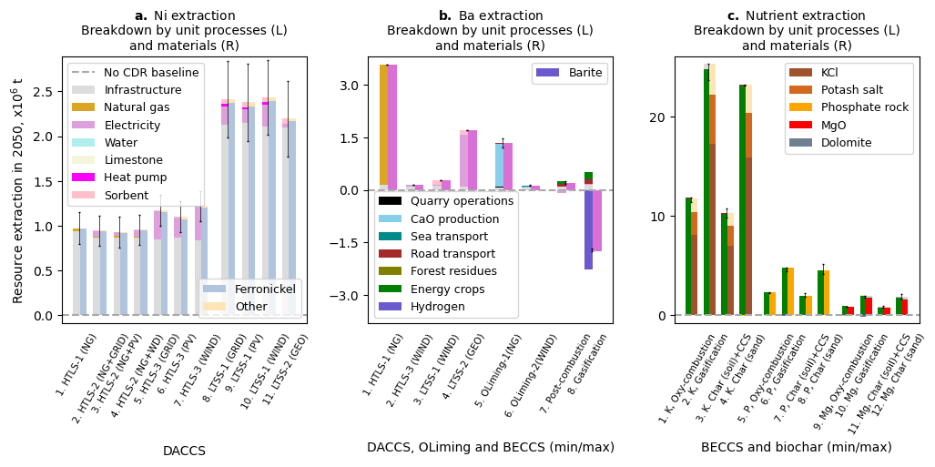
Supplementary Fig. 9. Mineral resource extraction associated with the deployment of Negative Emissions Technologies and Practices in 2050, relative to a baseline without Carbon Dioxide Removal (CDR). Breakdown of unit processes (left bars) and materials (right bars) contributing to resource extraction. Error bars represent the uncertainty of the results, considering best and worst foreground parameters. a Nickel extraction in 2050 due to the deployment of DACCS: High Temperature Liquid Sorbent (HTLS) and Low Temperature Solid Sorbent (LTSS). HTLS-1 is powered by natural gas (NG). NG supplies the heat of HTLS-2, while the electricity comes from the global average grid mix (GRID), solar photovoltaic (PV) or wind energy. HTLS-3 is powered by the GRID, PV or wind. The heating demand of LTSS is supplied by heat pumps (LTSS-1) or excess geothermal heat (LTSS-2) generated in the production of geothermal (GEO) electricity. b Minimum (min) and maximum (max) barium extraction in 2050 across the HTLS- and LTSS-DACCS, Ocean liming (OLiming) and Bioenergy with Carbon Capture and Storage (BECCS) scenarios, the latter based on post-combustion, oxy-combustion, and gasification. c Maximum and minimum extraction of potassium (K), phosphorus (P) and magnesium (Mg) in 2050 across the BECCS and biochar scenarios, the latter considering systems with and without Carbon Capture and Storage (CCS) and biochar applied to the soil or used as sand substitute.

6. References
1 A. Levasseur, P. Lesage, M. Margni, L. Deschěnes and R. Samson, Environ. Sci. Technol., 2010, 44, 3169–3174.
2 C. Smith, Z. R. J. Nicholls, K. Armour, W. Collins, P. Forster, M. Meinshausen, M. D. Palmer and M. Watanabe, in Climate Change 2021: The Physical Science Basis. Contribution of Working Group I to the Sixth Assessment Report of the Intergovernmental Panel on Climate Change, 2021.
3 J. R. Millar, Z. R. Nicholls, P. Friedlingstein and M. R. Allen, Atmospheric Chem. Phys., 2017, 17, 7213–7228.
4 M. A. J. Huijbregts, Z. J. N. Steinmann, P. M. F. Elshout, G. Stam, F. Verones, M. D. M. Vieira, A. Hollander, M. Zijp and R. van Zelm, ReCiPe 2016 v1.1. A harmonized life cycle impact assessment method at midpoint and endpoint level. Report I: Characterization., National Institute for Public Health and the Environment, 2017.
5 W. Steffen, K. Richardson, J. Rockström, S. E. Cornell, I. Fetzer, E. M. Bennett, R. Biggs, S. R. Carpenter, W. De Vries, C. A. De Wit, C. Folke, D. Gerten, J. Heinke, G. M. Mace, L. M. Persson, V. Ramanathan, B. Reyers and S. Sörlin, Science, 2015, 347, 1259855.
6 K. Richardson, W. Steffen, W. Lucht, J. Bendtsen, S. E. Cornell, J. F. Donges, M. Drüke, I. Fetzer, G. Bala, W. von Bloh, G. Feulner, S. Fiedler, D. Gerten, T. Gleeson, M. Hofmann, W. Huiskamp, M. Kummu, C. Mohan, D. Nogués-Bravo, S. Petri, M. Porkka, S. Rahmstorf, S. Schaphoff, K. Thonicke, A. Tobian, V. Virkki, L. Wang-Erlandsson, L. Weber and J. Rockström, Sci. Adv., 2023, 9, eadh2458.
7 S. Mathesius, M. Hofmann, K. Caldeira and H. J. Schellnhuber, Nat. Clim. Change, 2015, 5, 1107–1113.
8 A. Lenton, R. J. Matear, D. P. Keller, V. Scott and N. E. Vaughan, Earth Syst. Dyn., 2018, 9, 339–357.
9 S. Gore, P. Renforth and R. Perkins, Mitig. Adapt. Strateg. Glob. Change, 2019, 24, 1191–1211.
10 C. A. Clausen, A. Bjørn, E. Sanyé-Mengual and M. Ryberg, J. Ind. Ecol., 2024, 1–14.
11 L. Baumstark, N. Bauer, F. Benke, C. Bertram, S. Bi, C. C. Gong, J. P. Dietrich, A. Dirnaichner, A. Giannousakis, J. Hilaire, D. Klein, J. Koch, M. Leimbach, A. Levesque, S. Madeddu, A. Malik, A. Merfort, L. Merfort, A. Odenweller, M. Pehl, R. C. Pietzcker, F. Piontek, S. Rauner, R. Rodrigues, M. Rottoli, F. Schreyer, A. Schultes, B. Soergel, D. Soergel, J. Strefler, F. Ueckerdt, E. Kriegler and G. Luderer, Geosci. Model Dev., 2021, 14, 6571–6603.
12 K. Riahi, D. P. van Vuuren, E. Kriegler, J. Edmonds, B. C. O’Neill, S. Fujimori, N. Bauer, K. Calvin, R. Dellink, O. Fricko, W. Lutz, A. Popp, J. C. Cuaresma, S. KC, M. Leimbach, L. Jiang, T. Kram, S. Rao, J. Emmerling, K. Ebi, T. Hasegawa, P. Havlik, F. Humpenöder, L. A. Da Silva, S. Smith, E. Stehfest, V. Bosetti, J. Eom, D. Gernaat, T. Masui, J. Rogelj, J. Strefler, L. Drouet, V. Krey, G. Luderer, M. Harmsen, K. Takahashi, L. Baumstark, J. C. Doelman, M. Kainuma, Z. Klimont, G. Marangoni, H. Lotze-Campen, M. Obersteiner, A. Tabeau and M. Tavoni, Glob. Environ. Change, 2017, 42, 153–168.
13 D. P. van Vuuren, E. Stehfest, M. G. J. den Elzen, T. Kram, J. van Vliet, S. Deetman, M. Isaac, K. K. Goldewijk, A. Hof, A. M. Beltran, R. Oostenrijk and B. van Ruijven, Clim. Change, 2011, 109, 95–116.
14 M. W. Ryberg, M. Owsianiak, K. Richardson and M. Z. Hauschild, Ecol. Indic., 2018, 88, 250–262.
15 S. Cobo, Method to quantify metal extraction in life cycle models, showing supply risk levels for the EU. https://zenodo.org/records/15173715.
16 G. Wernet, C. Bauer, B. Steubing, J. Reinhard, E. Moreno-Ruiz and B. Weidema, Int. J. Life Cycle Assess., 2016, 21, 1218–1230.
17 U.S. Geological Survey, Mineral commodity summaries 2023, 2023.
18 S. Cobo, V. Negri, A. Valente, D. M. Reiner, L. Hamelin, N. M. Dowell and G. Guillén-Gosálbez, Environ. Res. Lett., 2023, 18, 023001.
19 D. W. Keith, G. Holmes, D. St. Angelo and K. Heidel, Joule, 2018, 2, 1573–1594.
20 D. R. Gómez et al., in IPCC guidelines for national greenhouse gas inventories, Hayama, 2006.
21 European Environment Agency, in EMEP/EEA air pollutant emission inventory guidebook 2019, Luxembourg, 2019.
22 C. M. Liu, N. K. Sandhu, S. T. McCoy and J. A. Bergerson, Sustain. Energy Fuels, 2020, 4, 3129–3142.
23 National Academies of Sciences Engineering and Medicine, Negative Emissions Technologies and Reliable Sequestration: A Research Agenda, The National Academies Press, Washinton, DC, 2019.
24 C. Beuttler, L. Charles and J. Wurzbacher, Front. Clim., 2019, 1, 10.
25 S. Deutz and A. Bardow, Nat. Energy, 2021, 6, 203–213.
26 World Intellectual Property Organization, WO 2010/091831 Al, 2010.
27 K. Lebling, H. Leslie-Bole, P. Psarras, E. Bridgwater, Z. Byrum and H. Pilorgé, Direct Air Capture: Assessing Impacts to Enable Responsible Scaling, 2022.
28 J. Koornneef, T. van Keulen, A. Faaij and W. Turkenburg, Int. J. Greenh. Gas Control, 2008, 2, 448–467.
29 P. Renforth, B. G. Jenkins and T. Kruger, Energy, 2013, 60, 442–452.
30 P. Renforth and G. Henderson, Rev. Geophys., 2017, 55, 636–674.
31 National Academies of Sciences Engineering and Medicine, A Research Strategy for Ocean-based Carbon Dioxide Removal and Sequestration, The National Academies Press, Washinton, DC, 2021.
32 J. Hartmann, A. J. West, P. Renforth, P. Köhler, C. L. De La Rocha, D. A. Wolf-Gladrow, H. H. Dürr and J. Scheffran, Rev. Geophys., 2013, 51, 113–149.
33 P. Renforth, Nat. Commun., 2019, 10, 1401.
34 N. Vakilifard, E. P. Kantzas, N. R. Edwards, P. B. Holden and D. J. Beerling, Environ. Res. Lett., 2021, 16, 094005.
35 S. J. T. Hangx and C. J. Spiers, Int. J. Greenh. Gas Control, 2009, 3, 757–767.
36 T. Amann, J. Hartmann, E. Struyf, W. De Oliveira Garcia, E. K. Fischer, I. Janssens, P. Meire and J. Schoelynck, Biogeosciences, 2020, 17, 103–119.
37 F. Buckingham, G. M. Henderson, P. Holdship and P. Renforth, Appl. Geochem., 2022, 147, 105482.
38 J. Strefler, T. Amann, N. Bauer, E. Kriegler and J. Hartmann, Environ. Res. Lett., 2018, 13, 034010.
39 F. Montserrat, P. Renforth, J. Hartmann, M. Leermakers, P. Knops and F. J. R. Meysman, Environ. Sci. Technol., 2017, 51, 3960–3972.
40 M. Anda, Geoderma, 2012, 189–190, 388–396.
41 B. J. Alloway, Heavy metals in soils. Trace metals in metalloids and soils and their bioavailability., Springer, 2013, vol. 22.
42 H. Wang, X. Li, Y. Chen, Z. Li, D. W. Hedding, W. Nel, J. Ji and J. Chen, Sci. Total Environ., 2020, 729, 139058.
43 M. E. Kelland, P. W. Wade, A. L. Lewis, L. L. Taylor, B. Sarkar, M. G. Andrews, M. R. Lomas, T. E. A. Cotton, S. J. Kemp, R. H. James, C. R. Pearce, S. E. Hartley, M. E. Hodson, J. R. Leake, S. A. Banwart and D. J. Beerling, Glob. Change Biol., 2020, 26, 3658–3676.
44 A. C. M. Bourg and J. P. G. Loch, in Biogeodynamics of Pollutants in Soils and Sediments, 1995, pp. 87–102.
45 C. N. McClain and K. Maher, Chem. Geol., 2016, 426, 135–157.
46 J. Hartmann, A. J. West, P. Renforth, P. Köhler, C. L. De La Rocha, D. A. Wolf-Gladrow, H. H. Dürr and J. Scheffran, Rev. Geophys., 2013, 51, 113–149.
47 F. J. Holden, K. Davies, M. I. Bird, R. Hume, H. Green, D. J. Beerling and P. N. Nelson, Sci. Total Environ., 2024, 955, 176568.
48 T. Xu, Z. Yuan, S. Vicca, D. S. Goll, G. Li, L. Lin, H. Chen, B. Bi, Q. Chen, C. Li, X. Wang, C. Wang, Z. Hao, Y. Fang and D. J. Beerling, Glob. Change Biol., 2024, 30, 1–17.
49 B. J. Stanton, D. B. Neale and S. Li, in Genetics and Genomics of Populus, 2010.
50 E. A. Heaton, F. G. Dohleman, A. F. Miguez, J. A. Juvik, V. Lozovaya, J. Widholm, O. A. Zabotina, G. F. McIsaac, M. B. David, T. B. Voigt, N. N. Boersma and S. P. Long, in Advances in Botanical Research, Academic Press, 2010, vol. 56, pp. 75–137.
51 J. H. Hansen, L. Hamelin, A. Taghizadeh‐Toosi, J. E. Olesen and H. Wenzel, GCB Bioenergy, 2020, 12, 1002–1013.
52 C. Andrade Díaz, H. Clivot, A. Albers, E. Zamora-Ledezma and L. Hamelin, Appl. Energy, 2023, 329, 120192.
53 N. Scarlat, F. Fahl, E. Lugato, F. Monforti-Ferrario and J. F. Dallemand, Biomass Bioenergy, 2019, 122, 257–269.
54 S. Searle and C. Malins, GCB Bioenergy, 2015, 7, 328–336.
55 T. Nurek, A. Gendek and K. Roman, BioResources, 2018, 14, 6–20.
56 P. Smith, S. J. Davis, F. Creutzig, S. Fuss, J. Minx, B. Gabrielle, E. Kato, R. B. Jackson, A. Cowie, E. Kriegler, D. P. Van Vuuren, J. Rogelj, P. Ciais, J. Milne, J. G. Canadell, D. McCollum, G. Peters, R. Andrew, V. Krey, G. Shrestha, P. Friedlingstein, T. Gasser, A. Grübler, W. K. Heidug, M. Jonas, C. D. Jones, F. Kraxner, E. Littleton, J. Lowe, J. R. Moreira, N. Nakicenovic, M. Obersteiner, A. Patwardhan, M. Rogner, E. Rubin, A. Sharifi, A. Torvanger, Y. Yamagata, J. Edmonds and C. Yongsung, Nat. Clim. Change, 2016, 6, 42–50.
57 N. E. Vaughan, C. Gough, S. Mander, E. W. Littleton, A. Welfle, D. E. H. J. Gernaat and D. P. Van Vuuren, Environ. Res. Lett., 2018, 13, 044014.
58 A. B. Harper, T. Powell, P. M. Cox, J. House, C. Huntingford, T. M. Lenton, S. Sitch, E. Burke, S. E. Chadburn, W. J. Collins, E. Comyn-Platt, V. Daioglou, J. C. Doelman, G. Hayman, E. Robertson, D. van Vuuren, A. Wiltshire, C. P. Webber, A. Bastos, L. Boysen, P. Ciais, N. Devaraju, A. K. Jain, A. Krause, B. Poulter and S. Shu, Nat. Commun., 2018, 9, 2938.
59 L. R. Boysen, W. Lucht, D. Gerten, V. Heck, T. M. Lenton and H. J. Schellnhuber, Earths Future, 2017, 5, 463–474.
60 S. V. Hanssen, V. Daioglou, Z. J. N. Steinmann, J. C. Doelman, D. P. Van Vuuren and M. A. J. Huijbregts, Nat. Clim. Change, 2020, 10, 1023–1029.
61 M. H. Gvein, X. Hu, J. S. Næss, M. D. B. Watanabe, O. Cavalett, M. Malbranque, G. Kindermann and F. Cherubini, Commun. Earth Environ., 2023, 4, 39.
62 J. F. Peters, D. Iribarren and J. Dufour, Environ. Sci. Technol., 2015, 49, 5195–5202.
63 W. Kuang, J. Liu, H. Tian, H. Shi, J. Dong, C. Song, X. Li, G. Du, Y. Hou, D. Lu, W. Chi, T. Pan, S. Zhang, R. Hamdi, Z. Yin, H. Yan, C. Yan, S. Wu, R. Li, J. Yang, Y. Dou, W. Wu, L. Liang, B. Xiang and S. Yang, Natl. Sci. Rev., 2022, 9, nwab091.
64 Z. Qin, J. B. Dunn, H. Kwon, S. Mueller and M. M. Wander, GCB Bioenergy, 2016, 8, 66–80.
65 J. Wang, W. Li, P. Ciais, L. Z. X. Li, J. Chang, D. Goll, T. Gasser, X. Huang, N. Devaraju and O. Boucher, Nat. Commun., 2021, 12, 7255.
66 I. Melnikova, P. Ciais, K. Tanaka, N. Vuichard and O. Boucher, Commun. Earth Environ., 2023, 4, 230.
67 L. Ercoli, M. Mariotti, A. Masoni and E. Bonari, Field Crops Res., 1999, 63, 3–11.
68 M. J. Stolarski, K. Warmiński and M. Krzyżaniak, Energies, 2020, 13, 1495.
69 Phyllis2 database., https://phyllis.nl/Browse/Standard/ECN-Phyllis#miscanthus [last accessed: 09.12.21], (accessed December 9, 2021).
70 IEA GHG, Biomass CCS Study, 2009.
71 M. Bui, C. S. Adjiman, A. Bardow, E. J. Anthony, A. Boston, S. Brown, P. S. Fennell, S. Fuss, A. Galindo, L. A. Hackett, J. P. Hallett, H. J. Herzog, G. Jackson, J. Kemper, S. Krevor, G. C. Maitland, M. Matuszewski, I. S. Metcalfe, C. Petit, G. Puxty, J. Reimer, D. M. Reiner, E. S. Rubin, S. A. Scott, N. Shah, B. Smit, J. P. M. Trusler, P. Webley, J. Wilcox and N. Mac Dowell, Energy Environ. Sci., 2018, 11, 1062–1176.
72 A. B. Rao, E. S. Rubin and M. B. Berkenpas, An integrated modeling framework for carbon management technologies. Volume 1 – Technical Documentation: Amine-Based CO2 Capture and Storage Systems for Fossil Fuel Power Plant, 2004.
73 International Energy Agency Greenhouse Gas R&D Programme, Environmental Impact of Solvent Scrubbing of CO2, 2006.
74 H. Althaus, M. Chudacoff, R. Hischier, N. Jungbluth, M. Osses, A. Primas and S. Hellweg, Life cycle inventories of chemicals. Data v2.0., EMPA Dübendorf, Swiss Centre for Life Cycle Inventories., Dübendorf, 2007.
75 H. Hagi, Y. Le Moullec, M. Nemer and C. Bouallou, Energy, 2014, 69, 272–284.
76 C. C. Cormos, Fuel, 2016, 169, 50–57.
77 X. Lin, H. Song and Y. Liu, Chem. Eng. Res. Des., 2022, 186, 568–586.
78 P. Brandl, M. Bui, J. P. Hallett and N. Mac Dowell, Int. J. Greenh. Gas Control, 2021, 105, 103239.
79 IEA GHG, Oxy-Combustion Turbine Power Plants, 2015.
80 D. Schlissel and A. Juhn, Blue Hydrogen: Not Clean, Not Low Carbon, Not a Solution, Institute for Energy Economics and Financial Analysis.
81 A. Susmozas, D. Iribarren, P. Zapp, J. Linβen and J. Dufour, Int. J. Hydrog. Energy, 2016, 41, 19484–19491.
82 B. Smith R J, M. Loganathan and M. S. Shantha, Int. J. Chem. React. Eng., 2010, 8, 1.
83 T. Brinkmann, J. Pohlmann, M. Bram, L. Zhao, A. Tota, N. Jordan Escalona, M. de Graaff and D. Stolten, Int. J. Greenh. Gas Control, 2015, 39, 194–204.
84 M. M. Rahman, C. Abetz, S. Shishatskiy, J. Martin, A. J. Müller and V. Abetz, ACS Appl. Mater. Interfaces, 2018, 10, 26733–26744.
85 J. Lillepärg, P. Georgopanos and S. Shishatskiy, J. Membr. Sci., 2014, 467, 269–278.
86 M. C. Braakhekke, J. C. Doelman, P. Baas, C. Müller, S. Schaphoff, E. Stehfest and D. P. Van Vuuren, Earth Syst. Dyn., 2019, 10, 617–630.
87 H. Aalde, P. Gonzalez, M. Gytarsky, T. Krug, W. A. Kurz, S. Ogle, J. Raison, D. Schoene, N. H. Ravindranath, N. G. Elhassan, L. S. Heath, N. Higuchi, S. Kainja, M. Matsumoto, M. J. S. Sánchez and Z. Somogyi, Chapter 4. Forest land. In: IPCC Guidelines for National Greenhouse Gas Inventories, 2006.
88 H. Aalde, P. Gonzalez, M. Gytarsky, T. Krug, W. A. Kurz, R. D. Lasco, D. L. Martino, B. G. McConkey, S. Ogle, K. Paustian, J. Raison, N. H. Ravindranath, D. Schoene, P. Smith, Z. Somogyi, A. A. Van and L. Verchot, Chapter 2. Generic methodologies applicable to multiple land-use categories. In: IPCC Guidelines for National Greenhouse Gas Inventories, 2006.
89 J. S. Powers, M. D. Corre, T. E. Twine and E. Veldkamp, Proc. Natl. Acad. Sci. U. S. A., 2011, 108, 6318–6322.
90 United Nations Environmental Programme, Spreading like wildfire - The rising threat of extraordinary landscape fires, Nairobi, 2022.
91 Food and Agriculture Organization of the United Nations, Global Forests Resources Assessment 2020: Main report, Rome, 2020.
92 European Environment Agency, in EMEP/EEA air pollutant emission inventory guidebook 2023, 2023.
93 N. Hasler, C. A. Williams, V. C. Denney, P. W. Ellis, S. Shrestha, D. E. Terasaki Hart, N. H. Wolff, S. Yeo, T. W. Crowther, L. K. Werden and S. C. Cook-Patton, Nat. Commun., 2024, 15, 2275.
94 D. Woolf, J. Lehmann, S. Ogle, A. W. Kishimoto-Mo, B. McConkey and J. Baldock, Environ. Sci. Technol., 2021, 55, 14795–14805.
95 L. Ye, M. Camps-Arbestain, Q. Shen, J. Lehmann, B. Singh and M. Sabir, Soil Use Manag., 2020, 36, 2–18.
96 L. Genesio, F. Miglietta, E. Lugato, S. Baronti, M. Pieri and F. P. Vaccari, Environ. Res. Lett., 2012, 7, 014025.
97 S. Meyer, R. M. Bright, D. Fischer, H. Schulz and B. Glaser, Environ. Sci. Technol., 2012, 46, 12726–12734.
98 Time-explicit LCA with bw_timex , https://docs.brightway.dev/projects/bw-timex/en/latest/index.html, (accessed August 12, 2024).
99 G. Cardellini, C. L. Mutel, E. Vial and B. Muys, Sci. Total Environ., 2018, 645, 585–595.
100 Y. Pigné, T. N. Gutiérrez, T. Gibon, T. Schaubroeck, E. Popovici, A. H. Shimako, E. Benetto and L. Tiruta-Barna, Int. J. Life Cycle Assess., 2020, 25, 267–279.
101 R. Sacchi, T. Terlouw, K. Siala, A. Dirnaichner, C. Bauer, B. Cox, C. Mutel, V. Daioglou and G. Luderer, Renew. Sustain. Energy Rev., 2022, 160, 112311.
102 M. Sendi, M. Bui, N. Mac Dowell and P. Fennell, One Earth, 2022, 5, 1153–1164.
103 H. M. Schellevis, J. D. de la Combé and D. W. F. Brilman, Energy Adv., 2024, 3, 1678–1687.
104 J. S. Campbell, S. Foteinis, V. Furey, O. Hawrot, D. Pike, S. Aeschlimann, C. N. Maesano, P. L. Reginato, D. R. Goodwin, L. L. Looger, E. S. Boyden and P. Renforth, Front. Clim., 2022, 4, 879133.
105 E. Camatti, S. Valsecchi, S. Caserini, E. Barbaccia, C. Santinelli, D. Basso and A. Azzellino, Mar. Pollut. Bull., 2024, 198, 115833.
106 CIA, The world factbook. Coastline, https://www.cia.gov/the-world-factbook/field/coastline/.

Functional unit varies with the year of analysis (e.g., 3.09 GtCO₂ removed in 2050).
Unit depends on the midpoint impact category (e.g., kgPM_{2.5} for fine particulate matter formation).
Unit depends on the type of elementary flow (e.g., m² for land).
Unit depends on the endpoint impact category (e.g., DALY for human health).
Unit depends on the type of activity (e.g., kg of fertilizer in the fertilizer production activities).
Unit depends on the Earth-system process (e.g., Dobson units for stratospheric ozone depletion).

