Spike protein recognizer receptor ACE2 targeted identification of potential natural antiviral drug candidates against SARS-CoV-2.

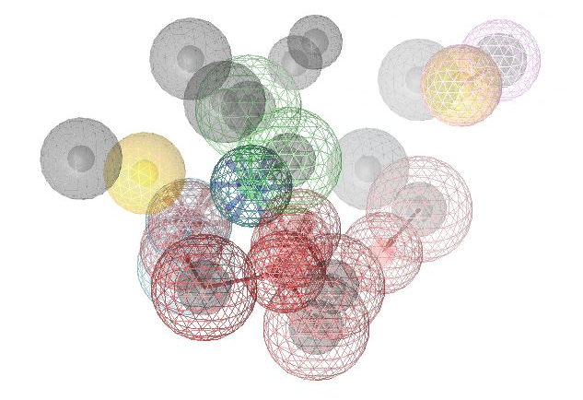
Figure S1: The 3D structure-based pharmacophore model of ACE2 protein in complex with XX5 ligand derived from the X-ray derived crystal structure of the protein retrieved from the PDB (PDB code: 1R4L). Pharmacophore features of the complex interaction, where 2 hydrophobic feature has indicated by yellow spherical shape 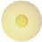, 1 positive ionizable by blue star shape 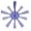, 2 negative ionizable by red star shape 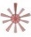, 2 hydrogen bond donor by green spherical or green arrow shape 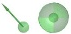, 5 hydrogen bond acceptor by red spherical or red arrow shape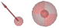, 1 zinc binding location by royal blue star or cone shape 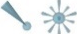, and 1 halogen bond donor by violet spherical or arrow shape 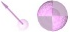 have represented within the protein ligand complex interaction. 15 excluded volume areas generated by the pharmacophore model has displayed in brown color.

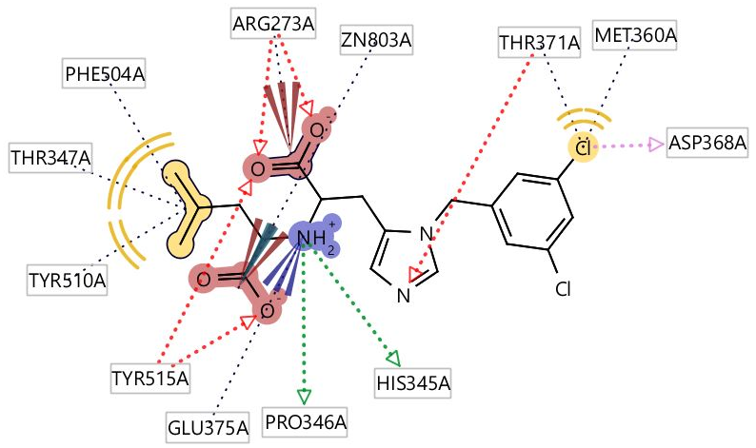
Figure S2: The 2D-depiction generated from LigandScout 4.3 Advanced, interpreting hydrophobic pocket (yellow color) of the ligand and their binding interaction with the amino acid residues of the ACE2 protein. Hydrogen bond acceptor features yielded most frequently, have indicated by the red color in the 2D interaction depiction. Hydrogen atoms on the compound and restricted area that define the shape and position of the binding pocket known as excluded volumes have not displayed in the figure.
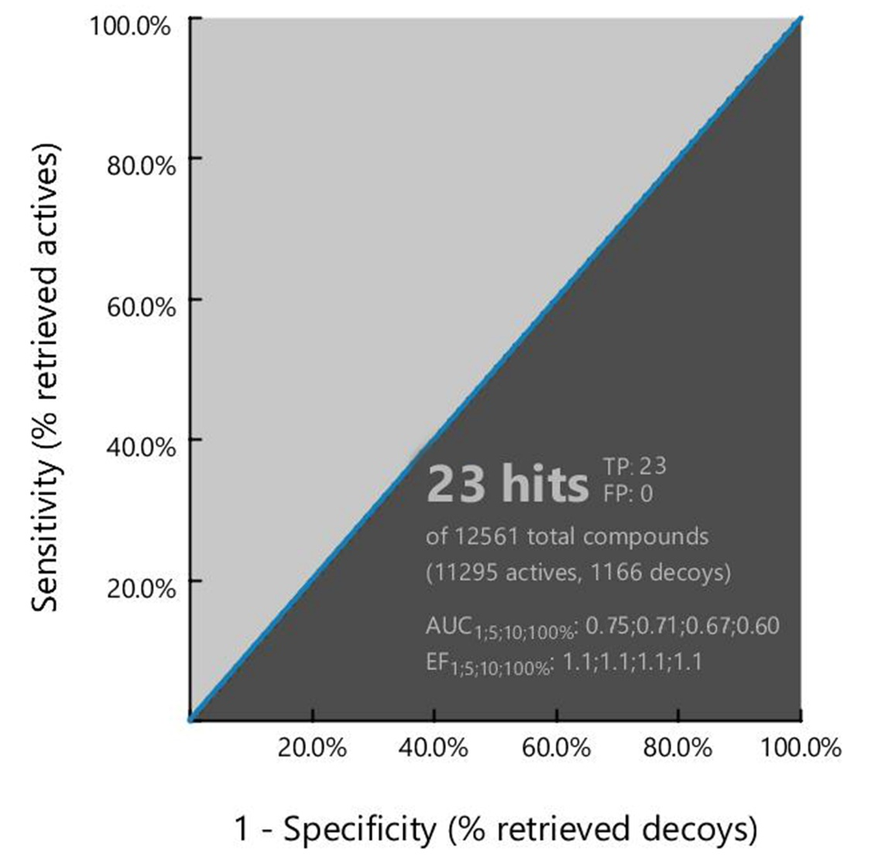
Figure S3: Representing the ROC curve for validating the pharmacophore model generated during the virtual screening process. The curve presenting the relationship between sensitivity (true positive fraction to the Y-axis) and specificity (false positive fraction to the x-axis) for every possible cut-off.

Table S1: Showing 23 hits compounds retrieved from pharmacophore based virtual screening. The table describing (from left) Ambinter ID, molecular formula, molecular docking score, pharmacophore fit score, molecular weight (MW), polar surface area (PSA), logP value and compounds chemical name, respectively. Red color indicating highest binding energy of the compounds were used for further evaluation.
No | Ambinter | Formula | Docking (kcal/mol) | P. fit score | MW | PSA | logP | Chemical Name
1 | Amb17613565 | C₉H₁₁NO₄ | -7.5 | 78.81 | 197.188 | 103.78 | 0.7525 | D-DOPA
2 | Amb6600091 | C₁₁H₂₀N₂O₆ | -7.1 | 78.75 | 276.286 | 149.95 | 0.5674 | L-Saccharopine
3 | Amb8514992 | C₆H₁₁NO₂ | -5.3 | 78.70 | 129.157 | 63.32 | 1.0648 | (S)-2-Amino-2-methylpent-4-enoic acid
4 | Amb8514700 | C₅H₁₁NO₂ | -5 | 78.62 | 117.146 | 63.32 | 0.8987 | H-D-Nva-OH
5 | Amb8514701 | C₅H₁₁NO₂ | -5 | 78.59 | 117.146 | 63.32 | 0.8987 | H-Nva-OH
6 | Amb19133021 | C₅H₁₁NO₃S | -4.8 | 78.55 | 165.211 | 99.6 | 165.211 | L-Methionine sulfoxide
7 | Amb6599999 | C₄H₉NO₃ | -5.2 | 78.51 | 119.119 | 83.55 | -0.5206 | D-Threonine
8 | Amb2694208 | C₄H₉NO₂ | -4.5 | 78.50 | 103.12 | 63.32 | 0.5086 | (2S)-2-aminobutanoic acid
9 | Amb8516280 | C₆H₁₃NO₂ | -5.3 | 78.44 | 131.173 | 1.1447 | 63.32 | H-D-Allo-Ile-OH
10 | Amb2720579 | C₆H₁₃NO₂ | -5.2 | 78.24 | 131.173 | 1.1447 | 63.32 | L-LEUCINE
11 | Amb6334822 | C₆H₁₁NO₄ | -5.3 | 77.97 | 161.156 | 100.62 | 0.3535 | 2-aminohexanedioic acid
12 | Amb3940754 | C₉H₁₁NO₂ | -7.1 | 77.71 | 165.189 | 63.32 | 1.3413 | D-Phenylalanine
13 | Amb2720519 | C₆H₁₃NO₂ | -5.1 | 77.60 | 131.173 | 63.32 | 1.1447 | L-Valine, 3-methyl
14 | Amb6297873 | C₅H₈N₂O₅ | -5.8 | 77.38 | 176.127 | 129.72 | -1.3097 | Dencichine
15 | Amb28974369 | C₆H₁₄N₄O₃ | -6.4 | 77.22 | 190.2 | 133.96 | 0.2635 | N-(omega)-Hydroxyarginine
16 | Amb21855906 | C₈H₁₀N₂O₄ | -7.0 | 77.12 | 198.176 | 105.55 | -0.3339 | L-Mimosine
17 | Amb6297293 | C₄H₉NO₃ | -5.2 | 77.02 | 119.119 | 83.55 | -0.5206 | L-Allothreonine
18 | Amb6298336 | C₃H₇NO₂ | -4.1 | 76.93 | 89.0932 | 63.32 | 0.1185 | (2S)-2-Aminopropanoic acid
19 | Amb8629519 | C₆H₁₃N₃O₃ | -5.6 | 76.88 | 175.186 | 118.44 | 0.6383 | H-D-Cit-OH
20 | Amb2720565 | C₅H₉NO₄ | -5.6 | 76.77 | 147.129 | 100.62 | -0.0366 | H-D-Glu-OH
21 | Amb3940322 | C₅H₉NO₄ | -5.5 | 76.59 | 147.129 | 100.62 | -0.0366 | L-Glutamic acid
22 | Amb2718751 | C₆H₁₃N₃O₃ | -5.9 | 76.08 | 175.186 | 118.44 | 0.6383 | N5-(Aminocarbonyl)-L-ornithine
23 | Amb2718757 | C₉H₁₁NO₃ | -6.2 | 75.71 | 181.189 | 83.55 | 1.0469 | (2R)-2-amino-3-(4-hydroxyphenyl) propanoic acid

