Supplementary Information

Ultrafast sintering of ultrafine-grained refractory metals at mild conditions
Erli Ni^{1†}, Jingrui Luo^{2†}, Yu Ding², Zhujun Kuang², Mengqi Zeng², Lei Fu^{1,2}*
¹Institute for Advanced Studies, Wuhan University; Wuhan 430072, China. ²College of Chemistry and Molecular Sciences, Wuhan University; Wuhan 430072, China
*Email: leifu@whu.edu.cn
†These authors contributed equally to this work.
Materials and Methods
Preparation of refractory metal bulks
All refractory metals (99.999 wt.%) powders were purchased from Meryer. The gallium was purchased from Shanghai Minor Metals Co., Ltd. 3.00 g Re powders, 2.96 g W powders, 2.75 g Ta powders, 1.99 g Mo powders, 1.70 g Nb powders, 1.30 g V powders, 1.50 g Cr powders, and 1.00 g Ti powders were pressed into pellets with the cylindrical dies with the diameter of 20 mm. Then, 0.1 g Ga was evenly coated on the surface of the Re pellet. The heat was held at 500 ºC and 300 ºC for 1 h respectively to promote liquid metal Ga penetration and the formation of compounds in the grain boundaries of refractory metal powders. Finally, the Re pellet, which was fully permeated with Ga, was clamped in the middle of the ringent carbon felt (AvCarb Felt 475A). By employing two copper clips, the carbon heaters were connected to a high-power DC source with tunable current (0–10 A) and voltage (0–20 V). The sintering temperature was set as 500-1000 ºC and the cooling rate was 40 ºC/s. The sintering process was performed in an argon atmosphere. As a result, the refractory metal bulks were obtained by removing the reacted Ga with hydrochloric acid.
Structural Characterization
SEM image of as-fabricated Re bulks and single-crystalline Re nanoparticles was performed by Tescan MIRA with energy dispersive X-ray spectroscopy (EDS) spectra collected by X-MaxN Oxford EDS. The XRD characterization at room temperature was conducted using Rigaku SmartLab 9kW with Cu–Kα radiation over the range of 2θ = 20–100°. The high-temperature in-situ XRD tests were performed on Rigaku SmartLab 3kW with the temperature control system. Inductively coupled plasma-atomic mass spectroscopy (ICP-MS) analyzed the content of each element in materials by Agilent 5110. HAADF-STEM images were recorded on a Cs-corrected JEM-ARM200CF microscope, operating at 200 kV with a Schottky cold-field emission gun. The energy-dispersive X-ray spectroscopy (EDX) elemental mapping was carried out using the JEOL SDD-detector with two 100 mm² X-ray sensors. Samples for electron backscattered diffraction (EBSD) were removed from the build plates via wire electro-discharge machining (EDM), and mechanically polished down to a 3 μm diamond suspension. Before EBSD analysis, the samples were polished using a Fischione 1051 at 5 kV, 5° for 0.5 h. EBSD was performed using a field emission gun scanning electron microscope (FEI Verios 5 UC) operating at 20 kV with a step size of 0.02 μm. EBSD data were analyzed using CHANNEL5 software (HKL) to determine the average grain size.
Tensile testing
Tensile tests were performed on an SEM tester100 (Mechanical Technology Inc) machine equipped with a 500 N load cell. The tensile samples were rectangular dog-bones with lengths, widths, and thicknesses of 5 mm, 1 mm, and 0.45 mm, respectively. The strain rate was 1 × 10⁻⁴ s⁻¹. All the tensile tests were performed perpendicular to the build direction at room temperature until fracture.
First-principles simulation
All first-principles calculations were conducted based on density functional theory (DFT), which was implemented in the Vienna ab initio simulation package (VASP) code^{1, 2}. To describe the electronic exchange-correlation energy, the generalized gradient approximation of Perdew–Burke–Ernzerhof (GGA-PBE) and the projector augmented-wave (PAW) method were adopted⁵⁴. To verify the mechanism of the liquid metal Ga weakened metal bonding process, we started from the hexagonal-close-packed (HCP) Re, Ti crystal structure (3 × 3 × 2 supercells, 36 atoms) and body-centered cubic (BCC) W, Ta, Nb, Mo, V, Cr crystal structure (2 × 2 × 2 supercells, 16 atoms), the refractory metal-Ga systems were constructed by replacing one of the refractory metal atoms with Ga atoms. The atomic positions are optimized with the convergence of force less than 0.02 eV Å^{–1} with the electronic relaxation threshold of 10⁻⁴ eV. The Brillouin zone is sampled with 6 × 6 × 6, and 8 × 8 × 8 gamma-centered k-points for the HCP crystal structure and BCC crystal structure, respectively. we estimated the metallic bond strength (MBS) of pure refractory metal systems and refractory metal-Ga systems using the following equation:
$$MBS\left(system\right)=\sum_{i=Re, W, Ta, Nb, Mo, V, Cr,Ti,Ga}{\frac{N_{i}+N_{pi}+N_{e}}{r_{i}^{2}}}$$
where $N_{i}$, $N_{pi}$ and $r_{i}$ are the number of i atoms in the unit cell as well as the atomic number and atomic radius of i atom, respectively. The $N_{e}$ value is the free or delocalized electrons per atom. Also, $N_{i}$, $N_{pi}$ and $r_{i}$ were obtained from the atomic periodic table, and Ne is estimated from the band structure (Supplementary Fig. 12 and 13), where the bands crossing the Fermi level were accounted for by the Ne value. To verify the difference in the diffusion ability of Re atoms in the matrix and the compounds, a supercell model of Re with about 96 atoms was built. The kinetic energy cutoff of 320 eV was used with the total energy convergence of 10⁻⁴ eV was adopted. The Hellmann–Feynman forces of all atoms were set smaller than 0.02 eV Å⁻¹ to obtain fully relaxed atomic configurations. In this work, a tilt grain boundary was constructed based on the coincidence site lattice model, and the crystallographic structure of the atomic model was shown in Supplementary Fig. 1a, wherein 24 Ga atoms were located in the interstitial sites of the GB. The ab initio molecular dynamics (AIMD) simulations were run for a minimum of 400 ps at a temperature of 1000 ºC and a timestep of 2 fs. To test our hypothesis that liquid metals can be easily separated, a 3×3 Re-Ga intermetallic compounds crystal supercell was constructed. The AIMD simulations were run for 200 ps at a temperature of 1000 ºC. Then, the configurations were cooled to 25 ºC with a cooling rate of 6×10¹³ ºC/s. To investigate the diffusion behavior of Re and Ga, mean square displacement (MSD), which is defined as the average square displacement of particle displacement at a specific time interval, was calculated from the following equation:
$$MSD\left(∆t\right)=〈{\left[∆\vec{r}(∆t)\right]}^{2}〉=\frac{1}{N}\sum_{i=1}^{N}{〈{\left[\vec{r}\left(t+∆t\right)-\vec{r}\left(t\right)\right]}^{2}〉}$$
where N is the number of particles, $\vec{r}\left(t\right)$ is the position vector of atom i at time t, and square brackets represent the average square displacement at a specific time interval $∆t$.
The pair distribution function g(r) for the cooling process, defined as the probability of finding an atom at distance r from an average center atom, is investigated to explore the mechanism and characteristics of dealloying. For a specific element α and β, the partial-pair distribution function can then be expressed as:
$$g_{αβ}\left(r\right)=\frac{1}{4πr^{2}ρN_{α}N_{β}}\sum_{i=1}^{N_{α}}{\sum_{j=1}^{N_{β}}{δ(\vec{r}-\left|{\vec{r}}_{ij}\right|)}}$$
where $ρ$ denotes the atomic number density of the system, $N_{α}$ and $N_{β}$ denote the number of atoms of the α and β elements, respectively, in the system; and${\vec{r}}_{ij}$ denotes the inter-atomic distances of atoms i (α elements) and j (β elements).
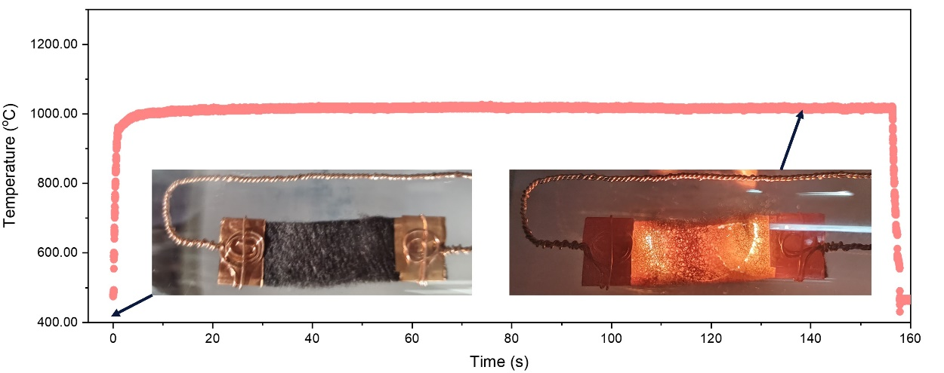
Supplementary Fig. 1. The temporal evolution of temperature during the sintering process.
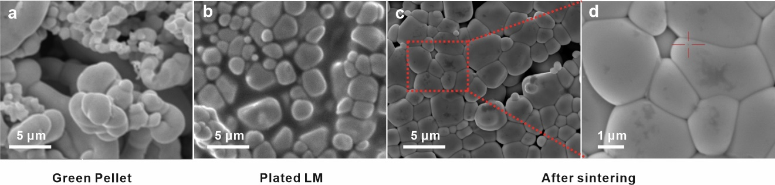
Supplementary Fig. 2. Typical manufacturing process of the refractory metal bulk by the liquid metal-induced bond softening (LMIBS) sintering approach. a, SEM image of the un-sintered refractory metal green pellet. b, SEM image of the green pellet after liquid metal penetration. c-d, SEM image of the refractory metal bulk after rapid sintering.
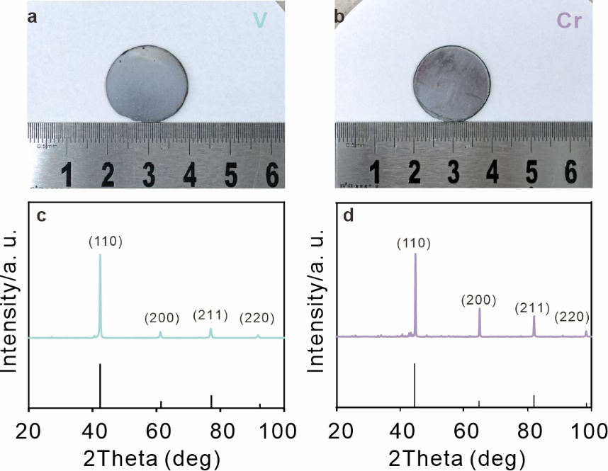
Supplementary Fig. 3. Typical samples of the refractory metal bulk by the LMIBS sintering approach. a-b, Optical images of the 2 as-sintered refractory metal sheets. Contains: V, and Cr. c-d, XRD pattern.
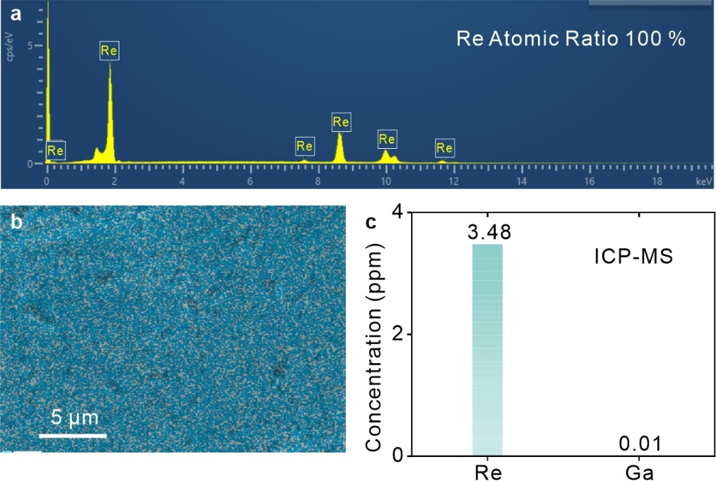
Supplementary Fig. 4. EDS mapping of element distributions in the Re bulk. a, The EDS spectra of Re bulk surface, showing that there are no Ga peaks. b, EDS mapping of Re bulk. c, ICP-MS of the Re and Ga in Re bulk.
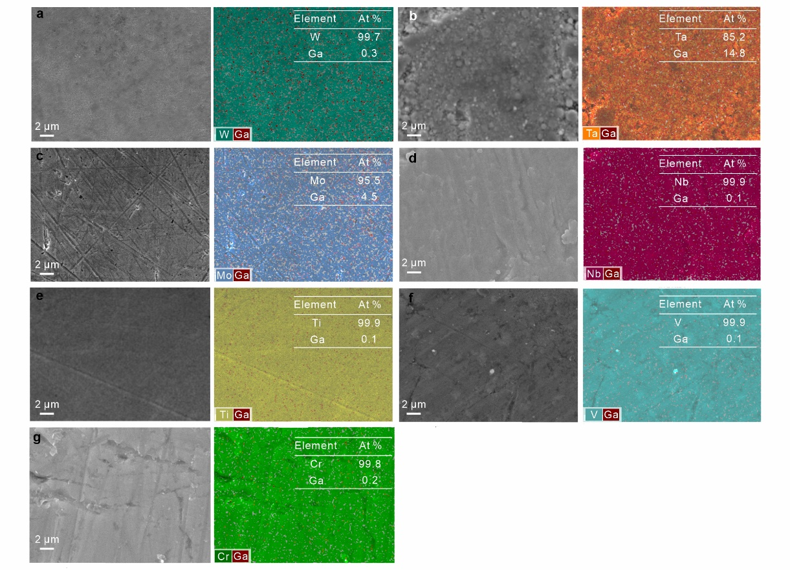
Supplementary Fig. 5. EDS mapping of element distributions in the bulk.
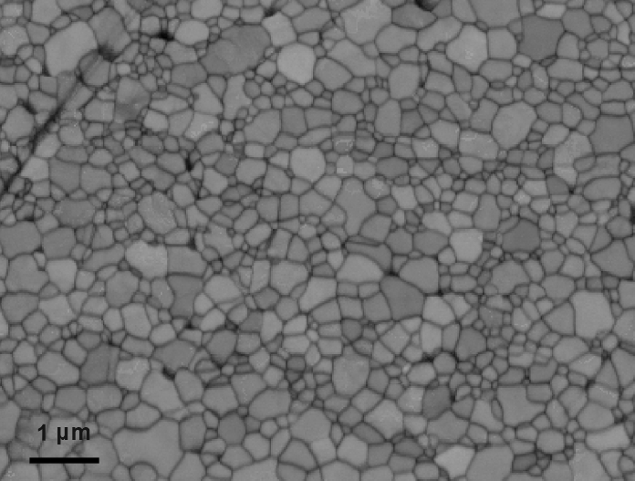
Supplementary Fig. 6. Uniform equiaxed grains by SEM image of the as-sintered Re sample.

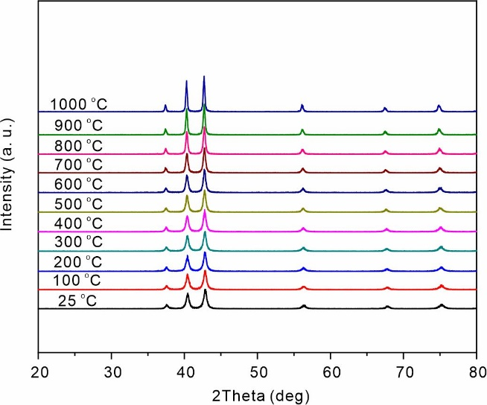
Supplementary Fig. 7. In situ X-ray diffraction pattern indicating the peaks of HCP Re matrix under room temperature (RT) to 1000 ºC.
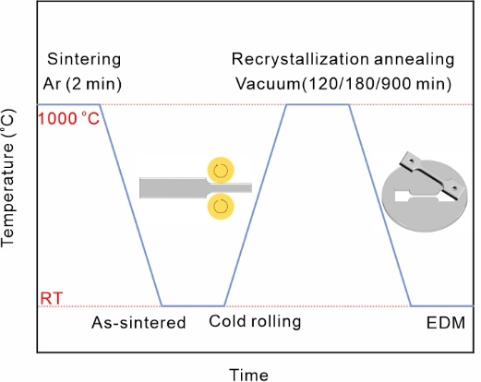
Supplementary Fig. 8. Schematic representation of the sample preparation and thermomechanical treatment process. Insets are schematic of cold-rolling and the cutting region of the tensile specimens by electrical discharge Machining (EDM).

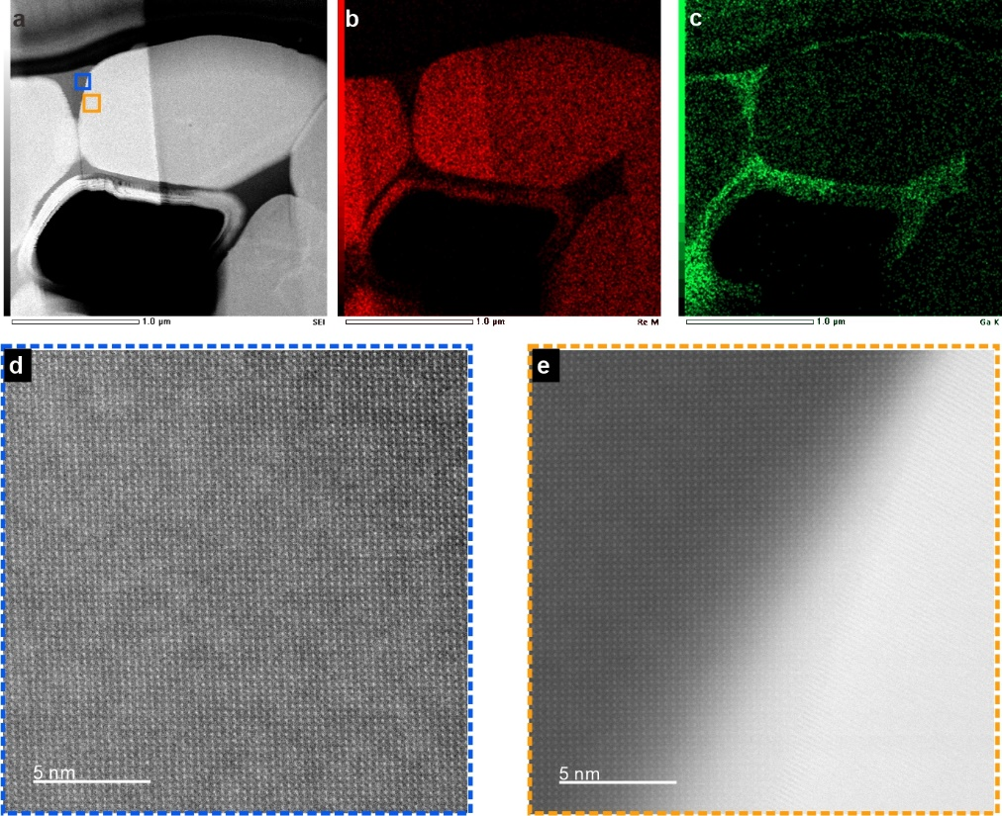
Supplementary Fig. 9. a, ADF-STEM image selected GBs cross-sections. b-c, STEM EDS elemental distribution maps. d-e, Enlarged view of the bule and orange boxed area in a.
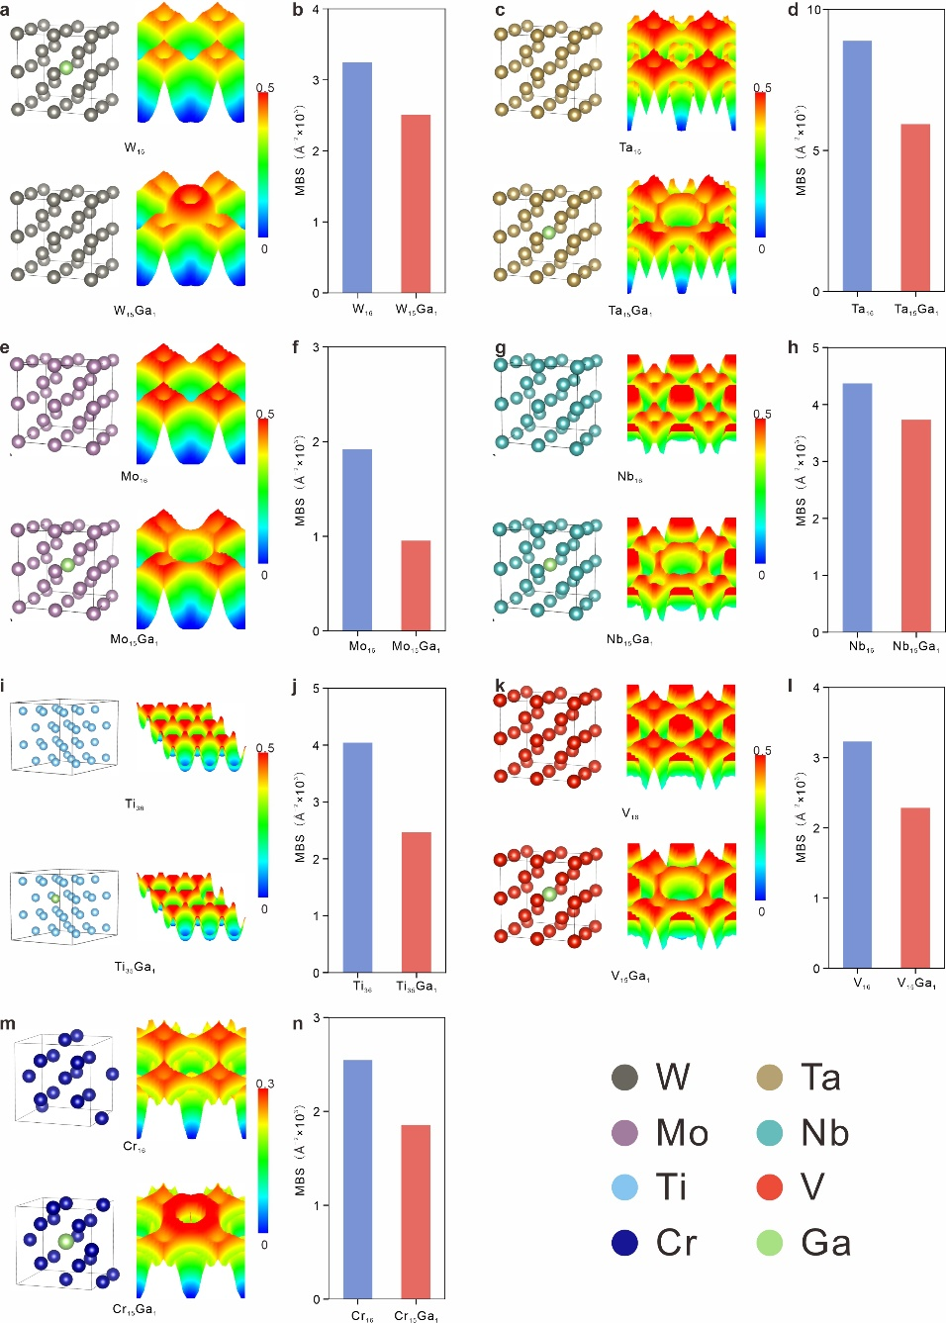
Supplementary Fig. 10. There-dimensional display of the electron localization function analysis and the MBS values of the corresponding pure Re systems and Re-Ga systems.
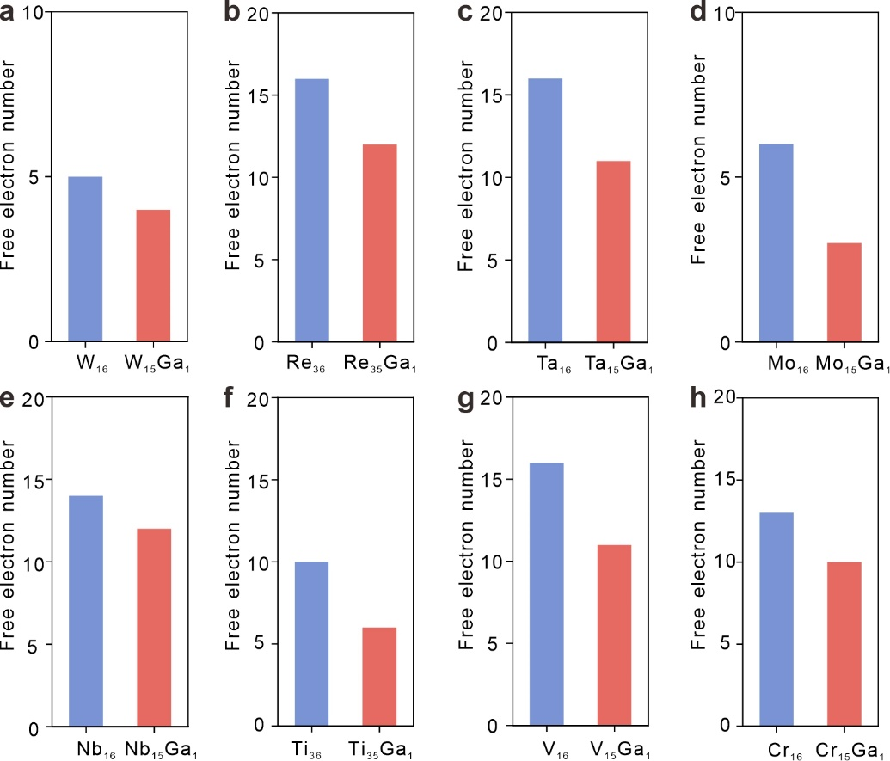
Supplementary Fig. 11. Statistic of the number of free electrons of the corresponding pure refractory metals systems and refractory metals-Ga systems.
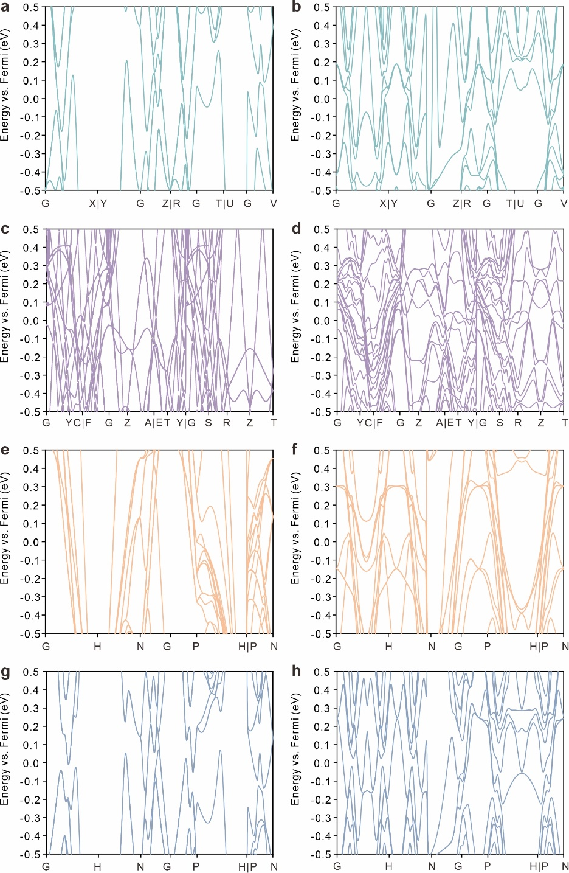
Supplementary Fig. 12. Band structure of a, W₁₆, b, W₁₅Ga₁. c, Re₃₆. d, Re₃₅Ga₁. e, Ta₁₆. f, Ta₁₅Ga₁. g, Mo₁₆. h, Mo₁₅Ga₁.
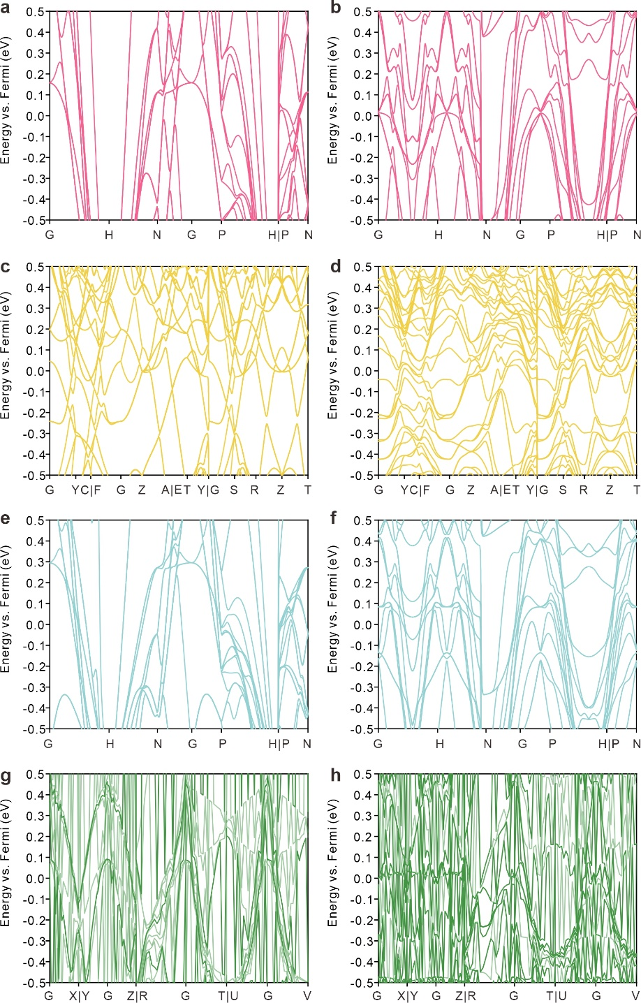
Supplementary Fig. 13. Band structure of a, Nb₁₆, b, Nb₁₅Ga₁. c, Ti₃₆. d, Ti₃₅Ga₁. e, V₁₆. f, V₁₅Ga₁. g, Cr₁₆. h, Cr₁₅Ga₁.
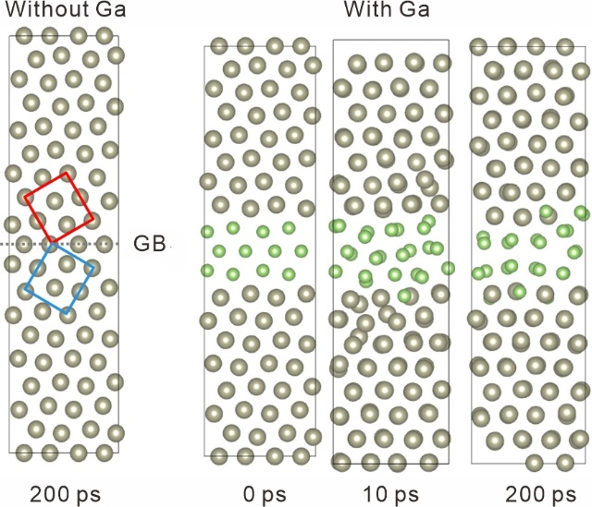
Supplementary Fig. 14. The crystallographic structure model of the tilt grain boundaries (with Ga atoms or without Ga atoms between the grain boundaries), the AIMD simulations were run for 400 ps at a temperature of 1000 ºC.

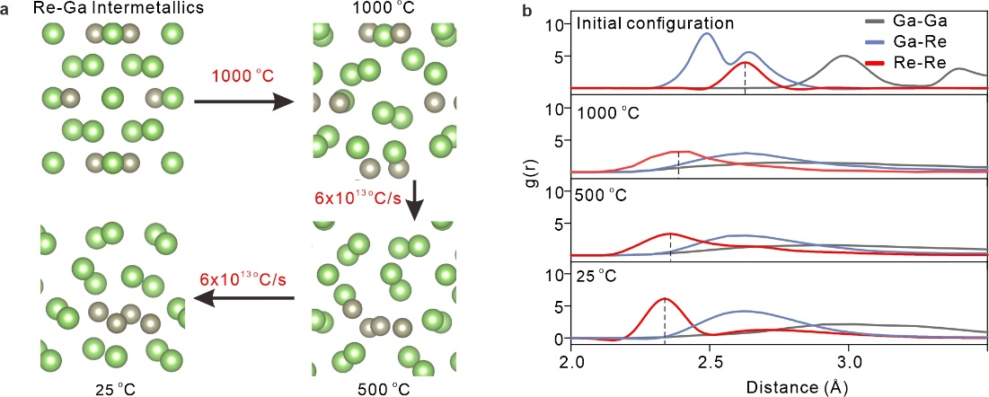
Supplementary Fig. 15. The Re atoms with the large cohesion energy were aggregated and precipitated out of the liquid metal solvent after being released from the intermetallic compounds lattice, while the Ga atoms reconverted to the liquid state. a, The compound model and configurations at 1000 ºC and during rapid cooling. b, Partial-pair distribution function at 1000 ºC and during rapid cooling.
References
1. Kresse, G. & Furthmüller, J. Efficiency of ab-initio total energy calculations for metals and semiconductors using a plane-wave basis set. Comp. Mater. Sci. 6, 15–50 (1996).
2. Kresse, G. & Furthmüller, J. Efficient iterative schemes for ab initio total-energy calculations using a plane-wave basis set. Phys. Rev. B 54, 11169–11186 (1996).

