Highly accurate ab initio gene annotation with ANNEVO
Pengyu Zhang, Tun Xu, Songbo Wang, Xiaofei Yang, Peisen Sun, Peng Jia,
Bo Wang, Stephen J. Bush, Zemin Ning, Kai Ye*
Contents
Supplementary Methods 1
Supplementary Method 1. Annotation Error Identification 1
Supplementary Method 2. ANNEVO model architecture, training, and hyper-parameters 1
Supplementary Method 3. Gene structure decoding 3
Supplementary Notes 6
Supplementary Note 1. Implementation and Execution Scripts for Augustus 6
Supplementary Note 2. Nucleotide-level Evaluation on CDS Region 7
Supplementary Note 3. BUSCO Score Evaluation 7
Supplementary Note 4. Computational Time 8
Supplementary Note 5. Gene Length Statistics and Completeness Evaluation 8
Supplementary Note 6. Implementation and Execution Scripts for BRAKER3 and GeneMark-ETP 8
Supplementary Note 7. Implementation and Execution Scripts for Helixer 9
Supplementary Note 8. Additional Complete BUSCO Genes and RNA-seq Validation 9
Supplementary Note 9. Separate Model Training 10
Supplementary Note 10. Resource Usage and Execution Scripts 10
Supplementary Figures 12
Supplementary Fig. 1 | Distribution of test species for Fungi. 12
Supplementary Fig. 2 | Distribution of test species for Embryophyta. 13
Supplementary Fig. 3 | Distribution of test species for Invertebrate. 14
Supplementary Fig. 4 | Distribution of test species for Vertebrate_other. 15
Supplementary Fig. 5 | Distribution of test species for Mammalia. 16
Supplementary Fig. 6 | Performance comparison of reference databases. 17
Reference 18

Supplementary Methods

Supplementary Method 1. Annotation Error Identification
Although RefSeq provides relatively high-quality annotations, unavoidable errors persist within the data. To minimize the impact of these errors on model training, we conducted a comprehensive review to identify and mask potential annotation errors¹. The main types of errors are as follows:
(1) Missing UTRs. Many genes have annotations where their exons and coding sequences (CDS) are identical, lacking UTR regions. In such cases, a masked region was defined as twice the average length of the 5'UTR and 3'UTR across all genes for that species.
(2) Empty Genes. Some genes are annotated with a genomic range but lack internal structural information. In these cases, the entire gene region was masked.
(3) Missing start or stop codons. This issue typically results from incomplete annotation. For these genes, the region upstream of the first codon or downstream of the last codon was masked. For missing start codons, the region from the gene's start site to the first CDS site was masked.
(4) Erroneous Intron Lengths. In some annotations, intron lengths are significantly shorter than expected. Regions with introns shorter than 30 bp were masked.
(5) CDS phase errors. If a gene's total CDS length is not a multiple of three, phase inconsistencies may arise. To mitigate this, the upstream and downstream regions of the CDS were masked, with a mask length of 1000.
(6) Exon out-of-range errors. Cases where exon annotations extend beyond the gene boundaries were masked.
(7) Overlapping exons within a single gene. Since only the longest transcript was considered, any overlapping exons within a single gene were masked.
(8) Mismatch between exon and CDS. Within the boundaries of the CDS, exon and CDS annotations should align precisely, as UTRs occur only before or after the CDS region. In cases where CDS and exon annotations conflicted, the CDS record was used as the reference, and the conflicting region was masked.

Supplementary Method 2. ANNEVO model architecture, training, and hyper-parameters
ANNEVO model architecture. ANNEVO contains three core modules: Distal Information Modeling Module, Joint Evolutionary Modeling Module, and Multi-task Learning Module. The detailed architecture and data flow are illustrated in Extended Data Fig. 1.
Distal Information Modeling Module. This consists of two main components: local feature extraction and long-range feature modeling (Extended Data Fig. 1a). The local feature extraction component includes two convolutional layers followed by a max pooling layer to process the input sequence. A convolutional tower with four ConvBlocks further extracts local sequence features. Through this process, an input 40kb sequence is compressed into a feature vector of length 1,250, where each position represents the aggregated information of 32 bases from the original sequence. The long-range feature modeling component employs positional encoding from the Transformer framework to incorporate positional information into the compressed feature vector, which is then processed through two Transformer encoder layers, capturing long-range interactions within the sequence.
Joint Evolutionary Modeling Module. This module consists of eight sub-lineage networks and a relationship calculation controller (Extended Data Fig. 1b). Each sub-lineage network contains two Transformer encoder layers that learn evolutionary features. The relationship calculation controller acts as a gating network, defining trainable parameters (equal in size to the feature vector length) that generate position-specific weights via a SoftMax function. Feature vectors from all sub-lineages are combined through weighted summation, producing the final fused feature representation.
Multi-task Learning Module. The module predicts three biologically interrelated tasks: Gene Category (intergenic, UTR, CDS, and intro), phase (0,1,2, or none), and state transitions (Extended Data Fig. 1c). To facilitate knowledge sharing across tasks while maintaining task-specific specialization, the module integrates a shared expert network alongside task-specific components, including individual gating networks, dedicated expert networks, and unique classification layers for each task. The final output format is 32 N, where 32 represents the number of bases summarized by each position after convolution and pooling, and N is the number of categories for the task. Finally, output tensor is reshaped to allow single-nucleotide resolution prediction.
ANNEVO training. ANNEVO employs cross-entropy loss for all three tasks. All categories are equally weighted in the loss function, even when some are rare. This design improves ANNEVO’s scalability, due to the fact that when adding new species, no category-specific weight adjustments are required.
Additionally, ANNEVO uses the AdamW optimizer combined with a cosine annealing schedule to dynamically adjust the learning rate for each epoch. To prevent overfitting, an early stopping mechanism is applied: training stops when the average F1 score of the three tasks on the validation set does not improve for five consecutive epochs. Typically, ANNEVO converges within 10–15 epochs. Resource usage for model training is provided in Supplementary Note 10.
Hyperparameters setting. The performance of deep learning models can be influenced by hyperparameter selection. Therefore, we determined several key parameters and their recommended values are based on the Mammalia model: the batch size was set to 24, the initial learning rate to 1e-3, and the cosine annealing schedule for the learning rate was aligned with the early stopping period to ensure that the model could explore various learning rate magnitudes during the five stagnation epochs. Recommended parameters for network layers are detailed in Extended Data Fig. 1. This set of hyperparameters was uniformly applied to across all other lineage models, ensuring consistent model architecture for further expansions as well as allowing user customization to adjust local pattern extraction depth and sub-lineage count in ANNEVO.

Supplementary Method 3. Gene structure decoding
Identification of potential gene regions.
Traditional sequence-wise decoding approaches suffer from two inherent limitations in parallel computing efficiency: (1) the computational throughput is constrained by both the total number of assembled sequences and the length of the longest sequence, and (2) the decoding process must be uniformly applied across both gene-rich and intergenic regions, regardless of their biological significance. To address these limitations, ANNEVO implements a sliding window strategy¹ that partitions complete sequences into multiple biologically meaningful segments (potential gene regions). This approach provides three significant computational advantages: (1) it maximizes parallel processing capacity by scaling with the number of segments rather than sequence count, (2) it reduces individual processing time to segment length rather than full sequence length, and (3) it eliminates unnecessary computational overhead by selectively avoiding extensive decoding of intergenic regions.
Specifically, since ANNEVO's deep learning model can predict each nucleotide individually, potential gene regions can be identified directly based on the category predictions. In ANNEVO’s deep learning framework, a position is predicted as intergenic only when its non-intergenic probability is less than 0.5. Conversely, for the purpose of regional segmentation, we require a broad potential region rather than precise boundary discrimination. Therefore, we consider a region as a potential gene region if the average non-intergenic probability within continuous sliding window falls below 0.1. This relaxed initial threshold ensures that true gene regions are included within the potential regions while enabling sequence segmentation to improve parallel processing efficiency. Within each identified region, gene structure determination is achieved through position-specific prediction and Viterbi algorithm decoding. A critical feature of this approach is that the emission and state transition probabilities for internal nucleotides remain unaffected by the length of flanking intergenic regions. This characteristic, which fundamentally differs from traditional HMM-based methods, ensures that the initial threshold selection does not affect final gene decoding. In addition, to maintain biological relevance and computational efficiency, the framework implements a minimum segment length filter of 100 nucleotides, based on the biological evidence that eukaryotic genes (including introns) rarely fall below this length threshold. This filtering step simultaneously increases confidence in identified gene regions and reduces decoding time.
State Definition. Based on the gene structure of eukaryotes, 13 fundamental states were defined: intergenic, 5'UTR, 3'UTR, three start codon states (Start0, Start2, Start1), four stop codon states (End0, End1-1, End1-2, End2), and three other codon states (CDS0, CDS1, CDS2) (Extended Data Fig. 2a). Different codon states represent coding nucleotides with different phases. To ensure proper splicing, we incorporated ​intron state groups for UTR and CDS states. We also provided parameters that allow splicing within start and stop codons by introducing five additional intron groups (Extended Data Fig. 2a). Within each intron state group, three splicing modes (GC-AG, GT-AG, AT-AC) were considered (Extended Data Fig. 2b). Each splicing mode includes states representing ​donor and acceptor, along with parameters specifying the ​minimum intron length, which is implemented by extending the number of sub-states within introns. Additionally, we introduced an extra set of ​CDS states to prevent excessively short single-CDS segments (e.g., single-nucleotide CDSs) outside of start and stop codons. Under the default configuration, this framework defines a total of ​46 gene structure states.
Transition Conditions. Certain state transitions require the current nucleotide to meet specific conditions. For example, the first nucleotide of a start codon must be A, and the second nucleotide must be T, among others. Detailed nucleotide requirements for all state transitions are provided in Extended Data Fig. 2.
Utilization of Model Predictions. The category prediction probabilities from the model are used as the emission probabilities for all states except those related to CDS. For example, the emission probabilities for 5'UTR and 3'UTR are equal to the probability of the UTR category from the category predictions. For CDS-related states, the emission probabilities are calculated as the average of the category prediction probabilities and the phase prediction probabilities. Specifically, the emission probabilities for CDS0, CDS2, and CDS1 are the averages of the CDS category prediction probability and the probabilities of phase 0, phase 2, and phase 1, respectively, from the phase predictions. The state transition probabilities are assigned based on the state prediction probabilities for each valid state transition. For example, a UTR state can remain unchanged, and in this case, the UTR-to-UTR transition probability equals the predicted probability of "no state change" at that site. Similarly, if the current nucleotide is A, the UTR-to-Start0 transition probability equals the predicted probability of "state change" at that site. For invalid state transitions (e.g., intergenic to intron), the transition probabilities are uniformly set to 1e-64 to prevent them from influencing path decoding.

Supplementary Notes

Supplementary Note 1. Implementation and Execution Scripts for Augustus
Augustus Training. The training and prediction processes for Augustus² (v3.5.0) followed standard protocols. Gene models were trained separately for each species in the ANNEVO training set. For each target species, the closest evolutionarily related species was identified using ete3³ (v3.1.3), and the gene model of that was used for gene prediction. All training processes were conducted with Augustus's default parameters:
new_species.pl --species= closest_species
gff2gbSmallDNA.pl path_to_closest_species_annotation path_to_ closest_species_genome 1000 train_with_sequences.gb
etraining --species=closest_species train_with_sequences.gb
Augustus Ab Initio Prediction Using DNA Sequence Only. To accelerate the gene prediction process in Augustus while ensuring consistent results, we employed a parallelized approach based on sequence segmentation. Specifically, the original genome was divided into multiple sequence-level fragments using SeqKit⁴ (v2.8.2). Gene prediction for each fragment was then performed in parallel using GNU parallel⁵ (v20160622), with each fragment processed using the gene model of the closest evolutionary relative and default parameters. Finally, the annotation results from all fragments were merged to produce the final gene annotation. All prediction processes were conducted with Augustus's default parameters:
augustus --species= closest_species path_to_genome > path_to_output_gff
Augustus Prediction Assisted by Evidence. To maximize the coverage of differentially expressed genes, we selected RNA-seq data from five different tissues (or growth stages for fungal species) from the SRA database for each test model species. The tissues (or growth stages) and their corresponding SRA Run Accessions of the RNA-seq data are listed in Supplementary Table 9. RNA-seq reads were quality-controlled using fastp⁶ (v0.23.4) with default parameters. The reads were then aligned and sorted using HISAT2⁷ (v2.2.1) and SAMtools⁸ (v1.12), both with default settings. Finally, Augustus's built-in tool bam2hints was used to extract the hints from the resulting BAM files to assist with gene prediction. These steps were performed separately for each RNA-seq dataset, and the resulting hint files was merged into a single input file for Augustus.
To incorporate homologous protein evidence, we first extracted protein sequences from the closest evolutionary relative of the target species using gffread⁹. These protein sequences were then aligned to the genome of the target species using miniprot¹⁰ (v0.13), and all CDS hints from the alignment results were used as input for hints in Augustus gene prediction. Compared to the standard workflow, we replaced exonerate with miniprot, due to its significantly higher speed and effectiveness in gene annotation¹⁰.
Augustus processes RNA-seq hints primarily as intron hints, while homologous protein hints provide CDS information. Since these two types of evidence are complementary, we combined them into a combined hints file to enhance Augustus gene prediction performance. Compared to the script in Prediction using DNA Sequence Only, Augustus adds an extra parameter during prediction: --hintsfile=path_to_rna_protein.hints.gff.

Supplementary Note 2. Nucleotide-level Evaluation on CDS Region
For two key reasons, we chose to evaluate model performance on coding sequence (CDS) regions rather than exons: first, many genes lack UTR annotations, particularly in the fungal lineage, where some species have no UTR annotations at all; second, Augustus, in its default usage, does not explicitly predict UTRs. Therefore, to ensure a consistent performance evaluation standard, we focused on CDS regions.
For reference annotations, we used the longest transcript for each gene as the ground truth. To minimize the impact of erroneous information, we excluded the reference annotation regions that were flagged as potential errors. Additionally, since each nucleotide can only have one label, for overlapping genes on the same strand of the genome, only the first label of the gene was retained to prevent label conflicts. Based on this, we calculated true positives (TP), false positives (FP), and true negatives (TN) for unmasked CDS sites, and CDS-F1 was computed using the following formula:
$$Recall=\frac{TP}{TP+FN}$$
$$Precision=\frac{TP}{TP+FP}$$
$$NT(CDS)-F1=\frac{2×Recall×Precision}{Recall+Precision}$$

Supplementary Note 3. BUSCO Score Evaluation
BUSCO score evaluation. Protein sequences were extracted from genome annotation using gffread⁹ (v0.12.7). Gene models with duplication gene or transcript IDs were filtered out (which could cause BUSCO to fail). Subsequently, annotation quality was then evaluated using BUSCO¹¹ (v5.3.2) in protein mode. Different databases were selected for different lineages: mammalia_odb10 for Mammalia, embryophyta_odb10 for Embryophyta, fungi_odb10 for Fungi, vertebrata_odb10 for Vertebrate_other, and metazoa_odb10 for Invertebrate. The script is as follows:
gffread -y path_to_output_protein -g path_to_genome path_to_annotation
busco -i path_to_output_protein -c 48 -o output_dir -m prot -l busco_database --offline -f
Parasitic-Reduced Genomes. During the BUSCO evaluation of the fungal species in RefSeq, 16 species triggered the warning: “The missing BUSCOs match the pattern of a parasitic-reduced genome.” This indicates that the original BUSCO scores for these genomes are severely biased. However, in Mitosporidium daphniae (Database: RefSeq, Version: GCF_000760515.2_UGP1.1), we observed a clear error in the automatically corrected BUSCO report, which stated: “A corrected score would be: C:83.0%[S:80.2%,D:2.8%],F:35.6%,M:-18.6%,n:253.” To ensure result reliability, we excluded all genomes flagged as “Parasitic-reduced genome” from our analyses. This issue was specific to the fungal lineage, affecting 2.6% of the fungal species in RefSeq.

Supplementary Note 4. Computational Time
We compared the runtime of ANNEVO and Augustus for 171 species in Embryophyta and Mammalia with genome sizes smaller than that of humans (0.11 Gb to 3.11 Gb). Both methods were run on the same CPU node using 48 parallel CPU cores (Supplementary Note 10). In addition to gene structure decoding, ANNEVO required extra time for the model prediction stage, which was conducted on a GPU cluster node (Supplementary Note 10).

Supplementary Note 5. Gene Length Statistics and Completeness Evaluation
To evaluate performance across different gene lengths, we analyzed gene predictions in Mammalia, as this group exhibits a broader distribution of gene lengths (Fig. 2c). Gene length was defined as the distance between the start codon and end codon in the longest transcript (including introns). Genes were categorized into four length groups: 0–10 kb, 10–40 kb, 40–100 kb, and greater than 100 kb. For each group, we assessed the proportion of genes predicted as complete using the same criteria as the gene-F1 metric.

Supplementary Note 6. Implementation and Execution Scripts for BRAKER3 and GeneMark-ETP
BRAKER3 Pipelines Predictions. BRAKER3¹² takes the genome, aligned RNA-seq, and homologous proteins as inputs, where the processing of RNA-seq and homologous proteins follows the same protocol as Augustus described above. The pipeline was run as follows:
braker.pl --genome=genome.softmasked.fasta --prot_seq=proteins.fa \
--rnaseq_sets_dirs=/location/of/local/RNA_Seq/Files \
--rnaseq_sets_ids=RNA_Seq_IDS --threads=48 --gff3
GeneMark-ETP Pipelines Predictions. The GeneMark-ETP¹³ pipeline generates initial gene predictions, which are then seamlessly integrated into the BRAKER3 workflow as input components. For performance benchmarking consistency, the GeneMark-ETP results were directly extracted from BRAKER3's execution outputs during comparative evaluation, ​as documented in the BRAKER3 publication. Then, we used the built-in script from the Another GFF Analysis Toolkit (AGAT) v1.4.2 to convert the data into a GFF file format for further analysis.
agat_convert_sp_gxf2gxf.pl -gtf path_to_gtf_file -o path_to_gff_file

Supplementary Note 7. Implementation and Execution Scripts for Helixer
Helixer Predictions. The code of Helixer^{1,14} was downloaded on 2025-03-22, with its last update dated February 2025. According to the commands provided on GitHub, the full prediction process is executed in three steps:
fasta2h5.py --species species_name --h5-output-path species_name.h5 --fasta-path path_to_genome --subsequence-length customized_length
HybridModel.py --load-model-path path_to_model --test-data Species_name.h5 --overlap --val-test-batch-size 32 -v --predict-phase
helixer_post_bin species_name.h5 predictions.h5 100 0.1 0.8 60 output_gff
Helixer employs lineage-specific subsequence length parameters across evolutionary lineages, a design choice that may optimize current performance metrics but could impede the development of unified cross-lineage models. As specified in Helixer, the implementation utilizes distinct parameterizations: Fungi (21384 bp), Embryophyta (64152 bp), and Invertebrate/Mammalia/Vertebrate_other lineages (213840 bp). Model selection adhered to the following protocol: (1) Primary selection of Helixer's designated optimal architecture for each lineage; (2) Substitution with alternative models when the optimal model's training set contained model species used for evaluation, ensuring exclusion of test species from training data. The finalized model assignments for each species are cataloged in Supplementary Table 27.

Supplementary Note 8. Additional Complete BUSCO Genes and RNA-seq Validation
We summarized BUSCO genes classified as 'Complete' in ANNEVO annotations but not in Ensembl, and used RNA-seq data from three tissues (SRR5195360, SRR8494318, and SRR28707126) to assess the accuracy of these predictions. Since Ensembl's annotation of Brassica oleracea lacks UTR annotations (i.e., all exon records fully overlap with CDS regions, making it impossible to infer UTR regions implicitly), we focused only on the CDS region and the splice sites therein. We therefore only display the CDS region in IGV. We manually reviewed all additional gene annotations using RNA-seq coverage and junction tracks, classifying them into four categories based on the types of errors (Fig. 4c).

Supplementary Note 9. Separate Model Training
The decision to train five distinct clade-specific models, rather than a single pan-taxonomic model, stemmed from the need to balance evolutionary signal preservation with computational tractability. While a unified model could theoretically capture higher-dimensional representations of vertical genetic relationships across the entire phylogenetic tree, resource constraints imposed critical trade-offs: increasing model capacity to span broader taxonomic diversity (horizontal space) inevitably reduced resolution for lineage-specific feature learning. Under fixed computational resource, training five clade-specific models (Fungi, Embryophyta, Invertebrate, Vertebrate_other, and Mammalia) effectively simulated evolutionary patterns across 40 sub-lineages (5 clades × 8 representative lineages each). In contrast, a single-model approach could only resolve signals from 8 sub-lineages.
This multi-model paradigm preserves deep vertical phylogenetic signals within each major clade while maintaining sufficient horizontal resolution to accommodate intra-clade diversity. The RefSeq-defined clade groupings provided biologically validated partitions that minimize information loss between evolutionarily distant lineages. Excessive model proliferation (>10) was avoided to prevent fragmentation of conserved ancestral genetic architectures.

Supplementary Note 10. Resource Usage and Execution Scripts
ANNEVO training. ANNEVO training was conducted on cluster GPU nodes with the following configuration: four Tesla V100S GPUs (CUDA Version:11.1), 376G of RAM, and an Intel(R) Xeon(R) Gold 6240 CPU (2.60GHz). Training time and peak memory usage depended on the dataset size, ranging from 5 hours per epoch with 152G of memory (the Fungi model) to 10 hours per epoch with 272G of memory (the Vertebrate_other model). Consequently, the training process for each lineage typically lasted 3–6 days. During training, the total GPU usage was 108G.
ANNEVO prediction. Predictions were run on the same GPU nodes used for training. Memory and computation were optimized by adjusting the batch size and chunking strategy. For the human genome (RefSeq, version: GCF_000001405.40_GRCh38.p14), peak GPU and RAM usage were 6G and 117G, respectively. Furthermore, ANNEVO allows the adjustment of resource-related parameters to accommodate personal computer (PC) environments. When the number of chunks were set to 20, peak RAM usage was reduced to 49G. The prediction script is as follows:
python -m ANNEVO.prediction --genome path_to_genome --lineage selected_lineage --model_prediction_path path_to_save_predction
Gene structure decoding. The gene decoding phase of ANNEVO was conducted on a cluster CPU node with 376G of RAM, an Intel(R) Xeon(R) Gold 6240 CPU (2.60GHz), and 48 CPU cores. The memory requirement during decoding was primarily influenced by the number of chunks and the number of parallel CPU cores. Under the default parameters (5 chunks and 48 parallel cores), the peak memory usage for decoding the human genome was 201G. When the number of chunks and parallel cores were adjusted to 20 and 8, respectively, the peak memory usage decreased to 44G. ANNEVO’s decoding algorithm operates independently of repeat-masking status, accepting genome assemblies without repeat mask. For soft-masked genomes, repeat regions are automatically detected through lowercase nucleotide filtering, and their presence only modulates gene confidence scores (via posterior probability adjustments) without affecting the decoding pathway. For model organisms with well-characterized intron length distributions, we applied the parameter --min_intron_length 30 to enforce biologically realistic intron size constraints. The decoding prediction script is as follows:
python -m ANNEVO.decoding --genome path_to_genome --model_prediction_path path_to_save_predction --output path_to_gff --cpu_num 48

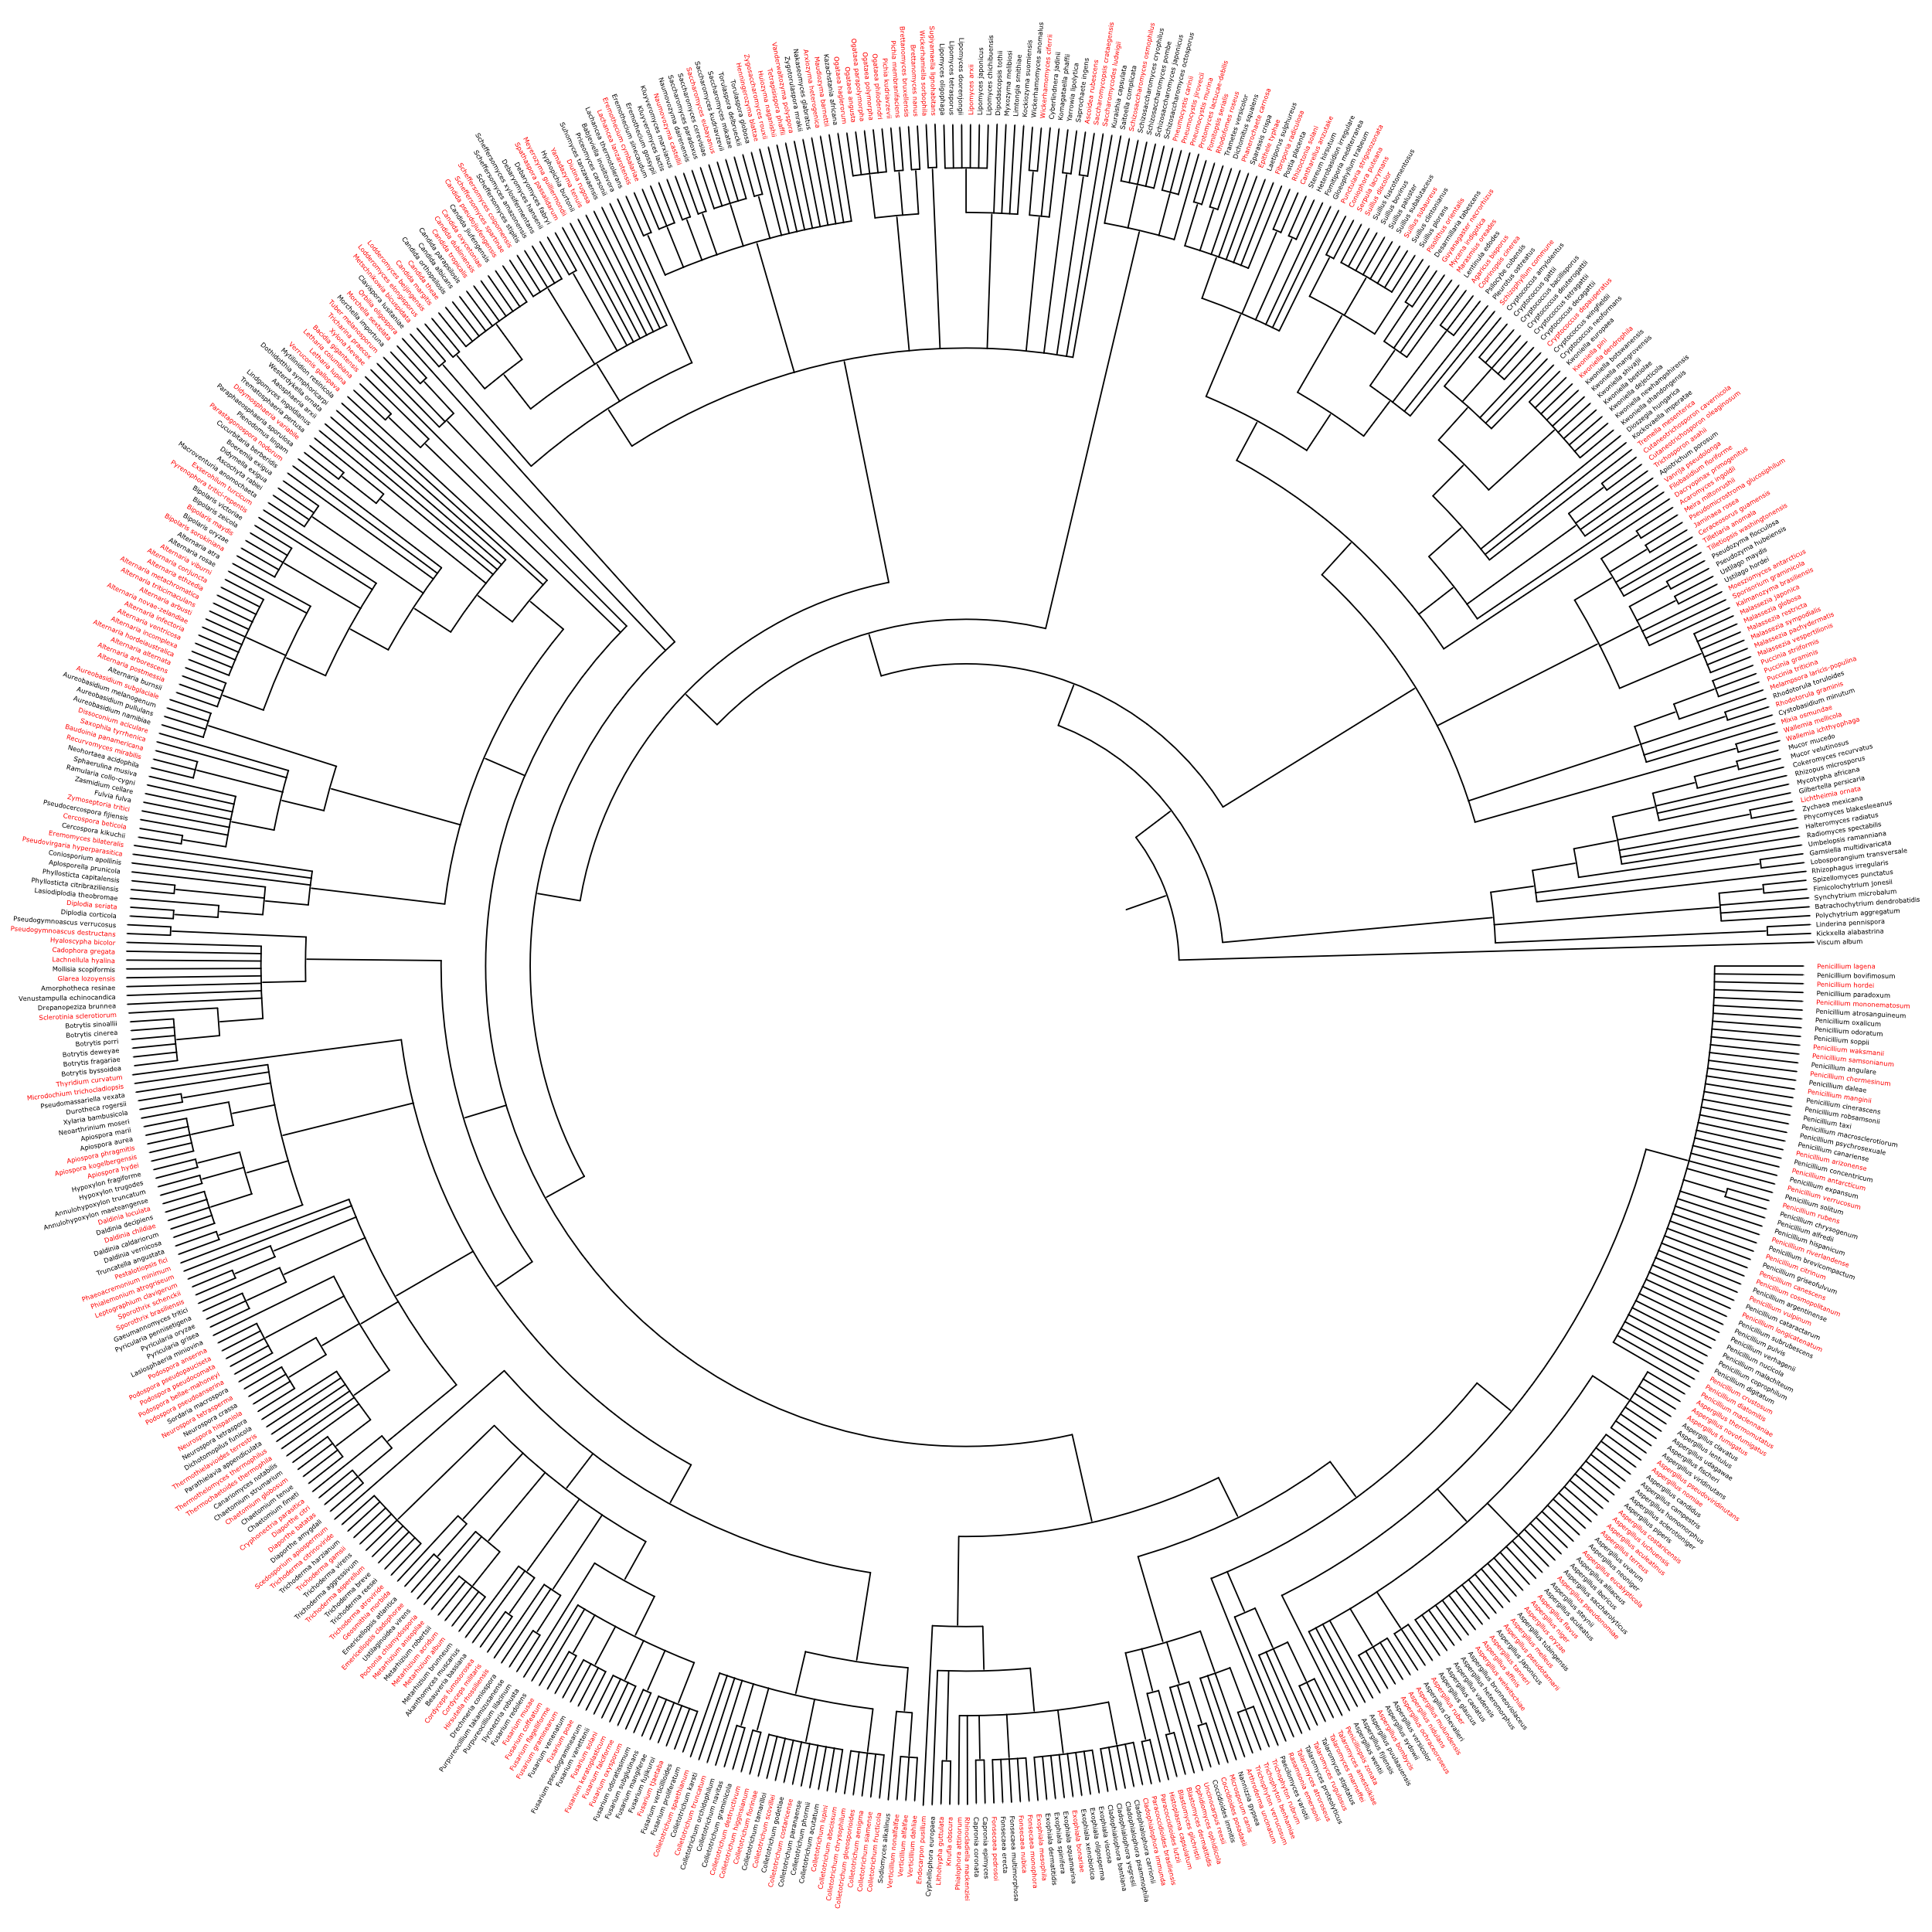
Supplementary Figures

Supplementary Fig. 1 | Distribution of test species for Fungi.
Test species (highlighted in red, n=288) represent phylogenetically distinct lineages, ensuring rigorous evaluation of model generalizability across broad evolutionary scales. Training species (n=306; Supplementary Table 17) were selected to maximize evolutionary diversity, enabling recovery of deep ancestral signals in vertical genomic dimensions. Genome size of training species spanned 9.5 Gb. Taxonomic assignments follow the NCBI Taxonomy database¹⁵.

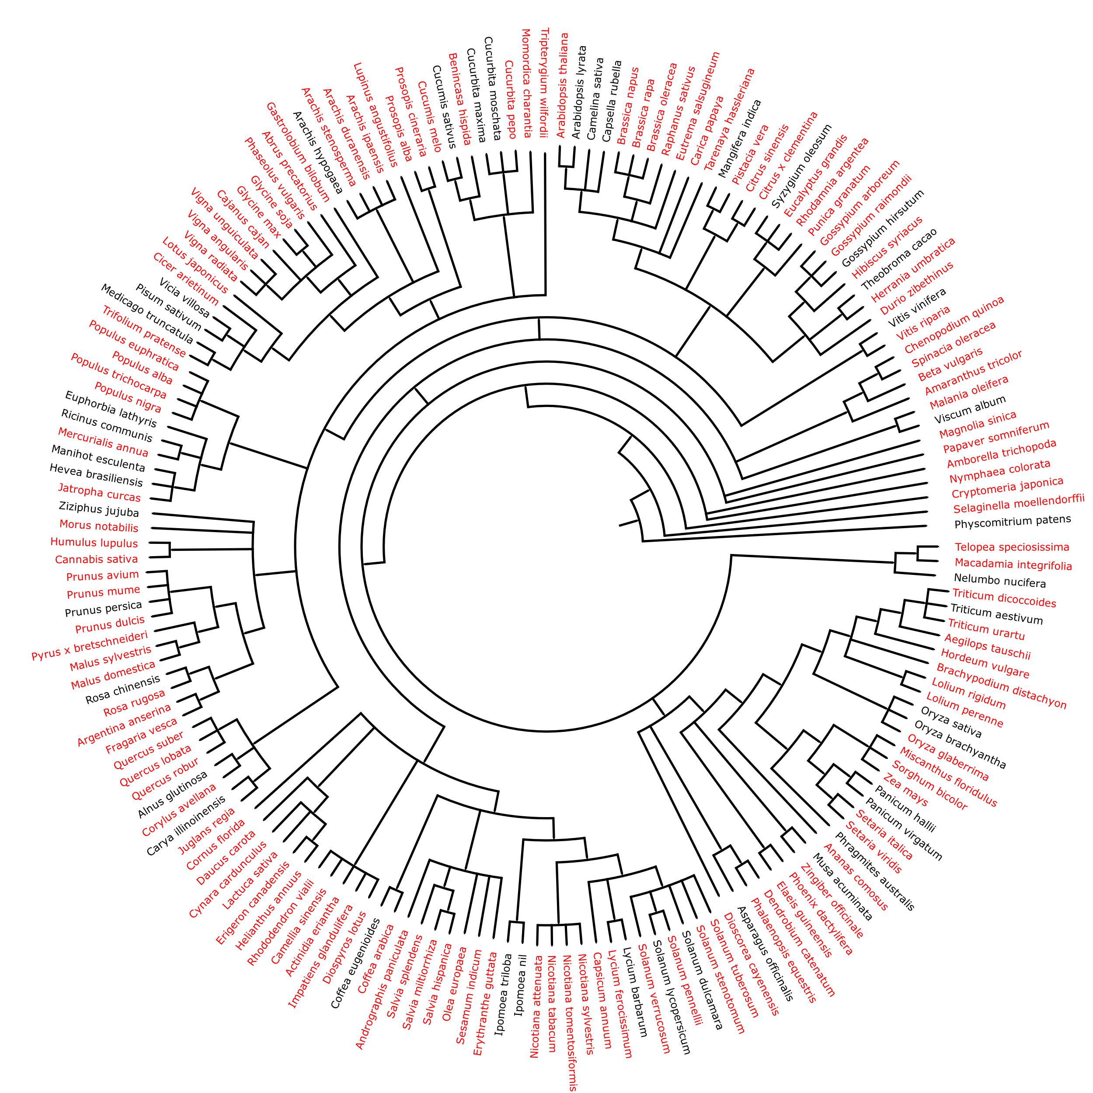
Supplementary Fig. 2 | Distribution of test species for Embryophyta.
Test species (highlighted in red, n=128) represent phylogenetically distinct lineages, ensuring rigorous evaluation of model generalizability across broad evolutionary scales. Training species (n=40; Supplementary Table 18) were selected to maximize evolutionary diversity, enabling recovery of deep ancestral signals in vertical genomic dimensions. Genome size of training species spanned 45 Gb. Taxonomic assignments follow the NCBI Taxonomy database¹⁵.

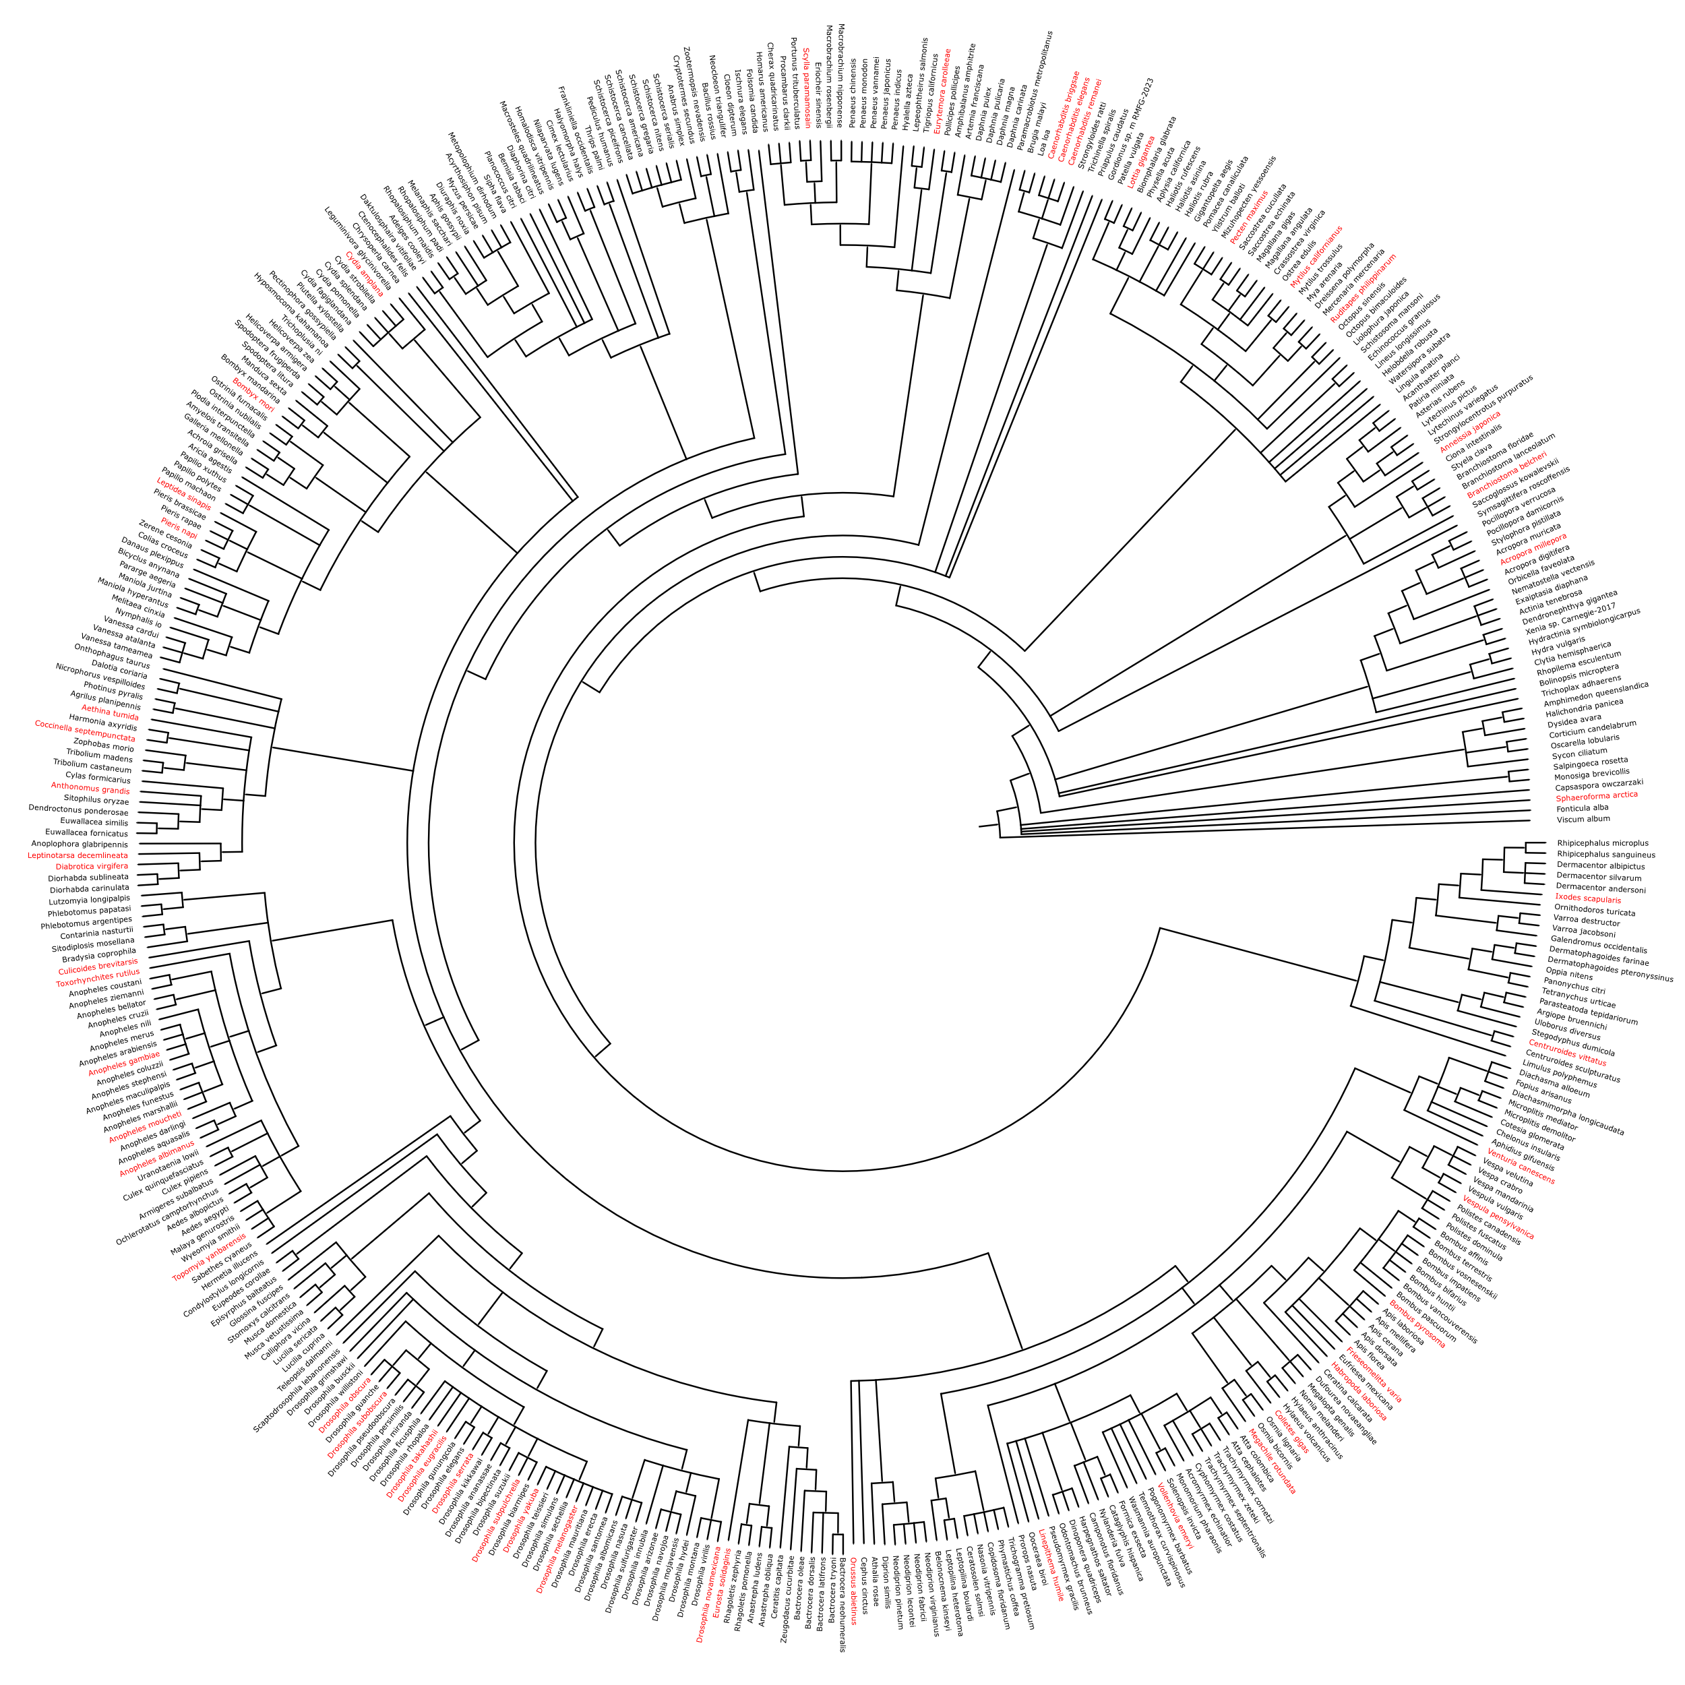
Supplementary Fig. 3 | Distribution of test species for Invertebrate.
Due to the large genome sizes of metazoans, 50 widely distributed species (including key model organisms) were randomly subsampled from candidate test sets to balance taxonomic diversity and computational feasibility. Test species (highlighted in red, n=50) represent phylogenetically distinct lineages, ensuring rigorous evaluation of model generalizability across broad evolutionary scales. Training species (n=58; Supplementary Table 19) were selected to maximize evolutionary diversity, enabling recovery of deep ancestral signals in vertical genomic dimensions. Genome size of training species spanned 40.4 Gb. Taxonomic assignments follow the NCBI Taxonomy database¹⁵.

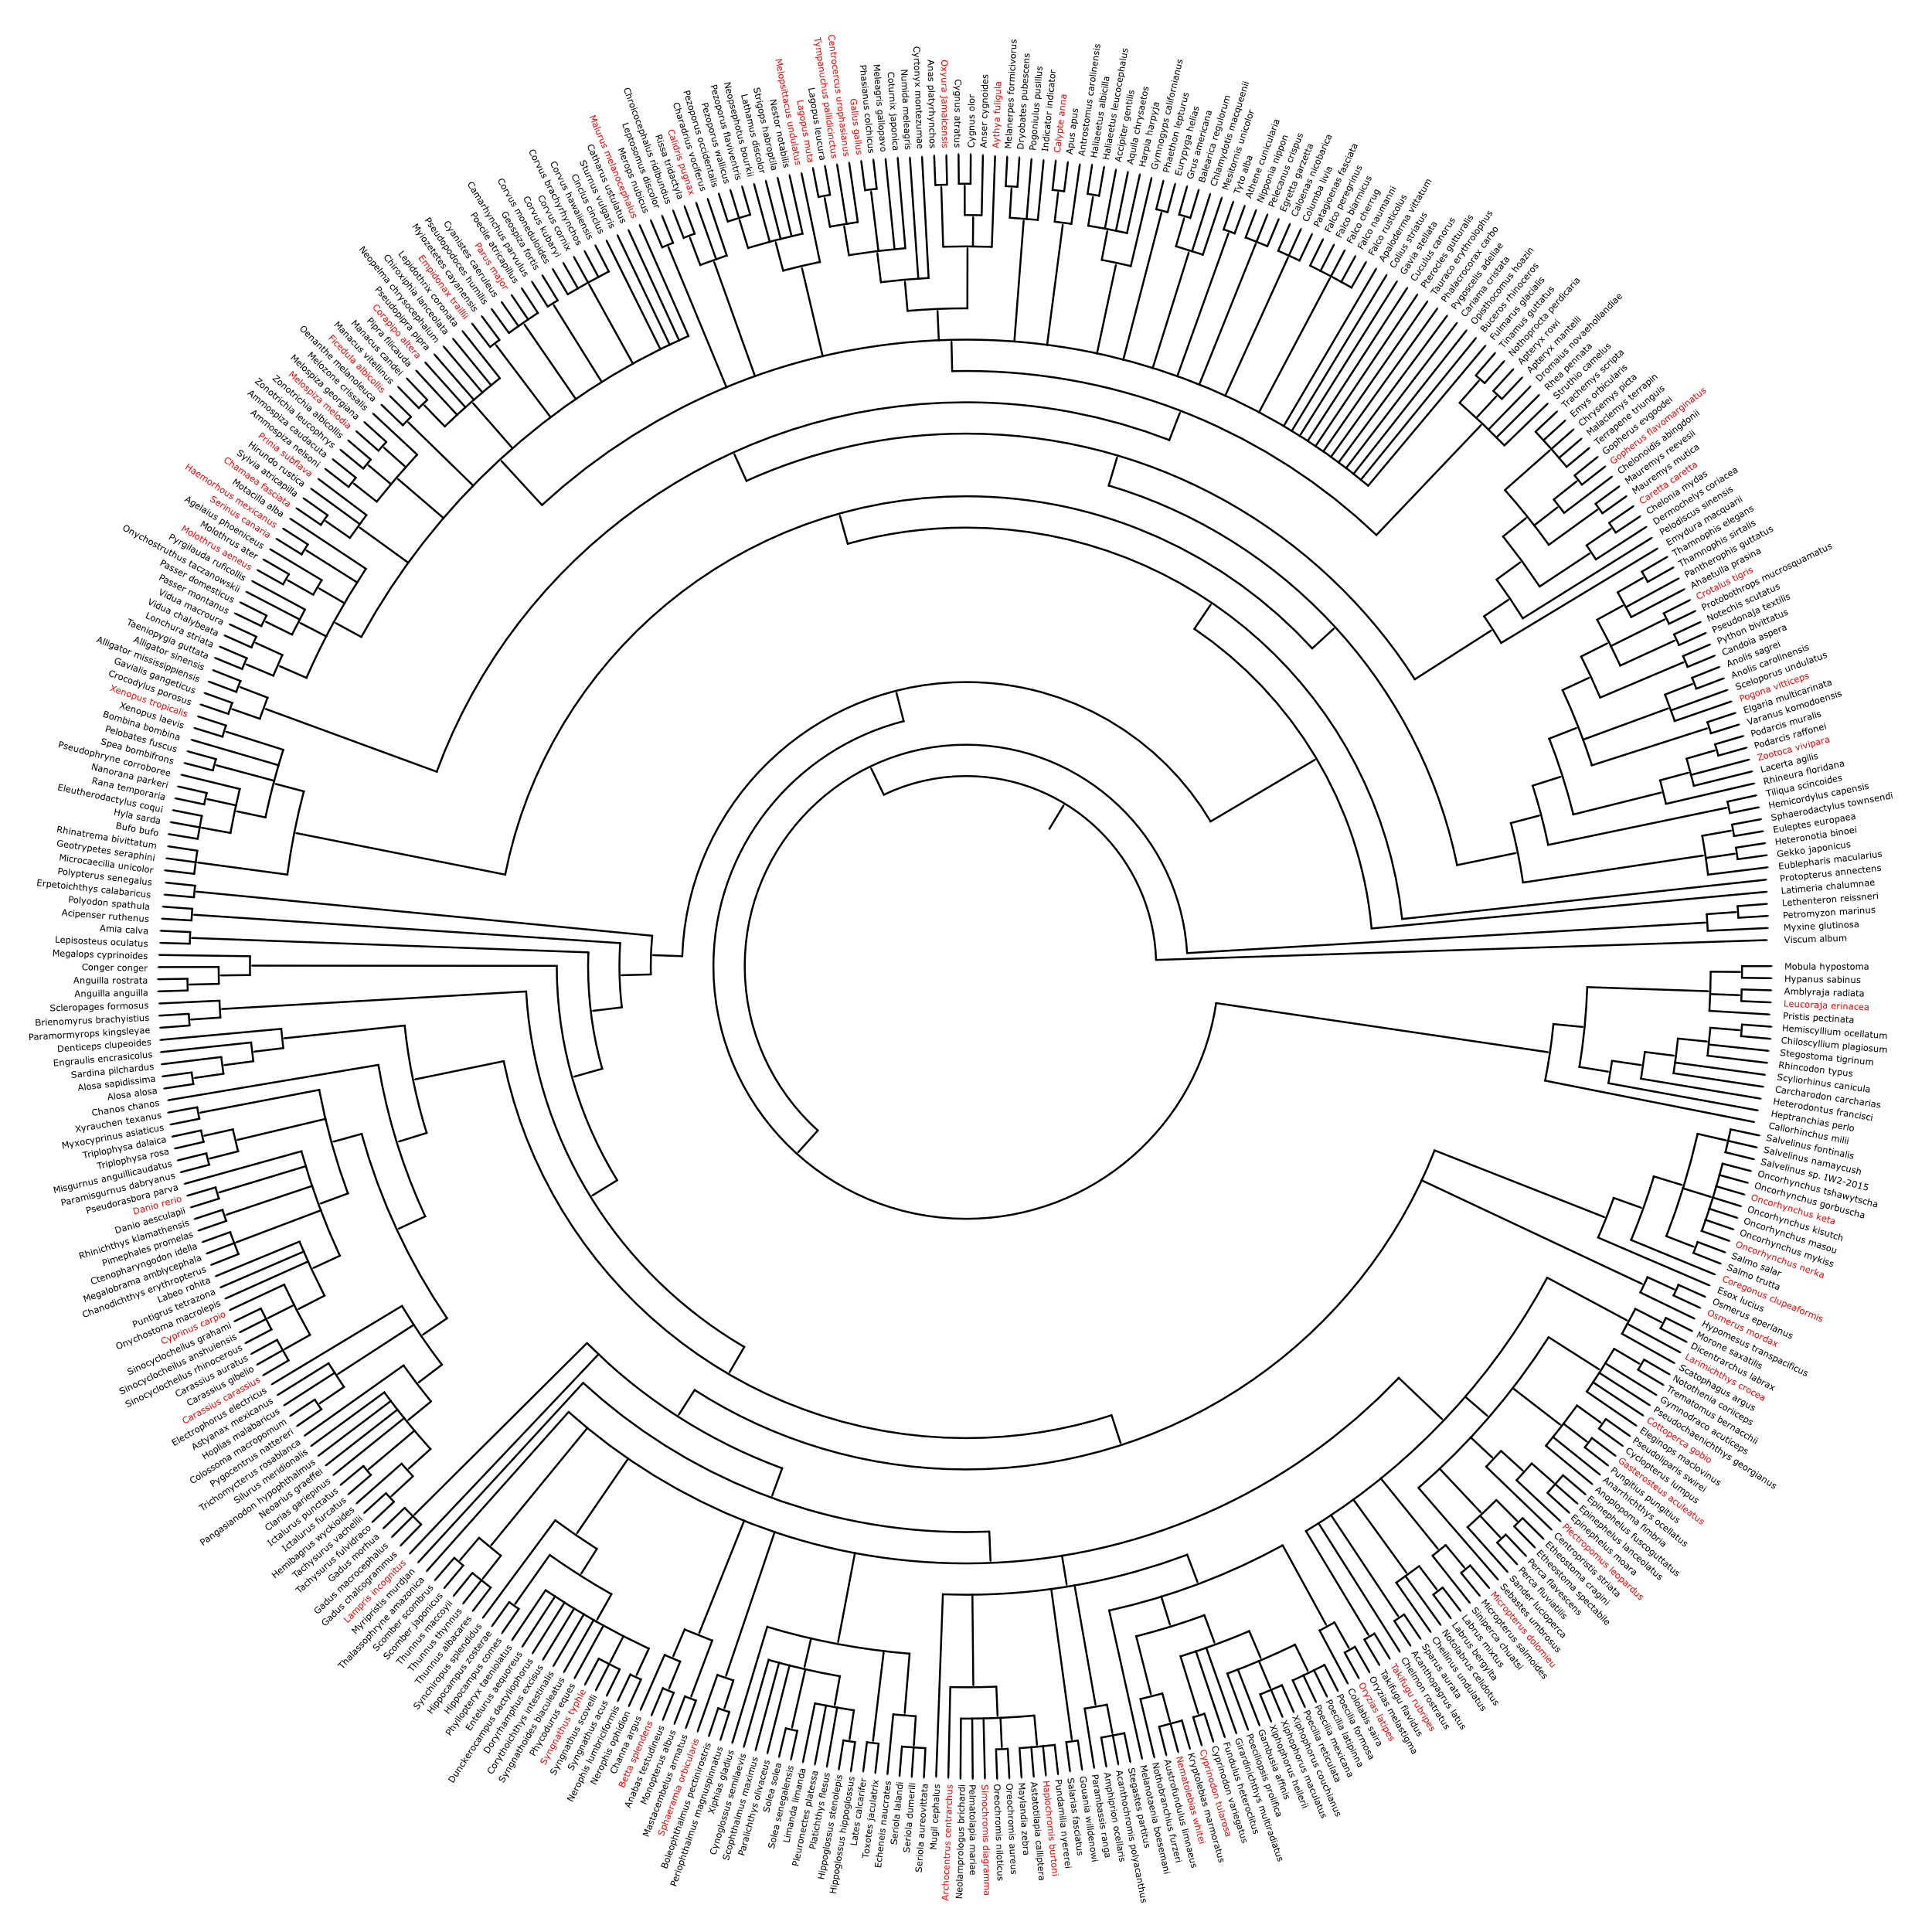
Supplementary Fig. 4 | Distribution of test species for Vertebrate_other.
Due to the large genome sizes of metazoans, 50 widely distributed species (including key model organisms) were randomly subsampled from candidate test sets to balance taxonomic diversity and computational feasibility. Test species (highlighted in red, n=50) represent phylogenetically distinct lineages, ensuring rigorous evaluation of model generalizability across broad evolutionary scales. Training species (n=30; Supplementary Table 20) were selected to maximize evolutionary diversity, enabling recovery of deep ancestral signals in vertical genomic dimensions. Genome size of training species spanned 47.4 Gb. Taxonomic assignments follow the NCBI Taxonomy database¹⁵.

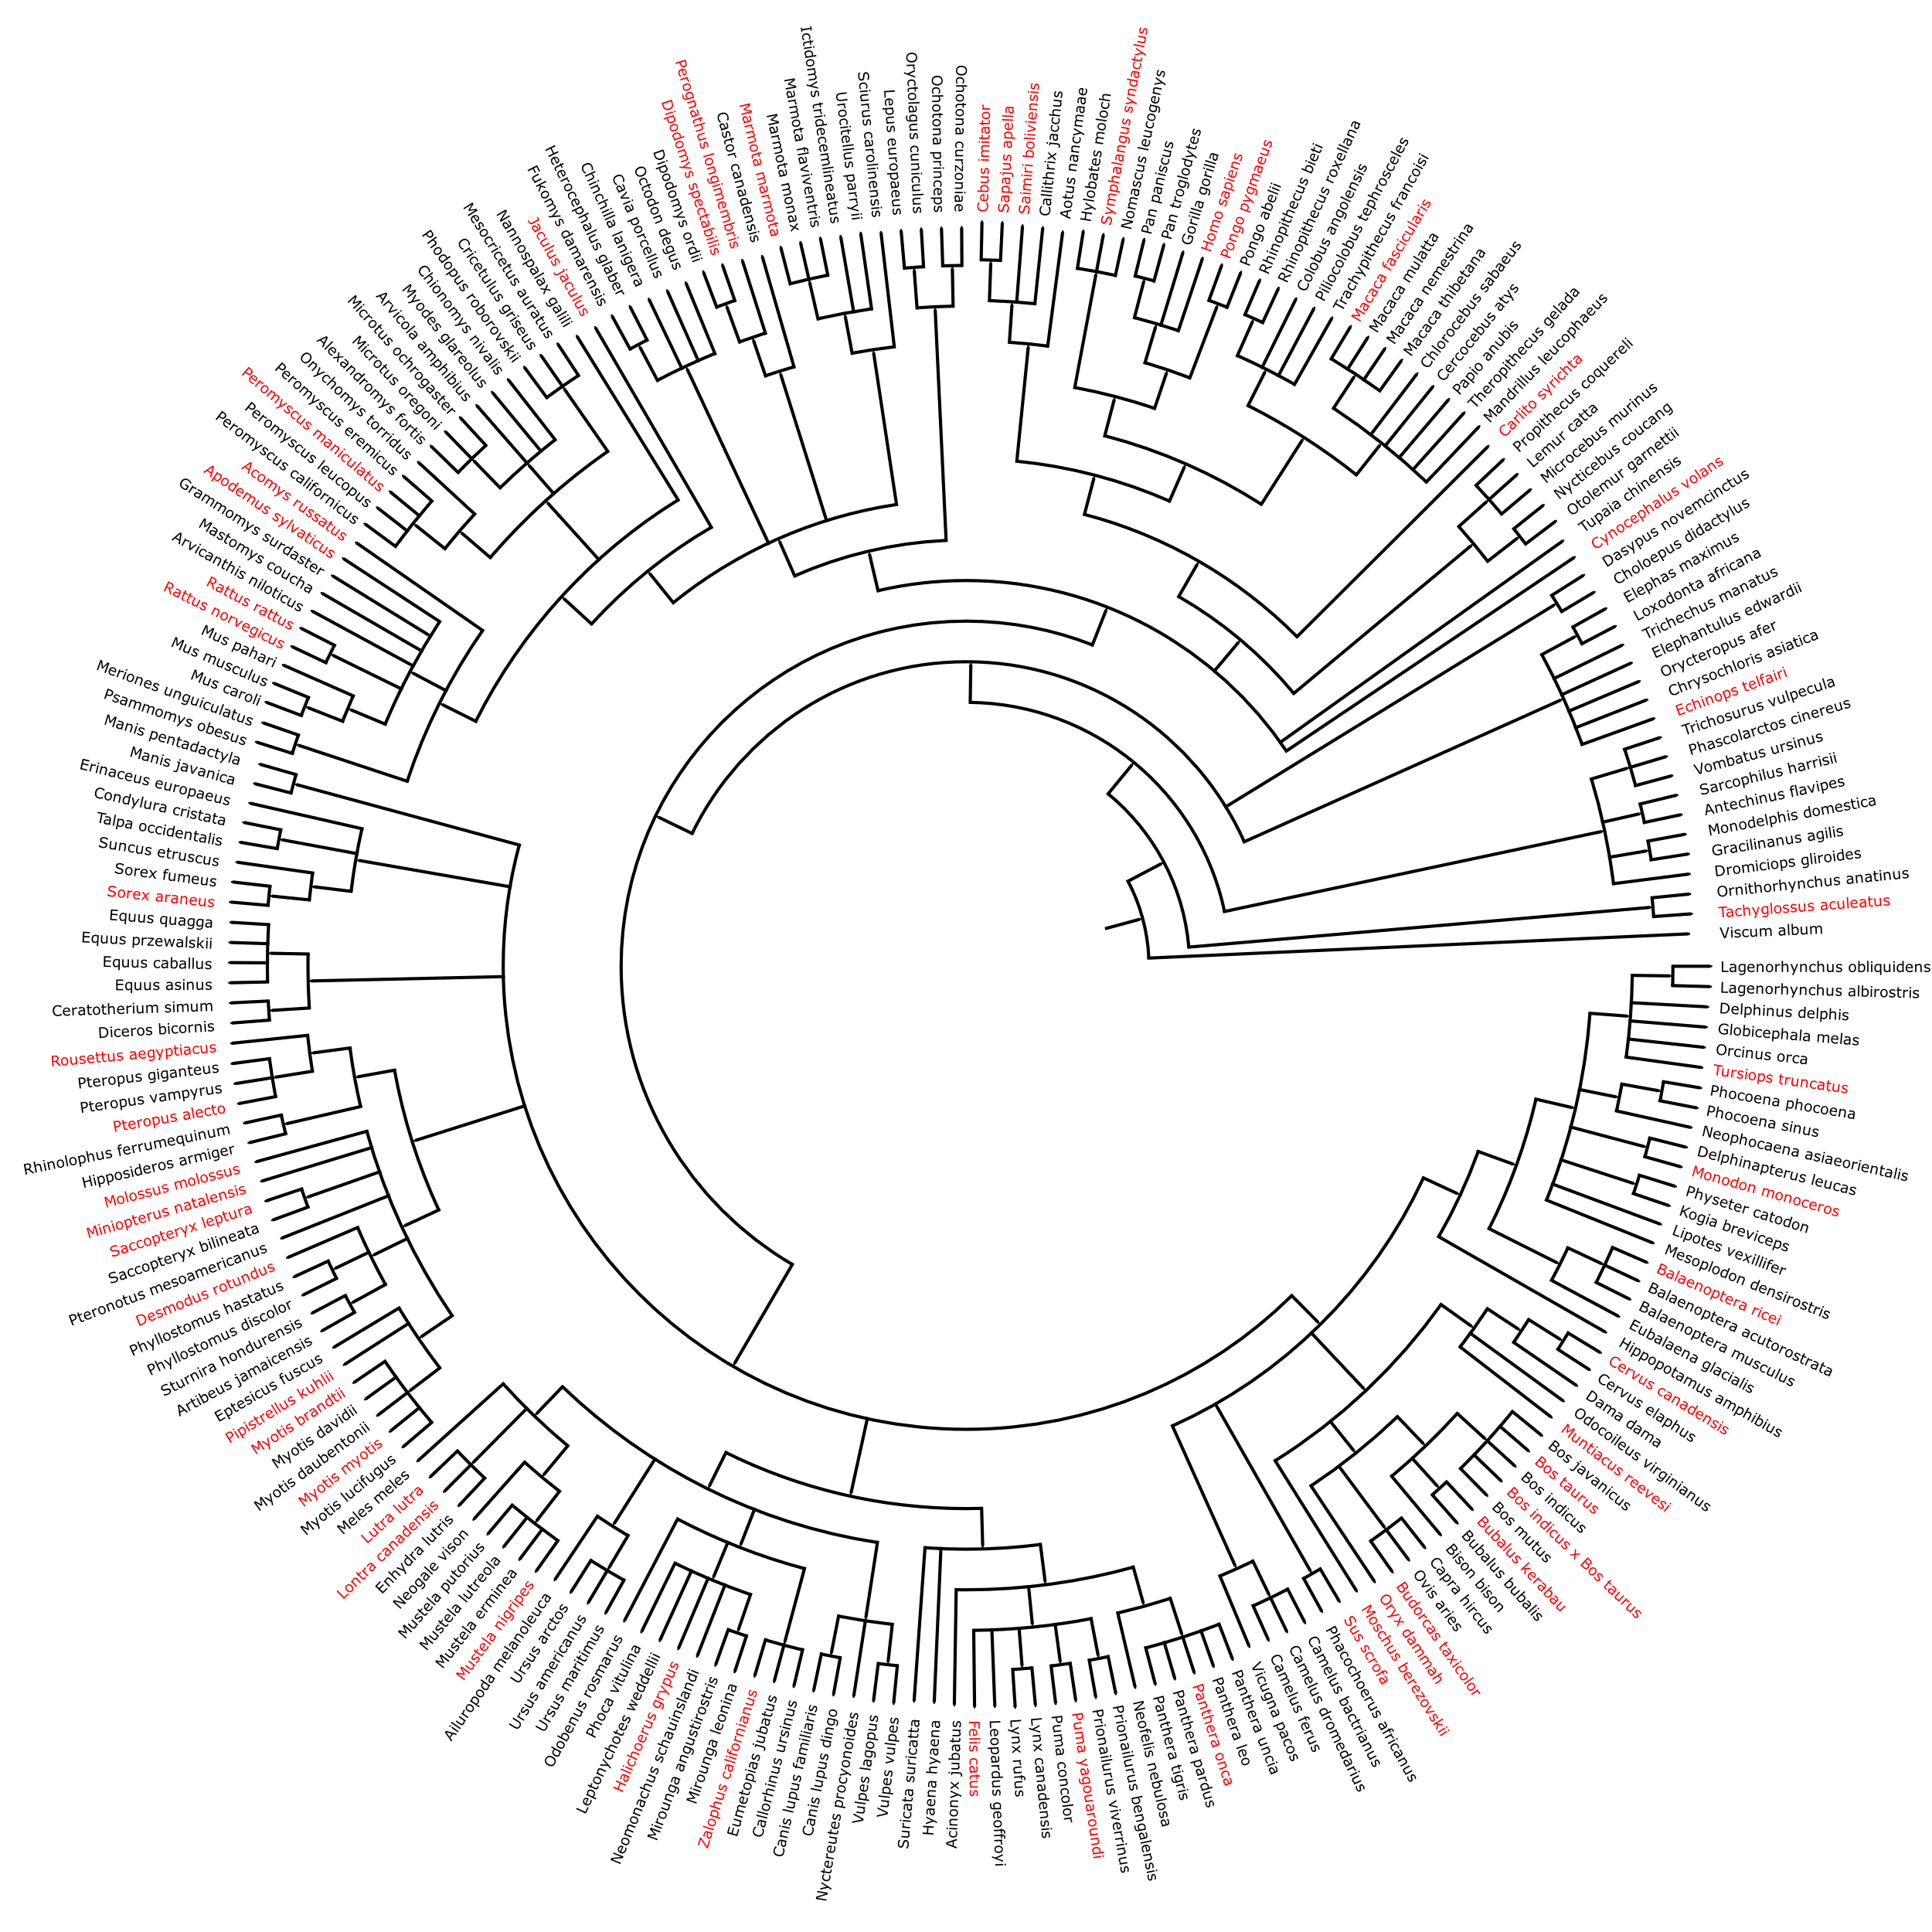
Supplementary Fig. 5 | Distribution of test species for Mammalia.
Due to the large genome sizes of metazoans, 50 widely distributed species (including key model organisms) were randomly subsampled from candidate test sets to balance taxonomic diversity and computational feasibility. Test species (highlighted in red, n=50) represent phylogenetically distinct lineages, ensuring rigorous evaluation of model generalizability across broad evolutionary scales. Training species (n=21; Supplementary Table 21) were selected to maximize evolutionary diversity, enabling recovery of deep ancestral signals in vertical genomic dimensions. Genome size of training species spanned 49.9 Gb. Taxonomic assignments follow the NCBI Taxonomy database¹⁵.
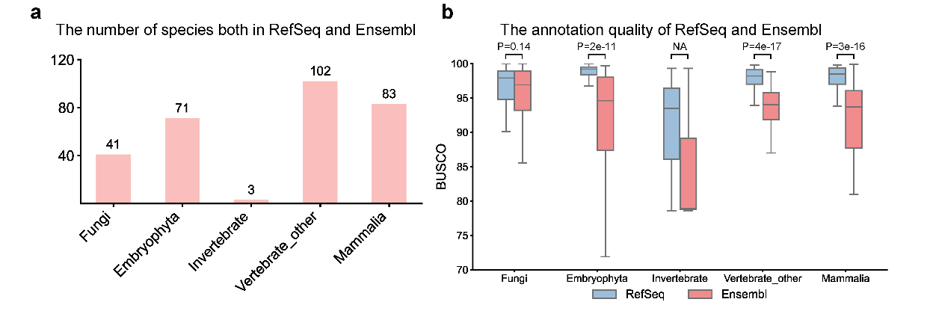
Supplementary Fig. 6 | Performance comparison of reference databases.
a, Number of species Both in RefSeq and Ensembl. It shows the number of species for performance comparison between RefSeq and Ensembl. b, Comparison of annotation quality between RefSeq and Ensembl. BUSCO scores for RefSeq and Ensembl are compared, with statistical significance assessed using the Mann-Whitney U test.

Reference
1 Holst, F. et al. Helixer–de novo prediction of primary eukaryotic gene models combining deep learning and a hidden Markov model. BioRxiv, 2023.2002. 2006.527280 (2023).
2 Stanke, M. et al. AUGUSTUS: ab initio prediction of alternative transcripts. Nucleic acids research 34, W435-W439 (2006).
3 Huerta-Cepas, J., Serra, F. & Bork, P. ETE 3: reconstruction, analysis, and visualization of phylogenomic data. Molecular biology and evolution 33, 1635-1638 (2016).
4 Shen, W., Le, S., Li, Y. & Hu, F. SeqKit: a cross-platform and ultrafast toolkit for FASTA/Q file manipulation. PloS one 11, e0163962 (2016).
5 Tange, O. Gnu parallel‐the command‐line power tool. Usenix Mag 36, 42 (2011).
6 Chen, S., Zhou, Y., Chen, Y. & Gu, J. fastp: an ultra-fast all-in-one FASTQ preprocessor. Bioinformatics 34, i884-i890 (2018).
7 Kim, D., Paggi, J. M., Park, C., Bennett, C. & Salzberg, S. L. Graph-based genome alignment and genotyping with HISAT2 and HISAT-genotype. Nature biotechnology 37, 907-915 (2019).
8 Li, H. et al. The sequence alignment/map format and SAMtools. bioinformatics 25, 2078-2079 (2009).
9 Pertea, G. & Pertea, M. GFF utilities: GffRead and GffCompare. F1000Research 9 (2020).
10 Li, H. Protein-to-genome alignment with miniprot. Bioinformatics 39, btad014 (2023).
11 Seppey, M., Manni, M. & Zdobnov, E. M. BUSCO: assessing genome assembly and annotation completeness. Gene prediction: methods and protocols, 227-245 (2019).
12 Gabriel, L. et al. BRAKER3: Fully automated genome annotation using RNA-seq and protein evidence with GeneMark-ETP, AUGUSTUS, and TSEBRA. Genome Research (2024).
13 Brůna, T., Lomsadze, A. & Borodovsky, M. GeneMark-ETP significantly improves the accuracy of automatic annotation of large eukaryotic genomes. Genome Research 34, 757-768 (2024).
14 Stiehler, F. et al. Helixer: cross-species gene annotation of large eukaryotic genomes using deep learning. Bioinformatics 36, 5291-5298 (2021). https://doi.org/10.1093/bioinformatics/btaa1044
15 Schoch, C. L. et al. NCBI Taxonomy: a comprehensive update on curation, resources and tools. Database (Oxford) 2020 (2020). https://doi.org/10.1093/database/baaa062

