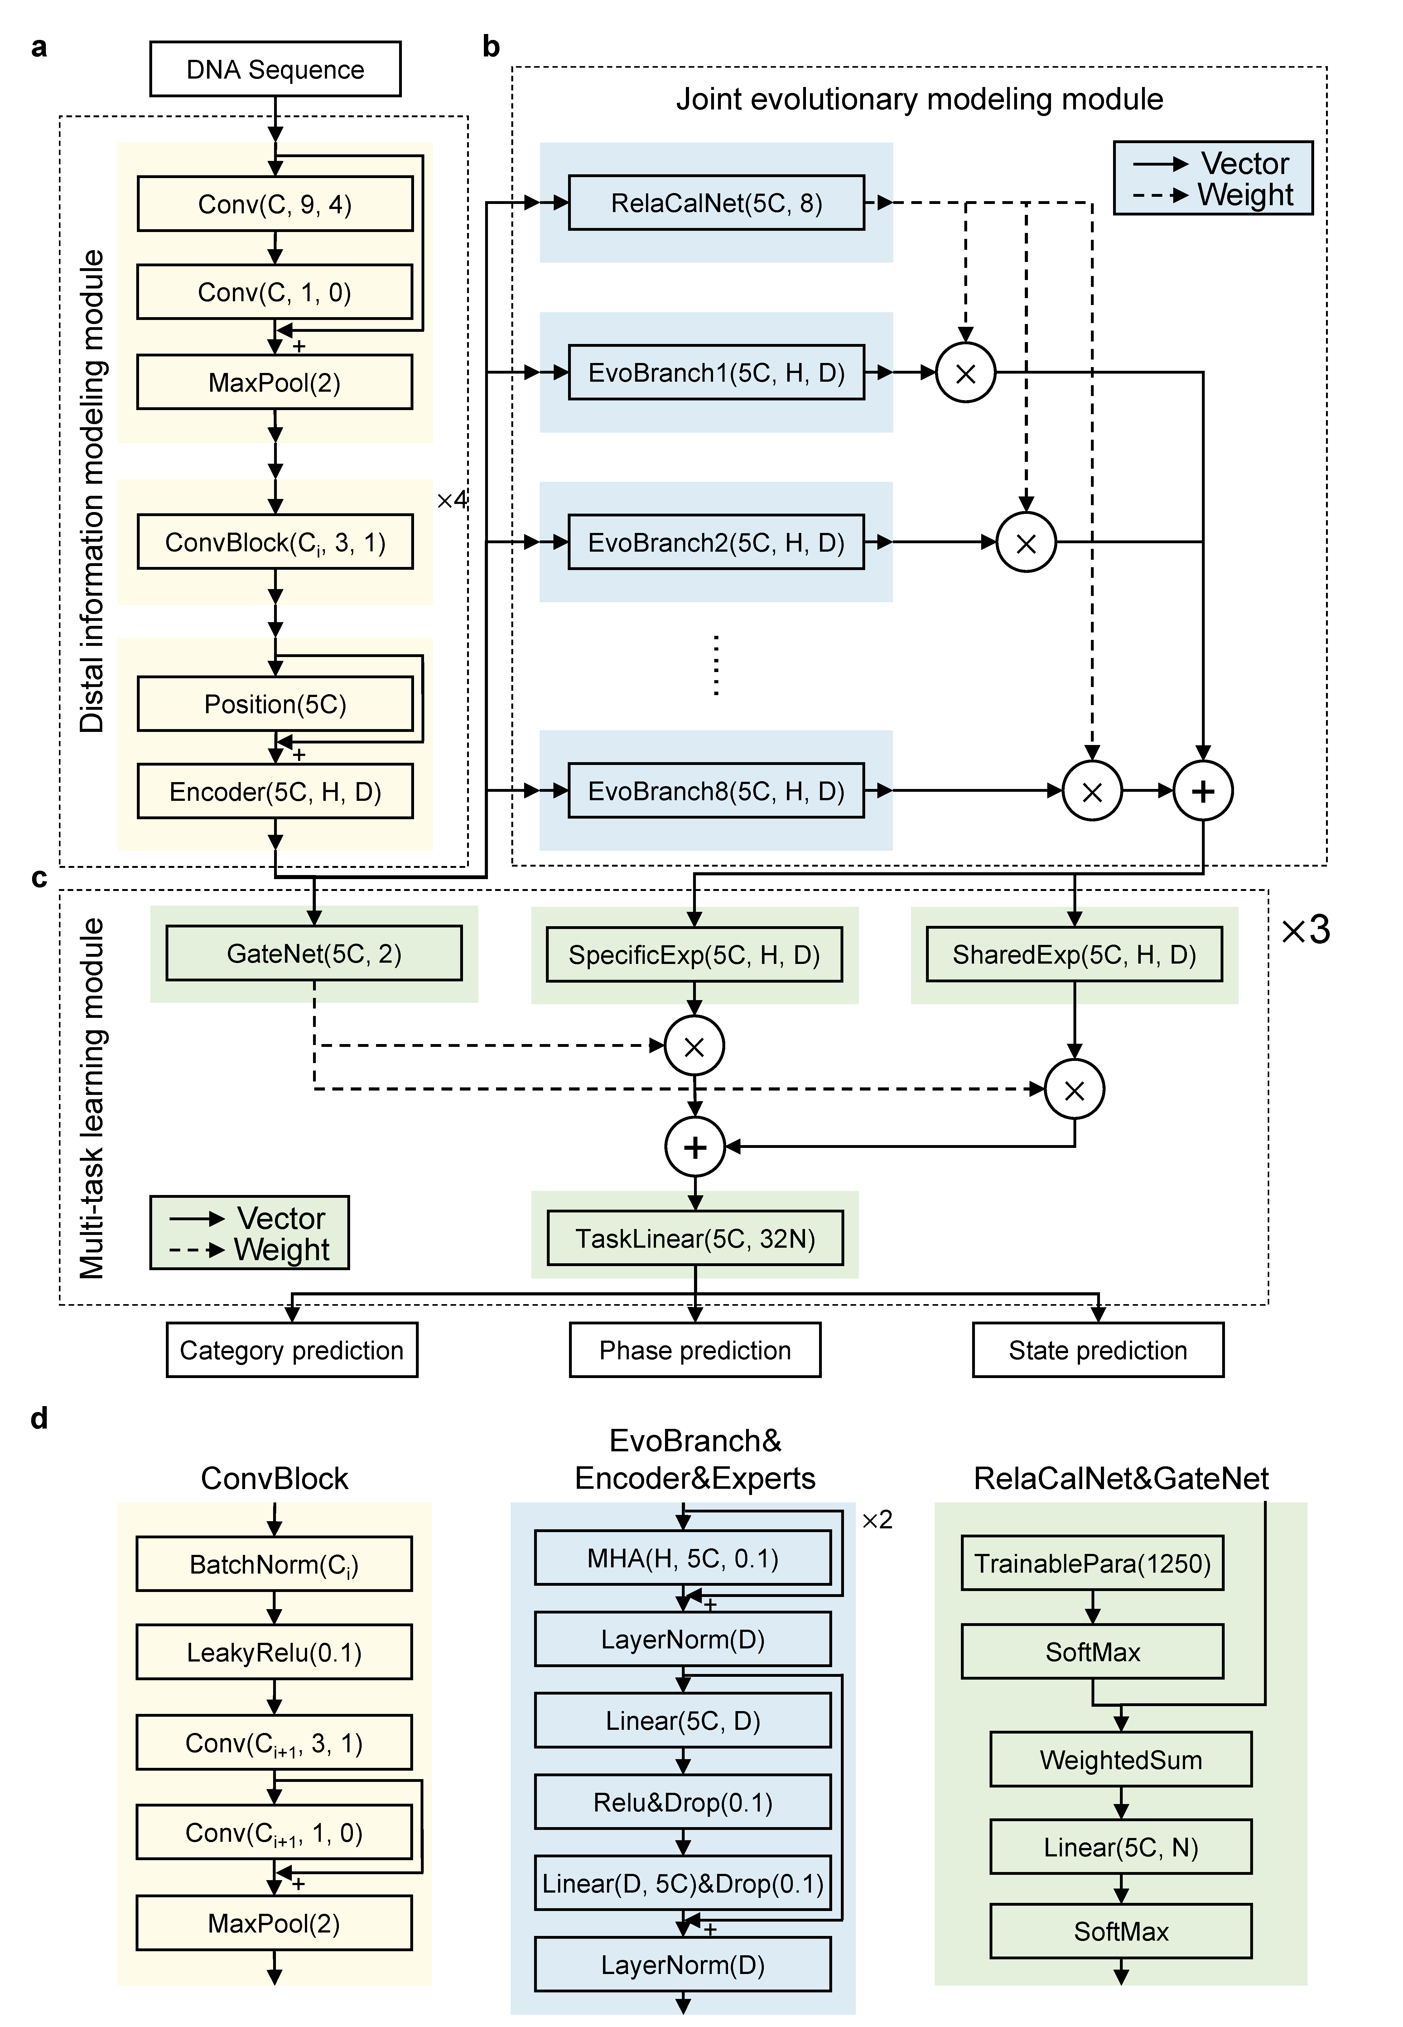
Extended Data Fig. 1 | Detailed model architecture of ANNEVO’s neural network component. a, Distal Information Modeling Module. This module extracts local sequence patterns using four consecutive ConvBlocks and learns long-range dependencies through positional encoding and Transformer encoder layers. b, Joint Evolutionary Modeling Module. The module consists of eight sub-lineage networks and a relationship computation controller. The sub-lineage networks capture diverse evolutionary relationships, while the relationship computation network models the affinity between the input sequence and each EvoBranch. c, Multi-task Learning Module. For the three tasks, the module employs a task-specific expert network and a shared expert network. These networks are integrated through gated networks, and a task-specific linear layer classifies each nucleotide. The output dimensions of the linear layer vary based on the number of task-specific categories. d, Detailed Architecture of Network Blocks. The ConvBlocks progressively increase the number of channels, with the convolutional layer channels expanding from 2C to 5C. After passing through four ConvBlocks, the features reach 5C = 80 channels. Each ConvBlock compresses information from two adjacent positions, embedding information from every 32 nucleotides into the same dimension. EvoBranch, Encoder, and Experts use the classical two-layer Transformer encoder structure to minimize parameter tuning. In ANNEVO, the number of attention heads is set to H = 8, and the hidden layer dimension is D = 256. Both the relationship computation network and the gated network define a set of trainable parameters to model the weights of each local pattern (32 nucleotides). These weights are aggregated through weighted summation, linear layers, and softmax normalization to produce N scalar weights. In the relationship computation network, N = 8, while in the gated networks of the multi-task learning module, N = 2.

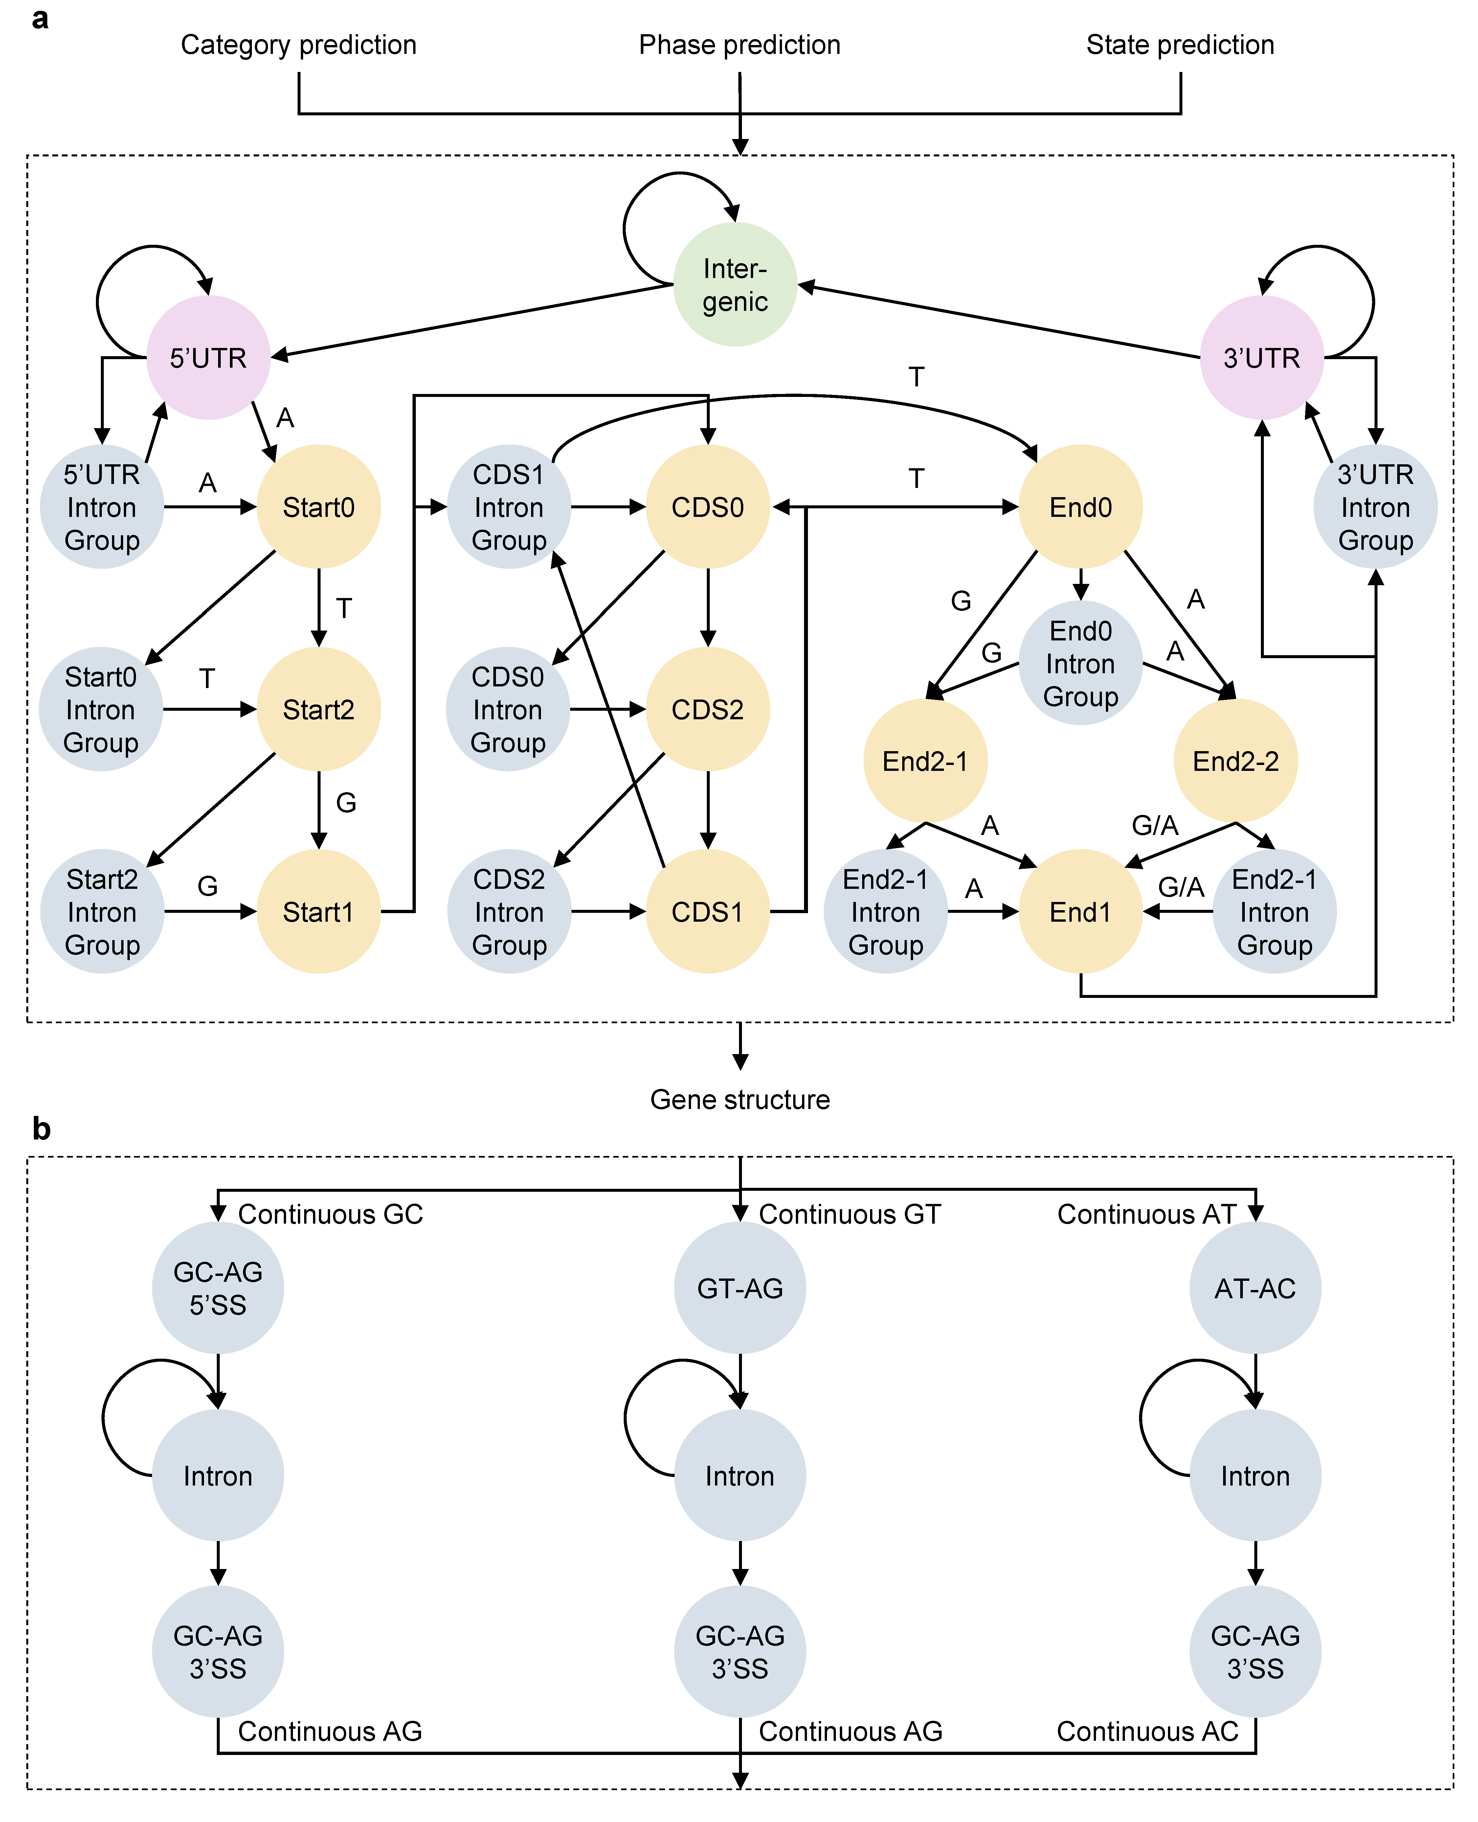
Extended Data Fig. 2 | Overview of the gene structure decoding component in ANNEVO. a, Predefined gene structure states. Gene structure states are defined based on the typical gene structure of eukaryotes. Each arrow in this diagram represents a possible state transition, with adjacent nucleotides specifying the required composition for the transition. Gene structure decoding utilizes the Viterbi algorithm, leveraging the three prediction probabilities provided by the deep learning model to determine the most likely sequence of states. b, Intron state groups. The intron state account for three primary splicing patterns: GC-AG, GT-AG, and AT-AC. These splicing patterns are incorporated in the decoding process and considered during gene structure predictions.
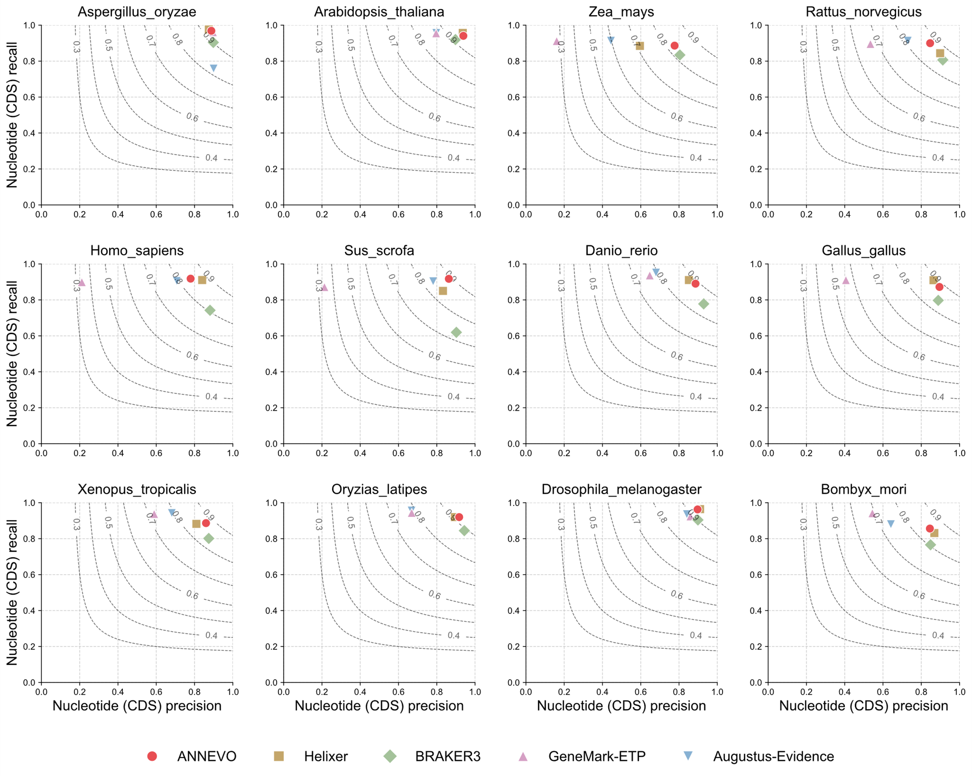
Extended Data Fig. 3 | Nucleotide-level performance comparison with evidence-assisted annotation pipelines across 12 model species. ANNEVO achieved the highest mean F1 score (0.89), driven by its superior recall (0.91), indicating more complete coding region identification. While BRAKER3 demonstrated marginally higher precision (0.89 vs. ANNEVO’s 0.87), this came at a significant cost to completeness (recall: 0.81 vs. ANNEVO’s 0.91). The 4% absolute improvement in F1 by ANNEVO reflects its optimized balance between precision and recall, surpassing evidence-dependent methods despite relying solely on genomic sequence inputs.

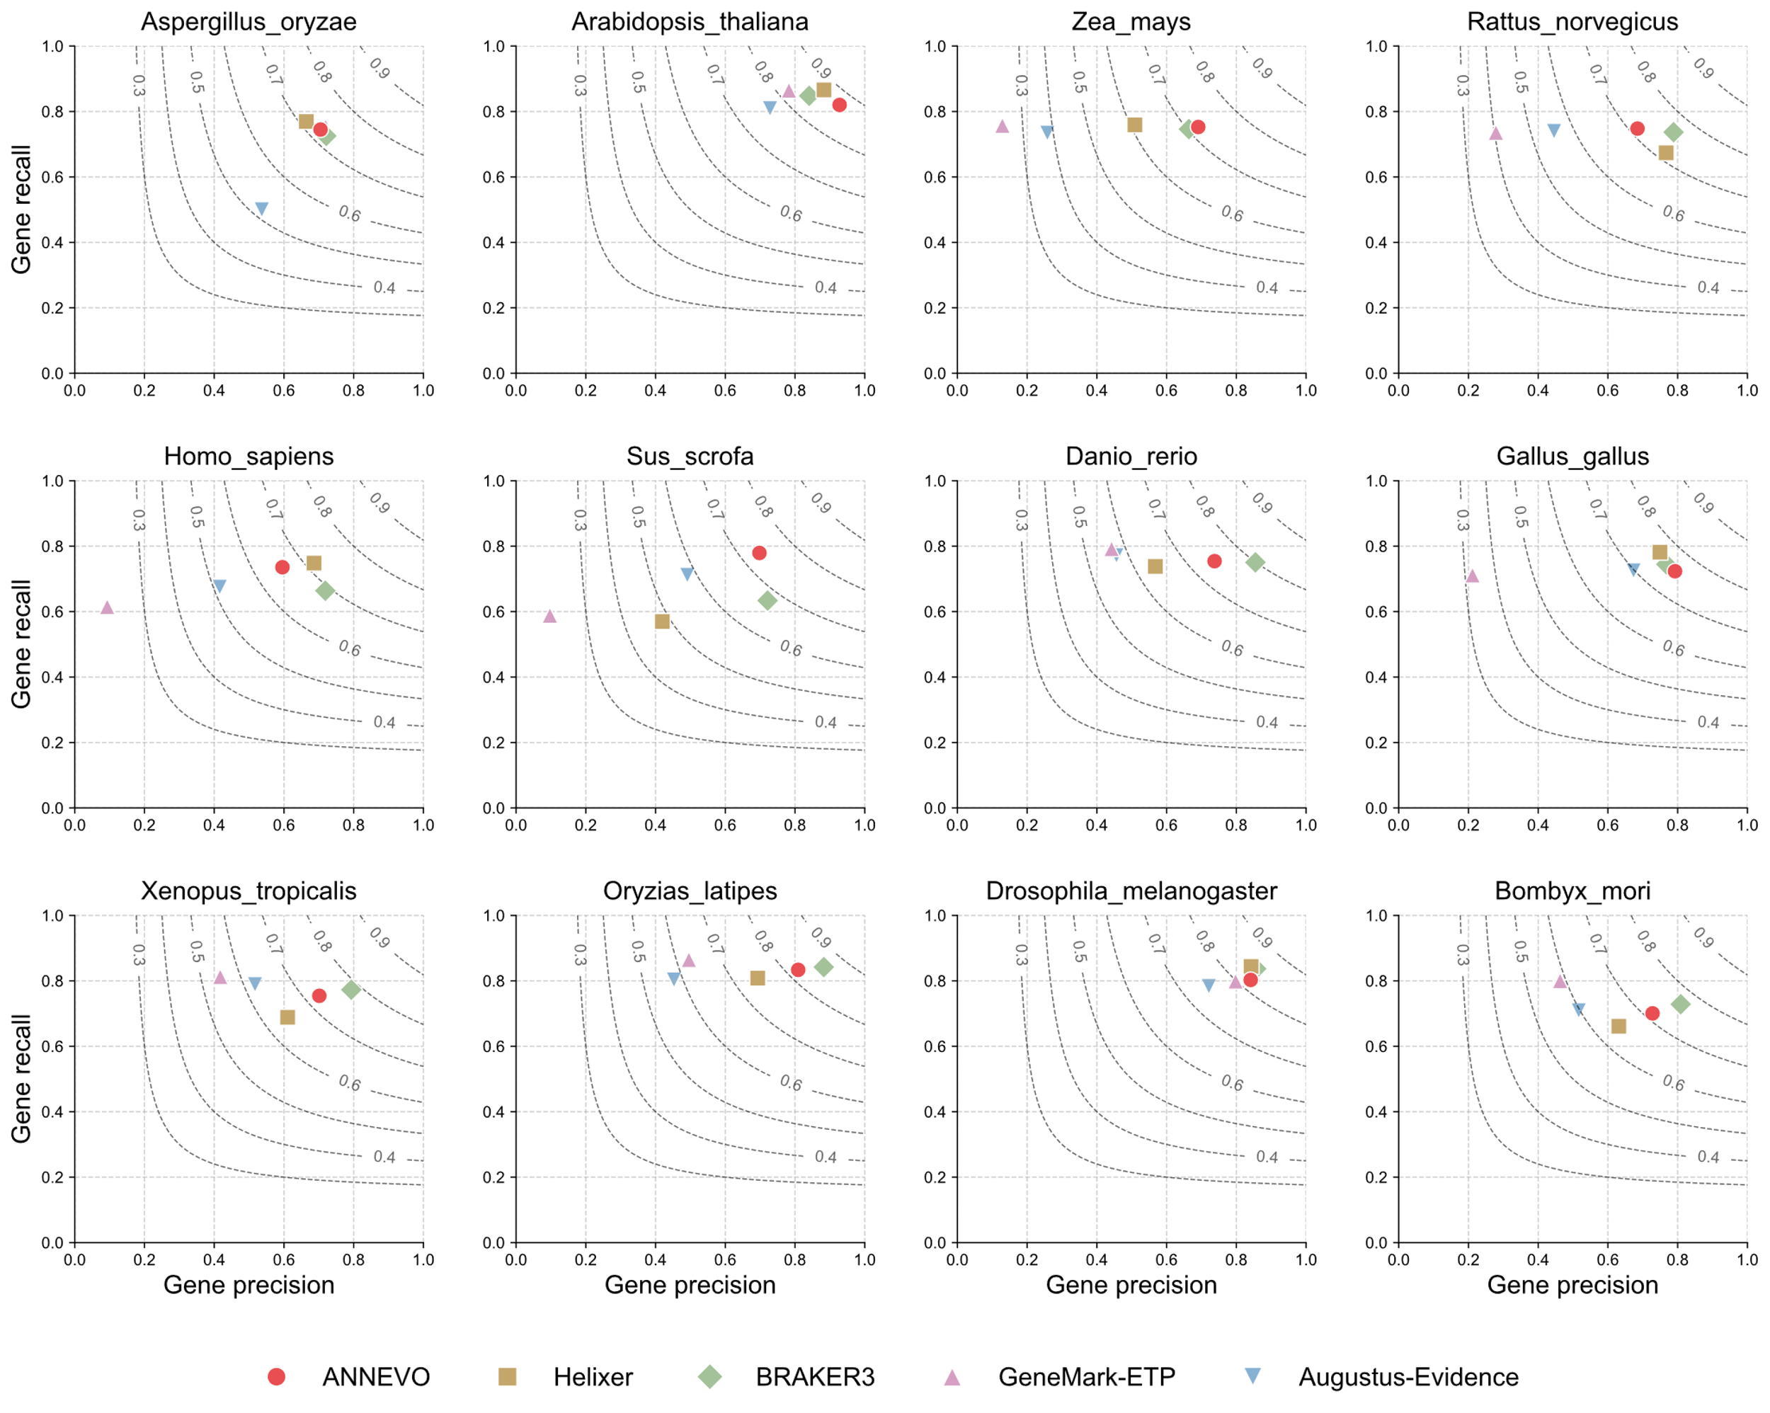
Extended Data Fig. 4 | Gene-level performance comparison with evidence-assisted annotation pipelines across 12 model species. ANNEVO achieved optimal performance in certain species such as Zea mays and Sus scrofa. ANNEVO demonstrates complete gene structure recovery (highest recall) that aligned with nucleotide-level performance. Across all 12 model species, ANNEVO matched BRAKER3 in average F1 scores while substantially outperforming the deep learning baseline Helixer by 5% absolute F1 improvement.

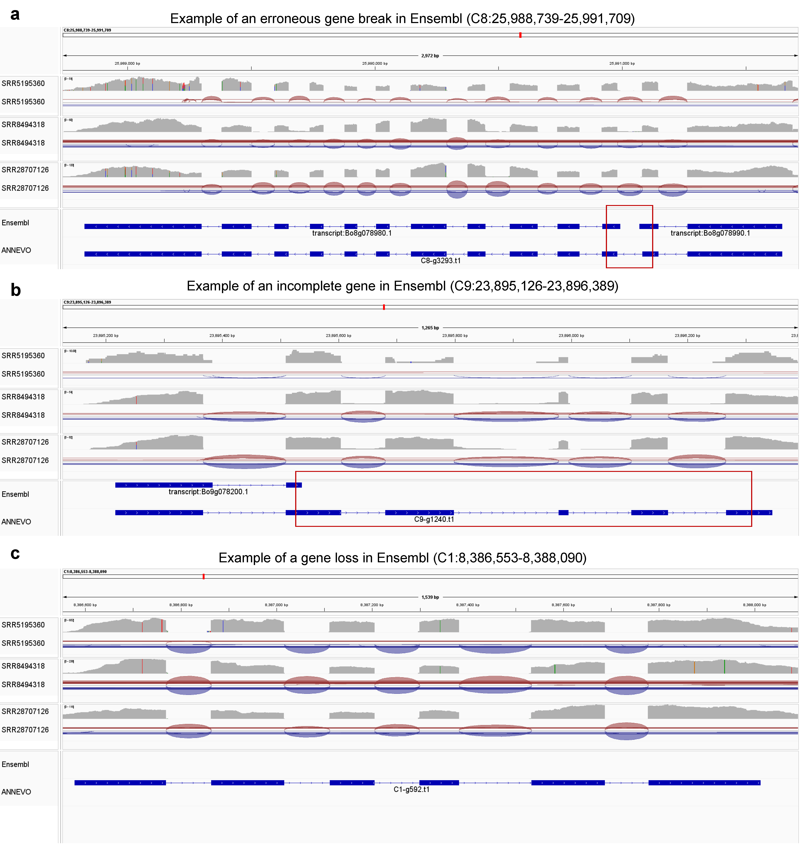
Extended Data Fig. 5 | Examples of ANNEVO Correcting Erroneous Gene Annotations in Ensembl. a, Correction of an erroneous gene break. Ensembl incorrectly split a single gene into two distinct loci. ANNEVO fused these fragments into a unified gene model, validated by RNA-seq splice junction reads spanning the breakpoint. b, Correction of an incomplete gene. A gene annotation in Ensembl missed 5 coding exons. ANNEVO extended the gene model to include the full CDS, supported by RNA-seq reads aligning to the omitted region. c, Correction of a gene loss. Ensembl failed to annotate a conserved BUSCO gene at C1:8,386,553-8,388,090. ANNEVO recovered this gene, fully supported by RNA-seq evidence.

