Supplementary Information

Asymmetric Cu⁰/Cu⁺ Interfaces for Efficient Electrochemical Nitrate Reduction to Ammonia Under Neutral and Ultralow Concentration
Beibei Xu,^{[1][5]} Shijie Zhao,^{[1][5]} Guanna Li,^{[3]} Jingyu Lu,^{[1]} Xiaoli Jiang,^{[1]} Haonan Zhang,^{[1]} Guidong Ju,^{[4]} Johannes Hendrik Bitter,^{[3]} Rengui Li,* ^{[2]} Jing Zhang* ^{[1]}
¹School of New Energy, Nanjing University of Science and Technology, Jiangyin, Jiangsu 214443, China
²State Key Laboratory of Catalysis, Dalian National Laboratory for Clean Energy, and The Collaborative Innovation Center of Chemistry for Energy Materials (iChEM), Dalian Institute of Chemical Physics, Chinese Academy of Sciences, Zhongshan Road 457, Dalian 116023, China
³Biobased Chemistry and Technology, Wageningen University & Research, Stippeneng 4, Wageningen 6708 WE, The Netherlands
⁴Shuangliang Eco-Energy Systems Co.,Ltd
⁵These authors contributed equally
Corresponding Authors
rgli@dicp.ac.cn; jingzhang_dicp@njust.edu.cn

1. Supplementary Experimental Section
2. Supplementary Figures
3. Supplementary Tables
4. Supplementary References

1. Supplementary Experimental Section
1.1 General information
The copper foam (~0.085 g/cm²) was purchased from Suzhou Willtek Photoelectric Materials Co., Ltd. (Suzhou, China). The reagents hydrochloric acid (HCl, 38.0%), acetone (C₃H₆O, 99.5%), sodium hydroxide (NaOH, 96.0%), sodium nitrate (NaNO₃, 99.0%) was purchased from Sinopharm Chemical Reagent Co., Ltd. Ammonium chloride (NH₄Cl, 99.5%) and sodium nitrite (NaNO₂, 99%) were purchased from Aladdin Ltd. (China). Sodium persulfate (Na₂S₂O₈, 99.99%) was purchased from Shanghai Macklin Biochemical Co., Ltd. All reagents were of analytical grade and used without further purification. All aqueous solutions were prepared using deionized water with a resistivity of 18.25 MΩ/cm.
1.2 Methods
Pre-treatment of Copper foam.
The copper foam was cut into a rectangle with an area of 1.5 cm × 1 cm, and then ultrasonicated in 3 M HCl aqueous solution and deionized water, respectively.
Synthesis of Cu nanodendrites (Cu NDs).
Cu NDs were prepared by electrodeposition followed by annealing, using a standard three-electrode system, with copper foam as both the working and counter electrode, and Ag/AgCl (saturated KCl) as the reference electrode. After 10 minutes at a potential of -1.7 V (vs. Ag/AgCl), nanodendrites grew in situ on the copper foam surface, followed by cleaning and drying at a rate of 5°C min⁻¹ and annealing at 400°C for 3 hours in a nitrogen atmosphere.
Synthesis of Cu(OH)₂ nanowires (Cu(OH)₂ NWs).
The copper foam was immersed in a solution of 30 mL sodium persulfate (0.357 g) and sodium hydroxide (1.2 g) for 15 minutes, during which the solution turned blue. Afterward, the blue-colored copper foam was washed with deionized water and ethanol, then dried under vacuum at 45°C.
Synthesis of Cu₂O/Cu nanosheet (Cu₂O/Cu).
The Cu₂O/Cu catalyst was obtained via electrochemical in-situ reconstruction. A standard three-electrode system was employed, with the Cu(OH)₂ NWs electrode as the working electrode, and a platinum sheet and Ag/AgCl (saturated KCl) as the counter and reference electrodes, respectively. The electrochemical in-situ reconstruction was performed in a 0.5 M Na₂SO₄ electrolyte containing 200 ppm NO₃⁻-N electrolyte at a constant potential of -1.1 V vs. Ag/AgCl for 2 hours. During in-situ electrochemical reduction, Cu(OH)₂ NWs gradually transformed into Cu₂O/Cu, with the catalyst color transitioning from blue to red. Finally, the Cu₂O/Cu was washed with deionized water and ethanol, then dried under vacuum at 45°C.
1.3 Materials characterization
The morphology of the samples was characterized using a scanning electron microscope (ZEISS Sigma 360) equipped with energy-dispersive X-ray spectroscopy (EDS) and a transmission electron microscope (JEOL JEM-2100Plus) with corresponding EDS mapping. The crystalline structure was analyzed using a Rigaku D/max-2500 X-ray diffractometer with Cu-Kα radiation at a scan speed of 8°/min. X-ray photoelectron spectroscopy (XPS) was performed using a Thermo Scientific K-Alpha spectrometer. Ultraviolet-visible (UV-Vis) absorption spectra were measured using a UV-2600i spectrophotometer. Work function measurements were conducted via ultraviolet photoelectron spectroscopy (UPS) using a Thermo Fisher Scientific Nexsa. Nuclear magnetic resonance (NMR) spectra were recorded on a Bruker 500 MHz instrument. Differential electrochemical mass spectrometry (DEMS, QAS100) was provided by Linglu Instruments (Shanghai) Co., Ltd. In-situ Fourier-transform infrared spectroscopy (ATR-FTIR) was conducted using a Thermo Fisher Scientific system from Shanghai.
1.4 Electrochemical measurements
The electrochemical performance of NO₃RR was measured using a DH7006 electrochemical workstation (Donghua Testing Technology Co., Ltd., Jiangsu). At room temperature, an Ag/AgCl electrode and a platinum sheet were used as the reference and counter electrodes, respectively. All electrochemical data, except for the stability tests, were repeated at least three times, with error bars representing the standard deviation. All potentials were calibrated to the reversible hydrogen electrode (RHE) scale using the Nernst equation: (E_{RHE} = E_{Ag/AgCl} + 0.059pH + 0.197 V). Electrochemical NO₃RR measurements were obtained in 0.5 M Na₂SO₄ with and without NaNO₃ using an H-type electrolytic cell, where the cathode and anode chambers were separated by a Nafion 117 membrane. Linear sweep voltammetry (LSV) was performed in a three-electrode system at a scan rate of 50 mV/s. The capacitance (C_{dl}) values of the samples were measured using a CHI760 E electrochemical workstation by varying the scan rates. Electrochemical impedance spectroscopy (EIS) measurements were conducted using the Interface 5000E electrochemical workstation over a frequency range of 10⁶ to 0.1 Hz with an amplitude of 5 mV. During stability tests, the electrolyte was replaced approximately every 0.5 hours without changing the working electrode or Nafion 117 membrane.
1.5 Determination and quantitation of ammonia using UV-vis
We used the Nessler reagent method to detect ammonia concentration. Specifically, after the NO₃RR reaction, an appropriate amount of electrolyte was taken from the electrolytic cell and diluted to 5 mL. Then, 0.1 mL of potassium sodium tartrate solution and 0.1 mL of Nessler's reagent were added sequentially, and the solution was shaken well before being left to stand at room temperature away from light for 20 minutes. The absorption spectra of the solution were measured using a UV-Vis spectrophotometer, and the absorbance at 420 nm was recorded. A series of standard ammonium chloride solutions were prepared in the same manner, and a concentration-absorbance curve was constructed to accurately quantify the ammonia concentration.
1.6 Determination and quantitation of nitrite using UV-vis
The nitrite concentration was detected using the Griess reagent. As described above, after the NO₃RR reaction, an appropriate amount of electrolyte was taken and diluted to 5 mL, followed by the addition of 0.1 mL of Griess reagent. After standing in the dark for 20 minutes, the absorption spectrum of the solution was measured using a UV-Vis spectrophotometer, and the absorbance at 540 nm was recorded. The Griess reagent (nitrite color development reagent) consisted of 4 g of p-aminobenzenesulfonamide, 10 mL of phosphoric acid, and 0.2 g of N-(1-naphthyl)-ethylenediamine dihydrochloride dissolved in 50 mL of deionized water. A concentration-absorbance curve for nitrite was constructed using the same method to accurately quantify the nitrite concentration.
1.7 Determination and quantitation of nitrate using UV-Vis
During the NO₃RR reaction, an appropriate amount of electrolyte was taken and diluted to 5 mL, followed by the addition of nitrate color-developing reagent. After standing in the dark for 20 minutes, the absorption spectrum of the solution was measured using a UV-Vis spectrophotometer, and the absorbance was recorded at wavelengths of 220 nm and 275 nm. The final absorbance value was calculated using the equation: A=A_{220nm}-2A_{275nm}. The nitrate color-developing reagent consisted of 0.1 mL of 1 M HCl and 10 µL of an 8%wt sulfamic acid solution. A concentration-absorbance curve for nitrate was constructed using the same method to accurately quantify the nitrate concentration.
1.8 Isotope labeling experiment and 1H NMR quantitative experiment
The ¹H nuclear magnetic resonance (NMR) peaks were recorded on a Bruker 500 MHz system. The integration of the typical triplet signal representative of ¹⁴NH4⁺ after NO₃RR at -1.21 V Ag/AgCl. Furthermore, isotope labelling experiments performed by using 8 mM Na¹⁵NO₃ as reactant confirm that the detected NH₃/NH₄⁺ originates from NO₃⁻ reduction.
1.9 Calculation of NH₃ yield and Faradaic efficiency
The NH₃ Faradaic efficiency (FE) was calculated according to:
$$\text{FE}\text{NH3}=(n×F×c_{{NH}_{3}}×V)/(M×Q)$$
where 𝑛 is the electron-transfer number (8 for 1 mol of ammonia), 𝐹 is Faraday constant (96485 C mol⁻¹), c_{NH3} is the concentration of NH₃ produced, V is the volume of the catholyte of the cathode chamber (50 mL), 𝑀 is the relative molecular mass of NH₃, 𝑄 is the total amount of charge consumed (C).
The rate of NH₃ yield rate was calculated according to:
$${Yield}_{{NH}_{3}}=(c_{{NH}_{3}}×V)/(M×t×S)$$
where 𝑐_{NH3} represents the concentration of NH₃ in the solution (mg/L), 𝑉 is the total volume of the electrolyte in the cathode chamber (50 mL), 𝑀 is the molar mass of NH₃, 𝑡 is the duration of the electrolysis process (h), and 𝑆 is the surface area of the cathode (cm⁻²).
The conversion rate was calculated according to:
$$Conversion=Δc_{NO_{3}^{-}}/c_{0}×100\%$$
where$Δ$c_{NO3-} represents the change in nitrate concentration in the solution before and after the reaction (mg/L), and $c_{0}$ denotes the initial concentration of nitrate (mg/L).
The selectivity of ammonia or nitrite was calculated according to:
$$Selectivity=c/Δc_{NO_{3}^{-}}×100\%$$
where 𝑐 represents the concentration of the produced ammonia or nitrite (mg/L).
1.10 DFT calculations
All DFT calculations have been performed using the Vienna Ab Initio Simulation package (VASP)^{1,2}. The generalized gradient approximation (GGA) with PBE exchange and correlation functional was used to account for the exchange-correlation energy^{2,3}. The kinetic energy cutoff of the plane wave basis set was set to 500 eV. The threshold for energy convergence for each iteration was set to 10⁻⁵ eV. Geometries were assumed to be converged when forces on each atom were less than 0.02 eV/Å. A Gaussian smearing of the population of partial occupancies with a width of 0.05 eV was used during iterative diagonalization of the Kohn-Sham Hamiltonian. The bulky Cu and Cu₂O unit cells were first fully optimized. The optimized lattice vectors are a=b=c=3.636 Å for Cu, and a=b=c=4.312 Å for Cu₂O. For the surface calculations, the 2x2x1 supercells of Cu (111) and Cu₂O (200) facets with a vacuum space of 10 Å were built to investigate the reaction mechanism. These slab models contain six Cu and six CuO layers, with the bottom four layers fixed while the rest were allowed to relax during the geometry optimization. Corrections for on-site Coulomb interactions using the DFT+U procedure were done with effective U = 4 eV for Cu for the Cu₂O system. The Cu₂O(200)/Cu(111) interface was constructed by aligning the lattice vectors of the Cu₂O(200) and Cu(111) facets to achieve optimal lattice matching. The Brillouin zone integration and k‐point sampling were 4x4x1, 3x3x1, 3x4x1 for Cu, Cu₂O, and Cu₂O/Cu slab models, individually. Thermodynamic corrections to the Gibbs free energy of reaction intermediates were performed by frequency analysis implemented in VASP and post-processing code VASPKIT 1.4⁴, according to the experimental reaction conditions of room temperature, ambient pressure, and the pH value of 7.
Ab initio molecular dynamics (AIMD) simulations were performed using the same software of VASP with solvation module (VASPsol)⁵. The implicit and explicit hybrid water solvent model was employed and water molecules were included in the simulations proportional to the supercell size, with 34 molecules for the Cu(111) surface and 42 molecules for the Cu₂O(200)/Cu(111) interface. The simulations were conducted in the canonical (NVT) ensemble, where the number of particles (N), volume (V), and temperature (T) were kept constant. The Nose-Hoover thermostat was employed to control the temperature to be 298K throughout the simulation. A time step of 0.5 femtoseconds (fs) was used to integrate the equations of motion, with a total of 5000 steps, resulting in a simulation time of 2.5 picoseconds (ps). Electronic structure calculations were based on the same density functional theory (DFT) within the framework of the projector augmented-wave (PAW) method, and the exchange-correlation effects were treated using PBE functional. Due to the high computational cost of AIMD simulations, the DFT accuracy was reduced by setting the kinetic energy cutoff of the plane-wave basis set to 350 eV. The energy convergence threshold for each electronic iteration was set to 10⁻⁴ eV. Geometries were considered converged when the forces on each atom were below 0.1 eV/Å.
2. Supplementary Figures
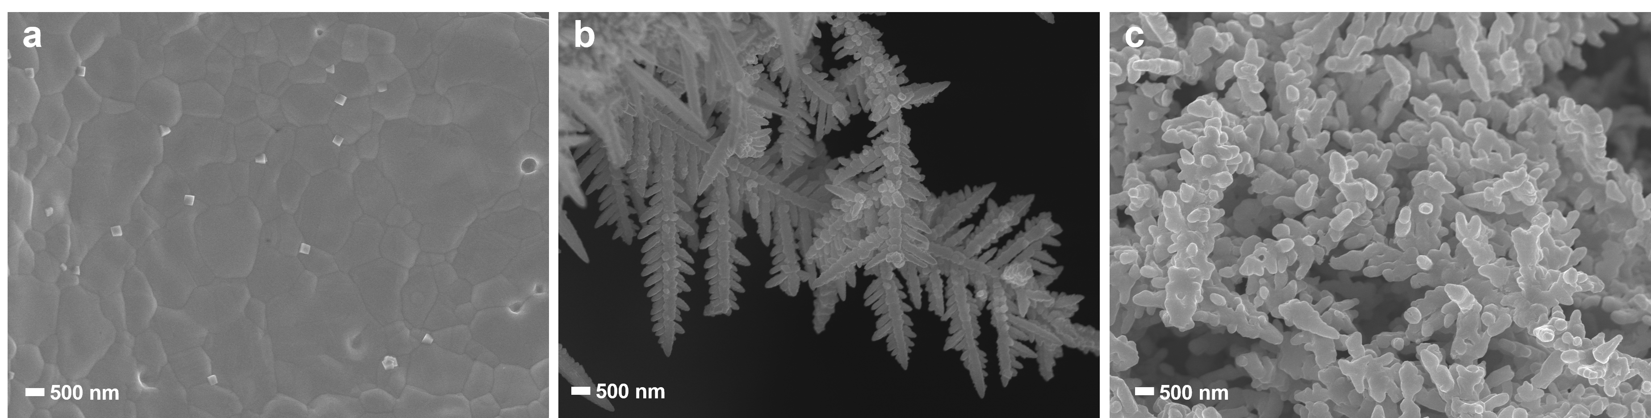
Figure S1. SEM images of the growth process of nanodendrites on Cu foam. (a) surface-cleaned copper foam, (b) nanodendrites grown after electrodeposition, (c) nanodendrites after annealing treatment.

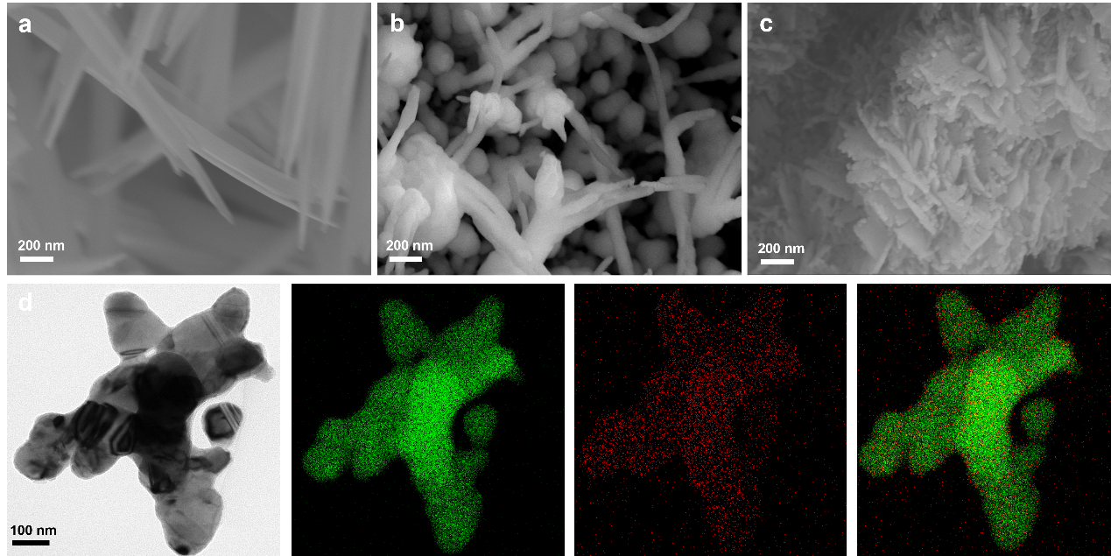
Figure S2. (a-c) SEM images of the transformation process from Cu(OH)₂ NWs to Cu₂O/Cu , (d) EDS mapping related to Cu and O of Cu₂O/Cu.

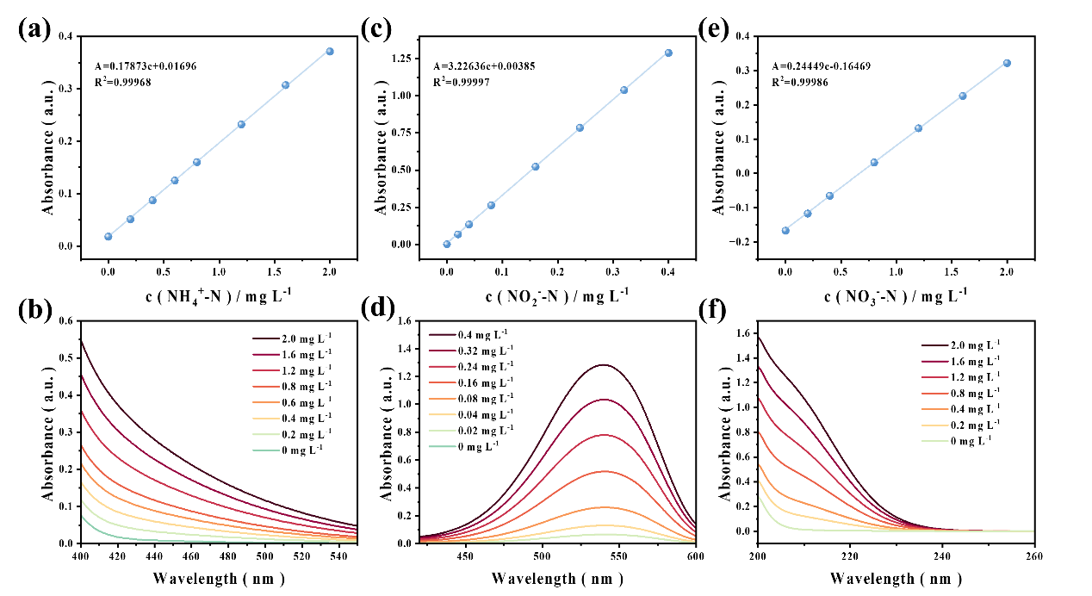
Figure S3. Calibration curves of concentration vs. absorbance for NH₄⁺, NO₃⁻, and NO₂⁻ using UV-vis spectrophotometry. (a), (c), and (e) represent the concentration-absorbance calibration curves for NH₄⁺, NO₃⁻, and NO₂⁻, respectively. (b), (d), and (f) show the corresponding UV absorption spectra for NH₄⁺, NO₃⁻, and NO₂⁻.

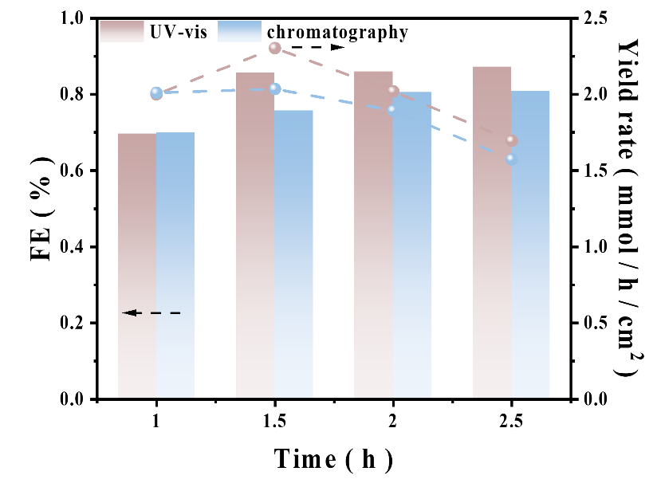
Figure S4. In a solution containing 0.5 M sodium sulfate and 0.1 M nitrate at a potential of -0.6 V versus the reversible hydrogen electrode (RHE), the Faraday efficiency (FE) and yield of ammonia were measured using chromatography and ultraviolet-visible spectroscopy methods.

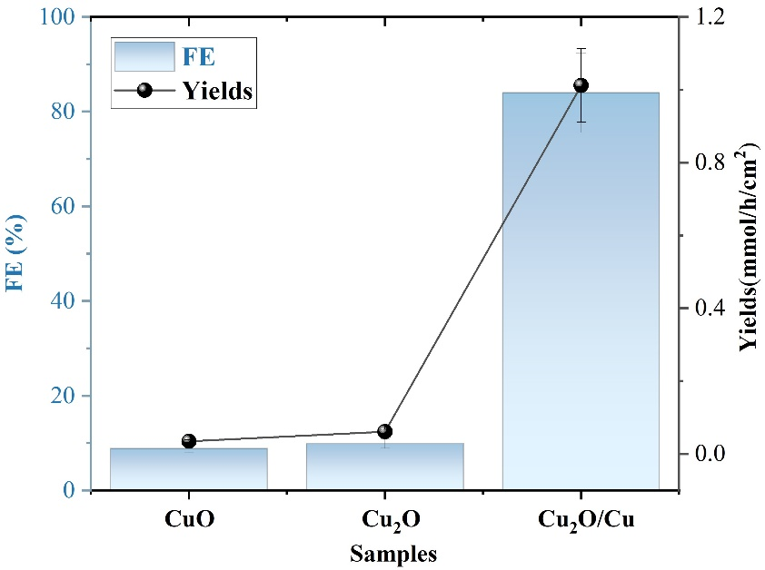
Figure S5. Performance comparison of CuO, Cu₂O, and Cu₂O/Cu under -0.5 V vs. RHE in a 0.1 M NO₃⁻ solution.

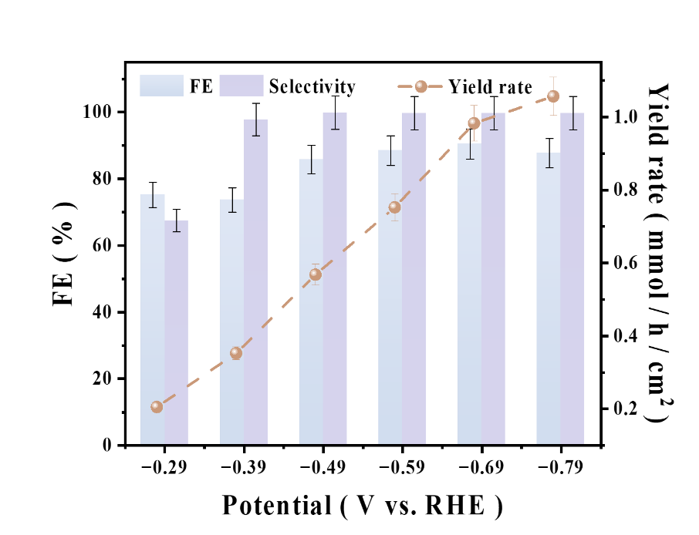
Figure S6. The influence of a wide potential window on the catalytic performance of Cu₂O/Cu in an electrolyte containing 0.5 M sodium sulfate (Na₂SO₄) and 200 ppm nitrate ion nitrogen (NO₃⁻-N)

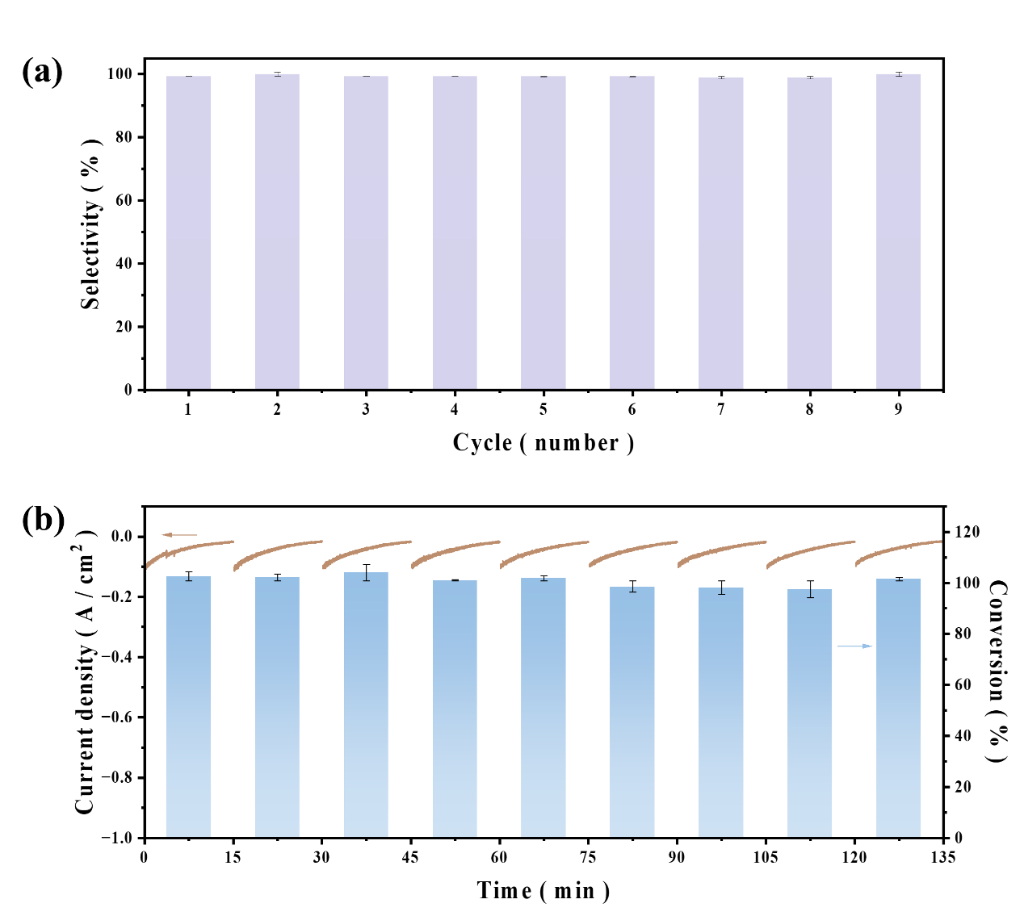
Figure S7. Electrochemical cycling stability of Cu₂O/Cu under 1 mM nitrate electrolyte. (a) Ammonia selectivity (%) across nine consecutive cycles (error bars represent standard deviation from triplicate tests). (b) Nitrate conversion rates in 15 minutes (%, right axis) and corresponding chronoamperometric current density profiles (A·cm⁻², left axis) for individual cycles.

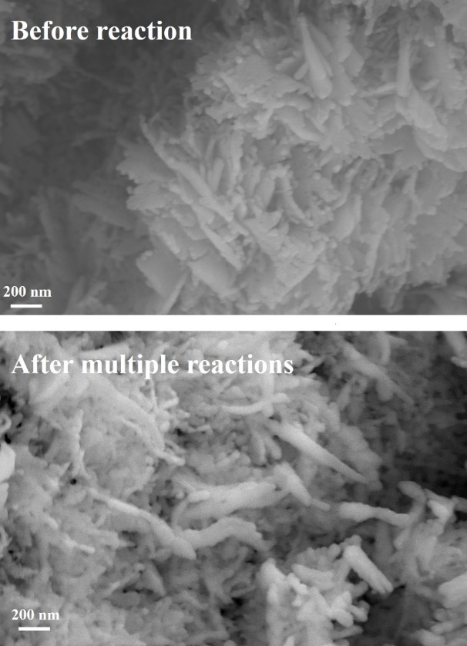
Figure S8. Changes in catalyst morphology before and after multiple reaction.

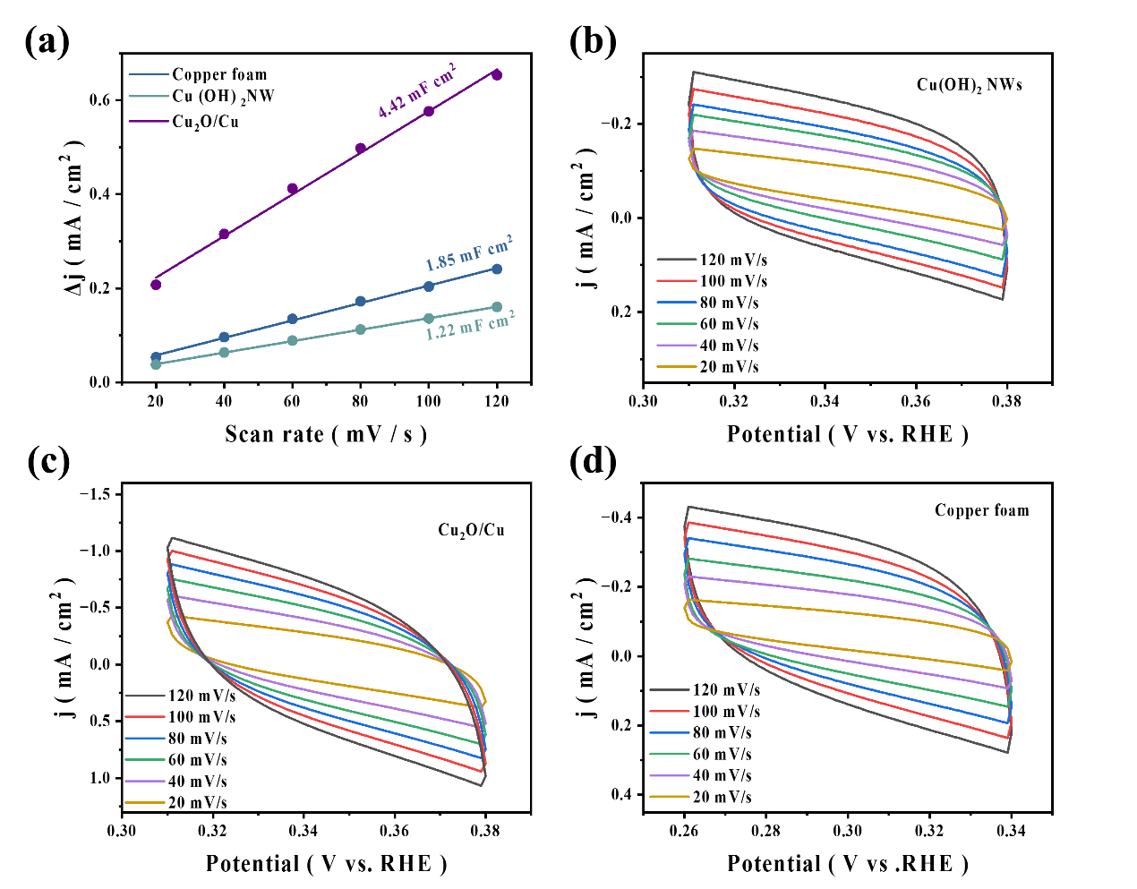
Figure S9. The relationship between scan rate and current in cyclic voltammetry (CV), along with the corresponding electrochemical active surface area (ECSA) analysis, was investigated in a 0.5 M Na₂SO₄ electrolyte containing 200 ppm NO₃⁻-N. (a). The electrochemical active surface area analysis for Cu foam, Cu(OH)₂ NWs and Cu₂O/Cu. (b) CV scan rate-current relationship for Cu(OH)₂ NWs, (c) Cu₂O/Cu, and (d) Cu foam.

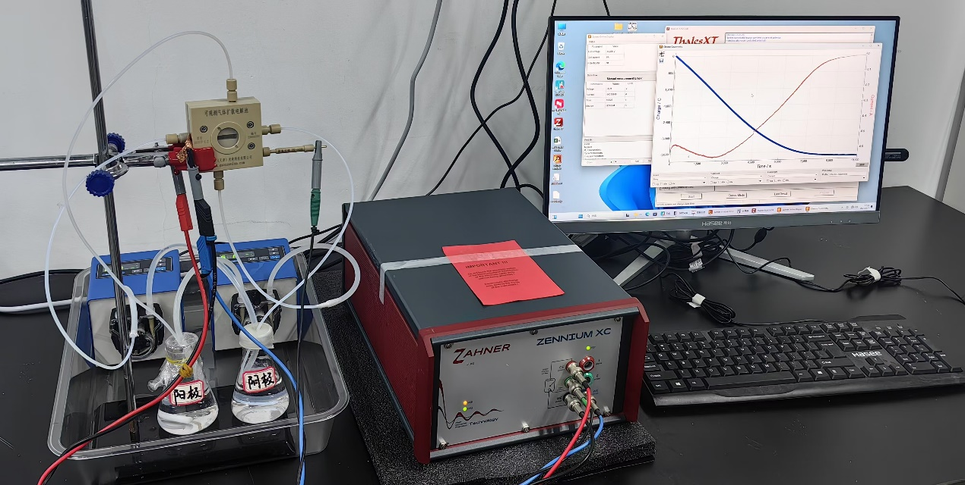
Figure S10. The structure of the flow cell electrolyzer with an electrolyte consisting of 0.5 M sodium sulfate and 0.1 M sodium nitrate, using an Ag/AgCl reference electrode, and with the catalyst located at the center of the electrolyzer.

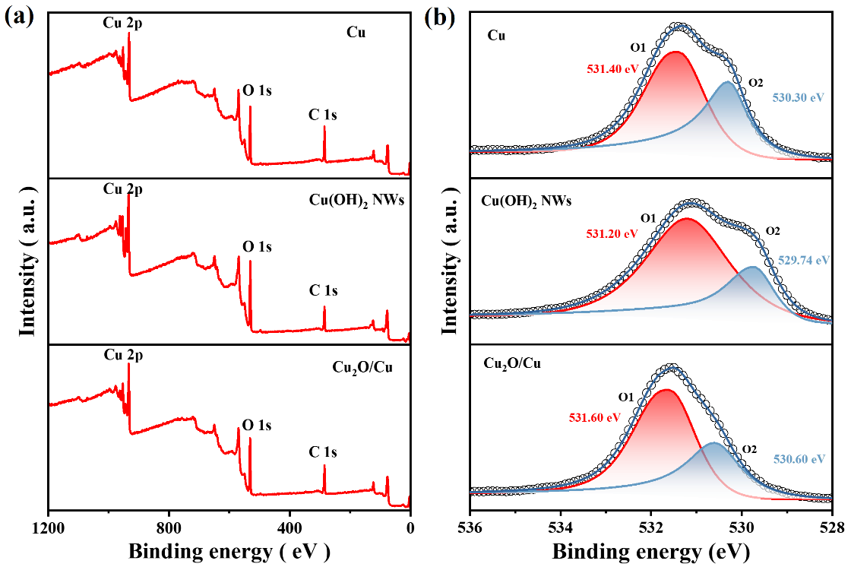
Figure S11. (a) Total XPS spectra and (b) O1s XPS spectra for Cu, Cu(OH)₂ NWs and Cu₂O/Cu.

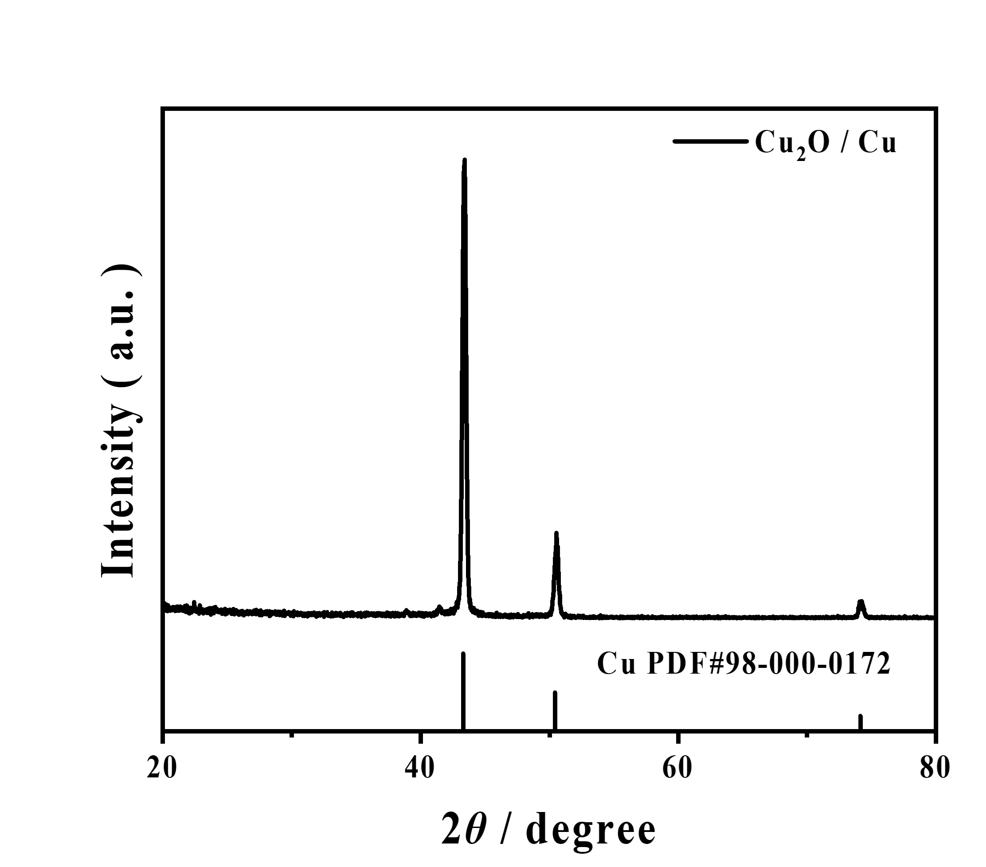
Figure S12. The grazing incidence X-ray diffraction (XRD) pattern of Cu₂O/Cu.

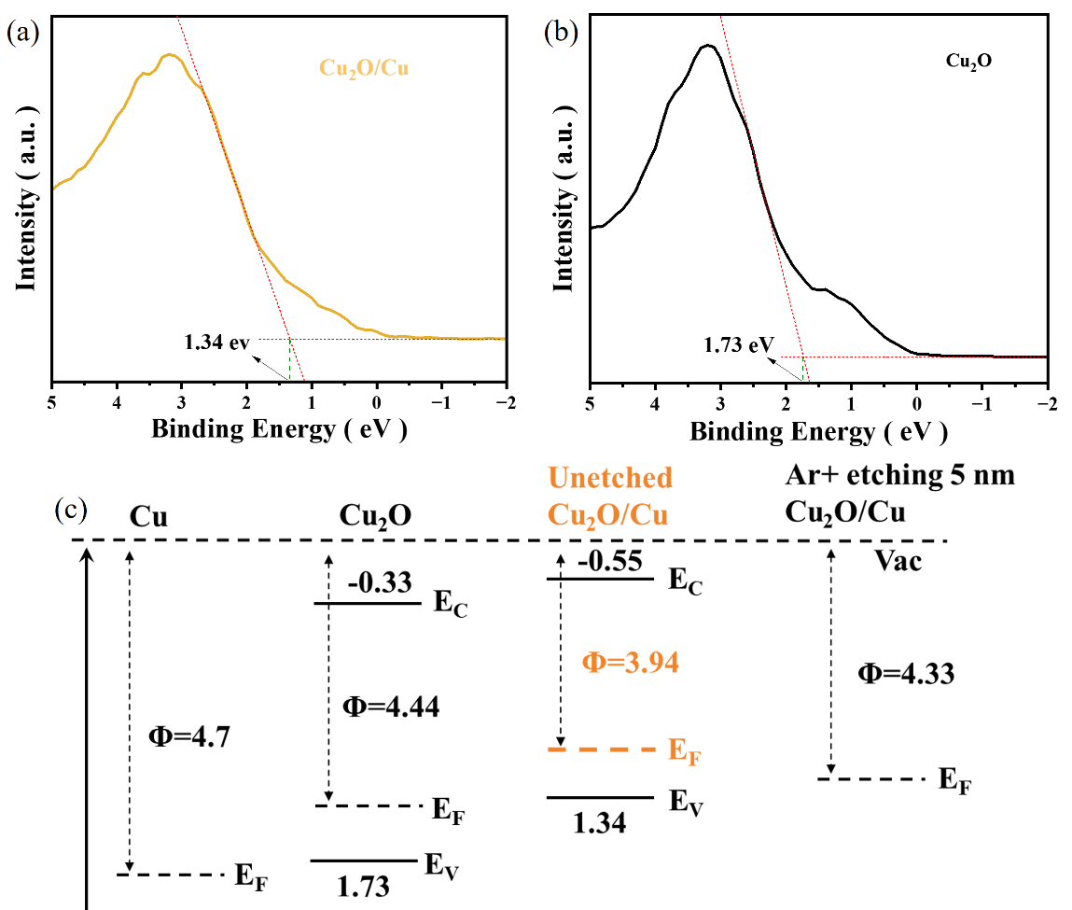
Figure S13. (a-b) VB-XPS spectra for Cu₂O/Cu and standard Cu₂O samples. (c) The ultraviolet photoelectron spectroscopy (UPS) with the Ar⁺ etching experiments.

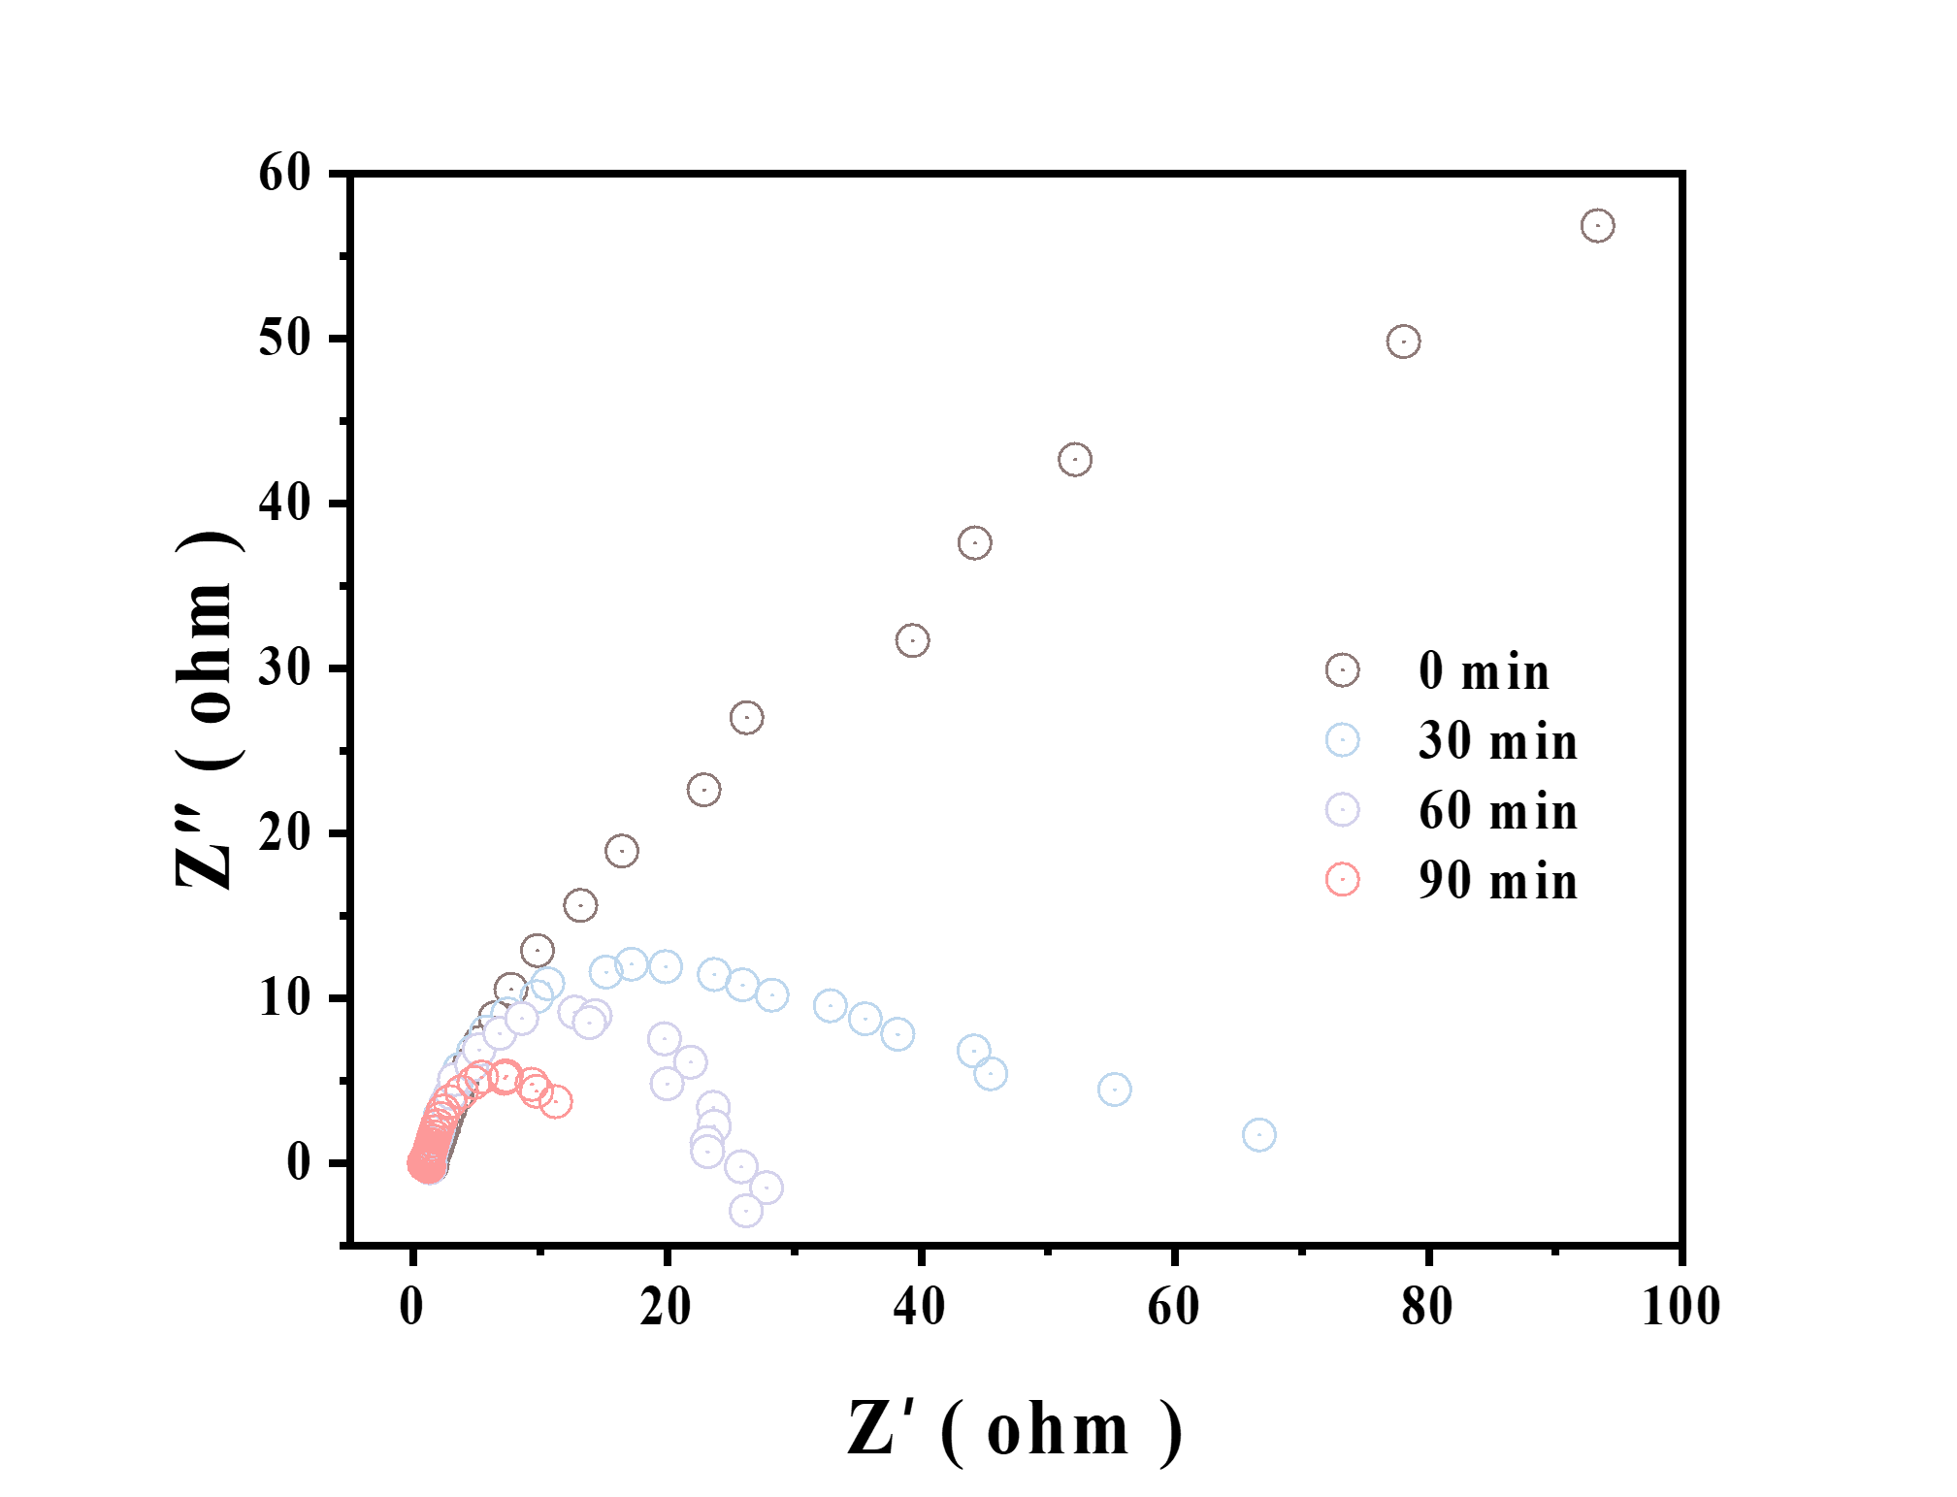
Figure S14. EIS image of the transformation from Cu(OH)₂ NWs to Cu₂O/Cu.

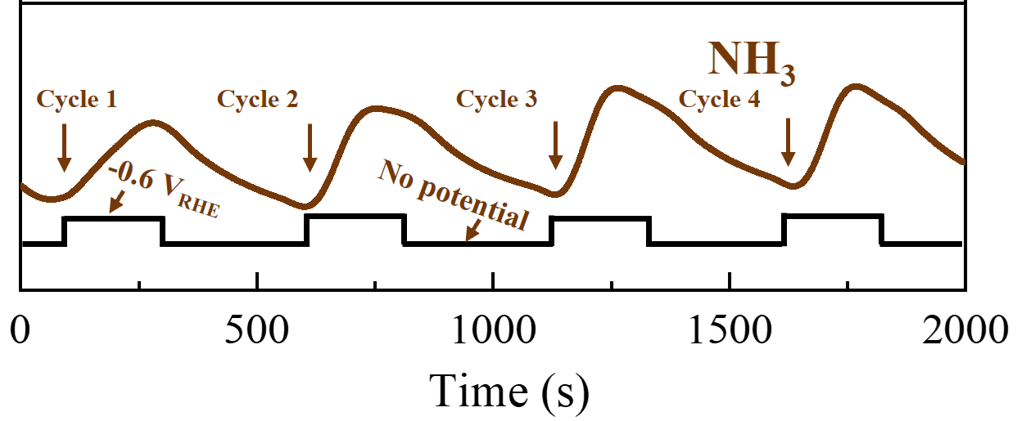
Figure S15. In-situ DEMS of the electrochemical NO₃RR on Cu₂O/Cu.
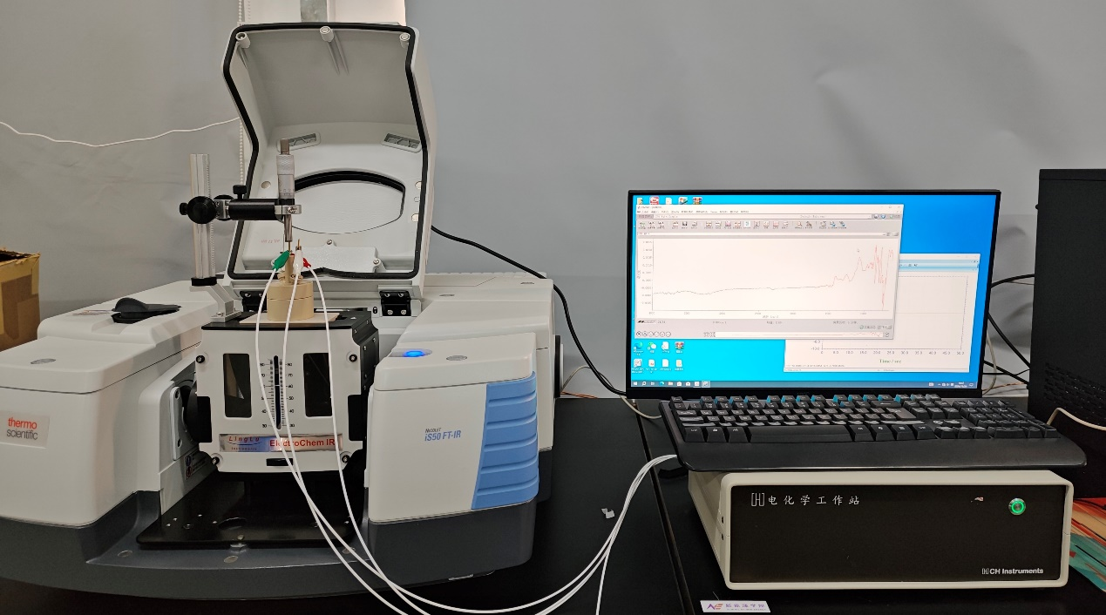
Figure S16. Laboratory setup for an electrochemical in situ infrared device, including an infrared spectrometer, an in situ infrared electrochemical cell, and an electrochemical workstation.

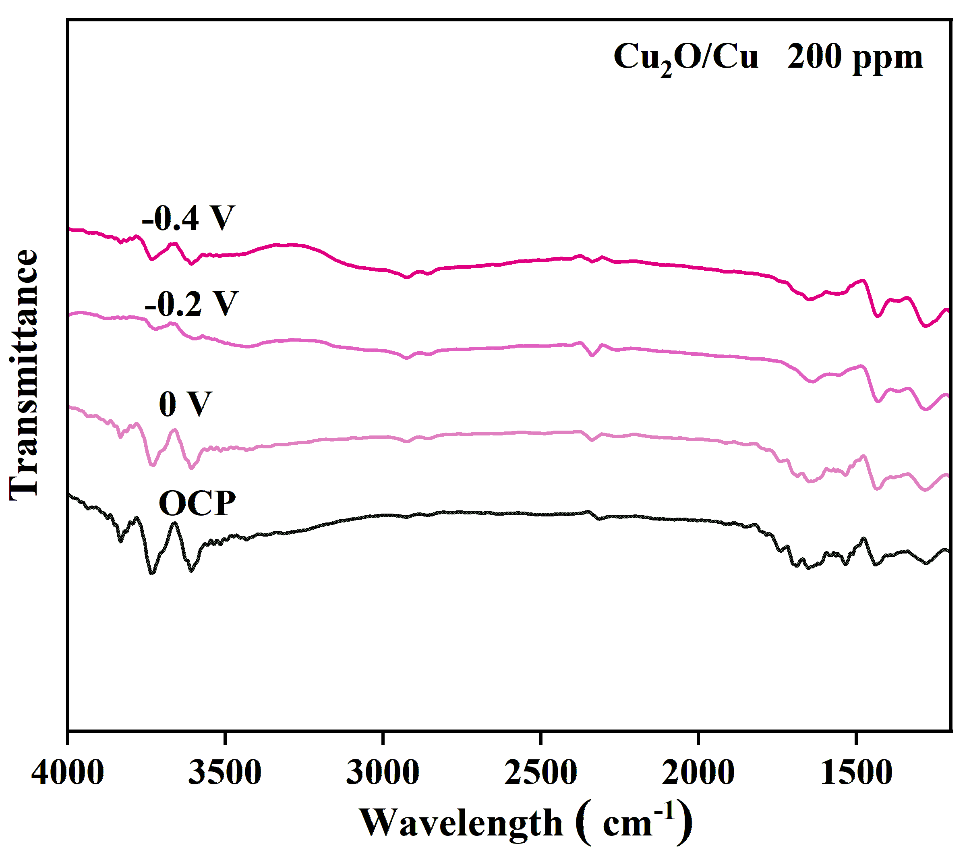
Figure S17. In-situ FTIR measurement for nitrate reduction on the Cu₂O/Cu surface in an electrolyte containing in 0.5 M Na₂SO₄ and 200 ppm NO₃⁻-N.
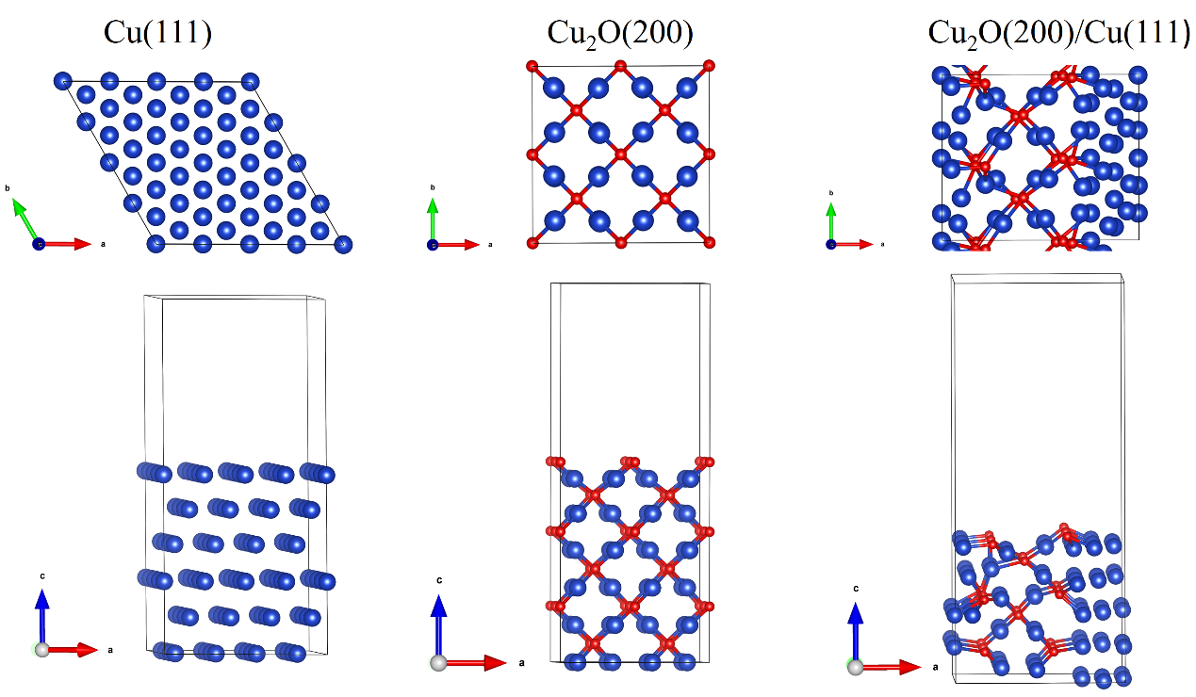
Figure S18. Top and side view of Cu(111), Cu₂O(200), and the interface of Cu₂O/Cu slab models used for DFT calculations
3. Supplementary Tables
Table S1. Comparison of the electrocatalytic activities of Cu₂O/Cu
with other reported materials for NO3RR.
Catalyst | Electrolyte | FE(%) | Yield rate (mg/h/cm²) | Ref.
CuCoSP | 1 mM NO₃⁻ + 0.1 M KOH | 91.2 | 0.267 | ⁶
Cu@C | 1 mM NO₃⁻ + 0.1 M KOH | 72.0 | 0.4695 | ⁷
Cu₅₀Ni₅₀ | 1 mM NO₃⁻ + 0.1 M KOH | 65.0 | 0.006 | ⁸
Ni₃Fe-CO₃ LDH/CF | 1 mM NO₃⁻ + 0.1 M KOH | 45.3 | 0.2119 | ⁹
Au/C | 1 mM NO₃⁻ + 0.1 M K₂SO₄ | 26.0 | 0.0269 | ¹⁰
CuCl_BEF | 1.6 mM NO₃⁻ + 0.5 M K₂SO₄ | 44.7 | 1.82 | ¹¹
TiO₂-x | 0.8 mM NO₃⁻ + 0.5 M K₂SO₄ | 85.0 | 0.765 | ¹²
Pd-Cu₂O CEO | 0.8 mM NO₃⁻ + 0.5 M K₂SO₄ | 96.5 | 0.92511 | ¹³
RuNi-MOF | 0.8 mM NO₃⁻ + 0.1 M K₂SO₄ | 73.0 | 0.274 | ¹⁴
CoCuO_{x}@CuO_{x}/CF | 1 mM NO₃⁻ + 1 M KOH | 99.8 | 0.5191 | ¹⁵
Cu-Co₃O₄/NF | 2 mmol KNO₃ + 0.2 M K₂SO₄ | 92.4 | 0.076 | ¹⁶
Defect-rich Cu NAE | 1 mM NO₃⁻ + 0.5 M K₂SO₄ | 90.6 | 1.5 | ¹⁷
Cu₂O/Cu | 0.5 M Na₂SO₄ + 1mmol NaNO₃ | 97.1 | 5.46 | This work

4. Supplementary References
1. Kresse G, Furthmüller J. Efficiency of ab-initio total energy calculations for metals and semiconductors using a plane-wave basis set. Computational Materials Science 6, 15-50 (1996).
2. Kresse G, Furthmüller J. Efficient iterative schemes for ab initio total-energy calculations using a plane-wave basis set. Phys Rev B Condens Matter 54, 11169-11186 (1996).
3. Perdew JP, Burke K, Ernzerhof M. Generalized Gradient Approximation Made Simple. Phys Rev Lett 77, 3865-3868 (1996).
4. Wang V, Xu N, Liu J-C, Tang G, Geng W-T. VASPKIT: A user-friendly interface facilitating high-throughput computing and analysis using VASP code. Computer Physics Communications 267, 108033 (2021).
5. Mathew K, Sundararaman R, Letchworth-Weaver K, Arias TA, Hennig RG. Implicit solvation model for density-functional study of nanocrystal surfaces and reaction pathways. J Chem Phys 140, 084106 (2014).
6. He W, et al. Splicing the active phases of copper/cobalt-based catalysts achieves high-rate tandem electroreduction of nitrate to ammonia. Nat Commun 13, 1129 (2022).
7. Song Z, Liu Y, Zhong Y, Guo Q, Zeng J, Geng Z. Efficient Electroreduction of Nitrate into Ammonia at Ultralow Concentrations Via an Enrichment Effect. Adv Mater 34, e2204306 (2022).
8. Wang Y, et al. Enhanced Nitrate-to-Ammonia Activity on Copper-Nickel Alloys via Tuning of Intermediate Adsorption. J Am Chem Soc 142, 5702-5708 (2020).
9. Kim KH, et al. Energy-efficient electrochemical ammonia production from dilute nitrate solution. Energy &amp; Environmental Science, (2023).
10. Choi J, Du HL, Nguyen CK, Suryanto BHR, Simonov AN, Macfarlane DR. Electroreduction of Nitrates, Nitrites, and Gaseous Nitrogen Oxides: A Potential Source of Ammonia in Dinitrogen Reduction Studies. ACS Energy Letters, (2020).
11. Sun W-J, et al. Built-in Electric Field Triggered Interfacial Accumulation Effect for Efficient Nitrate Removal at Ultra-Low Concentration and Electroreduction to Ammonia. Angewandte Chemie International Edition 60, 22933-22939 (2021).
12. Jia R, Wang Y, Wang C, Ling Y, Yu Y, Zhang B. Boosting Selective Nitrate Electroreduction to Ammonium by Constructing Oxygen Vacancies in TiO₂. ACS Catalysis 10, 3533-3540 (2020).
13. Xu Y, et al. Ultralow-content Pd in-situ incorporation mediated hierarchical defects in corner-etched Cu₂O octahedra for enhanced electrocatalytic nitrate reduction to ammonia. Applied Catalysis B: Environmental 306, 121094 (2022).
14. Qin J, et al. Achieving high selectivity for nitrate electrochemical reduction to ammonia over MOF-supported Ru_{x}O_{y} clusters. Journal of Materials Chemistry A 10, 3963-3969 (2022).
15. Xiao C, et al. Efficient electrocatalytic reduction of nitrate to ammonia at low concentration by copper-cobalt oxide nanowires with shell-core structure. Nano Research 17, 5087-5094 (2024).
16. Hu X, et al. Metal-organic frameworks derived Low-Cost Cu-doped Co₃O₄ for efficient reduction of Ultra-Low nitrate concentrations to ammonia. Chemical Engineering Journal, (2024).
17. Zhang B, et al. Defect-induced triple synergistic modulation in copper for superior electrochemical ammonia production across broad nitrate concentrations. Nat Commun 15, 2816 (2024).

