Supplementary Information
Sustainable Rare Earth Extraction from Phytomining by Ultrafast Electrothermal Activation
Mingyue Xu¹, Bing Deng^{1,2,*}, Erkang Feng¹, Teng Wang^{1,3}, Ziyu Huang¹, Wen-Shen Liu⁴, Lena Q. Ma⁵, Jianguo Liu^{1,2,*}

¹ School of Environment, Tsinghua University, Beijing 100084, China
² State Key Laboratory of Iron and Steel Industry Environmental Protection, Tsinghua University, Beijing, China
³ Tanwei College, Tsinghua University, Beijing 100084, China
⁴ School of Environmental Science and Engineering, Guangdong Provincial Key Laboratory of Environmental Pollution Control and Remediation Technology, and Guangdong Provincial Engineering Research Center for Heavy Metal Contaminated Soil Remediation, Sun Yat-sen University, Guangzhou 510006, China
⁵ Institute of Soil and Water Resources and Environmental Science, College of Environmental and Resource Sciences, and State Key Laboratory of Soil Pollution Control and Safety, Zhejiang University, Hangzhou 310058, China.
* Corresponding authors: B.D. (dengbing@tsinghua.edu.cn) and J.L. (jgliu@tsinghua.edu.cn)

Supplementary Text. Life cycle assessment and technoeconomic analysis.
Life Cycle Assessment (LCA) of the rapid electrothermal calcination (REC) process and furnace calcination (FC) process was conducted using SimaPro 9.5 software, with the Ecoinvent database and the World Recipe Midpoint H assessment methodology. The Ecoinvent database is recognized for its comprehensiveness and reliability, serving as a crucial reference for assessing the environmental impacts associated with materials and energy usage. The rare earth element-enriched plant biomass exhibited a mass yield of 15.0 wt% following REC treatment, compared to 10.6 wt% achieved through conventional calcination processes. The REC process was supposed to be operated at 1000℃ for 20 s, while calcination was operated at 550℃ for 3 h. According to the experimental results, treating 5 g of rare earth-enriched plants would consume 4.9 g sulphuric acid and 45.1 ml water. It is important to note that the LCA conducted in this study is preliminary; in actual production, the water requirement for separation and current efficiency may vary due to optimization efforts. These factors could introduce uncertainty into the LCA analysis.
In this study, the process is derived from the actual experimental data in this paper, and the data for the organic solvent, alkaline leaching, and direct calcination are derived from literature research. The required chemical reagents were sourced based on domestic market prices in China, with specific prices for relevant items detailed in table S3. Additionally, the industrial electricity consumption rate in China was estimated at $110 per MWh, while deionized water and H2SO4 was calculated at a flat rate of $1 per tonne and $85 per tonne. The process cost evaluation presented in this work does not account for the price of spent materials or the labor required for all processes. The energy consumption and economic benefit analysis is based on a predictive model derived from extended experimental data; while this model provides a reference for feasibility, actual implementation may face various challenges and limitations. The overall process cost was calculated using this predictive model, which evaluates economic feasibility by projecting energy consumption and potential benefits under the proposed operating conditions. Economic performance indicators such as net present value (NPV), internal rate of return (IRR), and payback period (PBP) were not included in this preliminary analysis but could be incorporated into future studies for a more comprehensive evaluation. It is also acknowledged that scaling the laboratory-based process to an industrial level may introduce additional technical and economic challenges, which could affect the overall feasibility and profitability of the proposed process.

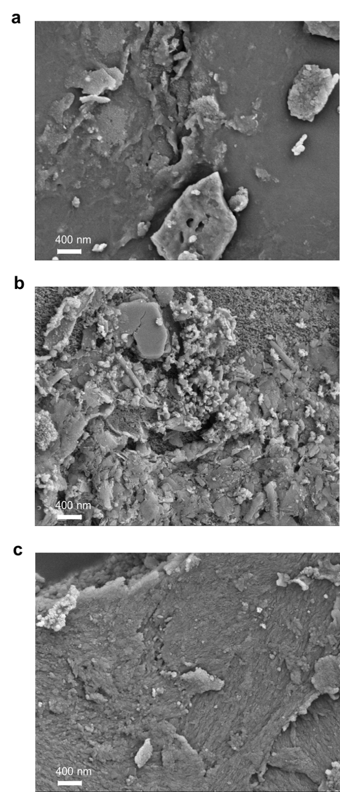

Supplementary Fig. 1. Characterization of the Raw BO, Activated BO, and Calcinated BO. (a) SEM image of BO Raw. Scale bar, 400 nm. (b) SEM image of Activated BO. Scale bar, 400 nm. (c) SEM image of Calcinated BO. Scale bar, 400 nm. Under SEM analysis at 400 nm scale, the morphological evolution exhibits progressive architectural modifications: Raw BO maintains its inherent compact morphology, Activated BO demonstrates a porous architecture, while Calcinated BO manifests discrete particulate domains embedded within the consolidated matrix.

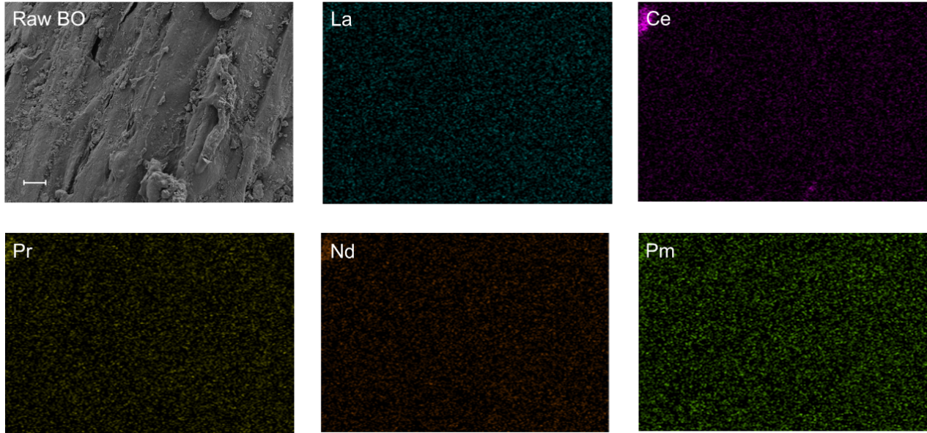
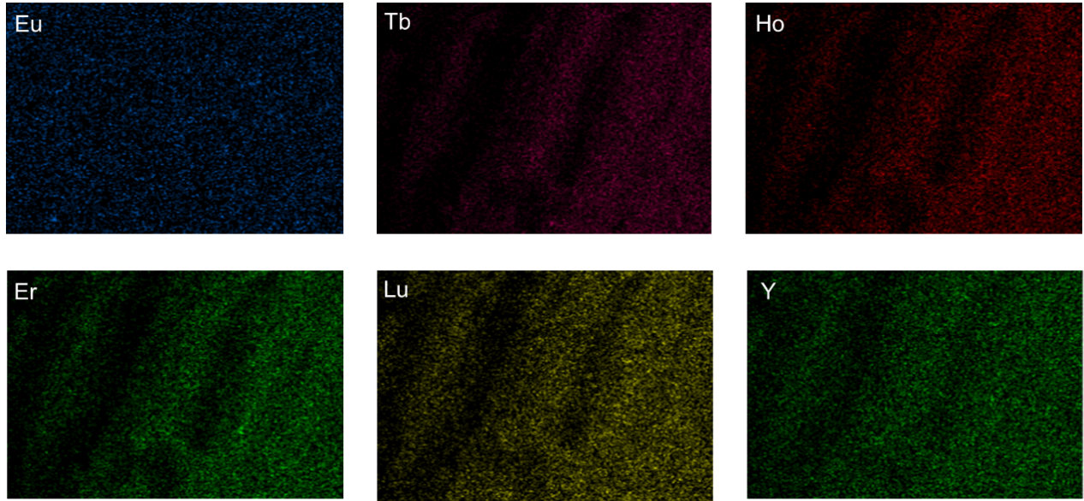

Supplementary Fig. 2. Characterization of the Raw BO. SEM image and corresponding EDS elemental maps of Raw BO. Scale bar, 5 μm.
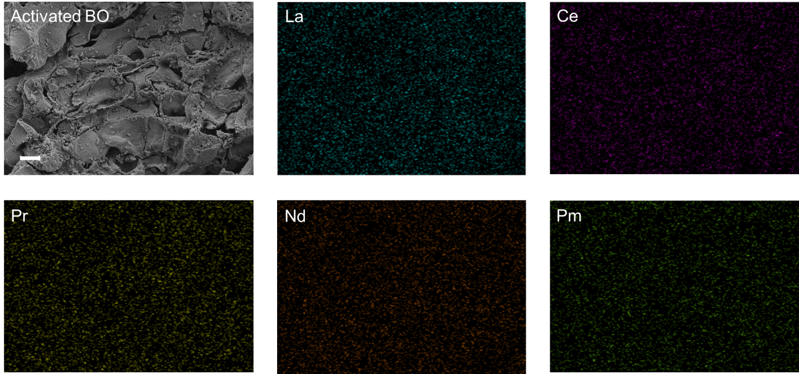
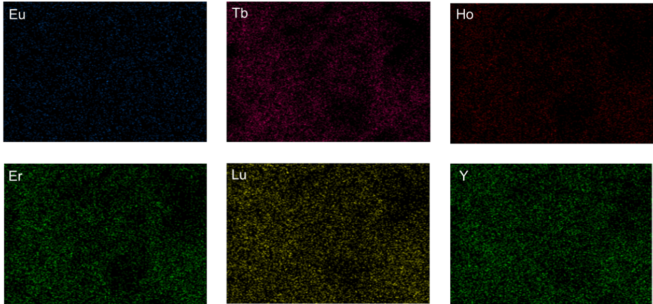

Supplementary Fig. 3. Characterization of the Activated BO. SEM image and corresponding EDS elemental maps of Activated BO. Scale bar, 5 μm.

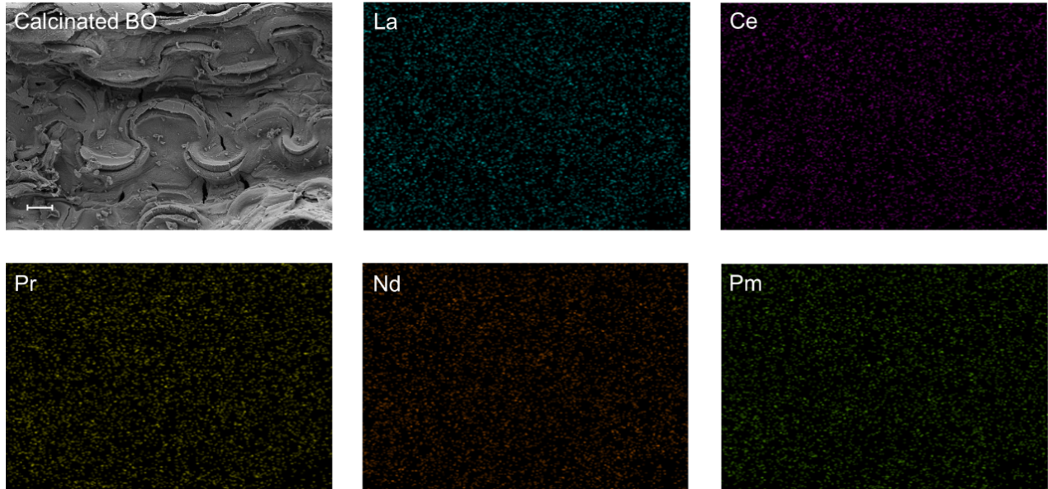
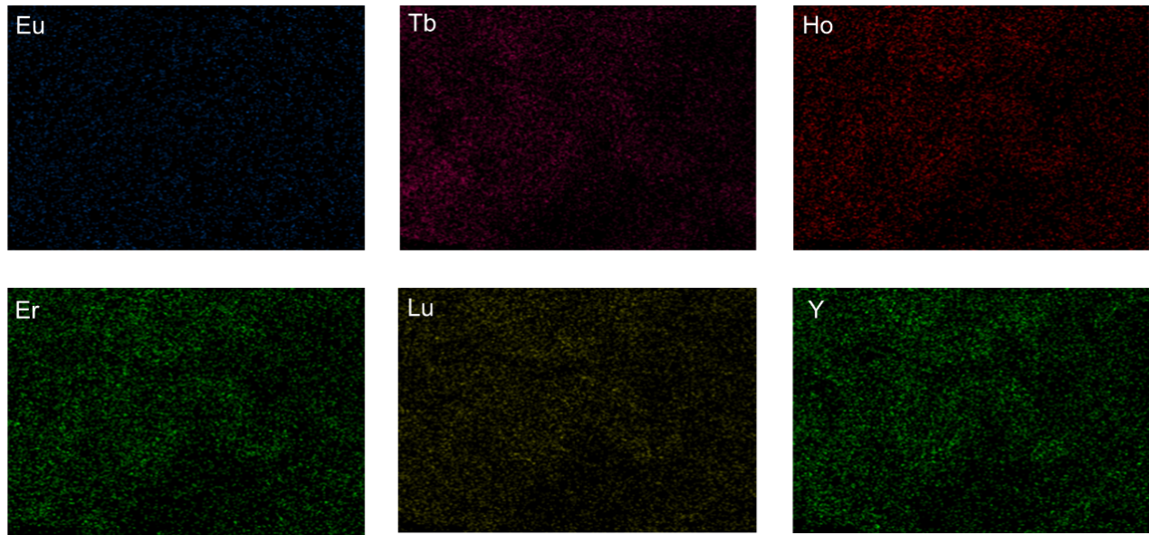

Supplementary Fig. 4. Characterization of the Calcinated BO. SEM image and corresponding EDS elemental maps of Calcinated BO. Scale bar, 5 μm.

Supplementary Fig. 5. Mechanism of the improved REE extractability by the electrothermal activation. XPS fine spectra of Nd 3d_{5/2} in Calcinated BO. The spectral feature observed at ~973 eV corresponds to the O KLL Auger transition.

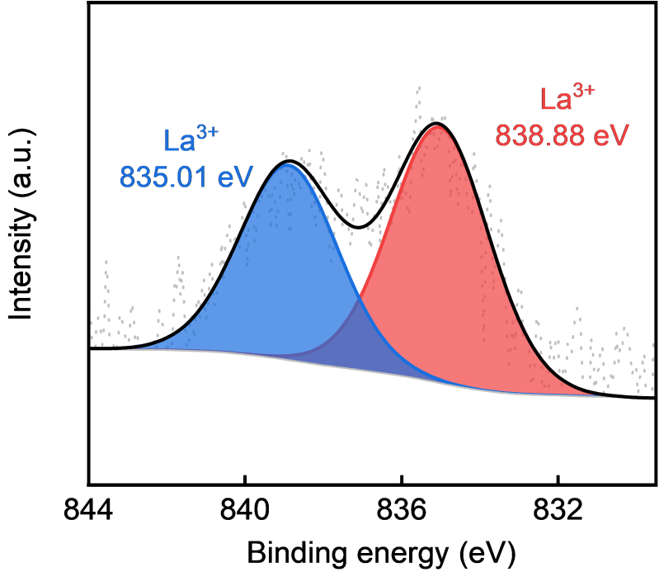

Supplementary Fig. 6. Mechanism of the improved REE extractability by the electrothermal activation. XPS fine spectra of La 3d_{5/2} in Calcinated BO.

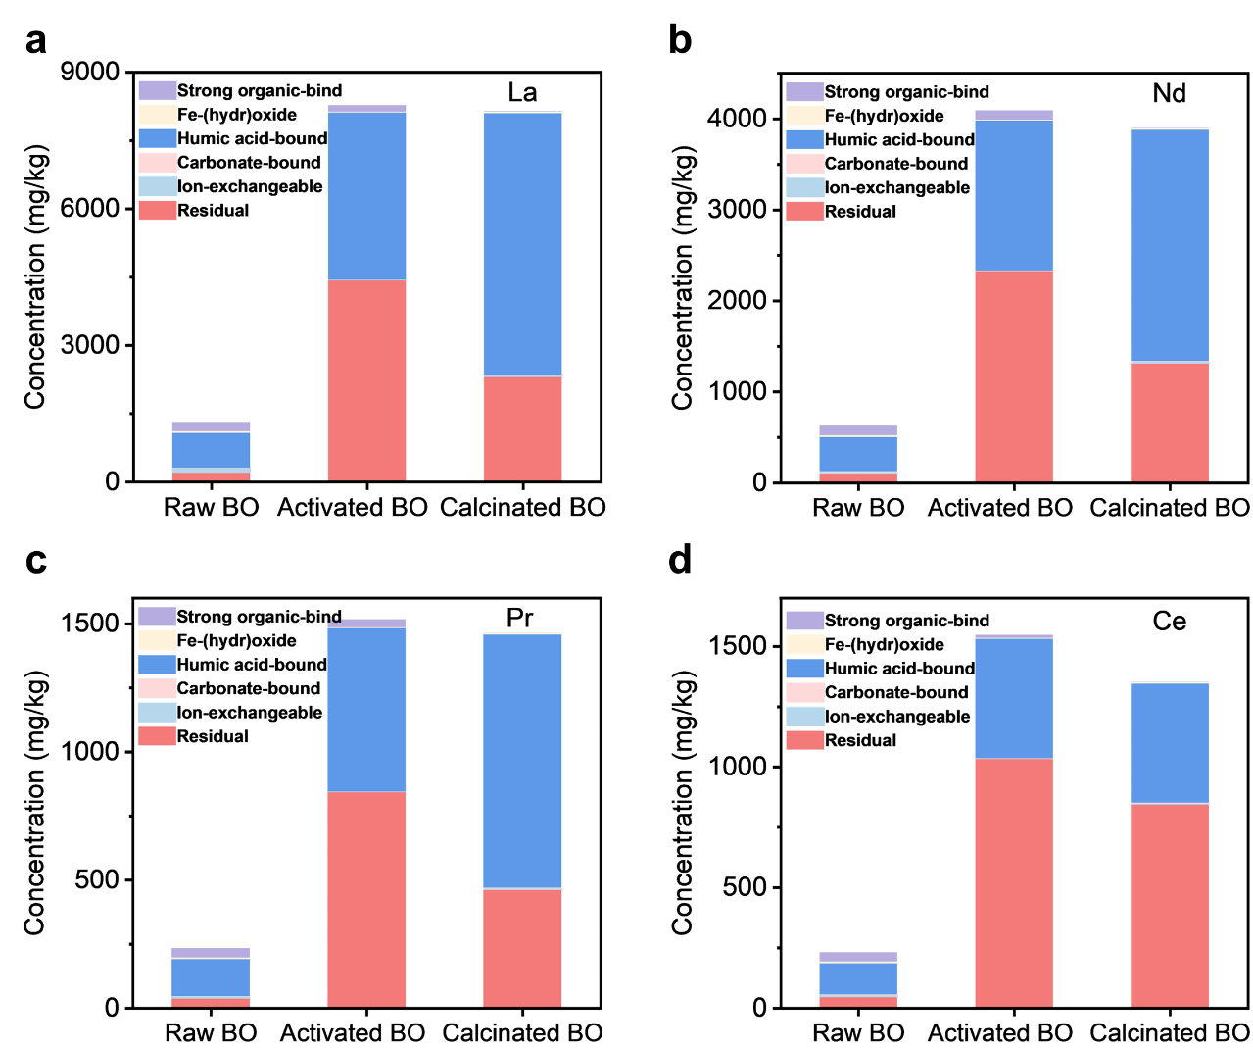

Supplementary Fig. 7. La, Nd, Pr, Ce speciations measured by sequential extraction. (a) Content of six REE forms (Strong organic-bind REE, Fe-(hydr)oxide REE, Humic acid-bound REE, Carbonate-bound REE, lon-exchangeable REE and Residual REE) of La in Raw BO, Activated BO and Calcinated BO. (b) Content of six REE forms (Strong organic-bind REE, Fe-(hydr)oxide REE, Humic acid-bound REE, Carbonate-bound REE, lon-exchangeable REE and Residual REE) of Nd in BO Raw, Activated BO and Calcinated BO. (c) Content of six REE forms (Strong organic-bind REE, Fe-(hydr)oxide REE, Humic acid-bound REE, Carbonate-bound REE, lon-exchangeable REE and Residual REE) of Pr in BO Raw, Activated BO and Calcinated BO. (d) Content of six REE forms (Strong organic-bind REE, Fe-(hydr)oxide REE, Humic acid-bound REE, Carbonate-bound REE, lon-exchangeable REE and Residual REE) of Ce in BO Raw, Activated BO and Calcinated BO.
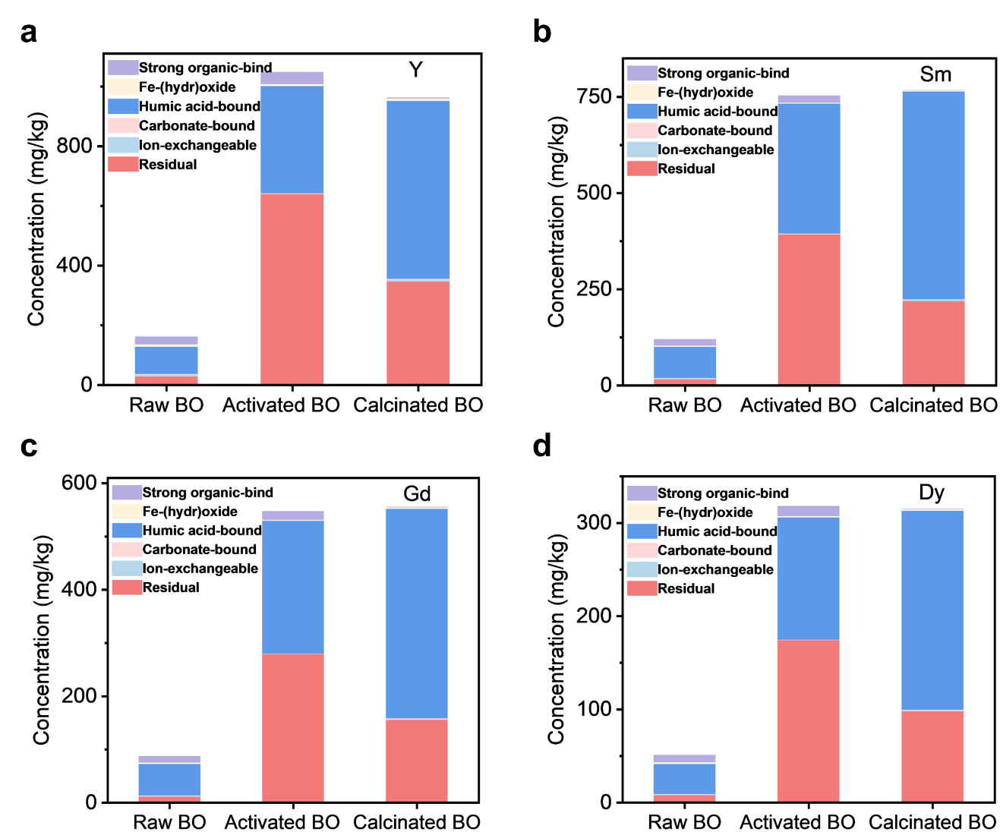

Supplementary Fig. 8. Y, Sm, Gd, Dy speciations measured by sequential extraction. (a) Content of six REE forms (Strong organic-bind REE, Fe-(hydr)oxide REE, Humic acid-bound REE, Carbonate-bound REE, lon-exchangeable REE and Residual REE) of Y in Raw BO, Activated BO and Calcinated BO. (b) Content of six REE forms (Strong organic-bind REE, Fe-(hydr)oxide REE, Humic acid-bound REE, Carbonate-bound REE, lon-exchangeable REE and Residual REE) of Sm in BO Raw, Activated BO and Calcinated BO. (c) Content of six REE forms (Strong organic-bind REE, Fe-(hydr)oxide REE, Humic acid-bound REE, Carbonate-bound REE, lon-exchangeable REE and Residual REE) of Gd in BO Raw, Activated BO and Calcinated BO. (d) Content of six REE forms (Strong organic-bind REE, Fe-(hydr)oxide REE, Humic acid-bound REE, Carbonate-bound REE, lon-exchangeable REE and Residual REE) of Dy in BO Raw, Activated BO and Calcinated BO.
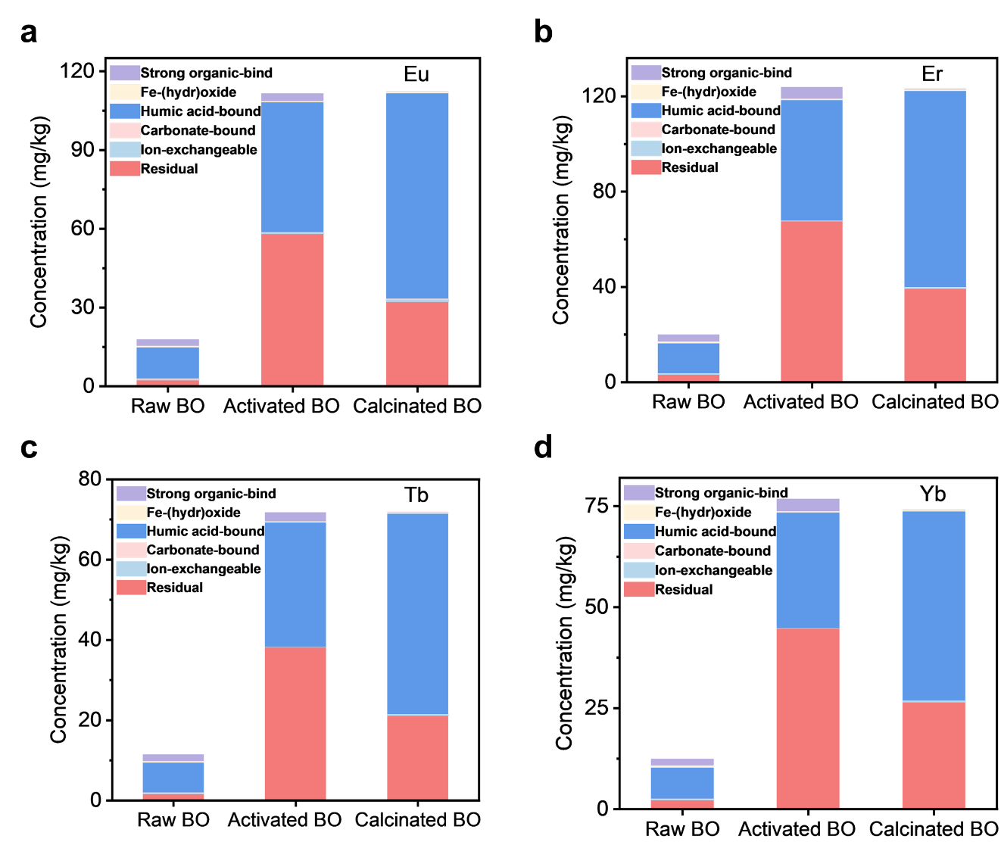

Supplementary Fig. 9. Eu, Er, Tb, Yb speciations measured by sequential extraction. (a) Content of six REE forms (Strong organic-bind REE, Fe-(hydr)oxide REE, Humic acid-bound REE, Carbonate-bound REE, lon-exchangeable REE and Residual REE) of Eu in Raw BO, Activated BO and Calcinated BO. (b) Content of six REE forms (Strong organic-bind REE, Fe-(hydr)oxide REE, Humic acid-bound REE, Carbonate-bound REE, lon-exchangeable REE and Residual REE) of Er in BO Raw, Activated BO and Calcinated BO. (c) Content of six REE forms (Strong organic-bind REE, Fe-(hydr)oxide REE, Humic acid-bound REE, Carbonate-bound REE, lon-exchangeable REE and Residual REE) of Tb in BO Raw, Activated BO and Calcinated BO. (d) Content of six REE forms (Strong organic-bind REE, Fe-(hydr)oxide REE, Humic acid-bound REE, Carbonate-bound REE, lon-exchangeable REE and Residual REE) of Yb in BO Raw, Activated BO and Calcinated BO.
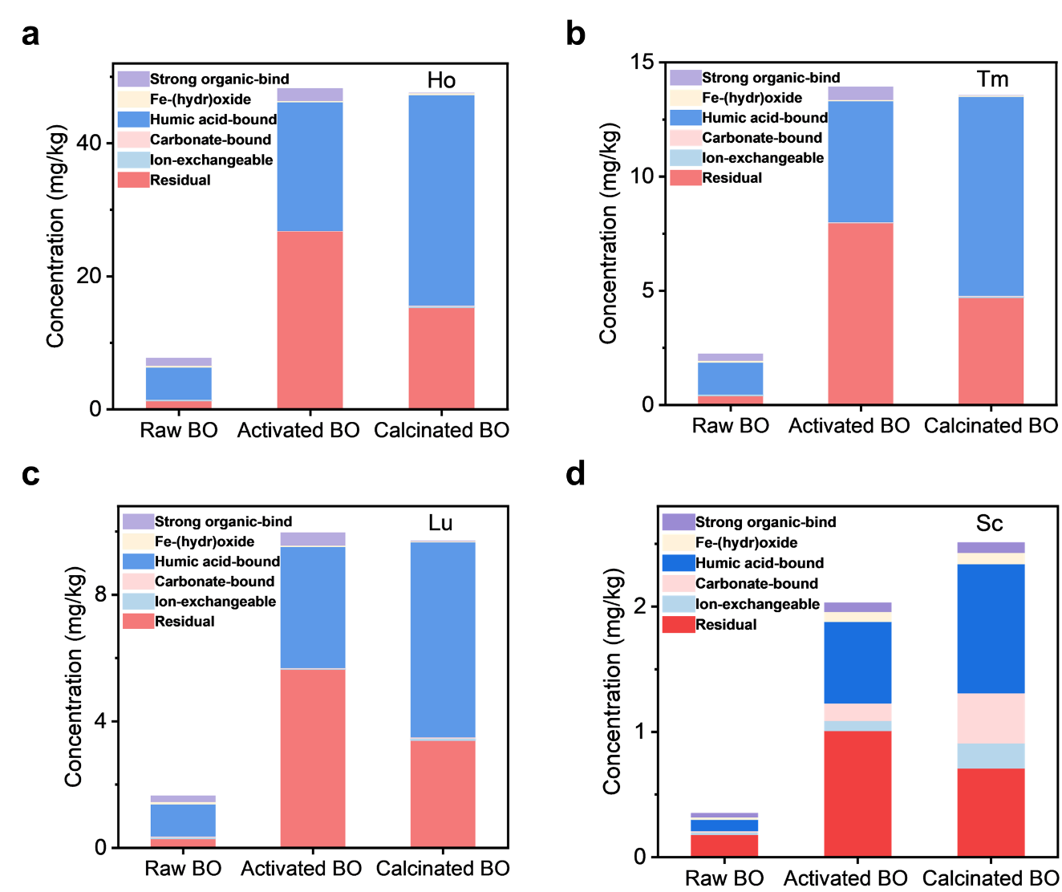

Supplementary Fig. 10. Ho, Tm, Lu, Sc speciations measured by sequential extraction. (a) Content of six REE forms (Strong organic-bind REE, Fe-(hydr)oxide REE, Humic acid-bound REE, Carbonate-bound REE, lon-exchangeable REE and Residual REE) of Ho in Raw BO, Activated BO and Calcinated BO. (b) Content of six REE forms (Strong organic-bind REE, Fe-(hydr)oxide REE, Humic acid-bound REE, Carbonate-bound REE, lon-exchangeable REE and Residual REE) of Tm in BO Raw, Activated BO and Calcinated BO. (c) Content of six REE forms (Strong organic-bind REE, Fe-(hydr)oxide REE, Humic acid-bound REE, Carbonate-bound REE, lon-exchangeable REE and Residual REE) of Lu in BO Raw, Activated BO and Calcinated BO. (d) Content of six REE forms (Strong organic-bind REE, Fe-(hydr)oxide REE, Humic acid-bound REE, Carbonate-bound REE, lon-exchangeable REE and Residual REE) of Sc in BO Raw, Activated BO and Calcinated BO.

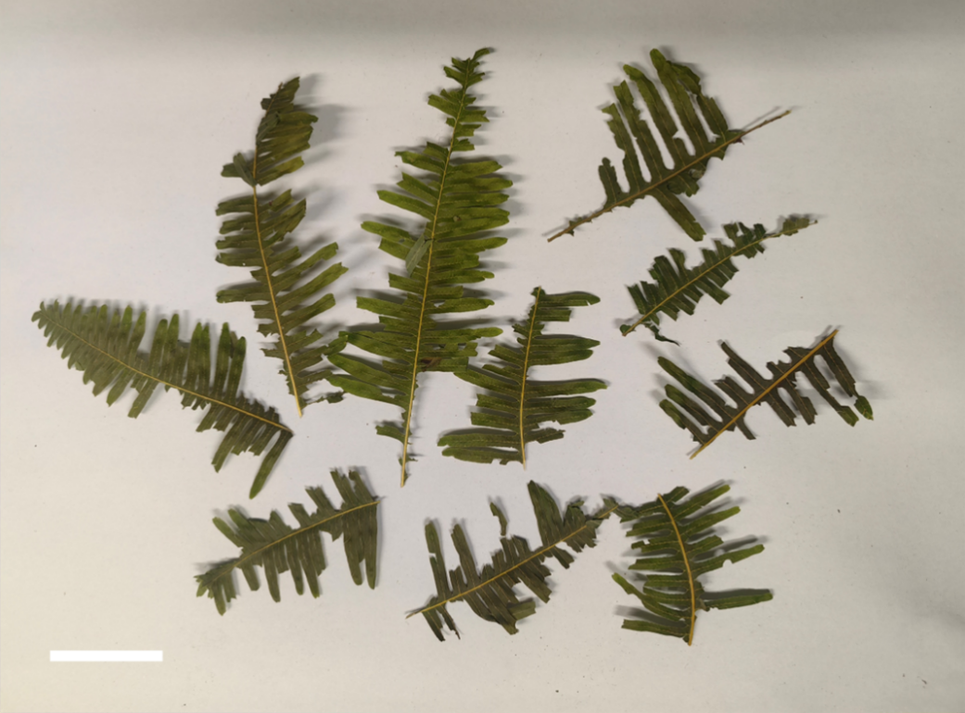

Supplementary Fig. 11. Characterization of Dicranopteris linearis (DL). Picture of DL leaves. Scale bar, 2.5 cm.

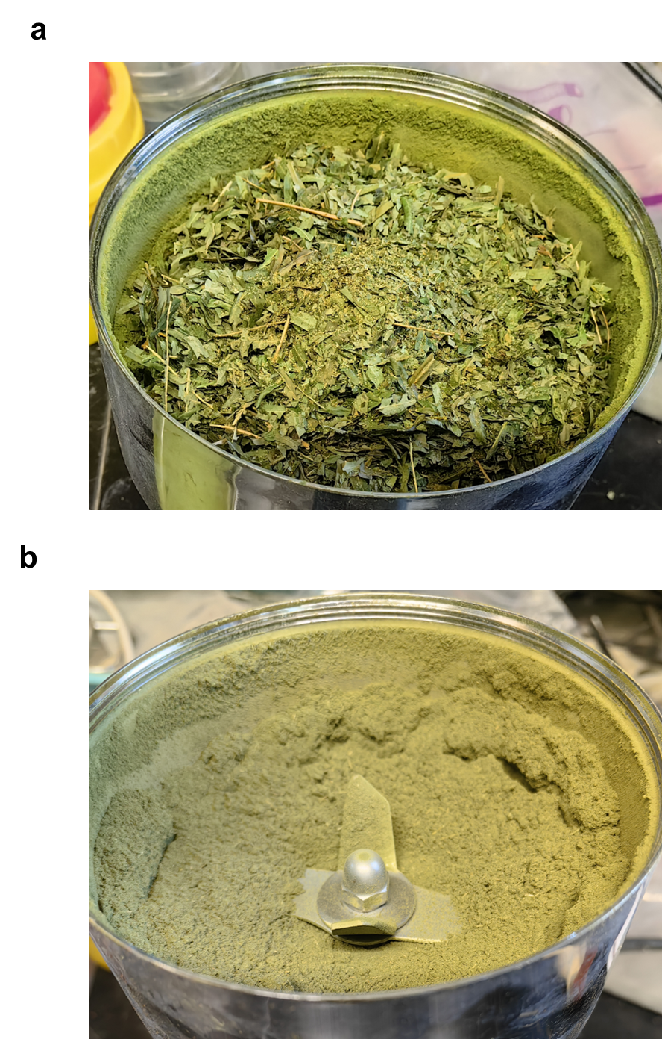

Supplementary Fig. 12. Characterization of the Dicranopteris linearis (DL) Raw. (a) Picture of dried DL before crushing. (b) Picture of dried DL after crushing.

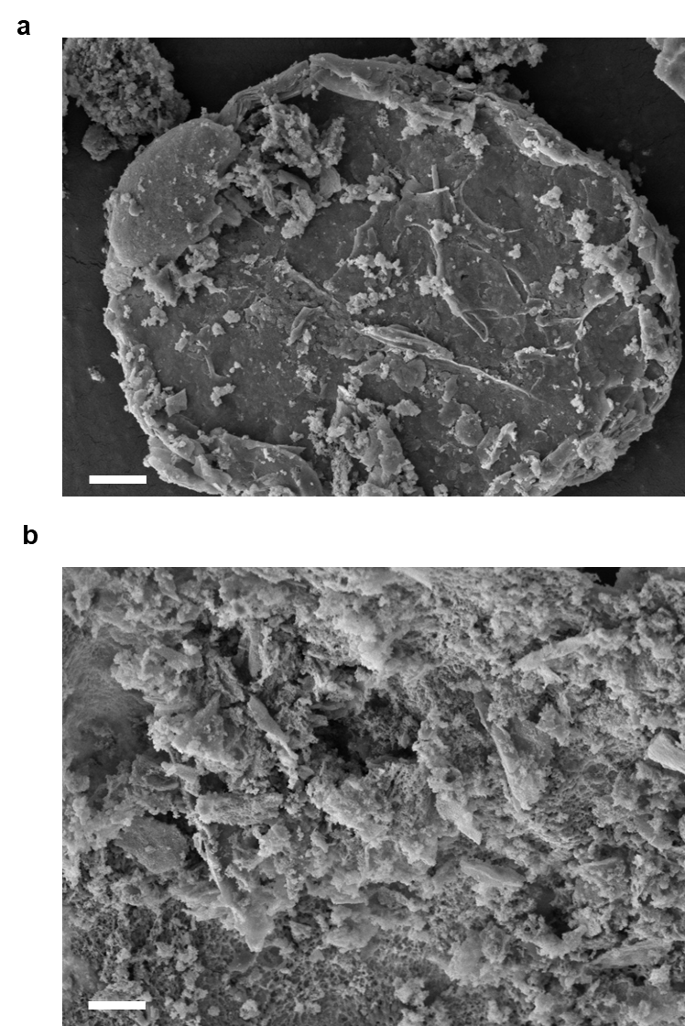

Supplementary Fig. 13. Characterization of Calcinated DL and Activated DL. (a) SEM image of Calcinated DL. Scale bar, 2 μm. (b) SEM image of Activated DL. Scale bar, 2 μm. SEM characterization at 2 μm scale reveals distinct microstructural configurations corresponding to different synthesis routes: The Calcinated DL phase preserves an architecturally integrated dense morphology, whereas Activated DL evolves heterogeneous features comprising discrete particle agglomerations within a consolidated framework.

Supplementary Fig. 14. Characterization of Calcinated DL. XRD patterns of Calcinated DL.
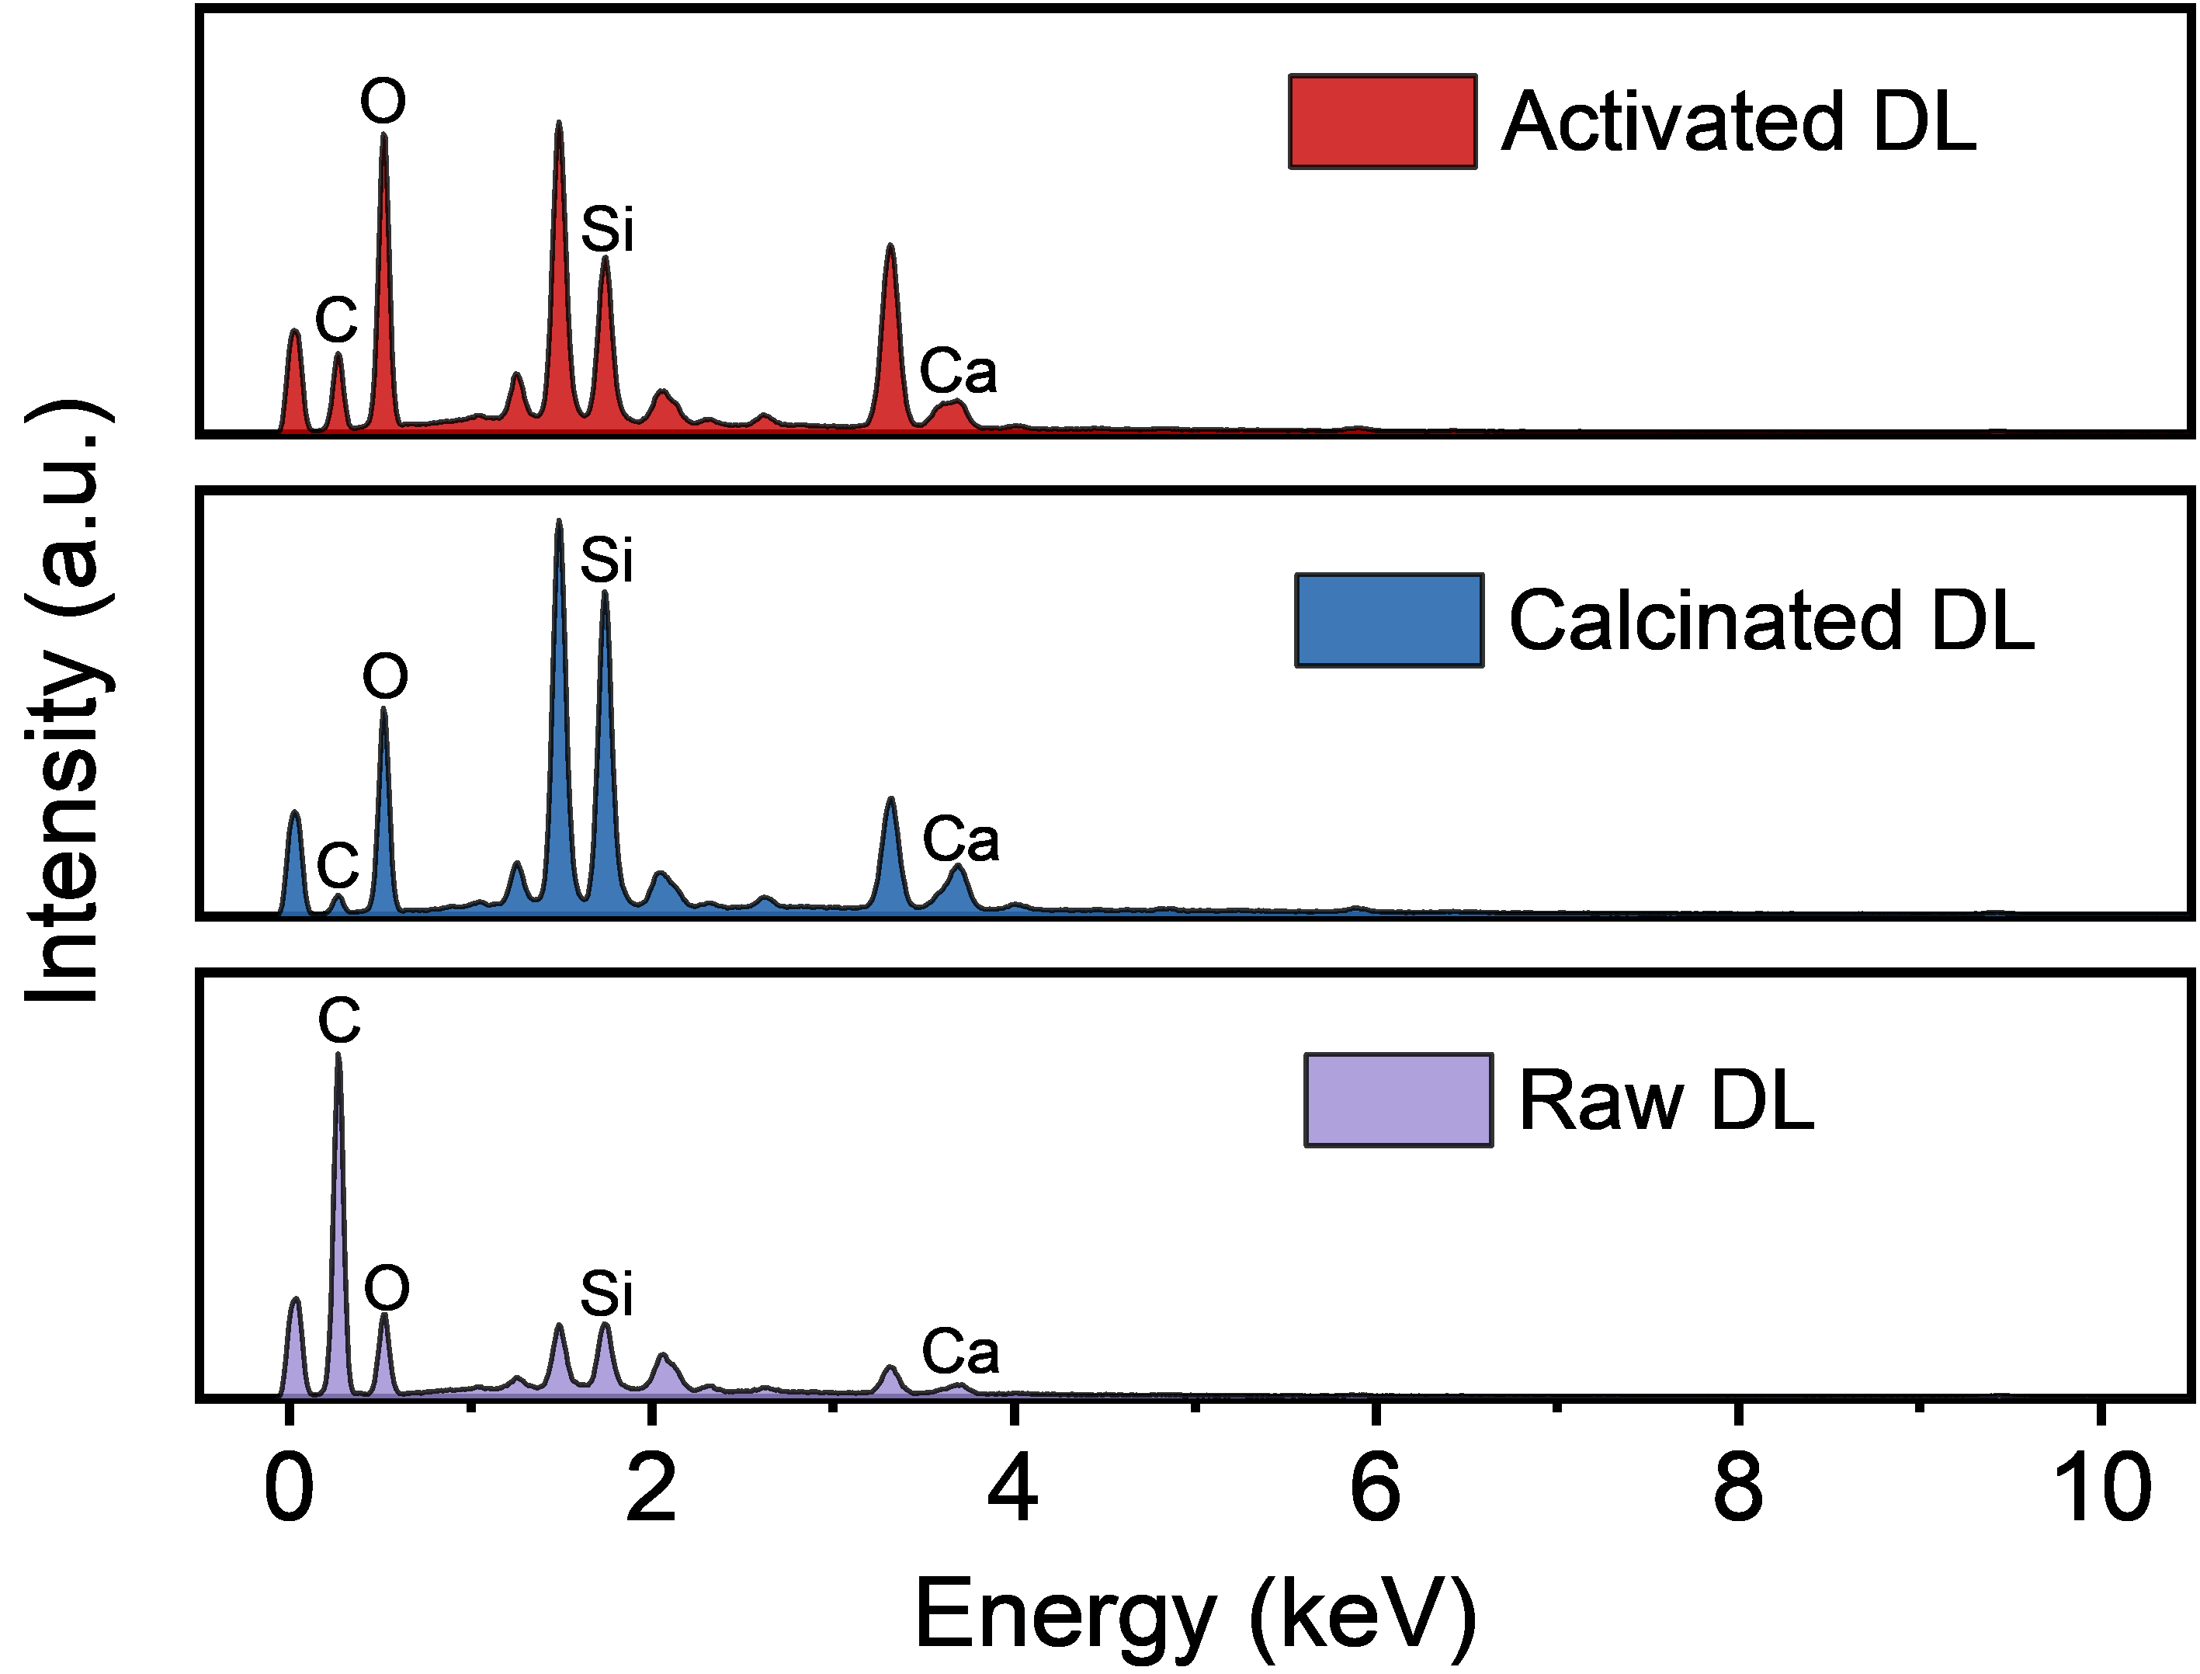

Supplementary Fig. 15. Characterization of Raw DL, Activated DL, and Calcinated BO. EDS elemental mapping of Raw DL, Calcinated DL, and Activated DL, showing distinct spatial distributions of C, O, Si, and Ca.

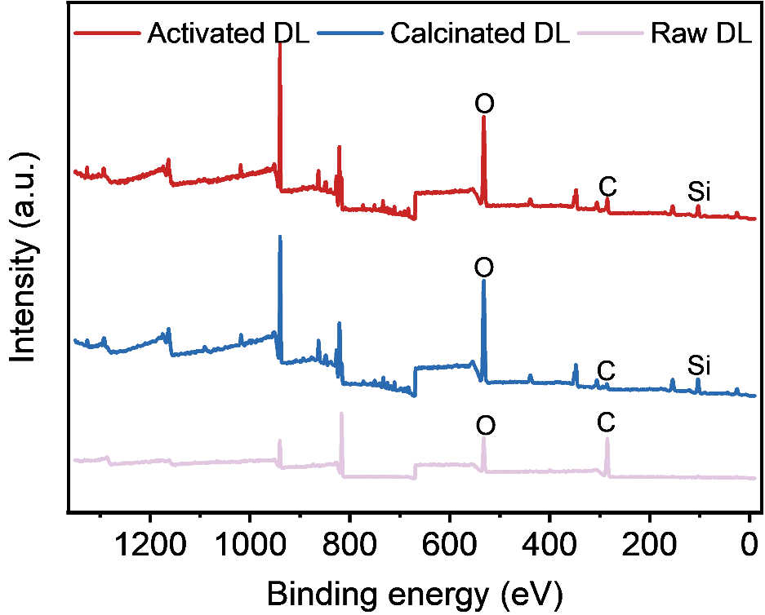

Supplementary Fig. 16. Characterization of Raw DL, Activated DL, and Calcinated BO. XPS full spectra of Raw BO, Activated BO, and Calcinated BO.

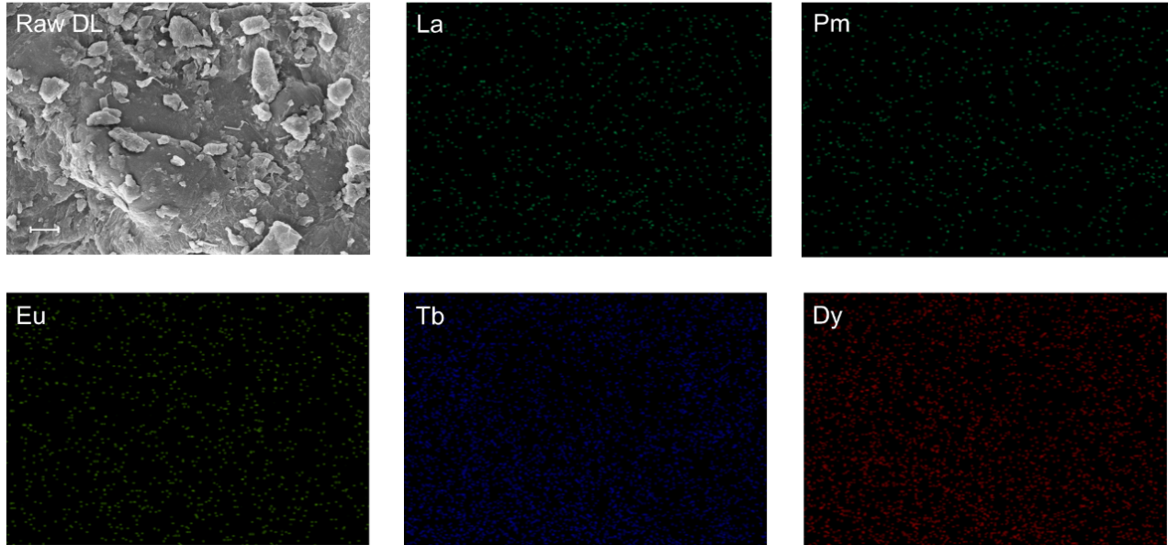
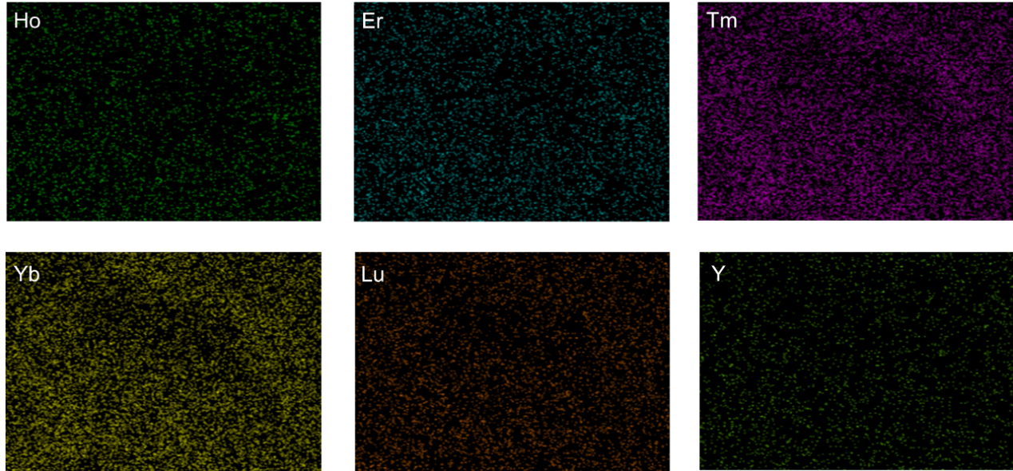

Supplementary Fig. 17. Characterization of Raw DL. SEM image and corresponding EDS elemental maps of Raw DL. Scale bar, 2 μm.

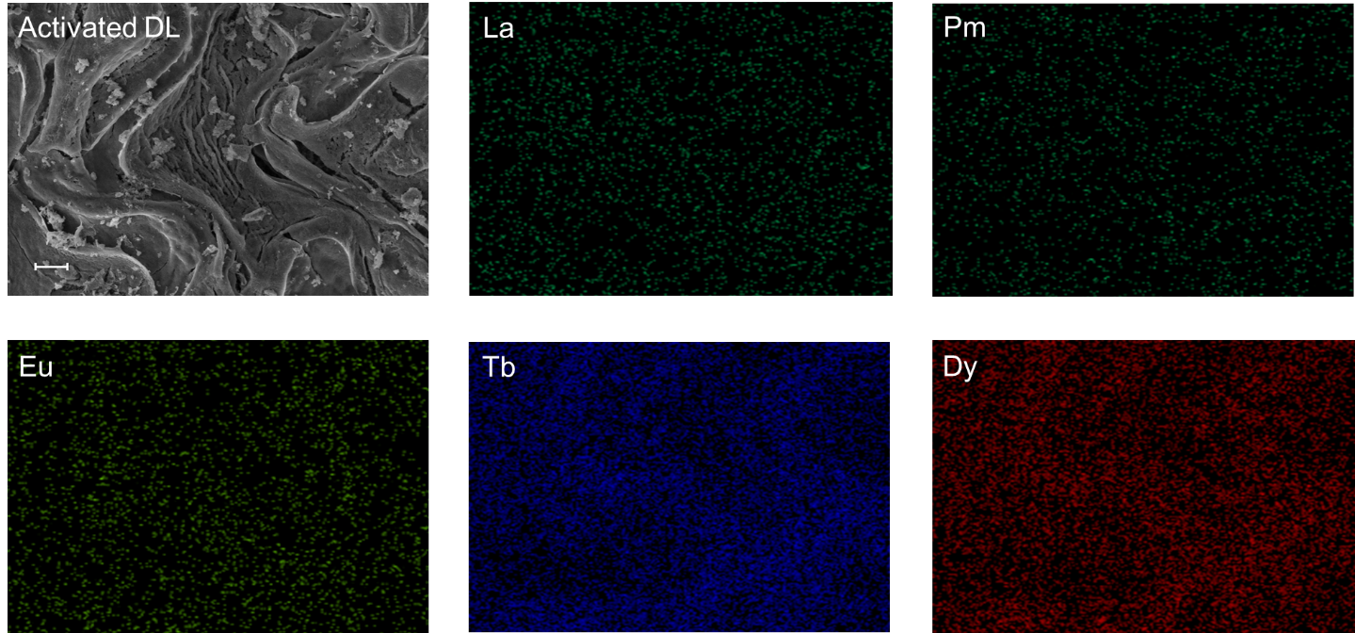
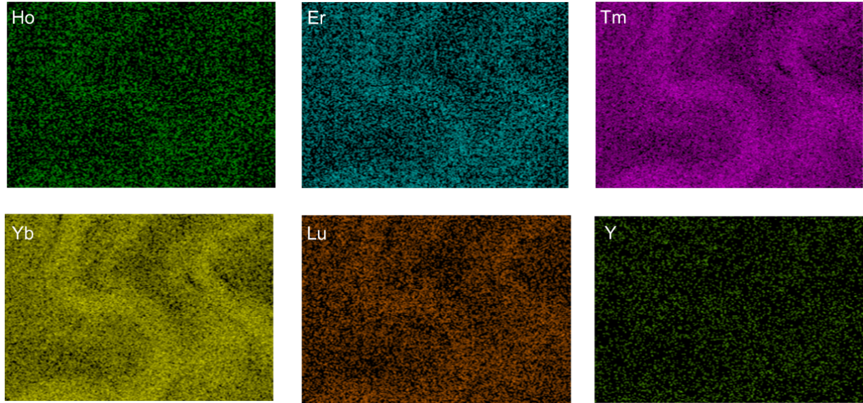

Supplementary Fig. 18. Characterization of Activated DL. SEM image and corresponding EDS elemental maps of Activated DL. Scale bar, 2 μm.

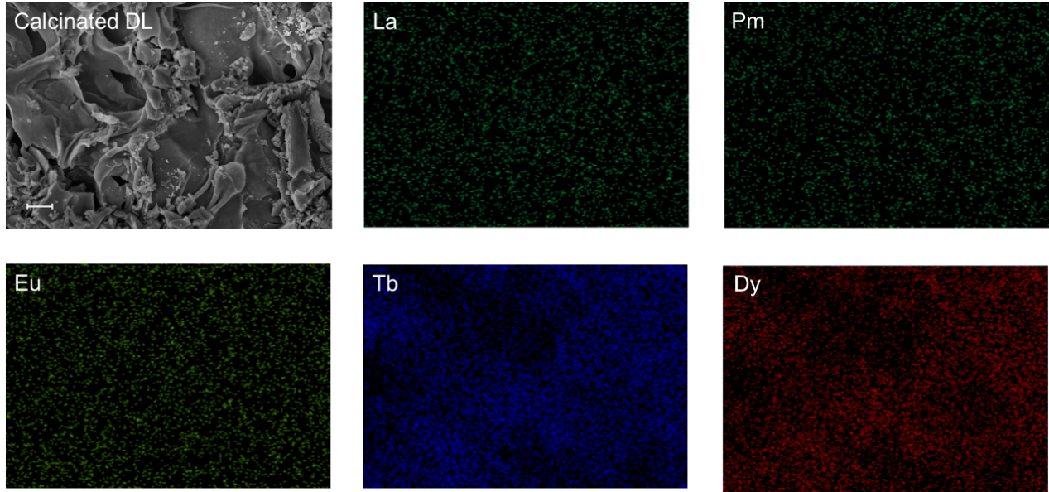
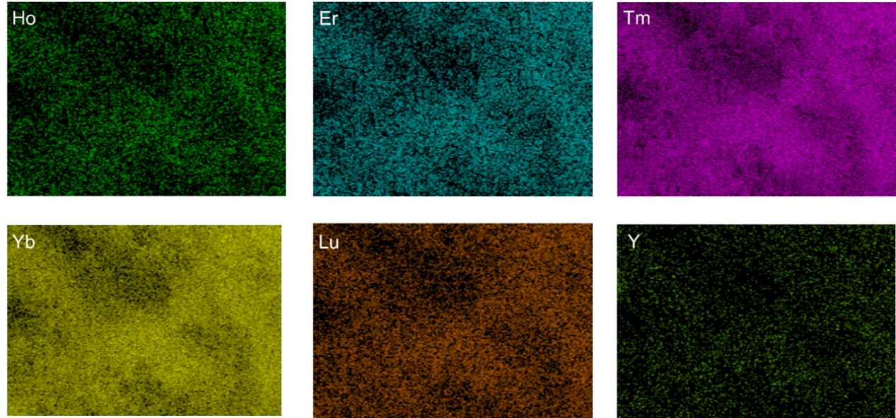

Supplementary Fig. 19. Characterization of Calcinated DL. SEM image and corresponding EDS elemental maps of Activated DL. Scale bar, 2 μm.

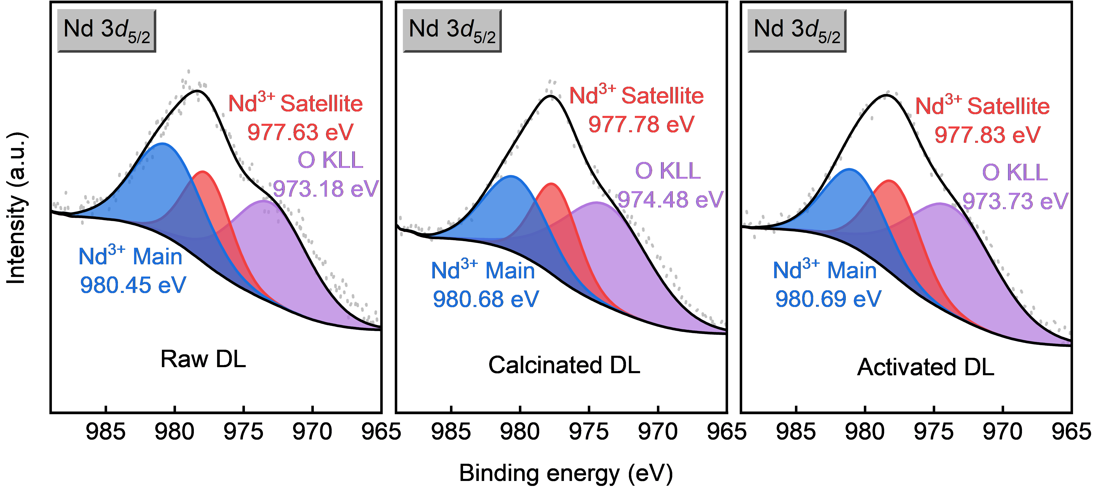

Supplementary Fig. 20. Mechanism of the improved REE extractability by the electrothermal activation. XPS fine spectra of Nd 3d_{5/2} in Raw DL, Calcinated DL, and Activated DL. The spectral feature observed at ~974 eV corresponds to the O KLL Auger transition.

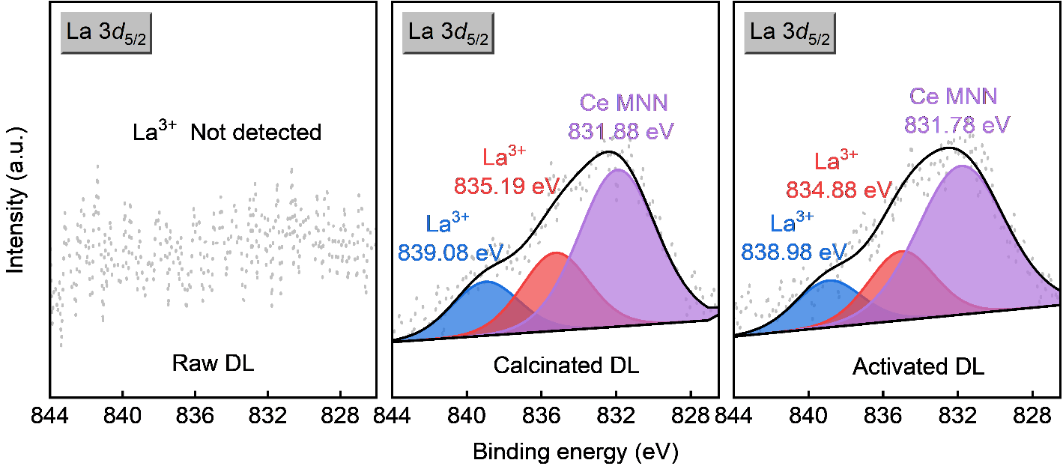

Supplementary Fig. 21. Mechanism of the improved REE extractability by the electrothermal activation. XPS fine spectra of La 3d_{5/2} in Raw DL, Calcinated DL, and Activated DL. La was not detected in Raw DL. The spectral feature observed at ~832 eV corresponds to the Ce MNN Auger transition.

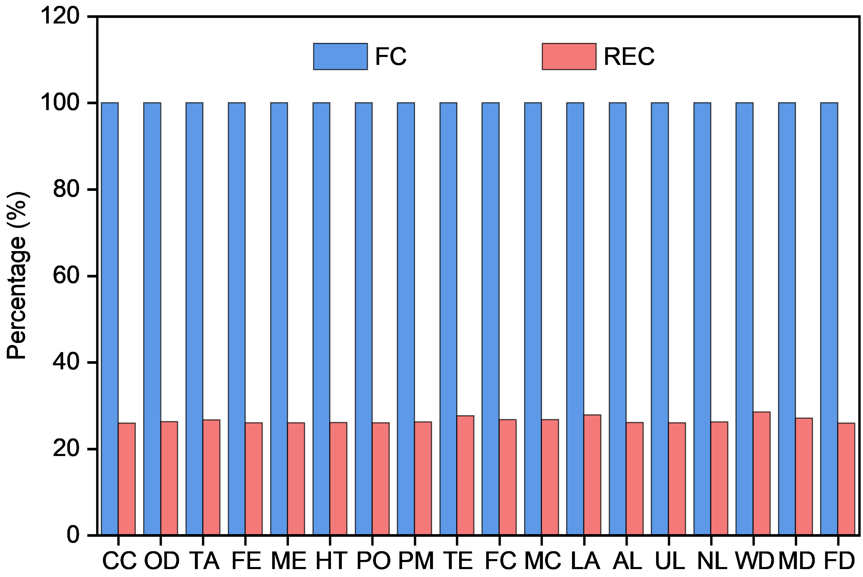

Supplementary Fig. 22. Environmental considerations for rare earth element (REE) separation processes. Comparison of the environmental impacts of separation processes. CC-Climate change, OD-Ozone depletion, TA-Terrestrial acidification, FE-Freshwater eutrophication, ME-Marine eutrophication, HT-Human toxicity, PO-Photochemical oxidant formation, PM-Particulate matter formation, TE-Terrestrial ecotoxicity, FC-Freshwater ecotoxicity, MC-Marine ecotoxicity, LA-Ionizing radiation, AL-Agricultural land occupation, UL-Urban land occupation, NL-Natural land transformation, WD-Water depletion, MD-Metal depletion, FD-Fossil depletion.
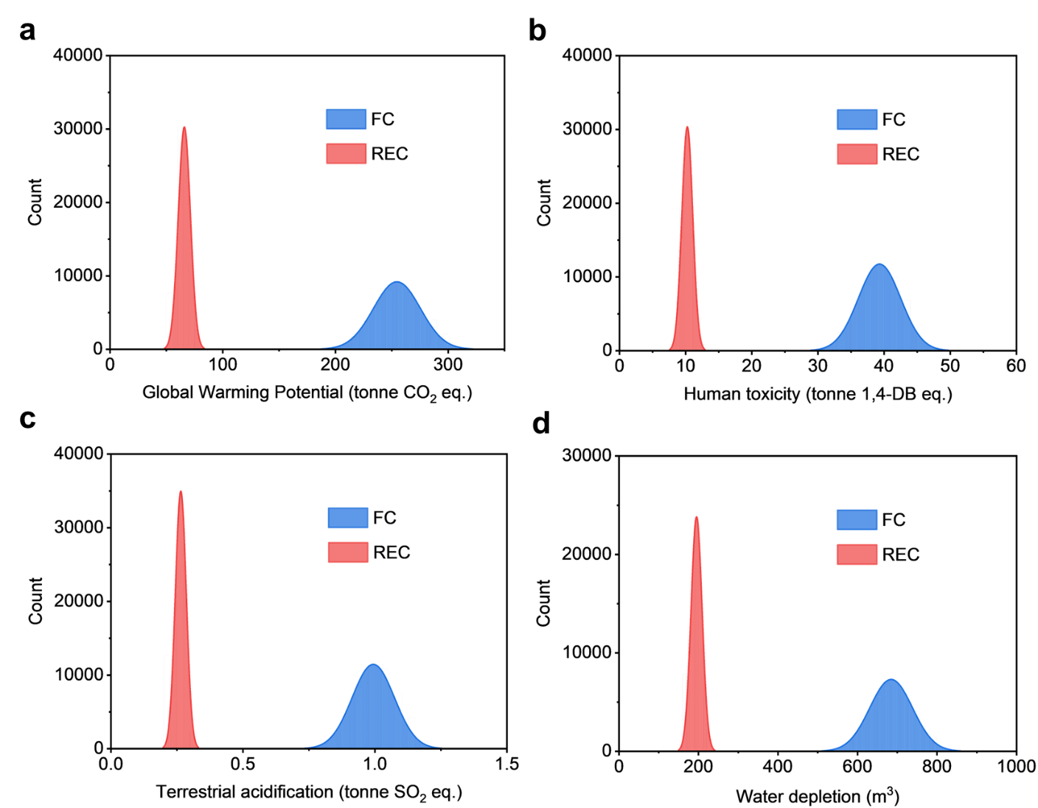

Supplementary Fig. 23. Environmental considerations for rare earth element (REE) separation processes. (A) Global warming potential comparison utilizing Monte Carlo uncertainty analysis with N=50,000 iterations. (B) Human toxicity comparison utilizing Monte Carlo uncertainty analysis with N=50,000 iterations. (C) Terrestrial acidification comparison utilizing Monte Carlo uncertainty analysis with N=50,000 iterations. (D) Water depletion comparison utilizing Monte Carlo uncertainty analysis with N=50,000 iterations.

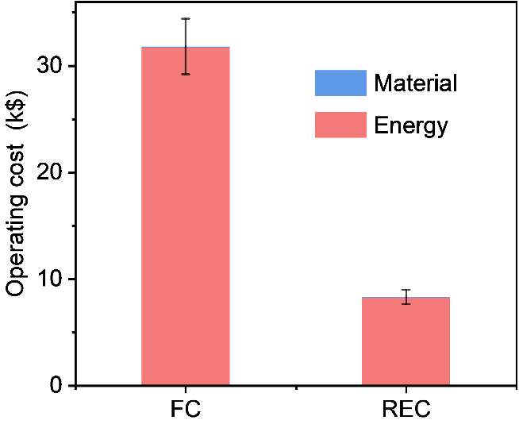

Supplementary Fig. 24. Economic considerations for REEs extraction processes. Comparison of operating costs between the furnace calcination and rapid electrothermal calcination processes. The scale bars indicate the standard deviation derived from Monte Carlo analysis.

Supplementary Table 1. X-ray fluorescence results of Raw BO.
Element | Percentage (%) | Element | Percentage (%)
C | 39.48 | Ba | 0.121
O | 33.68 | Y | 0.113
H | 5.62 | Cl | 0.0563
N | 1.11 | P | 0.0541
Si | 6.74 | Sm | 0.0533
Ca | 6.41 | Gd | 0.0381
Zn | 2.50 | Pb | 0.0317
La | 0.784 | Sr | 0.0256
K | 0.676 | Dy | 0.0227
Fe | 0.605 | Ag | 0.0131
Nd | 0.471 | Au | 0.0127
Al | 0.307 | Cu | 0.0102
S | 0.278 | Er | 0.0092
Mg | 0.246 | Br | 0.0083
Mn | 0.179 | Rb | 0.0056
Pr | 0.166 | Ni | 0.0043
Ce | 0.166 | Ge | 0.0038

Supplementary Table 2. X-ray fluorescence results of Raw DL.
Element | Percentage (%) | Element | Percentage (%)
C | 62.52 | P | 0.129
O | 27.26 | Ni | 0.0776
K | 2.93 | La | 0.0653
N | 2.75 | Zn | 0.0433
Si | 1.12 | Na | 0.0403
Al | 0.966 | Nd | 0.0324
Ca | 0.693 | Ba | 0.019
Si | 0.377 | Ti | 0.0157
Mg | 0.269 | Au | 0.0143
Mn | 0.236 | Rb | 0.0055
Fe | 0.153 | Cr | 0.0052
Ce | 0.142 | Cu | 0.0049
Cl | 0.140 | Y | 0.029

Supplementary Table 3. Life cycle inventory of REC and FC.
Scenario | Input | Price ($) | Unit | Amount
FC | H₂SO₄ | 85.000 | tonne | 0.976
FC | Deionized water | 1.000 | tonne | 9.000
FC | Electricity | 110.000 | MWh | 1.155
REC | H₂SO₄ | 85.000 | tonne | 0.976
REC | Deionized water | 1.000 | tonne | 9.000
REC | Electricity | 110.000 | MWh | 214.855

Supplementary Table 4. Life-cycle impact of global warming potential (GWP).
Scenario | Input | GWP (tonne CO₂ eq)
FC | H₂SO₄ | 0.117
FC | Deionized water | 0.001
FC | Electricity | 253.882
FC | Sum | 254.000
REC | H₂SO₄ | 0.117
REC | Deionized water | 0.001
REC | Electricity | 65.882
REC | Sum | 66.000

Supplementary Table 5. Life-cycle impact of terrestrial acidification (TA).
Scenario | Input | TA (tonne SO₂ eq)
FC | H₂SO₄ | 0.010
FC | Deionized water | 0.000
FC | Electricity | 0.982
FC | Sum | 0.992
REC | H₂SO₄ | 0.010
REC | Deionized water | 0.000
REC | Electricity | 0.254
REC | Sum | 0.264

Supplementary Table 6. Life-cycle impact of human toxicity (HT).
Scenario | Input | HT (tonne 1,4-DB eq)
FC | H₂SO₄ | 0.093
FC | Deionized water | 0.001
FC | Electricity | 39.106
FC | Sum | 39.200
REC | H₂SO₄ | 0.093
REC | Deionized water | 0.001
REC | Electricity | 10.126
REC | Sum | 10.220

Supplementary Table 7. Life-cycle impact of water depletion (WD).
Scenario | Input | WD (m³)
FC | H₂SO₄ | 15.210
FC | Deionized water | 8.866
FC | Electricity | 659.924
FC | Sum | 684.000
REC | H₂SO₄ | 15.210
REC | Deionized water | 8.866
REC | Electricity | 170.924
REC | Sum | 195.000

Supplementary Table 8. Evaluation of operating cost (OC).
Scenario | Input | OC (k$)
FC | H₂SO₄ | 0.083
FC | Deionized water | 0.009
FC | Electricity | 31.719
FC | Sum | 31.811
REC | H₂SO₄ | 0.083
REC | Deionized water | 0.009
REC | Electricity | 8.212
REC | Sum | 8.304

