Supplementary Information

Materials and Methods
Approach: The experiment was conducted at the University of Hawai‘i at Mānoa, Hawai‘i Institute of Marine Biology (HIMB) on Moku o Lo‘e (Coconut Island), immediately adjacent to the island of O‘ahu in the Hawaiian Archipelago, starting on 1 February 2016. Most samples and other measurements were collected after approximately two years of exposure under treatment conditions (Fig. S2). Like much of experimental coral reef research to date, this work was performed on a relatively high latitude reef, raising caveats about exactly how results apply to more equatorial reefs. Although mesocosms were located at ~21 °N latitude, roughly 1 in 6 reefs across the Indo-Pacific share a similar or cooler temperature profile⁴⁵. Furthermore, environmental diversity among reefs irrespective of latitude is one of the strengths for generality, because some reefs within the Indonesian Seas and other locations are cooler due to the influence of internal waves⁴⁶ and the Red Sea, at the same latitude as Hawai‘i, is one of the warmest and fastest warming ecosystems on the planet⁴⁷. In fact, mean annual temperatures on Oʻahu reefs are warmer than many in Florida, Okinawa or Australia where the majority of previous coral thermal stress⁴⁸ and reef mesocosm experiments^{18,20,21} have been performed to date, and yet such high latitude reef studies continue to form the basis for our understanding in the field.
The mesocosms received constant flow-through of unfiltered seawater drawn from the adjacent coral reef (2-3 m depth, depending on tide). Relative to the offshore source water, seawater temperature and chemistry are naturally modified by reef-associated physical and biogeochemical processes as the water flows through the bay ^{26,29,49}. To restore water temperature and chemistry of the incoming seawater close to that of the original source water, all incoming seawater was directed into a mixing tank where temperature was adjusted using a commercial heat pump on a temperature controller and chemistry was adjusted with small additions of 1.0 N NaOH via a peristaltic pump to achieve average present-day offshore temperature and chemistry conditions in Hawaiʻi (temperature 23.5-27.5 °C, pH 7.97-8.07, annually). These small adjustments resulted in modifications to the temperature, pH, and total alkalinity in the seawater input which, when combined with the same physical and biogeochemical processes in the mesocosms, allowed us to achieve conditions very similar to those observed on the reef ^{29,35,50}. This incoming water was then split off into a series of header tanks where it was heated or acidified according to treatment, with 2 replicate header tanks per treatment. Temperature was adjusted using commercial aquarium heaters on temperature controllers and seawater was dosed with CO₂ gas using high precision needle valves connected to venturi valves on aquarium pumps to deliver a precisely controlled quantity of CO₂ gas that was completely dissolved into the seawater in the header tanks before flowing into the mesocosms. The heated treatments were set to remain 2 °C above the Control (i.e., present-day average) temperature, whereas the acidified treatments were maintained at 0.2 pH units below the Control treatment, thereby replicating conditions expected at the end of the century. All mesocosms experienced natural daily and seasonal fluctuations in light, seawater temperature, and carbonate chemistry with appropriate offsets according to treatment (Table 1, Fig. 2, S1).
Two approaches were used to characterize the water temperature and chemistry in the mesocosms. First, water samples were taken from each mesocosm at 1200 hr local time once per week for total alkalinity and spectrophotometric pH, whereas salinity and temperature were measured with a YSI multimeter. All these procedures followed standard protocols ⁵¹. The precision of these measurements were: pH ±0.002 units, salinity ±0.01 psu, temperature ±0.01 °C, total alkalinity ±7 µmol kg⁻¹. The accuracies of these measurements are estimated as: pH ±0.005 units, salinity ±0.3 psu, temperature ±0.1 °C, total alkalinity ±7 µmol kg⁻¹. The accuracy and precision of total alkalinity titrations were assessed using Certified Reference Materials (CRMs) obtained from Andrew Dickson (Scripps Institution of Oceanography). Second, the temperature and chemistry measurements as described above, were assessed every 4 hr over the diel cycle once per quarter. For the remaining two months per quarter, bottle samples were taken for pH and total alkalinity only at 1200 and 0000 hr and a pH meter was used to assess pH at the other diel sampling points (1600, 2000, 0400, and 0800 hr). The pH meter was empirically calibrated to the 1200 and 0000 hr pH bottle samples at the time of collection, yielding an uncertainty of ±0.02 units for these sample points. The monthly diel samples were used to assess the hourly temperature and chemistry variation in the mesocosms as well as the daily mean values on those sampling dates. The weekly water samples, along with the empirically derived relationships between the offset of the mesocosm sea water to the incoming sea water measured at 1200 hr and the daily mean values (characterized during the diel sampling), were used to estimate the daily mean parameters for these remaining dates. These estimates yielded the following uncertainties in the calculated daily means: salinity ±0.12 psu, pH ±0.03 units, temperature ±0.17 °C, and total alkalinity ±16 µmol kg⁻¹. The remaining carbonate chemistry parameters were calculated with CO2SYS ⁵². This sampling protocol yielded data resolution similar to or greater than that used in previous studies ^{18–20}, but over a longer timeframe and at a much higher level of replication.
To reach initial target treatment temperature and pH values at the beginning of the experiment, adjustments were made in 0.5 °C and 0.03-0.05 pH unit increments every 10 days (starting on 1 February 2016 from baseline values that were intermediate between the temperature and pH treatment levels) until target values were reached (20 February 2016). The slow ramp to target temperature and pH during the winter minimized the chances of shocking the communities and was slower than many natural warming events. The design initially included 40 mesocosms (0.5×0.5×0.3 m, 70 L). Prior to this study, growth rates had been measured in only a few of the coral species and some of the corals showed higher skeletal extension rates than we expected (ranging from about 1-5 cm yr⁻¹). We became concerned that the corals would overgrow one another before the end of the experiment, which would have compromised some aspects of our study, necessitating the removal of some corals to provide additional space for continued unrestricted growth. Starting on 18 November 2017, an additional eight (2 per treatment) larger mesocosms (0.5×1.1×0.3 m, 180 L) were added to maintain three coral species (Montipora flabellata, Pocillopora meandrina, and Porites evermanni) selected for removal to prevent direct competition for space among corals in the mesocosms. We selected one species per genus that included one slow (Porites evermanni), moderate (Pocillopora meandrina), and fast (Montipora flabellata) growing species, to minimally impact the initial mesocosm design. None of the corals or the reef communities showed any obvious adverse reactions to this move. Further, because all 40 mesocosms received the same modification, our results are unbiased by treatment, but we consider the consequences of this move in our analyses, as described below.
The mesocosms were randomly assigned to treatment. Seawater inflow rate was adjusted to 1.2 L min⁻¹ (70 L mesocosms) or 3.5 L min⁻¹ (180 L mesocosms) for a residence time of 1 hr in all mesocosms. Additional water circulation was generated within each mesocosm by submerged seawater pumps with one Maxi-Jet Pro propeller pump (4900 L hr⁻¹) in each 70 L mesocosm and two pumps in each 180 L mesocosm. Flow speeds in the vicinity of the benthic communities (10-15 cm s⁻¹) were estimated from visual inspection of particle tracks and verified with an independent product review of the pumps ⁵³.
The 40 mesocosms were initially stocked with a 2 cm layer of carbonate reef sand and gravel as well as pieces of reef rubble (3 replicate 10-20 cm pieces randomly divided among mesocosms) collected from the adjacent reef, thereby including natural infaunal and surface-attached communities. In addition, a juvenile (3-8 cm) Convict surgeonfish (Acanthurus triostegus) and Threadfin butterflyfish (Chaetodon auriga), 5 herbivorous reef snails (Trochus sp.), and the eight regionally most common reef-building coral species were added to the mesocosms. Over the course of the experiment, additional Trochus snails recruited into the mesocosms, ranging from about 10-40 snails per mesocosm at the end. Corals were attached to ceramic plugs with cyanoacrylate gel, to allow them to be moved or manipulated during the experiment. The corals and rubble were placed on a plastic grate 6 cm above the bottom soft sediments, to simulate their attachment to hard substrate in nature. The surgeonfish is a generalist grazer on benthic algae whereas the butterflyfish is a generalist grazer on non-coral invertebrates. Together, the fish provided the essential ecological functions of herbivory and predation in the mesocosms, and at fish biomass values similar to those reported for Hawaiian reefs⁵⁴. As the fish grew larger (5-10 cm) their densities were slowly reduced and the two species were rotated through the mesocosms about every other week, to provide similar levels of grazing throughout the experiment. Fish were supplementally fed 3 g wet weight of frozen mysis or brine shrimp daily (which they consumed within about 5 min), thereby provisioning the fish and wider reef communities with allochthonous (i.e., non-local, imported) zooplankton at a rate similar to that measured in nature⁵⁵. Assessing responses by the fish was not a major focus of this study, though they showed no obvious differences in behavior or condition among treatments, consistent with recent work⁵⁶.
The eight coral species included in the mesocosms (Montipora capitata, Montipora flabellata, Montipora patula, Pocillopora acuta, Pocillopora meandrina, Porites compressa, Porites evermanni, and Porites lobata) are the dominant species across the Hawaiian archipelago and collectively comprise >95% of the coral cover on Hawaiian reefs^{57,58}. Historically, four of these species were once thought to be Hawaiian endemics (Montipora flabellata, Montipora patula, Porites compressa, and Porites evermanni), though more recent analyses have shown that all eight species (or their genetically indistinguishable kin) are in fact widespread across the Indo-Pacific ^{59–61}. These eight species represent both major lineages of reef-building corals (Complexa and Robusta) ⁶², and all four of the major life history strategies exhibited by corals ⁶³ including competitive (Montipora capitata, Pocillopora meandrina, and Porites compressa), generalist (Montipora flabellata and Montipora patula, inferred from the ecologically similar Montipora monasteriata), stress-tolerant (Porites lobata and Porites evermanni, with the strategy for Porites evermanni inferred from the ecologically similar Porites lutea), and weedy strategies (Pocillopora acuta, inferred from its ecologically similar sister species Pocillopora damicornis). In prior thermal stress events these species have shown differing resistance to bleaching ranging from low (Montipora flabellata, Pocillopora acuta, and Pocillopora meandrina), to moderate (Montipora capitata, Montipora patula, Porites compressa, and Porites lobata), to high (Porites evermanni)(50). They also include the major reef-building coral families worldwide (Acroporidae, Pocilloporidae, and Poritidae) yielding broad ecological and spatial relevance to this study. Corals were collected at 2±1 m depth from a total of six locations around O‘ahu³⁵ between 17 August 2015 and 13 November 2015, to help ensure that a representative sample of their phenotypic and genotypic diversity was included in the study. Sampling of each species was restricted to the subset of sites where it was relatively common (3-5 sites per species), and conspecifics were separated by at least 5 m to minimize the chances of accidentally sampling clones or biasing the sampling towards particular microenvironments³⁵. All 232 coral parent colonies sampled for this study (22 parent colonies for Montipora flabellata; 30 parent colonies for each of the other seven species) were genotyped to ensure that they were distinct genets and results were not biased by inclusion of many clonally derived colonies. After collection, the corals were allowed 12 weeks to recover and acclimate to the mesocosm system under the same temperature and pH conditions, thereby standardizing their short-term histories prior to beginning the experiment on 1 February 2016. Most genets contributed one ramet (i.e., coral fragment, 3-5 cm) per treatment whereas four genets per species were represented by three replicate ramets per treatment, resulting in 1184 coral ramets total in the experiment. Each mesocosm initially contained 29-30 ramets (3-4 ramets per species, each of which was a distinct genet) and an initial coral cover of about 10%.
Irradiance data were obtained from the HIMB weather station (https://www.pacioos.hawaii.edu/metadata/AWS-HIMB.html?format=fgdc). Sunlight was attenuated with 30% shade cloth to provide irradiance similar to that at mean collection depth (2 m) with a maximum instantaneous irradiance of about 1730 µmol m⁻² s⁻¹ in the mesocosms and 2470 µmol m⁻² s⁻¹ in the air. A handheld quantum meter was used to take periodic spot checks to ensure that the desired level of shading was achieved. Light spectrum was not adjusted due to the trivial differences between 0.3 m (mesocosm depth) and 2 m (mean collection depth). The nominal coral bleaching threshold (27.98 °C) was estimated as the mean monthly maximum temperature for the Main Hawaiian Islands (26.98 °C)⁶⁴ +1 °C.

Coral genotyping: Multilocus genotyping of coral hosts was performed following published methods^{65,66}. Briefly, total genomic DNA was isolated using the E.Z.N.A. Tissue DNA Kit (Omega Bio-tek, Inc., Norcross, GA, USA) following the manufacturer protocol. Amplicons were generated via PCR using microsatellite primers⁶⁷, but with short unique barcodes⁶⁸ added to each primer to identify each position in a 96 well plate. Amplicons were pooled equimolarly, and a dual-index system of adaptors was used to identify individuals on each plate and libraries were sequenced on an Illumina MiSeq platform (v3 2x300 PE) at the Hawaiʻi Institute of Marine Biology. We used a custom bioinformatic genotyping workflow pipeline⁶⁵ to call alleles, which were then converted to GenoDive v. 2.0b27⁶⁹ file format for analyses. Individual genotypes were created using two different methods. First, we used sequence length (equivalent to peak calling in a microsatellite fragment analysis sensu⁷⁰), such that all sequences of the same length, regardless of underlying sequence variation, would be scored as the same allele (sequence length). Second, we identified alleles by their sequence (ID) so that only two exactly identical alleles had the same ID, whereas alleles with the same length but differing in nucleotide composition would have different allelic IDs. Similar to previous findings⁶⁵, both approaches gave the same result. Using the 'assign clones' feature of GenoDive⁷¹, we tested whether coral colonies sampled in the field had a unique multilocus genotype. To be conservative, we allowed for up to 2 scoring errors among individuals and checked potential clones against the location of collection. Given that some of the microsatellites used for this testing were not species-specific (such as Porites evermanni and Montipora flabellata) they likely had low power to confidently reject that sampled colonies were unique multi-locus genotypes. These species, however, were not ones that were used in the detailed analyses of physiology or symbiont identity and were moved to larger mesocosm tanks part-way through the experiment to allow for continued coral growth of the focal species (See Methods). Based on previous work^{67,72–74} we expected clonal replication among the sampled colonies to be on the order of 1% or less³⁵. Consistent with that expectation, among the five species that remained in the initial mesocosms (Montipora capitata, Montipora patula, Pocillopora acuta, Porites compressa, and Porites lobata), there were very few individuals flagged as potential clones, and only Porites compressa showed evidence for inclusion of one potential clone pair, allowing for one scoring error among colonies that were collected from the same site (Pc13 & Pc16). Based on 9 loci each, none of the Porites lobata collected at the same location appeared to be clones. Likewise, based on 8 loci, there were no potential clones in Montipora patula and none of the potential clones identified in Montipora capitata were collected at the same site. Finally, based on 10 loci, none of the potential clones identified in Pocillopora acuta were collected at the same site.

Coral bleaching, survivorship, and species richness: At the beginning of the experiment, all corals appeared healthy and had normal pigmentation. Bleaching and survivorship were assessed visually at the end of the study using the following categories: (i) normal: >90% normal pigmentation; (ii) pale or bleached: obvious overall paling or >10% bleached white; (iii) alive: discernable live tissue, regardless of pigmentation; (iv) dead: no discernable live tissue. One live coral went missing before the end of the experiment (probably due to dislodgement and burial by crabs that recruited into the mesocosms) so it was dropped from the analysis. The bleaching and survivorship data were analyzed by fitting generalized linear mixed models (GLMMs) with binomial error distributions for each type of data (i.e., normal pigmentation vs. pale/bleached and alive vs. dead) with temperature and pH as crossed, fixed effects and header tank and mesocosm as random effects. Significance of each factor was evaluated via likelihood ratio tests (LRTs). Pairwise contrasts by treatment were fit using the Tukey method. Coral species richness was analyzed via ANOVA with temperature and pH as fixed factors and header tank as a nested factor, followed by a TukeyHSD post hoc. Analyses were performed using the R packages lme4 and lsmeans in R v.3.5.2^{75–77}.

Zooplankton: Nighttime zooplankton densities in the mesocosms were sampled on 8 December 2017 from 3 randomly selected mesocosms per treatment (12 mesocosms total). Sea water from each mesocosm was flushed through a 55 μm filter via a peristaltic pump for 5 min, resulting in 14 L filtered per mesocosm. A dive torch was used to illuminate the mesocosms during the brief sampling interval to encourage demersal zooplankton which may have been disturbed during installation of the tubing to re-enter the water column. Zooplankton captured in the filter were resuspended in ~100 ml sea water and enumerated via microscopy in 12 ml aliquots until the entire filtrate had been counted. Mean nighttime zooplankton densities observed on reefs were obtained from the literature⁷⁸.

Coral, rubble, and mesocosm calcification rates: Coral community and rubble-associated community calcification rates were assessed via the buoyant weighing technique⁷⁹. Initial weights were taken in spring 2016, weights were taken again in summer 2017 (prior to moving the three coral species to the additional larger mesocosms), and final weights were taken in autumn 2018, thereby accounting for seasonal variation in calcification and providing time-integrated estimates for both growth periods. The original 40 mesocosms provided the coral communities with 0.25 m² of space. Moving the three coral species to the larger mesocosms provided each set of corals with an additional 0.11 m² of space (0.36 m²). A subset of the corals was sampled for the physiological and microbial analyses during the second growth period (see below). For the microbial analyses, small samples were removed from the corals with bone cutters, whereas for the physiology analyses, fragments were cut from each ramet using a diamond-coated band saw. The corals were weighed before and after fragmentation to determine the skeletal mass removed. None of the corals showed any obvious adverse reactions to fragmentation and they tended to overgrow the wound sites within a couple weeks. Net calcification rates for these corals were then estimated assuming that the fragments removed would have calcified at rates proportional to the remainder of the colony retained in the experiment. In addition to the one live coral that went missing (as mentioned above), four which had previously died also went missing before the end of the experiment (again, likely due to dislodgement and burial by crabs), Therefore, all five of these corals were dropped from the coral community calcification analysis.
Net coral community calcification rates were estimated for each of the two growth periods via ANOVA, as described below, and were normalized to the planar mesocosm surface area for each growth period (0.25 m² for the first period and 0.36 m² for the second period). Coral community calcification responses to the treatments were essentially indistinguishable for the two periods, and ANOVA comparisons showed the same patterns. Therefore, we present the coral community calcification data as the net response over the entire experiment and normalized to the final available mesocosm area (0.36 m²).
Rubble calcification rates were averaged for the three replicate pieces per mesocosm and normalized to planar surface area of the rubble. Planar surface areas were estimated from photographs using ImageJ⁸⁰. Two pieces of rubble were accidentally damaged during the experiment, so they were dropped from the analysis.
Whole mesocosm calcification rates were assessed via the total alkalinity anomaly technique⁸¹. Briefly, calcification rates were determined from the alkalinity influx into the mesocosms (in the incoming sea water) minus the alkalinity efflux from them (in the outgoing sea water), divided by 2, given the stoichiometry of carbonate precipitation/dissolution. Seawater flow-through rate was determined by measuring the amount of time needed to fill a container of known volume (875 ml) with a stopwatch (about 45 s). Alkalinity, pH, temperature, and salinity were assessed as above every 4 hr for a 24 hr period (i.e., 1200, 1600, 2000, 0000, 0400, 0800 hr) once per quarter (summer, autumn, winter, spring) from summer 2016 to autumn 2017, resulting in 6 sampling points per day and 6 sampling days total. Daily net calcification rates were taken as the mean of the 6 daily measurements, and the average calcification rate for each mesocosm was taken as the mean of the 6 sampling days, normalized to the planar surface area of the mesocosms (0.25 m²), thereby taking into account seasonal variation in community calcification rates. These daily mean values were scaled to annual values by multiplying by 365 d yr⁻¹. To assess the precision of these estimates we propagated the error associated with the total alkalinity titrations (7 µmol kg⁻¹) and seawater flow-through rates (1.6 L hr⁻¹). The resulting uncertainties were 0.12 g d⁻¹ and 0.19 g yr⁻¹, or 2-4 orders of magnitude smaller than the estimated calcification rates.
All calcification data were analyzed via ANOVA with temperature and pH as fixed factors, header tank as a nested factor, and mesocosm as the unit of replication, followed by a Tukey HSD as a post hoc. Assumptions of normality and equality of variance for ANOVA were assessed via diagnostic plots of the residuals. Analyses were performed using R v.3.5.2⁷⁷.

Coral color, physiology, and microbes: After 22 months of exposure to treatment conditions, coral color as well as physiological measurements (respiration, photosynthesis, protein, lipids, total organic carbon (TOC) flux, and maximum skeletal extension) were made from 23 November to 13 December 2017 on Montipora capitata, and Porites compressa collected from 4 of 5 locations, and on Porites lobata collected from 3 of 5 locations.
Bleaching intensity (percent whiteness) of each coral fragment was measured according to published methods⁸². Briefly, fragments were individually photographed from multiple angles next to a white reference card. Photographs were converted to 18-bit grayscale, and the mean intensity gray value of 20 randomly selected polyps were measured using the software ImageJ⁸⁰. Values were normalized relative to the white reference card. Color data failed to meet ANOVA assumptions, so they were analyzed via a Kruskal Wallis ANOVA on ranks with treatment as a factor, followed by a Dunn’s Test as a post hoc. A Benjamini-Hochberg correction for multiple comparisons was applied to control for the family-wise error rate.
Net photosynthesis, as well as day and night respiration were measured according to prior work⁸³. During December 2017 when these measurements were being made, there were 11 hours of daylight and 13 hours of darkness on Oʻahu, HI. Gross photosynthesis was calculated as the sum ofnet photosynthesis and day respiration, calculated over an 11-hour daylight period. Eleven hours of day and 13 hours of night respiration values were used to calculate total respiration (R_{total}). Coral TOC fluxes (i.e., the uptake or release of TOC) were measured on each individual coral fragment concurrent with the P and R incubations⁸⁴. Total soluble lipid was chloroform:methanol extracted from a 1–1.2 g subsample of the ground coral fragment^{85,86}. Total soluble protein was extracted from a 400–500 mg subsample of each ground coral fragment^{87,88}. Photosynthesis, respiration, TOC flux, lipid content, and protein content were standardized to ash-free dry weight. Maximum skeletal extension was quantified as the change in planar aerial surface area over the 22-month experimental period using photograph analysis and the software ImageJ. Each physiological parameter was analyzed via ANOVA with temperature and pH as fixed factors and header tank and mesocosm as nested factors, followed by a TukeyHSD post hoc. To meet ANOVA assumptions prior to analysis, the photosynthesis and respiration data were transformed using ln(x), the TOC data were transformed using ln(x+200), and the skeletal extension data were transformed using ln(x+1). To examine the treatment effects on overall coral physiology, a PERMANOVA was fit based on the photosynthesis, respiration, TOC flux, lipid content, and protein content data with temperature and pH as fixed factors and header tank and mesocosm as nested factors. Neither header tank nor mesocosm were significant (p > 0.05, data not shown) so these factors were dropped from the analysis and a PERMANOVA was fit based on temperature and pH. Pairwise PERMANOVAs were then fit to examine contrasts among treatments and a Benjamini-Hochberg correction was applied.
Prior to sacrificing the corals, small samples were taken from each coral fragment using sterile bone cutters and wearing gloves on 25 November to 4 December 2017 and preserved in a 20% DMSO–0.25M EDTA saline-saturated solution (pH 8.0) (DESS) for characterization of the coral-associated microbes. Microbial community composition analyses included one additional coral species, Pocillopora acuta collected from 4 locations. To characterize the microbial communities (specifically the bacteria and archaea), DNA was isolated from airbrushed coral tissue and mucus together for each coral fragment using the DNEasy PowerSoil Kit. The V5-V6 region of the 16S rRNA gene was amplified via PCR using 784F and 1061R primers and sequenced on an Illumina Miniseq platform at the University of Illinois at Chicago Sequencing Core (2 x 150 bp paired-ends, mid-output). The sequences were quality filtered and trimmed using the QIIME software package (version 1.9.0) and taxonomy was subsequently assigned using the SILVA 132 rRNA reference database. OTUs were clustered at 97% via UCLUST, chimeric sequences were removed via USEARCH, and rare OTUs were eliminated by removing those OTUs which occurred in <10% of samples. Sequences identified as chloroplasts and mitochondria, as well as bacteria belonging to the order Halanaerobiales (laboratory contaminant), were removed. Microbial richness was assessed via ANOVA based on the observed number of OTUs with temperature and pH as fixed factors and header tank and mesocosm as nested factors, followed by a TukeyHSD as a post hoc. Microbial community structure was assessed via a Bray-Curtis dissimilarity index and PERMANOVA. First, a PERMANOVA was fit with temperature and pH as fixed factors and header tank and mesocosm as nested factors. Neither header tank nor mesocosm were significant (p > 0.05, data not shown) so these factors were dropped from the analysis and a PERMANOVA was fit based on temperature and pH. Pairwise PERMANOVAs were then fit to examine contrasts among treatments and a Benjamini-Hochberg correction was applied to the pairwise comparisons. All analyses were performed in R v.3.5.2 and Primer v6⁷⁷.

Coral algal endosymbionts: For Symbiodiniaceae identification, small samples were taken from each surviving coral in November 2018 and preserved in DESS. Depending on survivorship, up to 12 corals per species per treatment were randomly selected from Montipora capitata, Montipora patula, Pocillopora acuta, Porites compressa and Porites lobata. Coral fragments had their DNA extracted using E.Z.N.A Tissue DNA Kit. DNA concentration was measured using a Nanodrop (Thermofisher) and diluted to 1/10 or 1/100 based on initial concentration. Symbiont relative abundance was quantified from each DNA sample using quantitative real time PCR (qPCR). Primers and probes for qPCR assays targeted specific actin loci in Cladocopium (formerly clade C) and Durusdinium (formerly clade D)⁸⁹. These two genera were targeted because the coral species sampled are only known to host Cladocopium and Durusdinium in Hawai‘i^{90–93}. All qPCR reactions were performed using a StepOnePlus Real-Time PCR System (Applied Biosystems). Symbiont analysis followed prior work⁸⁹. To examine the treatment effects on algal community composition, a GLMM with binomial error distribution was fit based on the proportion of Cladocopium or Durusdinium hosted by the corals, with temperature and pH as crossed, fixed effects and header tank and mesocosm as random effects. Since corals hosted either Cladocopium alone or a mixture of Cladocopium and Durusdinium, a GLMM of the same structure was fit to examine algal species richness. Significance of each factor was evaluated with LRTs. Pairwise contrasts by treatment were fit using the Tukey method. Analyses were performed using the R packages lme4 and lsmeans in R v.3.5.2^{75–77}.

Settlement tiles: Three-tiered stacks of settlement tiles (modified Autonomous Reef Monitoring Structures, ARMS) were deployed in the mesocosms in July 2016 and retrieved in June 2018 to assess structure and species richness of the benthic communities with six arrays per treatment (three arrays per replicate header tank) which were assigned randomly to a subset of the mesocosms. Upon retrieval the stacks were disassembled, photographed, subsampled for sponges and coralline algae (for barcoding and morphological identification), and then scraped of all accumulated biomass for metabarcoding, as described below.
Benthic cover: The upper and lower face of each plate was photographed and the images were loaded into CoralNet (https://coralnet.ucsd.edu/) for benthic cover analysis. Thirty stratified random points were overlaid on each image and the benthic cover was identified to functional group (e.g., sponge, vermetid gastropod, coralline algae, turf algae, etc.), resulting in 180 points per unit. Treatment effects on overall community structure were assessed via pairwise PERMANOVA using the R package pairwise.Adonis (https://github.com/pmartinezarbizu/pairwiseAdonis). First, a pairwise PERMANOVA was fit using header tank as a factor, to determine if it affected community structure; none of the comparisons were significant (p > 0.05, data not shown) so this factor was dropped from the analysis. A PERMANOVA was then fit with temperature and pH as factors in the R package vegan⁹⁴. Pairwise contrasts by treatment were then fit using pairwise.Adonis and a Benjamini-Hochberg correction was applied. To examine treatment effects on functional groups we used two approaches. First, we took a multivariate approach with the R package indicspecies⁹⁵. Second, we took a univariate approach and the proportion data were arcsine square root transformed and an ANOVA was fit with temperature and pH as fixed factors and header tank as a nested factor, followed by a TukeyHSD post hoc. For those groups where the data violated the assumptions of ANOVA, a Kruskal-Wallis ANOVA on ranks was fit instead, followed by a Dunn’s test post hoc with a Benjamini-Hochberg correction. Both approaches showed that the benthic cover of encrusting green algae, turf algae, and vermetid gastropods were major drivers of the differences in community structure among treatments.
Sponges: Settlement tile units were disassembled into individual plates for subsampling of sponges as detailed previously^{96,97} and summarized below. Each plate face was carefully observed for sponges showing unique morphologies in each unit. Additional sponge samples showing limited characters with the naked eye per unit were also collected. Sponge individuals measuring 0.5 cm or more were photographed and subsampled from each unit using a scalpel. Samples were fixed in 95% ethanol. When enough tissue was available, samples were also fixed in 4% paraformaldehyde and 4% glutaraldehyde in 0.1M sodium cacodylate with 0.35M sucrose for subsequent histological evaluation. Duplicate samples of every sponge species were deposited at the Florida Museum of Natural History.
DNA was extracted from samples fixed in ethanol using the Promega E.Z.N.A. Tissue DNA Kit, following the manufacturer’s instructions. PCR was used to amplify partial fragments of the 28S rRNA and COI mtDNA gene sequences. COI amplification first used primers COI1490F (GGT CAA CAA ATC ATA AAG ATA TTG G) and COXR1 (GCG ACT ACA TAA TAA GTR TCR TG)^{98,99}. For those samples that did not yield a product, we used a second primer set, jgLCO1490F (TIT CIA CIA AYC AYA ARG AYA TTG) and jgHCO2198R (TAI ACY TCI GGR TGI CCR AAR AAC A)¹⁰⁰, then the forward primer mlCOIintF (GGW ACW GGW TGA ACW TWT AYC CYC C)¹⁰¹ paired with the primer jgHCO2198R mentioned above. A similar format was used for 28S rRNA analysis starting with the primer pair 28F63mod (ACC CGC TGA AYT TAA GCA TAT HAN TMA G) and 28R1072 (GCT ATC CTG AGG GAA ACT TCG G)¹⁰². For those samples that did not yield a product we used a second pair of primers 28S-C2-fwd (FAA AAG AAC TTT GRA RAG AGA GT) and 28S-D2-rev (TCC GTG TTT CAA GAC GGG)¹⁰³. All PCR reactions were carried out in 40 µL total volume including the following: 14.49 µL of H2O, 20 µL of BioMixTM Red (Bioline, Taunton, MA, USA) PCR Mastermix, 0.8 µL of each primer (10 mM), 3.2 µL of BSA (100 mg mL⁻¹), and 0.85 µL of template DNA (5-50 ng µL⁻¹). The PCR programs all consisted of an initial denaturation at 94 °C for 3 min followed by 34 cycles of 94 °C for 30 s. Annealing times and temperatures varied depending on the primer set (20-80 s, 45-48 °C) for the first primer pair and 30 s annealing for the second primer pair at 45 °C. Annealing was followed by a 1 min extension at 72 °C and a final extension at 72 °C varying between 5-10 min based on primer set. PCR products were all run on a 1% agarose gel stained with GelRed and purified using EXOFAP (EXO1 and FastAP) or via gel excision. Sequencing reactions were performed using 3.2 mM of respective primers and the BigDye TM terminator v. 3.1, and sequencing was done with an ABI Prism 3730XL automated sequencer. Forward and reverse reads were sequenced to achieve the greatest base calling accuracy for each species and targeted gene fragment. Sequence chromatograms in forward and reverse directions were trimmed (at an error probability limit of 0.05). Chromatograms were then assembled and edited by eye using Geneious 10¹⁰⁴. Base calling while editing was made using the highest confidence score for any given base on one of the two chromatograms. All assembled chromatograms resulted in >90% high quality base pair reads with a mean Phred quality score ≥ 40. Assembled sequences were saved and exported as a fasta file. Each fasta file from targeted gene sequences was checked for contamination using the BLAST¹⁰⁵ function from GenBank. BLAST results that showed >85% sequence identity and a query cover of >60% to those belonging to Porifera were exported to Geneious 10 and aligned using the ClustalW function with default parameters. Samples showing ≥ 1% sequence differences along with unique morphological features were classified as different operational taxonomic units (OTUs). OTU abundance was measured as presence or absence of each OTU per side of plate, where values ranged from 0 to 6 for each OTU.
Sponge species richness datasets were analyzed via ANOVA with temperature and pH as fixed factors, and header tank as a nested factor for each of: (i) overall sponge richness, (ii), calcareous sponge richness, and (iii) non-calcifying sponge richness, followed by TukeyHSD post hocs.
Coralline algae: In order to assess species richness, crustose coralline algae were preliminarily sorted into parataxonomic units^{106,107} using a combination of surface morphology, and histological characters. Surface characters included texture (e.g., tessellation), color, conceptacle type, size, and shape. Histological information included presence of secondary pit connections and/or cell fusions, thallus thickness, conceptacle type, shape and structure, and size and morphology of epithelial cells. For the surface of each plate of the settlement tiles, samples of each species, as identified by eye, were lightly brushed across the surface with a soft toothbrush to remove visible epibionts and biofilm. Samples were removed with a chisel blade and quick dried in silica gel with indicator¹⁰⁸. Samples were further cleaned of epibionts under a dissecting microscope. When sufficient sample was available, reproductive material was saved for histology.
Internal morphological characters were identified using histology¹⁰⁹. Specimens were prepared for histology by fixing in formalin for 24 hr, then decalcified in three changes of 0.6 M HNO₃ for a cumulative 5 hours soak time. Samples were dehydrated in a graded series of denatured alcohol (1 hr in each 10% increment, from 50% to 100%). Using JB-4® plastic embedding media (glycol methacrylate) and following kit instructions, specimens were soaked in two changes of infiltration solution (3 hr and 12 hr, respectively), transferred into embedding capsules (BEEM®, size 00), and embedded in catalyzed resin. From each embedded specimen, 10 sections (approximately 7 μm thick) were obtained by serial sectioning on an MT1 Porter-Blum microtome outfitted with a glass knife. The sections were floated on distilled water droplets distributed on microscope slides and then dried on a “warmer” (an electric griddle). Tissue sections (now affixed to the slides) were stained in a 0.5% solution of Toluidine Blue in water for 60 s. Excess stain was removed with a gentle stream of tap water, slides were rinsed in distilled water, and again dried on the “warmer”. Coverslips were affixed to slides with Permount microscope slide mounting medium. Coralline algae species richness was analyzed via ANOVA with temperature and pH as fixed factors, and header tank as a nested factor, followed by a TukeyHSD post hoc.
Metabarcoding: Total genomic DNA from the homogenized tile scrapings was isolated using a Powermax Soil Isolation Kit following published²⁸ modifications to the manufacturer’s protocol. Amplicons were generated via PCR in triplicate 20 μl reaction volumes for each sample targeting a 313 bp fragment of the cytochrome c oxidase I (COI) gene¹⁰¹. Libraries were sequenced at the University of California, Riverside’s Institute for Integrative Genome Biology on a MiSeq platform using v3 chemistry (2 x 300 bp paired-ends). Raw sequencing reads were processed using the metabarcoding R modular package pipeline Just Another Metabarcoding Pipeline (JAMP - https://github.com/VascoElbrecht/JAMP) and Molecular Operational Taxonomic Units (MOTUs) were defined at a 97% clustering identity. Singleton MOTUs were removed in the resulting cluster output and only MOTUs with a read abundance above 0.01% were considered for each sample to reduce the number of false positives due to PCR and sequencing errors^{110–112}. Metazoan species richness was analyzed via ANOVA with temperature and pH as fixed factors, and header tank as a nested factor, followed by a TukeyHSD post hoc. All settlement tile analyses were performed using R v.3.5.2⁷⁷.

Water column microbes: Mesocosms were sampled on 26 July 2018. A peristaltic pump was used to flush 350 mL of sample over a 0.22 µm sterivex filter cartridge (47mm diameter equivalent, Sterivex, Millipore, Maryland) placed on ice and frozen at -80 °C within 4 hours of collection. Sterivex cartridges were cracked and filters transferred into Qiagen DNeasy PowerSoil Bead Tubes (Qiagen 12888-100) using a sterile scalpel and forceps. DNA was extracted following the DNeasy PowerSoil Kit protocol and eluted DNA was stored at -80 °C. Amplicon libraries targeting the 16S SSU rRNA V3-V4 hypervariable regions were generated from a single round of PCR using dual index 341F and 785R primers¹¹³ and 1 μL genomic DNA template following standard reagents and PCR and library pooling conditions outlined by¹¹⁴. A Zymobiomics mock community (Zymo D6306) was included as a positive control while PCR grade water was used as a negative control. Libraries were sequenced using an Illumina MiSeq V3 600 cycle run at the University of Hawai‘i at Mānoa Advanced Studies in Genomics, Proteomics and Bioinformatics core facility. Raw sequencing reads were processed using mothur v1.41.3¹¹⁵. Following demultiplexing, contig assembly, and quality filtering, sequences were aligned to the silva rRNA database v132¹¹⁶. Sequences were denoised and then classified¹¹⁷ within the mothur software environment. All sequences classified as Chloroplasts, Mitochondria, or as an Unknown domain were removed and each sample was subsampled to 6785 sequences. OTUs were clustered at 97% and rare OTUs were eliminated by removing any OTU that did not have a minimum relative abundance of 10⁻⁶ across all samples. Weighted unifrac community distance matrices were generated in mothur for multivariate comparisons of beta diversity from this pooled dataset. Species richness was examined via ANOVA with temperature and pH as fixed factors and header tank as a nested factor. To examine community structure between the mesocosms and header tanks (incoming water), a PERMANOVA was fit depending on tank type using vegan⁹⁴. A pairwise PERMANOVA was then fit for the mesocosm data alone with pairwise.adonis using header tank as a factor, to determine if it affected community structure; none of the comparisons were significant (p > 0.05, data not shown) so this factor was dropped from the analysis. Finally, a PERMANOVA was fit for the mesocosm samples with temperature and pH as fixed factors.

Fleshy algae: Small subsamples of the fleshy algae species present in each mesocosm were collected in July 2018. Each frondose and turf sample was placed in a plastic bag with sea water from the mesocosm and transported to the Botany Department at UH Mānoa in a cooler for further identification¹¹⁸. Permanent slides of macroalgae and turf were made within a day of collection. All slides were identified using an Olympus BH-2 compound microscope and keys contained in prior work^{119,120} and updated via algaebase.org¹²¹. Fleshy algae species richness was analyzed via ANOVA with temperature and pH as fixed factors, and header tank as a nested factor.

Overall species richness: Proportional changes in species richness for each of the datasets (sponges, coralline algae, and metabarcoding of metazoans from settlement tiles, coral-associated microbes, water column-associated microbes, coral-associated algal endosymbionts, fleshy algae, and corals) were calculated as the mean species richness for each group in each treatment relative to the maximum mean observed richness for that group in any of the four treatments. Analyses were performed by fitting a generalized linear model (GLM) with binomial error distribution, with temperature and pH as fixed effects. Significance of each factor was evaluated with LRTs. Analyses were performed using the R packages lme4 and lsmeans in R v.3.5.2^{75–77}.

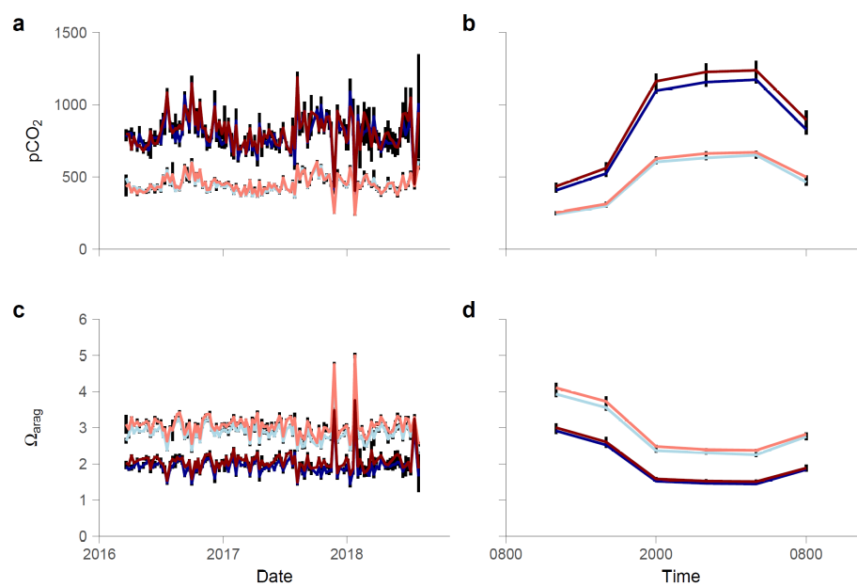

Fig. S1.
Carbonate chemistry data from the mesocosm experiment. Panels show timeseries of carbon dioxide partial pressure (pCO₂) (a,b) and aragonite saturation state (Ω_{arag}) (c,d) as daily means over the course of the experiment (a,c), and hourly means over the diel cycle (b,d) for the control (blue), ocean acidification (dark blue), ocean warming (red), and combined future ocean (dark red) treatments (individual lines not visible where they overlap). Data are derived from weekly samples collected at 1200 hr local time as well as the mean of samples collected every 4 hr over the diel cycle once per quarter. All data shown as mean±SD. See Table 1 and Fig. 2 for additional chemistry data, and see the Supplementary Information for additional details.

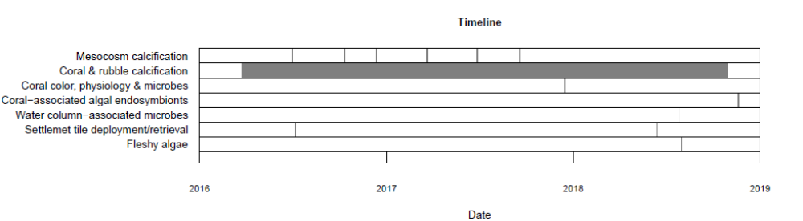

Fig. S2.
Timeline of the experiment. Vertical lines in each row show sampling dates for each measurement and the gray bar indicates the integration period for the coral and rubble calcification measurements. Mesocosm calcification was the average of the six sampling dates shown.

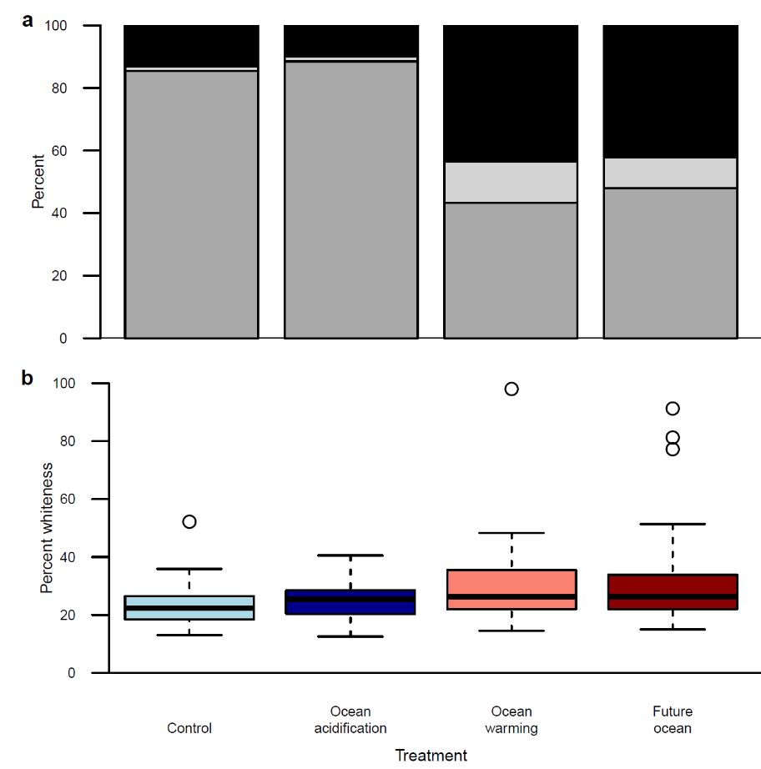

Fig. S3.
Treatment effects on coral survivorship, paling, and bleaching. (a) Stacked bar chart showing the percentage of corals that were alive and showed normal pigmentation at the end of the experiment (dark grey), percent that were alive and were pale or bleached (light grey), and percent that were dead (black) (n = 295-296). Elevated temperature significantly reduced survivorship and increased the incidence of paling and bleaching whereas acidification had no effect. (b), Variation in the extent of paling among corals (a subset of Montipora capitata, Porites compressa, and Porites lobata) that survived the treatments (n = 55-86). Box-plot shows the median as the center line, box limits are upper and lower quartiles, whiskers are 1.5x interquartile range, and points are outliers. All treatments showed significantly higher paling relative to the control. See Table S1, & 2 for test results.

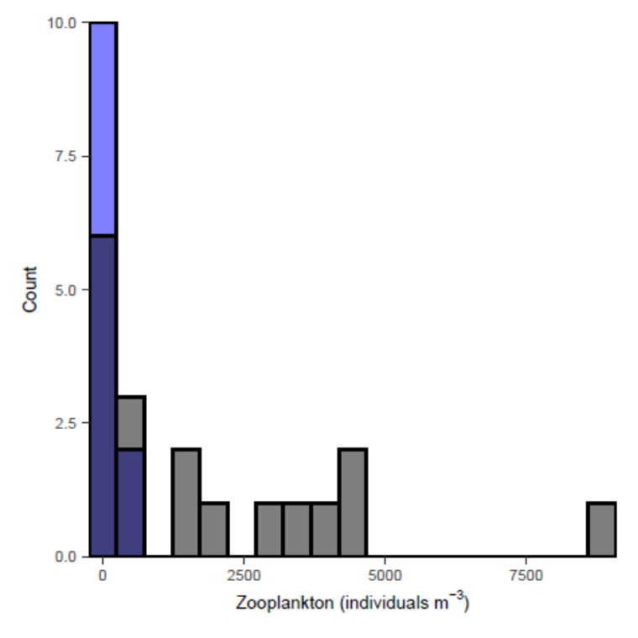

Fig. S4.
Histograms of nighttime zooplankton densities in the mesocosms as compared to mean values for coral reefs. Mesocosm zooplankton (blue) was at the lower end of typical values reported for reefs (grey) reported in the literature⁷⁸. Bars represent the count of observations for each bin, and where bars overlap, they appear blue-grey (n =12 samples for mesocosms, n = 18 studies for reefs).

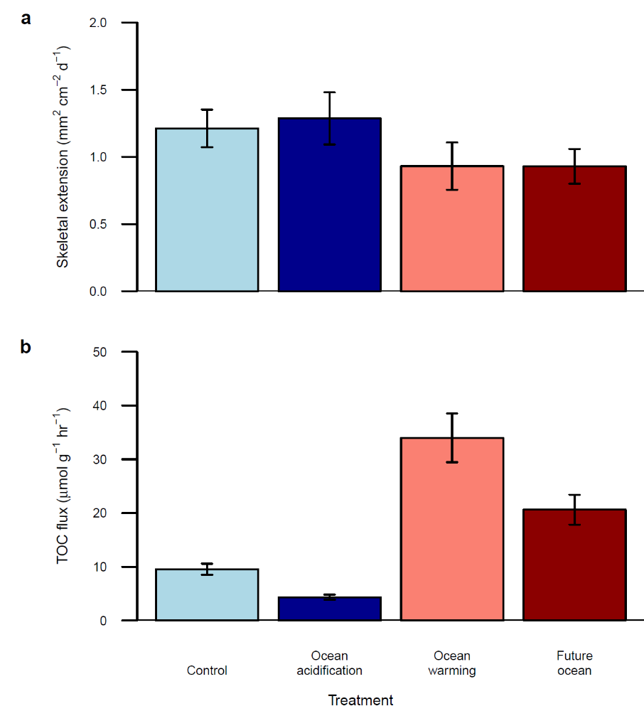

Fig. S5.
Treatment effects on coral physiology. (a) Skeletal extension rate and (b), total organic carbon (TOC) flux. Data bars shown as mean±SEM. (n = 28-86). Coral photosynthesis, respiration, protein content, and lipid content did not respond significantly to the treatments. See Table S3 for test results.

Response | P-value
Coral bleaching
Fixed effects
Temp | <0.001
pH | 0.210
Temp×pH | 0.416
Random effects
(1|Header) | 0.992
(1|Mesocosm) | 0.046
Coral survivorship
Fixed effects
Temp | <0.001
pH | 0.332
Temp×pH | 0.371
Random effects
(1|Header) | 0.938
(1|Mesocosm) | 0.712
Endosymbiont richness
Fixed effects
Temp | 0.012
pH | 0.995
Temp×pH | 0.794
Random effects
(1|Header) | 1.000
(1|Mesocosm) | 0.961

Table S1.
Likelihood ratio test results for treatment effects. Results are for coral bleaching, survivorship, and coral-associated algal endosymbiont species richness, from the mesocosms based on GLMM and GLM model fits. Algal endosymbiont community composition and overall species richness showed no treatment effects. For all factors, degrees of freedom = 1.

Response | Chi-square | Df | p
Coral Color | 21.455 | 3 | <0.001
Benthic cover
Encrusting green algae | 9.8182 | 3 | 0.020

Table S2.
Results of Kruskal-Wallis tests for treatment effects on coral color and benthic cover on settlement tiles. Benthic cover of anemones, bivalves, bivalve shells, solitary tunicates, uncolonized space, unavailable space, and upright green algae showed no treatment effects. P-values show in bold are significant at alpha=0.05.

Response | Df | SS | MS | F | p
Calcification
Mesocosms
Temp | 1 | 48.96 | 48.96 | 88.521 | <0.001
pH | 1 | 24.38 | 24.38 | 44.076 | <0.001
Temp×pH | 1 | 0.01 | 0.01 | 0.025 | 0.874
Header(Temp×pH) | 4 | 7.14 | 1.78 | 3.226 | 0.025
Residuals | 32 | 17.70 | 0.55
Corals
Temp | 1 | 28.282 | 28.282 | 163.765 | <0.001
pH | 1 | 0.004 | 0.004 | 0.020 | 0.887
Temp×pH | 1 | 0.039 | 0.039 | 0.227 | 0.637
Header(Temp×pH) | 4 | 1.688 | 0.422 | 2.444 | 0.067
Residuals | 32 | 5.526 | 0.173
Rubble
Temp | 1 | 0.61 | 0.613 | 0.499 | 0.485
pH | 1 | 27.84 | 27.841 | 22.667 | <0.001
Temp×pH | 1 | 0.05 | 0.054 | 0.044 | 0.836
Header(Temp×pH) | 4 | 2.58 | 0.644 | 0.524 | 0.719
Residuals | 32 | 39.30 | 1.228
Coral physiology
Skeletal extension
Temp | 1 | 1.435 | 1.4351 | 8.516 | <0.01
pH | 1 | 0.003 | 0.0029 | 0.017 | 0.895
Temp×pH | 1 | 0.013 | 0.0135 | 0.080 | 0.778
Header(Temp×pH) | 4 | 0.358 | 0.0894 | 0.531 | 0.713
Mesocosm(Header(Temp×pH) | 32 | 4.079 | 0.1275 | 0.757 | 0.822
Residuals | 159 | 26.793 | 0.1685
Total organic carbon flux
Temp | 1 | 0.412 | 0.4119 | 7.175 | <0.01
pH | 1 | 0.110 | 0.1104 | 1.923 | 0.167
Temp×pH | 1 | 0.008 | 0.0084 | 0.146 | 0.702
Header(Temp×pH) | 4 | 0.460 | 0.1150 | 2.004 | 0.095
Mesocosm(Header(Temp×pH) | 32 | 1.296 | 0.0405 | 0.705 | 0.882
Residuals | 238 | 13.662 | 0.0574
Benthic cover
Vermetid gastropods
Temp | 1 | 0.01991 | 0.019907 | 7.130 | 0.017
pH | 1 | 0.02673 | 0.026729 | 9.574 | <0.01
Temp×pH | 1 | 0.00809 | 0.008086 | 2.896 | 0.108
Header(Temp×pH) | 4 | 0.01098 | 0.002744 | 0.983 | 0.445
Residuals | 16 | 0.04467 | 0.002792
Turf algae
Temp | 1 | 0.01966 | 0.019659 | 4.917 | 0.041
pH | 1 | 0.01320 | 0.013197 | 3.301 | 0.088
Temp×pH | 1 | 0.00674 | 0.006740 | 1.686 | 0.213
Header(Temp×pH) | 4 | 0.00953 | 0.002382 | 0.596 | 0.671
Residuals | 16 | 0.06398 | 0.003998
Coralline algae
Temp | 1 | 0.03060 | 0.030598 | 4.679 | 0.046
pH | 1 | 0.01348 | 0.013480 | 2.061 | 0.170
Temp×pH | 1 | 0.00006 | 0.000058 | 0.009 | 0.926
Header(Temp×pH) | 4 | 0.01288 | 0.003219 | 0.492 | 0.742
Residuals | 16 | 0.10463 | 0.006539
Species richness
Sponges
Temp | 1 | 3.37 | 3.37 | 0.463 | 0.506
pH | 1 | 35.04 | 35.04 | 4.806 | 0.044
Temp×pH | 1 | 2.04 | 2.04 | 0.280 | 0.604
Header(Temp×pH) | 4 | 44.83 | 11.21 | 1.537 | 0.239
Residuals | 16 | 116.67 | 7.29
Corals
Temp | 1 | 21.025 | 21.025 | 46.722 | <0.001
pH | 1 | 0.025 | 0.025 | 0.056 | 0.815
Temp×pH | 1 | 0.225 | 0.225 | 0.500 | 0.485
Header(Temp×pH) | 4 | 1.300 | 0.325 | 0.722 | 0.583
Residuals | 32 | 14.400 | 0.450
Coral-associated microbes
Temp | 1 | 304,960 | 304,960 | 4.148 | 0.043
pH | 1 | 137,310 | 137,310 | 1.868 | 0.173
Temp×pH | 1 | 50,826 | 50,826 | 0.691 | 0.407
Header(Temp×pH) | 4 | 546,551 | 136,638 | 1.859 | 0.119
Mesocosm(Header(Temp×pH) | 32 | 1,283,217 | 40,101 | 0.546 | 0.978

Table S3.
ANOVA test results for treatment effects on calcification, coral physiology, benthic cover on settlement tiles, and species richness. Coral photosynthesis, respiration, protein content, and lipid content showed no treatment effects, nor did the benthic cover of sediment, serpulid worms, or sponges, or the species richness of water column-associated microbes or fleshy algae. P-values in bold are significant at alpha=0.05. Df=degrees of freedom, SS=sum of squares, MS=mean sum of squares.

Response | Df | SS | MS | F | P
Coral physiology
Temp | 1 | 17.109 | 17.109 | 3.449 | <0.01
pH | 1 | 1.89 | 1.89 | 0.844 | 0.494
Temp×pH | 1 | 8.55 | 8.55 | 0.777 | 0.541
Residuals | 274 | 1359.4 | 9.61
Total | 277 | 1385
Benthic community structure
Temp | 1 | 0.032352 | 0.032352 | 2.95481 | 0.017
pH | 1 | 0.019522 | 0.019522 | 1.78301 | 0.117
Temp×pH | 1 | 0.009421 | 0.009421 | 0.86051 | 0.499
Residuals | 20 | 0.218976 | 0.010949
Total | 23 | 0.280271
Coral-associated microbes
Temp | 1 | 10,861 | 10,861 | 2.6884 | <0.001
pH | 1 | 6482.9 | 6482.9 | 1.6047 | 0.049
Temp×pH | 1 | 5082 | 5082 | 1.258 | 0.179
Residuals | 242 | 977,650 | 4039.9
Total | 245 | 999,180

Table S4.
PERMANOVA test results for treatment effects on coral physiology, benthic community structure on settlement tiles, and coral-associated microbial communities. Water column-associated microbial communities showed no treatment effects.

