SUPPLEMENT 1

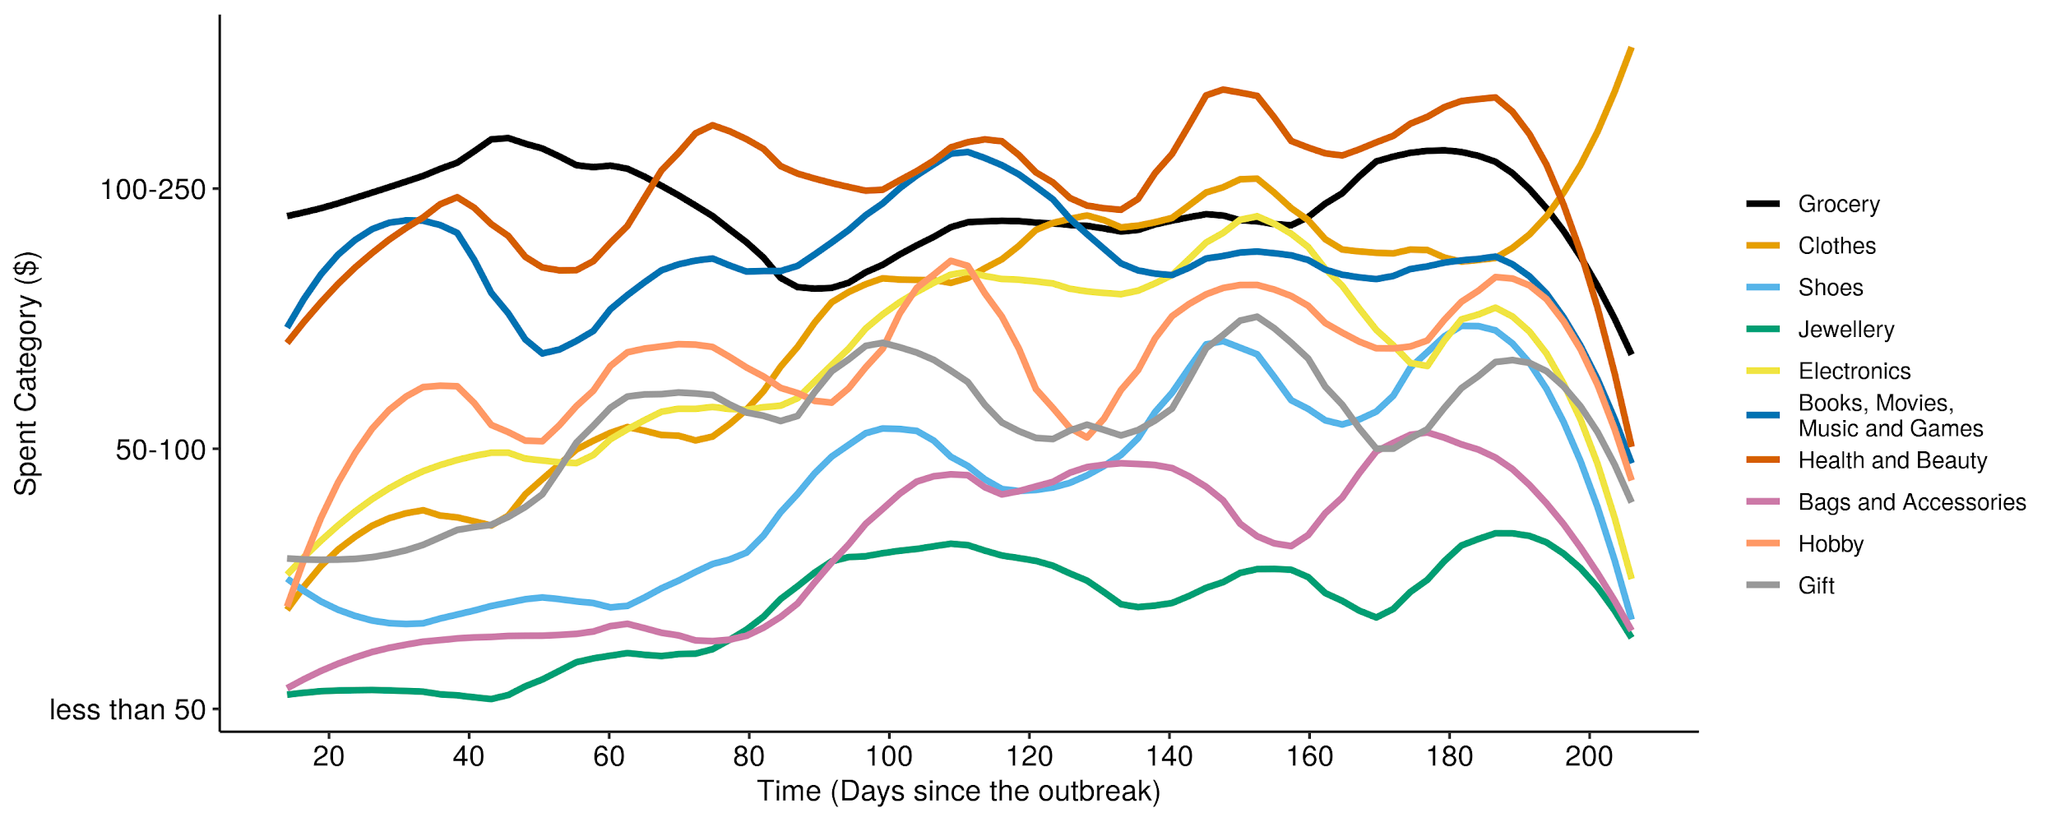
Past seven-day spending during the pandemic (between 26/03/2020 and 02/10/2020)
Note: Lines are smoothed to reduce noise in the raw data. Participants were asked to select from pre-determined categories for their past-seven-day spending in the given goods category.

