SUPPLEMENT 3

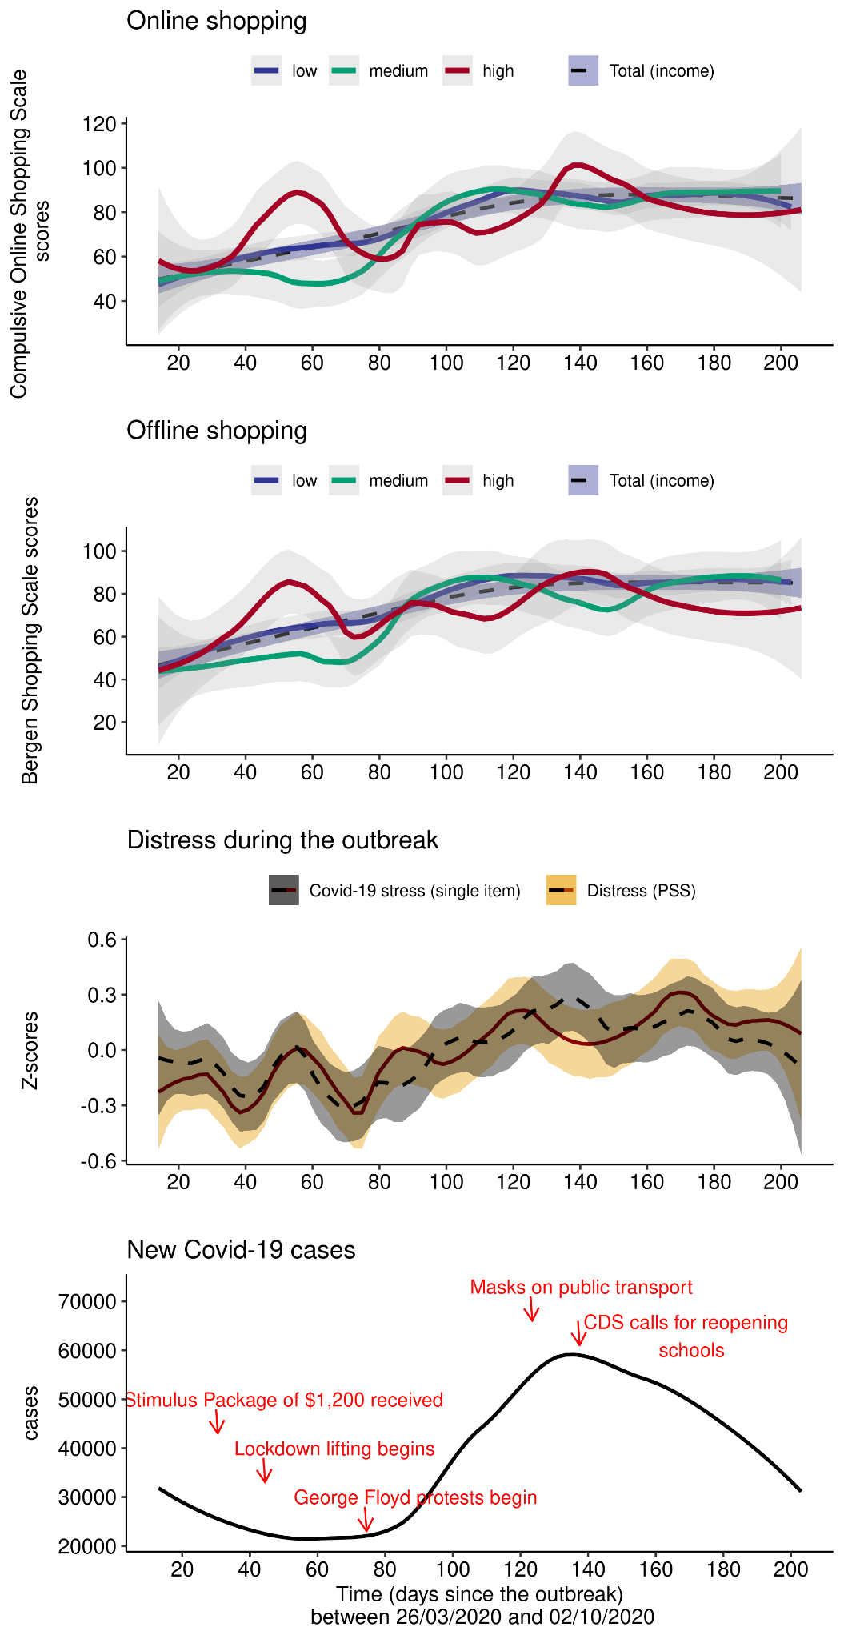
Compulsive buying represented alongside distress and case numbers in the US and according to income groups
Note: smoothed lines are presented to reduce noise in visualising. Case numbers are taken from https://www.ecdc.europa.eu/en/publications-data/download-todays-data-geographic-distribution-covid-19-cases-worldwide

