Nanopore Direct RNA-Seq Reveals Widespread and Predictable Non-Coding Transcriptional Variations in DNA Methylation-deficient Arabidopsis
Wanghong Shi^{a,b}, Luyao Wang^{b}, Na Zhou, Mengke Zhang^{a,b}, Yupeng Hao^{a,b}, Ke Nie^{a,b}, Xueying Guanª, Ting Zhaoª*
ª Zhejiang Provincial Key Laboratory of Crop Genetic Resources, Institute of Crop Science, Plant Precision Breeding Academy, College of Agriculture and Biotechnology, Zhejiang University, Hangzhou, China
^{b} Hainan Institute of Zhejiang University, Building 11, Yonyou Industrial Park, Yazhou Bay Science and Technology City, Yazhou District, Sanya, Hainan, 572025, China

* Corresponding author.
E-mail address: tingzhao@zju.edu.cn (Ting Zhao)

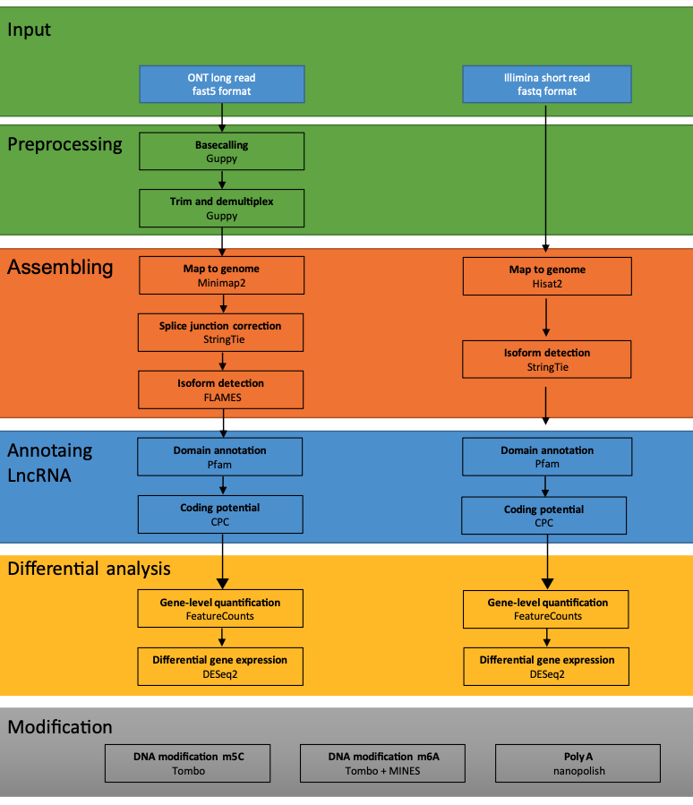
Fig. S1. Analysis pipeline for ONT DRS and Illumina ssRNA-seq. The diagram describes the approaches and software used in the analysis of ONT RDS (left) and Illumina RNA-seq (right).

Fig. S2. Mapping ratio of ONT RDS. Mapping ratio of LR against the Arabidopsis thaliana reference genome TAIR10 (http://www.arabidopsis.org) (red) and the enclosed RNA annotation (green) across different sample.

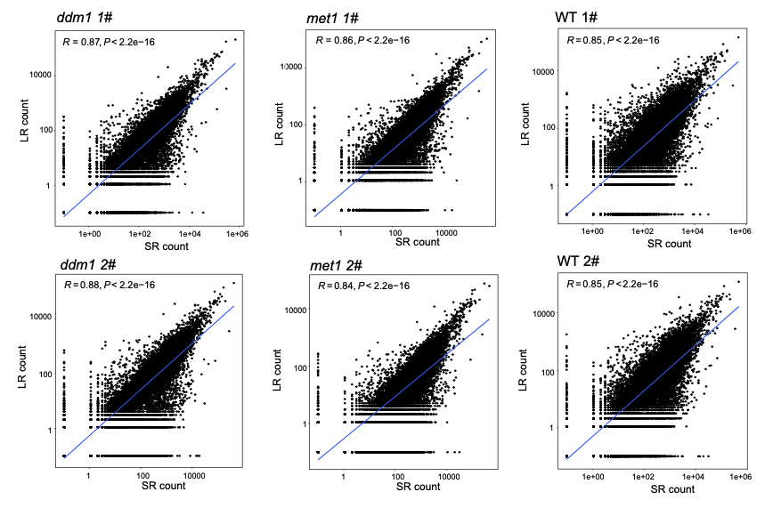
Fig. S3. Correlation between LR and SR. Correlation gene count after genome mapping for ONT DRS (LRs) and Illumina. ssRNA-seq short reads (SR). P-values were calculated using the spearman correlation statistical analysis.

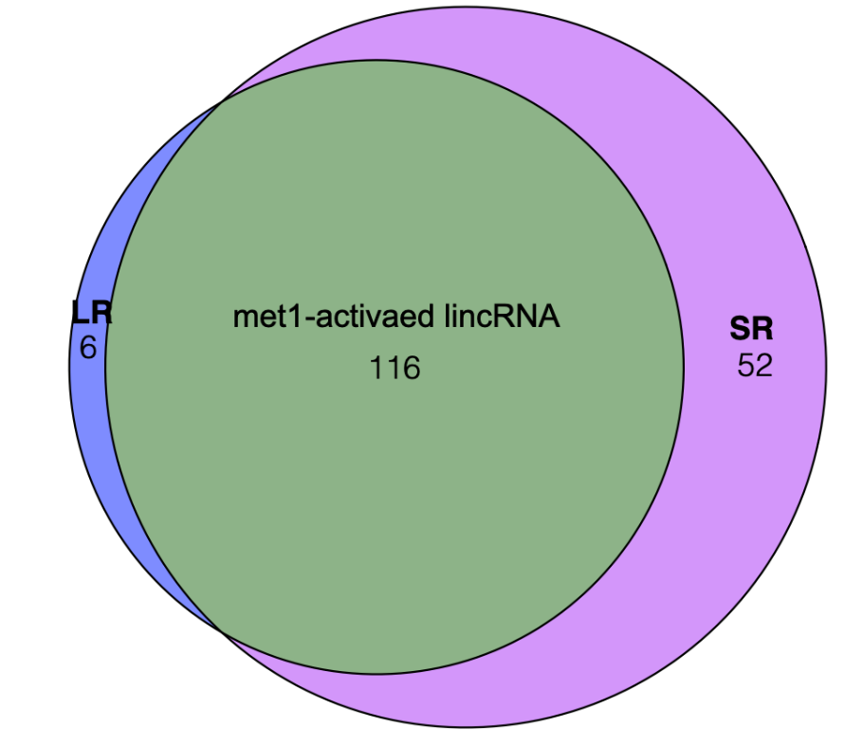
Fig. S4. met1-activated lincRNA detected by SR and LR. Venn plot showing the differently expressed lincRNA between met1 and WT using ONT RDS and Illumina ssRNA-seq.

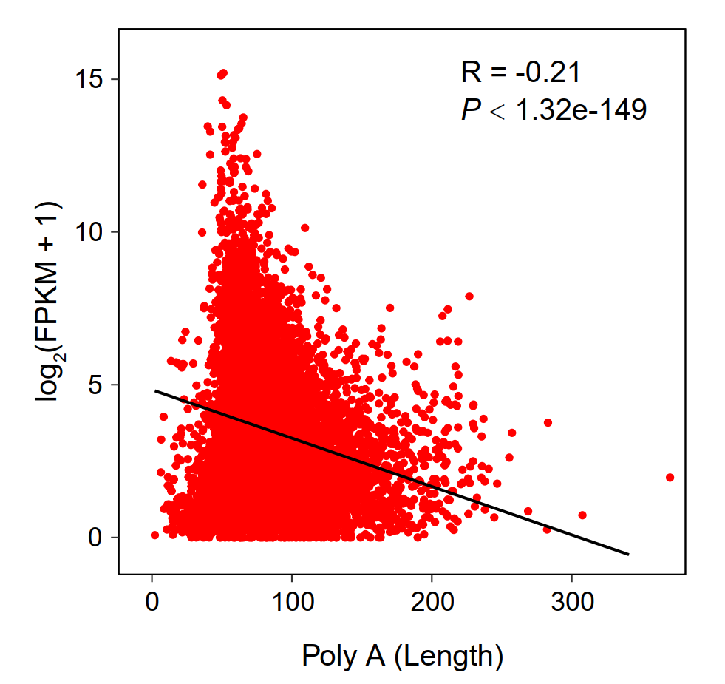
Fig. S5. Dotplot showing the negatively correlation between ployA length (x axis) and expression levels (y axis).

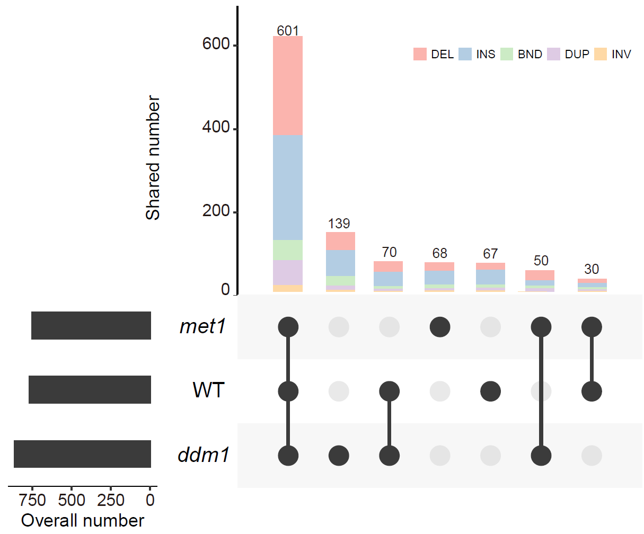Fig. S6. Number of detected SVs by types. Histogram showing genome structural variations (SV) as identified by long DNA sequencing. The x-axis represents different types of structural variation, and the y-axis represents the number of variations. DEL is short for deletion, INS is short for insertion, BND is short for translocation, INV is short for inversion and DUP is short for duplication.

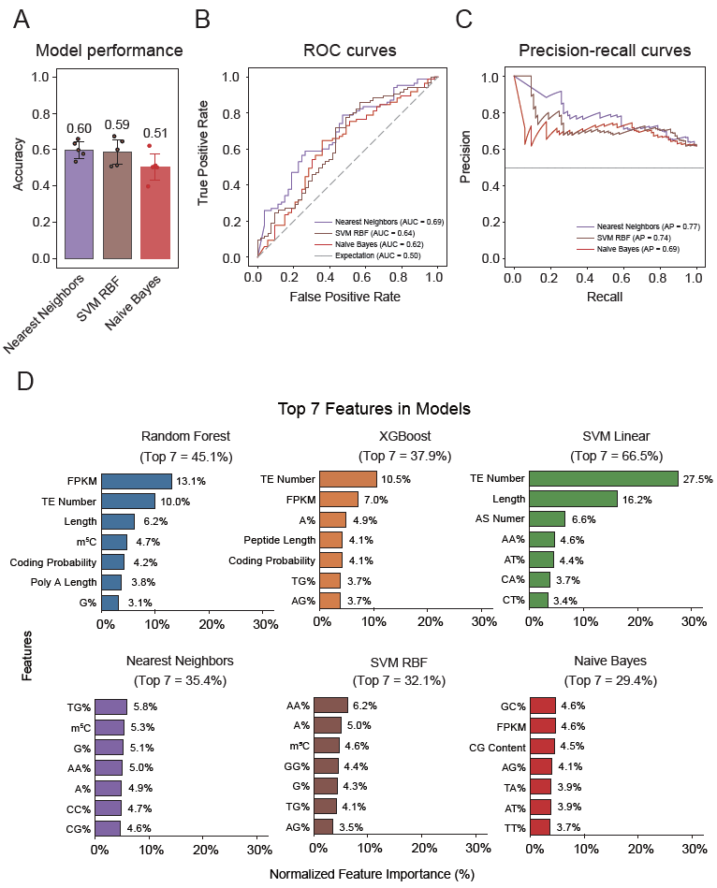
Fig. S7. Nearest Neighbors, SVM RBF and Naive Bayes models to predict ddm1-actived lincRNA. A: The histogram shows mean accuracy and the dots represent the five-fold cross-validation results. B: Receiver operating characteristic (ROC) curve for prediction of ddm1-activated lincRNAs. C: Precision-recall curve for prediction of ddm1-activated lincRNAs. D: The top seven important features evaluated by each model.

