The ARRIVE Essential 10
Study design | This study is a one-way, randomized controlled trial with 24 nude mice randomly divided into four groups(the L-SVF, M-SVF, C-SVF, and PBS groups). The experimental groups were subcutaneously injected with 0.1 ml of the corresponding SVF cell suspension (2×10^5 cells/ml), and the control group received 0.1 ml of PBS. Digital photos were taken on days 0, 2, 4, 7, 10, and 14, and skin tissue around the wound was collected on days 7 and 14.
Sample size | The sample size of this study was set as n = 6, based on the following considerations: Prior wound surface studies[1-3] confirmed this sample size effectively detects target effects, with similar designs exhibiting reproducible directional trends. And limited resources prioritized standardized protocols, while adhering to the 3R Reduction principle to minimize animal use without compromising rigor.
Inclusion and exclusion criteria | The animals were included in the study if they underwent successful SVF cells transplantation injections and the wounds healed normally. The animals were excluded if the wound is infected, discharging pus, generating an abnormal inflammatory response, or if the animal dies prematurely, preventing the collection of images and histological data.
Randomisation | Twenty-four 6-8-week-old female nude rats, weighing 20–23g, were obtained from Experimental Animal Center of Southern Medical University (Guangzhou, China) and randomly divided into four groups (6 rats/group): the L-SVF, M-SVF, C-SVF, and PBS groups. Random numbers were generated using the standard = RAND() function in Microsoft Excel.
Blinding | For each animal, two different investigators were involved as follows: a first investigator administered the treatment based on the randomization table and was responsible for taking photos and collecting materials. This investigator was the only person aware of the treatment group allocation. A second investigator(unaware of treatment) further processed the wound tissue and assessed the collected data.
Outcome measures | The following parameters were assessed: the wound healing rate、hematoxylin and eosin (H&E) staining、granulation tissue thickness、Masson’s trichrome staining、collagen volume fractions、CD31 immunostaining.
Statistical methods | All the data are expressed as the means ± standard errors of the means. Statistical significance was determined via an unpaired t test for comparisons between two groups and two-way ANOVA for comparisons among three or more means, followed by Dunnett’s test for pairwise comparisons (Graph Pad Prism version 10). P values < 0.05 denoted statistical significance.
Experimental animals | Twenty-four female mice were used: BALB/c-nu nude mice from Experimental Animal Center of Southern Medical University (Guangzhou, China). The mice were bred through a regular breeding program at the Experimental Animal Center of Southern Medical University. The animals were maintained on a standard food diet with free access to food under a 12-h light‒dark cycle. At the time of the test the mice were 6-8 weeks old and had body weights of 20-23g.
Experimental procedures | After the mice were anesthetized with an isoflurane anesthesia machine (Yuyan Corporation, China) at a flow rate of 1 L/min, a circular full-thickness wound (diameter of 6 mm) was created through the skin on the on both sides of the dorsum of each mouse. The mice were randomly divided into four groups, namely the L-SVF, M-SVF, C-SVF, and PBS groups, with six mice in each group. The experimental groups were subcutaneously injected with 0.1 ml of the corresponding SVF cell suspension (2×10^5 cells/ml), whereas the control group received 0.1 ml of PBS. The wound was then wrapped with sterile Tegaderm dressings (3M Healthcare, St Paul, MN, USA), which were changed every other day until day 14. Digital photos were taken on days 0, 2, 4, 7, 10, and 14, and skin tissue around the wound was collected on days 7 and 14. For the anesthetized mice from which samples have already been taken, trained and skilled personnel euthanized them via the method of cervical dislocation. Death was confirmed by absence of corneal reflex and cessation of heartbeat for 5 minutes. All procedures were approved by the Experimental Animal Care and Use Committee of Nanfang Hospital and complied with the ARRIVE Guidelines 2.0.
Results | 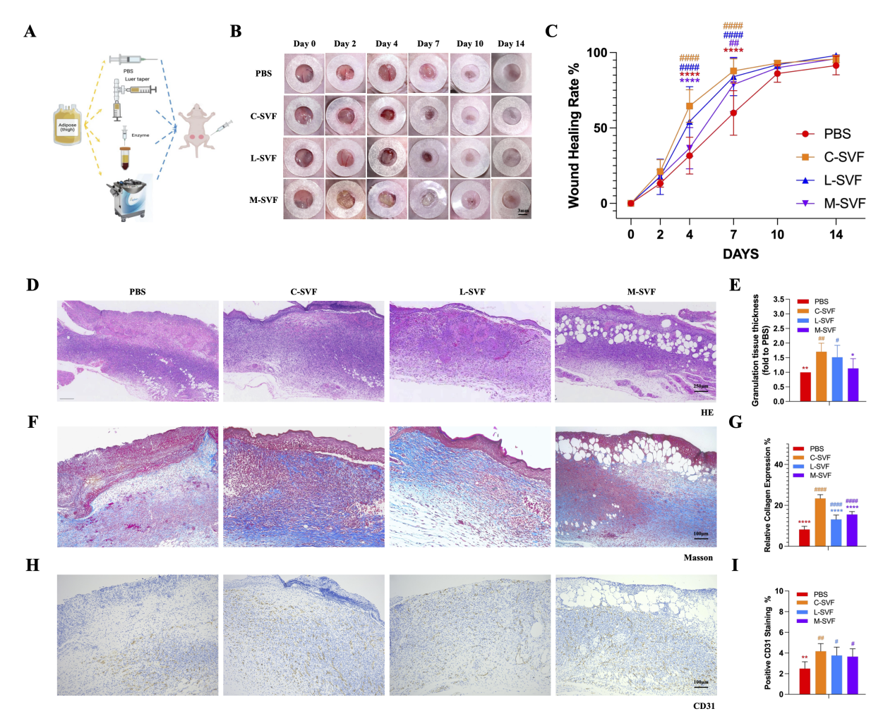  To compare the regenerative capacity of SVF cells obtained via different methods, we used a full-thickness wound model in nude mice (Figure A). Faster wound healing was observed in both the C-SVF and L-SVF groups (Figure B). By the 7th day, the wound healing rate for C-SVF had reached 87.86±7.54%, and that for L-SVF had reached 83.96±11.80% (P>0.05). Concurrently, the wound closure rates for the PBS group and M-SVF group were 60.01±13.49% (P<0.001) and 77.01±17.39% (P>0.05), respectively (Figure C). The morphological characteristics of the wounds in each group were observed via H&E and Masson's trichrome staining. H&E staining on day 7 in each treatment group revealed a significant increase in granulation tissue thickness in the groups treated with C-SVF and L-SVF (compared with the PBS group, the C-SVF and L-SVF groups presented increases of 1.71±0.26-fold and 1.51±0.37-fold, respectively, P<0.05; the M-SVF group presented an increase of 1.13±0.3-fold, P>0.05), indicating more effective re-epithelialization and a well-structured epidermis compared with the other groups. No significant differences were observed between these two groups. In stark contrast, the wound tissue of the M-SVF group contained many mature adipocytes ectopically deposited between the epidermis and dermis (Figure D, E). Furthermore, Masson's trichrome staining demonstrated increased collagen deposition in the C-SVF-treated group. Compared with the PBS group (8.22±1.40%), the C-SVF, L-SVF and M-SVF groups presented increased collagen deposition (23.38±1.71%, 13.14±1.96% and 15.55±1.32%, respectively, P<0.001)(Figure F,G). Next, we used CD31 for immunohistochemical staining to assess angiogenesis in each group. The results revealed that the C-SVF group had the highest vascular density (4.17±0.68%), which surpassed those of the M-SVF group and L-SVF group (3.65±0.69% and 3.76±0.74%, respectively, P>0.05) (Figure H,I).  (* represents statistical significance compared with C-SVF; # represents statistical significance compared with PBS. ∗ P < 0.05, ∗∗ P < 0.01, ∗∗∗ P < 0.001).

1. Zhang, Y., et al., Exosomes derived from human umbilical cord blood mesenchymal stem cells stimulate regenerative wound healing via transforming growth factor-β receptor inhibition. Stem Cell Res Ther, 2021. 12(1): p. 434.
2. Sun, J., et al., Tideglusib promotes wound healing in aged skin by activating PI3K/Akt pathway. Stem Cell Res Ther, 2022. 13(1): p. 269.
3. Deng, Q., et al., Activation of angiopoietin-1 signaling with engineering mesenchymal stem cells promoted efficient angiogenesis in diabetic wound healing. Stem Cell Res Ther, 2025. 16(1): p. 75.

