Supplementary Information

A lateral valley tunnel junction controlled by ferroelectric polarization

Kai Chang¹*†, Jing-Rong Ji^{2†}, Zi’Ang Gao^{1†}, Angiolo Huamán³, Rui-Qi Cao^{1,4,5}, Wen-Lin Wang¹, Chengguang Yue¹, Chong Liu¹, Salvador Barraza-Lopez³*, Stuart S. P. Parkin²*

† These authors contributed equally to this work.
* Corresponding authors. Emails: changkai@baqis.ac.cn, sbarraza@uark.edu, stuart.parkin@mpi-halle.mpg.de

This PDF file includes:
Supplementary Figures S1 to S8

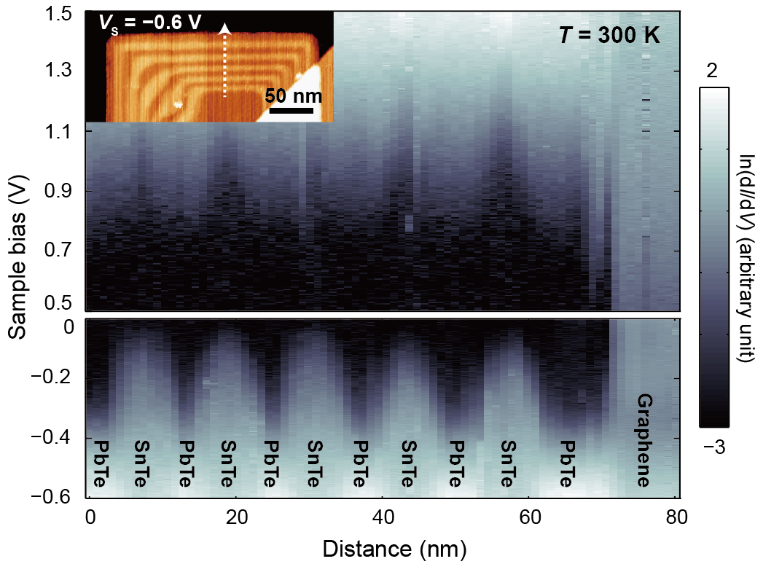
Fig. S1. Band alignment of SnTe/PbTe monolayer LSLs at room temperature. Spatially resolved dI/dV spectra acquired at 300 K along the path indicated by the dashed arrow in the inset image. Setpoints: V_{s} = 1.5 V, I = 30 pA for positive bias voltage and V_{s} = −0.6 V, I = 30 pA for negative bias voltage. The seesaw band bending is no longer seen given that the SnTe monolayer is paraelectric at this temperature.

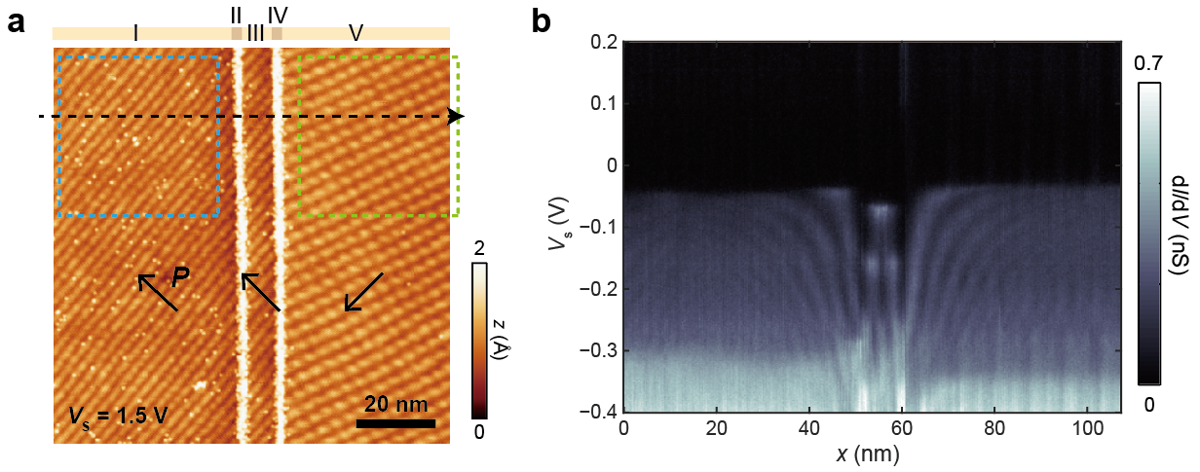
Fig. S2. Differential conductance spectra across a dual-junction structure acquired at 4.7 K. a, Topography image of the dual-junction structure. This image was acquired at a bias voltage between the CBMs of SnTe and PbTe MLs, thus the PbTe sections appear higher than those of SnTe. Setpoint: V_{s} = 1.5 V, I = 3 pA. The blue and green dashed squares indicate the areas that Fig. S8 a, b, were acquired. b, dI/dV spectra acquired along the dashed arrow in a. This structure was grown on bilayer graphene substrate, thereby the VBM is below E_{F}, different from that in Fig. 3. Setpoint: V_{s} = −0.4 V, I = 100 pA. Discontinuities in section I can be observed at −0.16 eV and −0.27 eV, corresponding to the energies of the band apices of the second- and third-order 1D bound states in section III.

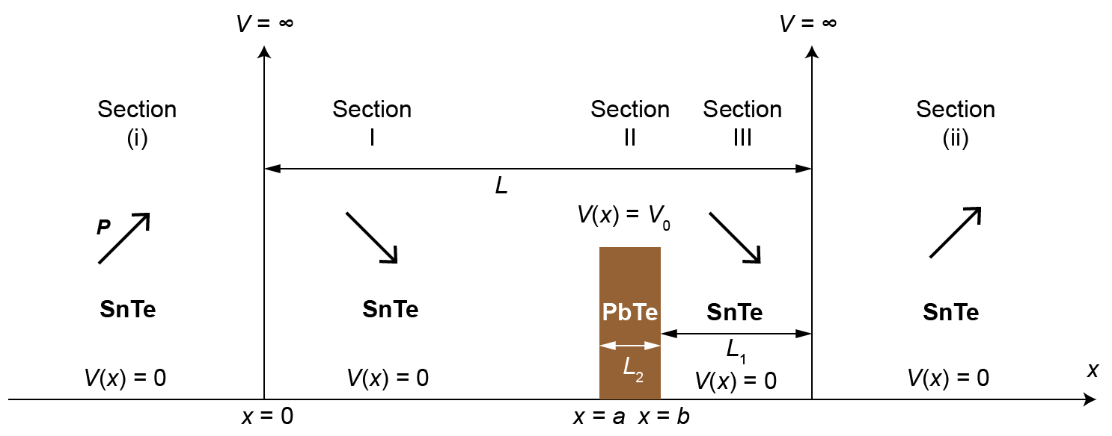
Fig. S3. Potential energy for the quantum mechanical model of lateral ferroelectric tunnel junctions. Regions (i), (ii), (I) and (III) are SnTe ML sections, and the polarization direction P is rotated 90° in (i) and (ii) with respect to (I) and (III). Due to the suppression of transmission through SnTe ML regions of mutually orthogonal polarization, we represent the interfaces (i)/(I) and (III)/(ii) as infinite barriers with negligible width. The paraelectric PbTe strip is modelled as a barrier of height V₀, width L₂ and at a L₁ distance of the (III)/(ii) interface, with boundaries a = L − L₁ − L₂ and b = L − L₁. The potential is zero otherwise. The numerical values of all the relevant parameters are given in part 4 of the Methods section.

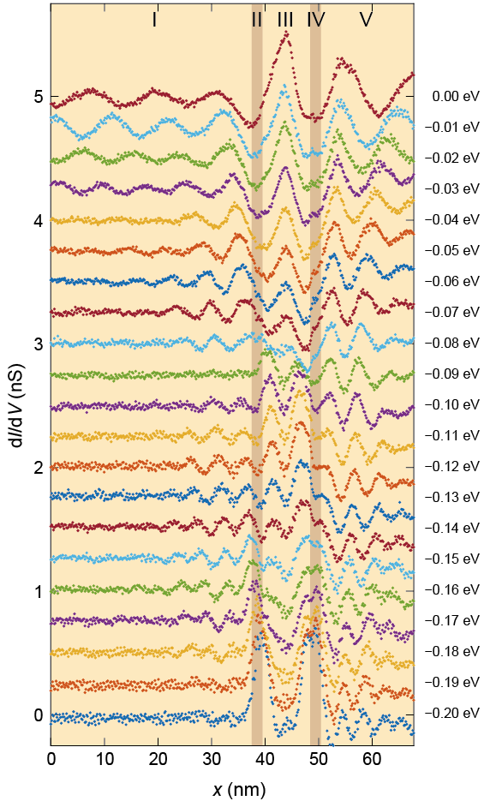
Fig. S4. Energy dependence of the dI/dV intensity profiles extracted from Fig. 3b. The data points in Fig. 3g are derived from these curves following the definition in Fig. 3e. Corresponding energies are labeled on the right. An averaged constant background has been subtracted in each profile. The profiles are vertically shifted with an interval of 0.25 nS for clarity.
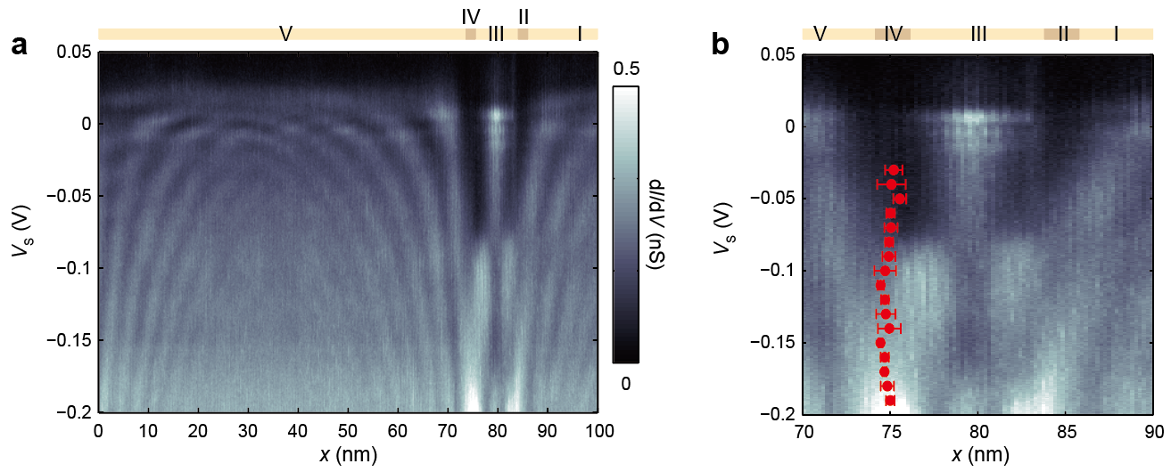
Fig. S5. Absence of energy dependence in the effective position of the tunnel barrier between two SnTe ML sections with polarization directions perpendicular to each other. a, Spatially resolved dI/dV spectra acquired across two tunnel junctions. The Roman labels I to V indicate the same material sections as those in Fig. 3a of main text. Setpoint: V_{s} = −0.2 V, I = 50 pA. b, Extracted tunnel barrier effective positions (red spots) between regions III and V, which exhibit no observable energy dependence.

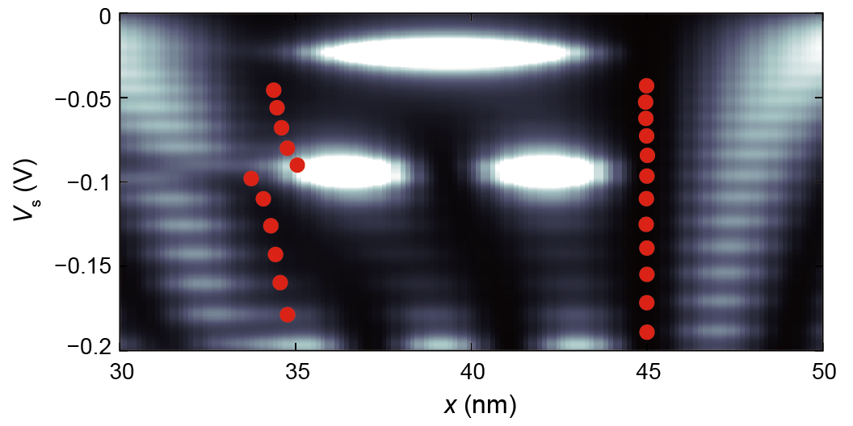
Fig. S6. Simulated energy dependence of the effective barrier positions. The value of x_{b} (red dots) was extracted from the simulated electronic standing wave patterns in Fig. 3d and overlaid into the raw data.

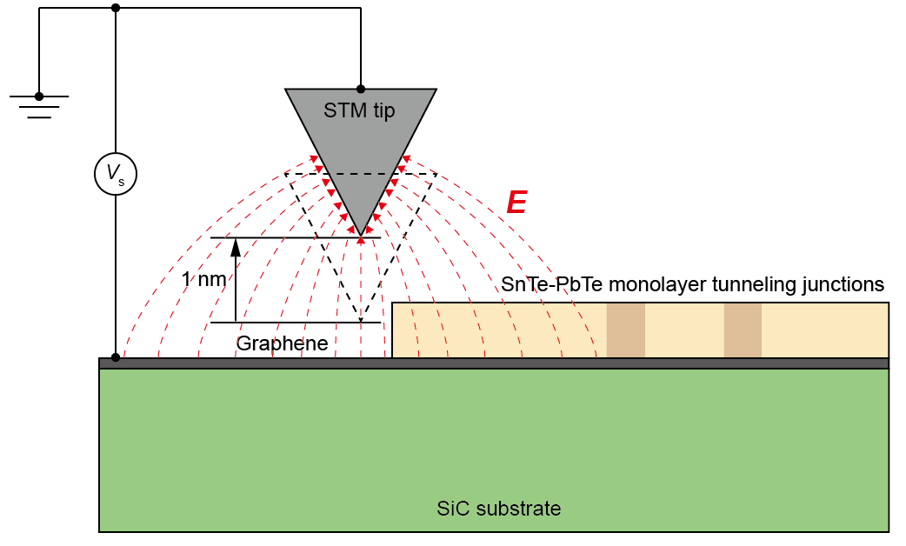
Fig. S7. Schematic of the domain wall manipulation procedure. The tip is raised from the imaging height by 1 nm before applying an external electric field so as not to induce a high tunneling current into the substrate. The polarization of the outermost SnTe ML section is switched by the horizontal component of the electric field between the STM tip and the substrate. See part 3 within the Methods section for additional details.

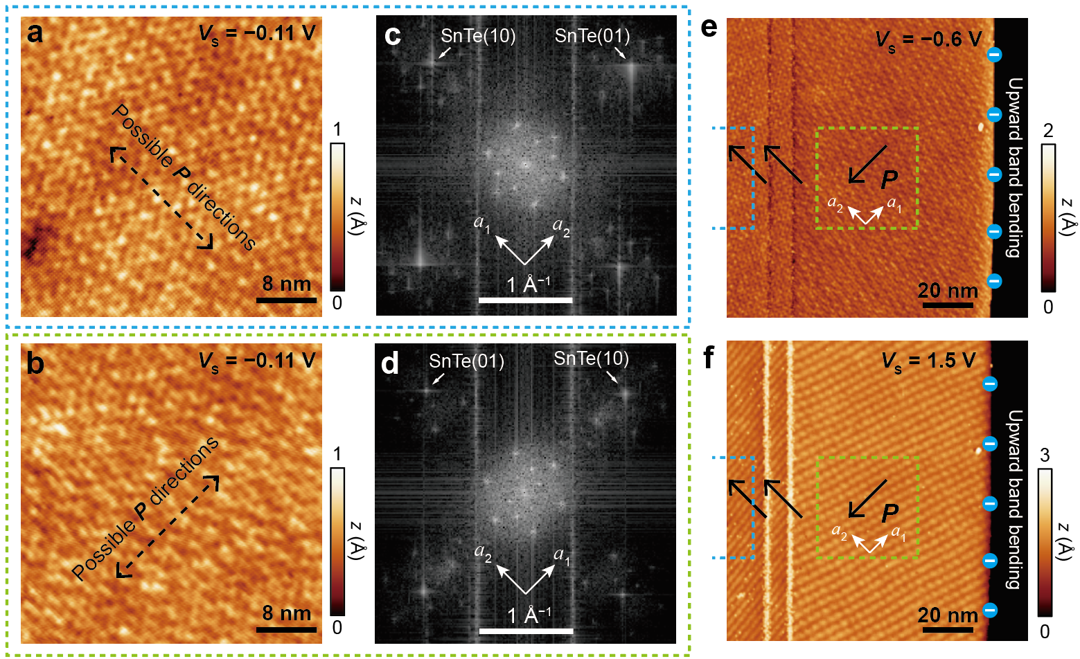
Fig. S8. Method for determining the polarization direction in the dual-junction structures. The dual-junction structure examined here is the same as that in Fig. S2. a, b, Atom resolved topography images of the areas indicated by the blue (a) and green (b) dashed squares in Fig. S2 a. Setpoint: V_{s} = −0.11 V, I = 100 pA for both images. c, d, Fourier transformed images of a, b, respectively. The polarization directions P in a, b, are extracted by identifying the crystalline direction of the SnTe ML having a larger lattice constant from the Fourier transformed images. e, f, Topography images of the dual-junction area acquired as negative (e) and positive (f) bias voltages, respectively. A free edge of the SnTe ML with upward band bending is resolved, so that the polarization direction in the SnTe ML section with the edge can be determined. The polarization directions in the other SnTe ML sections can be deduced accordingly. Setpoints: V_{s} = −0.6 V, I = 3 pA for e, and V_{s} = 1.5 V, I = 3 pA for f.

