Supplementary Materials:

A GSH-Consuming Polymeric Nanoparticles Drives Ferroptosis Amplification and Combines Chemotherapy to Enlarge Breast Cancer Treatment
Mingliang Pei *^{, #, 1,}, Xin Guan ^{#, 2} , Xiaodong Hou ^{#, 4}, Zhiyuan Niu ⁵, Qi Lyu ², Kai Wang ³, Shanshan Wang ³, Jingkai Zhang ¹, Yun Ke ¹, Shuting Zhuang ¹, Jie Chen *^{, 3}, Huixiong Xu *^{, 2}, Fan Yang *^{, 1}
¹ Dr. M. Pei, Prof. F. Yang, S. Zhuang, Y. Ke and J. Zhang
Department of Orthopaedics, Shanghai Key Laboratory for Prevention and Treatment of Bone and Joint Diseases, Shanghai Institute of Traumatology and Orthopaedics, Ruijin Hospital, Shanghai Jiao Tong University School of Medicine, Shanghai, 200025, China.
² Prof. H. Xu, X. Guan and Q. Lyu
Department of Ultrasound, Zhongshan Hospital, Institute of Ultrasound in Medicine and Engineering, Fudan University, Shanghai, 200032, P. R. China.
³ Dr. J. Chen, K. Wang and S. Wang
Shanghai Chest Hospital, Shanghai Jiao Tong University School of Medicine, No. 241 West Huaihai Road, Shanghai, 200030, P. R. China.
⁴ Dr. X. Hou
Department of Medical Ultrasound and Center of Minimally Invasive Treatment for Tumor, Shanghai Tenth People’s Hospital, School of Medicine, Tongji University, No. 301 Yan-chang-zhong Road, Shanghai, 200072, P.R. China.
⁵ Z. Niu
Department of Medical Ultrasound, Henan Provincial People's Hospital, School of Medicine, Henan University, Zhengzhou, Henan, 450003, P.R. China.

# The authors contributed equally to this work.
* Correspondence to Huixiong Xu (xuhuixiongs@126.com), Jie Chen (snoopy_cj@126.com), Mingliang Pei (pei1991@sjtu.edu.cn), and Fan Yang (yf12498@sjtu.edu.cn).

Fig. S1. Synthesis route of ssP-COOH, ssP-EDA, and ssP-tHB copolymers.
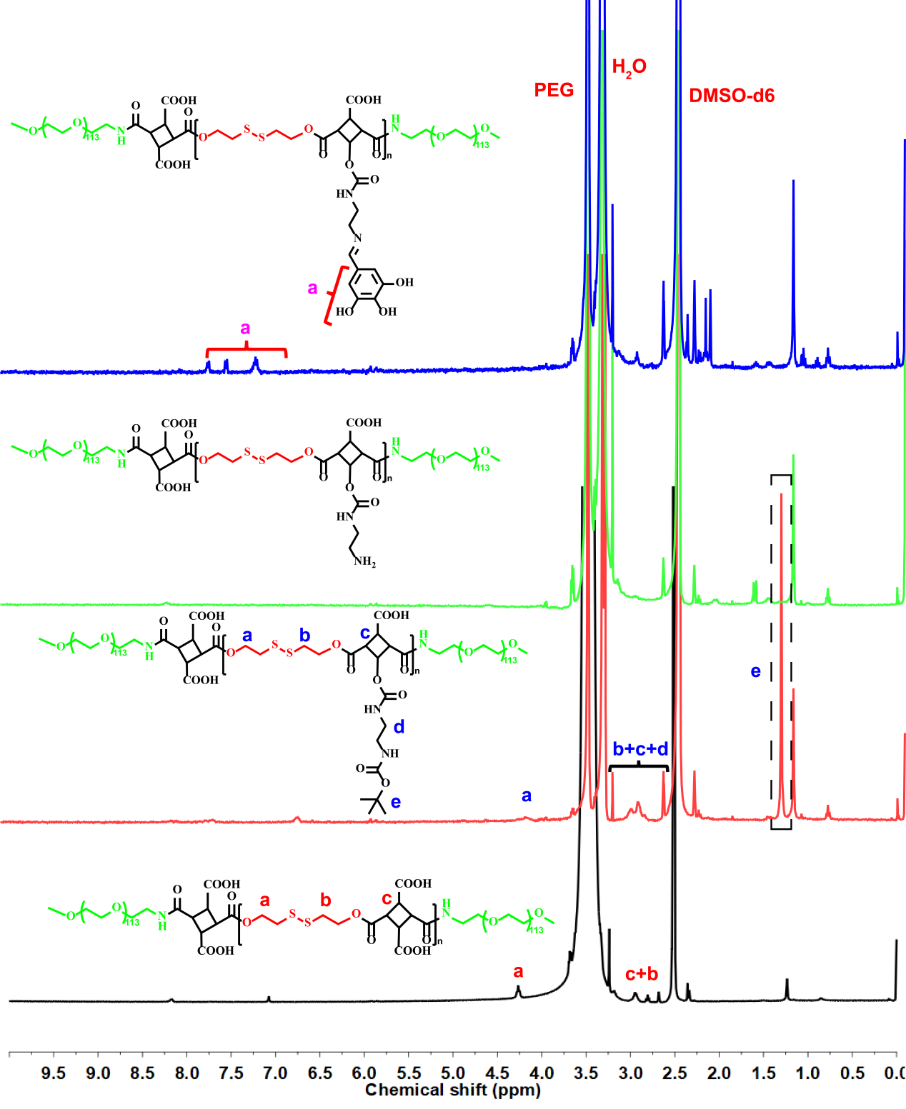
Fig. S2. Characterization of ssP-COOH, ssP-EDA-Boc, ssP-EDA and ssP-tHB copolymer by ¹H NMR.
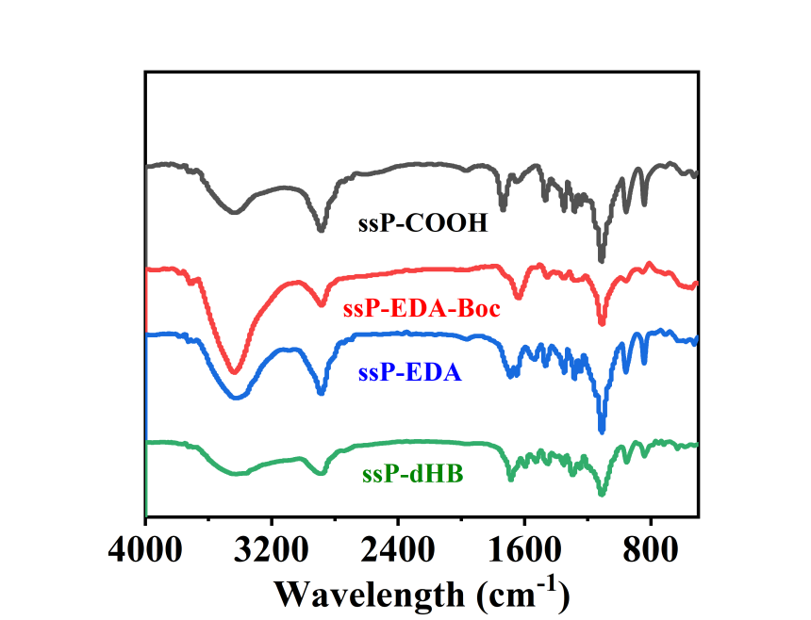
Fig. S3. FTIR spectra of ssP-COOH, ssP-EDA-Boc, ssP-EDA, and ssP-tHB copolymer.
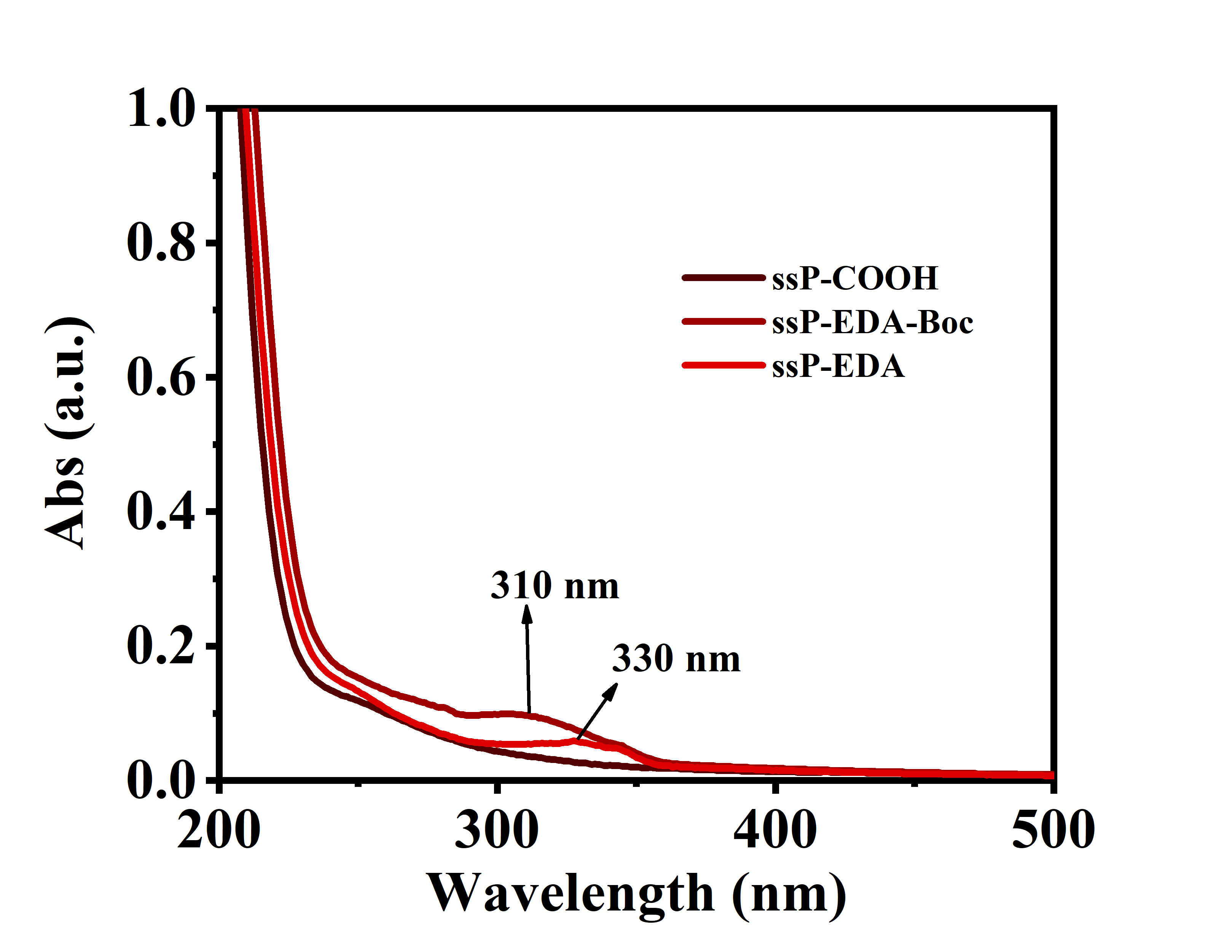
Fig. S4. UV-vis spectra of ssP-COOH, ssP-EDA-Boc, and ssP-EDA block copolymer in water solution.
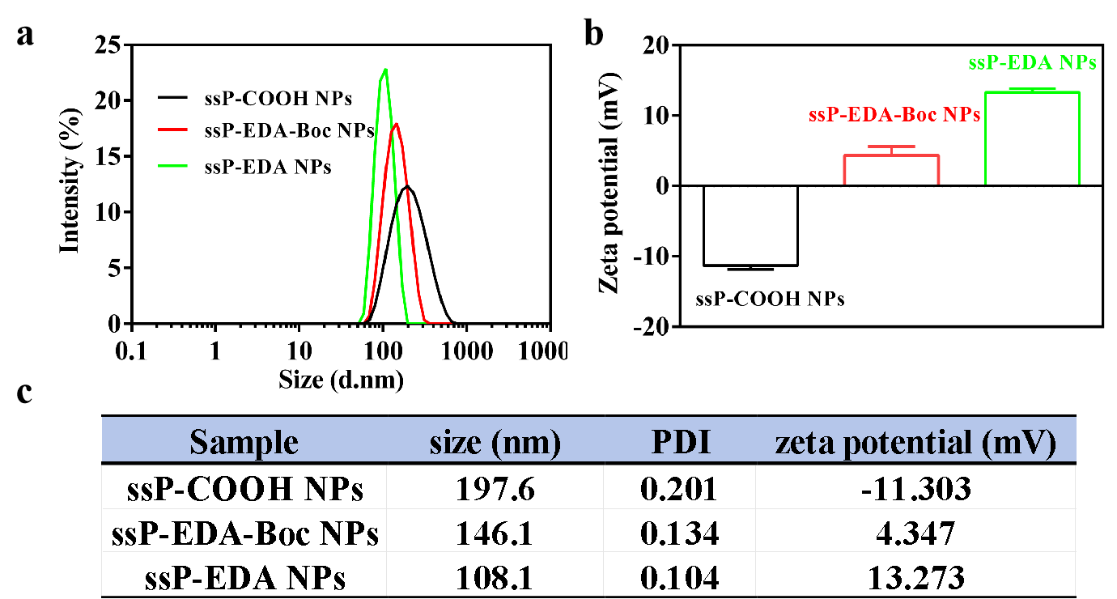

Fig. S5. (a) The diameter of ssP-COOH NPs, ssP-EDA-Boc NPs, and ssP-EDA NPs in water solution. (b) Zeta potential of different NPs (n = 3). (c) Summary of parameters of different samples.
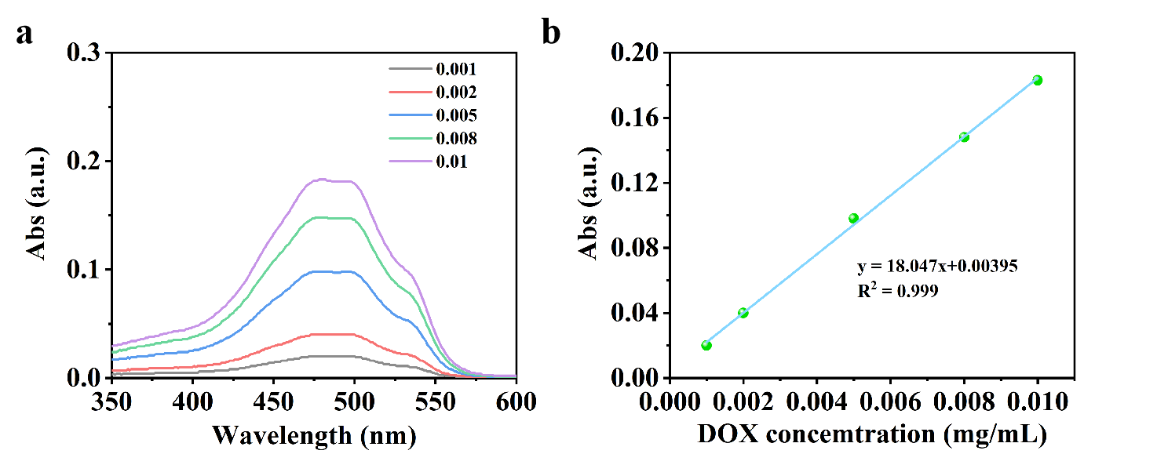
Fig. S6. UV-vis absorption spectra of different concentration DOX. (B) The linear relationship between the UV-vis absorption intensity at 480 nm and the DOX concentration.

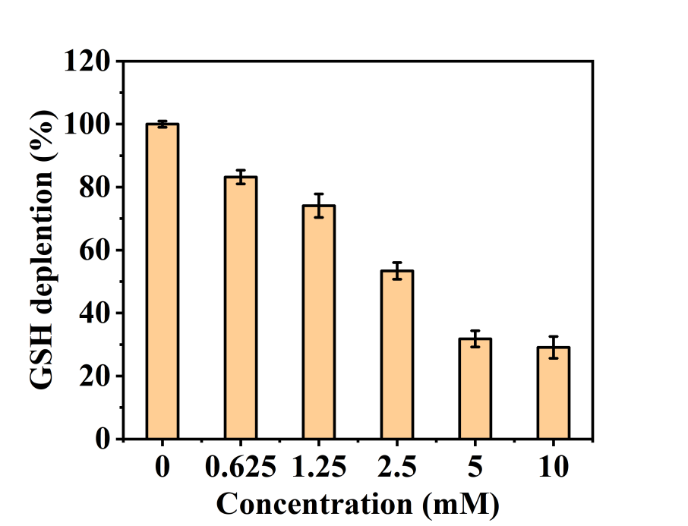

Fig. S7. Changes in GSH depletion in the different concentration of GSH solution treated with ssP-tHB NPs.

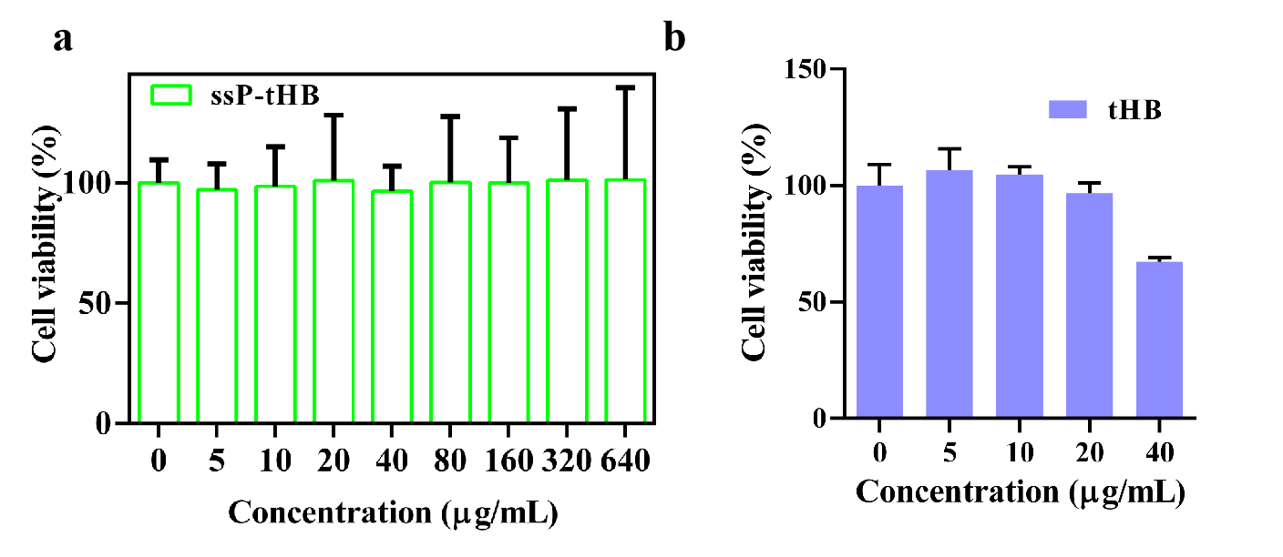
Fig. S8. The cellular cytotoxicity of different concentrations of ssP-tHB NPs (a) and free tHB monomer (b) on 4T1 cells.
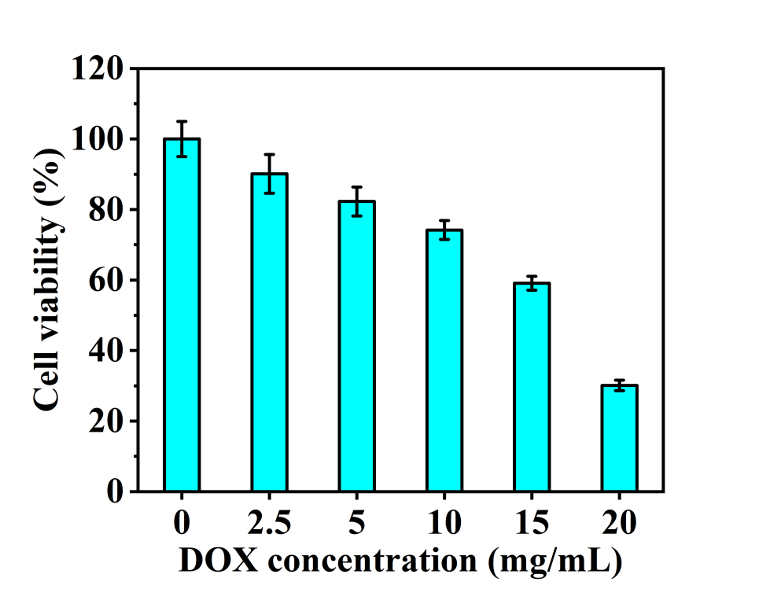
Fig. S9. The cellular cytotoxicity of different dose of DOX on L929 cells.

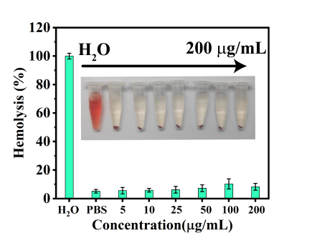

Fig. S10. Hemolysis assay using mouse erythrocytes when incubated with ssP-tHB@Fe/DOX NPs of various concentrations.

Table. S1. Blood routine analysis of the healthy mice at 8 days and 14 day post-injection of ssP-tHB@Fe/DOX NPs.
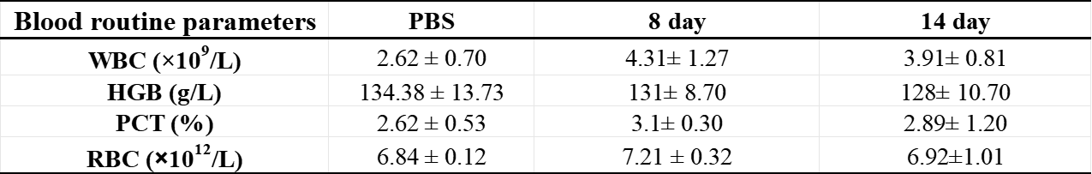

Table. S2. the bio-functions of liver and kidney analysis of the healthy mice at 8 days and 14 day post-injection of ssP-tHB@Fe/DOX NPs.
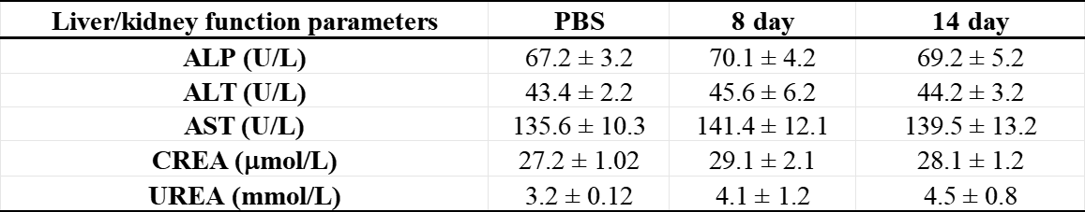

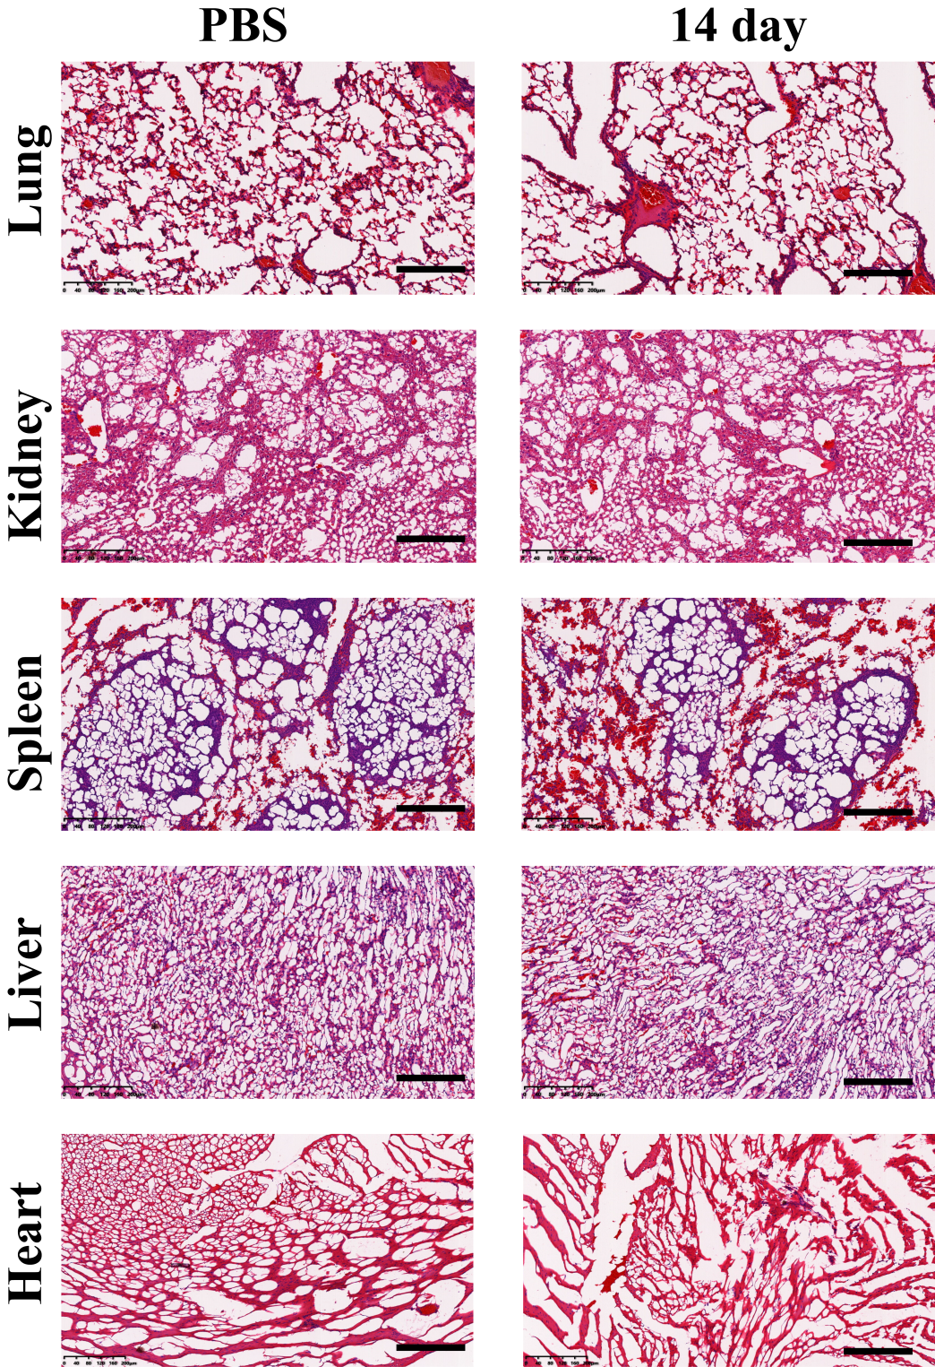
Fig. S11. Haematoxylin-eosin (H&E) staining of major organs (heart, liver, spleen, lung, and kidney) of healthy mice in ssP-tHB@Fe/DOX NPs after the 14-day. (scale bar: 200 μm).

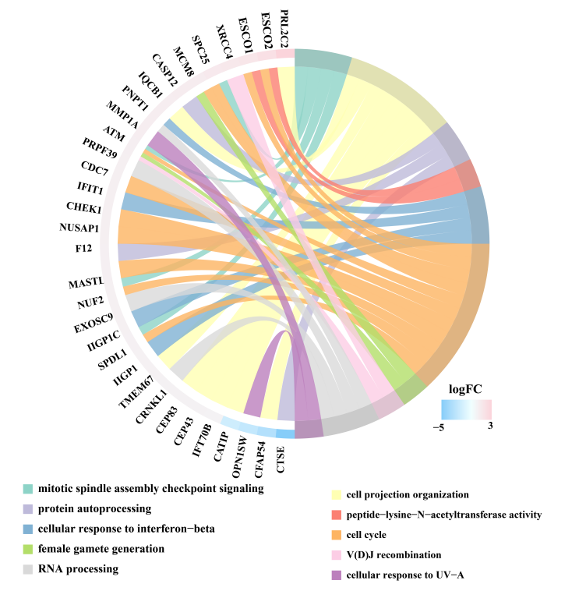
Fig. S12. Diagram of differential genes that enriched in GO pathway.

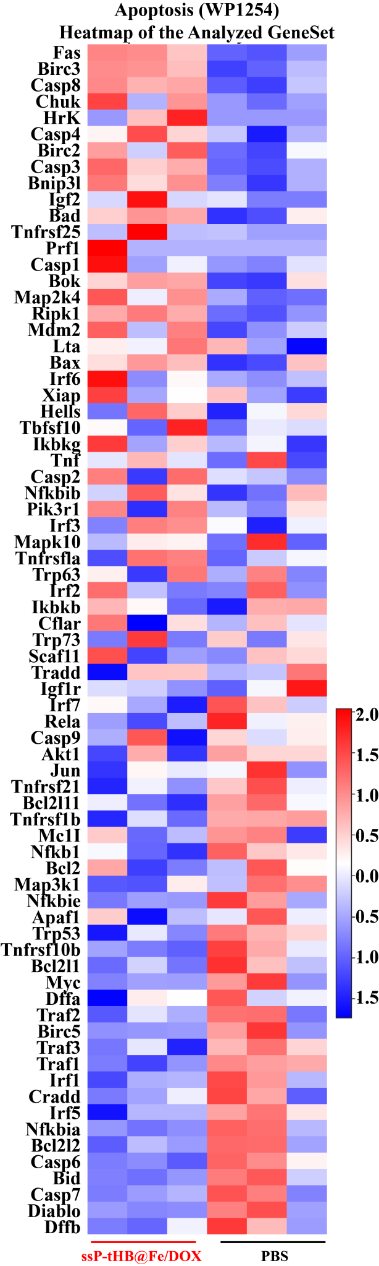

Fig. S13. Heat map showing distinctly apoptosis after ssP-tHB@Fe/DOX NPs treatments.

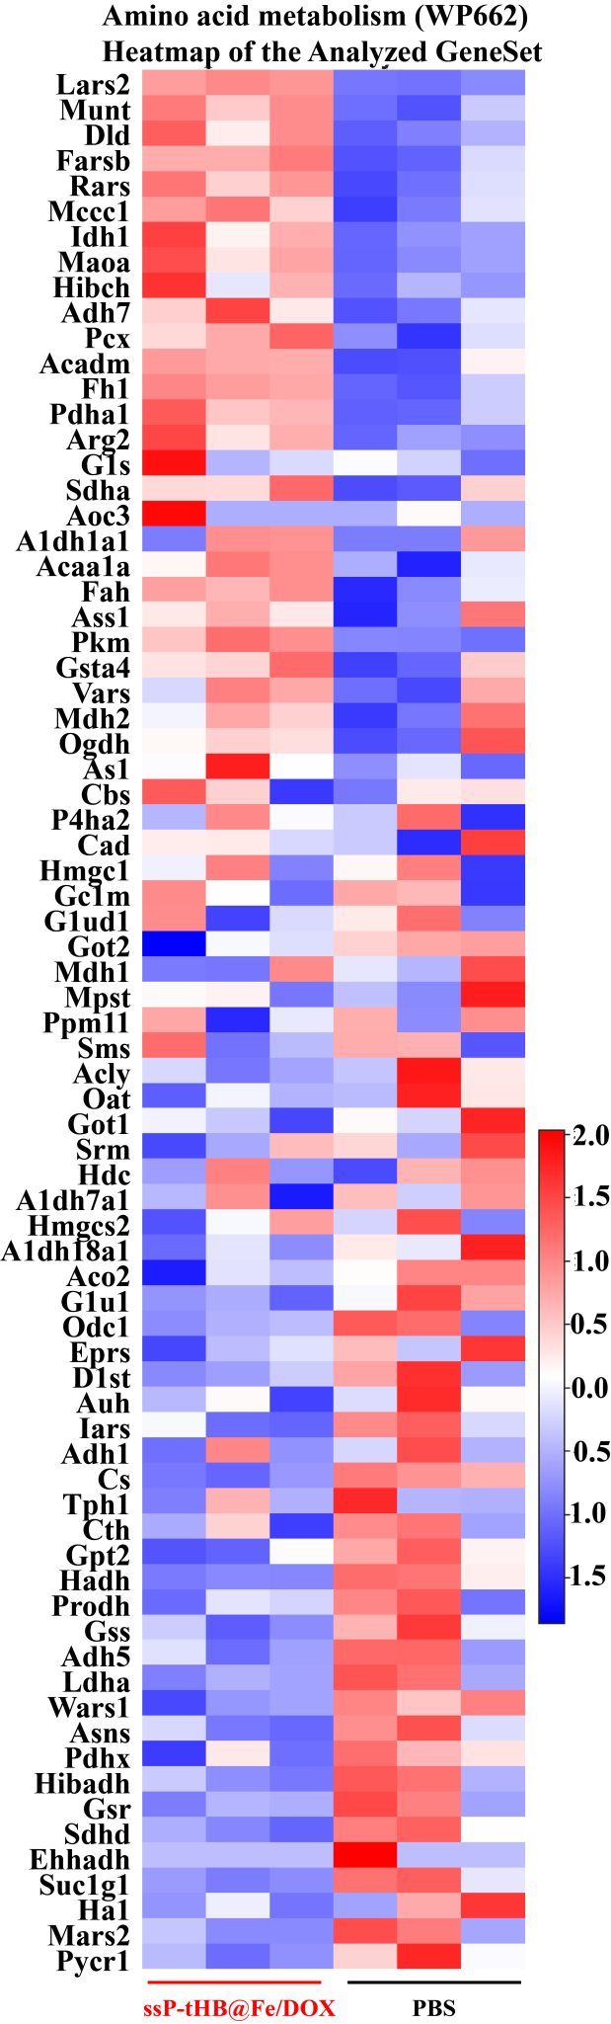
Fig. S14. Heat map showing distinctly amino acid metabolism after ssP-tHB@Fe/DOX NPs treatments.

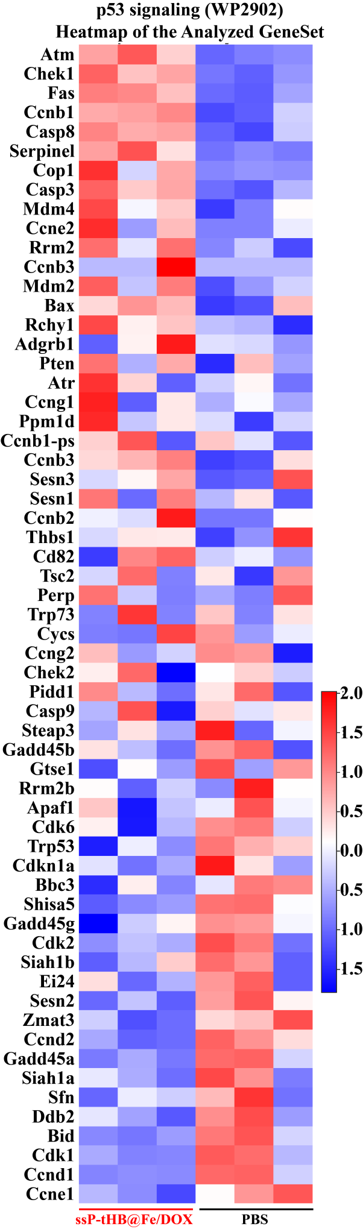
Fig. S15. Heat map showing distinctly P53 signaling after ssP-tHB@Fe/DOX NPs treatments.

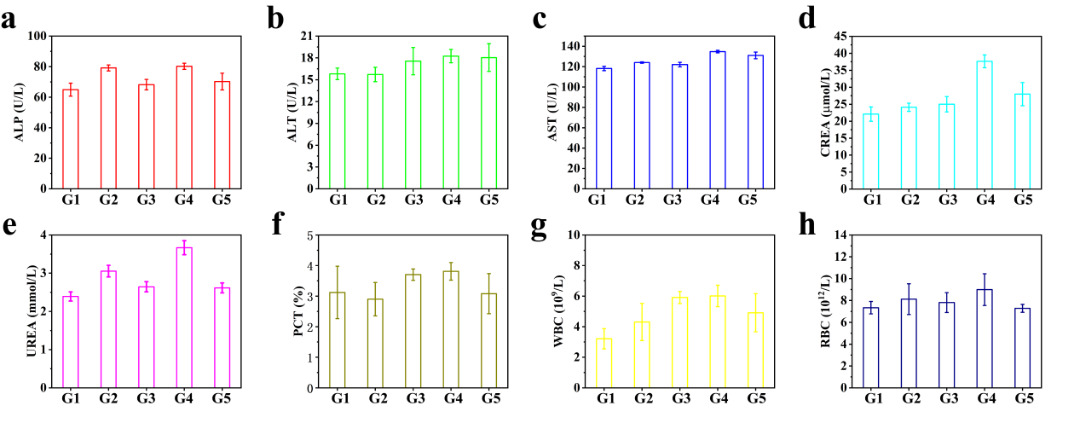Fig. S16. Hematological tests and blood biochemical analysis after intravenous injection of different samples. G1: PBS; G2: ssP-tHB NPs; G3: FeCl₃; G4: DOX; G4: ssP-tHB@Fe/DOX NPs (n = 5).

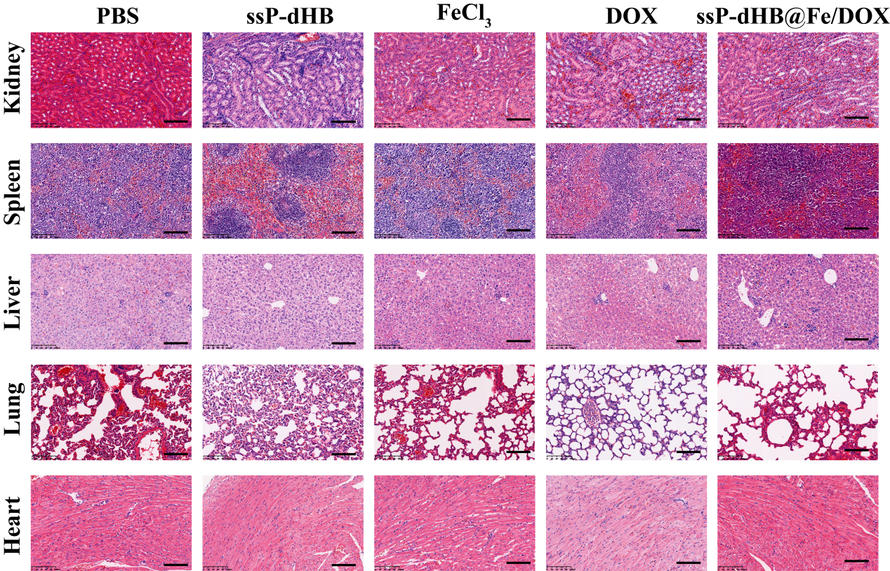
Fig. S17. H&E staining of major organs (heart, liver, spleen, lung, and kidney) of treated mice in different samples after the 17-day therapy (scale bar: 100 μm).

