Supplementary 2
Oscar Godínez Gómez

Example 2: Connectivity of protected areas in Colombia
In this example, we assess the connectivity of Colombia’s protected areas network in 33 ecoregions of great importance to the country using the Protected Connected Indicator (ProtConn). Particularly, there are 1,530 polygons of protected areas (PAs) in these ecoregions of Colomb ia. The protected area polygons were obtained from the World Database on Protected Areas (WDPA) from official data reported as of November 2019 (UNEP-WCMC, 2019). National protected areas are those that have a category designated by the country’s official authority, while subnational protected areas are those that are created and managed by communities or private owners. The spatial information used in this example is derived from the connectivity assessment study of protected areas in the Andean Amazon region, as conducted by Castillo et al., (2020). In order to estimate the ProtConn index, we use the MK_ProtConn() and MK_ProtConn_mult() functions. In this example, we will consider an organism median dispersal distance of 10 km, which corresponds to a connection probability pij = 0.5, and a transboundary PA search radius of 50 km (for further details, please refer to Castillo et al., 2020; Saura et al., 2017). We used Euclidean distances and specifically the distances between edges to determine the connections between nodes (PAs).

Load R packages
library(Makurhini)
library(sf)
library(ggplot2)
library(classInt)
library(ggspatial)
library(rmapshaper)

Loading inputs
#Protected areas
load(system.file("extdata", "Protected_areas.rda",
package = "Makurhini", mustWork = TRUE))
nrow(Protected_areas)
## [1] 1530
#Ecoregions
data("Ecoregions", package = "Makurhini")
nrow(Ecoregions)
## [1] 33
#For practicality we will use the first three columns.
Ecoregions <- Ecoregions[,1:3]
Plot:
mask_ecoregions <- ms_dissolve(Ecoregions)
PAs_national <- ms_clip(Protected_areas, mask_ecoregions)
PAs_transnational <- ms_erase(Protected_areas, mask_ecoregions)
PAs_transnational$Type <- "PAs in neighboring countries"
PAs_subnational <- PAs_national[PAs_national$ESCALA_2 == "Subnacional",]
PAs_subnational$Type <- "Subnational PAs"
PAs_national <- PAs_national[PAs_national$ESCALA_2 == "Nacional",]
PAs_national$Type <- "National PAs"
PAs <- rbind(PAs_national, PAs_subnational, PAs_transnational)
PAs$Type <- factor(PAs$Type, levels = c("National PAs", "Subnational PAs", "PAs in neighboring countries"))
ggplot() +
geom_sf(data = Ecoregions, aes(fill = "Ecoregions"), color = "black") +
geom_sf(data = PAs, aes(fill=Type), color = NA) +
scale_fill_manual(name = "Type", values = c("#1DAB80", "#FF00C5", "#E06936", "#8D8BBE"))+
theme_minimal() +
annotation_scale(
location = "bl",
bar_cols = c("grey10", "white"),
text_family = "ArcherPro Book"
) +
annotation_north_arrow(
location = "br", which_north = "true",
height = unit(1, "cm"),
width = unit(1, "cm"),
style = north_arrow_orienteering(
fill = c("grey10", "white"),
line_col = "grey5",
text_family = "ArcherPro Book"
)
)
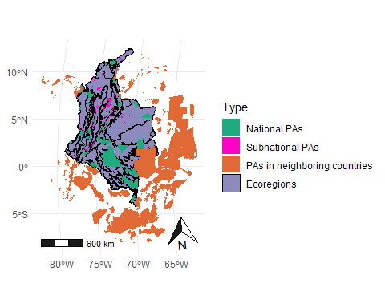

MK_ProtConn()
This function calculates the Protected Connected indicator (ProtConn) for a region, the ProtConn fractions and the importance (contribution) of each protected area to maintain connectivity in the region under one or more distance thresholds. In this example, we use the edge Euclidean distance, a more appropriate Euclidean method to capture the distance to be traversed outside the PA, but that is also more demanding in terms of RAM and processing time as it considers all the vertices of the polygons in the distance calculations. One way to speed up the process of estimating the distances between nodes is to use the “keep” option of the “distance” parameter, which is used to simplify the polygons by reducing the number of vertices. The value can range from 0 to 1 and represents the proportion of vertices to be retained. A higher value results in increased speed but decreased precision in the distance calculation.
#Select first ecoregion
Ecoregion_1 <- Ecoregions[1,]
#keep = 0.6 simplify the geometry and reduce the number of vertices
ProtConn_1 <- MK_ProtConn(nodes = Protected_areas, region = Ecoregion_1,
area_unit = "ha",
distance = list(type= "edge", keep = 0.6),
distance_thresholds = 10000, probability = 0.5,
transboundary = 50000, plot = TRUE, intern = FALSE)
A dynamic table is generated, displaying the values of ProtConn and its fractions. Additionally, a graph is produced, illustrating the ProtConn values and comparing them with the percentage of protected and connected area recommended for a region in the Aichi and Kumming-Montreal targets.
class(ProtConn_1)
## [1] "list"
names(ProtConn_1)
## [1] "Protected Connected (Viewer Panel)" "ProtConn Plot"
ProtConn_1$`Protected Connected (Viewer Panel)`
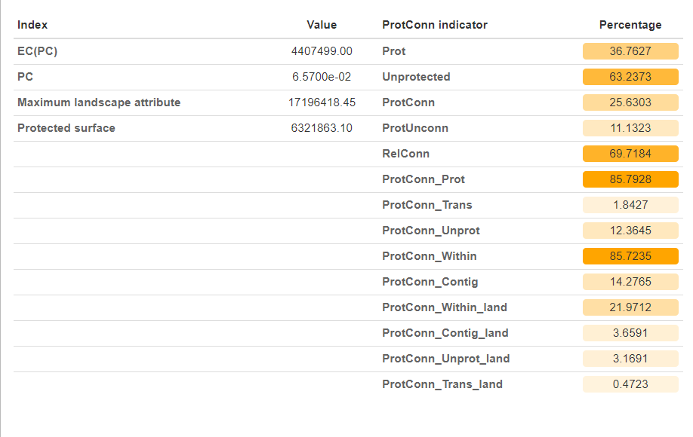
ProtConn_1$`ProtConn Plot`
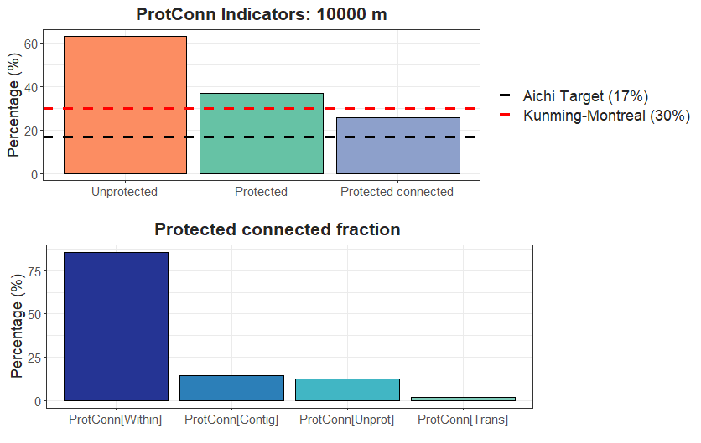
We can obtain the ProtConn value for each ecoregion using a loop such as lapply, for, map, etc. In this example we will use the lapply function.
ProtConn_1 <- lapply(1:nrow(Ecoregions), function(x){
x.1 <- MK_ProtConn(nodes = Protected_areas,
region = Ecoregions[x,],
area_unit = "ha",
distance = list(type= "edge"),
distance_thresholds = 10000,
probability = 0.5, transboundary = 50000,
LA = NULL, plot = TRUE, intern = FALSE)
return(x.1) })
class(ProtConn_1)
Each element of the list will result in the creation of an object of type “formattable” and “data.frame” This object will behaves in a manner similar to a normal data.frame, but canit will be visualized in a sensible and attractive format within the user’s RStudio viewer. In order to visualize the results of any of our ecoregions, it is necessary to access the list elements. If the intention is to save the results in the shapefile format, it is possible to use the sapply() function.
Ecoregions$Protconn <- sapply(x.1, function(x){
x.1 <- as.data.frame(x)
x.1 <- x.1[3, 4] #Extract ProtConn value
return(x.1)})
head(Ecoregions)
It can be exported using the sf functions and in its vector formats (e.g., shp, gpkg) using the sf package (Pebesma et al., 2024), for example:
write_sf(Ecoregions, "./Protconn.gpkg")

MK_ProtConnMult()
In order to facilitate the estimation of the ProtConn index for a variety of geographical regions, the MK_ProtConnMult function has been incorporated into Makurhini, which enables the estimation of the ProtConn indicator and fractions for different regions.
ProtConn_2 <- MK_ProtConnMult(nodes = Protected_areas,
region = Ecoregions,
area_unit = "ha",
distance = list(type= "edge"),
distance_thresholds = 10000,
probability = 0.5, transboundary = 50000,
plot = TRUE, parallel = 4)
A dynamic table and vector (sf class) are generated, displaying the ProtConn values and their fractions. Additionally, a graph is produced, illustrating the ProtConn values and comparing them with the percentage of protected and connected area recommended for a region in the Aichi and Kumming-Montreal targets.
class(ProtConn_2)
## [1] "list"
names(ProtConn_2)
## [1] "ProtConn_10000"
Table:
ProtConn_2$ProtConn_10000$ProtConn_overall10000
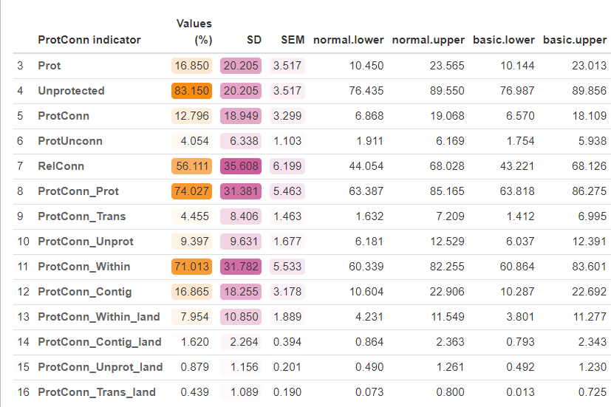
Plot showing the mean and standard deviation values:
ProtConn_2$ProtConn_10000$`ProtConn Plot`}
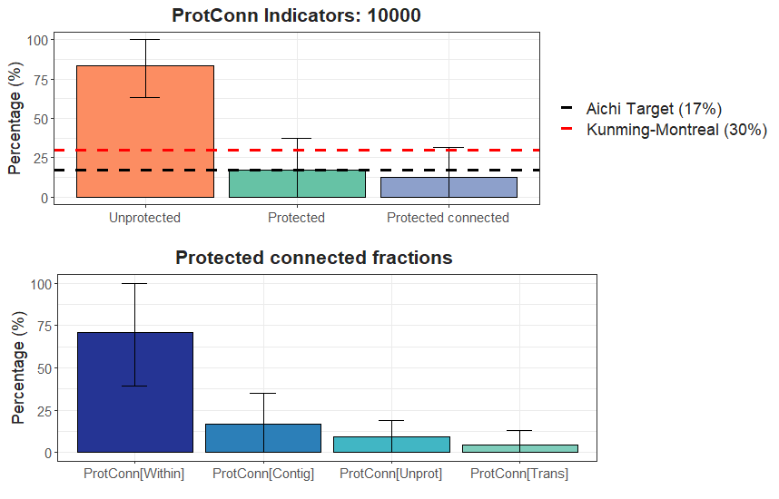
Vector file of class sf:
ProtConn_2$ProtConn_10000$ProtConn_10000
## Simple feature collection with 33 features and 19 fields
## Geometry type: GEOMETRY
## Dimension: XY
## Bounding box: xmin: -7920394 ymin: -522895.5 xmax: -6700933 ymax: 1536361
## Projected CRS: World_Mollweide
## First 10 features:
## ECO_ID_U ECO_CODE ECO_NAME EC(PC)
## 1 10319 NT0107 Caqueta Moist Forests 4407499.00
## 2 10320 NT0108 Catatumbo Moist Forests 68241.03
## 3 10321 NT0109 Cauca Valley Montane Forests 188885.91
## 4 10327 NT0115 Chocó-Darién Moist Forests 220615.52
## 5 10330 NT0118 Cordillera Oriental Montane Forests 634964.37
## 6 10333 NT0121 Eastern Cordillera Real Montane Forests 180919.61
## 7 10334 NT0122 Eastern Panamanian Montane Forests 34718.44
## 8 10339 NT0182 Guianan Piedmont And Lowland Moist Forests NA
## 9 10342 NT0128 Iquitos Varzeá 2183.84
## 10 10346 NT0132 Japurá-Solimoes-Negro Moist Forests 794644.14
## PC Prot Unprotected ProtConn ProtUnconn RelConn ProtConn_Prot
## 1 6.5700e-02 36.7627 63.2373 25.6303 11.1323 69.7184 85.7928
## 2 1.0300e-02 10.1265 89.8735 10.1251 0.0014 99.9865 91.1015
## 3 3.5000e-03 14.0252 85.9748 5.8789 8.1463 41.9167 63.0300
## 4 1.3000e-03 7.0816 92.9184 3.6713 3.4103 51.8430 79.6504
## 5 1.1500e-02 22.8199 77.1801 10.7244 12.0956 46.9956 63.1873
## 6 2.7500e-02 23.1047 76.8953 16.5873 6.5174 71.7919 78.1763
## 7 1.7520e-01 41.8570 58.1430 41.8570 0.0000 100.0000 99.9997
## 8 NA 0.0000 100.0000 NA NA NA NA
## 9 3.3283e-06 8.5256 91.4744 8.5256 0.0000 NA 100.0000
## 10 5.1900e-02 22.7864 77.2136 22.7864 0.0000 100.0000 100.0000
## ProtConn_Trans ProtConn_Unprot ProtConn_Within ProtConn_Contig
## 1 1.8427 12.3645 85.7235 14.2765
## 2 1.0256 7.8729 90.7351 9.2649
## 3 4.5807 32.3893 42.6304 57.3696
## 4 5.9092 14.4404 64.0252 35.9748
## 5 22.5662 14.2465 61.2057 38.7943
## 6 3.3240 18.4996 61.7719 38.2281
## 7 0.0003 0.0000 99.9997 0.0003
## 8 NA NA NA NA
## 9 NA NA 100.0000 NA
## 10 0.0000 0.0000 100.0000 0.0000
## ProtConn_Within_land ProtConn_Contig_land ProtConn_Unprot_land
## 1 21.9712 3.6591 3.1691
## 2 9.1870 0.9381 0.7971
## 3 2.5062 3.3727 1.9041
## 4 2.3506 1.3208 0.5302
## 5 6.5639 4.1604 1.5278
## 6 10.2463 6.3410 3.0686
## 7 41.8569 0.0001 0.0000
## 8 NA NA NA
## 9 NA NA NA
## 10 22.7864 0.0000 0.0000
## ProtConn_Trans_land geometry
## 1 0.4723 MULTIPOLYGON (((-7354073 34...
## 2 0.1038 POLYGON ((-7208574 1001585,...
## 3 0.2693 MULTIPOLYGON (((-7480526 88...
## 4 0.2169 MULTIPOLYGON (((-7692447 10...
## 5 2.4201 POLYGON ((-7154131 1377384,...
## 6 0.5514 POLYGON ((-7676692 240705.2...
## 7 0.0001 MULTIPOLYGON (((-7705753 10...
## 8 NA MULTIPOLYGON (((-6777542 50...
## 9 NA MULTIPOLYGON (((-7008087 -5...
## 10 0.0000 MULTIPOLYGON (((-6812922 35...
Visualize using ggplot2:
interv <- classIntervals(ProtConn_2$ProtConn_10000$ProtConn_10000$ProtConn, 9, "jenks")[[2]]
ggplot()+
geom_sf(data = Ecoregions)+
geom_sf(data = ProtConn_2$ProtConn_10000$ProtConn_10000,
aes(fill = cut(ProtConn, breaks = interv)), color = NA)+
scale_fill_brewer(type = "qual",
palette = "RdYlGn",
name = "ProtConn",
na.translate = FALSE)+
theme_minimal() +
theme(
legend.position.inside = c(0.1,0.21),
legend.key.height = unit(0.4, "cm"),
legend.key.width = unit(0.5, "cm"),
legend.text = element_text(size = 6, family = "Times"),
legend.title = element_text(size = 6, family = "Times")
)
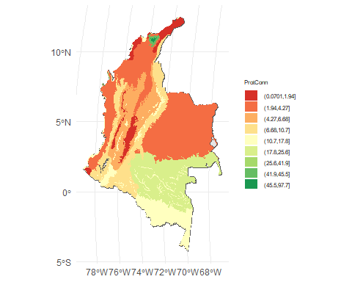
This analysis was performed on a desktop computer with the following characteristics:
- Processor (CPU): Intel(R) Core(TM) i7-8750H CPU running at 2.20GHz
- Memory (RAM): 32 GB
- Operating System: Windows 11
- R Version: 4.4.1

References
- Castillo, L. S., Correa Ayram, C. A., Matallana Tobón, C. L., Corzo, G., Areiza, A., González-M., R., Serrano, F., Chalán Briceño, L., Sánchez Puertas, F., More, A., Franco, O., Bloomfield, H., Aguilera Orrury, V. L., Rivadeneira Canedo, C., Morón-Zambrano, V., Yerena, E., Papadakis, J., Cárdenas, J. J., Golden Kroner, R. E., & Godínez-Gómez, O. (2020). Connectivity of Protected Areas: Effect of Human Pressure and Subnational Contributions in the Ecoregions of Tropical Andean Countries. Land, 9(8), Article 8. https://doi.org/10.3390/land9080239
- Saura, S., Bastin, L., Battistella, L., Mandrici, A., & Dubois, G. (2017). Protected areas in the world’s ecoregions: How well connected are they? Ecological Indicators, 76, 144-158. https://doi.org/10.1016/j.ecolind.2016.12.047
- UNEP-WCMC. Manual de Usuario para la Base de Datos Mundial Sobre Áreas Protegidas y Base de Datos Mundial Sobre Otras Medidas Eficaces de Conservación Basadas en Áreas: 1.6; UNEP-WCMC: Cambridge, UK, 2020.

