Table 1. Recovery rates of PE particles in samples shipped via varying containers and packing methods. All samples were done in triplicate in separate shipping containers and on different dates.
Shipping Test | Recovery rate (%) | Description of Shipping | Picture of Shipping Container
1 | 20-35 | The sample was shipped in a small cardboard box via USPS, with space for movement inside the box. | 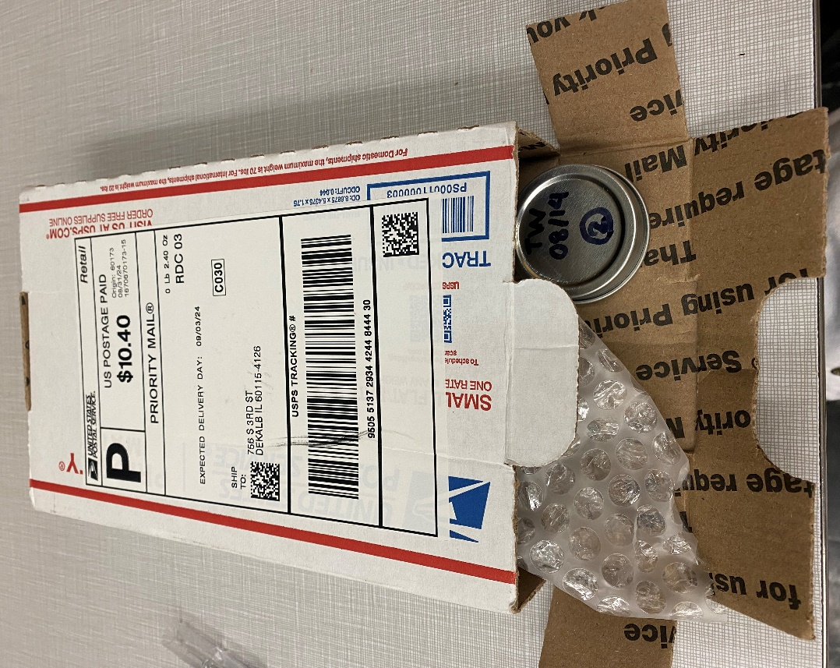
2 | 68-70 | The sample was shipped in a small cardboard box via FedEx, with materials that eliminate space for movement inside the box. | 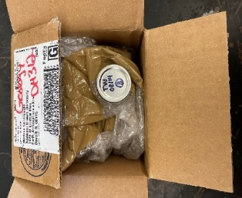
3 | 14-32 | The sample was shipped in an envelope via USPS, with space for movement. | 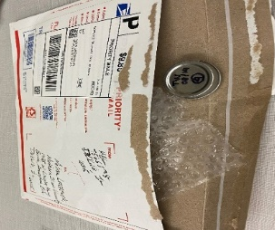
4 | 91-94 | The sample was shipped in an Igloo cooler box via FedEx, with ice packs and paper pieces inside to ensure there was no space for movement. | 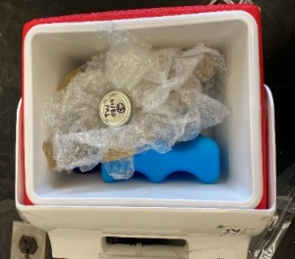
5 | 91-92 | The sample was shipped in a foam cooler box with an ice pack and paper pieces inside that eliminate space for movement. | 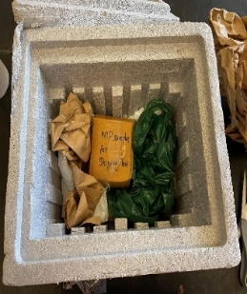
6 | 70 | The sample was placed in a small cardboard box and shipped from Cambodia via DHL, with materials that eliminate space for movement inside the box. This is the only sample not done in triplicate. | 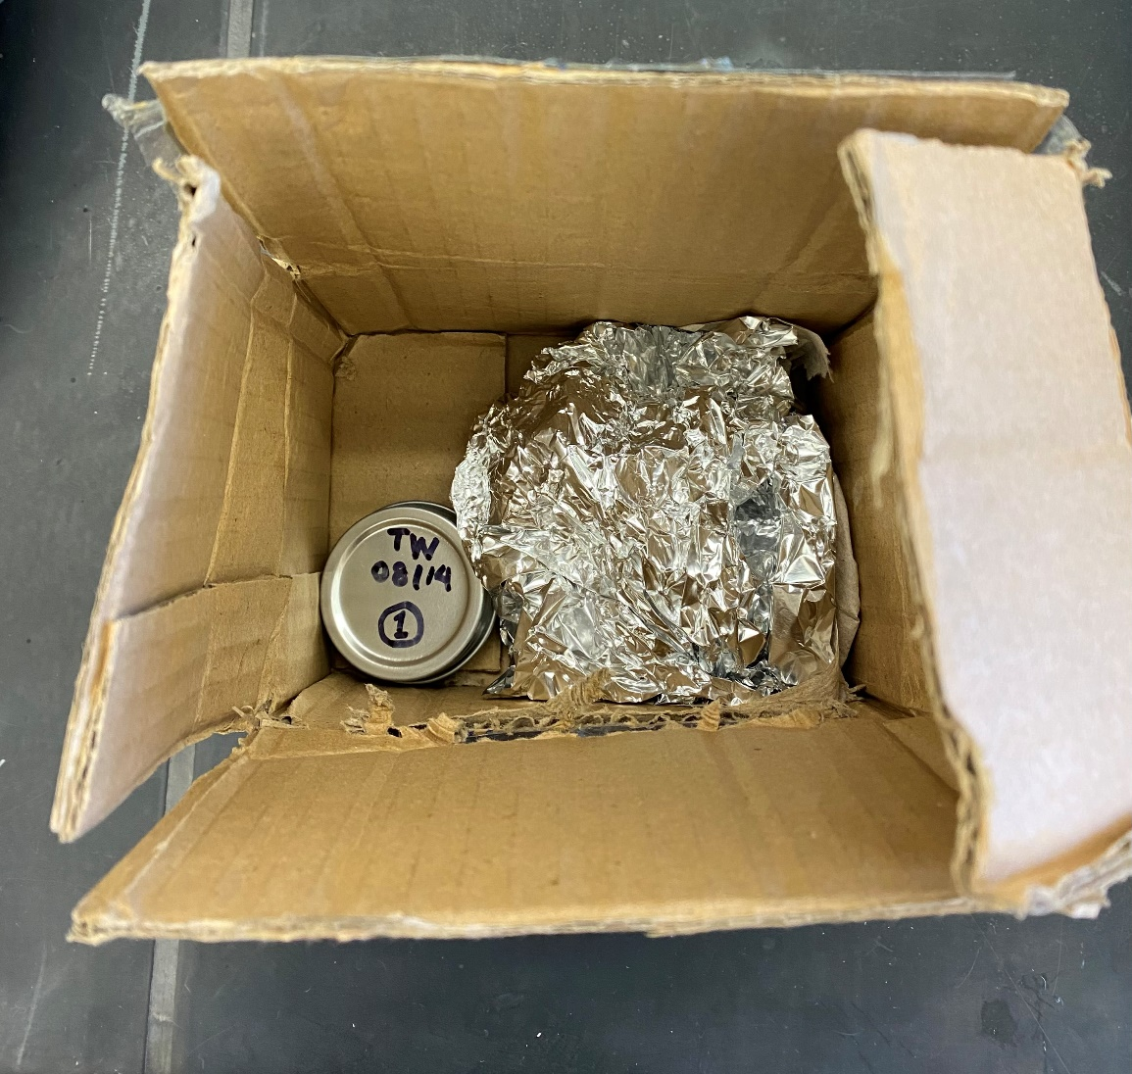  F
Control Sample | 100 | The sample was not shipped.

