Supplementary Materials

Extended Methods
1. Empirical Data Collection and Processing
To inform our modeling framework, we compiled extensive empirical data from multiple sources. This section details the data sources utilized, the key variables measured, and the statistical techniques employed to collect, integrate, and analyze these data.

1.1. Data Sources
1.1.1. Household Survey
The primary source of behavioral data was a comprehensive household survey conducted in Austin, Texas. The survey aimed to capture a broad range of information on residents’ socio-demographic attributes, attitudes, awareness, personal norms, social networks, and financial considerations related to GSI practices. A mixed-method sampling approach was used to gather responses: (1) random postcard invitations were sent to households across all city districts, and (2) targeted outreach was performed via community-based organizations in underrepresented neighborhoods. This strategy ensured inclusion of diverse socio-economic and demographic groups. In total, 592 valid survey responses were collected citywide (Tables S1-S2). Responses were processed and cleaned; any missing or incomplete responses were addressed through Bayesian multiple imputation techniques, which allowed us to preserve the full dataset without bias by statistically inferring missing values. The survey instrument itself was refined and validated through community focus groups to make the questions accurately reflect local values, knowledge, and concerns regarding stormwater and GSI.
1.1.2. Census Data
To complement the survey, we obtained secondary data from the U.S. Census Bureau’s American Community Survey (ACS) for Austin. In particular, we used ACS 5-year estimates at the census tract level to characterize the socio-economic context of each neighborhood. The ACS provided the distribution of household incomes across ten income brackets for each census tract, as well as other demographic statistics (e.g., racial composition, educational attainment) relevant to GSI adoption. These census data served as the basis for constructing a synthetic population of households in the model that statistically mirrors the real population. By leveraging ACS data, we ensured that the model’s representation of household income levels and other demographics in each area of the city aligns with observed real-world patterns. For integration, we treated each census tract’s data as defining probability distributions from which individual household attributes could be sampled (detailed under Statistical Techniques below). Because income data are typically right-skewed, we later fit tract-level income distributions to appropriate statistical models (log-normal curves) to enable realistic random sampling of household incomes. In addition to income, aggregate census statistics on race and education were used to probabilistically assign each synthetic household an attribute profile consistent with its tract’s demographics.

Table S1. Respondent demographics by sampling Method.
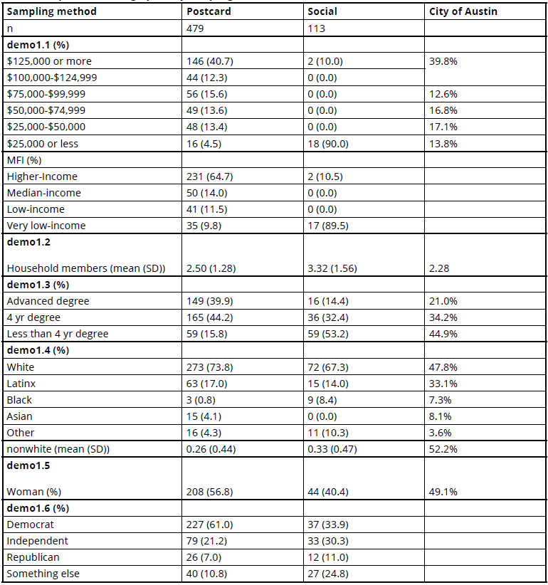
Table S2. Respondent demographics by city Council District.
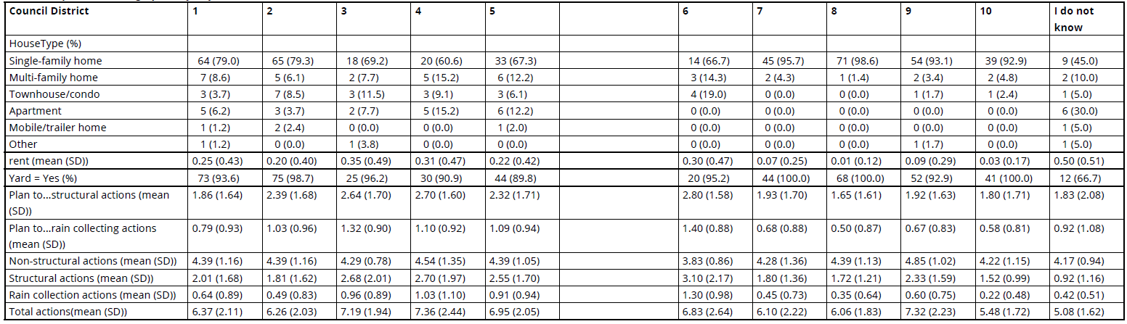

1.1.3. Spatial GIS Data
The physical characteristics and spatial context of each household were derived from the City of Austin’s GIS datasets. We obtained parcel-level shapefiles and building footprint data for the entire city, which allowed us to determine each parcel’s lot size and building area. By spatially intersecting the parcel map with building footprints, we calculated two key attributes for each household: parcel area (the lot size in square feet) and building area (the footprint of the house in square feet). These GIS data enable us to gauge the available space and physical capacity for implementing GSI at each household (for instance, larger yards might accommodate rain gardens, and larger roofs might allow bigger rainwater harvesting systems). Because our study focuses on single-family residential behavior (where individual households make GSI decisions), we filtered the parcels database to include only likely single-family properties. Specifically, parcels with total area roughly between 500 and 10,000 square feet and a building footprint between 500 and 5,000 square feet were selected as our sample of eligible households. These criteria effectively exclude multi-family complexes and outlier properties.
1.1.4. Adoption and Program Data
In addition to the cross-sectional data above, we integrated information about GSI adoption trajectories to incorporate a temporal dimension. Through the survey, respondents indicated not only their current engagement in GSI practices but also their future intentions (“plan-to-action” stages) for various GSI measures. This self-reported plan-to-action data served as a proxy for longitudinal adoption trends, allowing us to estimate how interest in GSI might progress over time within the community. We used these insights on adoption timing and progression in calibrating the model (aligning the simulation to reflect realistic adoption rates over a multi-year period). Furthermore, the survey included scenario-based questions about participation in incentive programs (e.g., willingness to adopt GSI under different rebate levels), which provided empirical grounding for how financial incentives could shift adoption behavior. All of these data sources—survey responses, census statistics, spatial GIS layers, and adoption intentions—were carefully combined to build a strong dataset for driving the agent-based model.

1.2. Measured Variables
Using the above sources, we assembled a wide array of variables capturing both the social and environmental dimensions of GSI adoption. Each variable was measured or derived through appropriate methods (surveys, statistics, or spatial calculations), as described below:
1.2.1. Socio-Demographic Attributes
Key household characteristics included income, education, and race/ethnicity were collected from survey response. However, for agent-based model, since we are simulating the entire city not just the survey responders, these demographic variables were derived from ACS census tract data. We measured income in terms of annual household income, drawing from the distribution of incomes in the household’s tract (ensuring the model reflects local economic conditions). Educational attainment (such as whether a household has members with advanced degrees) and racial/ethnic group were similarly assigned based on either survey responses or, when not available per household, probabilistic sampling from census tract proportions. These socio-demographic variables establish the context of each household, as factors like income and education can influence both the ability and willingness to adopt GSI.
1.2.2. Latent Behavioral Constructs
Four latent behavioral variables were measured via the household survey: Attitudes, Awareness, Personal Norms, and Social Capital. Each of these represents an underlying propensity or mindset that could affect GSI adoption. They were captured through multiple Likert-scale survey items. For example, Attitude toward GSI was assessed by agreement with statements about the importance of stormwater management (e.g., rating “The health of creeks is important to me” on a scale from 1 = strongly disagree to 5 = strongly agree). Awareness was measured by questions testing knowledge or recognition of local water issues and GSI benefits. Personal Norms (internalized sense of environmental responsibility) were gauged by statements like willingness to take action for environmental benefit (“I feel a moral obligation to reduce runoff from my property”). Social Capital was measured by indicators of community network strength and engagement, such as involvement in neighborhood groups or perceived willingness of neighbors to work together on environmental projects. We combined and analyzed these survey responses to derive a quantitative score for each latent construct per respondent. Statistical validation (using techniques like factor analysis or Cronbach’s alpha for internal consistency) confirmed that the sets of survey questions reliably represented each latent factor. The result is that each household in our data has an initial Attitude score, Awareness score, Personal Norms score, and Social Capital level, all on a normalized scale, reflecting their socio-behavioral disposition toward GSI.
1.2.3. GSI Adoption and Intentions
The concept of “adoption” was measured broadly to encompass any implementation of GSI practices by a household. In the survey, respondents reported both current adoption behaviors and future intentions. We asked whether they had already adopted or experimented with any GSI practices (even small-scale ones like using a rain barrel) and whether they plan to adopt certain measures in the future. From these responses, we derived an adoption likelihood score for each household, representing how inclined they are to implement GSI. Importantly, adoption was defined inclusively: it ranged from temporary or minor actions (e.g., occasionally diverting downspouts to a garden, using a rain barrel) to more permanent structural installations (e.g., building a rain garden, regrading a yard for better infiltration, planting water-thrifty landscaping). By counting even small contributions, we acknowledge that GSI adoption is not all-or-nothing; households can contribute to stormwater management in various degrees. The survey’s plan-to-action questions effectively place households on a timeline of adoption (from just considering it, to planning, to acting), which we use to estimate adoption rates over time in the community. In our dataset, each household thus has indicators for whether it has adopted each of several specific GSI practices and how likely it is to do so if not already.

1.2.4. GSI Practices and Parcel Characteristics
We explicitly tracked six GSI practices, divided into two categories: three rain-catching practices (Rain Barrel, Cistern, Rain Garden) and three structural water management practices (Yard Slope Modification, Yard Vegetation Change, Irrigation Reduction). For each practice, two quantitative attributes were measured or assigned: an implementation cost and an importance value. These were derived from the survey’s scenario questions where respondents considered various GSI options under hypothetical incentive levels. The importance value reflects how beneficial or high-priority the community perceives each practice (for example, residents might value rain gardens highly for their aesthetics and impact, whereas cisterns might be seen as less immediately useful). The cost is an average estimate of what installing that practice would require financially. While cost data were informed by typical market costs and city programs, the survey’s questions about willingness to adopt with certain rebates (100%, 50%, 25%, or 0%) allowed us to infer the perceived cost burden on households. Additionally, the physical feasibility of each practice at a given parcel was characterized by site-specific potential indices. These scores were calculated from the parcel’s spatial attributes: for instance, a larger yard would yield a higher Rain Garden potential index (more space to install one), and a bigger roof area would contribute to a higher Rain Barrel/Cistern potential (more runoff to capture). We computed these potential indices using the GIS-derived parcel and building areas, ensuring that each household’s capacity to implement a practice is quantified. In summary, for each household we know whether each of the six practices is already adopted (yes/no), what it would cost on average, how important it is considered, and a suitability score based on their property’s characteristics.

1.2.5. Financial Constraints
Financial capacity and constraints were explicitly measured through the survey’s questions on rebate needs. Households were asked whether they would be able to adopt GSI practices under various hypothetical rebate or subsidy levels: 100% cost covered, 50% covered, 25% covered, or 0% (no rebate). Their responses across these scenarios allowed us to gauge their price sensitivity and budget limitations. From this, we constructed a Financial Constraint Index for each household, effectively a normalized scale (0 to 1) of how dependent a household is on external financial assistance to implement GSI. A value of 1 indicates the household likely requires a full rebate (100% subsidy) to afford adoption – this often corresponds to lower-income households with little disposable income for such investments. A value of 0 would indicate the household could adopt even with no financial aid (more affluent or perceiving high personal benefit). Intermediate values reflect partial subsidy needs. This index synthesizes the survey responses about affordability and serves as a crucial parameter in the model to adjust adoption likelihood based on economic constraints.

1.3. Statistical Techniques
A variety of statistical methods were applied to analyze the data and integrate the different sources into a coherent model-ready format:
1.3.1. Survey Data Analysis – Latent Constructs
To translate the survey responses into meaningful latent variables, we applied factor analysis and structural equation modeling (SEM). Exploratory factor analysis helped confirm that groups of Likert-scale items correspond to the intended constructs (attitude, awareness, norms, social capital), by examining item loadings and ensuring each construct is uni-dimensional. We then used confirmatory factor analysis within an SEM framework to validate the measurement model for these latent variables, checking that the survey data fit the latent construct structure well. Using SEM for behavioral analysis, we also examined the relationships between these latent factors and self-reported GSI adoption intention. This allowed us to quantify how strongly each psychological factor (e.g., attitude or social capital) correlates with a household’s propensity to adopt GSI. The SEM provided regression weights for pathways between constructs and the adoption outcome, which we later leveraged to inform how changes in one latent variable might affect others and overall adoption in the simulation model. In sum, SEM was critical not only for data analysis but also for translating behavioral theory into model parameters.
1.3.2. Multiple Regression Models
We developed multiple linear regression models using the survey data to further quantify the influence of household attributes on adoption-related outcomes. In particular, two key regression equations were derived to calculate a household’s baseline behavior score for structural GSI and for rain-catching GSI, respectively. The dependent variables in these regressions were composite indices representing a household’s likelihood or propensity to adopt structural practices versus rain-catching practices. The predictors included the household’s socio-demographic attributes (income bracket, education level, etc.), latent construct scores (attitude, norms, awareness, social capital). Categorical variables like income or education were encoded appropriately (e.g., dummy variables for income ranges). These regression models were statistically significant and explained a substantial portion of variance in self-reported adoption propensity, indicating that the included factors indeed drive differences in GSI adoption. We used the fitted regression coefficients to create formulae that can compute an adoption propensity score for any given combination of attributes. During model initialization, these equations are applied to each synthetic household agent to assign their starting behavior scores, ensuring that agents with, say, higher income and pro-environment attitudes indeed get higher baseline propensity to adopt GSI, consistent with the empirical evidence.
1.3.3. Spatial Data Integration & Sampling
To merge the disparate data sources (survey, census, GIS), we used spatial aggregation and probabilistic sampling techniques. At the census tract level, we constructed probability density functions (PDFs) for household income. This involved taking the ACS-provided histogram of income brackets for each tract and fitting a smooth distribution; given the right-skewed nature of income data, we found that a log-normal distribution provided a good fit for most tracts. By fitting a log-normal curve to the binned income data, we could interpolate and generate random income values that respect the observed frequency in each tract. We similarly treated other census-derived variables: for example, if a tract is 30% college-educated and 70% not, then each synthetic household in that tract has a 30% chance to be assigned “advanced degree = yes,” determined through random draws. This Monte Carlo sampling approach, underpinned by the law of large numbers, ensures that while individual assignments are random, the aggregate characteristics of thousands of agents in a tract will closely match the known census proportions.
For the latent behavioral variables, we faced the challenge that our survey sample (592 responses) was smaller than the total households, and not every tract had enough direct survey responses. To address this, we aggregated the survey results to a slightly larger spatial unit – the City Council District – and estimated the distribution of, say, attitude scores within each district. We then randomly sampled each agent’s initial attitude, norms, awareness, and social capital values from the distribution of survey respondents in that agent’s district. This approach preserves spatial heterogeneity (assuming residents of different districts might have different social attitudes) without overfitting noise at the tract level where data were sparse.
1.3.4. Data Imputation and Validation
As mentioned, Bayesian multiple imputation was used for the survey to handle missing answers. This statistical technique creates several plausible datasets by modeling the joint distribution of the survey variables and sampling missing entries, then combines results to yield estimates that account for uncertainty due to missing data. By using this method, we avoided discarding partially filled surveys and retained the full sample size for analysis, which is especially important for capturing variation in smaller subgroups. Additionally, we performed validation checks on our synthesized dataset. For instance, after assigning all household agents their attributes through sampling, we aggregated the synthetic population back up to the city and tract levels to compare with original data. We found that the modeled distributions of income and other demographics closely matched the ACS data by design, confirming the sampling approach’s accuracy. We also compared the average latent construct levels in each district among our agents to the survey-reported averages, finding a good alignment (differences were minor due to random sampling variability).
1.3.5. Structural Equation Modeling
Structural Equation Modeling (SEM) is a multivariate analytical approach that enables researchers to estimate complex networks of relationships among variables. In our study, SEM serves as a critical bridge between empirical data and the simulation model. It provides a high-level, quantitative understanding of how key behavioral factors interrelate and drive Green Stormwater Infrastructure (GSI) adoption. By using SEM to analyze survey data, we can assess the strength and direction of influence between these constructs and households’ self-reported GSI adoption intentions. This approach leverages theoretical insights from behavior models (e.g., the Theory of Planned Behavior and Social Cognitive Theory) in a data-driven manner. For instance, it quantitatively tests how social capital and awareness might reinforce one another. How change in others impact the other one.

2. Agent-Based Modeling Framework
Green Stormwater Infrastructure (GSI) adoption is modeled as a coupled socio-behavioral, economic, and environmental process. We employ an Agent-Based Model (ABM) to capture the complex interactions among household characteristics, social behaviors, financial constraints, and physical environmental factors that influence GSI adoption. ABM is well-suited for this problem because it simulates the decision-making processes of individual households over time and space, allowing emergent adoption patterns to arise from heterogeneous behaviors and peer influences. By integrating empirical data (survey responses, census statistics) and behavioral theory into the ABM, we ensure that both quantitative factors (e.g., income, parcel characteristics) and qualitative drivers (e.g., social norms, perceived benefits) are represented. The ABM serves as tool to explore how and why households decide to implement GSI practices under varying socio-economic and neighborhood conditions, and how these decisions collectively lead to city-scale adoption patterns over time. This modeling approach is particularly effective for simulating policy scenarios and long-term diffusion processes, as it can incorporate feedback loops and time-lagged effects in household decision-making.
Our ABM consists of four major components that together simulate the GSI adoption process (Figure S1). These components are:
- Household Agents – representing individual households with specific socio-demographic profiles, spatial properties, and latent behavioral traits;
- Social Interactions – a representation of neighbor networks and rules of engagement through which agents influence each other;
- Behavioral Evolution – mechanisms for how agents’ internal attitudes, awareness, norms, and social capital change over time via self-reflection and social influence;
- Adoption Decision Rules – criteria and thresholds that determine if and when an agent implements a GSI practice.
Each component is detailed in the subsections below. In overview, the model initializes a population of household agents with attributes derived from real-world data, then iteratively updates each agent’s latent behavioral state and adoption propensity by simulating interactions with their social network, neighboring agents and personal feedbacks. The decision rules evaluate whether an agent’s propensity, adjusted for economic and practical constraints, exceeds its adoption threshold for specific GSI practices. Through these interacting components, the ABM captures the multi-faceted drivers of GSI adoption at the household level and their aggregation to broader adoption dynamics.
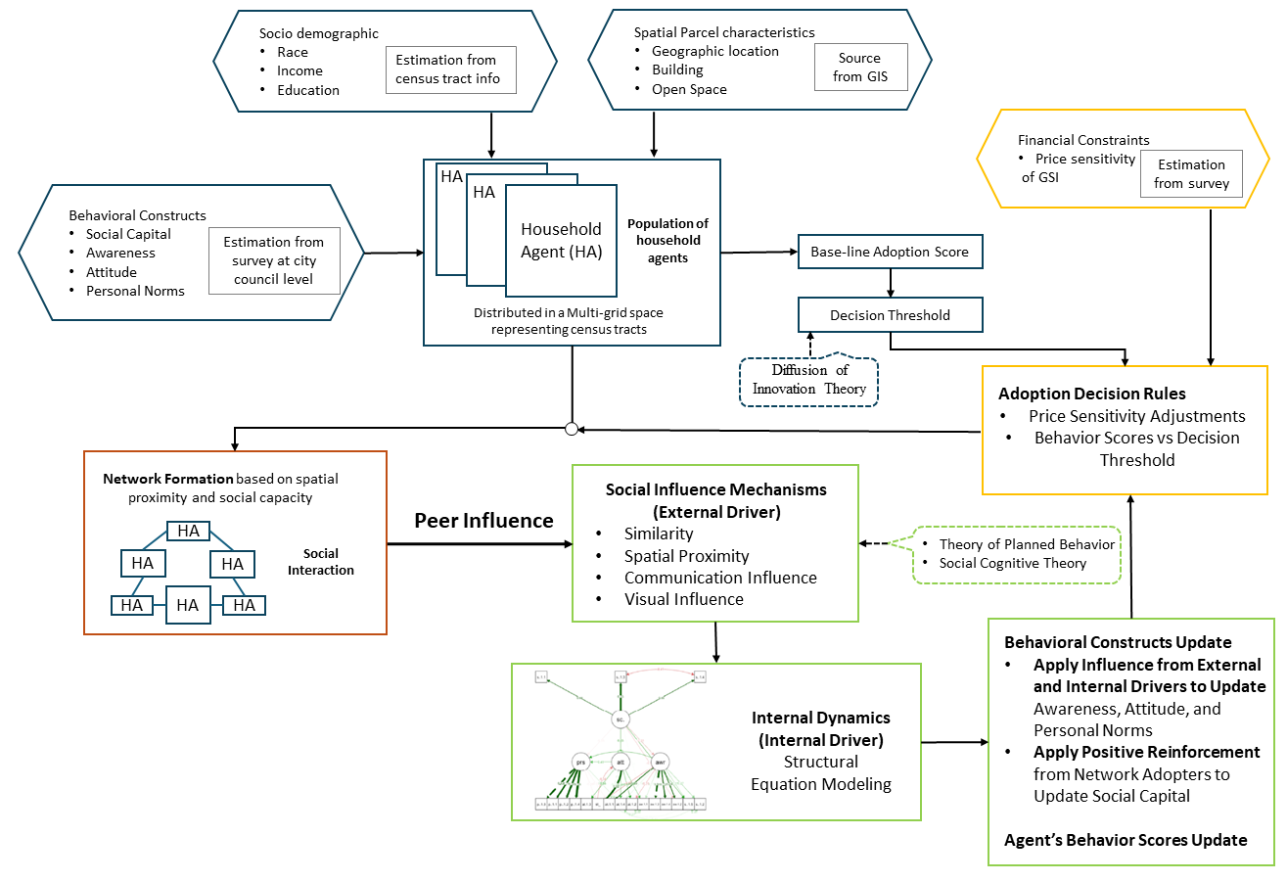
Figure S1. Agent-based modeling framework for GSI adoption. Hexagons represent data sources or model inputs (e.g., socio-demographics, GIS layers), while rectangular boxes indicate key processes or decision modules within the simulation. The color-coded boundaries correspond to the four major components of the model: blue for Household Agents (demographics, property attributes, and behavioral traits), red for Social Interactions (network formation and peer influence), green for Behavioral Evolution (dynamic updates of attitudes, awareness, norms, and social capital), and orange for Adoption Decision Rules (criteria and thresholds for GSI implementation). Together, these interconnected components capture how individual household decisions, shaped by both internal states and social networks, evolve over time to produce emergent citywide adoption patterns.

2.1. Household Agent Design
Household agents are the fundamental actors in the model, each characterized by a set of static attributes, spatial properties, and latent behavioral variables. The static socio-demographic attributes include factors such as income, race, and educational attainment, which are assigned to each agent based on census tracts data distribution in the study area. Spatial attributes define the physical context of the household – for example, parcel size and building footprint – which influence the feasibility of certain GSI practices. We incorporate a “potential” index ($P_{i}$) for each agent, representing the suitability of the property for rain-catching or structural GSI implementations (e.g., available roof or yard area). Larger building or yard areas yield higher $P$ values, indicating greater capacity to install features like cisterns or rain gardens. In addition to these static attributes, each agent has latent behavioral variables drawn from survey-derived distributions. These include Attitude, Awareness, Personal Norms, and Social Capital.

2.1.1. Baseline Propensity
Each agent’s baseline propensity to adopt GSI is quantified by behavior scores for two categories of practices: (1) structural measures and (2) rain-catching measures. We compute these scores using multiple linear regression models (Eq. 1 and Eq. 2) calibrated on the survey data (as describe in section 2.1.3) plus integrating the spatial potential index $P$ (as described in section 2.1.2) in the final score. For example, higher income or education might increase the baseline score, while limited suitable space would constrain it. The outcome of these regression models is a pair of scores (one for structural practices, one for rain-catching) for each agent, representing their inherent predisposition to adopt each type of GSI given their characteristics. We also assign each agent a price sensitivity factor between 0 and 1 based on their income percentile and survey responses about willingness to pay. A value of 1 indicates the household would require a full rebate to afford the GSI (high financial barrier), whereas a value of 0 indicates little to no subsidy is needed. This factor does not initially alter the behavior score but will modulate the adoption decision as described in Section 2.2.5.

$$B_{s,i}^{0}=\left(1.51-0.45×I\left({\text{Demographic subgroup}}_{i}=\text{NonWhite}\right)+β_{\text{IncomeB}}\left(IncomeB\right)-0.16×I\left({\text{Education}}_{i}=\text{NoAdvDegree}\right)+0.37×N_{i}^{0}+0.23×S_{i}^{0}-0.02×A_{i}^{0}+0.02×W_{i}^{0}\right)×P_{s,i}$$ | Eq. 1
$$B_{r,i}^{0}=\left(0.39-0.18×I\left({\text{Demographic subgroup}}_{i}=\text{NonWhite}\right)+β_{\text{IncomeB}}\left(IncomeB\right)-0.05×I\left({\text{Education}}_{i}=\text{NoAdvDegree}\right)+0.22×N_{i}^{0}+0.07×S_{i}^{0}+0.005×A_{i}^{0}-0.02×W_{i}^{0}\right)×P_{r,i}$$ | Eq. 2

where Income (B refer to income bracket), Demographic Subgroup, and education are categorical variables integrated into the regression models to influence behavior scores, with specific coefficients assigned to each category to reflect their impact on the likelihood of adopting GSI practices (Section 2.1.3). The $P_{i}$ is potential index for agent $i$, the subscript $s$, and $r$ refer to structural and rain-catching, respectively.
2.1.2. Decision Thresholds
Finally, during initialization each agent is given an adoption threshold for deciding to implement a GSI practice. To reflect heterogeneity in willingness to act, we derive thresholds from the distribution of behavior scores ($B_{i}^{0})$using a sigmoid (S-shaped) function (Eq. 3 and Eq. 4).
In other words, for each agent i, we compute a rank $R_{i}$​ among all households based on their $B_{i}^{0}$ (Eq. 4). We then use this rank in a sigmoid expression (Eq. 3) to produce an agent-specific threshold $θ_{i}$​. Agents with higher baseline scores (more predisposed to adopt) receive lower thresholds, meaning they require less additional incentive or social pressure to trigger adoption – analogous to “early adopters” in diffusion theory. Conversely, agents with lower scores get higher thresholds, representing “late majority” or “laggards” who need much stronger impetus to adopt, though the function is bounded so that no agent’s threshold is insurmountable. This approach, grounded in Rogers’ (2003) diffusion of innovations theory, ensures an initial variety in adoption resistance across the population, helping the model produce a realistic sigmoidal adoption curve over time (few early adopters, then acceleration, then saturation).

$$θ_{i}=B_{\text{base}}+\left(1/\left(1+e^{\left(-k\left(R_{i}-0.5\right)\right)}\right)\right)×B_{i}^{0}×\left(1+0.5\left(1-R_{i}\right)\right)$$ | Eq. 3
$$R_{i}=\left(\text{Rank of }B_{i}^{0}-1\right)/\left(N-1\right)$$ | Eq. 4

where $N$ is the total number of households, $B_{\text{base}}$is the median of all $B_{i}^{0}$ ​ scores, $R_{i}$​ is the percentile rank of agent i’s score, and $k$controls the steepness of the sigmoid function. This approach ensures that households across the entire spectrum of behavior scores have the opportunity to adopt GSI practices without excluding those with initially lower scores.

2.2. Social Network and Interaction Rules
2.2.1. Network Structure
Household agents influence one another through localized and broader social networks defined by spatial proximity and social capacity. The agents are placed in a simulated spatial environment that mirrors the geography of our case study: we divide a two-dimensional grid into regions corresponding to real census tracts and distribute agents within these regions proportional to the number of households in each tract. The grid wraps toroidally (edges connect), which prevents artificial boundary effects in neighbor interactions.
Within this space, agents interact through two distinct mechanisms—Neighborhood Influence and Social Network Influence—each governed by different spatial radii to capture varying degrees of interaction. Neighborhood Influence remains localized, where each agent considers others within a fixed radius of two grid cells as its immediate neighbors. This reflects real-world patterns where households are most influenced by those in close proximity, such as on the same street. However, broader social interactions extend beyond these immediate neighbors. To account for slightly wider influence through social ties, Social Network Influence extends to a radius of three grid cells, allowing agents to interact with a larger pool of connections beyond their immediate neighborhood. This differentiation ensures that influence spreads both locally (radius = 2) and socially (radius = 3), facilitating wider diffusion of adoption behaviors while maintaining realistic spatial constraints. Additionally, multiple agents can occupy the same grid cell to represent high-density areas.
Each agent’s social network size is bounded by its social capital level, linking the breadth of social interactions to the agent’s networking capability. Agents with high social capital can maintain up to 12 social connections, whereas those with low social capital may only have 2–3 connections. In other words, socially well-connected agents interact with a larger peer group—amplifying both the influence they receive and impart—while less connected agents remain in smaller circles. If an agent has more neighbors within the broader radius than its maximum network size, it will interact preferentially with a subset (e.g., the closest or most similar neighbors), effectively capping its active network to the allowed size. This dynamic network-sizing ensures that direct networks (immediate contacts) are larger for agents with greater social capital, reflecting their ability to engage more broadly within the community.

2.2.2. Influence Mechanisms
When agents interact, the influence of one neighbor on another is quantified by an interaction weight that combines multiple influence factors. We implement four components for peer influence, drawn from social and behavioral theory: Similarity, Spatial Proximity, Communication, and Visual cue. The Similarity component ($Sim_{ij}$) gives higher weight to interactions between agents who share socio-demographic traits (e.g., similar income or education), representing homophily (like influences like). Spatial Proximity ($Spa_{ij}$) gives higher weight to neighbors that are physically closer on the grid, acknowledging that very nearby neighbors (perhaps on the same street) exert stronger influence than those farther away. The Communication Influence ($Com_{ij}$) component represents social interactions such as conversations or online exchanges; it is modeled as a function of the social capital of both the influencer and the receiver, emphasizing that an agent with higher social capital (strong social networks) can more strongly sway others. We weight the primary agent’s social capital more heavily in this term (the idea that a well-networked household can act as a local opinion leader). Finally, Visual Influence captures observational learning – if a neighbor has visibly adopted a GSI practice (e.g., one can see a rain barrel or rain garden), that neighbor’s influence on the agent is increased. This aligns with social learning theory: seeing a behavior in one’s vicinity can enhance one’s self-efficacy and normalize the behavior. Each of these components is mathematically defined (Eqs. 5–8), and they are combined to calculate the overall interaction weight between agent i and neighbor j (Eq. 9). The weighting scheme assigns significant influence to similarity and proximity (emphasizing that people are most influenced by those who are like them and near them) and also substantial roles to communication and visual evidence of adoption.
$${\text{Sim}}_{ij}=\frac{\left(L_{i}⋅L_{j}\right)}{|L_{i}||L_{j}|}$$ | Eq. 5
$$Spa_{ij}=\frac{1}{1+{\text{Distance}}_{ij}}$$ | Eq. 6
$$Com_{ij}={2S}_{i}^{t}+S_{j}^{t}$$ | Eq. 7
$$Vis_{ij}=[ 1, ​if agent j has adopted the behavior$$  $$0, otherwise$$ | Eq. 8
$$I_{ij}=0.4×{\text{Sim}}_{ij}+ 0.25×{\text{Spa}}_{ij}+0.1×{\text{Com}}_{ij}+0.25×{\text{Vis}}_{ij}$$ | Eq. 9

where $I_{ij}$ ties these components to a unified index that while the weights reflect the relative importance of each influence component in shaping the influence. Importantly, in our implementation, Attitude, awareness, and personal norms are updated based on interactions with broader “social network” neighbors (within radius = 3), who contribute these four influence factors.
Social interactions in the model are underpinned by behavioral theories. Drawing on the Theory of Planned Behavior (TPB), we interpret the communication influence as a proxy for subjective norms – neighbors with strong social ties create a normative pressure to follow suit – and as perceived behavioral control, since being connected to a well-informed neighbor could reduce uncertainty about adopting. The Social Cognitive Theory (SCT) motivates the visual influence: observing a neighbor’s GSI implementation provides an example to emulate, enhancing the observer’s self-efficacy in doing the same. In effect, TPB and SCT guide the inclusion of these interaction channels to reflect both normative influence and observational learning in our rules of neighbor interaction.
Social capital is conceptualized as a distinct latent variable. By treating social capital as an independent factor, the model captures the network-level dynamics that influence individual behaviors without conflating them with individual-level behavioral constructs. We incorporate two mechanisms for social capital growth from the interactions. First, positive reinforcement from network adopters, where the presence of adopters within an agent's social network directly increases social capital by enriching the agent's access to resources and connections. Second, neighborhood-based feedback loops, these activate only when both the agent and its neighbors (radius = 2) adopt GSI practices, leveraging shared traits to strengthen mutual trust and coordination. This bidirectional influence ensures that agents experience both direct and indirect social capital benefits, enhancing their network connections and reinforcing positive feedback loops (Figure S2).
It is important to note that the model tempers the influence of non-adoption. Agents within the network who have not adopted GSI contribute much less weight in the interaction calculations, effectively reducing negative peer pressure. This is implemented by assigning a lower weight to all influence components (similarity, communication, etc.) when interacting with a non-adopter, so that an agent is not strongly discouraged by other agents’ inaction. The rationale is that, since GSI adoption is not a highly salient issue in the community, non-adoption does not carry strong normative weight. In line with TPB and SCT, social influence is primarily shaped by the presence of a behavior rather than its absence. By minimizing negative influence from non-adopters, the model avoids scenarios where a few initially hesitant neighbors could indefinitely suppress adoption in their area. Instead, the diffusion process is driven primarily by the presence of adopters (positive examples), while non-adoption remains a weak counterforce. This assumption, grounded in theories of social influence that prioritize learning from positive deviants, helps the simulation produce realistic diffusion where social reinforcement is key and lack of participation does not create disproportionate deterrence.
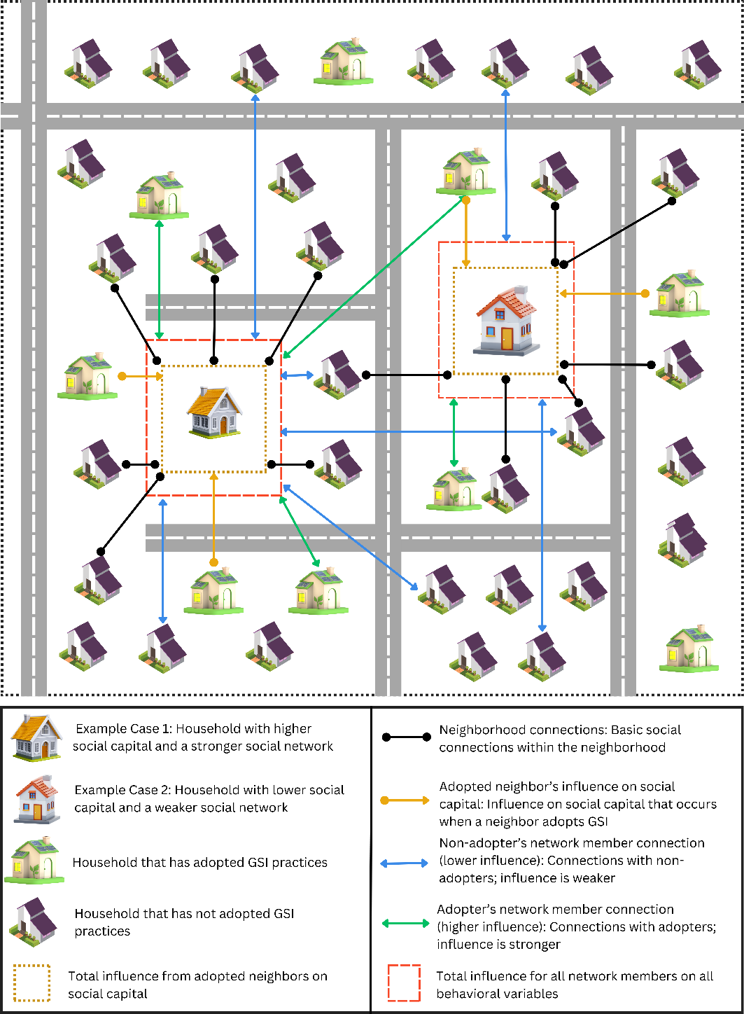
Figure S2. Schematic illustration of household-level social interactions and network formation, highlighting two contrasting scenarios. In Case Example 1, the focal household (outlined in orange) has higher social capital and maintains a stronger social network, evident from multiple connections extending to the broader network (red dashed rectangle) and direct links to immediate neighbors (brown dotted rectangle). In Case Example 2, the focal household (outlined in orange) exhibits lower social capital, resulting in fewer overall connections to the broader network, though some ties to immediate neighbors remain. Network influence (connections to the red dashed rectangle) is two-way for all linked households—regardless of whether they have adopted GSI—though adopters (green houses) exert stronger influence. By contrast, immediate neighbor influence (brown dotted rectangle) is one-way and activates only when those neighbors have adopted a GSI practice. This distinction illustrates how variations in social capital and network reach can shape both the spread of adoption and the strength of peer influence at the neighborhood level.

2.3. Behavioral Update
At each time step 𝑡, agents update their personal norms, awareness, and attitude for each behavior—structural and rain-catching—through the influence of (1) social interactions and (2) internal feedback effects among the latent variables derived from Structural Equation Modeling (SEM) results. The update process is governed by the following equation:
$$L_{i,b}^{t} = α × L_{i,b}^{t-1} + β × \left( \frac{\sum_{j ∈ N_{i}}{I_{ij}} × L_{j,b}^{t-1}}{\sum_{j ∈ N_{i}}{I_{ij}} } \right) + γ_{b}× Δ L_{i,b}^{t}$$ | Eq. 10

where $L_{i,b}^{t}$ is the latent variable (Attitude, Awareness, or Personal Norms) for behavior b, α is the self-influence weigh, β is the network-influence weight, γ is the SEM influence weight scaling the internal feedback term, $Δ L_{i,b}^{t}$ represents the net change to the latent variable due to interdependencies uncovered by SEM – essentially, how much L should shift because other latent factors have changed, and N is the set of network connections for agent i.
In our model, SEM analysis of survey data provided path coefficients indicating, for example, how a change in social capital ($S_{i}^{t}$) could lead to a change in personal norm ($N_{s,i}^{t}$), or how increased awareness ($W_{i}^{t}$) could affect attitude ($A_{i}^{t}$), etc. We encode these relationships as additive adjustments each time step. In practice, for each latent variable and behavior type, there is an equation (Eq. 11–16).

$ΔW_{i,\text{structural}}^{t}=-2.2×\left(S_{i}^{t}-S_{i}^{t-1}\right)$ + 1.89 ($×\left(A_{i}^{t}-A_{i}^{t-1}\right)$ | Eq. 11
$$ΔA_{i,\text{structural}}^{t}=0.49 ×\left(S_{i}^{t}-S_{i}^{t-1}\right)$$ | Eq. 12
$$ΔN_{i,\text{structural}}^{t}=-0.62 ×\left(S_{i}^{t}-S_{i}^{t-1}\right)+ 0.53×\left(W_{i}^{t}-W_{i}^{t-1}\right)×+ 3.09 \left(A_{i}^{t}-A_{i}^{t-1}\right)$$ | Eq. 13
$ΔW_{i,raincatching}^{t}=-1.31×\left(S_{i}^{t}-S_{i}^{t-1}\right)$ | Eq. 14
$$ΔA_{i,raincatching}^{t}=0.46 ×\left(S_{i}^{t}-S_{i}^{t-1}\right)$$ | Eq. 15
$$ΔN_{i,raincatching}^{t}=-0.56 ×\left(S_{i}^{t}-S_{i}^{t-1}\right)+ 0.57×\left(W_{i}^{t}-W_{i}^{t-1}\right)×+ 3.1 \left(A_{i}^{t}-A_{i}^{t-1}\right)$$ | Eq. 16

We calibrate the weights α, β, and γ to ensure a balance between stability and social influence. In the baseline configuration, we set α = 0.85 and β = 0.15, meaning an agent’s own prior state has a large influence (85%) on its next state while network collectively contribute 15%. These values reflect the idea that attitudes and norms are generally stable but can be shifted to some extent by social interactions. However, as the overall adoption in the community increases, we gradually decay the neighbor influence weight β, representing the diminishing marginal effect of social pressure in a saturated environment. Intuitively, if most people have adopted, the incremental influence of each additional adopting neighbor on a holdout household is smaller (because adoption is already normative). We implement this by tying β to the global adoption rate of each GSI behavior – β is high when few have adopted (neighbors are crucial to kickstart the trend) and decreases as adoption becomes widespread (late-stage adopters are less sensitive to peers). The self-influence weight α is adjusted in tandem to keep the sum α+β roughly constant, ensuring the update equation remains properly normalized.
Meanwhile, the agent’s social capital (SC) is updated in parallel each step using Eq. 17, as described earlier.

$$SC_{i,t}=SC_{i,t-1}+$$  $$\frac{ΔSC_{\text{network}}}{1+e^{-\sum_{j∈N_{i}}{I_{ij}}×A_{j}}}×\text{network influence rate}×\sum_{j∈N_{i}}{I_{ij}}×A_{j}+$$  $$\frac{ΔSC_{\text{neighborhood}}}{1+e^{-\sum_{j∈{\text{Neighborhood}}_{i}}{I_{ij}}×A_{j}}}×\text{neighborhood influence rate}×\sum_{j∈{\text{Neighborhood}}_{i}}{I_{ij}}×A_{j}×I\left(\text{agent has adopted any behavior}\right)$$ | Eq. 17

Where $SC_{i,t}$ is social capital of agent i at time t. $ΔSC_{\text{network}}$ captures direct contributions from network adopters. $ΔSC_{\text{neighborhood}}$captures additional synergy if both the agent and neighbors adopt GSI practices. The exponential terms ($e^{-\sum_{j∈N_{i}}{I_{ij}}⋅A_{j}}$) saturate social-capital gains when many neighbors have already adopted. $I_{ij}$ is interaction weight between agents as calculated in previous section. $A_{j}$ is the adoption state of neighbor j (1 if j has adopted; 0 otherwise). $I$ is indicator function (1 if the agent has adopted any GSI practice; 0 otherwise).
To avoid all agents eventually converging to identical attitudes and norms (which would be unrealistic), we introduce a small amount of stochasticity into the update process. At each time step, a random noise term (drawn from a uniform range, e.g., ±0.01) is added to each latent variable update. This noise represents idiosyncratic influences or unmodeled factors (e.g., personal experiences, errors in perception) that keep each agent’s trajectory somewhat unique. Social capital is also treated with a bit of randomness in its update to reflect unpredictability in social interactions. These noise perturbations preserve diversity in the population’s behavior and prevent lock-step evolution of agents, thereby maintaining a realistic spread of opinions and readiness levels over time.

2.4. Adoption Decision Process
Once an agent’s behavior scores (for structural and rain-catching) have been updated in a given time step, the model determines whether the agent will adopt any new GSI practices (Figure S3). This decision-making rule accounts for financial constraints via price sensitivity, practice-specific requirements, and individual thresholds, ensuring that both personal motivation and feasibility align before an adoption occurs.
Financial Constraints and Price Sensitivity Adjustments: If the agent’s price sensitivity for a specific practice is high (e.g., = 1), the agent’s effective score for that practice is drastically reduced (down to zero), indicating it cannot afford to adopt unless subsidized. If price sensitivity is zero, the agent retains the full behavior score for that practice. By scaling or nullifying portions of the behavior score in this manner, the model ensures that households needing significant financial support do not adopt high-cost practices on their own, even if they are socially motivated.
Practice-Specific Adoption Likelihood Calculation: next, we translate each agent’s structural or rain-catching score into sub-scores for the six GSI practices considered (grouped as structural vs. rain-catching, per Section 2.1.2). To do this, we decompose the category-level score (e.g., structural) into importance-weighted sub-scores, reflecting each practice’s relative cost/complexity. More expensive or involved practices (e.g., major yard regrading) receive higher importance values, thereby requiring a larger portion of the agent’s overall behavioral capacity. Then, apply price sensitivity to each sub-score individually: If an agent is highly sensitive to the cost of a particular practice, the sub-score for that practice is partially or wholly nullified. Finally, recombine the adjusted sub-scores back into an effective category score (e.g., updated structural). By partitioning, adjusting, and re-summing in this manner, the model ensures that low-cost practices do not artificially inflate an agent’s overall motivation while still allowing more expensive practices to remain viable for adoption.
Suitability Checks and Final Decision Criteria: Finally, the model checks the adoption criteria for each practice. A household will adopt a given GSI practice in the current time step if the practice’s adjusted score exceeds the household’s adoption threshold for that practice, and (b) the household’s property meets the basic suitability requirements for that practice. Condition (a) ensures the household’s propensity—after accounting for motivation and financial ability—is high enough to take action, surpassing the behavioral threshold determined at initialization (which represents the household’s intrinsic resistance). Condition (b) ensures realism; for example, a household without any yard space cannot install a rain garden, or an apartment (not in our single-family set, but hypothetically) couldn’t install a large cistern. Suitability was encapsulated in the potential index φ earlier; here it acts as an enabling check (the model only considers practices for which φ indicates sufficient space or feasibility). If both conditions are satisfied, the agent’s status for that practice is set to “adopted,” and the adoption is recorded. An agent may adopt more than one practice over the course of the simulation, but typically, adoption of at least one practice signifies that the agent is no longer a “complete non-adopter.” We also include a minor rule that once an agent has adopted a given practice, it will not “un-adopt” it in later steps—the adoption is cumulative, reflecting long-term implementation. These decision rules are applied for each agent at each time step, after which the simulation proceeds to the next step where neighbors’ influence takes effect again, and so on. Additionally, a separate adoption process for plan-to-action practices is implemented. Households evaluate plan-to-action adoption based on distinct regression models and price sensitivity adjustments. This allows for nuanced decision-making where households may adopt specific GSI practices over time, influenced by both their internal states and external social interactions.
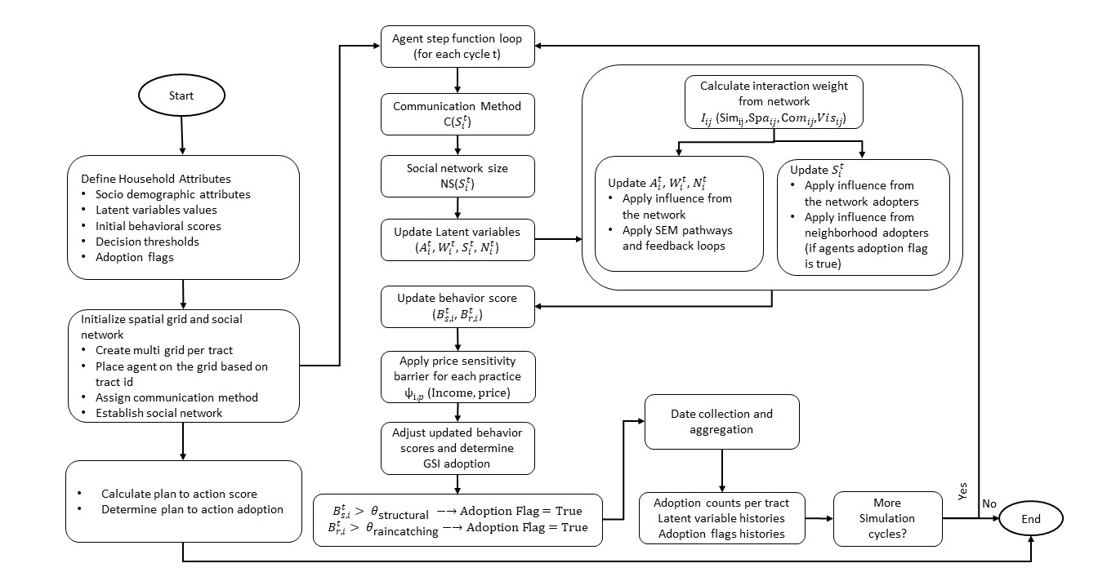
Figure S3. Conceptual framework of the GSI Agent-Based Model.

2.5. Application to Austin, Texas
Austin’s rapid growth and diverse urban fabric offer a dynamic backdrop for examining household-level GSI adoption, as decades of sustained population influx have transformed what was once a relatively compact city into a sprawling region shaped by new development patterns, evolving municipal priorities, and a strong civic identity. The city consists of ten council districts (Figure S4 and Table S3) with widely differing land use histories, socio-economic conditions, and housing types; for example, peripheral subdivisions often provide more expansive lots suited to green stormwater infrastructure, while older central neighborhoods may face zoning constraints and redevelopment pressures that shape on-site stormwater decisions. In light of this variability, the agent-based modeling (ABM) framework incorporates council district boundaries, tract-level demographics, and city-specific parcel data so that each household agent mirrors the local reality of building footprints, yard sizes, and typical incomes. This tailored approach, further informed by district-level census information and community surveys, aligns model assumptions with the city’s diverse physical and social landscape, thereby reflecting how policymaking and outreach often occur not only across the municipality as a whole but also through distinct district-level initiatives and local leadership.
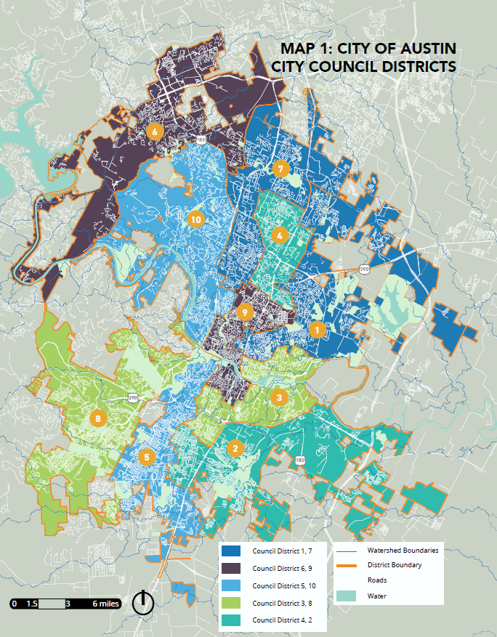
Figure S4. City of Austin Council Districts

Table S3. District level demographic data
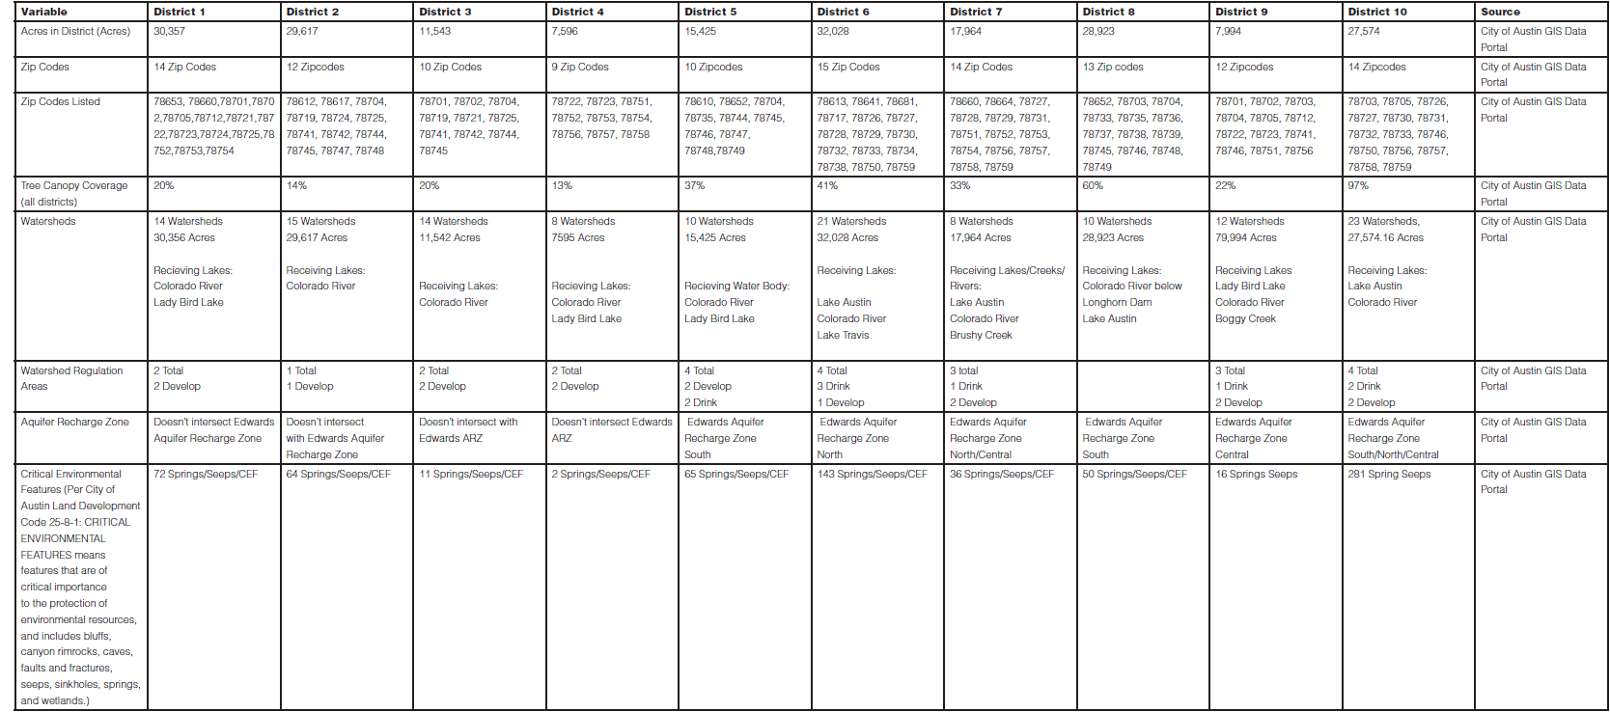

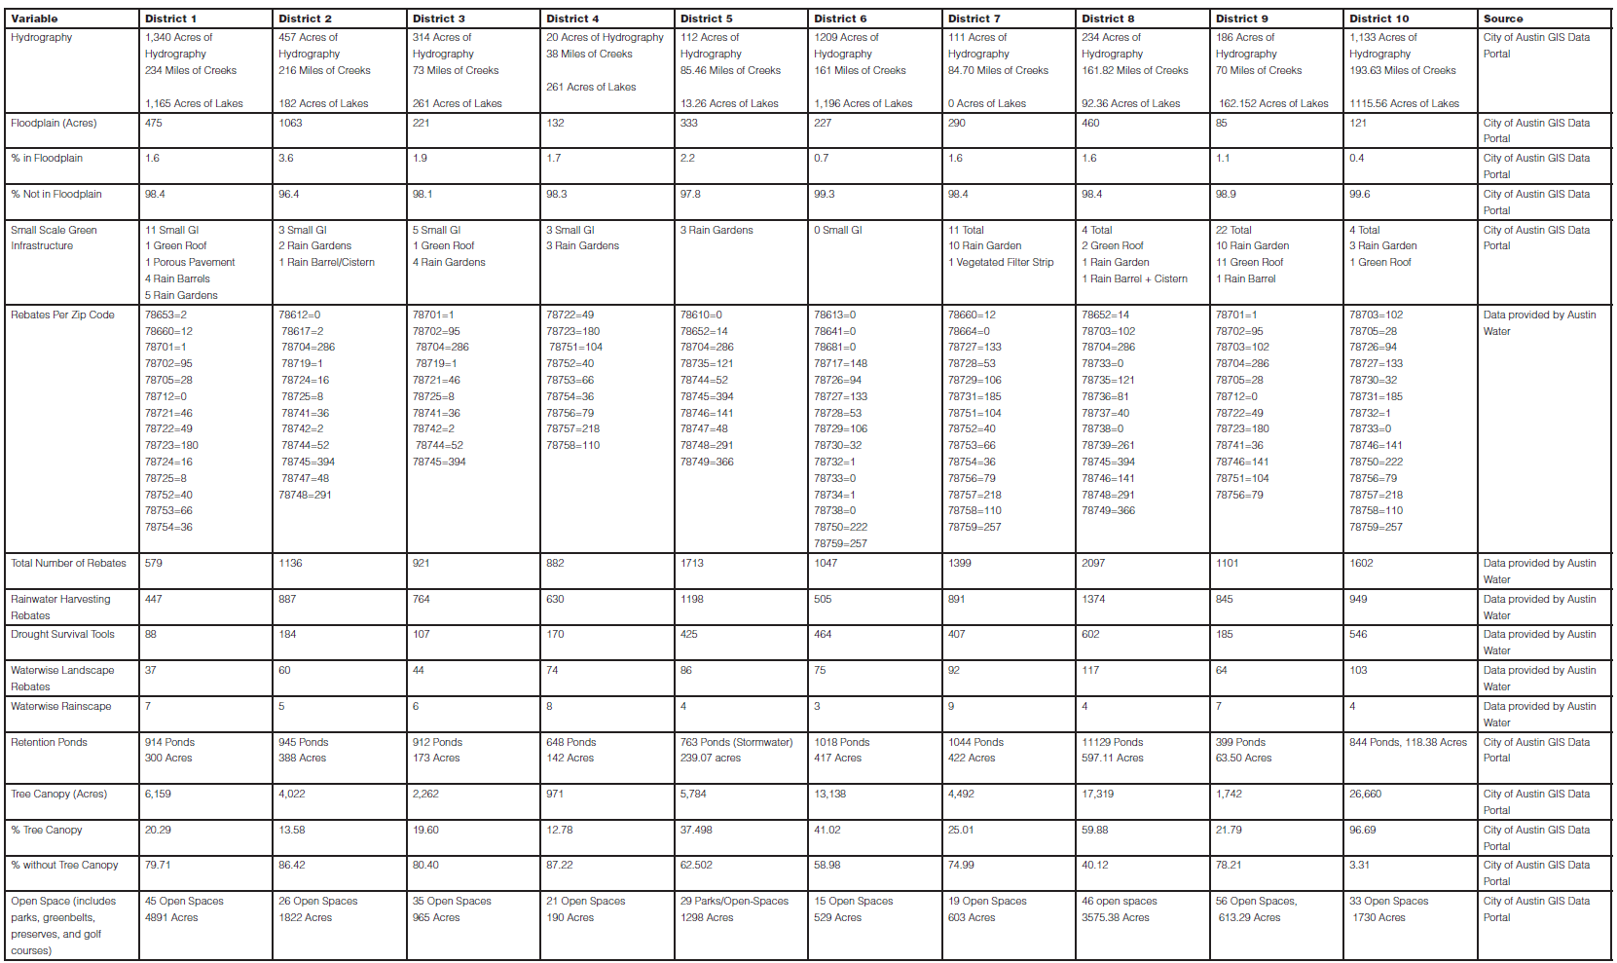
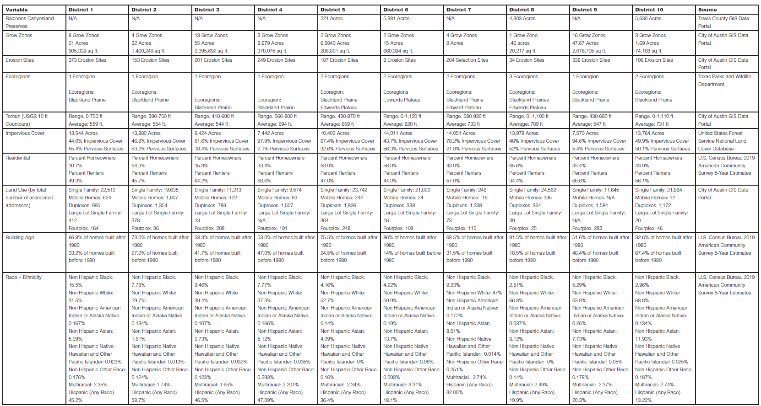
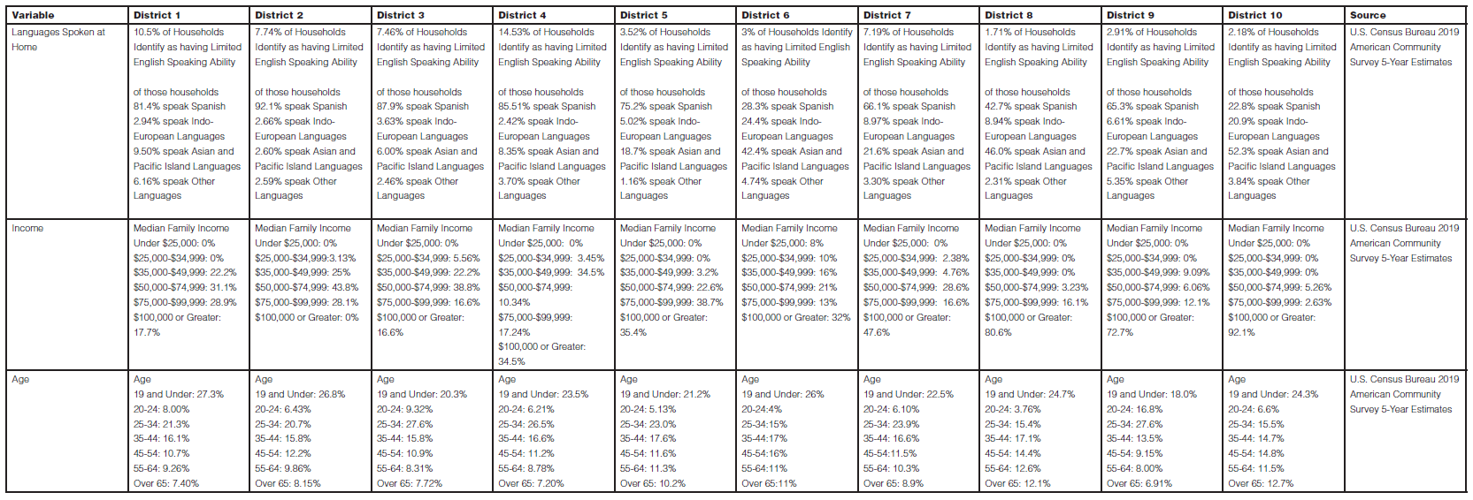

2.6. Model Calibration
We calibrated the model’s key parameters against empirical data on intended GSI adoption (from the “plan-to-action” measures) to ensure realistic simulation outputs. Our calibration target is a single, system-wide measure of cumulative GSI adoption intentions (i.e., we do not attempt to match adoption intentions at finer spatial units like neighborhoods). Specifically, we ran the model over a 20-year horizon (40 cycles, with each cycle representing 6 months) and adjusted parameters such that the overall, city-wide cumulative adoption in the simulation aligned with the plan-to-action intentions reported in the survey. At the midpoint of the simulation (year 10, or 20 cycles), we tuned the total number of simulated adopters for each GSI practice to match the system-wide adoption intentions (Figure S5). This ensures that the model is neither over- nor under-predicting adoption in the early diffusion phase while still converging on plausible final adoption levels. Parameters adjusted during this calibration include:
- Self-influence weight (α) – the extent to which an agent’s prior state dominates its current update (initially 0.85).
- Neighbor-influence weight (β) – the baseline strength of neighbor influence on latent updates (initially 0.15), along with the rate at which this influence decays as global adoption rises.
- SEM influence weights (𝛾_{𝑏}) – coefficients for SEM-derived latent variable pathways, potentially differing for structural vs. rain-catching behaviors.
- Social influence component weights – the relative weights of the four interaction components (similarity, proximity, communication, visual) in Eq. 9, which shape how neighbor interaction weight is calculated.
- Network and neighborhood influence rates on social capital – parameters in Eq. 17 that control how much social capital grows from network’s adoption and from mutual adoption feedback.
By manually varying these parameters, observing adoption outcomes, and iterating, we achieved close alignment between the model’s final 10-year adoption levels and the system-wide intentions reported in the survey. Adopting this single-target approach at the city (or system) scale means we are not calibrating separate adoption curves per neighborhood, but rather ensuring that the overall simulated diffusion aligns with aggregated plan-to-action data.
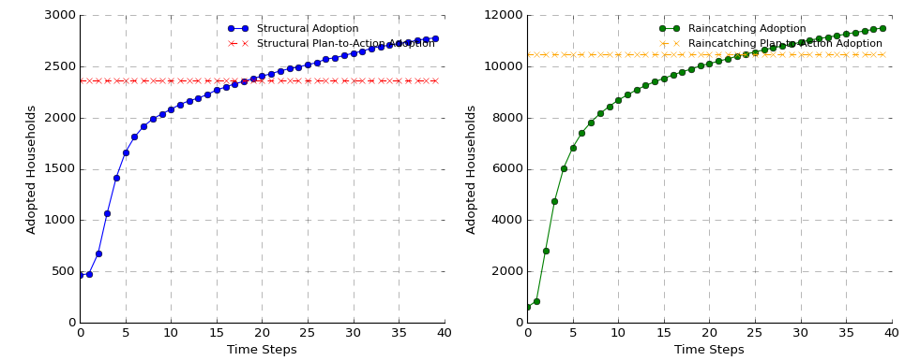
Figure S5. Total number of households that adopted each GSI practice vs the projected plan-to-action intentions measured at the model’s initial state.

2.7. Sensitivity Analysis and Robustness Testing
Following calibration, we performed a one-at-a-time (OAT) sensitivity analysis on a single, representative district to further explore the model’s robustness and the relative influence of key parameters. OAT sensitivity analysis is a widely used method for assessing the importance of individual parameters in complex models, offering a straightforward approach to examine parameter influence systematically (Pianosi et al., 2016; Saltelli et al., 2008). We chose this district by locating the median values of structural and rain-catching adoption from the citywide model run, thereby ensuring that the district’s behavior was broadly representative. This approach aligns with best practices in sensitivity analysis, where selecting a representative sample reduces computational overhead while preserving the key dynamics of the system being modeled (Ligmann-Zielinska & Sun, 2010; Razavi & Gupta, 2016; Zellner, 2008).
Eleven parameters that were discussed above for calibration—comprising self-influence weight, non-adopters influence weight, the three SEM influence weights for structural and rain-catching behaviors, and the six social-influence weights (similarity, spatial proximity, communication, and visual influence, as well as network- and neighborhood-influence rates)—were each perturbed by a specific range (± 5%, ±10%, and ±15%) from their calibrated baseline values. At each parameter setting, the entire simulation was rerun with the same initial conditions and random seed to ensure that differences in the results arose solely from parameter changes rather than stochastic variation.
For each sensitivity scenario, we tracked the final adoption percentages for structural and rain-catching GSI practices over the 40-cycle simulation. The difference in adoption percentage relative to the calibrated baseline scenario was recorded for each parameter variation. To maintain comparability across all scenarios, we fixed the random seed inside each simulation run, ensuring that identical household placements, initial adopters, and social-network configurations were generated for all parameter tests. This fixed-seed approach isolated the effect of parameter changes from random fluctuations. Through this OAT sensitivity analysis, we verified that the calibrated parameters provided stable results and identified which parameters had the greatest impact on GSI adoption dynamics. This process further validated our ABM’s design, confirming that its core mechanisms—behavioral reinforcement via social networks, price sensitivity, and latent-variable feedback loops—were both theoretically sound and empirically robust.

For structural adoption, the model exhibits moderate sensitivity to individual-level behavioral parameters, particularly SEM Awareness and SEM Personal Norms, which show consistent increases in adoption rates with positive variations. For example, a 15% increase in SEM Awareness results in an absolute change of 0.14%, while SEM Personal Norms yields a similar increase of 0.13%. These findings highlight the critical role of internal behavioral constructs in shaping structural GSI adoption. Social interaction parameters, such as Similarity and Communication, also exert moderate influence, with Communication producing increases of up to 0.16% for positive perturbations. This indicates that while peer interactions contribute to structural adoption, their impact is less pronounced compared to individual behavioral factors. In contrast, community-level parameters, such as SC Network Influence Rate and SC Neighborhood Influence Rate, exhibit relatively low sensitivity, with changes in adoption rates remaining below 0.07% across all tested variations. This lower impact aligns with the observed diffusion dynamics of structural practices, which tend to propagate more slowly and rely less on broader social networks (Figure S6).
Rain-catching adoption demonstrates higher overall sensitivity to parameter variations, particularly those associated with community-level and observable social dynamics. Parameters such as SC Neighborhood Influence Rate and SC Network Influence Rate—which influence social capital—have the most significant impacts, with adoption rate changes reaching 0.40% and 0.32%, respectively, for a 15% positive variation. This underscores the importance of localized social influence and strong community networks in driving rain-catching practices. Similarly, Visual Influence shows substantial sensitivity, with increases of up to 0.38% for the highest positive variation. This highlights the role of observational learning, where visible adoption by neighbors reinforces behavioral norms and motivates further adoption. Social interaction parameters, such as Similarity and Communication, also contribute significantly to rain-catching adoption, with Similarity producing adoption increases of up to 0.32%.
Notably, the uniform color gradients within each parameter row indicate that variations in a single parameter exert a relatively consistent effect on final adoption rates across all increment levels. This pattern implies that deviations from the baseline value produce predictable, proportional changes in adoption outcomes, regardless of the magnitude of the variation. Such consistency confirms the stability of the calibrated baseline and the robustness of the model, as small to moderate deviations in individual parameters do not drastically alter the overall adoption dynamics.

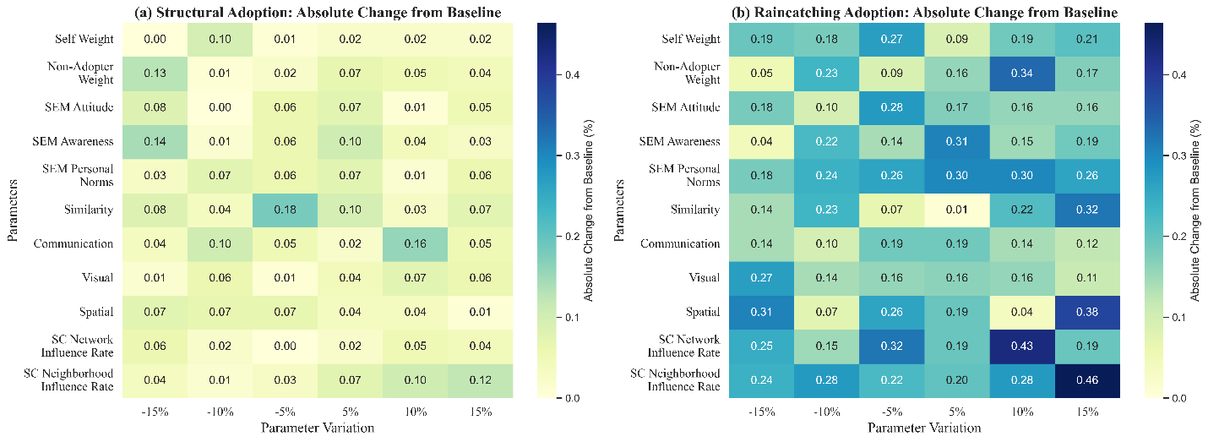
Figure S6. Sensitivity analysis results. Left panel shows the structural practices, and right panel shows the raincatching practices

