Table 1 Descriptive statistics of water quality parameters of private dug wells at Hebron district
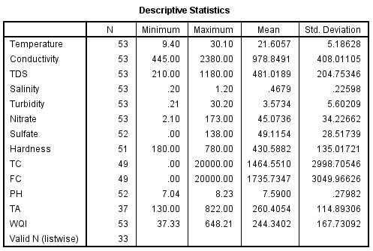

Table 3 correlation coefficient values between WQI and water quality parameters.
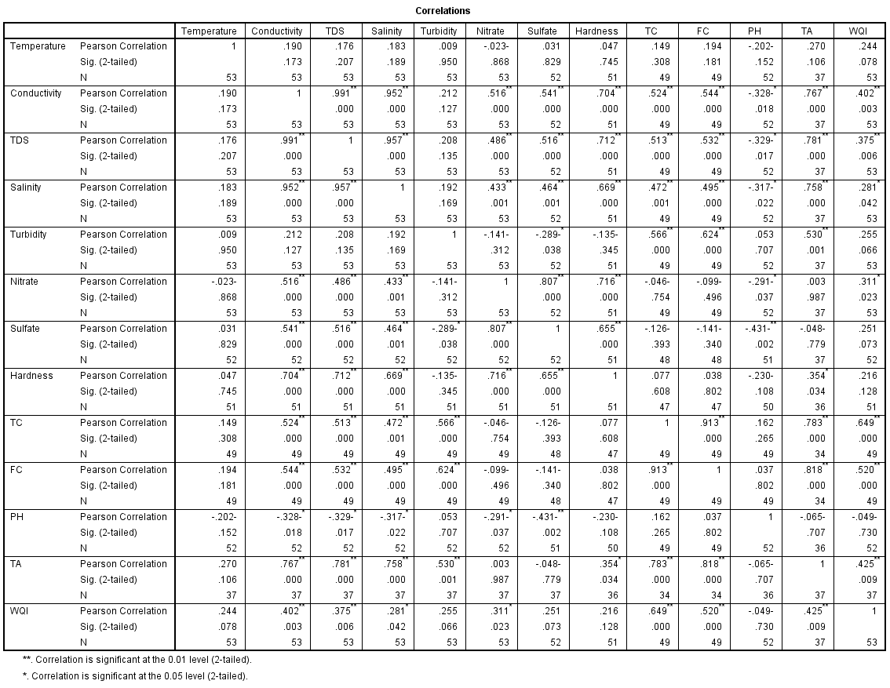

Table 4 percentage of different classification of water quality index in private dug wells in Hebron District
