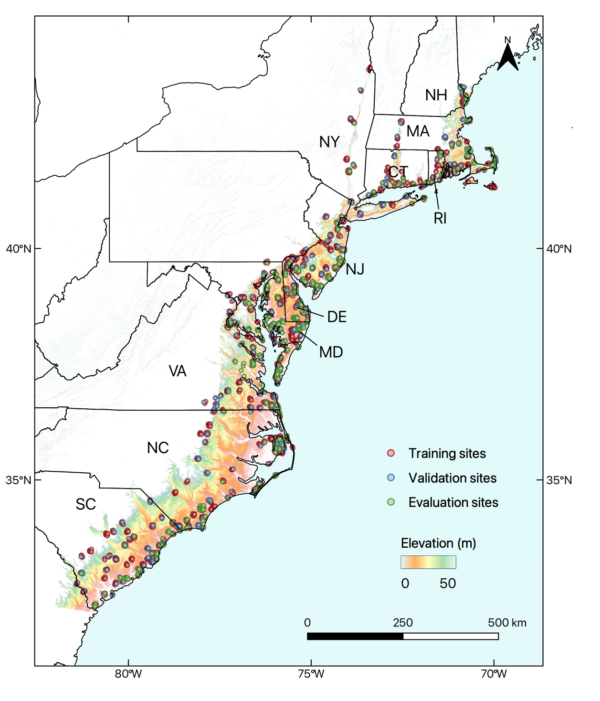
Extended Data Fig. 1 | Overview of training and evaluation sites. The locations of the 1,519 training and 260 validation sites of random sizes (at least 256 x 256 pixels) used for model training, containing a total of 142,012 dead tree labels. We developed 350 1-ha independent evaluation sites that capture different elevation and dead tree density gradients, consisting of 9,624 dead trees. The background map shows the elevation (from 0 to 50 m above sea level) of the US Atlantic coast.

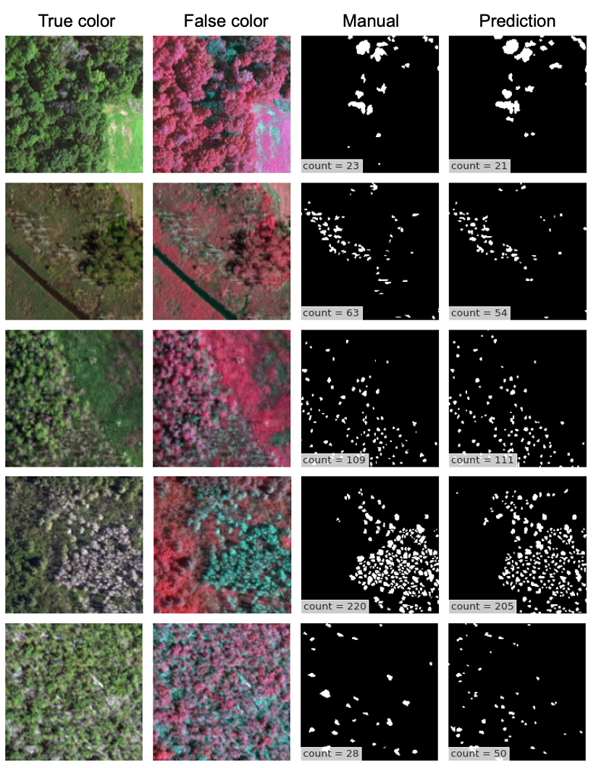
Extended Data Fig. 2 | Examples of evaluation dataset. Manually labeled dead trees were compared with predicted dead trees in 350 1-ha plots distributed across the Atlantic coast. We defined dead trees as overstory dead trees with visible shadow and white/grey appearance. Model accuracy was evaluated at plot-level (counting) and tree-level (localization). Last row showed an occasion where dead tree delineation by both human and deep learning model was difficult.

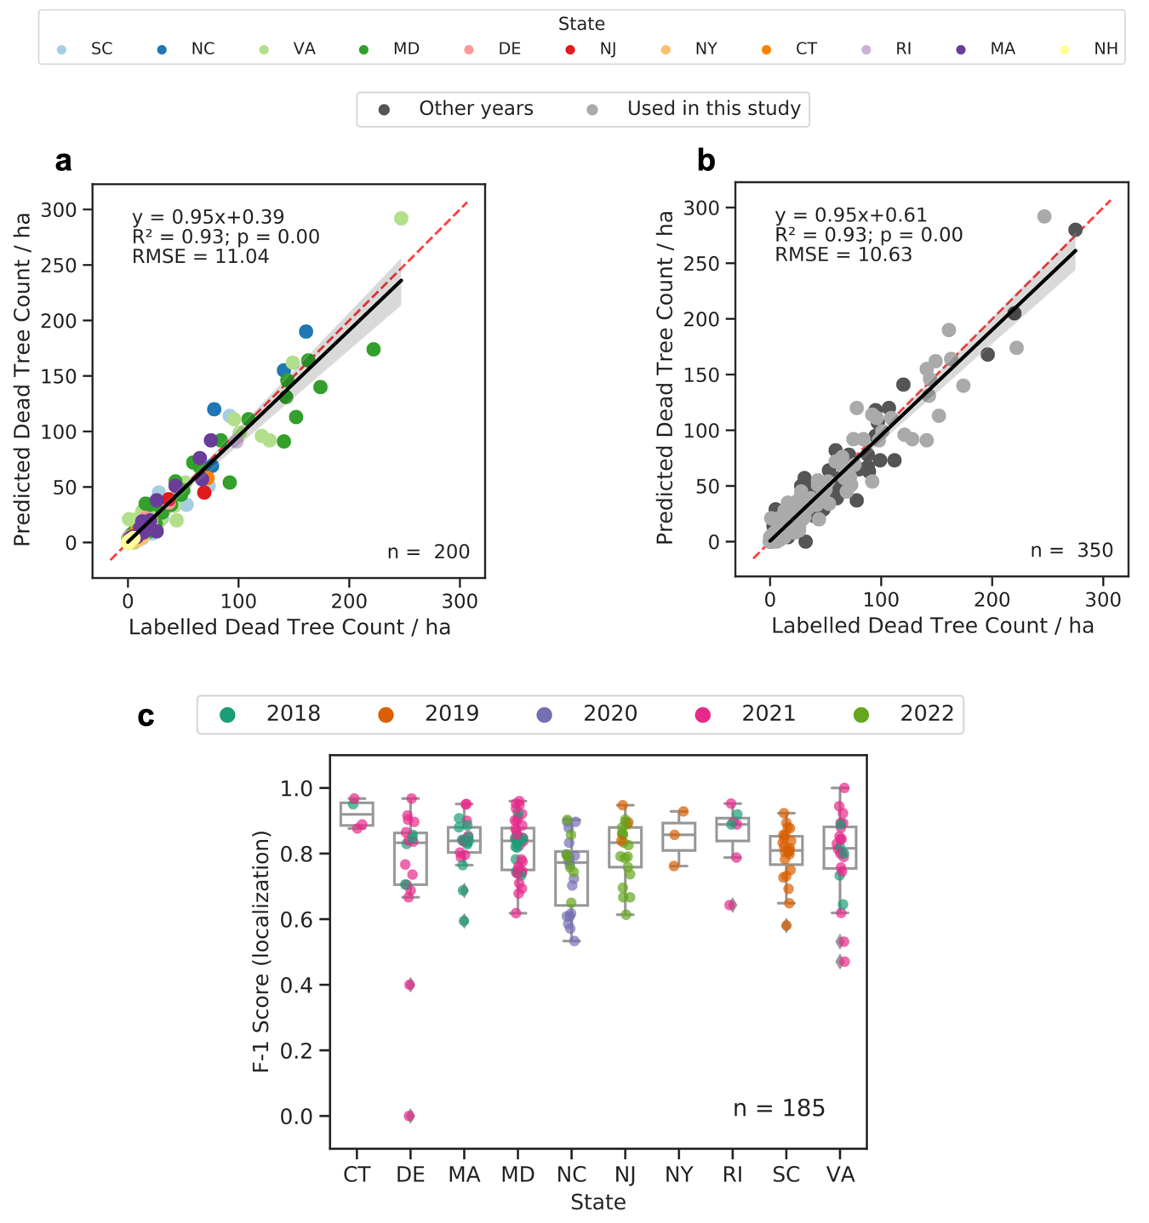
Extended Data Fig. 3 | Plot-level and tree-level evaluation. a. Manually labeled dead trees were compared with predicted dead trees in 200 1-ha plots collected in the NAIP year used in this study. Here, the number of dead trees per ha was compared. Color indicates different states. b. As in a, but using all 350 plots, including those state-year NAIP combination that were not used in the study. c. Overall accuracy (F1 score) of localizing Individual trees across states. Each point represent the F1 score of a plot. The figure only showed plots with > 10 manual labeled dead trees since F1 score is highly sensitive when sample size is low. The overall F1 score considering all labels and predictions is 0.82.

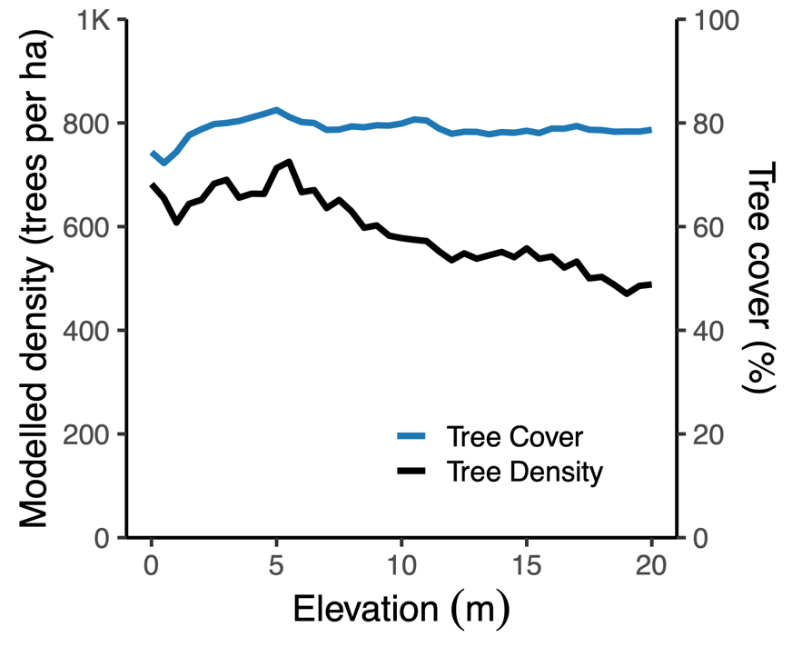

Extended Data Fig. 4 | Modelled total tree density and tree cover across elevation gradients. Tree density data from the USFS tree density map in 2012, which was modeled using the Forest Inventory and Analysis (FIA) field plots and gridded environmental data⁸⁰. Tree cover data from the Hansen tree cover map in 2000 derived from Landsat⁶⁷. It is important to note that these datasets are not directly comparable with our product due to differences in methodology and input data source. Instead, these datasets are used as a reference to assess how tree cover or total tree count changes with elevations. We found that tree cover remains stable across elevations, and although the total tree density slowly increases with decreasing elevation, it cannot explain the drastic increase in tree mortality density below 5 m in this study.

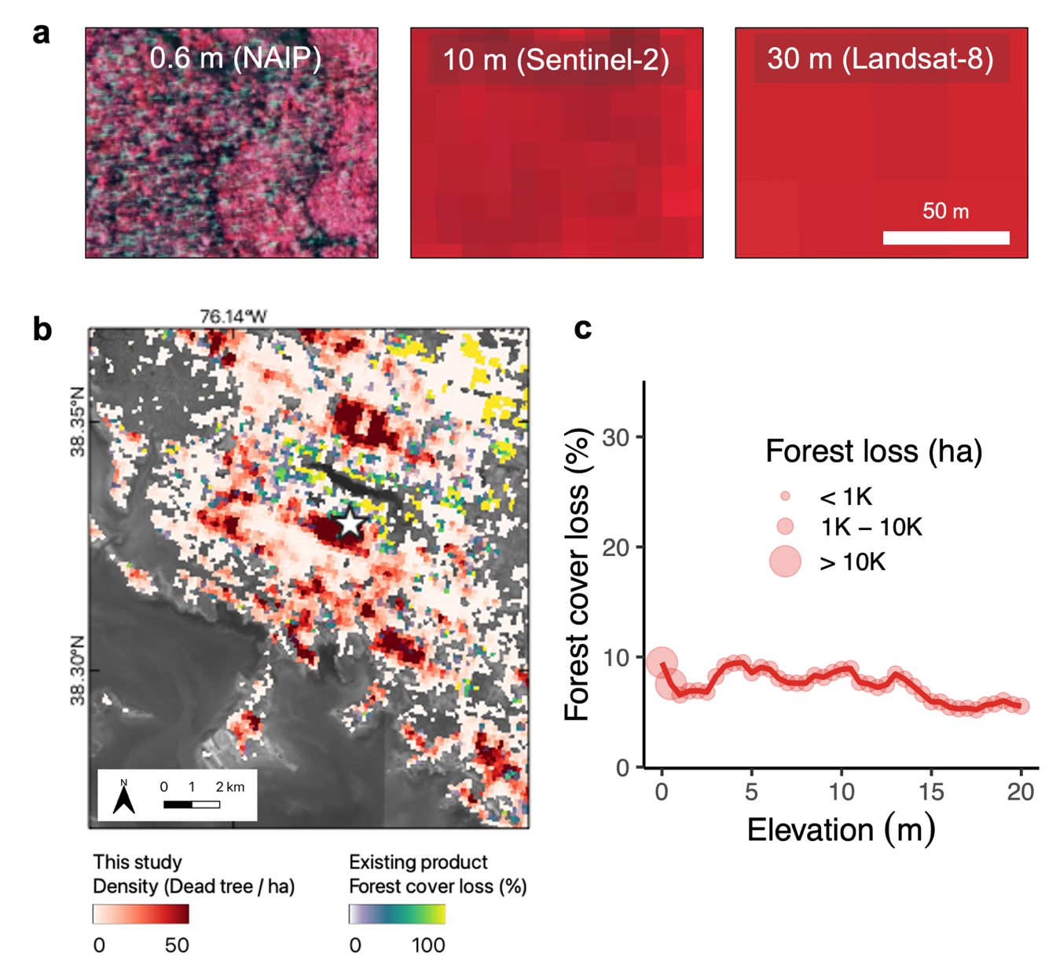

Extended Data Fig. 5 | Comparison with existing coastal forest loss product. a. Comparing ghost forest scene in NAIP (0.6m), Sentinel (10m) and Landsat (30m). All images are in false-color. Dead trees and healthy vegetation are displayed in white/grey and red respectively. b. An example comparing our tree mortality map with an existing Landsat-based coastal forest loss product from 2001 to 2016 (C-CAP)⁶⁸, excluding human-driven landcover change (e.g. agriculture conversion). The star symbol represents the location of a. There was very little overlap between the high dead tree density area in our map and the high forest loss area in the existing product, since most mortality mapped in our study was not detected in the Landsat-based map. c. Mean forest loss from 2001 to 2016 across elevations (0.5 bin). This highlights that coarse-resolution product severely underestimates coastal forest mortality in low-lying areas. Comparing with forest loss data from 2001 to 2021 yielded similar results.

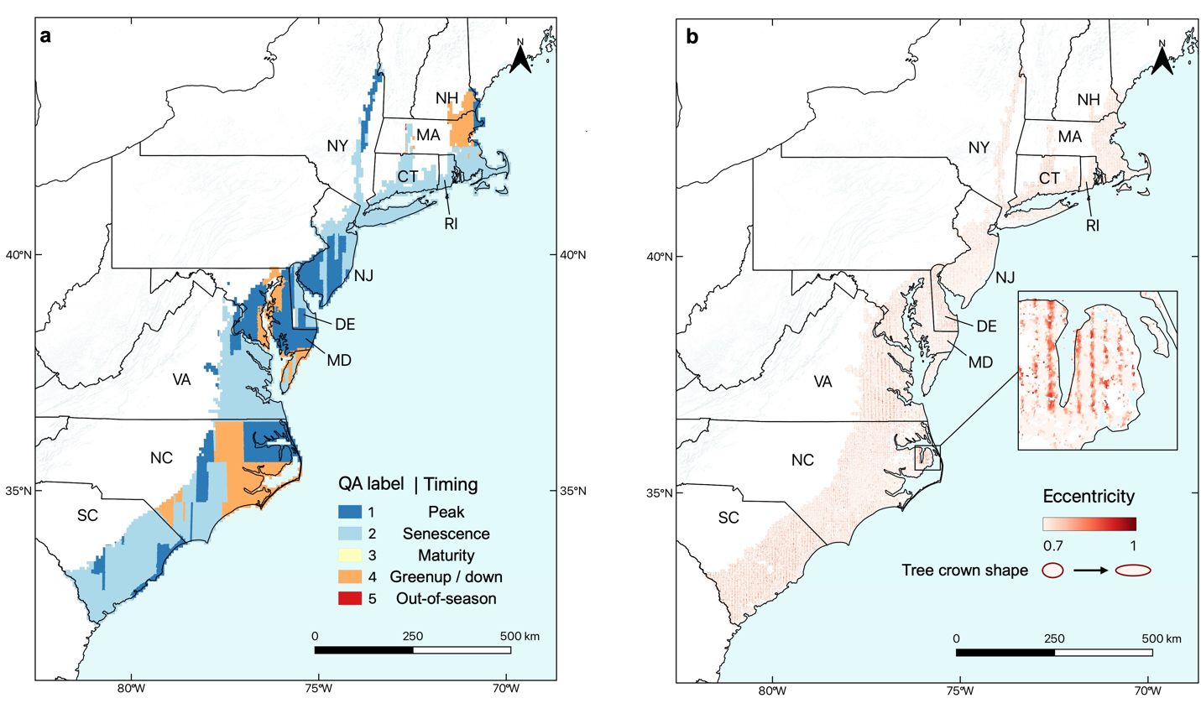

Extended Data Fig. 6 | Quality of NAIP imagery in this study. a. Spatial distribution of acquisition timing of NAIP imagery for our map. The quality assurance (QA) label was assigned based on state-averaged forest phenological timing using MODIS land surface phenology product. b. Eccentricity map showing median dead tree crown eccentricity per 500 m pixel. Generally, we advise careful use of data acquired during green-up, green-down, and with high eccentricity values.

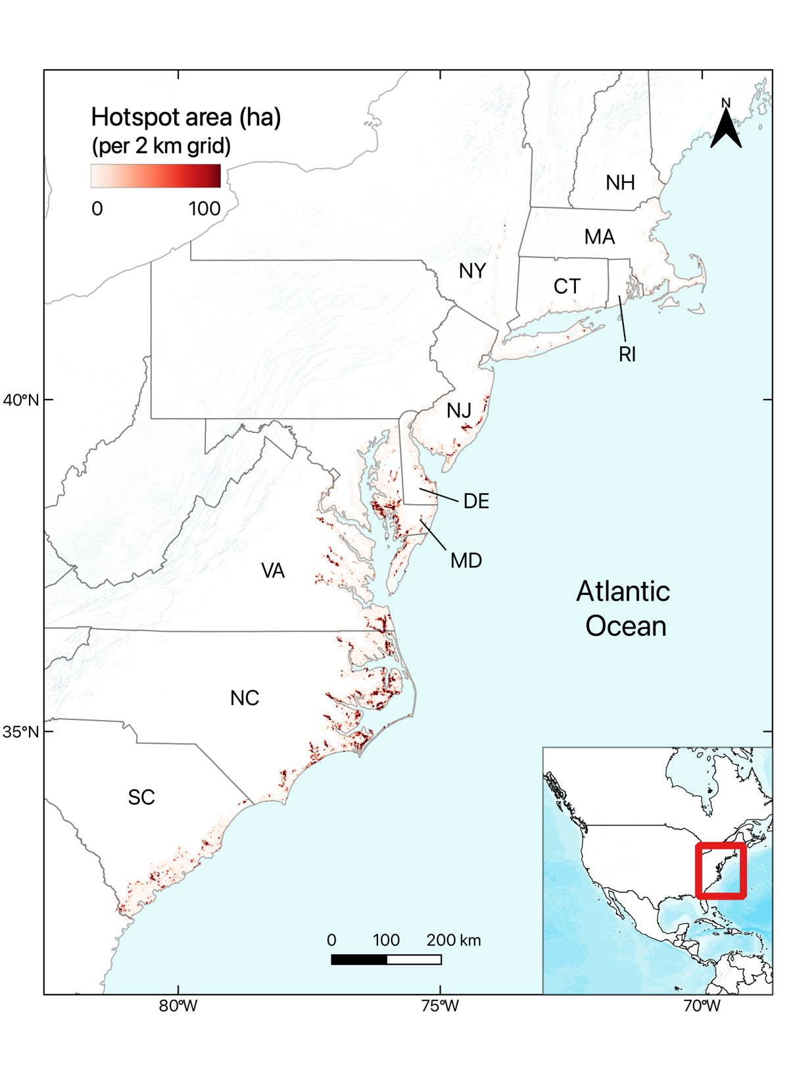
Extended Data Fig. 7 | Ghost forest hotspots in low-lying (< 5 m) areas. Hotspots of clustered dead trees were identified using spatial autocorrelation statistics (Methods).

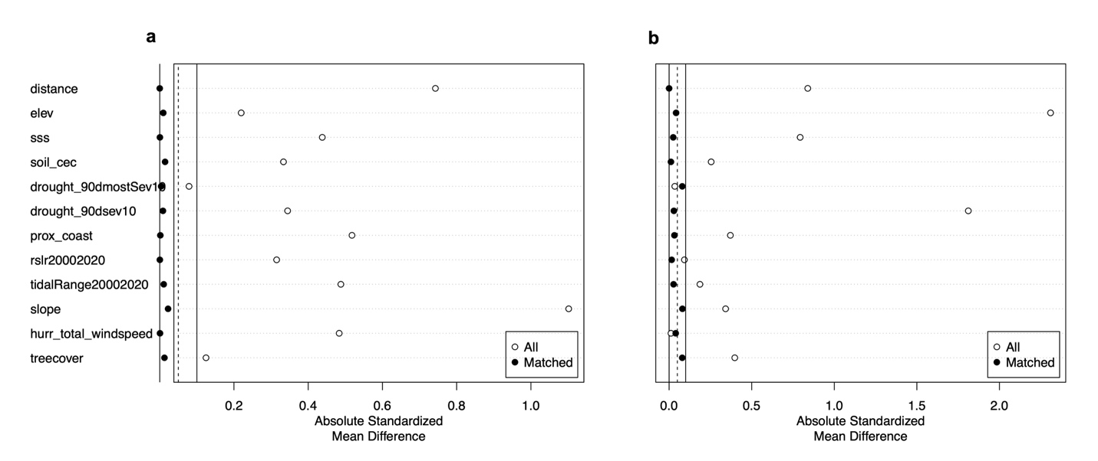
Extended Data Fig. 8 | Site-matching performance for flood-controlled areas. a. Matching for sites with and without roads. b. Matching for sites with and without levees. Absolute standardized mean difference (ASMD) refers to the difference between the matched and unmatched (all) data. ASMD values less than 0.1 indicate good matching.

Extended Data Table 1 | Model performance across states
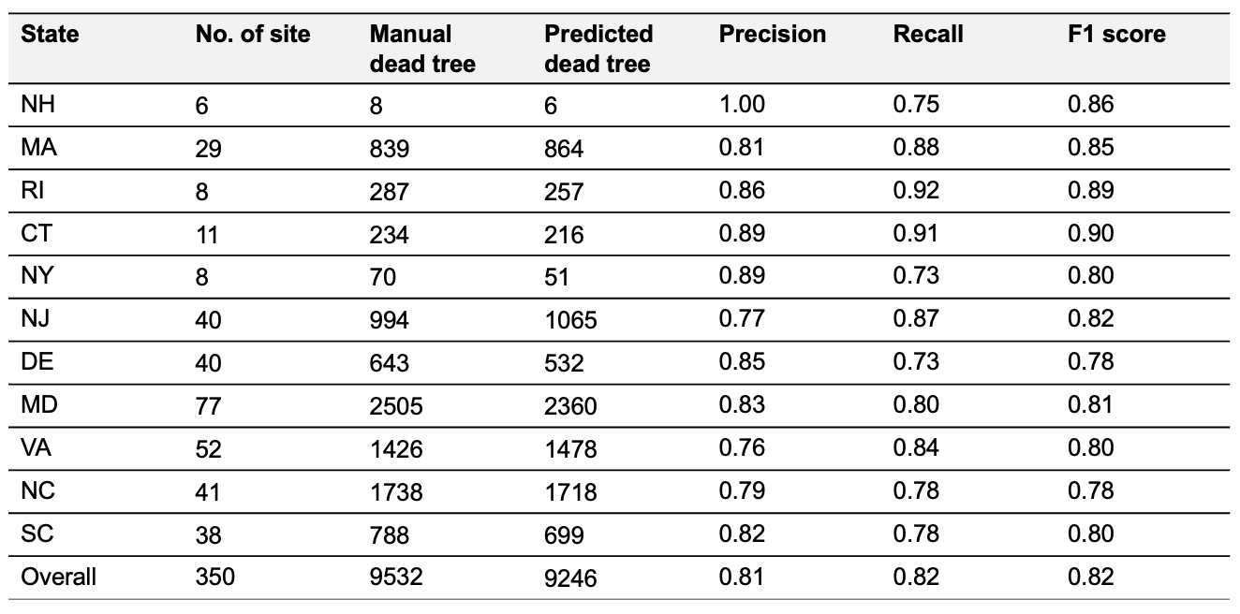
Precision, recall and F1 score were calculated based on the true positive, false positive and false negative predictions of individual trees (Methods).

Extended Data Table 2 | Distribution of dead trees and hotspots across states in low-lying areas (< 5 m)
